**AMP Journal**

**Name: Mastan Iram Mukhtar**

**ROLL NO:471**

**Practical No : 1**

**Hello World Program**

Activiy_main.xml:

<?xml version="1.0" encoding="utf-8"?>  
<androidx.constraintlayout.widget.ConstraintLayout xmlns:android="http://schemas.android.com/apk/res/android"  
 xmlns:app="http://schemas.android.com/apk/res-auto"  
 xmlns:tools="http://schemas.android.com/tools"  
 android:layout_width="match_parent"  
 android:layout_height="match_parent"  
 tools:context=".MainActivity">  
  
 <TextView  
 android:layout_width="wrap_content"  
 android:layout_height="wrap_content"  
 android:text="Hello World!"  
 android:textSize="30dp"  
 android:textColor="@color/black"  
 android:background="@color/purple_200"  
 app:layout_constraintBottom_toBottomOf="parent"  
 app:layout_constraintEnd_toEndOf="parent"  
 app:layout_constraintStart_toStartOf="parent"  
 app:layout_constraintTop_toTopOf="parent" />  
  
</androidx.constraintlayout.widget.ConstraintLayout>

MainActivity.java:

package com.example.iram471;  
  
import androidx.appcompat.app.AppCompatActivity;  
  
import android.os.Bundle;  
  
public class MainActivity extends AppCompatActivity {  
  
 @Override  
 protected void onCreate(Bundle savedInstanceState) {  
 super.onCreate(savedInstanceState);  
 setContentView(R.layout.*activity_main*);  
 }  
}

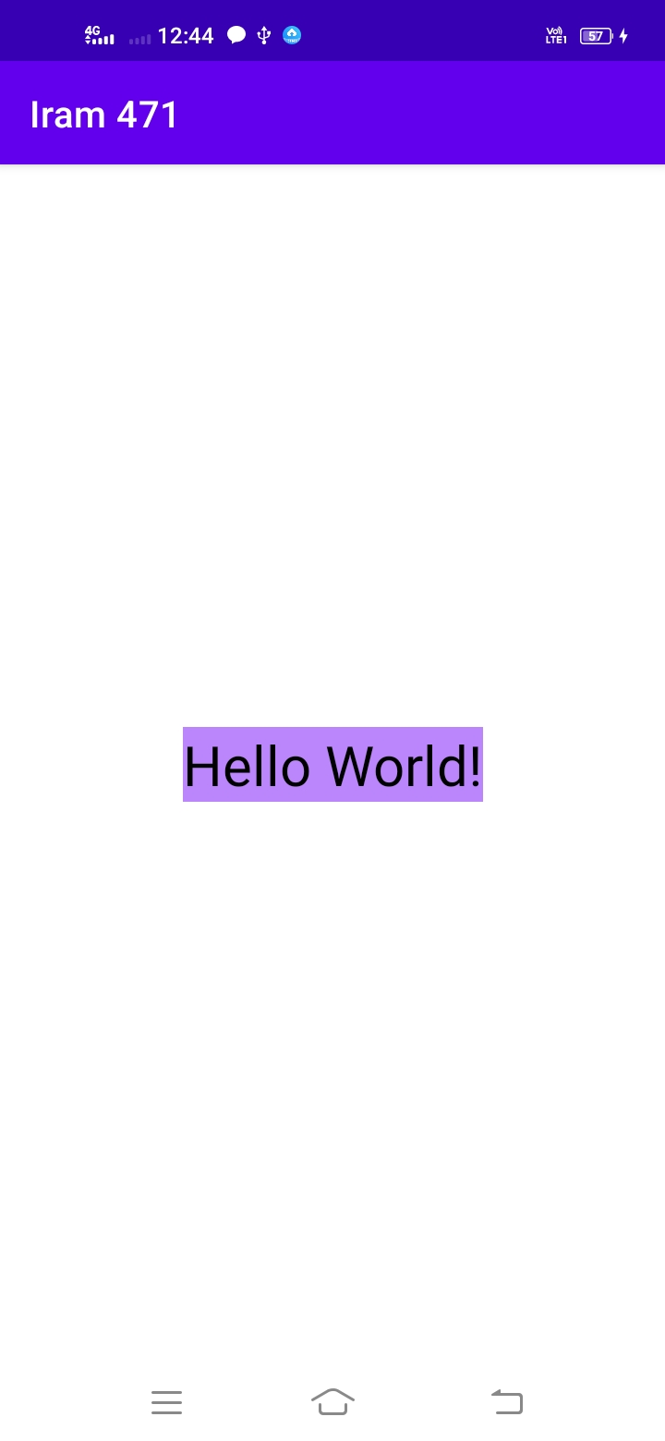

**Practical No : 2**

**a)Defining Color Property:**

Activiy_main.xml:

<?xml version="1.0" encoding="utf-8"?>  
<LinearLayout xmlns:android="http://schemas.android.com/apk/res/android"  
 xmlns:app="http://schemas.android.com/apk/res-auto"  
 xmlns:tools="http://schemas.android.com/tools"  
 android:layout_width="match_parent"  
 android:layout_height="match_parent"  
 tools:context=".MainActivity">  
  
 <LinearLayout  
 android:layout_width="409dp"  
 android:layout_height="729dp"  
 android:orientation="vertical"  
 app:layout_editor_absoluteX="1dp"  
 app:layout_editor_absoluteY="1dp">  
  
 <TextView  
 android:id="@+id/textView"  
 android:layout_width="match_parent"  
 android:layout_height="56dp"  
 android:text="TextView"  
 android:background="@color/Red"></TextView>  
  
 <TextView android:id="@+id/textView2"  
 android:layout_width="match_parent"  
 android:layout_height="52dp"  
 android:text="TextView"  
 android:background="@color/Grey"></TextView>  
  
 <TextView android:id="@+id/textView3"  
 android:layout_width="match_parent"  
 android:layout_height="59dp"  
 android:text="TextView"  
 android:background="@color/Blue"></TextView>  
  
 <TextView android:id="@+id/textView4"  
 android:layout_width="match_parent"  
 android:layout_height="51dp"  
 android:text="TextView"  
 android:background="@color/Cyan"></TextView>  
  
 </LinearLayout>  
</LinearLayout>

colors.xml:

<?xml version="1.0" encoding="utf-8"?>  
<resources>  
 <color name="purple_200">#FFBB86FC</color>  
 <color name="purple_500">#FF6200EE</color>  
 <color name="purple_700">#FF3700B3</color>  
 <color name="teal_200">#FF03DAC5</color>  
 <color name="teal_700">#FF018786</color>  
 <color name="black">#FF000000</color>  
 <color name="white">#FFFFFFFF</color>  
  
 <color name="Red">#FF0000</color>  
 <color name="Blue">#0000FF</color>  
 <color name="Pink">#FF00FF</color>  
 <color name="Cyan">#00FFFF</color>  
 <color name="Grey">#AABBFF</color>  
  
</resources>

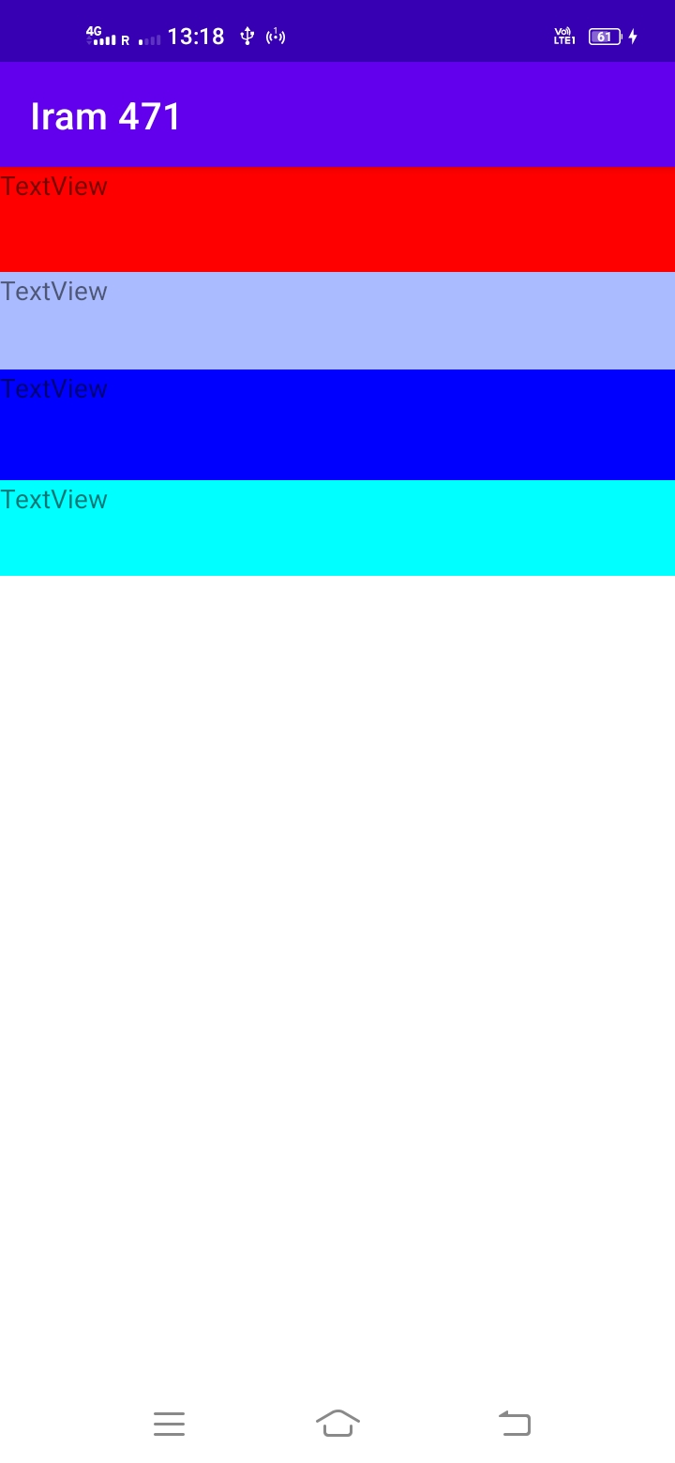

**b)Defining Theme Property:**

themes.xml:

<resources xmlns:tools="http://schemas.android.com/tools">  
 <!-- Base application theme. -->  
 <style name="Theme.Iram471" parent="Theme.MaterialComponents.DayNight.DarkActionBar">  
 <!-- Primary brand color. -->  
 <item name="colorPrimary">@color/purple_500</item>  
 <item name="colorPrimaryVariant">@color/purple_700</item>  
 <item name="colorOnPrimary">@color/white</item>  
 <!-- Secondary brand color. -->  
 <item name="colorSecondary">@color/teal_200</item>  
 <item name="colorSecondaryVariant">@color/teal_700</item>  
 <item name="colorOnSecondary">@color/black</item>  
 <!-- Status bar color. -->  
 <item name="android:statusBarColor" tools:targetApi="l">?attr/colorPrimaryVariant</item>  
 <!-- Customize your theme here. -->  
  
 <item name="android:background">#000000</item>  
 <item name="android:textColor">#FFFFAA</item>  
  
 </style>  
</resources>

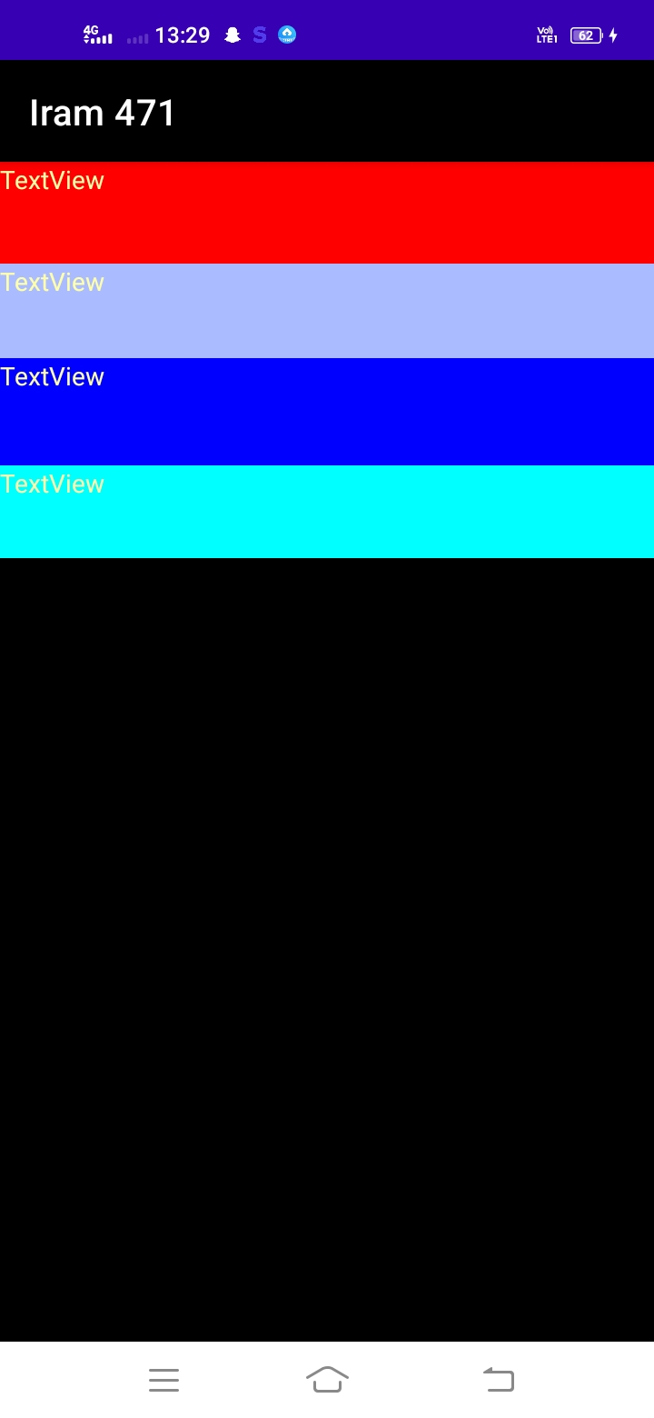

**c)Defining String Property:**

Activiy_main.xml:

<?xml version="1.0" encoding="utf-8"?>  
<LinearLayout xmlns:android="http://schemas.android.com/apk/res/android"  
 xmlns:app="http://schemas.android.com/apk/res-auto"  
 xmlns:tools="http://schemas.android.com/tools"  
 android:layout_width="match_parent"  
 android:layout_height="match_parent"  
 tools:context=".MainActivity">  
  
 <LinearLayout  
 android:layout_width="409dp"  
 android:layout_height="729dp"  
 android:orientation="vertical"  
 app:layout_editor_absoluteX="1dp"  
 app:layout_editor_absoluteY="1dp">  
  
 <TextView  
 android:id="@+id/textView"  
 android:layout_width="match_parent"  
 android:layout_height="56dp"  
 android:text="@string/Heading"  
 android:textSize="24dp"  
 android:background="@color/Red"></TextView>  
  
 <TextView android:id="@+id/textView2"  
 android:layout_width="match_parent"  
 android:layout_height="wrap_content"  
 android:text="@string/Description"  
 android:textSize="24dp"  
 android:background="@color/Grey"></TextView>  
  
 <TextView android:id="@+id/textView3"  
 android:layout_width="match_parent"  
 android:layout_height="59dp"  
 android:text="TextView"  
 android:background="@color/Blue"></TextView>  
  
 <TextView android:id="@+id/textView4"  
 android:layout_width="match_parent"  
 android:layout_height="51dp"  
 android:text="TextView"  
 android:background="@color/Cyan"></TextView>  
  
 </LinearLayout>  
</LinearLayout>

strings.xml:

<resources>  
 <string name="app_name">Iram 471</string>  
  
 <string name="Heading">Programming Resources</string>  
 <string name="Description">  
  
 Android is a mobile operating system developed by Google.  
 It is based on a modified version of the Linux  
 kernel and other open source software, and is  
 designed primarily for touch screen mobile devices  
 such as smart phones and tablets.  
 </string>  
</resources>

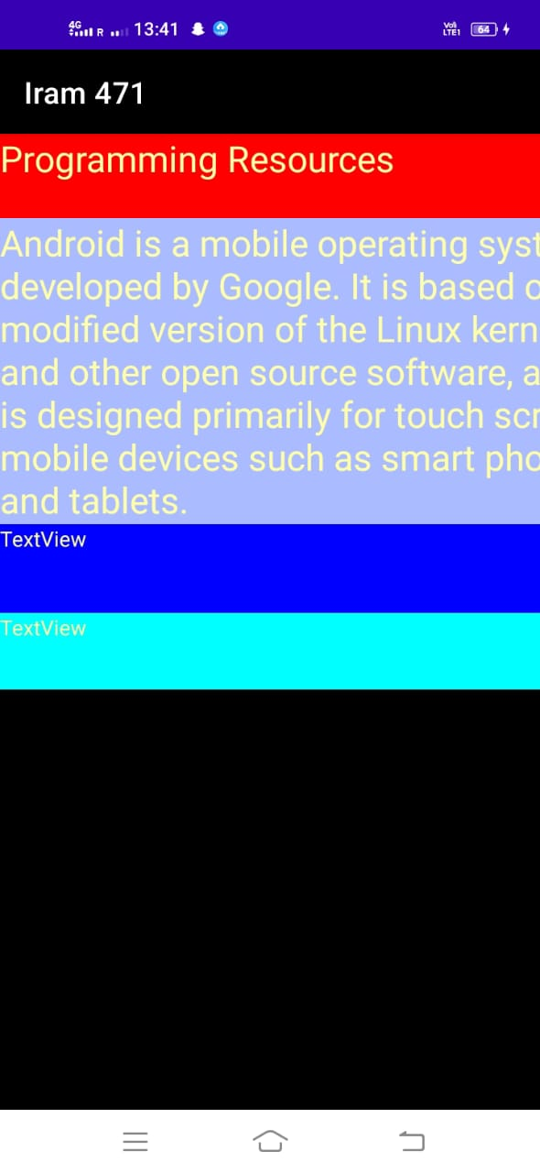

**d)Adding images and dimensions:**

**Add a new file dim.xml file and write the following code in dimens.xml.**

<?xml version="1.0" encoding="utf-8"?>  
<resources>

<dimen name="textview_height">35dp</dimen>  
<dimen name="textview_width">150dp</dimen>  
<dimen name="font_size">26dp</dimen>

</resources>

Activiy_main.xml:

<LinearLayout android:layout_width="409dp"  
 android:layout_height="729dp"  
 android:orientation="vertical"  
 tools:layout_editor_absoluteX="1dp"  
 tools:layout_editor_absoluteY="1dp">  
  
  
 <ImageView android:id="@+id/imageView"  
 android:layout_width="match_parent"  
 android:layout_height="wrap_content"  
 app:srcCompat="@drawable/iram"></ImageView>  
  
</LinearLayout>

MainActivity.java:

package com.example.iram471;  
  
import androidx.appcompat.app.AppCompatActivity;  
  
import android.os.Bundle;  
  
public class MainActivity extends AppCompatActivity {  
  
 @Override  
 protected void onCreate(Bundle savedInstanceState) {  
 super.onCreate(savedInstanceState);  
 setContentView(R.layout.*activity_main*);  
 }  
}

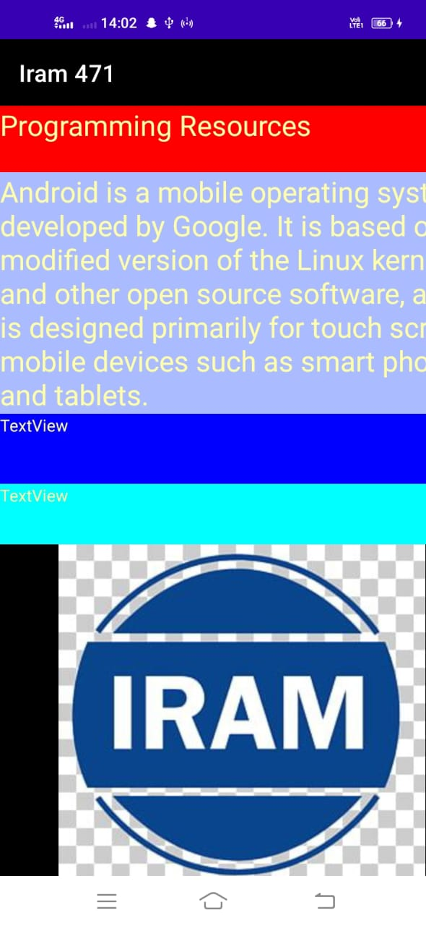

**Practical No : 3**

**Activity Life Cycle:**

## The various methods to be created are onStart(), onRestart(), onStop(), onResume(),onDestroy() and onPause() as shown in the figure.

MainActivity.kt:

package com.example.iram_471;  
  
import androidx.appcompat.app.AppCompatActivity;  
  
import android.os.Bundle;  
import android.util.Log;  
  
  
public class MainActivity extends AppCompatActivity {  
 String tag= "Android Lifecycle Demonstration";  
  
 @Override  
 protected void onCreate(Bundle savedInstanceState) {  
 super.onCreate(savedInstanceState);  
 setContentView(R.layout.*activity_main*);  
 Log.*d*(tag, "In the onCreate() event");  
 }  
  
 public void onStart()  
 {  
 super.onStart();  
 Log.*d*(tag,"In the onStart() event");  
 }  
  
 public void onRestart()  
 { super.onRestart();  
 Log.*d*(tag,"In the onRestart() event");  
 }  
  
 public void onPause()  
 {  
 super.onPause();  
 Log.*d*(tag,"In the onPause() event");  
 }  
  
 public void onStop()  
 {  
 super.onStop();  
 Log.*d*(tag,"In the onStop() event");  
 }  
  
 public void onDestroy()  
 {  
 super.onDestroy();  
 Log.*d*(tag,"In the onDestroy() event");  
 }  
  
}

**Output:**

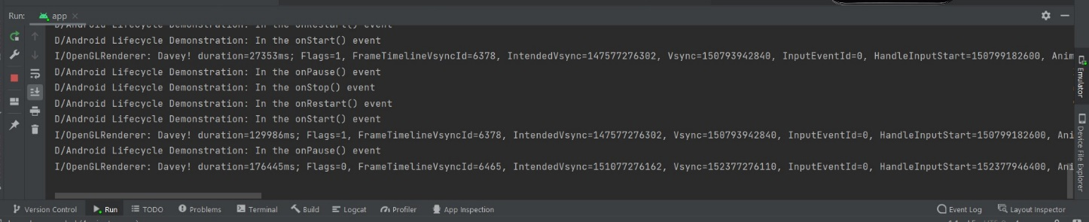

**Practical No : 4**

**Programs related to different layouts(linear, relative, table)**

**Linear Layout:**

# **Linear Layout in Android**

LinearLayout is a ViewGroup that is responsible for holding views in it. It is a layout that arranges its children i.e the various views and layouts linearly (one after another) in a single column(vertically) or a single row(horizontally).

# **Horizontal LinearLayout**

In a horizontal LinearLayout, as the name suggests, the Views defined inside the Linear Layout will be arranged horizontally one after another, like in a row. By default, the orientation is set to horizontal.

But its a good practice to explicitly specify the orientation of the linear layout by setting the attribute android:orientation with value horizontal in the LinearLayout tag.

# **Vertical Linear Layout**

In a vertical LinearLayout, as the name suggests, the Views defined inside the Linear Layout are arranged vertically one after another, like in a column. And for this we need to mention

the android:orientation attribute with value vertical within the LinearLayout tag.

Activiy_main.xml:

Horizantal:

<?xml version="1.0" encoding="utf-8"?>  
<LinearLayout  
 xmlns:android="http://schemas.android.com/apk/res/android"  
 xmlns:tools="http://schemas.android.com/tools"  
 xmlns:app="http://schemas.android.com/apk/res-auto"  
 android:layout_width="match_parent"  
 android:layout_height="match_parent"  
 android:orientation="horizontal"  
 tools:context=".MainActivity">  
  
 <EditText android:id="@+id/editText"  
 android:layout_width="wrap_content"  
 android:layout_height="86dp"  
 android:layout_weight="1"  
 android:ems="10"  
 android:hint="Enter The Text"  
 android:inputType="textPersonName"  
 android:text="Type Here"  
 android:textColor="#FFEB3B"></EditText>  
  
 <Button  
 android:id="@+id/button"  
 android:layout_width="wrap_content"  
 android:layout_height="wrap_content"  
 android:layout_weight="1"  
 android:text="Button"></Button>  
  
 <TextView  
 android:id="@+id/textView2"  
 android:layout_width="wrap_content"  
 android:layout_height="wrap_content"  
 android:layout_weight="1"  
 android:text="TextView"></TextView>  
  
 <TextView  
 android:id="@+id/textView3"  
 android:layout_width="wrap_content"  
 android:layout_height="wrap_content"  
 android:layout_weight="1"  
 android:text="TextView"></TextView>  
  
 <TextView  
 android:id="@+id/textView4"  
 android:layout_width="wrap_content"  
 android:layout_height="wrap_content"  
 android:layout_weight="1"  
 android:text="TextView"></TextView>  
  
  
</LinearLayout>

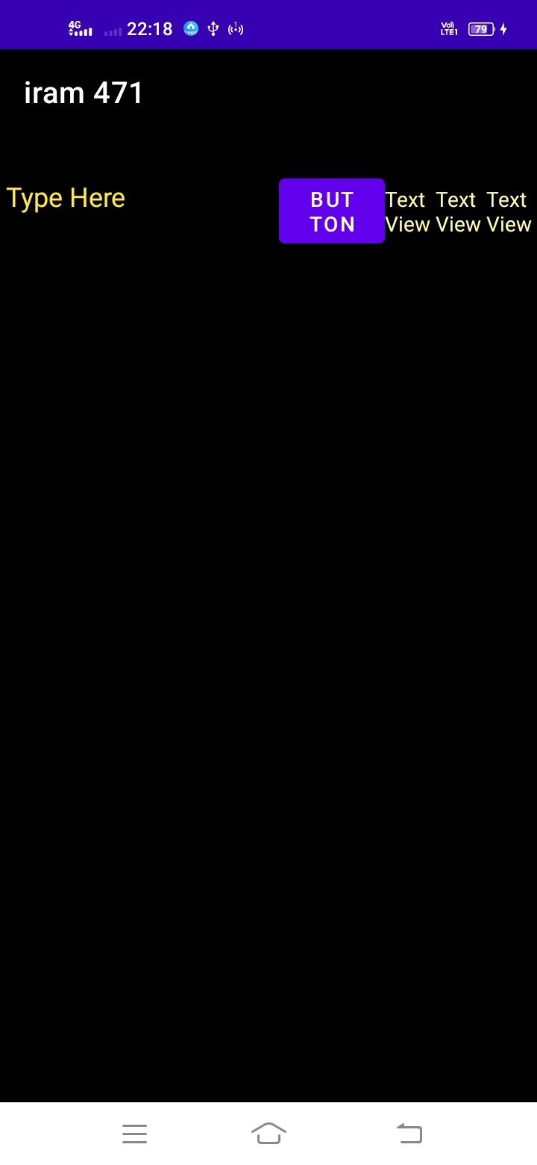

Activiy_main.xml:

Vertical:

<?xml version="1.0" encoding="utf-8"?>  
<LinearLayout  
 xmlns:android="http://schemas.android.com/apk/res/android"  
 xmlns:tools="http://schemas.android.com/tools"  
 xmlns:app="http://schemas.android.com/apk/res-auto"  
 android:layout_width="match_parent"  
 android:layout_height="match_parent"  
 android:orientation="vertical"  
 tools:context=".MainActivity">  
  
 <EditText android:id="@+id/editText"  
 android:layout_width="wrap_content"  
 android:layout_height="86dp"  
 android:layout_weight="1"  
 android:ems="10"  
 android:hint="Enter The Text"  
 android:inputType="textPersonName"  
 android:text="Type Here"  
 android:textColor="#FFEB3B"></EditText>  
  
 <Button  
 android:id="@+id/button"  
 android:layout_width="wrap_content"  
 android:layout_height="wrap_content"  
 android:layout_weight="1"  
 android:text="Button"></Button>  
  
 <TextView  
 android:id="@+id/textView2"  
 android:layout_width="wrap_content"  
 android:layout_height="wrap_content"  
 android:layout_weight="1"  
 android:text="TextView"></TextView>  
  
 <TextView  
 android:id="@+id/textView3"  
 android:layout_width="wrap_content"  
 android:layout_height="wrap_content"  
 android:layout_weight="1"  
 android:text="TextView"></TextView>  
  
 <TextView  
 android:id="@+id/textView4"  
 android:layout_width="wrap_content"  
 android:layout_height="wrap_content"  
 android:layout_weight="1"  
 android:text="TextView"></TextView>  
  
  
</LinearLayout>

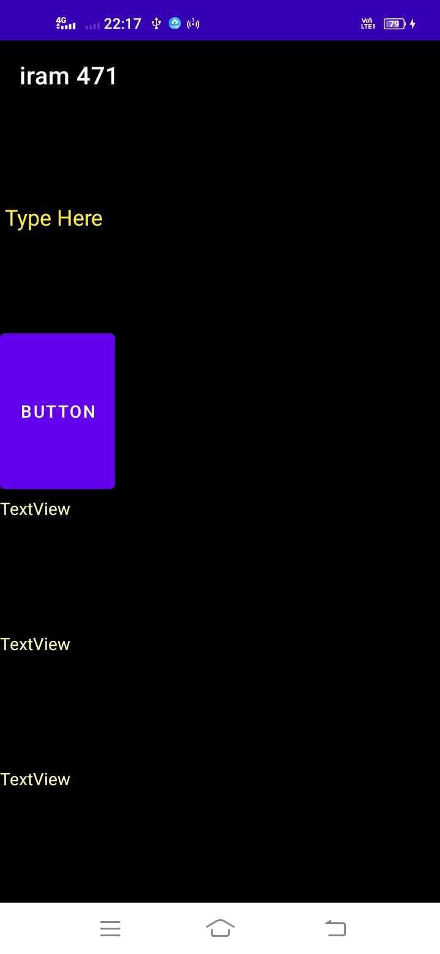

**Relative Layout:**

Activiy_main.xml:

<?xml version="1.0" encoding="utf-8"?>  
<RelativeLayout  
 xmlns:android="http://schemas.android.com/apk/res/android"  
 xmlns:tools="http://schemas.android.com/tools"  
 xmlns:app="http://schemas.android.com/apk/res-auto"  
 android:layout_width="match_parent"  
 android:layout_height="match_parent"  
 android:orientation="horizontal"  
 tools:context=".MainActivity">  
  
 <EditText  
 android:id="@+id/name"  
 android:layout_width="match_parent"  
 android:layout_height="wrap_content"  
 android:hint="Enter Text Here"></EditText>  
  
 <Spinner  
 android:id="@+id/dates"  
 android:layout_width="0dp"  
 android:layout_height="wrap_content"  
 android:layout_below="@id/name"  
 android:layout_alignParentLeft="true"  
 android:layout_toLeftOf="@+id/times"></Spinner>  
  
 <Spinner  
 android:id="@id/times"  
 android:layout_width="96dp"  
 android:layout_height="wrap_content"  
 android:layout_below="@id/name"  
 android:layout_alignParentRight="true"></Spinner>  
  
 <Button  
 android:layout_width="96dp"  
 android:layout_height="wrap_content"  
 android:layout_below="@id/times"  
 android:layout_alignParentRight="true"  
 android:text="Click Here"></Button>  
  
</RelativeLayout>

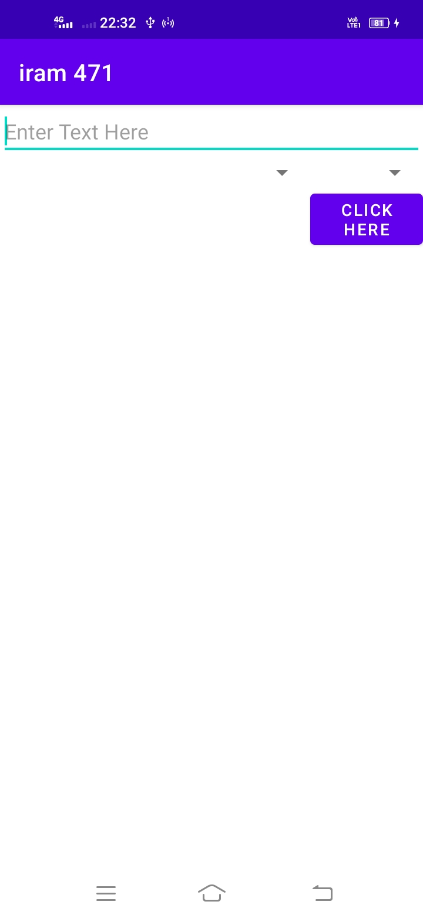

**Table Layout:**

Activiy_main.xml:

<?xml version="1.0" encoding="utf-8"?>  
<TableLayout  
 xmlns:android="http://schemas.android.com/apk/res/android"  
 xmlns:tools="http://schemas.android.com/tools"  
 xmlns:app="http://schemas.android.com/apk/res-auto"  
 android:layout_width="match_parent"  
 android:layout_height="match_parent"  
 android:orientation="horizontal"  
 tools:context=".MainActivity">  
  
 <TableRow>  
 <TextView  
 android:layout_width="225dp"  
 android:layout_height="56dp"  
 android:padding="3dip"  
 android:text="Row1,Col1" />  
  
 <TextView  
 android:layout_height="match_parent"  
 android:gravity="right"  
 android:padding="3dip"  
 android:text="Row1,Col2" />  
 </TableRow>  
  
 <TableRow>  
 <TextView  
 android:layout_width="242dp"  
 android:layout_height="64dp"  
 android:padding="3dip"  
 android:text="Row2,Col1" />  
  
 <TextView  
 android:layout_height="match_parent"  
 android:gravity="right"  
 android:padding="3dip"  
 android:text="Row2,Col2" />  
 </TableRow>  
  
</TableLayout>

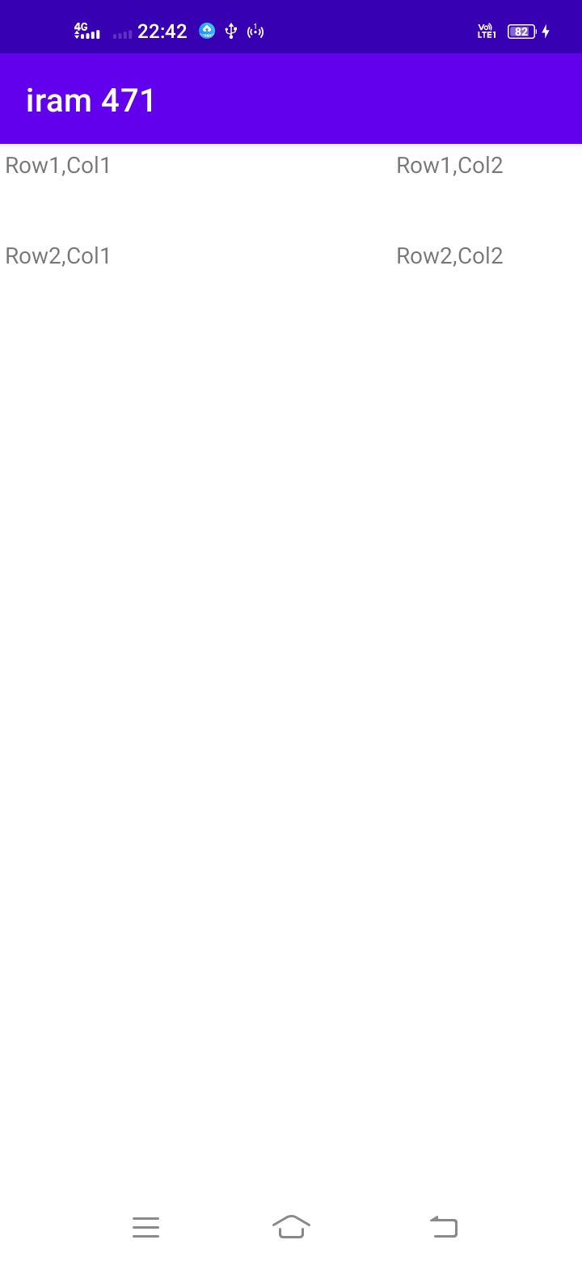

**Practical No : 5A**

**Login Example**

Activiy_main.xml:

<?xml version="1.0" encoding="utf-8"?>  
<RelativeLayout xmlns:android="http://schemas.android.com/apk/res/android"  
 xmlns:app="http://schemas.android.com/apk/res-auto"  
 xmlns:tools="http://schemas.android.com/tools"  
 android:layout_width="match_parent"  
 android:layout_height="match_parent"  
 tools:context=".MainActivity">  
  
 <TextView  
 android:id="@+id/textview"  
 android:layout_width="wrap_content"  
 android:layout_height="wrap_content"  
 android:layout_alignParentTop="true"  
 android:layout_centerHorizontal="true"  
 android:text="Login Example"  
 android:textSize="35dp"></TextView>  
  
 <EditText  
 android:layout_width="wrap_content"  
 android:layout_height="wrap_content"  
 android:id="@+id/editText"  
 android:hint="Enter Name"  
 android:focusable="true"  
 android:textColorHighlight="#ff7eff15"  
 android:layout_marginTop="46dp"  
 android:layout_alignParentLeft="true"  
 android:layout_alignParentStart="true"  
 android:layout_alignParentRight="true"  
 android:layout_alignParentEnd="true"></EditText>  
  
 <EditText  
 android:layout_width="wrap_content"  
 android:layout_height="wrap_content"  
 android:inputType="textPassword"  
 android:ems="10"  
 android:id="@+id/editText2"  
 android:layout_below="@+id/editText"  
 android:layout_alignParentLeft="true"  
 android:layout_alignParentStart="true"  
 android:layout_alignRight="@+id/editText"  
 android:layout_alignEnd="@+id/editText"  
 android:hint="Password"></EditText>  
  
 <TextView  
 android:id="@+id/textView2"  
 android:layout_width="wrap_content"  
 android:layout_height="wrap_content"  
 android:layout_below="@+id/editText2"  
 android:layout_alignParentStart="true"  
 android:layout_alignParentLeft="true"  
 android:text="Attempts Remaining"  
 android:textSize="25dp"></TextView>

<TextView  
 android:id="@+id/textView3"  
 android:layout_width="wrap_content"  
 android:layout_height="wrap_content"  
 android:layout_alignTop="@+id/textView2"  
 android:layout_alignBottom="@+id/textView2"  
 android:layout_alignParentEnd="true"  
 android:layout_alignParentRight="true"  
 android:layout_toEndOf="@+id/textview"  
 android:layout_toRightOf="@+id/textview"  
 android:text="Text"  
 android:textSize="25dp"></TextView>  
  
 <Button  
 android:layout_width="wrap_content"  
 android:layout_height="wrap_content"  
 android:text="login"  
 android:id="@+id/button"  
 android:layout_alignParentBottom="true"  
 android:layout_toLeftOf="@+id/textview"  
 android:layout_toStartOf="@+id/textview"></Button>  
  
 <Button  
 android:layout_width="wrap_content"  
 android:layout_height="wrap_content"  
 android:text="Cancel"  
 android:id="@+id/button2"  
 android:layout_alignParentBottom="true"  
 android:layout_toRightOf="@+id/textview"  
 android:layout_toEndOf="@+id/textview"></Button>  
  
</RelativeLayout>

MainActivity.java:

package com.example.Iram_471;  
  
import androidx.appcompat.app.AppCompatActivity;  
  
import android.graphics.Color;  
import android.os.Bundle;  
  
import android.view.View;  
import android.widget.Button;  
import android.widget.EditText;  
import android.widget.TextView;  
import android.widget.Toast;  
public class MainActivity extends AppCompatActivity {  
 Button b1,b2;  
 EditText ed1,ed2;  
  
 TextView tx1;  
 int counter = 3;  
  
 @Override  
 protected void onCreate(Bundle savedInstanceState) {  
 super.onCreate(savedInstanceState);  
 setContentView(R.layout.*activity_main*);  
  
 b1 = (Button)findViewById(R.id.*button*);  
 ed1 = (EditText)findViewById(R.id.*editText*);  
 ed2 = (EditText)findViewById(R.id.*editText2*);  
  
 b2 = (Button)findViewById(R.id.*button2*);  
 tx1 = (TextView)findViewById(R.id.*textView3*);  
  
  
 b1.setOnClickListener(new View.OnClickListener() {  
 @Override  
 public void onClick(View v) {  
 if(ed1.getText().toString().equals("TYIT") &&  
 ed2.getText().toString().equals("TYIT")) {  
 Toast.*makeText*(getApplicationContext(),  
 "Redirecting...",Toast.*LENGTH_SHORT*).show();  
 }else{  
 Toast.*makeText*(getApplicationContext(), "Login Failed",Toast.*LENGTH_SHORT*).show();  
  
 tx1.setVisibility(View.*VISIBLE*);  
 tx1.setBackgroundColor(Color.*RED*);  
 counter--;  
 tx1.setText(Integer.*toString*(counter));  
  
 if (counter == 0) {  
 b1.setEnabled(false);  
 }  
 }  
 }  
 });

b2.setOnClickListener(new View.OnClickListener() {  
 @Override  
 public void onClick(View v) {  
 finish();  
 }  
 });  
  
 }  
}

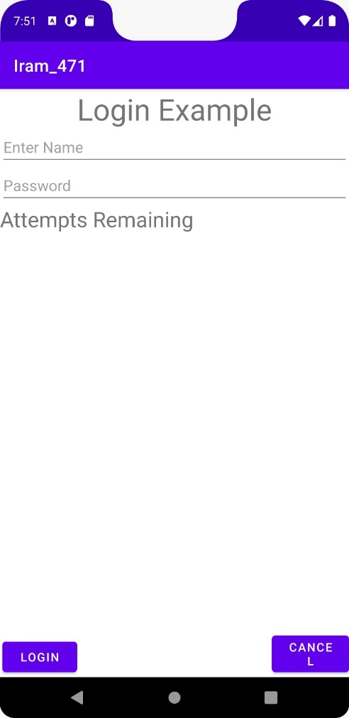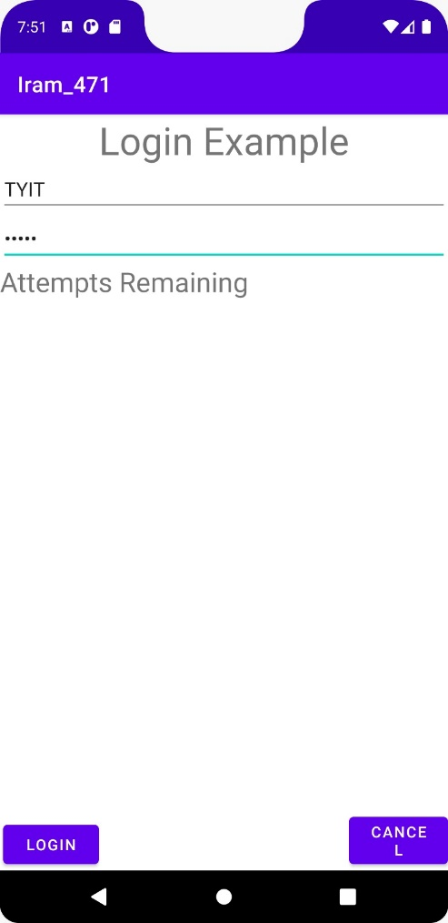

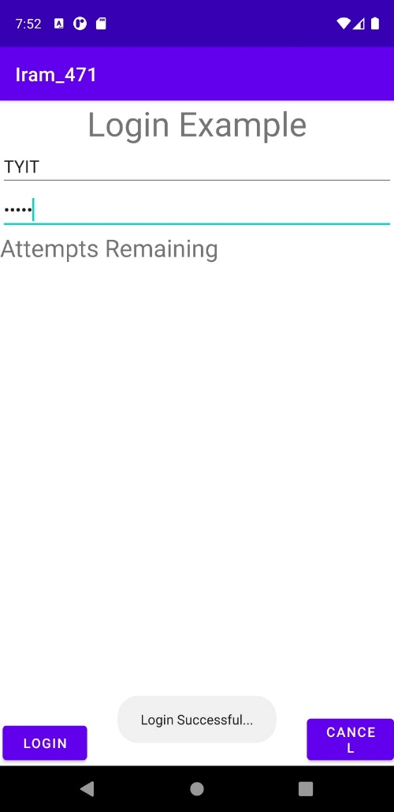

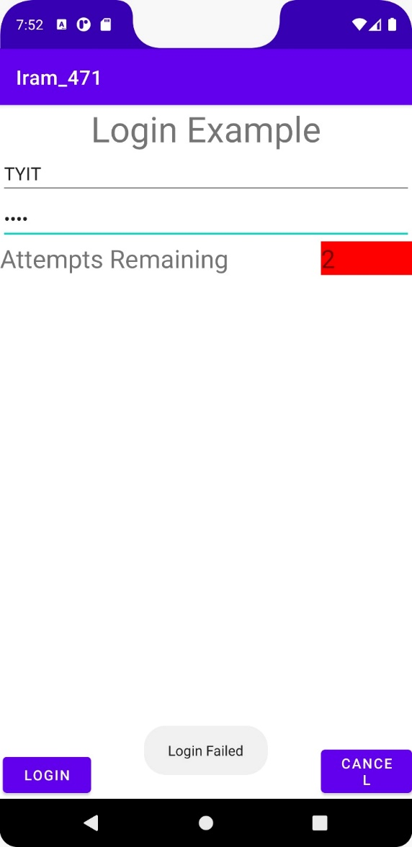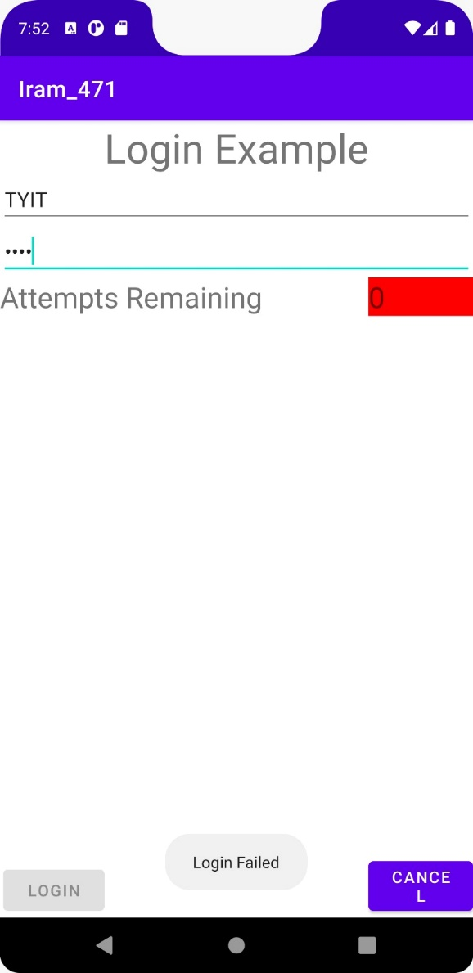

**Practical No : 5B**

**Calculator**

Activiy_main.xml:

<?xml version="1.0" encoding="utf-8"?>  
<LinearLayout xmlns:android="http://schemas.android.com/apk/res/android"  
 xmlns:app="http://schemas.android.com/apk/res-auto"  
 xmlns:tools="http://schemas.android.com/tools"  
 android:layout_width="match_parent"  
 android:layout_height="match_parent"  
 android:orientation="horizontal"  
 android:stretchColumns="1"  
 tools:context=".MainActivity">  
  
 <LinearLayout  
 android:layout_width="match_parent"  
 android:layout_height="match_parent"  
 android:orientation="vertical">  
  
 <EditText  
 android:id="@+id/et1"  
 android:layout_width="match_parent"  
 android:layout_height="70dp"  
 android:ems="10"  
 android:inputType="textPersonName"  
 android:text="Input1" />  
  
 <EditText  
 android:id="@+id/et2"  
 android:layout_width="match_parent"  
 android:layout_height="64dp"  
 android:ems="10"  
 android:inputType="textPersonName"  
 android:text="Input2" />  
  
 <Button  
 android:id="@+id/btnAdd"  
 android:layout_width="match_parent"  
 android:layout_height="wrap_content"  
 android:text="Addition" />  
  
 <Button  
 android:id="@+id/btnSub"  
 android:layout_width="match_parent"  
 android:layout_height="wrap_content"  
 android:text="Subtraction" />  
  
 <Button  
 android:id="@+id/btnMult"  
 android:layout_width="match_parent"  
 android:layout_height="wrap_content"  
 android:text="Multiplication" />  
  
 <Button  
 android:id="@+id/btnDiv"  
 android:layout_width="match_parent"  
 android:layout_height="wrap_content"  
 android:text="Division" />  
  
 <Button  
 android:id="@+id/btnClear"  
 android:layout_width="match_parent"  
 android:layout_height="wrap_content"  
 android:text="Clear" />  
  
 <TextView  
 android:id="@+id/tv1"  
 android:layout_width="match_parent"  
 android:layout_height="63dp"  
 android:text="Output"  
 android:textColor="@android:color/background_dark"  
 android:textSize="18sp"  
 android:textStyle="bold"  
 app:fontFamily="casual" />  
 </LinearLayout>  
</LinearLayout>

MainActivity.java:

package com.example.iram 471;  
  
import androidx.appcompat.app.AppCompatActivity;  
import android.os.Bundle;  
import android.view.View;  
import android.widget.*;  
  
import static android.view.View.*;  
  
public class MainActivity extends AppCompatActivity {  
  
 EditText t1,t2;  
 Button b1,b2,b3,b4,b5;  
 TextView tv1;  
 int n1=0,n2=0;  
 String s1,s2;  
  
 @Override  
 protected void onCreate(Bundle savedInstanceState) {  
 super.onCreate(savedInstanceState);  
 setContentView(R.layout.*activity_main*);  
  
 t1 = (EditText) findViewById(R.id.*et1*);  
 t2 = (EditText) findViewById(R.id.*et2*);  
 b1 = (Button) findViewById(R.id.*btnAdd*);  
 b2 = (Button) findViewById(R.id.*btnSub*);  
 b3 = (Button) findViewById(R.id.*btnMult*);  
 b4 = (Button) findViewById(R.id.*btnDiv*);  
 b5 = (Button) findViewById(R.id.*btnClear*);  
 tv1 = (TextView) findViewById(R.id.*tv1*);  
  
 b1.setOnClickListener(new OnClickListener() { @Override  
 public void onClick(View v) {  
  
 try {  
 String s1 = t1.getText().toString();  
 String s2 = t2.getText().toString();  
 n1 = Integer.*parseInt*(s1);  
 n2 = Integer.*parseInt*(s1);  
 int sum = n1 + n2;  
 tv1.setText("Addition ="+sum);  
 }  
 catch (NumberFormatException e)  
 {  
  
 }  
 }  
 });  
  
 b2.setOnClickListener(new View.OnClickListener() { @Override  
 public void onClick(View v) {  
  
 try {  
 String s1 = t1.getText().toString();  
 String s2 = t2.getText().toString();  
 n1 = Integer.*parseInt*(s1);  
 n2 = Integer.*parseInt*(s1);  
 int sub = n1 - n2;  
 tv1.setText("Subtraction ="+sub);  
 }  
 catch (NumberFormatException e)  
 {  
  
 }  
 }  
 });  
 b3.setOnClickListener(new View.OnClickListener() { @Override  
 public void onClick(View v) {  
  
 try {  
 String s1 = t1.getText().toString();  
 String s2 = t2.getText().toString();  
 n1 = Integer.*parseInt*(s1);  
 n2 = Integer.*parseInt*(s1);  
 int m = n1 * n2;  
 tv1.setText("Multiplication ="+m);  
  
 }  
 catch (NumberFormatException e)  
 {  
  
 }  
  
 }  
 });  
  
 b4.setOnClickListener(new View.OnClickListener() { @Override  
 public void onClick(View v) {  
  
 try {  
 String s1 = t1.getText().toString(); String s2 = t2.getText().toString(); n1 = Integer.*parseInt*(s1);  
 n2 = Integer.*parseInt*(s1);  
 int d = n1 / n2; tv1.setText("Division ="+d);  
 }  
 catch (NumberFormatException e)  
 {  
  
 }  
 }  
 });  
  
  
 b5.setOnClickListener(new OnClickListener() { @Override  
 public void onClick(View v) {  
  
 t1.setText(" ");  
 t2.setText(" ");  
 tv1.setText(" ");  
 }  
 });  
 }  
}

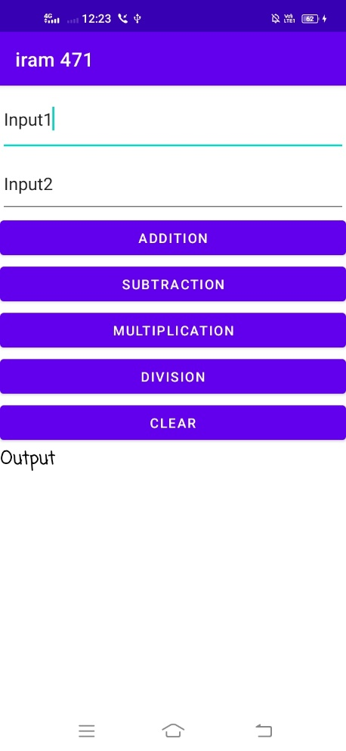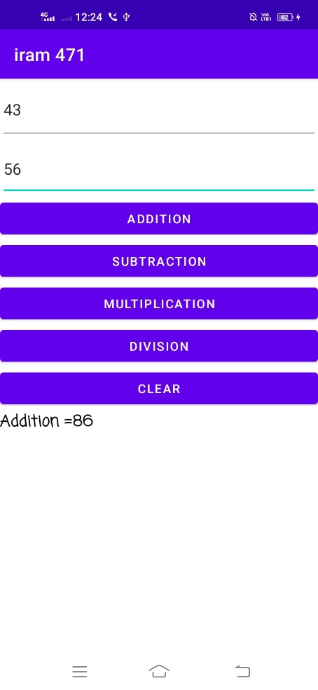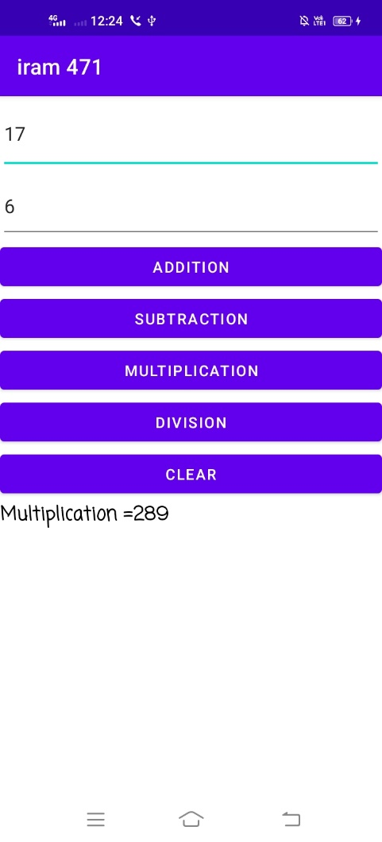

**Practical No : 6**

**Creation of Menu**

# **Create a new project and go to,**

* **Project > App -> src -> res(Right-click on res and select) -> New -> Android Resource File -> Filename(menus) and Resource Type Menu**
* **Now go to, menus.xml file and make the following changes to code file.**

menus.xml:

<?xml version="1.0" encoding="utf-8"?>  
<menu xmlns:android="http://schemas.android.com/apk/res/android">  
 <item android:id="@+id/settings" android:title="Setting"></item>  
 <item android:id="@+id/Search" android:title="Search"></item>  
 <item android:id="@+id/CEmail" android:title="Compose Email" android:enabled="false"></item>  
 <item android:id="@+id/Feedback" android:title="Feedback"></item>  
  
</menu>

MainActivity.java:

package com.example.iram471;  
  
import androidx.appcompat.app.AppCompatActivity;  
import android.content.Intent;  
import android.graphics.Color;  
import android.os.Bundle;  
import android.view.Menu;  
import android.view.MenuInflater;  
import android.view.MenuItem;  
import android.widget.Toast;  
  
public class MainActivity extends AppCompatActivity {  
 MenuInflater mi;  
  
 @Override  
 protected void onCreate(Bundle savedInstanceState) {  
 super.onCreate(savedInstanceState);  
 setContentView(R.layout.*activity_main*);  
 }  
  
 public boolean onCreateOptionsMenu(Menu menus)  
 {  
 mi = getMenuInflater();  
 mi.inflate(R.menu.*menus*,menus);  
  
 return true;  
 }  
  
 public boolean onOptionsItemSelected(MenuItem item)  
 {  
  
  
 switch(item.getItemId())  
 {  
 case R.id.*settings*:  
 Toast.*makeText*(this,"Option Setting is selected",Toast.*LENGTH_SHORT*).show();  
 return true;  
 case R.id.*Search*:  
 Toast.*makeText*(this,"Option Search is selected",Toast.*LENGTH_SHORT*).show();  
 return true;  
 case R.id.*Feedback*:  
 Toast.*makeText*(this,"Option Feedback is selected",Toast.*LENGTH_SHORT*).show();  
 return true;  
  
 case R.id.*CEmail*:  
  
  
 Toast.*makeText*(this,"Option Compose Mail is selected",Toast.*LENGTH_SHORT*).show();  
 return true;  
  
 default:  
 Toast.*makeText*(this,"Default",Toast.*LENGTH_SHORT*).show();  
 return super.onOptionsItemSelected(item);  
 }  
 }  
  
  
}

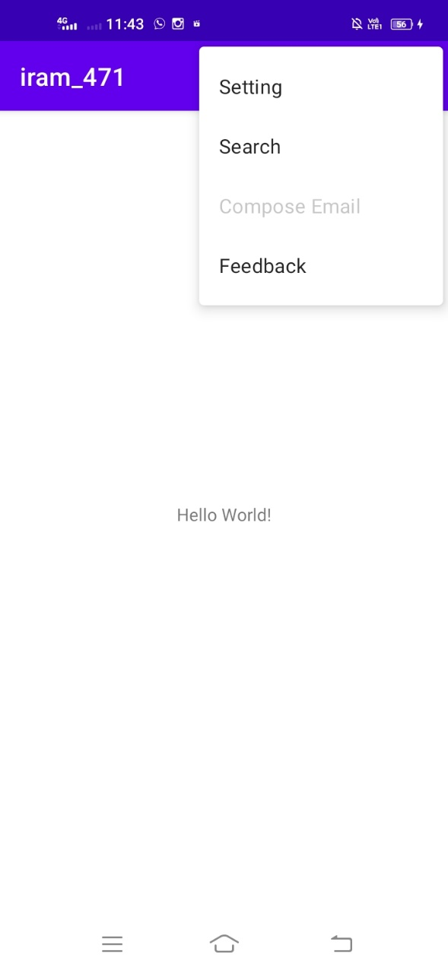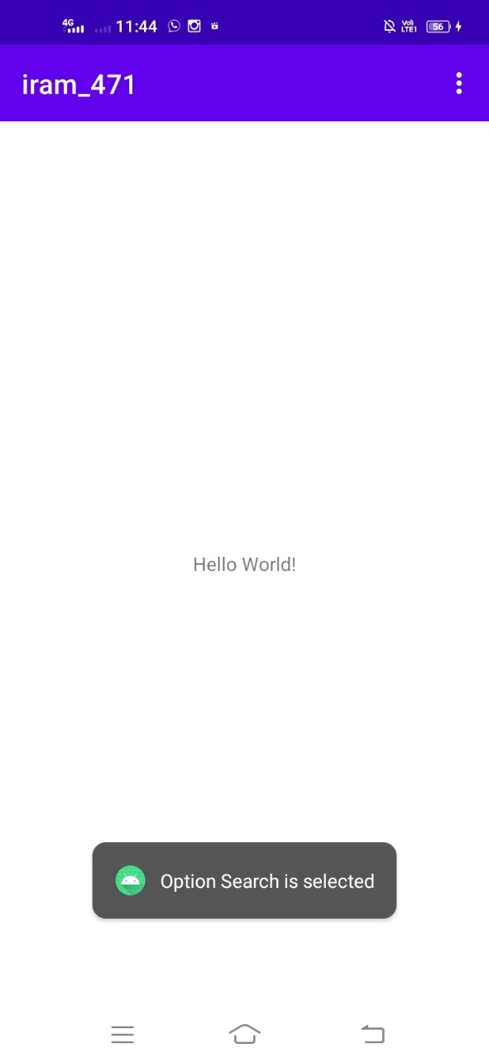

**Practical No : 7A**

**Intent Class**

Activiy_main.xml:

<?xml version="1.0" encoding="utf-8"?>  
<RelativeLayout xmlns:android="http://schemas.android.com/apk/res/android"  
 xmlns:app="http://schemas.android.com/apk/res-auto"  
 xmlns:tools="http://schemas.android.com/tools"  
 android:layout_width="match_parent"  
 android:layout_height="match_parent"  
 tools:context=".MainActivity">  
  
 <LinearLayout  
 android:layout_width="match_parent"  
 android:layout_height="match_parent"  
 android:orientation="vertical">  
  
 <TextView  
 android:layout_width="fill_parent"  
 android:layout_height="wrap_content"  
 android:layout_marginTop="10dp"  
 android:gravity="center"  
 android:text="Input your Name"></TextView>  
  
 <TableLayout  
 android:id="@+id/tableLayout1"  
 android:layout_width="match_parent"  
 android:layout_height="wrap_content"  
 android:layout_margin="10dp"  
 android:stretchColumns="1">  
 <TableRow  
 android:id="@+id/tableRow1"  
 android:layout_width="match_parent"  
 android:layout_height="wrap_content">  
  
 <TextView  
 android:id="@+id/textView1"  
 android:layout_width="match_parent"  
 android:layout_height="wrap_content"  
 android:text="First Name"></TextView>  
  
 <EditText  
 android:id="@+id/etFName"  
 android:layout_width="match_parent"  
 android:layout_height="wrap_content"  
 android:layout_marginLeft="5dp">  
 <requestFocus></requestFocus></EditText>  
 </TableRow>  
  
 <TableRow  
 android:id="@+id/tableRow2"  
 android:layout_width="match_parent"  
 android:layout_height="wrap_content">  
  
 <TextView  
 android:id="@+id/textView2"  
 android:layout_width="match_parent"  
 android:layout_height="wrap_content"  
 android:text="Last Name"></TextView>  
  
 <EditText  
 android:id="@+id/etLName"  
 android:layout_width="match_parent"  
 android:layout_height="wrap_content"  
 android:layout_marginLeft="5dp"></EditText>  
 </TableRow>  
 </TableLayout>  
 <Button  
 android:id="@+id/btnSubmit"  
 android:layout_width="wrap_content"  
 android:layout_height="wrap_content"  
 android:layout_gravity="center_horizontal"  
 android:text="Submit"></Button>  
  
 </LinearLayout>  
</RelativeLayout>

MainActivity.java:

package com.example.iram_471;  
  
import androidx.appcompat.app.AppCompatActivity;  
  
import android.content.Intent;  
import android.graphics.Color;  
import android.os.Bundle;  
  
  
import android.view.View;  
import android.widget.Button;  
import android.widget.EditText;  
import android.widget.QuickContactBadge;  
import android.widget.TextView;  
import android.widget.Toast;  
  
import java.util.Random;  
public class MainActivity extends AppCompatActivity {  
  
 EditText etFName;  
 EditText etLName;  
 Button btnSubmit;  
  
 @Override  
 protected void onCreate(Bundle savedInstanceState) {  
 super.onCreate(savedInstanceState);  
 setContentView(R.layout.*activity_main*);  
  
 etFName = (EditText) findViewById(R.id.*etFName*);  
 etLName = (EditText) findViewById(R.id.*etLName*);  
  
 btnSubmit = (Button) findViewById(R.id.*btnSubmit*);  
 btnSubmit.setOnClickListener(new View.OnClickListener() {  
 @Override  
 public void onClick(View v) {  
 Intent intent = new Intent(getApplicationContext(), MainActivity2.class);  
 intent.putExtra("fname", etFName.getText().toString());  
 intent.putExtra("lname", etLName.getText().toString());  
 startActivity(intent);  
 }  
 });  
  
 }  
}

Now create an another activity as MainActivity.java:

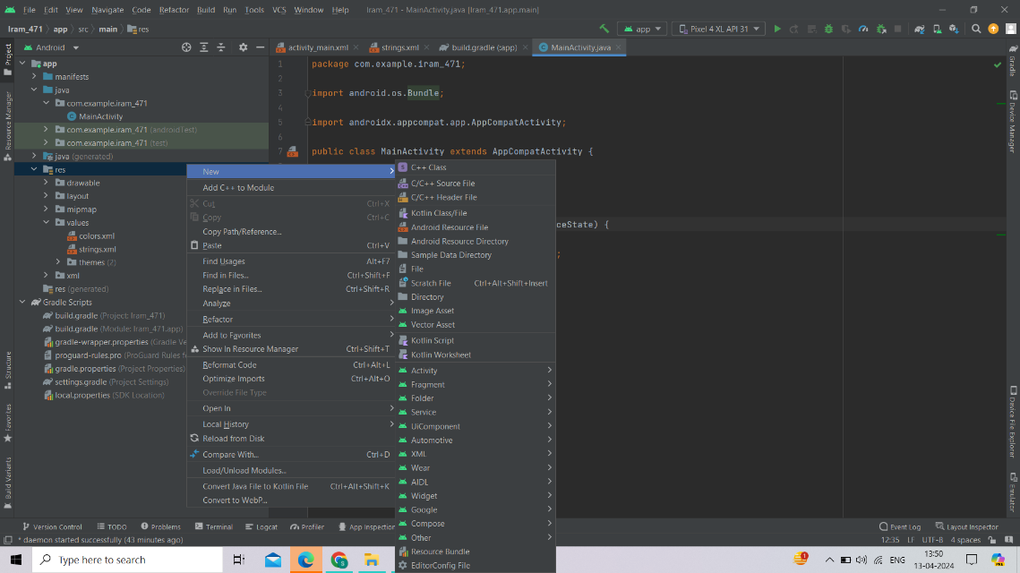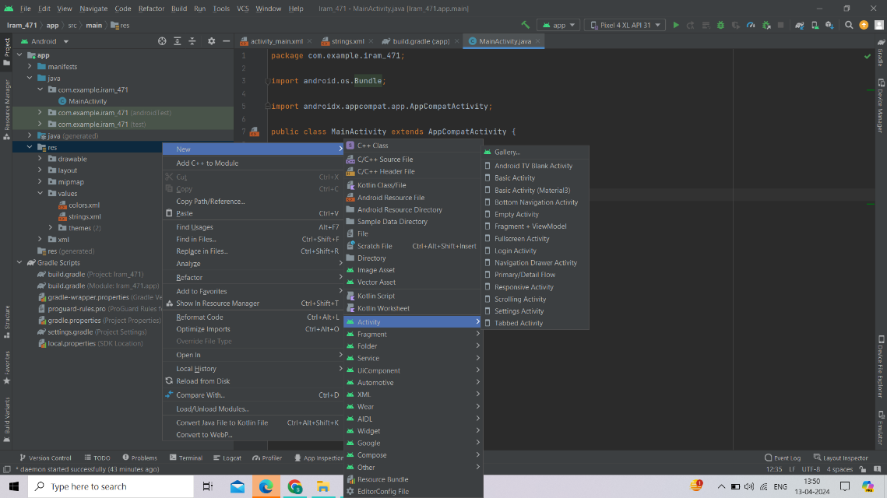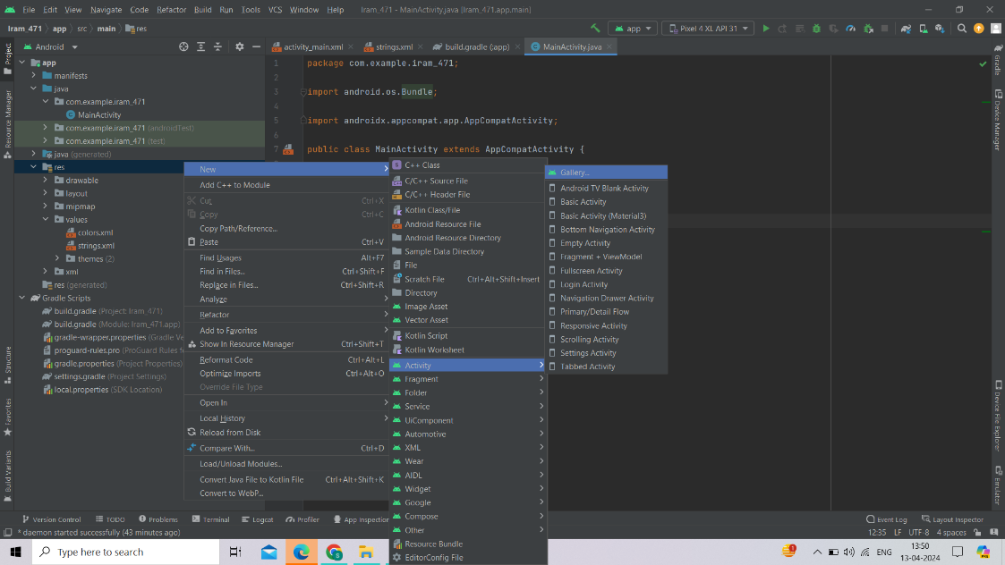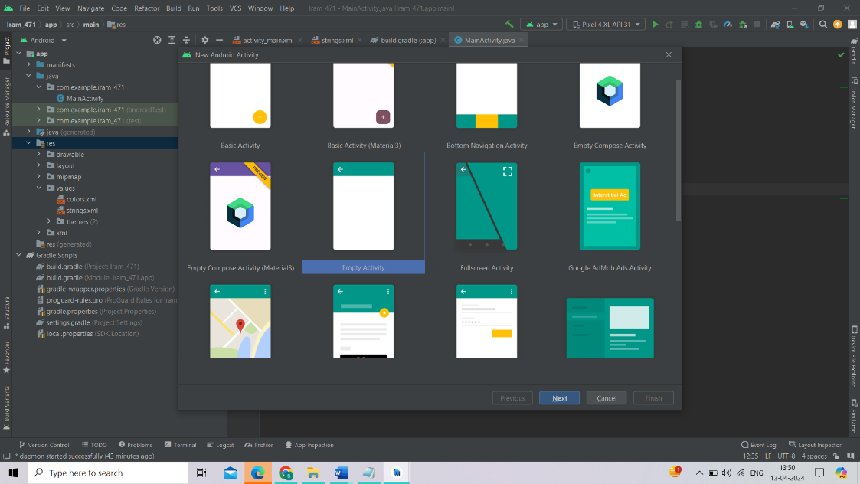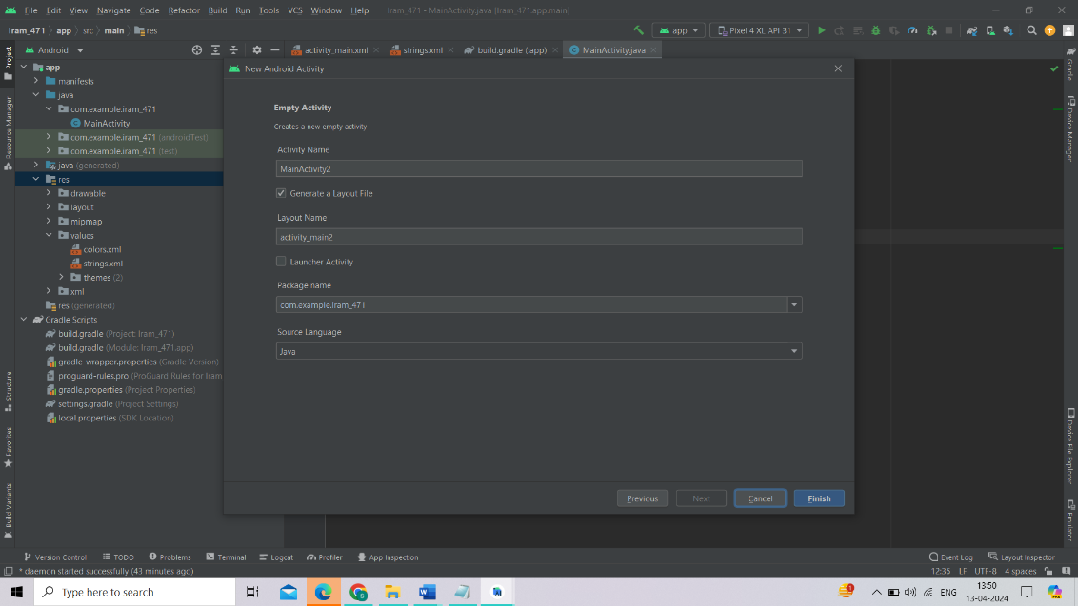

Activiy_main2.xml:

<?xml version="1.0" encoding="utf-8"?>  
<LinearLayout xmlns:android="http://schemas.android.com/apk/res/android"  
 xmlns:app="http://schemas.android.com/apk/res-auto"  
 xmlns:tools="http://schemas.android.com/tools"  
 android:layout_width="match_parent"  
 android:layout_height="match_parent"  
 tools:context=".MainActivity2">  
  
  
  
 <TextView  
 android:id="@+id/tvView"  
 android:layout_width="400dp"  
 android:layout_height="85dp"  
 android:layout_gravity="center_horizontal"  
 android:layout_marginTop="20dp"  
 android:text="Output"  
 android:textColor="@android:color/holo_blue_dark"  
 android:textSize="24sp"  
 android:textStyle="bold"></TextView>  
  
</LinearLayout>

MainActivity2.java:

package com.example.iram_471;  
  
import androidx.appcompat.app.AppCompatActivity;  
  
import android.content.Intent;  
import android.os.Bundle;  
import android.widget.TextView;  
  
public class MainActivity2 extends AppCompatActivity {  
  
 TextView tvView;  
  
 @Override  
 protected void onCreate(Bundle savedInstanceState) {  
 super.onCreate(savedInstanceState);  
 setContentView(R.layout.*activity_main2*);  
  
  
  
 tvView = (TextView) findViewById(R.id.*tvView*);  
  
 Intent intent = getIntent();  
  
 String fName = intent.getStringExtra("fname");  
 String lName = intent.getStringExtra("lname");  
  
 tvView.setText("Your name is: " + fName + " " + lName);  
  
 }  
}

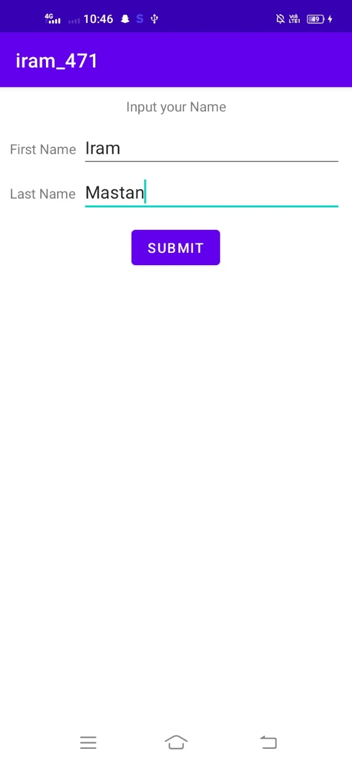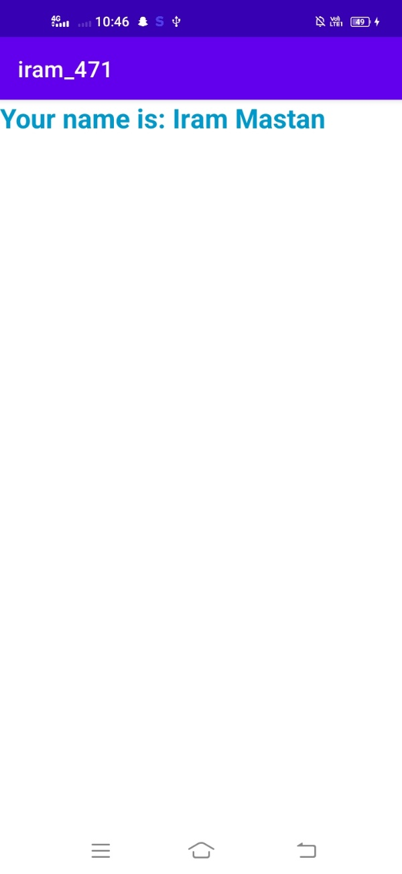

**Practical No : 7B**

**Random Number Generator**

Activiy_main.xml:

<?xml version="1.0" encoding="utf-8"?>  
<RelativeLayout xmlns:android="http://schemas.android.com/apk/res/android"  
 xmlns:app="http://schemas.android.com/apk/res-auto"  
 xmlns:tools="http://schemas.android.com/tools"  
 android:layout_width="match_parent"  
 android:layout_height="match_parent"  
 tools:context=".MainActivity"  
 android:id="@+id/rl">  
  
  
 <LinearLayout  
 android:layout_width="match_parent"  
 android:layout_height="match_parent"  
 android:orientation="vertical">  
  
  
 <Button  
 android:id="@+id/button2"  
 android:layout_width="match_parent"  
 android:layout_height="62dp"  
 android:text="Ganerate Random Number" />  
  
 <TextView  
 android:id="@+id/textView6"  
 android:layout_width="match_parent"  
 android:layout_height="45dp"  
 android:text="Output"  
 android:textAppearance="@style/TextAppearance.AppCompat.Display1" />  
 </LinearLayout>  
</RelativeLayout>

MainActivity.java:

package com.example.iram471;  
  
import androidx.annotation.NonNull;  
import androidx.appcompat.app.AppCompatActivity;  
  
import android.content.Intent;  
import android.database.sqlite.SQLiteDatabase;  
import android.graphics.Color;  
import android.media.MediaPlayer;  
import android.os.Bundle;  
import android.util.Log;  
import android.view.Menu;  
import android.view.MenuInflater;  
import android.view.MenuItem;  
import android.view.MotionEvent;  
import android.view.View;  
import android.widget.Button;  
import android.widget.EditText;  
import android.widget.ImageView;  
import android.widget.RelativeLayout;  
import android.widget.TextView;  
import android.widget.Toast;  
  
public class MainActivity extends AppCompatActivity {  
  
 Button b1;  
 TextView lbl;  
 @Override  
 protected void onCreate(Bundle savedInstanceState) {  
 super.onCreate(savedInstanceState);  
 setContentView(R.layout.*activity_main*);  
 b1 = findViewById(R.id.*button2*);  
 lbl = findViewById(R.id.*textView6*);  
  
 b1.setOnClickListener(new View.OnClickListener() {  
 @Override  
 public void onClick(View view) {  
 int r = (int) (Math.*random*() * 100);  
 lbl.setText("Random Number =" + r);  
 }  
 });  
  
  
 }  
  
  
  
}

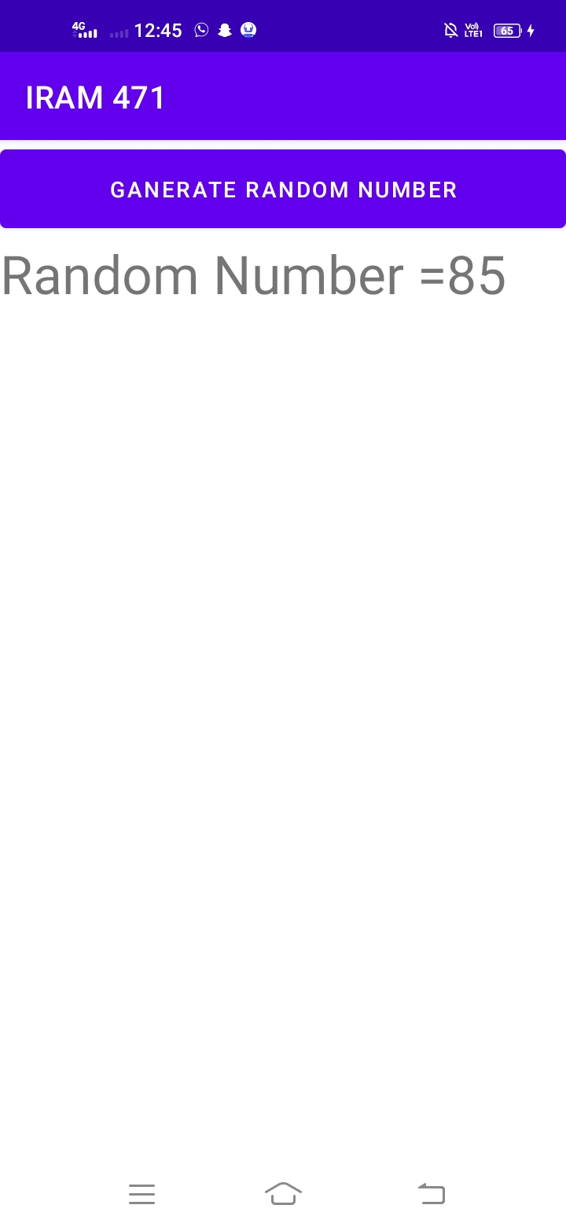

**Practical No : 8**

**Music Play**

Activiy_main.xml:

<?xml version="1.0" encoding="utf-8"?>  
<RelativeLayout xmlns:android="http://schemas.android.com/apk/res/android"  
 xmlns:app="http://schemas.android.com/apk/res-auto"  
 xmlns:tools="http://schemas.android.com/tools"  
 android:layout_width="match_parent"  
 android:layout_height="match_parent"  
 tools:context=".MainActivity">  
  
 <Button  
 android:id="@+id/button"  
 android:layout_width="wrap_content"  
 android:layout_height="wrap_content"  
 android:layout_alignParentTop="true"  
 android:layout_centerHorizontal="true"  
 android:layout_marginTop="70dp"  
 android:text="Play Music"  
 android:textSize="24dp"  
 app:layout_constraintBottom_toBottomOf="parent"  
 app:layout_constraintEnd_toEndOf="parent"  
 app:layout_constraintLeft_toLeftOf="parent"  
 app:layout_constraintRight_toRightOf="parent"  
 app:layout_constraintStart_toStartOf="parent"  
 tools:layout_editor_absoluteY="100dp"  
 android:onClick="playAudio"/>  
  
 <Button  
 android:id="@+id/button2"  
 android:layout_width="wrap_content"  
 android:layout_height="wrap_content"  
 android:layout_alignParentBottom="true"  
 android:layout_centerHorizontal="true"  
 android:layout_marginBottom="390dp"  
 android:text="Stop Music"  
 android:textSize="24dp"  
 android:onClick="onPause"/>  
  
 <ImageView  
 android:id="@+id/imageView"  
 android:layout_width="237dp"  
 android:layout_height="241dp"  
 android:layout_alignParentBottom="true"  
 android:layout_centerHorizontal="true"  
 android:layout_marginBottom="116dp"  
 app:srcCompat="@drawable/musicc"  
 android:visibility="invisible"/>  
  
</RelativeLayout>

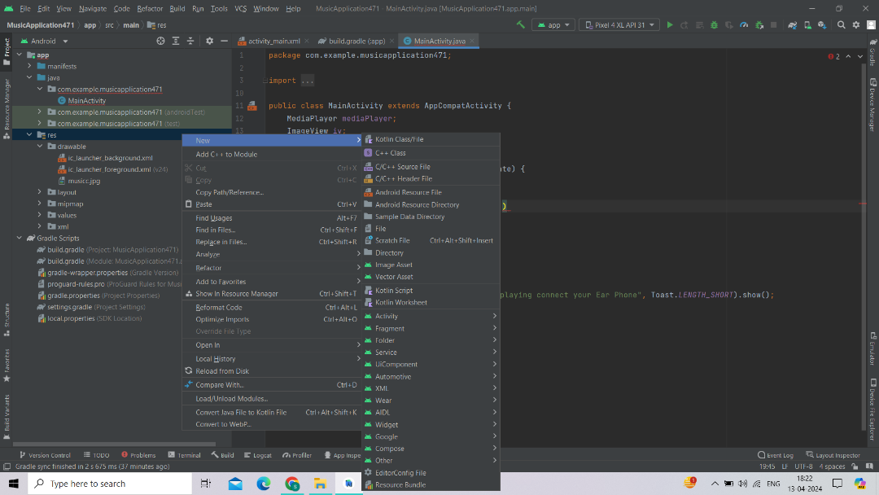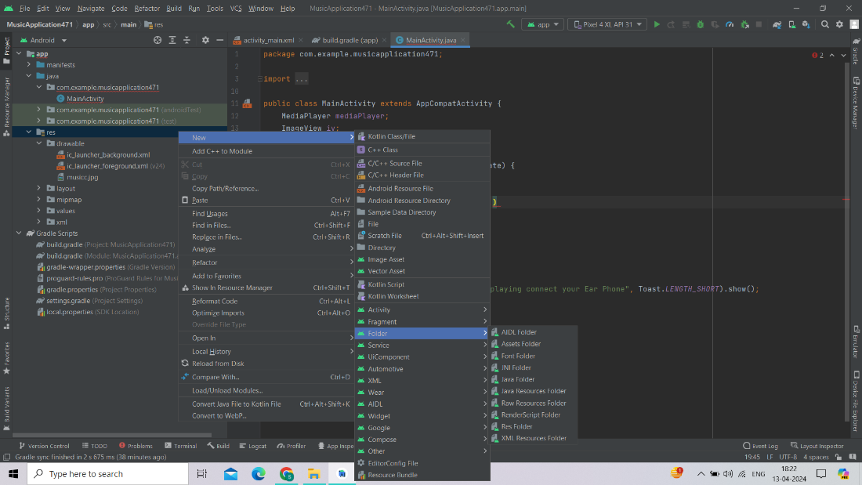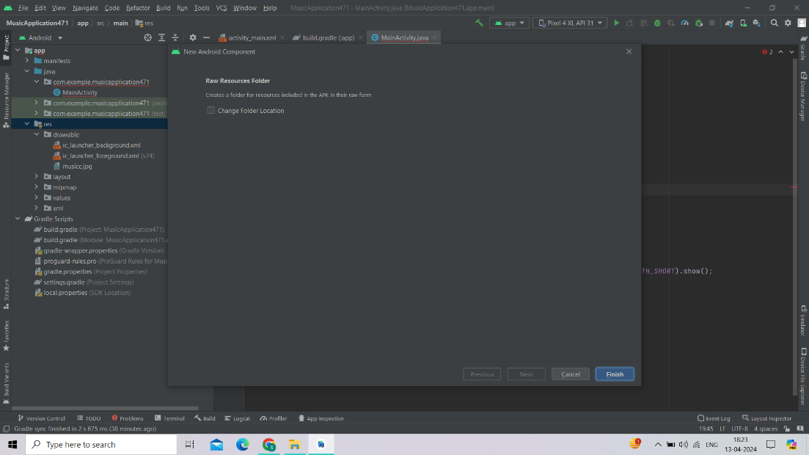

MainActivity.java:

package com.example.musicapplication471;  
  
import androidx.appcompat.app.AppCompatActivity;  
  
import android.media.MediaPlayer;  
import android.os.Bundle;  
import android.view.View;  
import android.widget.ImageView;  
import android.widget.Toast;  
  
public class MainActivity extends AppCompatActivity {  
 MediaPlayer mediaPlayer;  
 ImageView iv;  
  
 @Override  
 protected void onCreate(Bundle savedInstanceState) {  
 super.onCreate(savedInstanceState);  
 setContentView(R.layout.*activity_main*);  
 mediaPlayer=MediaPlayer.*create*(this,R.raw.*music*);  
 }  
  
 public void playAudio(View v){  
 iv=findViewById(R.id.*imageView*);  
 iv.setVisibility(View.*VISIBLE*);  
 mediaPlayer.start();  
 Toast.*makeText*(this, "Music is playing connect your Ear Phone", Toast.*LENGTH_SHORT*).show();  
 }  
  
 public void onPause(View v){  
 super.onPause();  
 mediaPlayer.release();  
 iv.setVisibility(View.*INVISIBLE*);  
 }  
}

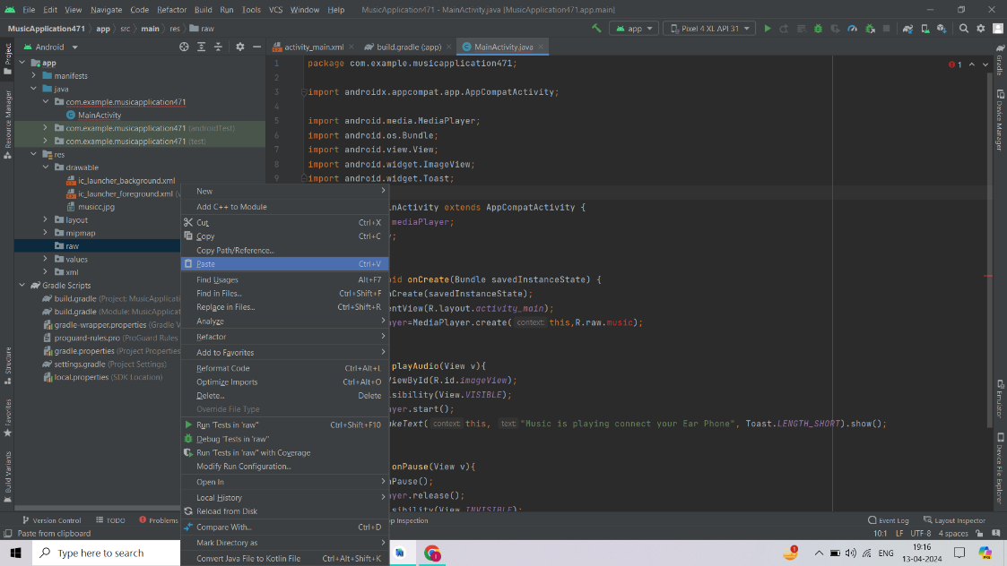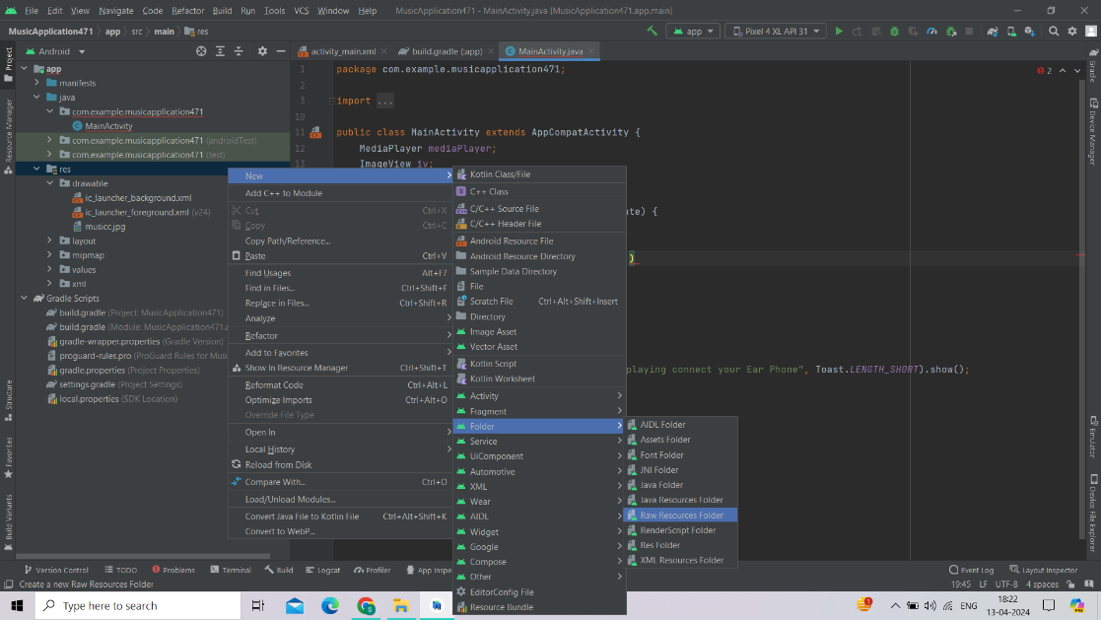

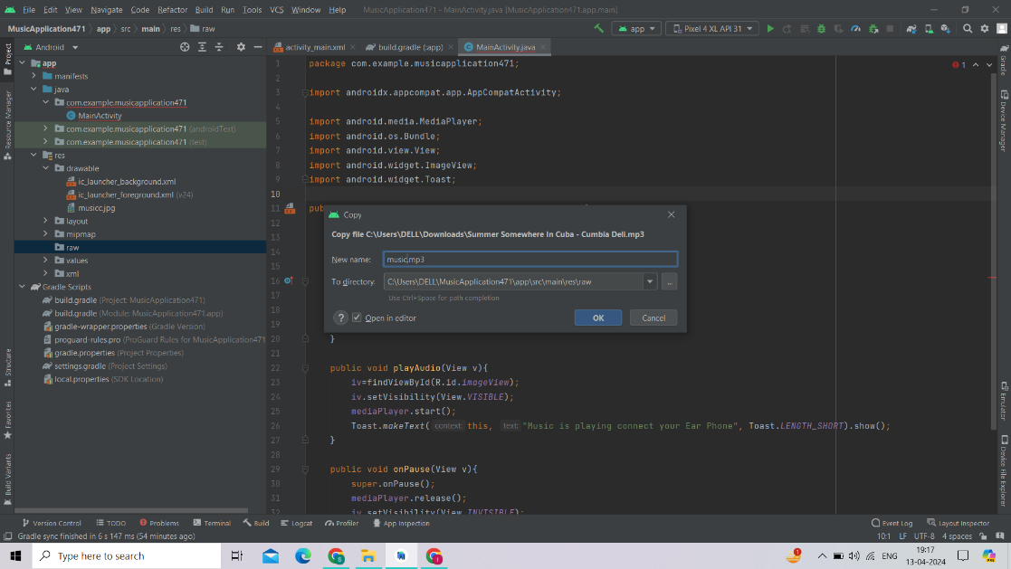

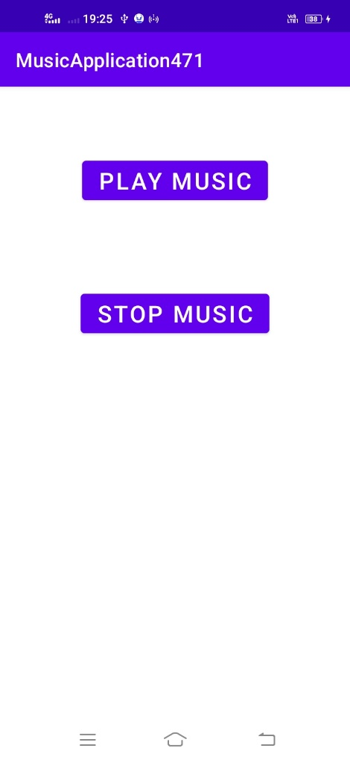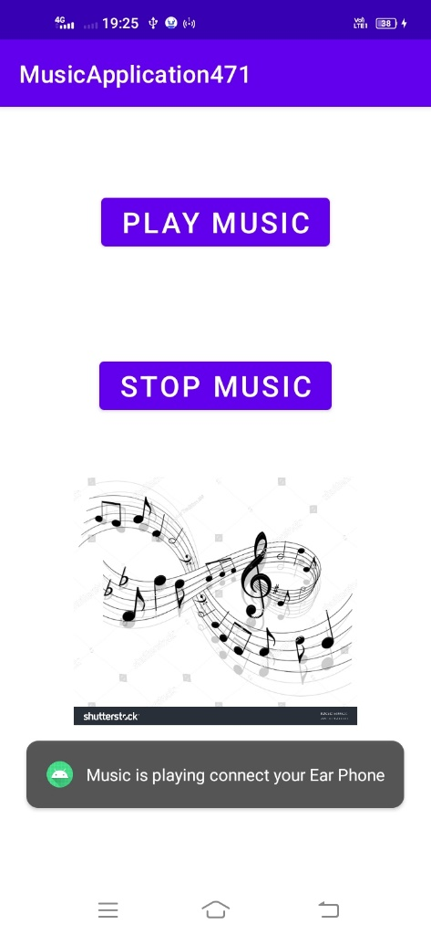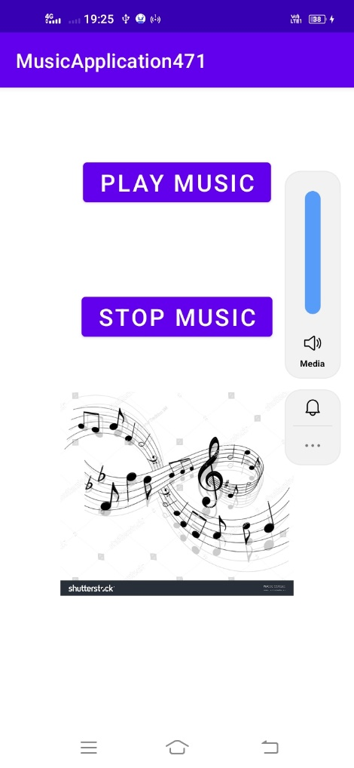

**Practical No : 9A**

**Dial Number**

Activiy_main.xml:

<?xml version="1.0" encoding="utf-8"?>  
<RelativeLayout xmlns:android="http://schemas.android.com/apk/res/android"  
 xmlns:app="http://schemas.android.com/apk/res-auto"  
 xmlns:tools="http://schemas.android.com/tools"  
 android:layout_width="match_parent"  
 android:layout_height="match_parent"  
 tools:context=".MainActivity">  
  
 <EditText  
 android:id="@+id/et1"  
 android:layout_width="wrap_content"  
 android:layout_height="wrap_content"  
 android:layout_alignParentStart="true"  
 android:layout_alignParentTop="true"  
 android:layout_centerHorizontal="true"  
 android:layout_marginStart="101dp"  
 android:layout_marginTop="66dp"  
 android:ems="10"  
 android:hint="Enter Phone Number"  
 android:inputType="textPersonName" />  
  
 <Button  
 android:id="@+id/btn1"  
 android:layout_width="wrap_content"  
 android:layout_height="wrap_content"  
 android:layout_alignParentTop="true"  
 android:layout_centerHorizontal="true"  
 android:layout_marginTop="194dp"  
 android:text="Call Number" />  
  
</RelativeLayout>

MainActivity.java:

package com.example.dialnumber471;  
  
import androidx.appcompat.app.AppCompatActivity;  
  
import android.content.Intent;  
import android.net.Uri;  
import android.os.Bundle;  
import android.util.Log;  
import android.view.View;  
import android.widget.Button;  
import android.widget.EditText;  
import android.widget.Toast;  
  
public class MainActivity extends AppCompatActivity {  
 EditText txt1;  
 Button b1;  
  
 @Override  
 protected void onCreate(Bundle savedInstanceState) {  
 super.onCreate(savedInstanceState);  
 setContentView(R.layout.*activity_main*);  
  
 txt1=findViewById(R.id.*et1*);  
 b1=findViewById(R.id.*btn1*);  
  
 b1.setOnClickListener(new View.OnClickListener() {  
 @Override  
 public void onClick(View view) {  
 try {  
 String strPhone=txt1.getText().toString();  
 Intent intent=new Intent(Intent.*ACTION_CALL*, Uri.*parse*("tel: 7588436898

"+strPhone));  
 startActivity(intent);  
 Toast.*makeText*(MainActivity.this, "Mobile is calling on phone number", Toast.*LENGTH_SHORT*).show();  
  
 }  
  
 catch (Exception ex){  
 Log.*d*("Error",ex.toString());  
 }  
  
 }  
 });  
 }  
}

AndroidManifest.xml:

<?xml version="1.0" encoding="utf-8"?>  
<manifest xmlns:android="http://schemas.android.com/apk/res/android"  
 xmlns:tools="http://schemas.android.com/tools"  
 package="com.example.dialnumber471">  
  
 **<uses-permission android:name="android.permission.CALL_PHONE"></uses-permission>**  
  
 <application  
 android:allowBackup="true"  
 android:dataExtractionRules="@xml/data_extraction_rules"  
 android:fullBackupContent="@xml/backup_rules"  
 android:icon="@mipmap/ic_launcher"  
 android:label="@string/app_name"  
 android:roundIcon="@mipmap/ic_launcher_round"  
 android:supportsRtl="true"  
 android:theme="@style/Theme.DialNumber471"  
 tools:targetApi="31">  
 <activity  
 android:name=".MainActivity"  
 android:exported="true">  
 <intent-filter>  
 <action android:name="android.intent.action.MAIN" />  
  
 <category android:name="android.intent.category.LAUNCHER" />  
 </intent-filter>  
 </activity>  
 </application>  
  
</manifest>

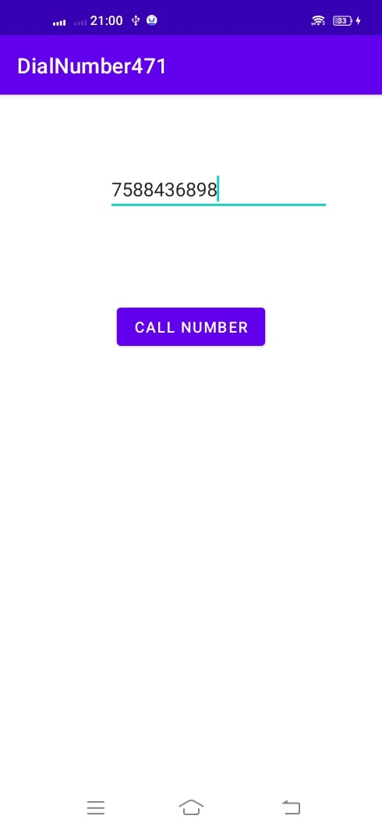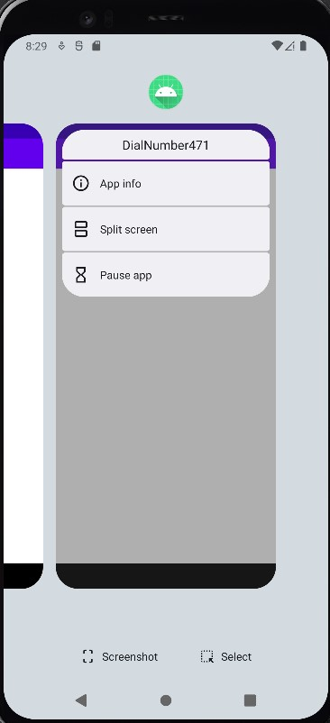

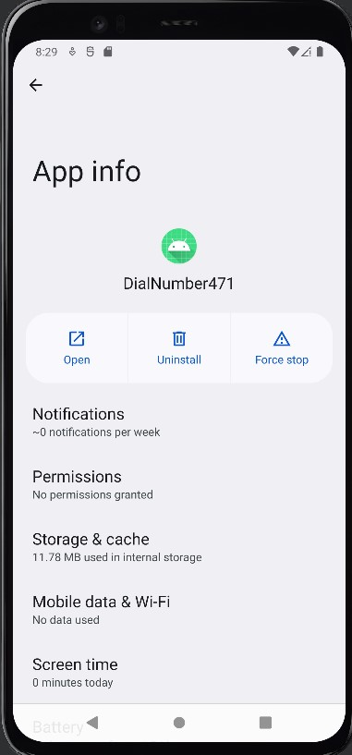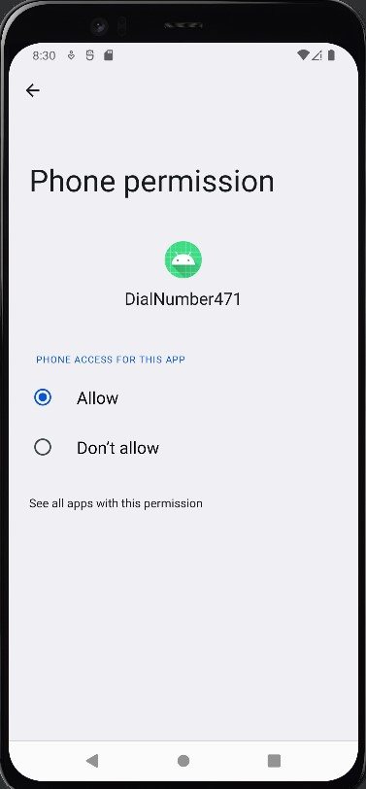

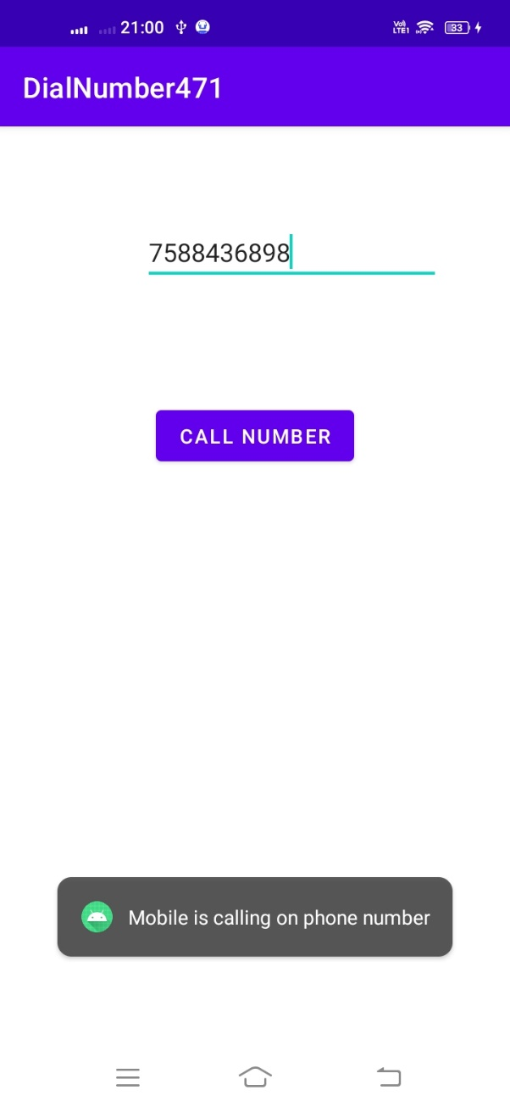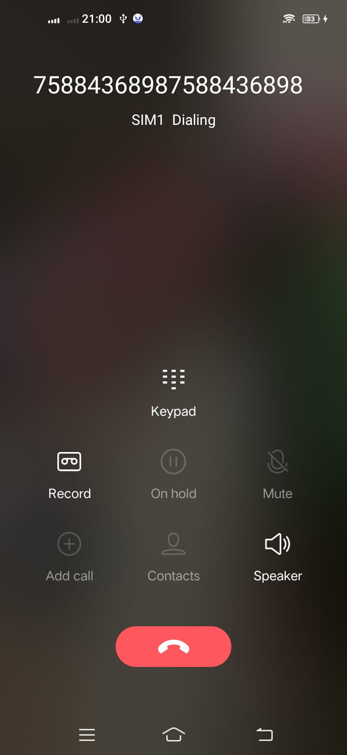

**Practical No : 9B**

**OnTouchListener**

Activiy_main.xml:

<?xml version="1.0" encoding="utf-8"?>  
<RelativeLayout xmlns:android="http://schemas.android.com/apk/res/android"  
 xmlns:app="http://schemas.android.com/apk/res-auto"  
 xmlns:tools="http://schemas.android.com/tools"  
 android:layout_width="match_parent"  
 android:layout_height="match_parent"  
 tools:context=".MainActivity"  
 android:id="@+id/rl">  
  
</RelativeLayout>

MainActivity.java:

package com.example.ontouchlist471;  
  
import androidx.appcompat.app.AppCompatActivity;  
  
import android.graphics.Color;  
import android.os.Bundle;  
import android.view.MotionEvent;  
import android.view.View;  
import android.widget.RelativeLayout;  
  
public class MainActivity extends AppCompatActivity {  
  
 RelativeLayout relativeLayout;  
  
 @Override  
 protected void onCreate(Bundle savedInstanceState) {  
 super.onCreate(savedInstanceState);  
 setContentView(R.layout.*activity_main*);  
 relativeLayout=findViewById(R.id.*rl*);  
 relativeLayout.setOnTouchListener(new View.OnTouchListener() {  
 @Override  
 public boolean onTouch(View view, MotionEvent motionEvent) {  
 int r=(int)(Math.*random*()*255);  
 int g=(int)(Math.*random*()*255);  
 int b=(int)(Math.*random*()*255);  
 int col= Color.*rgb*(r,g,b);  
 switch (motionEvent.getAction())  
 {  
 case MotionEvent.*ACTION_MOVE*:  
 relativeLayout.setBackgroundColor(col);  
 break;  
 }  
 return true;  
 }  
 });  
 }  
}

