National Rugby League

Player/Team Management Software

User Manual

*’.sln’ file’s path: *\\Assignment_03\Assignment_03_20008378\Ass3_20008378\RugbyManager.sln*

**Import from file**

This application is designed to manage rugby teams and players. For better experience, please use following highlighted text files to import players and teams.

However, other teams and players which don’t belong to NRL are also able to be accepted.

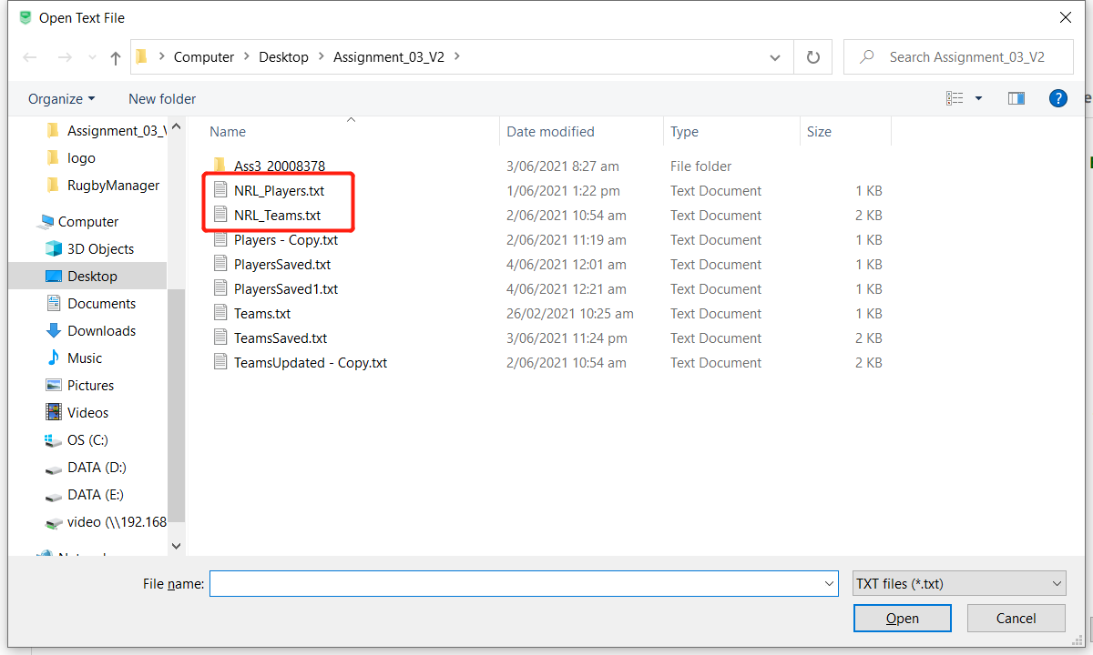

As mentioned at beginning, user may input many teams/players at same time by using ‘Import’. Please note that every item of a team/plaer’s information needs to be seprated by “;”.

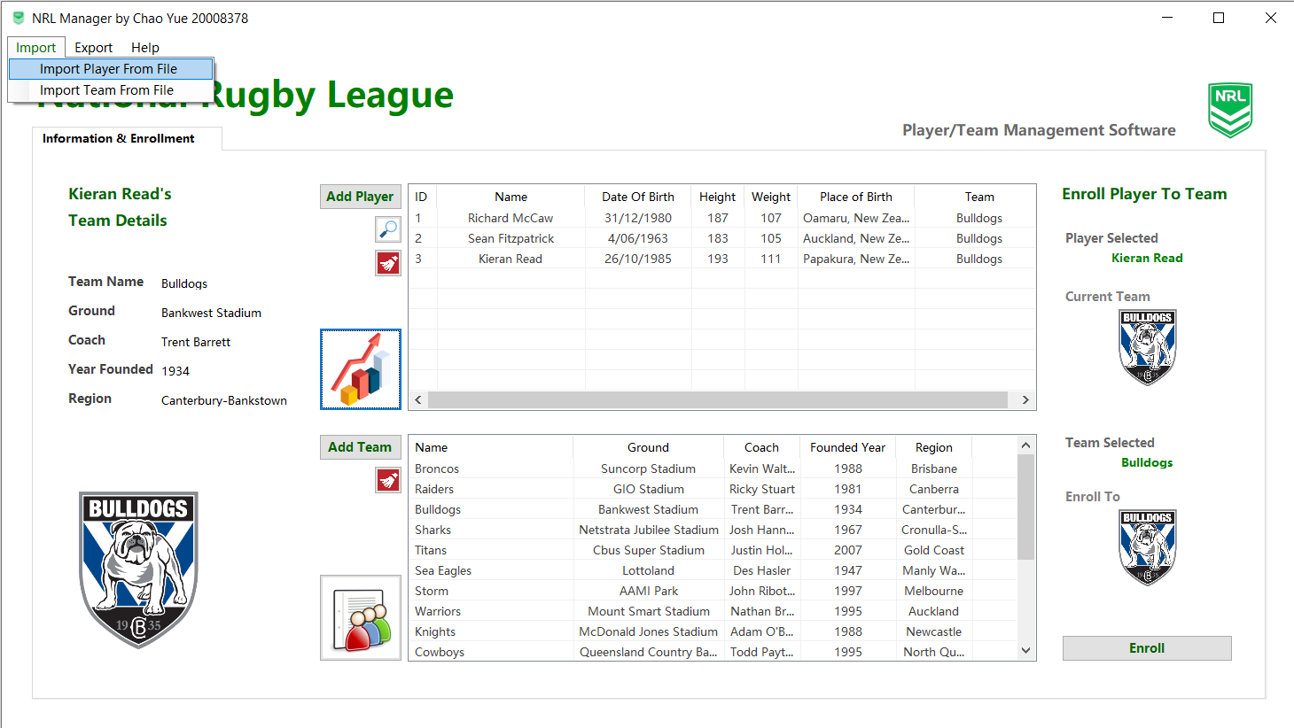 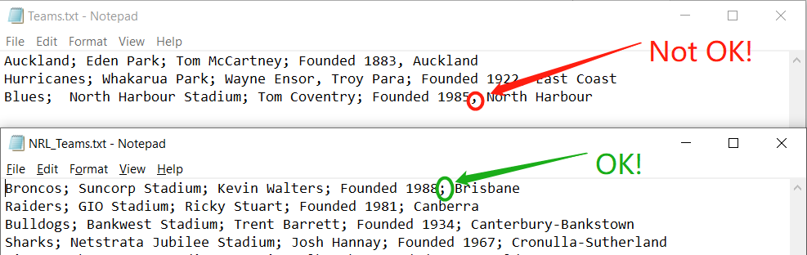

**Export**

The exported team file looks like below. It’s designed for better readability. And the best part is that it also can be imported back to the application.

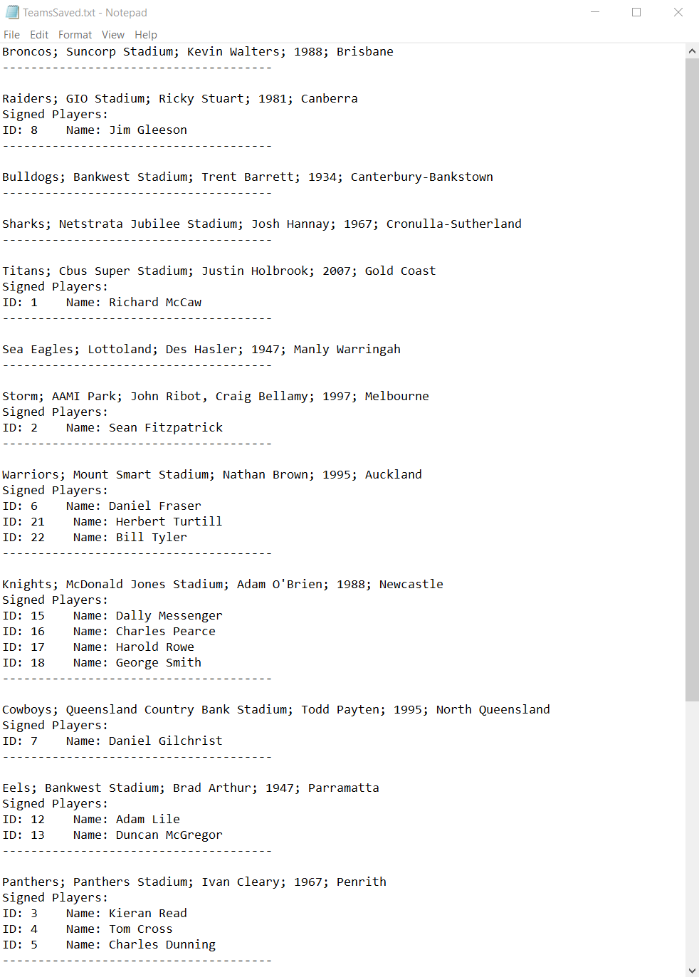

**Get started**

When first use, the main UI’s appearance looks as below (Some icons may have some minor changes in the fianl version). A yellow waring is to remind user to import team information at first. It doen’t mean that the application will crash if user choose not to. It’s just a reminder for user to have better experience when using this software.

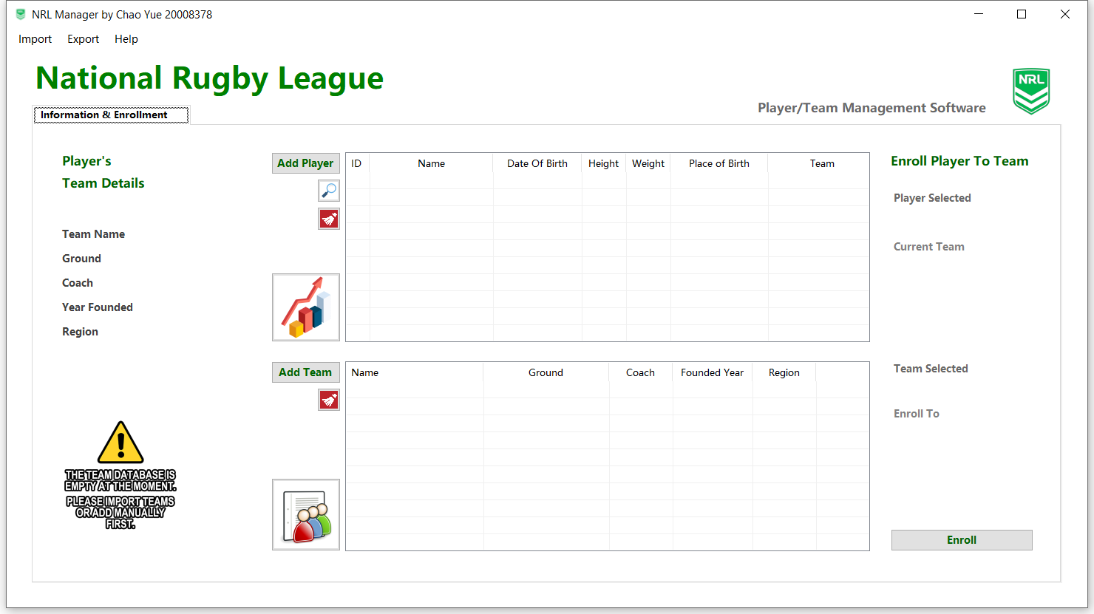

After teams and players are loaded, the application will be looking as below

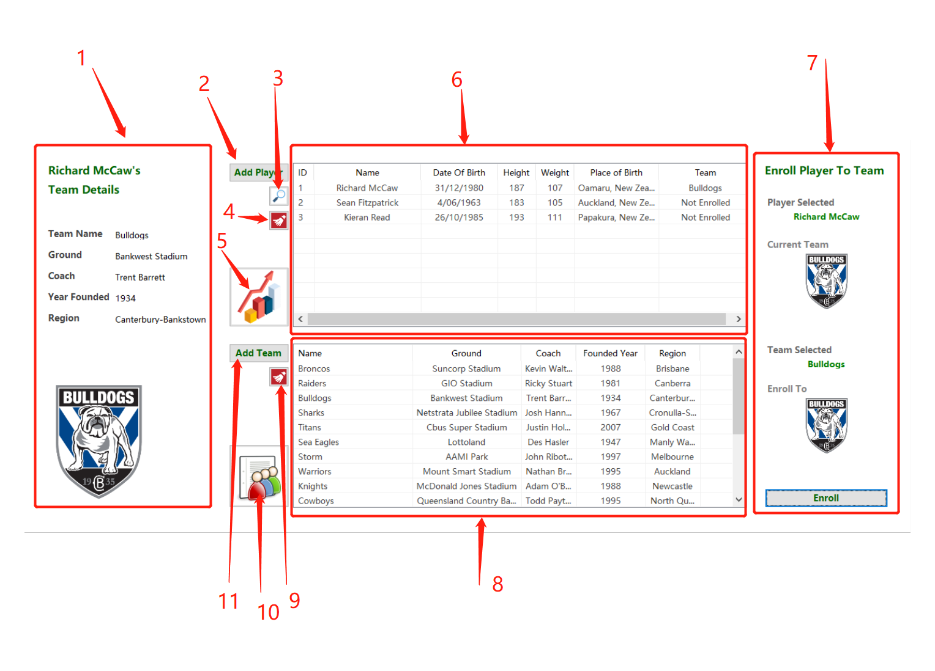

1. When a player in 6 is selected, if the player has enrolled to a team, the team’s details will be showing here.
2. This button is for adding one player manually, when clicked, a form will appear as below. Every input box has its own input rule. If input value doesn’t match the requirement, a message box will pop up and give user some information to correct the input value.

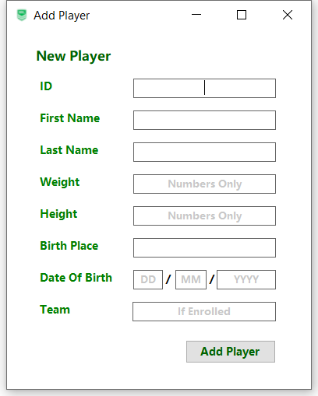

1. Search button, a search interface will appear when clicked. Input rules are also applied. The hint at the bottom and some message boxes will geuide user through.

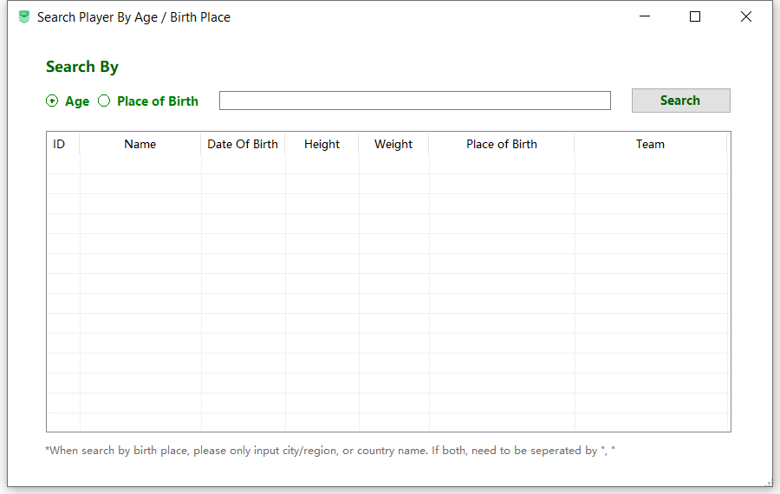

1. Clear button. It will reset all players’ data when pushed. However, the appliacation will guide you to save all information first.
2. The button to display histogram and charts of all imported players’ age group, height and weight. User may switch tabs to check two different charts.

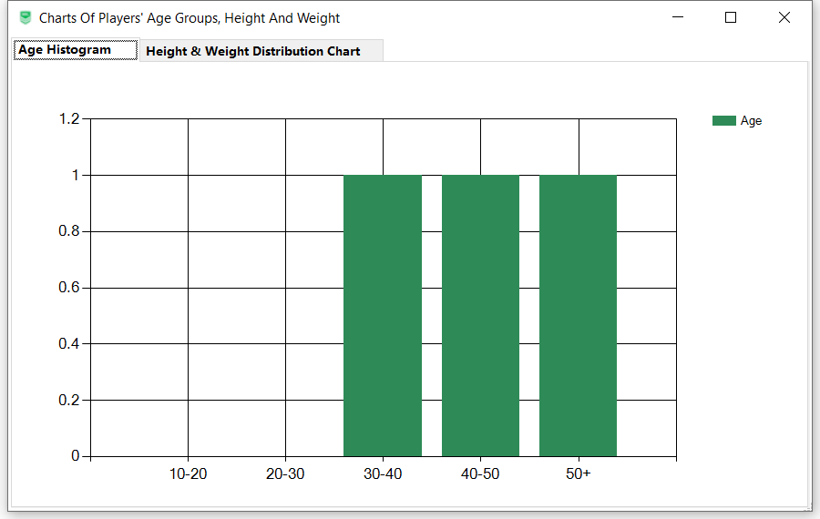

1. The view list of players. It shows all information of all imported informations. The ‘Team’ colume is able to change content dynamicaly if enrroment happens.
2. Enrollment area. It displays player’s (slected in 6) current team, and the team(slected in 8) where player may be enrolled to. The slected player’s name, team’s name and logos can change dynamicaly when choosing on 6 and 7. Once decided, user may simply click ‘Enroll’ button, then player will be unenrolled from previous team and enroll to the new one.
3. The view list of teams, it works just like area 6.
4. Clear button for team. It woks the same way as 4.
5. The button to show a list of all players who have enrolled to the team selected in 8.

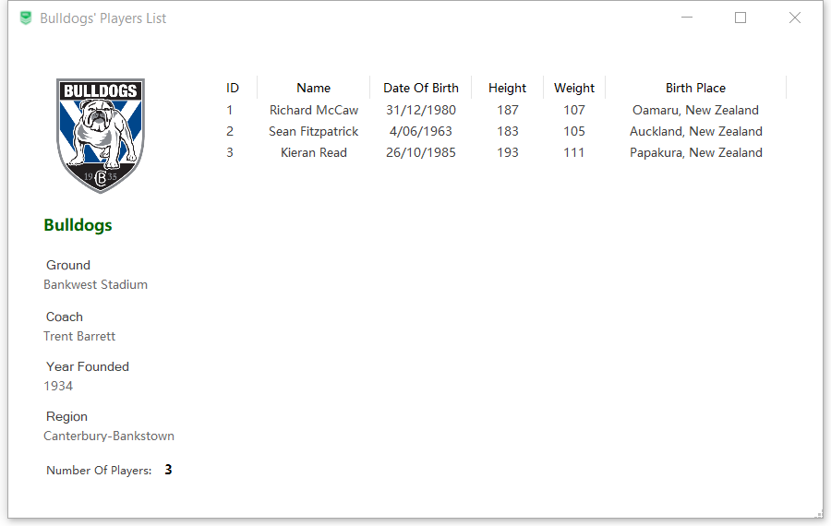

1. Add team button. When clicked, an input menu will appear, input rules apply.

