

Software Engineering

Faculty of Prince Al-Hussein Bin Abdallah II for Information Technology

The Hashemite University, Zarqa-Jordan

**TAJMELNA**

**By**

**Abdulrahman Majad Mahmoud AbuKhalaf (1933507)**

**Rawan Muneer Mohammad Al Marafi (1938918)**

**Salameh Faisal Fares Al Zoubi (1837539)**

**Farah Talal Yacoub Hassan (1934437)**

**Supervised by**

**Dr. Hani Ahmad Khalaf Bani-Salameh**

***Submitted in partial fulfillment of the requirements of B.Sc. Degree in Computer science***

**Month Year**

***2/2022***

# CERTIFICATE

It is here by certified that the project titled “**TAJMELNA**”, submitted by

**Abdulrahman Majad Mahmoud AbuKhalaf** (**1933507**), **Rawan Muneer Mohammad Al Marafi (1938918)**, **Salameh Faisal Fares Al Zoubi (1837539)** and **Farah Talal Yacoub Hassan (1934437)**, in partial fulfillment of the award of the Degree of Bachelor Software Engineering embodies original work done by them under my supervision

Project Supervisor: Dr. Hani Bani-Salameh

Department of Software Engineering

# ABSTRACT

*At this time, the demand for services via the Internet, especially matters that are related to cosmetics increased.*

*for this reason, we have chosen to create a website that provides a type of services that can be useful in saving time and effort.*

*Our website helps a group of people to reach and be able to call or visit beauty institutions or workers within women's cosmetics such as (hair, makeup, nails…etc.) in order to view all their work, offers and available appointments in a way that makes it easier for the costumers to decide how they want to pay and evaluate those services which would lead them to make a clear decision on who they want to work with.*

*In this paper we aim to give you as a customer a great opportunity to seek big salons and beauty professionals all over Jordan, we hope someday we be able to aid every young lady that loves the person she sees when she looks in the mirror.*

# tABLE OF CONTENT

Table of Content

CERTIFICATE 3

ABSTRACT 4

TABLE OF CONTENT 5

Abbreviations 7

LIST OF FIGURES 8

LIST OF Tables 9

ACKNOWLEDGEMENTS 10

Chapter 1: Introduction 11

1.1 Brief 11

1.2 Problem Statement 11

1.3 Objective(s) 11

1.4 Report Organization 12

Chapter 2: Literature Review 13

2.1 Existing Systems: 13

2.2 Comparison: 14

Chapter 3: Software Requirements 15

3.1 Requirements Elicitation and Functional User Requirements 15

3.2 Non-Functional User Requirements: 16

3.3 usecase diagram: 17

Chapter 4: Software Design 20

4.1 Software (system) Architecture 20

4.2 Database Specification 20

4.3 Interface Specification 22

Chapter 5: Software Implementation and Testing 27

5.1 Software Implementation 27

5.2 Software Testing 27

5.2.1 Component Testing 27

5.2.2 System Testing 28

5.2.3 Acceptance Testing 28

Chapter 6: Conclusion 29

6.1 Summary of accomplished project 29

6.2 Future Work 29

References 30

## Abbreviations

• **ER**: An Entity relationship model (ER model) describes the structure of a database with the help of a diagram, which is known as the Entity-Relationship Diagram (ER Diagram).

• **Database:** An organized collection of data, generally stored and accessed electronically from a computer system. Where databases are more complex, they are often developed using formal design and modeling techniques.

• **Use case diagram** as a graphical depiction of a user's possible interactions with a system. A use case diagram shows various use cases and different types of users the system has and will often be accompanied by other types of diagrams as well.

• **Analysis**: The process of breaking a complex topic or substance into smaller parts to gain a better understanding of it.

• **Stakeholder**: A party that has an interest in a company and can either affect or be affected by the business.

• **Programming Language:** A formal language including a set of strings that produce various kinds of machine code output.

• **Application Programming Interface (API):** An interface that defines interactions between multiple software applications or mixed hardware-software intermediaries.

• **HTML:** The Hypertext Markup Language or HTML refers to the standard markup language for documents designed to be displayed in a web browser. which can be assisted by technologies such as Cascading Style Sheets and scripting languages such as JavaScript.

•**CSS**: Cascading Style Sheets: it’s a style sheet language used for describing the presentation of a document written in a markup language such as HTML. CSS is a cornerstone technology of the World Wide Web, alongside HTML and JavaScript.

•**PHP**: A general-purpose scripting language geared toward web development. It was originally created by Danish-Canadian programmer Rasmus Lerdorf in 1994. The PHP reference implementation is now produced by The PHP Group.

•**JavaScript**: Often abbreviated as JS, it’s a programming language that is one of the core technologies of the World Wide Web, alongside HTML and CSS.

• **Frameworks:** They are often built, assessed, and optimized by several experienced software engineers and programmers, software frameworks are versatile, robust, and efficient.

**• Laravel:** it’s a free, open-source PHP web framework, created by Taylor Otwell and intended for the development of web applications following the model–view–controller (MVC) architectural pattern and based on Symfony.

# LIST OF FIGURES

Figure 1:The Typical User. 17

Figure 2:Provider. 18

Figure 3:Admin. 19

Figure 4:ER Diagram. 21

Figure 5: Home Page. 23

Figure 6: Sign-up Page. 24

Figure 7: Log-in Page. 25

Figure 8 : Main Information Page. 26

# LIST OF Tables

Table 1. Comparison between existing systems. 14

Table 2. Requirements Specification. 15

Table 3.non-functional requirement. 16

# ACKNOWLEDGEMENTS

At first, we would like to extend our heartfelt thanks to those who gave us a hand while creating this project. The list starts with DR. Hani Bani-Salaameh, our doctor, teacher, and guide who deserves all the gratitude for keeping us under his supervision during the whole process.

Secondly is Ms. Dania Al Refai, who contributed with her brilliant ideas and a whole mountain of information that we used in best ways to help showing Jordanian ladies how small and non-complicated is the world of beauty works and how variable are the opportunities found in this business.

We would like also to mention some of the ladies who took part in our studies for the way of pointing out some critical issues they faced, all that came after trusting our abilities on doing our best, such as the marvelous Ms. Maysaa Al Shawaa.

At last, the most precious, the most worthy of complement; Our families, our mothers and our sisters. These angels were the main reason why we understood the journey and helped us solve all the mysteries of the world of beauty business.

# Chapter 1: Introduction

## 1.1 Brief

These time women are a huge part of our community, women with beauty needs that may have a huge effect in their life and personalities; therefore, we came up with the idea of a website that give them the ability to take care of themselves in an easy, reachable way.

## 1.2 Problem Statement

Lots of Women face difficulty and trouble with reaching the ideal salon they need in accordance with the product quality, quality of desired services and price that suits them. So, we thought of creating a website we believe it will be helpful in determining the most suitable service provider, the nature of service and compare different opinions coming from their own experiences with one salon or another so they can finally choose the best one for each one of them.

## 1.3 Objective(s)

There are four main goals for our website, the first one is that we aim to make the services easier to get and access,

The second one is that we want to help to get the best service in the least time, the third one that we aim to supply jobs for a very large piece of the society, at the end we want to be someday a leading platform in the field of beauty.

## 1.4 Report Organization

*The rest of the report is organized as follows:*

*Chapter 2 introduces* a number of the existing systems related to our topic; *Chapter 3 lists all the requirement analysis that you need to know about and explaining them in a usecase diagram; Chapter 4 presents the design and architecture components are described in Chapter 5. Chapter 6 presents the future work and concludes the report.*

# Chapter 2: Literature Review

This chapter presents a few the existing systems related to our topic. Also, it documents the state of the art with respect to the topic we are working on. Finally, it compares the existing systems to extract the needed requirements.

## 2.1 Existing Systems:

1. CLOUD MASHGALI [1]: is a system to manage beauty salons and everything you want to manage your salon in one system successfully. This system offers many offers such as managing all the functions of the salon from the Department of bookings, sales, services, doing all the financial transactions of the company and calculate it accurately.
2. Velvet Unit [2]: Application provides beauty salon services in your home, the service is provided to you by the famous beauty salons "Mohamed Al Sagheer", and the leading home services company in Egypt "Fiel Khidmah".
3. Grand Salon & Med Spa [3]: it’s a spa where you’ll discover your style, with a skincare service to help you look younger and feel rejuvenated.
4. Fakera [4]: A web site that provides an explanation of how to perform all cosmetic work.
5. Google maps [5]: It is a site that provides you with a service to know the locations of the salons around you.

## 2.2 Comparison:

Here’s a table to compare between these systems and ours in many aspects.

|  |  |  |  |  |  |  |
| --- | --- | --- | --- | --- | --- | --- |
| Functions-websites | CLOUD MASHGALI | Velvet Unit | Grand Salon & Med Spa | Fakera | Google maps | Tajmelna |
| Appointment Reservation | ✓ | ✓ | ✓ | ✗ | ✗ | ✓ |
| View prices | ✓ | ✓ | ✓ | ✗ | ✗ | ✓ |
| service provider location | ✓ | ✓ | ✓ | ✗ | ✓ | ✓ |
| Show pictures of work | ✗ | ✗ | ✓ | ✗ | ✗ | ✓ |
| Connecting salons to customers | ✓ | ✓ | ✓ | ✗ | ✓ | ✓ |
| Determine the number of service recipients | ✗ | ✗ | ✓ | ✗ | ✗ | ✓ |
| Determine the type of service needed | ✗ | ✓ | ✓ | ✓ | ✗ | ✓ |
| Determine the location of the service | ✗ | ✗ | ✗ | ✗ | ✗ | ✓ |
| Select payment method | ✓ | ✓ | ✓ | ✗ | ✗ | ✓ |
| knowing the experiences of worker | ✗ | ✗ | ✗ | ✓ | ✗ | ✓ |
| Make offers | ✓ | ✗ | ✓ | ✗ | ✗ | ✓ |
| Determine the gender of the service provider | ✗ | ✗ | ✗ | ✗ | ✗ | ✓ |

Table . Comparison between existing systems.

# Chapter 3: Software Requirements

## 3.1 Requirements Elicitation and Functional User Requirements

|  |  |  |
| --- | --- | --- |
| **Character name** | **The tasks** | **The main task** |
| **Admin** | 1- Provide the best form to the user according to their type.  2- Give the ability to make a checkup over everything.  3- Obedience and accuracy of the user’s duties.  4- Accept the opinions of the users according to their nature.  5- Provide improvements to the website according to user’s opinions.  6- Give different ways to pay.  7- To help the users to have the best services. | Full management of  the website and  users |
| **The provider** | 1- Give the admin the needed information.  2-View experiences, location and services and receive the feedback.  3- Choose the right appointment time.  4- Contact with the admin and other users of the website.  5- Drop some appointments and schedule some other appointments.  6- Provide available times for reservations.  7- Determine the appropriate method of payment.  8- Receive the cash.  9- Enter the username and password.  10- Give the needed services. | Give the needed  services to  get paid |
| **The typical user** | 1- Provide the needed information.  2- Enter the username and password.  3- Browse the displayed works and choose the proper one as desired.  4- Choose the best appointment from the given times from the provider.  5- Contact with the provider (if needed).  6- Determine the appropriate method of payment.  7- Get the needed services.  8- Logout from the website | Give the needed  services from the  provider and pay  for it |

Table . Requirements Specification.

## 3.2 Non-Functional User Requirements:

The requirements that specify criteria that can be used to judge the operation of the website.

her is a table of many non-functional user requirements in our website:

|  |  |
| --- | --- |
| **Accessibility** | our website is in the worldwide net it is very easy to access unless you are being a threat |
| **Security** | * In our website we give every information that the users need to know. * We supply a full protection to our users using a variety of methods. * We supply a copyright protection to everyone. |
| **Usability** | as an admin I provide methods to other users to show them how my website can support them |
| **Privacy** | we got a very powerful protection system to ensure that everything in our website stays there |
| **Efficiency and effectively** | * we help you to achieve your purpose from our website with everything we got in our users’ hands. * We help to provide jobs to a big piece of our society. |

Table .non-functional requirement.

## Diagram Description automatically generated3.3 usecase diagram:

Figure :The Typical User.

Figure :Provider.

Figure :Provider.

Figure 3: Admin.

# Chapter 4: Software Design

## 4.1 Software (system) Architecture

* Admin: the manager of everything in our website.
* The Typical User: the one who do the appointment registration …. etc.
* Provider: the one who’s responsible for the booking accept and reject …etc.

## 4.2 Database Specification

ER Diagram:

Is an Entity relationship model (ER model) describing the structure of a database with the help of a diagram, which is known

as the Entity-Relationship Diagram.

we prisent the ER diagram for our website to show you the relations bettween the entity of our website we

hope you will understand the architecture of the Tajmelna website when you see in figure(4).

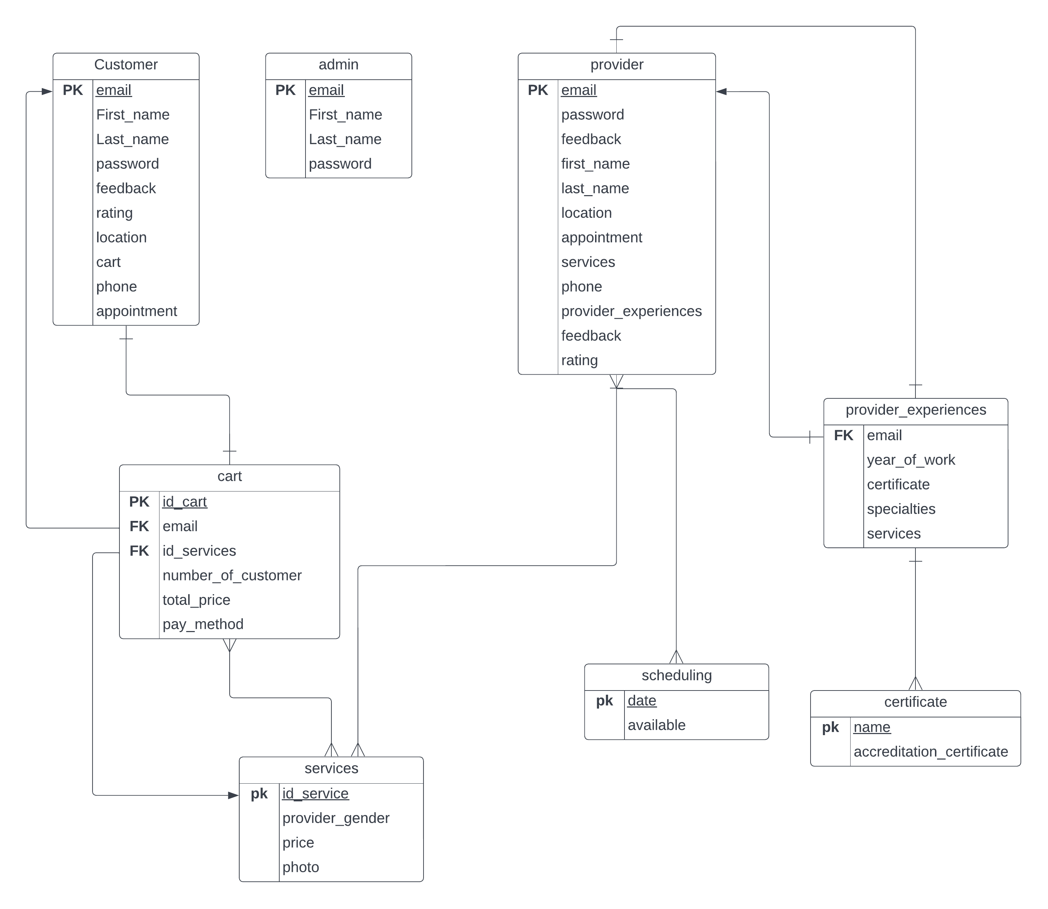

Figure :ER Diagram.

## 4.3 Interface Specification

This is a prototype to show you how our users will see the website that we are working on

We hope to give you an image about it:

* In figure (5) the typical user will see the home page of our website and if she wants to get

the needed services from any salon on the website she must sign up on the website or if she

has an account she can login.

* In figures (6,7) the users will provide the needed information in order to enter our website

to get the needed services.

* In figure (8) we give you a brief of what the users will see when they choose a salon.

Figure :Home Page.

Figure :Sign-up Page.

Figure :Log-in Page.

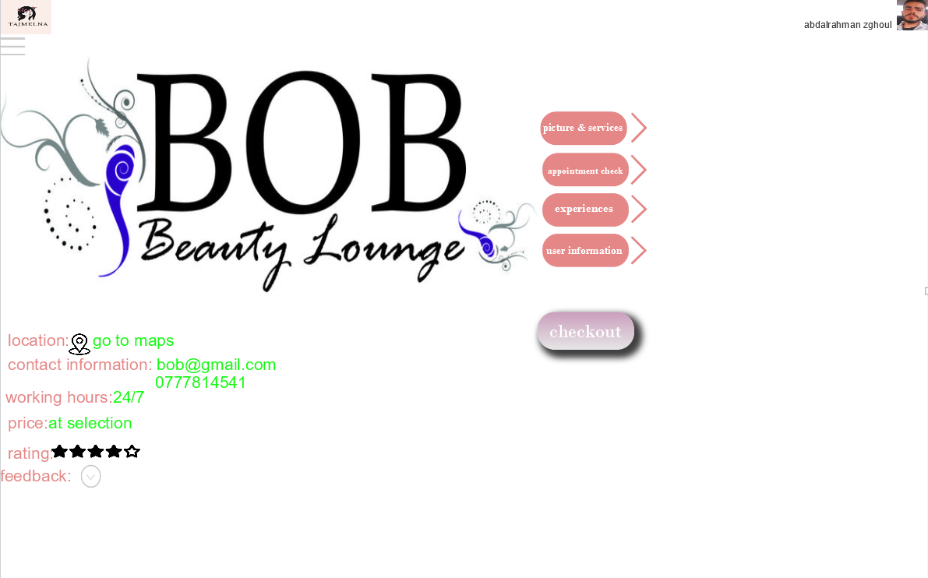

Figure :Main Information Page.

# Chapter 5: Software Implementation and Testing

## 5.1 Software Implementation

In this phase, visions and plans become real. This is the logical conclusion, after evaluating, deciding,

Visioning and planning. In this chapter, we will discuss the future vision of deploying and publishing TAJMELNA

website for widespread use.

## 5.2 Software Testing

[6] Laravel is built with testing in mind. In fact, support for testing with (PHPUnit) is included out of the box and

a (phpunit. xml) file is already set up for your application. The framework also ships with convenient helper methods that allow you to expressively test your applications.

### 5.2.1 Component Testing

Also known as program or module testing, is done after unit testing. In this type of testing those test objects can be tested independently as a component without integrating with other components e.g., modules, classes, objects, and programs. This testing is done by the development team.

In our website we will use Laravel framework, this framework supports component testing using a tool called [7] Blade testing.

### 5.2.2 System Testing

System testing entails testing the whole system. All the modules/components are linked together to see whether the system performs as planned. After Integration Testing, System Testing is carried out. This is crucial for producing high-quality output.

Laravel is the most popular PHP framework for application development. From the testing perspective, it is also known to be highly adequate for its creative testing features. In Laravel, there are two ways to test your app. One is with Unit testing while other is with Feature testing. Unit testing allows to test your classes models, controllers etc, while Feature testing enables you to test your code base.

That’s how our system will be tested.

### 5.2.3 Acceptance Testing

Is a method of software testing where a system is tested for acceptability. The major aim of this test is to evaluate the compliance of the system with the business requirements and assess whether it is acceptable for delivery or not.

Acceptance Testing is the last phase of software testing performed after System Testing and before making the website available for actual use.

# Chapter 6: Conclusion

## 6.1 Summary of accomplished project

The TAJMELNA website was created to fulfill the needs of women in matters related to beauty. The site allows Users

choose the proper time for them to book an appointment, payment method them and how many individuals receive

the service, and they can also see information about the service provider. The site aims to meet all what women want

Search for the salon and see the evaluation of it and the results that they provide.

## 6.2 Future Work

We will improve and develop the site by adding some features such as adding categories that receive service such as

youth and children, we will also publish the site to reach more users.

# References

[1] CLOUD MASHGALI.<https://mashgali.com/?fbclid=IwAR1T5_xIkjnlDgShA8wQ1pkeFvkaa8UN8xvPjIqYI8T14Be4Z3WJwIUk3o0>.Last accessed April 6, 2022

[2] Velvet Unit. <https://play.google.com/store/apps/details?id=com.filkhedma.velvetunit>. Last accessed April 6, 2022

[3] Grand Salon & Med Spa. <https://mashgali.com/?fbclid=IwAR1T5_xIkjnlDgShA8wQ1pkeFvkaa8UN8xvPjIqYI8T14Be4Z3WJwIUk3o0>.Last accessed April 6, 2022

[4] Fakera. <https://www.fekera.com/?fbclid=IwAR2WOQmz0avAOwLwQN6BN94y-70VH2l-C8vvNG6qpBs-CP3Eok_1WzXtu6g>.Last accessed April 6, 2022

[5] Google maps. <https://www.google.com/maps/@31.9619072,35.88096,12z>. Last accessed April 6, 2022

[6] Laravel. [https://laravel.com/](https://laravel.com/%20.) .Last accessed April 6, 2022