1.1.4、预定义设置

1.1.4.1、预定义设置
- 预定义设置
1.点击系统设置-->预定义设置，增加预定义触发频率和预定义防护模式 (1).触发频率没有固定参数，用户可根据自已网站正常连接请求数设置合适参数。如果请求数和时间都设为0就是绝对触发，但是通过白名单后，在白名单时间内不会再触发 (2).防CC有哪些模式可查看文档：防cc模式
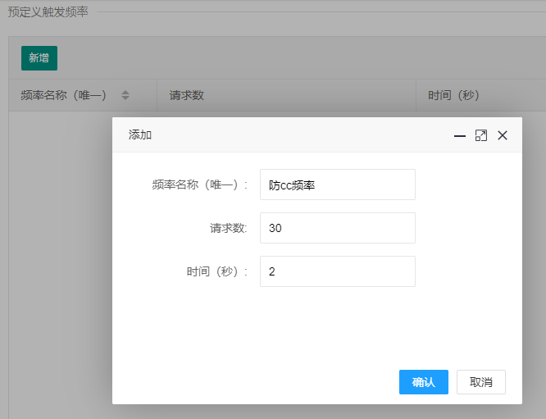
2.登陆站点后进入应用防火墙设置，找到防cc设置，把刚刚增加的触发频率，防护模式选上，点击提交
添加好后,在站点的应用防火墙中可以看到防CC的设置选项
- 备注：防CC代码模式有以下几种： 注：复制代码时代码中间一定要空一行，如下格式： 1.http redirect（普通）
HTTP/1.1 302 FOUND
Connection: keep-alive
Location: {{url}}
continue
2.html redirect
HTTP/1.1 200 OK
Content-Type: text/html; charset=utf-8
Connection: keep-alive
Cache-Control: no-cache,no-store
continue
3.js plain
HTTP/1.1 200 OK
Content-Type: text/html; charset=utf-8
Connection: keep-alive
Cache-Control: no-cache,no-store
continue
4.js concat
HTTP/1.1 200 OK
Content-Type: text/html; charset=utf-8
Connection: keep-alive
Cache-Control: no-cache,no-store

5.js revert(复杂)
HTTP/1.1 200 OK
Content-Type: text/html; charset=utf-8
Connection: keep-alive
Cache-Control: no-cache,no-store

6.html manual
HTTP/1.1 200 OK
Content-Type: text/html; charset=utf-8
Connection: keep-alive
Cache-Control: no-cache,no-store
continue
7.deny
HTTP/1.1 200 OK
Content-Type: text/html; charset=utf-8
Connection: keep-alive
Cache-Control: no-cache,no-store
try again later

