Piece by Piece
By Zachary Sansone

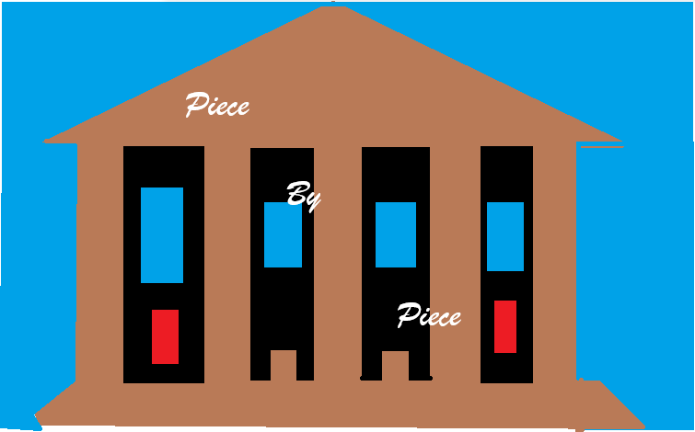
Contents
1 Game Design Document 7
1.1 Overview 7
1.2 Game Mechanics and Features 8
1.2.1 Interactions, Rules, and resources 8
1.2.1.1 Recovery Team and Fragment Excavation 8
1.2.1.2 Exhibit Screens and Fragment collection 9
1.2.1.3 Fragment cleaning 9
1.2.1.4 Artifact Assembly 10
1.2.1.5 Museum Funding 11
1.2.1.6 Upgrades 11
1.2.1.7 Reputation 12
1.2.1.8 Excavation Tools 12
1.2.1.9 Archaeological Sites and Progression 12
1.2.2 Objectives 12
1.2.3 Conflict 13
1.2.4 Menus and Interfaces 13
1.2.4.1 Shared HUD and navigation 13
1.2.4.2 Main Menu 14
1.2.4.3 Exhibit Screen 15
1.2.4.4 Excavation Map 16
1.2.4.5 Site information 17
1.2.4.6 Excavation Tools 17
1.2.4.7 Pause / Settings 18
1.2.4.8 Settings Screen 18
1.2.4.9 Win Screen 18
2 Technical Design Document and Art List 20
2.1 Game engine 20
2.2 Other software and Tools 20
2.3 Platform 20
2.4 Scenes State Diagram 21
2.5 Scene List 22
2.5.1 Main Menu 22
2.5.2 Settings 22
2.5.3 Exhibit 1 23
2.5.4 Exhibit 2 24
2.5.5 Excavation Menu 25
2.5.6 Win Menu 25
2.5.7 Pause Menu 26
2.6 Game Object / Component Diagrams 27
2.6.1 Main Menu 27
2.6.2 Exhibit 1 28
2.6.3 Exhibit 2 28
2.6.4 Excavation Menu 29
2.6.5 Win Menu 29
2.6.6 Pause Menu 30
2.6.7 Settings Menu 30
2.7 Game Object List 31
2.7.1 Game State 31
2.7.2 Main Menu Manager 31
2.7.3 Main Menu UI 32
2.7.4 Menu Music 33
2.7.5 Settings Manager 33
2.7.6 Settings UI 34
2.7.7 Exhibit 1 Manager 35
2.7.8 Exhibit 1 Background 35
2.7.9 HUD 36
2.7.10 Exhibit Navigation Buttons 37
2.7.11 Artifact Display 37
2.7.12 Artifact Sprite 38
2.7.13 Fragment Case 39
2.7.14 Assemble Button 39
2.7.15 Exhibit 2 Manager 40
2.7.16 Exhibit 2 Lock UI 41
2.7.17 Excavation Manager 41
2.7.18 World Map 42
2.7.19 Site Marker 43
2.7.20 Site Information Panel 43
2.7.21 Excavation Tools Panel 44
2.7.22 Pause Menu Manager 45
2.7.23 Pause Menu UI 46
2.7.24 Win Menu Manager 47
2.7.25 Win Menu UI 47
2.8 Component List 48
2.8.1 GameState.gd 48
2.8.2 MainMenuController.gd 49
2.8.3 SettingsController.gd 49
2.8.4 Exhibit1Controller.gd 49
2.8.5 Exhibit2Controller.gd 50
2.8.6 ExcavationController.gd 50
2.8.7 PauseController.gd 50
2.8.8 WinController.gd 51
2.8.9 Node 51
2.8.10 Node2D 51
2.8.11 Control 52
2.8.12 CanvasLayer 52
2.8.13 Sprite2D 52
2.8.14 TextureRect 53
2.8.15 Label 53
2.8.16 Button and TextureButton 53
2.8.17 Panel and ColorRect 54
2.8.18 VBoxContainer and HBoxContainer 54
2.8.19 ProgressBar 54
2.8.20 HSlider 54
2.8.21 AudioStreamPlayer 55
2.8.22 PackedScene 55
2.8.23 AnimationPlayer 55
2.9 Art List 56
2.9.1 Static 2D Assets 56
2.9.1.1 Main Menu Background 56
2.9.1.2 Main Menu Title Splash 56
2.9.1.3 Exhibit Backgrounds 56
2.9.1.4 World Map Background 56
2.9.1.5 Fragment Case Sprites 57
2.9.1.6 Pedestal Sprites 57
2.9.1.7 Light Overlay Sprite 57
2.9.1.8 Site Marker Sprite Sheet 57
2.9.1.9 Excavation Tool Icons 57
2.9.1.10 HUD and UI Icon Set 58
2.9.1.11 UI Panels and Buttons 58
2.9.1.12 Win Screen Background / Completion Art 58
2.9.2 Animated 2D Assets 58
2.9.2.1 Artifact Assembly Animation 58
2.10 Audio Assets 60
2.10.1 Music Assets 60
2.10.1.1 Museum Theme 60
2.10.2 Sound Effect Assets 60
2.10.2.1 Museum Theme 60
2.10.2.2 Excavation Attempt 60
2.10.2.3 Fragment Found 60
2.10.2.4 Excavation Failure 60
2.10.2.5 Fragment Cleaning 61
2.10.2.6 Upgrade / Tool Purchase 61
2.10.2.7 Artifact Assembly 61
2.10.2.8 Exhibit Completion 61
3.0 Task list 62

1 Game Design Document

1.1 Overview
Piece by Piece will be a 2D incremental museum management game in which the player recovers artifacts from archaeological sites and restores them to display in their museum. The player will send a recovery team to these sites to search for fragments of artifacts. The recovery team can also sometimes find things that will be automatically sold and give the player a small amount of funds for their museum. These funds can be used to increase the speed of the teams and the chance of finding fragments.
Once found, fragments are placed on the artifact’s designated display case. In this form, artifact fragments generate a very small amount of funds per second. The player can also click to clean and touch up each fragment piece. Cleaned fragment pieces generate marginally more funds. Once every fragment has been collected, the player can choose to assemble the artifact, which generates much more funds per second and gives a one-time increase to reputation points, which unlock new upgrades.
This version of the game will include two archaeological sites for the player to send their team to. The first area will contain an artifact that will not be accessible to the player until they have made progress in the second area through the purchase of a reputation-locked tool. The player wins the game by restoring and displaying all artifacts in the museum.
Piece by Piece will combine a simplified version of the generation and upgrade progress of Cookie Clicker (Orteil, 2013, Figure 1) with the collection and excavation themes of Digseum (Rat Monthly, 2024, Figure 2, 3). This game will use a pixel-art art style.

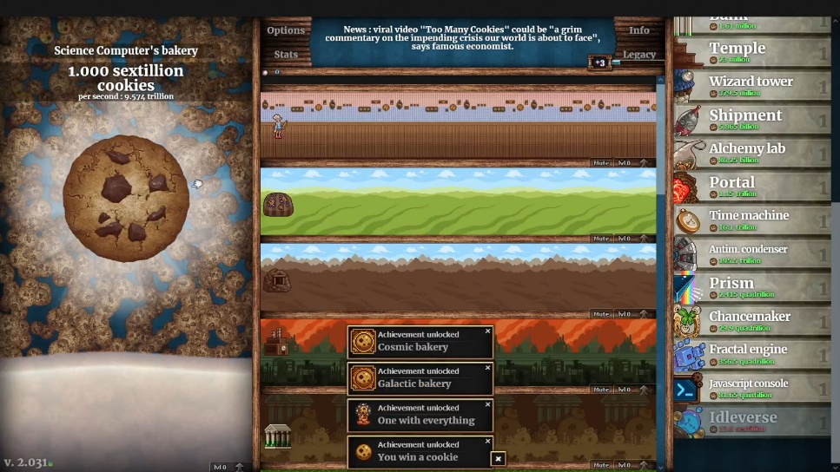
Figure 1. Cookie Clicker from steam page
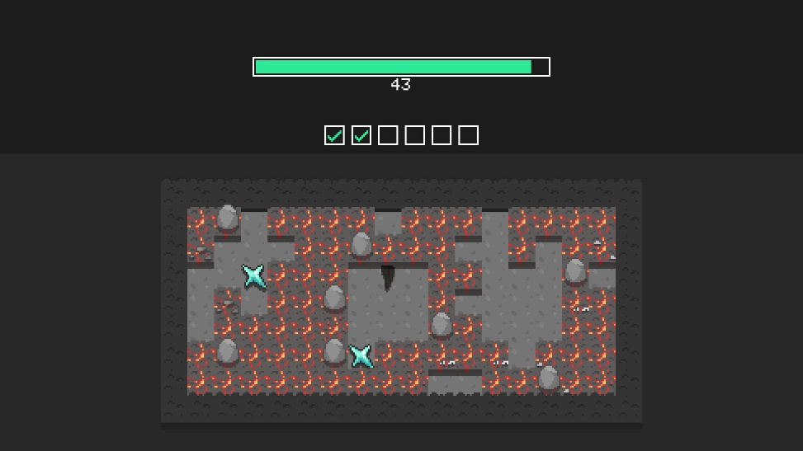
Figure 2. Digseum collection from steam page
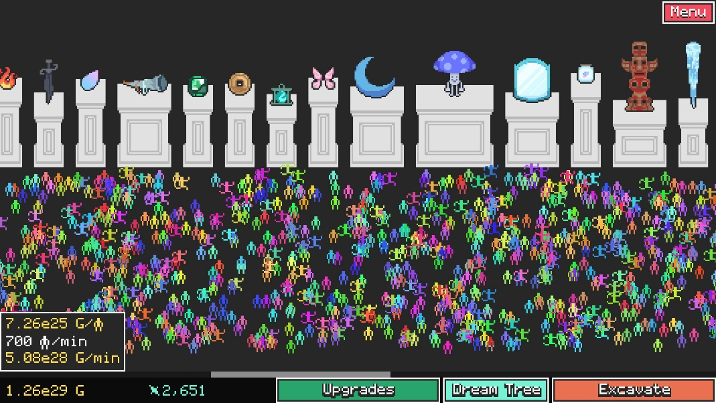
Figure 3. Digseum display from steam page

Game Mechanics and Features

1.2.1 Interactions, Rules, and resources

1.2.1.1 Recovery Team and Fragment Excavation
The player manages a recovery team that can be assigned to any unlocked archeological site. The selected site attempts to extract an artifact fragment at regular intervals.
At the beginning of the game, the excavation results in success or failure every 10 seconds. At the beginning of the game, the chance of successfully extracting a fragment depends on the selected artifact’s multiplier and the area’s base success chance. On failure, the player will receive a small amount of funds within a range of values unique to each area. The player can spend funds to reduce the time between attempts and increase the chance of a successful attempt.
The player selects the active artifact from the chosen site’s information panel. The recovery team continues attempting to excavate fragments for that artifact until the player selects a different valid artifact or all of its fragments have been recovered.
Certain artifacts cannot be selected by the player until the player has purchased an upgrade to unlock a specific tool that lets the recovery team attempt to extract that artifact’s fragments.
The player can manually switch the recovery team to another unlocked area at any time, pausing the excavation timer for the previous area.
Once all artifacts for an area are unlocked, the player receives a boost in income for that specific exhibit.

1.2.1.2 Exhibit Screens and Fragment collection
In this version of the game, the museum will contain two exhibit screens, themed for each of the archaeological sites. Each exhibit contains initially empty display pedestals, cases, frames, or whatever else is appropriate for each artifact that is available for that exhibit.
Extracted artifact fragments are automatically delivered to a case next to the display which has a fixed number of spaces. Empty spaces for un-extracted fragments and are filled in when delivered. (Figure 4)
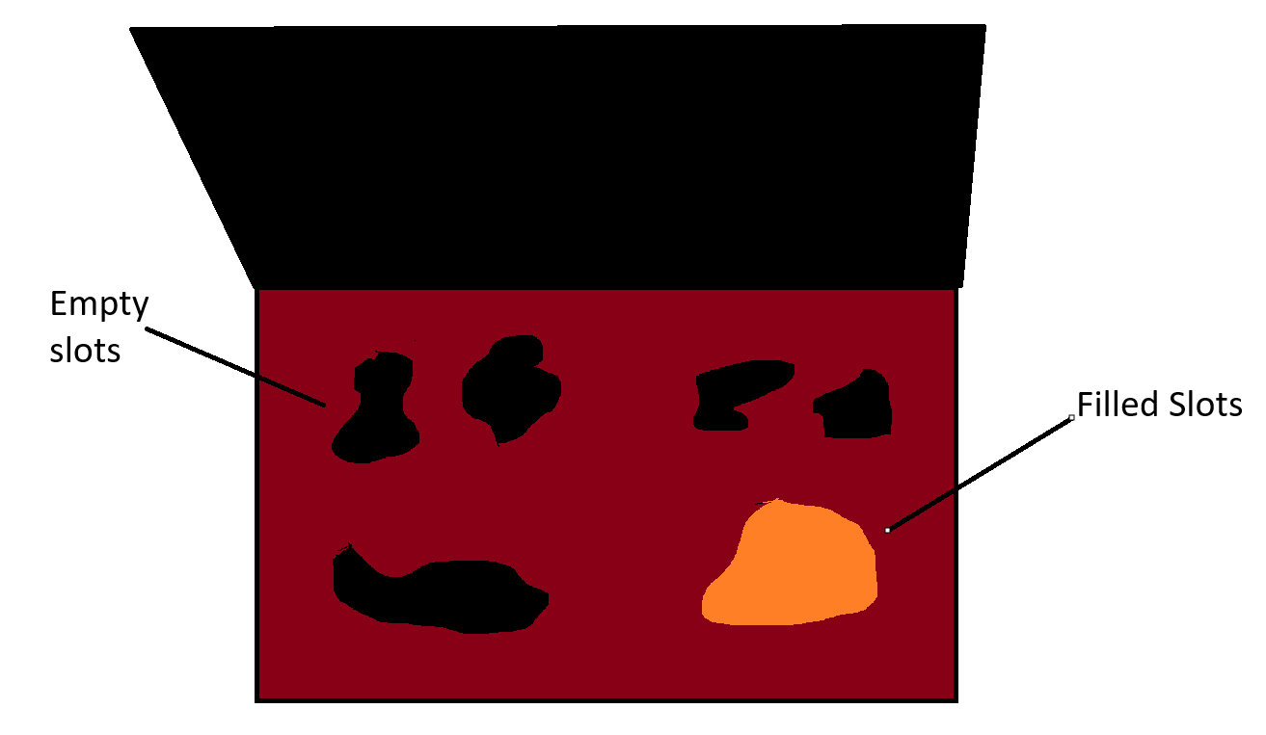
Figure 4. Case Example

1.2.1.3 Fragment cleaning
When fragments are extracted by the recovery team, they arrive uncleaned. Uncleaned fragments in their case generate a very small amount of passive income which can be seen by hovering over the case as a total for all fragments currently inside the case. When the player selects the case, they can choose fragments to clean. By clicking and dragging their mouse over the fragment, the fragment changes color to a brighter, cleaner version. (Figure 5) Once a sufficient amount of the fragment has been cleaned off, the remaining dirt the player may have missed gets cleaned automatically and the fragment is registered as cleaned.
Cleaned fragments generate an increased income. To fully assemble an artifact, the player must clean all fragments.
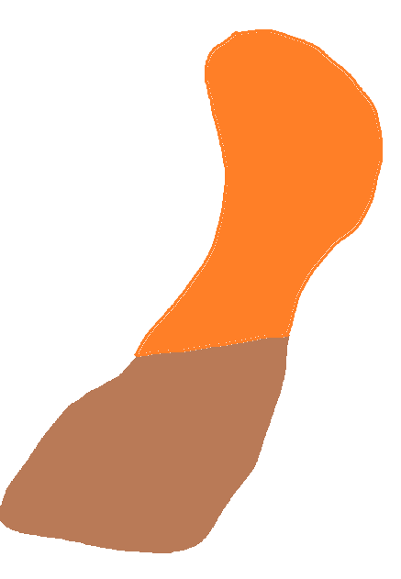
Figure 5. Cleaning

1.2.1.4 Artifact Assembly
Once every fragment for an artifact has been recovered and cleaned, an assemble artifact button becomes available within the case. An exclamation mark hovers above the case on the exhibit screen and menu UI to show players when they have acquired all fragments of an artifact, regardless of whether they are cleaned yet or not.
Once the player selects the assemble button, a restoration animation plays, and the fragments float out of their case towards the display, rotate, and move into the correct positions. The fragments snap together with some sound and visual effects and gently drop the completed artifact into place. (Figure 6)
A complete artifact generates much more income than when fragmented and gives the player a one-time reputation reward.
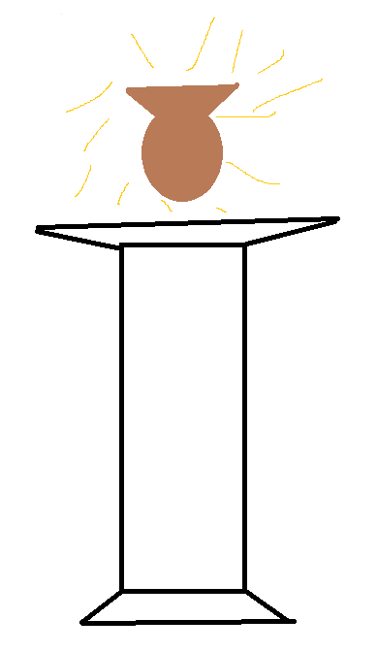
Figure 6. Artifact Display

1.2.1.5 Museum Funding
Museum Funds are the primary spending resource of the game. The player earns funds from a failed fragment-recovery attempt and from passive gains from museum visitors for fragments and completed artifacts present in the museum.
Uncleaned fragments generate the smallest amount, cleaned fragments generate marginally more, and completed artifacts generate the most. Museum funding can be used to purchase upgrades for the recovery team and excavation tools.

1.2.1.6 Upgrades
The player can spend museum funding on upgrades to improve the recovery team. Each area has its own set of upgrades and an initial value for each upgradable statistic.
The current planned upgrades are to the speed of excavation and the chance that fragments are discovered.
Each upgrade becomes more expensive after it is purchased.

1.2.1.7 Reputation
Reputation represents how popular the museum is. The player earns reputation when an artifact is fully completed and displayed in its exhibit. Reputation is not spent but rather used as a requirement to unlock certain upgrades and archaeological sites.

1.2.1.8 Excavation Tools
Some artifacts cannot be excavated with the recovery team’s current equipment and require a specific excavation tool.
This tool is unlocked after the player reaches a certain amount of reputation and pays a cost in funds. Once unlocked, the recovery team can extract any fragments that that tool is made to extract.

1.2.1.9 Archaeological Sites and Progression
This version of the game will contain two archaeological sites and six total artifacts.
The first exhibit contains three artifacts, two of which can be unlocked at the beginning of the game. The third artifact will require the player to unlock the first excavation tool. This area will have an initial excavation time of 10 seconds and a base chance of success of 35%. The first artifact has a success multiplier of 1x, the second artifact has a success multiplier of 0.8x, and the third artifact has a success multiplier of 0.5x.
The second exhibit will also contain artifacts, only one of which will be attainable upon unlocking the area. The second artifact will require the use of the same tool as the third artifact in area 1, and the third artifact will require the use of a second tool. The initial excavation time will be 20 seconds, and the base success chance will be 15%. The multipliers follow the same structure as the first area. This area will also give much more funds on a failed excavation than the first area.

1.2.2 Objectives
The player’s main objective is to recover, restore, and display the six artifacts across the museum’s two exhibits. To restore an artifact, the player must collect all its fragments, clean all the fragments, and select the option to assemble the artifact.
The player begins with access to two artifacts in the first exhibit. Completing the artifact generates income and gains the player an increase to reputation, allowing the player to improve the recovery team and unlock the second exhibit and tools to excavate the locked artifact. Exhibit 2 earns the player more funds on a failed excavation but has a much lower chance of successfully excavating a fragment.
The player must earn enough museum funding and reputation to unlock excavation tools. Tool 1 provides access to the third artifact in Exhibit 1 and the second artifact in Exhibit 2. Tool 2 provides access to the final artifact in Exhibit 2.
The final objective is to obtain both excavation tools and assemble all six artifacts. Once every artifact has been placed on display, both exhibits are complete and the player wins the game.

1.2.3 Conflict
The main conflict arises from the fact that the player only has access to one recovery team. The player must choose between a safe, slow approach by finishing the early artifacts to gain enough funds to upgrade the team enough to quickly obtain the harder fragments or try to go to the harder zones first and hope to get lucky with the low fragment success chance and high excavation times.
Area 2 has a lower base fragment-discovery chance and a longer excavation interval than Area 1. However, unsuccessful excavation attempts in Area 2 provide larger amounts of sellable salvage funding. This creates a risk/reward decision: the player may attempt to rush difficult late-game artifacts and earn more funding from failures or remain in the earlier site to complete safer artifacts and purchase upgrades first.
Museum funding is limited and can be spent on recovery-speed upgrades, fragment-discovery upgrades, excavation tools, and archaeological-site access. Spending funding on one option delays progress toward the others. Reputation also creates progression barriers because it can only be earned by completing artifacts.

1.2.4 Menus and Interfaces

1.2.4.1 Shared HUD and navigation
A shared HUD is visible on both the museum exhibit screens and on the excavation map. The HUD displays the player’s current museum funds, reputation, and the active artifact excavation’s current timer. It also contains a button that opens the pause and settings menu.
The exhibit screen also says the name of the current exhibit as part of the environment.
Navigation Arrows also appear on either side of the screen start, leftmost with the world map, exhibit 1, and exhibit 2. The Left arrow disappears on the world map, and right arrow disappears on exhibit 2 since there are no more screens in those directions. (Figure 7, 8)
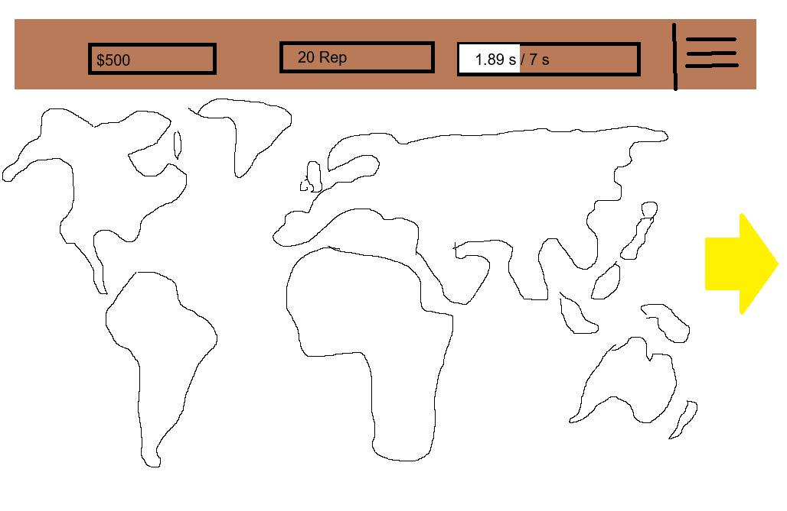
Figure 7. Map w/ Hud

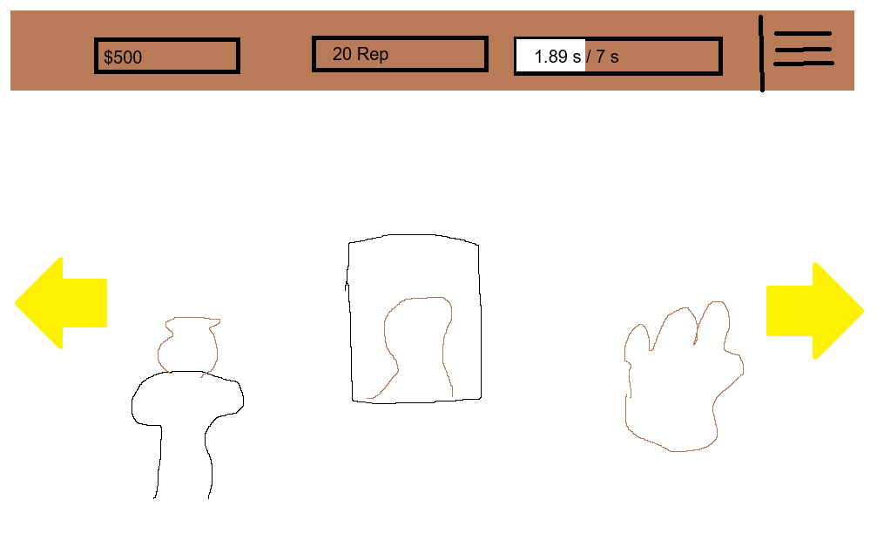
Figure 8. Museum Menu w/ Hud

1.2.4.2 Main Menu
The main menu is shown when the game launches. It displays the name of the game and buttons to start the game, settings, and quit the game. Selecting start begins a new game in exhibit 1, settings opens the settings menu, and quit game exits the game. (Figure 9)
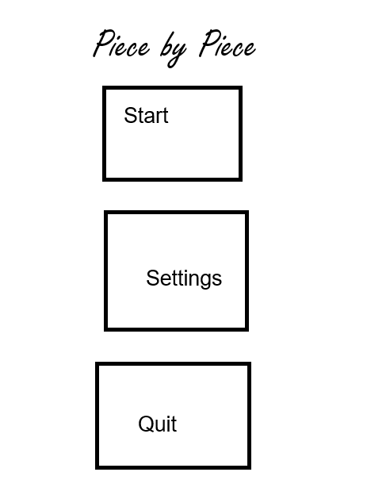
Figure 9. Main Menu

1.2.4.3 Exhibit Screen
There will be 2 exhibit screens. At game start, the second exhibit screen will be a dark background and have a locked icon that says the unlock conditions underneath it. (Figure 10)

Figure 10. Locked Exhibit
Once exhibit screens are unlocked but not all artifacts are completed, completed artifacts will be displayed on their pedestal or other display method with a bright light above it illuminating the artifact. Unlocked but not finished artifacts will have a case present in the space where the artifact would be displayed without the light. If the player has all available pieces to finish an exhibit, the case will have an exclamation mark above it to let the player know. Locked artifacts will be dark, and a locked icon will cover the space along with the requirement to unlock the artifact. (Figure 11)
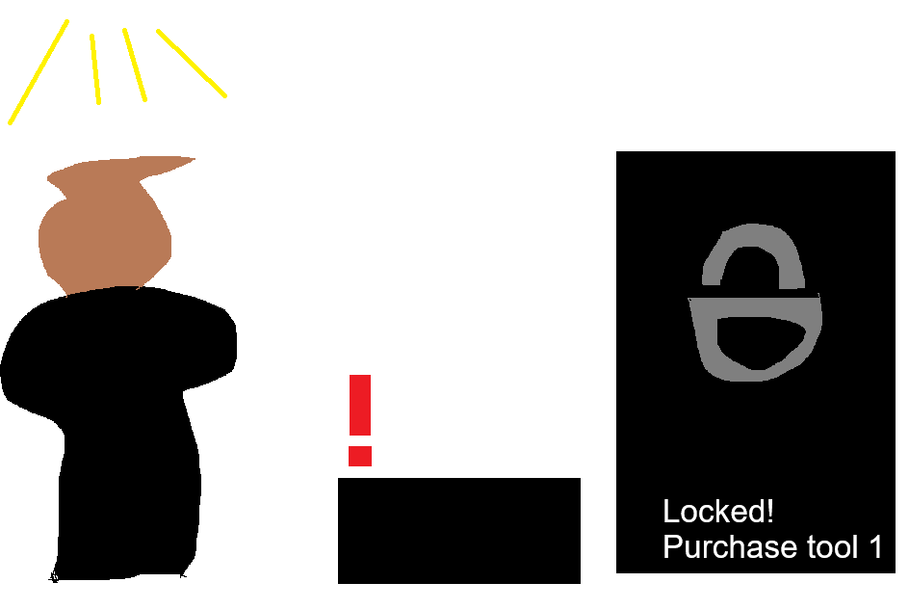
Figure 11. Example Exhibit

1.2.4.4 Excavation Map
The excavation map, accessed by moving left from the first exhibit menu, has a stylized world map with selectable markers for each archaeological site. Available sites use colored map markers, while locked sites are marked in gray. A locked site can still be selected to view its requirements.
Selecting an available site opens the site’s information panel, is described below
When a player meets the requirements to unlock a new site, an exclamation mark appears above the marker on the map. The site then enables the user to select the unlock button. (Figure 12)
A site that has all its artifacts completed appears as gold on the map and a gold bordered information panel.
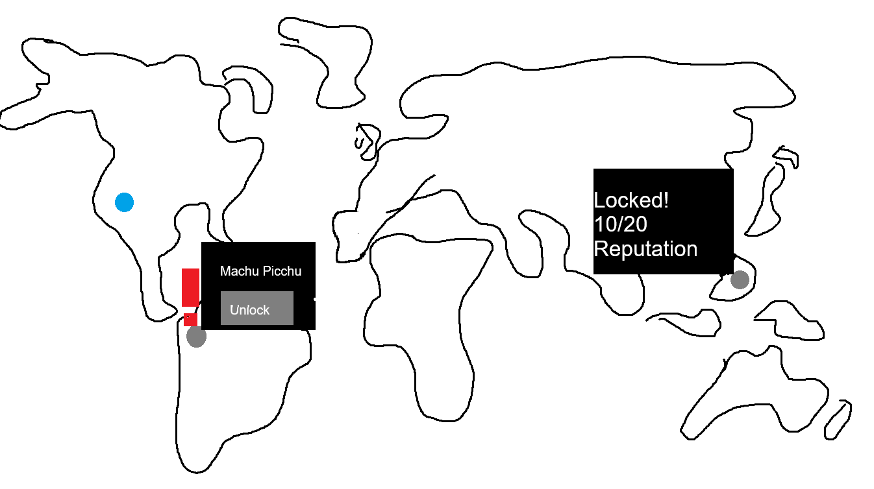
Figure 12. World Map

1.2.4.5 Site information
The site information panel allows the player to select an available artifact as the active target for excavation. The selected artifact has a red border to denote the active one. The panel also displays a progress bar showing the time remaining until the excavation attempt finishes.
The player can change the active artifact at any time by selecting another valid artifact in the panel. Locked artifacts cannot be selected until the player has unlocked the required excavation tool.
The panel also contains two site-specific upgrade buttons for excavation speed and fragment discovery chance. Each button displays the upgrades current effect, next effect, and cost. (Figure 13)
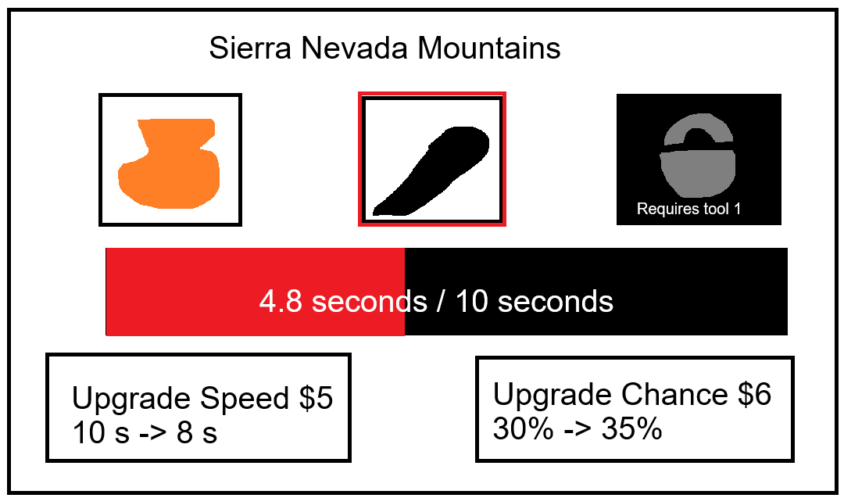
Figure 13. Site Information Panel

1.2.4.6 Excavation Tools
The Excavation map will have a button that opens the equipment panel. This panel shows every unlockable tool in the game, its required reputation amount if still locked and the cost. Tools that are still locked show a locked icon. (Figure 14)
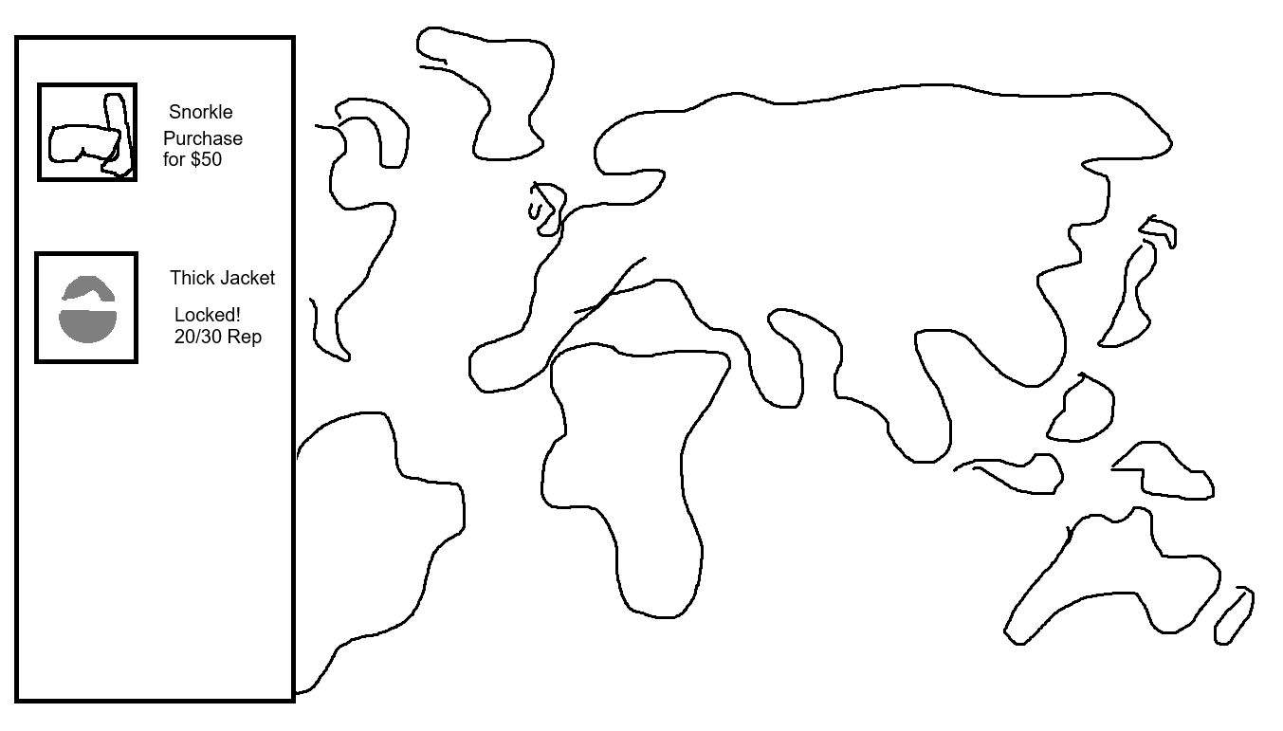
Figure 14. Excavation Tool Panel

1.2.4.7 Pause / Settings
The pause and settings menu is opened from the shared HUD. It has buttons to resume the game, quit the game and open the settings menu. When resumed, the player should return to the previous screen (Figure 15)
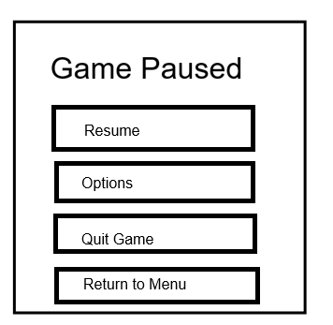
Figure 15. Pause

1.2.4.8 Settings Screen
The settings menu has options for music volume, sound effects volume, a back button, and a short instructional message on how to play the game. The back button should return the player to the previous screen. (Figure 16)
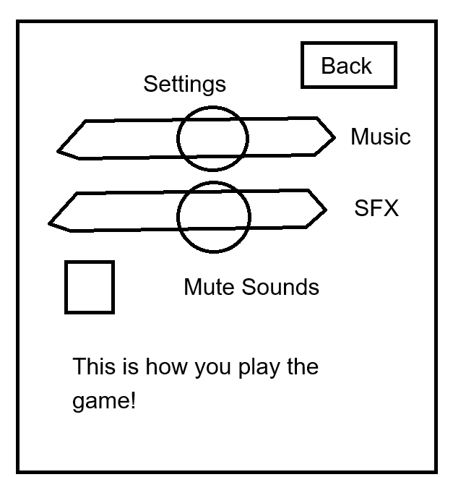
Figure 16. Settings Menu

1.2.4.9 Win Screen
The win screen appears when the player displays all 6 completed artifacts. In congratulates the player and shows the player’s final funds, reputation. The buttons allow the player to quit to the main menu, start a new game or exit the game. (Figure 17)
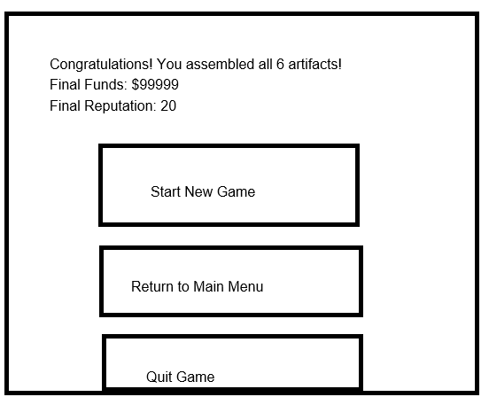
Figure 17. Win Screen

Technical Design Document and Art List

2.1 Game engine
Piece by Piece will be developed using the Godot Game Engine, which provides 2D rendering, UI controls, scene management tools, input handling, and scripting which is perfect for this kind of game.
The game will use Godot scenes to organize the main menu, exhibits, pause, settings, and excavation map. The mechanics such as the excavation timers, funds, reputation, progress, and button interactions will be implemented with GDScript.

Other software and Tools
- Pixelorama: Free pixel art editor to create artifacts, backgrounds, HUD elements, and other visuals.
- Audacity: Free audio editor used to edit music and sound effects such as button clicks, cleaning sounds, and artifact assembly effects
- Git and GitHub: Git will be used for version control, while the project itself will be stored on GitHub.
Microsoft Word: Microsoft Word will be used to write and format the Game Design Document.

Platform
The game will be developed as a Windows Executable

Scenes State Diagram
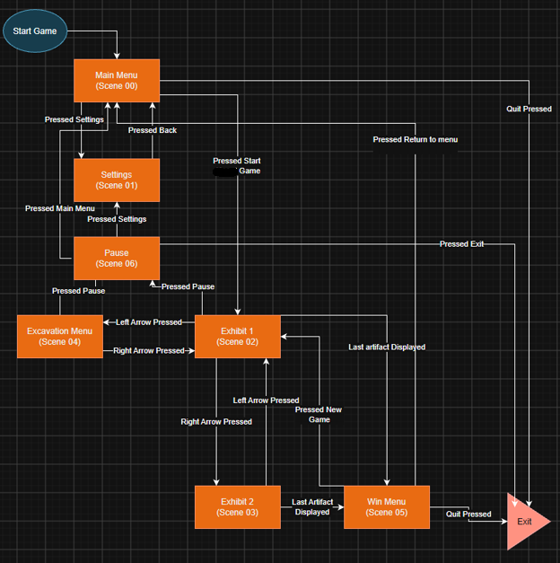
Figure 18. Scene State Diagram

Scene List

Main Menu
Scene00
Objectives | Provides the player with a way to start a new game, open settings, or quit the game
Outgoing Transitions | TO Exhibit 1 WHEN player pressed Start  TO settings WHEN player presses settings  TO exit WHEN player presses Quit Game
Game Objects | Main Menu Manager  Main Menu UI  Title Text  Background Artwork  Start Game Button  Settings Button  Quit Game Button  MenuMusic
Comments | n/a

Settings
Scene01
Objectives | Allows the player to adjust the music and sound-effect volume, mute audio, and view basic tutorials
Outgoing Transitions | TO Main Menu WHEN player presses Back when opening from main menu  TO Pause Menu WHEN player presses Back when opening from paused
Game Objects | Settings Manager  Settings UI  Instructions Label  Music Volume Slider  SFX Volume Slider  Mute Toggle  Back Button
Comments | Should return to scene from which player called it

Exhibit 1
Scene02
Objectives | Displays the first museum exhibit and allows player to view, clean, and assemble the 3 artifacts from Area 1
Outgoing Transitions | TO Excavation Menu WHEN player presses left arrow  TO Exhibit 2 WHEN player presses right arrow  TO Pause Menu WHEN player presses pause button  TO Win Menu WHEN final artifact displayed
Game Objects | Exhibit 1 Manager  Exhibit Background  CanvasLayer  HUD  Right Arrow  Left Arrow  Pause Button  Display Areas  Fragment Cases  Assemble Artifact Button  Locked Artifact Display Overlay  Artifact Sprites
Comments | N/A

Exhibit 2
Scene03
Objectives | Displays the second museum exhibit. Before the exhibit is unlocked, the scene shows an overlay showing the exhibit is locked with its requirements. After unlocking, the player can view, clean and assemble the 3 artifacts from Area 2
Outgoing Transitions | TO Exhibit 1 WHEN player presses left arrow  TO Pause Menu WHEN player presses pause button  TO Win Menu WHEN final artifact displayed
Game Objects | Exhibit 2 Manager  Exhibit Background  CanvasLayer  HUD  Left Arrow  Pause Button  Display Areas  Fragment Cases  Assemble Artifact Button  Locked Artifact Display Overlay  Artifact Sprites  Locked Exhibit Overlay  Unlock Requirement Label
Comments | N/A

Excavation Menu
Scene04
Objectives | Allows the player to select an archaeology site and active artifact, purchase site upgrades, and open the excavation tools panel.
Outgoing Transitions | TO Exhibit 1 WHEN player presses right arrow  TO Pause Menu WHEN player presses pause button
Game Objects | Excavation Menu Manager  World Map Background  Site Markers  CanvasLayer  HUD  Site Information Panel  Active Artifact Buttons  Excavation Progress Bar  Speed Upgrade Button  Discovery Chance Upgrade Button  Excavation Tools Panel  Right Arrow  Pause Button
Comments | Site Information Panel and Excavation Tools panel within this scene

Win Menu
Scene05
Objectives | Congratulates the player for restoring all artifacts and displays final museum funds, and reputation
Outgoing Transitions | TO Exhibit 1 WHEN player presses New Game  TO Main Menu WHEN player presses Main Menu  TO Exit WHEN player presses Quit Game
Game Objects | Win Menu Manager  Win Menu UI  Completed Exhibit Background  Completion Label  Final Funding Label  Final Reputation Label  New Game Button  Main Menu Button  Quit Game Button
Comments | Should only be reached after completing all six artifacts

Pause Menu
Scene06
Objectives | Pauses gameplay and provides options to resume, open settings, quit, and return to main menu
Outgoing Transitions | TO previous scene WHEN player presses Resume  TO Settings WHEN player presses Settings  TO Main Menu WHEN player presses Return to Main Menu  TO Exit WHEN player presses Quit
Game Objects | Pause Menu Manager  Pause Menu UI  Darkened Background Overlay  Resume Button  Settings Button  Quit Button  Return to Main Menu Button
Comments | Can be opened from Exhibit 1, Exhibit 2, or the Excavation Menu

Game Object / Component Diagrams

Main Menu
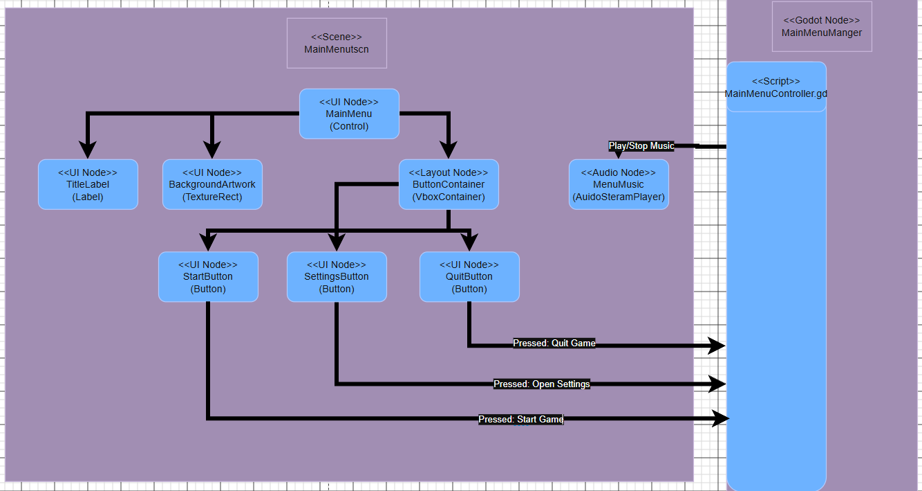
Figure 19. Main Menu Game Object / Component Diagram

Exhibit 1
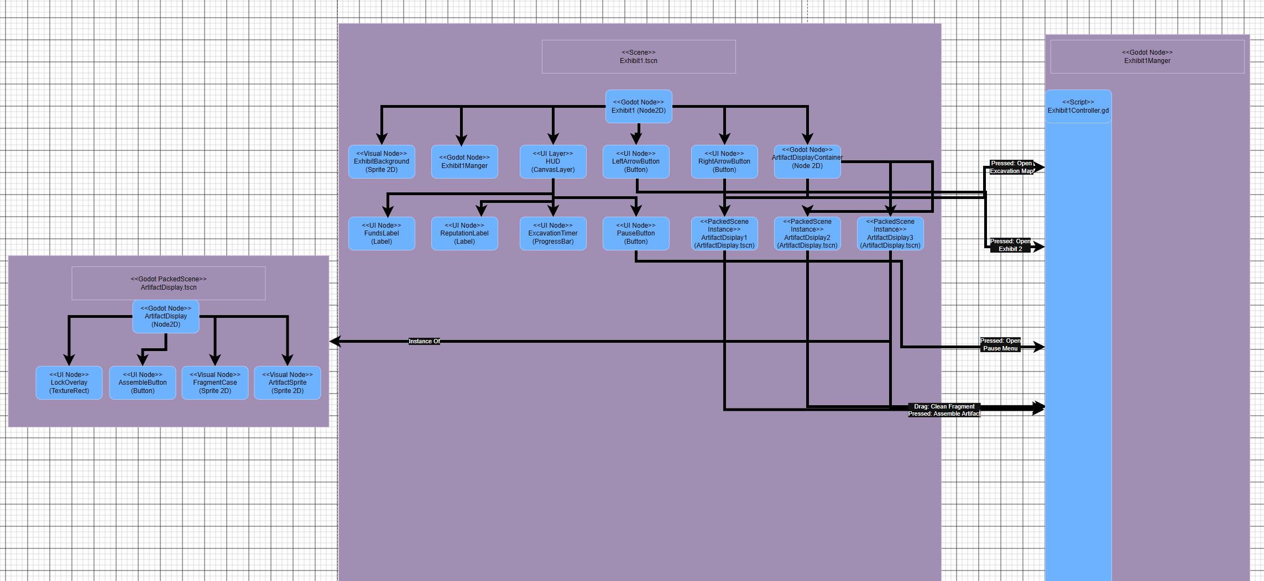
Figure 20. Exhibit 1 Game Object / Component Diagram

Exhibit 2
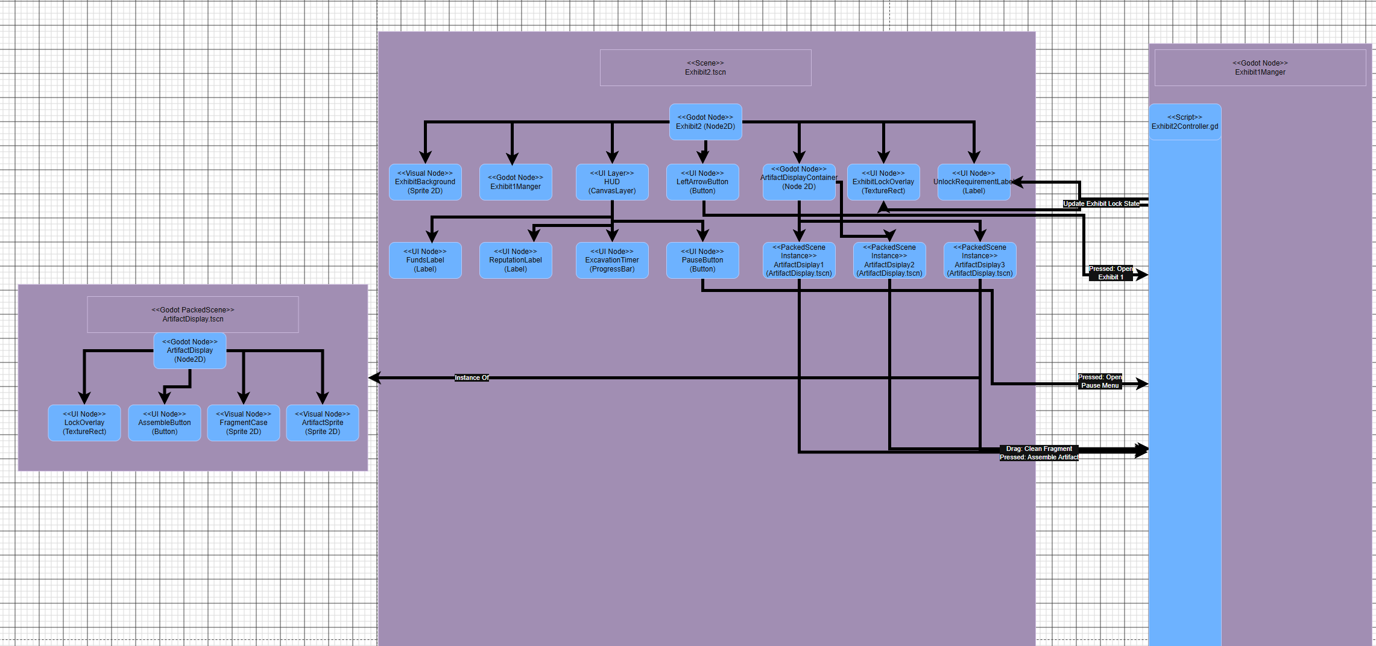
Figure 21. Exhibit 2 Game Object / Component Diagram

Excavation Menu
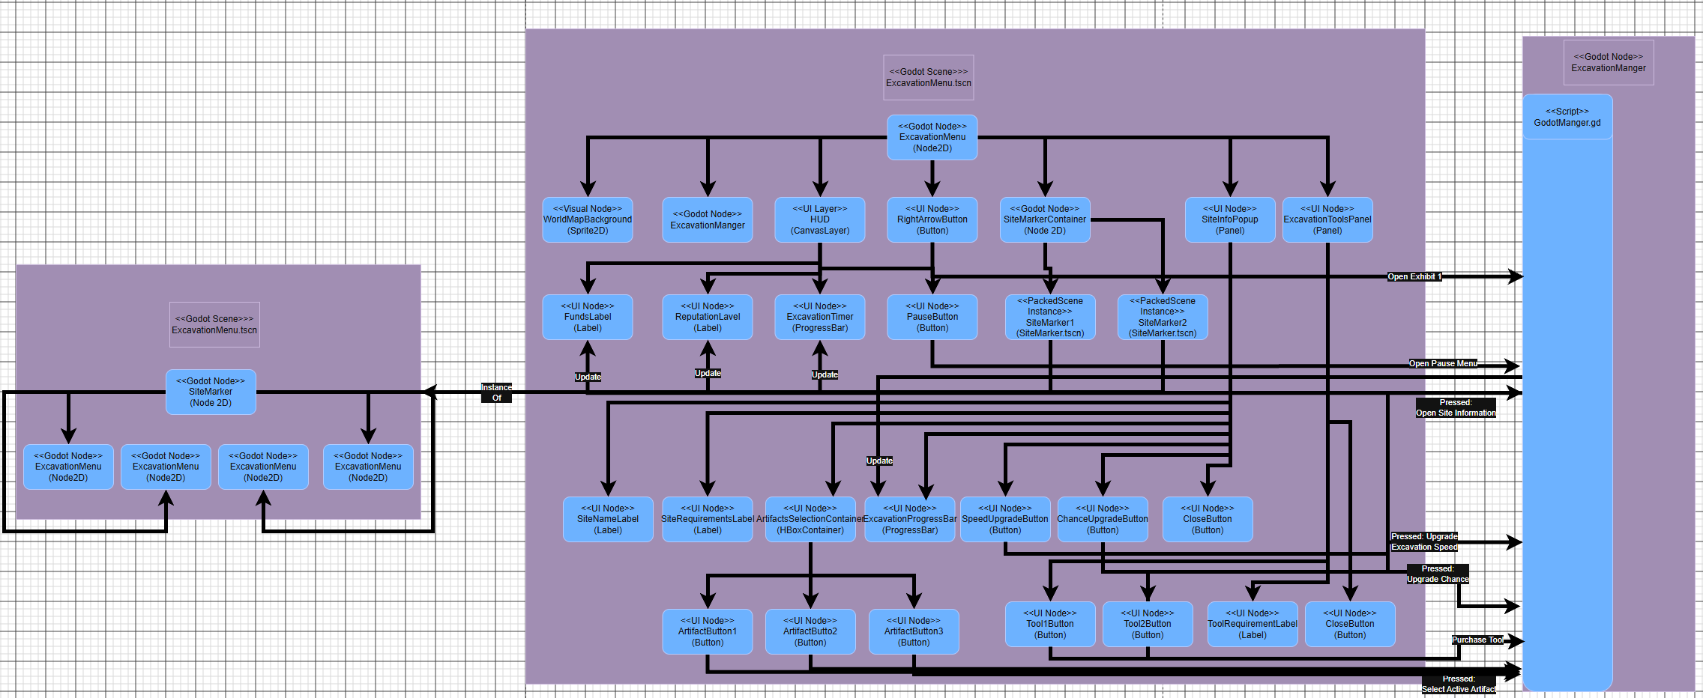
Figure 22. Excavation Menu Game Object / Component Diagram

Win Menu
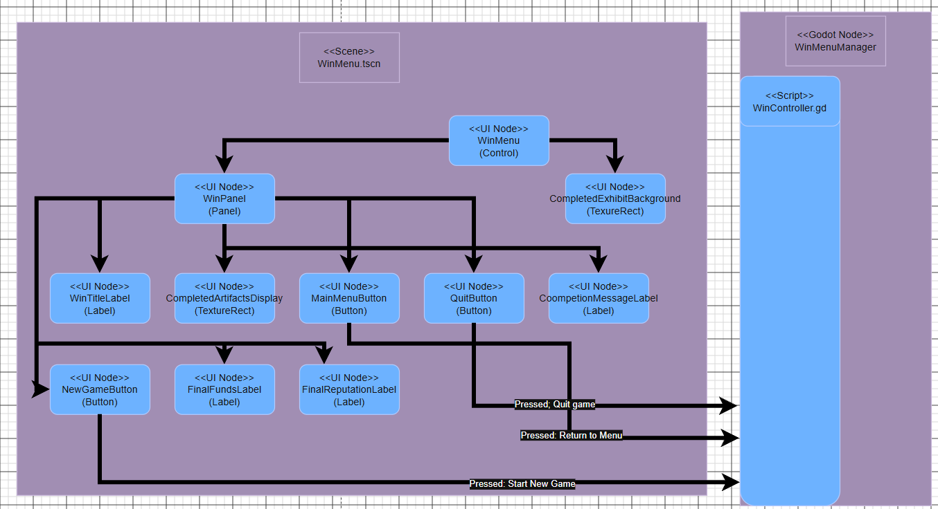
Figure 23. Win Menu Game Object / Component Diagram

Pause Menu
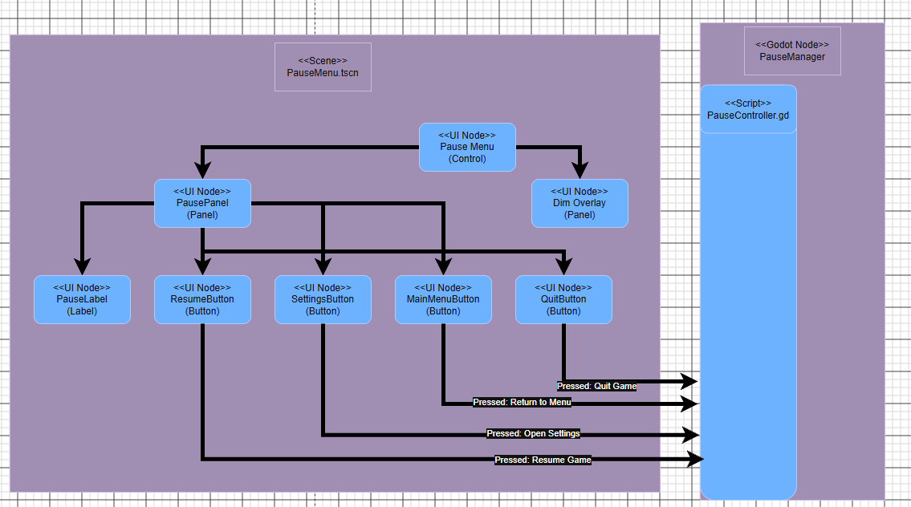
Figure 24. Pause Menu Game Object / Component Diagram

2.6.7 Settings Menu
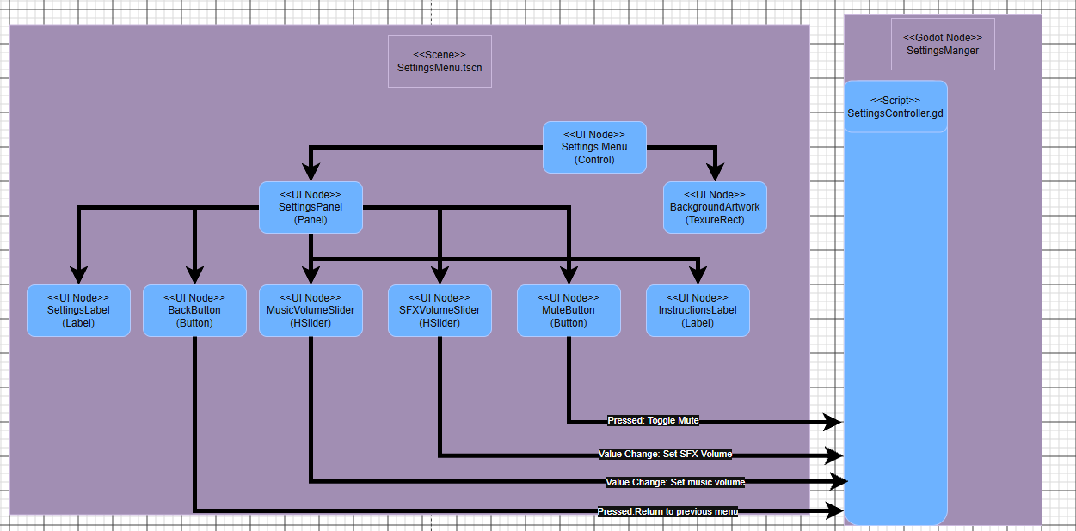
Figure 25. Settings Menu Game Object / Component Diagram

2.7 Game Object List

2.7.1 Game State
Game State (Autoload)
Description | Stores the player’s funds, reputation, artifact progress, unlocked tools, site unlocks, and active excavation data across scenes.
Tags | Game Data; Persistent
Required  Components | Node  GameState.gd
Related Game Objects
Parent | n/a - Autoload
Children | n/a
Associations | All scene managers
Comments | Keeps progress when the player changes scenes.

2.7.2 Main Menu Manager
Main Menu Manager
Description | Controls the Main Menu scene and processes menu-button input.
Tags | Menu; Manager
Required  Components | Node  MainMenuController.gd
Related Game Objects
Parent | MainMenu
Children | n/a
Associations | Main Menu UI  Settings Menu  Exhibit 1  Game State
Comments | Opens the selected menu, starts a new game, or exits the game.

2.7.3 Main Menu UI
Main Menu UI
Description | The visual Main Menu interface.
Tags | UI; Menu
Required  Components | Control  TextureRect  Label  VBoxContainer
Related Game Objects
Parent | MainMenu
Children | TitleLabel  BackgroundArtwork  ButtonContainer  StartButton  SettingsButton  QuitButton
Associations | MainMenuManager
Comments | ButtonContainer organizes the menu buttons vertically.

2.7.4 Menu Music
Menu Music
Description | Plays the background music used on the Main Menu.
Tags | Audio; Menu
Required  Components | AudioStreamPlayer  Menu music audio file
Related Game Objects
Parent | MainMenu
Children | n/a
Associations | MainMenuManager  Settings Menu audio controls
Comments | Volume can be changed through the Settings Menu.

2.7.5 Settings Manager
Settings Manager
Description | Controls settings changes and returns the player to the menu that opened Settings.
Tags | Menu; Manager; Settings
Required  Components | Node  SettingsController.gd
Related Game Objects
Parent | SettingsMenu
Children | n/a
Associations | Settings UI  Main Menu  Pause Menu  Audio buses
Comments | Applies music and sound-effect volume changes.

2.7.6 Settings UI
Settings UI
Description | Displays the settings controls and basic instructions.
Tags | UI; Settings
Required  Components | Control  Panel  Label  HSlider  Button
Related Game Objects
Parent | SettingsMenu
Children | BackgroundArtwork  SettingsPanel  SettingsLabel  MusicVolumeSlider  SFXVolumeSlider  MuteButton  InstructionsLabel  BackButton
Associations | SettingsManager
Comments | BackButton returns to either Main Menu or Pause Menu.

2.7.7 Exhibit 1 Manager
Exhibit 1 Manager
Description | Controls Exhibit 1 artifact cleaning, assembly, passive donations, and navigation.
Tags | Gameplay; Manager; Exhibit 1
Required  Components | Node  Exhibit1Controller.gd
Related Game Objects
Parent | Exhibit1
Children | n/a
Associations | HUD  ArtifactDisplay  Game State  Exhibit 2  Excavation Menu  Pause Menu
Comments | Controls the first three artifacts and the Area 1 exhibit.

2.7.8 Exhibit 1 Background
Exhibit 1 Background
Description | The pixel-art museum environment displayed behind Exhibit 1’s artifacts.
Tags | Visual; Museum; Exhibit 1
Required  Components | Sprite2D  Exhibit background texture
Related Game Objects
Parent | Exhibit1
Children | n/a
Associations | Exhibit1Manager
Comments | Contains the visual exhibit cases and museum setting.

2.7.9 HUD
HUD
Description | Displays the player’s funds, reputation, active excavation timer, and pause control.
Tags | UI; Gameplay
Required  Components | CanvasLayer  Control  Label  ProgressBar  Button
Related Game Objects
Parent | Exhibit 1, Exhibit 2, or Excavation Menu
Children | FundsLabel  ReputationLabel  ExcavationTimer  PauseButton
Associations | Scene managers  Game State  Pause Menu
Comments | Reused in all gameplay scenes.

2.7.10 Exhibit Navigation Buttons
Exhibit Navigation Buttons
Description | Allows the player to move between museum exhibits and the Excavation Menu.
Tags | UI; Navigation
Required  Components | Button  Arrow-button texture
Related Game Objects
Parent | Exhibit 1, Exhibit 2, or Excavation Menu
Children | LeftArrowButton and/or RightArrowButton
Associations | Exhibit1Manager  Exhibit2Manager  ExcavationManager
Comments | Only valid navigation arrows are visible in each scene.

2.7.11 Artifact Display
Artifact Display (Godot PackedScene)
Description | A reusable display case for a single artifact and its fragments.
Tags | Gameplay; Artifact; Museum
Required  Components | Node2D  Artifact display controller connection
Related Game Objects
Parent | ArtifactDisplayContainer
Children | ArtifactSprite  FragmentCase  AssembleButton  LockOverlay
Associations | Exhibit1Manager  Exhibit2Manager  Game State
Comments | ArtifactDisplay.tscn. Instanced six times, once for each artifact.

2.7.12 Artifact Sprite
Artifact Sprite
Description | Shows an artifact’s visual state, from fragments to a completed museum display.
Tags | Visual; Artifact
Required  Components | Sprite2D  Artifact sprite-sheet or texture
Related Game Objects
Parent | ArtifactDisplay
Children | n/a
Associations | ArtifactDisplay  Exhibit manager
Comments | Uses the completed-artifact sprite after the assembly animation.

2.7.13 Fragment Case
Fragment Case
Description | Holds uncleaned and cleaned artifact fragments before assembly.
Tags | Visual; Gameplay; Artifact
Required  Components | Sprite2D  Cleaning interaction area
Related Game Objects
Parent | ArtifactDisplay
Children | n/a
Associations | ArtifactDisplay  Exhibit manager
Comments | Fragments earn small passive donations before assembly.

2.7.14 Assemble Button
Assemble Button
Description | Starts the artifact assembly animation after all fragments are cleaned.
Tags | UI; Gameplay; Artifact
Required  Components | Button
Related Game Objects
Parent | ArtifactDisplay
Children | n/a
Associations | ArtifactDisplay  Exhibit manager  Game State
Comments | Disabled until every collected fragment is clean.

2.7.15 Exhibit 2 Manager
Exhibit 2 Manager
Description | Controls Exhibit 2’s lock state, artifact displays, cleaning, assembly, and navigation.
Tags | Gameplay; Manager; Exhibit 2
Required  Components | Node  Exhibit2Controller.gd
Related Game Objects
Parent | Exhibit2
Children | n/a
Associations | HUD  ArtifactDisplay  Game State  Exhibit 1  Pause Menu
Comments | Controls the three Area 2 artifacts.

2.7.16 Exhibit 2 Lock UI
Exhibit 2 Lock UI
Description | Shows that Exhibit 2 is locked and displays the requirement needed to unlock it.
Tags | UI; Lock; Exhibit 2
Required  Components | TextureRect  Label
Related Game Objects
Parent | Exhibit2
Children | ExhibitLockOverlay  UnlockRequirementLabel
Associations | Exhibit2Manager  Game State
Comments | The player may view this scene before it is unlocked but cannot interact with artifacts.

2.7.17 Excavation Manager
Excavation Manager
Description | Controls the map, selected site, active artifact, excavation upgrades, and Excavation Tool purchases.
Tags | Gameplay; Manager; Excavation
Required  Components | Node  ExcavationController.gd
Related Game Objects
Parent | ExcavationMenu
Children | n/a
Associations | World Map  Site Marker  Site Information Panel  Excavation Tools Panel  HUD  Game State
Comments | Updates site locks, alerts, timers, and artifact availability.

2.7.18 World Map
World Map
Description | Displays the stylized map containing the two archaeological-site markers.
Tags | Visual; Gameplay; Map
Required  Components | Sprite2D  World-map texture
Related Game Objects
Parent | ExcavationMenu
Children | SiteMarkerContainer
Associations | ExcavationManager  Site Marker
Comments | Acts as the Excavation Menu background.

2.7.19 Site Marker
Site Marker (Godot PackedScene)
Description | A reusable clickable world-map marker representing one archaeological site.
Tags | Gameplay; Map; Excavation
Required  Components | Node2D  TextureButton  Sprite2D
Related Game Objects
Parent | SiteMarkerContainer
Children | MarkerButton  MarkerSprite  LockOverlay  AlertIcon
Associations | ExcavationManager  Site Information Panel  Game State
Comments | SiteMarker.tscn. Instanced twice, once for each site.

2.7.20 Site Information Panel
Site Information Panel
Description | Shows the selected site’s requirements, three artifact choices, excavation progress, and upgrade controls.
Tags | UI; Gameplay; Excavation
Required  Components | Panel  Label  HBoxContainer  TextureButton  ProgressBar  Button
Related Game Objects
Parent | ExcavationMenu
Children | SiteNameLabel  SiteRequirementsLabel  ArtifactSelectionContainer  ArtifactButton1-3  ExcavationProgressBar  SpeedUpgradeButton  ChanceUpgradeButton  CloseButton
Associations | ExcavationManager  Site Marker  Game State
Comments | The player chooses the active artifact and purchases that site’s upgrades here.

2.7.21 Excavation Tools Panel
Excavation Tools Panel
Description | Lets the player purchase Excavation Tool 1 and Excavation Tool 2.
Tags | UI; Gameplay; Tools
Required  Components | Panel  Button  Label
Related Game Objects
Parent | ExcavationMenu
Children | Tool1Button  Tool2Button  ToolRequirementLabel  CloseButton
Associations | ExcavationManager  Game State  Exhibit 1  Exhibit 2
Comments | Tools require sufficient funds and reputation.

2.7.22 Pause Menu Manager
Pause Menu Manager
Description | Pauses gameplay and controls the actions selected on the Pause Menu.
Tags | Menu; Manager; Pause
Required  Components | Node  PauseController.gd
Related Game Objects
Parent | PauseMenu
Children | n/a
Associations | Pause Menu UI  Settings Menu  Main Menu  Current gameplay scene  Game State
Comments | Can be opened from Exhibit 1, Exhibit 2, or the Excavation Menu.

2.7.23 Pause Menu UI
Pause Menu UI
Description | Provides controls to resume, open settings, return to the Main Menu, or quit while gameplay is paused.
Tags | UI; Menu; Pause
Required  Components | Control  Panel  ColorRect or Panel  Label  Button
Related Game Objects
Parent | PauseMenu
Children | DimOverlay  PausePanel  PauseLabel  ResumeButton  SettingsButton  MainMenuButton  QuitButton
Associations | PauseMenuManager
Comments | DimOverlay darkens the gameplay scene behind the menu.

2.7.24 Win Menu Manager
Win Menu Manager
Description | Controls the completion screen after all six artifacts have been assembled.
Tags | Menu; Manager; Win
Required  Components | Node  WinController.gd
Related Game Objects
Parent | WinScreen
Children | n/a
Associations | Win Menu UI  Game State  Exhibit 1  Main Menu
Comments | Opens a new game, returns to Main Menu, or quits.

2.7.25 Win Menu UI
Win Menu UI
Description | Displays the completed museum, final player progress, and post-game controls.
Tags | UI; Menu; Win
Required  Components | Control  Panel  TextureRect  Label  Button
Related Game Objects
Parent | WinScreen
Children | BackgroundArtwork  WinPanel  WinTitleLabel  CompletedArtifactsDisplay  CompletionMessageLabel  FinalFundsLabel  FinalReputationLabel  NewGameButton  MainMenuButton  QuitButton
Associations | WinMenuManager  Game State
Comments | Only appears after all six artifacts are assembled.

2.8 Component List

2.8.1 GameState.gd
GameState.gd (Custom)
Description | Stores persistent game data, including funds, reputation, artifact progress, tools, site unlocks, and the active excavation.
Requires | Node
Comments | Configured as a Godot Autoload so every scene manager can access the same progress data.

2.8.2 MainMenuController.gd
MainMenuController.gd (Custom)
Description | Handles Main Menu button input and changes to the selected scene.
Requires | MainMenu  Game State
Comments | Starts a new game, opens Settings, and quits the application.

2.8.3 SettingsController.gd
SettingsController.gd (Custom)
Description | Controls the settings menu and applies the player’s audio preferences.
Requires | SettingsMenu  Godot audio buses
Comments | Updates music volume, sound-effect volume, mute state, and Back button destination.

2.8.4 Exhibit1Controller.gd
Exhibit1Controller.gd (Custom)
Description | Controls Exhibit 1 fragment cleaning, artifact assembly, passive donations, and navigation.
Requires | Exhibit1  ArtifactDisplay instances  Game State
Comments | Updates the HUD and locks the third Area 1 artifact until Tool 1 is purchased.

2.8.5 Exhibit2Controller.gd
Exhibit2Controller.gd (Custom)
Description | Controls Exhibit 2 lock state, artifact displays, cleaning, assembly, and navigation.
Requires | Exhibit2  ArtifactDisplay instances  Game State
Comments | Enables the exhibit after its unlock requirement is met and applies tool restrictions.

2.8.6 ExcavationController.gd
ExcavationController.gd (Custom)
Description | Controls site selection, active-artifact selection, excavation progress, upgrades, and Excavation Tool purchases.
Requires | ExcavationMenu  SiteMarker instances  SiteInfoPopup  ExcavationToolsPanel  Game State
Comments | Updates marker locks, alert icons, artifact availability, funds, reputation, and timers.

2.8.7 PauseController.gd
PauseController.gd (Custom)
Description | Pauses and resumes gameplay and handles Pause Menu controls.
Requires | PauseMenu  Current gameplay scene  Game State
Comments | Opens Settings, returns to Main Menu, resumes gameplay, or quits the game.

2.8.8 WinController.gd
WinController.gd (Custom)
Description | Controls the Win Screen after all six artifacts are assembled.
Requires | WinScreen  Game State
Comments | Displays final progress and handles New Game, Main Menu, and Quit buttons.

2.8.9 Node
Node (Provided by Godot)
Description | A basic Godot node used for non-visual organization and manager objects.
Requires | Godot Engine
Comments | Used for GameState and scene managers that do not need a visual position or interface.

2.8.10 Node2D
Node2D (Provided by Godot)
Description | A 2D node with position, rotation, and scale.
Requires | Godot Engine
Comments | Used as the root for exhibits, Excavation Menu, ArtifactDisplay, and SiteMarker objects.

2.8.11 Control
Control (Provided by Godot)
Description | A base node for interface elements that supports anchors, layout, and input.
Requires | Godot Engine
Comments | Used as the root for menu interfaces and as the basis for UI elements.

2.8.12 CanvasLayer
CanvasLayer (Provided by Godot)
Description | Draws child interface elements above the 2D game world.
Requires | Godot Engine
Comments | Used for the HUD so its values remain visible over gameplay scenes.

2.8.13 Sprite2D
Sprite2D (Provided by Godot)
Description | Displays a 2D texture or sprite in the game world.
Requires | Godot Engine  Image texture or sprite sheet
Comments | Used for museum backgrounds, artifact sprites, fragment cases, map markers, and alert icons.

2.8.14 TextureRect
TextureRect (Provided by Godot)
Description | Displays and scales a texture as a user-interface element.
Requires | Godot Engine  Image texture
Comments | Used for menu artwork and locked-overlay visuals.

2.8.15 Label
Label (Provided by Godot)
Description | Displays text in the user interface.
Requires | Godot Engine  Font resource
Comments | Used for titles, funds, reputation, requirements, instructions, and completion messages.

2.8.16 Button and TextureButton
Button and TextureButton (Provided by Godot)
Description | Interface controls that emit a pressed signal when clicked. Button uses text; TextureButton uses an image.
Requires | Godot Engine
Comments | Used for menus, navigation arrows, artifact selections, upgrades, tools, pause controls, and assembly actions.

2.8.17 Panel and ColorRect
Panel and ColorRect (Provided by Godot)
Description | Interface elements used to create popup windows, menu backgrounds, and screen-darkening overlays.
Requires | Godot Engine
Comments | Panels are used for site information, tools, settings, pause, and win menus.

2.8.18 VBoxContainer and HBoxContainer
VBoxContainer and HBoxContainer (Provided by Godot)
Description | Layout nodes that automatically arrange child controls vertically or horizontally.
Requires | Godot Engine
Comments | VBoxContainer organizes Main Menu buttons; HBoxContainer organizes artifact-selection buttons.

2.8.19 ProgressBar
ProgressBar (Provided by Godot)
Description | Displays a value as a visual progress bar.
Requires | Godot Engine
Comments | Used for the active excavation timer and selected-site progress.

2.8.20 HSlider
HSlider (Provided by Godot)
Description | Lets the player choose a numeric value by dragging a slider handle.
Requires | Godot Engine
Comments | Used for music and sound-effect volume settings.

2.8.21 AudioStreamPlayer
AudioStreamPlayer (Provided by Godot)
Description | Plays an audio file in a Godot scene.
Requires | Godot Engine  Audio stream file
Comments | Used to play Main Menu music and controlled through Settings.

2.8.22 PackedScene
PackedScene (Provided by Godot)
Description | A reusable saved Godot scene that can be instanced multiple times.
Requires | Godot Engine  .tscn scene file
Comments | Used for ArtifactDisplay.tscn and SiteMarker.tscn.

2.8.23 AnimationPlayer
AnimationPlayer (Provided by Godot)
Description | Plays timed property and sprite animations.
Requires | Godot Engine  Animation tracks
Comments | Used for the artifact assembly animation, where fragments rise, rotate, snap together, and drop into the display.

Art List

Static 2D Assets

2.9.1.1 Main Menu Background
Main Menu Background
Description | Pixel art title image for Piece by Piece. It shows the museum building against a blue sky and is used on the title page and Main Menu.
Format | PNG RGBA, 1920 x 1080p
Comments | Static Background  Menu Buttons and title render above this image
Concept Art | Figure 10, Overview image

2.9.1.2 Main Menu Title Splash
Main Menu Title Splash
Description | Stylized font for main menu displaying the name of the game.
Format | PNG RGBA, approx 512 x 256p
Comments | Static image with transparent background  Rendered over the main menu background
Concept Art | Figure 10, Overview Image

2.9.1.3 Exhibit Backgrounds
Exhibit Backgrounds
Description | Pixel art Museum rooms containing pedestals, artifact cases, lighting, and exhibit overlays. There should be one for each of the 2 rooms in different styles.
Format | PNG RGBA 1920 x 1080p. Two files
Comments | Static background art
Concept Art | Figure 8

2.9.1.4 World Map Background
World Map Background
Description | Stylized pixel art world map for the excavation menu. Displays locations of the archaeological sites.
Format | PNG RGBA, 1920 x 1080p
Comments | Static local background  Site markers and popup menus render over map
Concept Art | Figure 7

2.9.1.5 Fragment Case Sprites
Fragment Case Sprites
Description | Pixel art display cases that hold the uncleaned and cleaned artifact fragments before artifact assembly
Format | PNG RGBA, 128 x 128p
Comments | Static Local Sprite. A case may show fragments, empty spots, or an exclamation mark above the case when ready to assemble. Should be a variation for each of the 6 artifacts. Can use the same sprite when closed on the ground
Concept Art | Figure 4

2.9.1.6 Pedestal Sprites
Pedestal Sprites
Description | Pixel art museum pedestals used to display fully assembled artifacts
Format | PNG RGBA, 128 x 128p
Comments | Static Local sprite. Completed artifacts per 2.9.2.1 should be placed on top. Should be unique and match each of the 6 artifacts.
Concept Art

2.9.1.7 Light Overlay Sprite
Light Overlay Sprite
Description | A transparent pixel art glow overlay placed above a completed artifact to show a completed display
Format | PNG RGBA with transparent background 128 x 128p
Comments | Hidden for incomplete artifacts
Concept Art

2.9.1.8 Site Marker Sprite Sheet
Site Marker Set
Description | Clickable pixel art markers representing archaeological sites on the world map. 3 variants for locked, available and completed states.
Format | PNG RGBA sprite sheet, 32 x 32p cells
Comments | Local asset used by the reusable SiteMarker PackedScene. Includes lock, alert, and completed-gold variants
Concept Art | Figure 12

2.9.1.9 Excavation Tool Icons
Excavation Tool Icons
Description | Pixel art icons for Excavation tool 1 and Excavation tool 2, including the locked and purchased states
Format | PNG RGBA, 32 x 32p
Comments | Static local icons shown in the Excavation Tools Panel and artifact requirement displays.
Concept Art | Figure 14

2.9.1.10 HUD and UI Icon Set
HUD and UI Icon Set
Description | Pixel-art icons and UI decorations for funds, reputation, excavation timer, pause, navigation arrows, locks, alerts, and artifact-selection borders.
Format | PNG RGBA; 16 x 16, 24 x 24, and 32 x 32 pixel icons
Comments | Static local interface assets. Selection and completion borders may also be created through Godot UI styling.
Concept Art | Figures 7, 8, 10, and 14

2.9.1.11 UI Panels and Buttons
UI Panels and Buttons
Description | Pixel-art panels and buttons used for menus, settings, pause controls, site information, tool purchases, and the Win Screen.
Format | PNG RGBA nine-slice panels; 32 x 32 to 128 x 128 base textures
Comments | Local UI assets. Buttons include normal, hovered, disabled, locked, and selected states where needed.
Concept Art | Figures 10, 14, 15, and 16

2.9.1.12 Win Screen Background / Completion Art
Win Screen Background / Completion Art
Description | Pixel-art final museum image showing a completed exhibit and restored artifacts behind the Win Screen controls.
Format | PNG RGBA; 1920 x 1080 pixels
Comments | Static local background used with the completion message, final funds, final reputation, and Win Screen buttons.
Concept Art | Figure 16. Win Screen

Animated 2D Assets

Artifact Assembly Animation
Artifact Assembly Animation
Description | A local pixel-art animation that plays when the player presses Assemble after cleaning every fragment of an artifact. The pieces rise from the case, rotate, snap together, and drop onto the pedestal as a completed artifact.
Format | PNG RGBA sprite sheet; 64 x 64 pixel cells; played through Godot AnimationPlayer
Animated Sequence | 1. Uncleaned Idle: fragments sit in the case with a subtle dust or shimmer effect.  2. Cleaning: fragments brighten as the player cleans them.  3. Assembly: fragments rise, rotate, snap together, and drop onto the pedestal.  4. Completed Display: the restored artifact has a brief shine/light animation.
Comments
Concept Art

Audio Assets

Music Assets

2.10.1.1 Museum Theme
Museum Theme
Description | A calm looping instrumental tract that plays in the main menu, museum exhibits, and excavation.
Format | OGG, Stereo, 1-2 minutes, seamless loop
Comments | Probably use midi sounds to complement the pixel art
Concept Art

Sound Effect Assets

2.10.2.1 UI Button Click
UI Button Click
Description | A short click sounds when the player selects a button, arrow, marker, or menu option
Format | OGG, mono, under a second
Comments | Used through menus  Maybe record keyboard sound
Concept Art

2.10.2.2 Excavation Attempt
Excavation Attempt
Description | A short brushing sound when an excavation attempt begins
Format | OGG, mono, about a second
Comments | Plays when the player selects a new valid artifact
Concept Art

2.10.2.3 Fragment Found
Fragment Found
Description | A positive sounding chime played when an excavation attempt is successful
Format | OGG, mono, about a second
Comments
Concept Art

2.10.2.4 Excavation Failure
Excavation Failure
Description | A soft coin clanking sound to indicate that the player got money from the excavation instead of a fragment
Format | OGG, mono, about a second
Comments
Concept Art

2.10.2.5 Fragment Cleaning
Fragment Cleaning
Description | A gentle polishing sound played while the player cleans a fragment
Format | OGG, mono, short looping sound
Comments | Stops when cleaning ends
Concept Art

2.10.2.6 Upgrade / Tool Purchase
Upgrade / Tool Purchase
Description | A purchase confirmation sound played when the player buys an upgrade or tool
Format | OGG, mono, about a second
Comments
Concept Art

2.10.2.7 Artifact Assembly
Artifact Assembly
Description | A layerd ceramic sound that playes as the fragments rise, rotate and snap together
Format | OGG, mono, 3-4 seconds
Comments | Maybe add some extra sounds to the end once the artifact finished
Concept Art

2.10.2.8 Exhibit Completion
Exhibit Completion
Description | A longer chime or fanfare that plays when an exhibit is completed
Format | OGG, mono, 3-4 seconds
Comments | Should make the player feel like they are progressing well
Concept Art

3.0 Task list

Week | Team Tasks | Programming Tasks | Art/Audio Tasks | Testing  TODO
Week00 | • Finish and submit the Game Design Document  • Create project schedule  • Learn basic Godot workflow and node structure | • Create the Godot project and organize folders  • Configure game window and input settings  • Create small test scenes to practice Buttons, Control nodes, scene changes, timers, and AnimationPlayer  • Experiment with the museum/excavation concept in Godot | • Create initial concept art for museum exhibits and excavation map  • Experiment with pixel-art style in Pixelorama  • Plan artifact, pedestal, fragment-case, and UI asset sizes | N/A
Week01 | • Review project scope and update tasks if needed | • Create Main Menu, Settings, Pause, Exhibit 1, Exhibit 2, Excavation Menu, and Win scenes  • Implement scene navigation and navigation arrows  • Create HUD structure for funds, reputation, excavation timer, and pause button  • Create basic game-state variables for funds, reputation, artifacts, and unlock requirements | • Main Menu background and title splash  • Exhibit 1 background  • Excavation Map background  • Basic UI panels, buttons, and HUD icons  • Placeholder artifact, pedestal, and fragment-case sprites | • Test every scene transition  • Test menu buttons and pause/settings navigation  • Check HUD readability at the game’s intended resolution
Week02 | • Review core loop and adjust scope if needed | • Implement archaeological site markers and artifact-selection pop-ups  • Implement excavation timer, success chance, fragment rewards, and failed-attempt funds rewards  • Implement funds and reputation display updates  • Add cleaning interaction and fragment case states  • Implement Exhibit 1’s three artifact displays | • Finalize Exhibit 1 backgrounds and display props  • Create fragment-case sprites and pedestal sprites  • Create Site Marker sprite states: available, locked, completed  • Create initial excavation and fragment sprites  • Create UI click, excavation, success, and failure sound effects | • Test excavation success/failure calculations  • Test funds rewards after failed attempts  • Test collecting and cleaning fragments  • Test Exhibit 1 artifact completion flow
Week03 | • Review progression pacing | • Implement Exhibit 2 and its locked overlay  • Add Exhibit 2 reputation requirement  • Implement excavation tool purchases and tool-gated artifacts  • Add speed and relic-chance upgrades  • Implement passive funds from incomplete and completed artifacts  • Connect all win-condition checks | • Exhibit 2 background and display props  • Tool icons and locked-artifact icons  • Lighting overlay sprites  • Create remaining artifact sprites  • Create cleaning, tool-purchase, and completion sound effects  • Create looping museum background music | • Test locked Exhibit 2 behavior  • Test tool requirements and purchases  • Test upgrades and passive-income values  • Test progression from Exhibit 1 to Exhibit 2
Week04 | • Final GDD revision  • Prepare final game build and submission materials | • Create and connect Artifact Assembly Animation using AnimationPlayer  • Finish Win Scene and final statistics display  • Fix bugs and replace remaining placeholder content  • Polish UI feedback, notifications, and scene transitions | • Finalize artifact assembly sprite sheet  • Add uncleaned idle, cleaning, assembly, and completed-display animation sequences  • Polish UI, background, pedestal, case, and lighting assets  • Balance music and sound-effect volume | • Full playthrough from beginning to Win Scene  • Balance excavation time, success chances, prices, and requirements  • Test every button, pop-up, upgrade, tool, locked state, and scene  • Check for visual layering, text readability, audio, and animation issues

