***1.Transistor circuit***

-guess and sketch the waveform of VA and VB

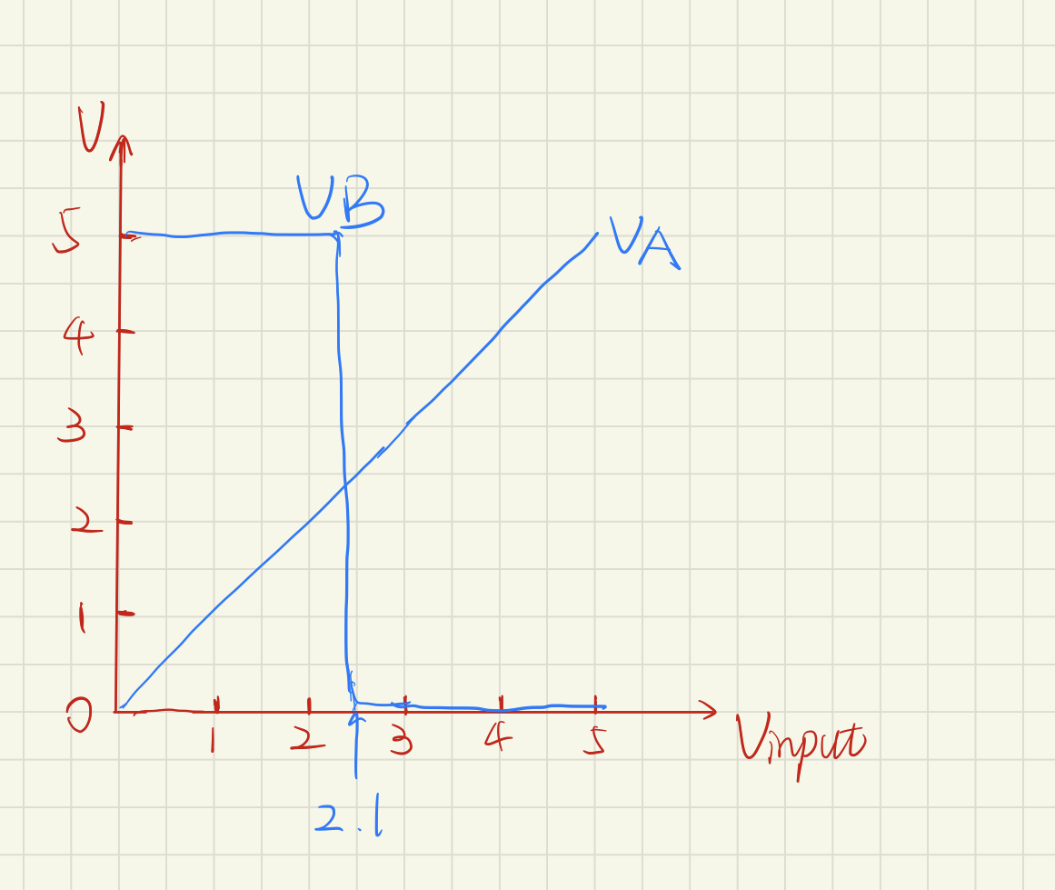

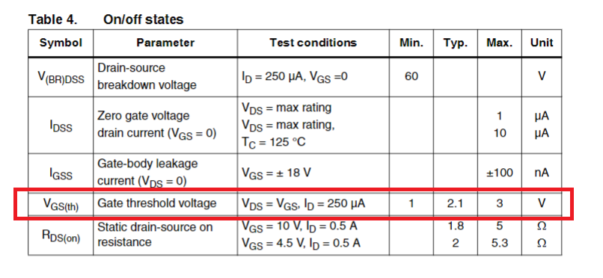

Reason:

Query the datasheet and we could find that the gate threshold voltage is about 2.1V.

VA is always almost equal to the input voltage.

When the input voltage < 2.1V, the NMOS is on, so VB=VDD=5V.

And when the input voltage > 2.1V, the NMOS is off, so VB=0V.

- Build the circuit in Multisim, use ‘DC sweep’ or ‘transient’ simulation to validate your guess.

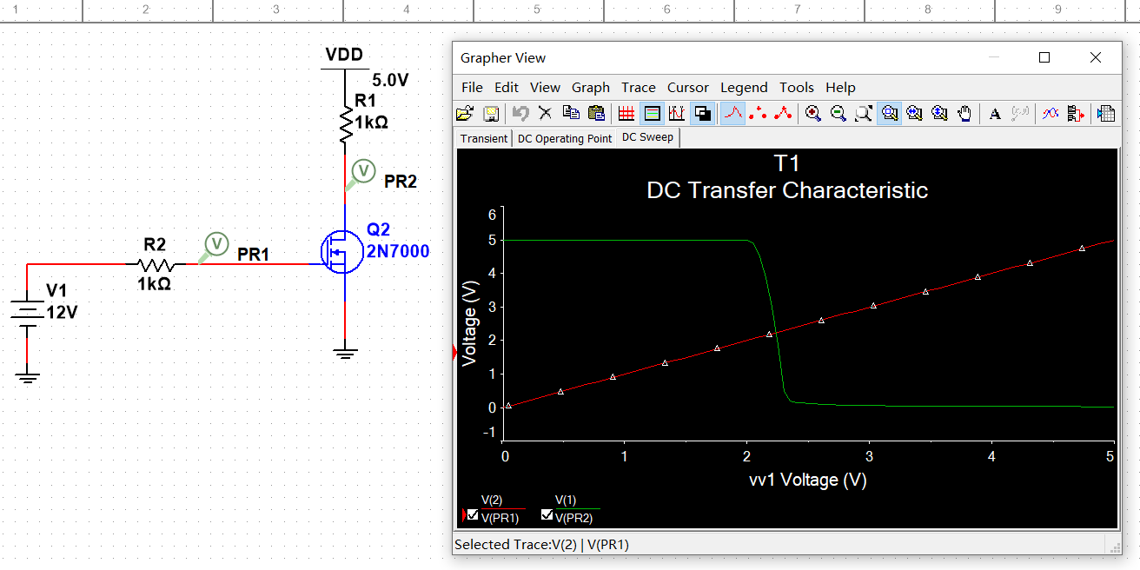

- Find the output waveform of VB, and calculate the voltage gain.

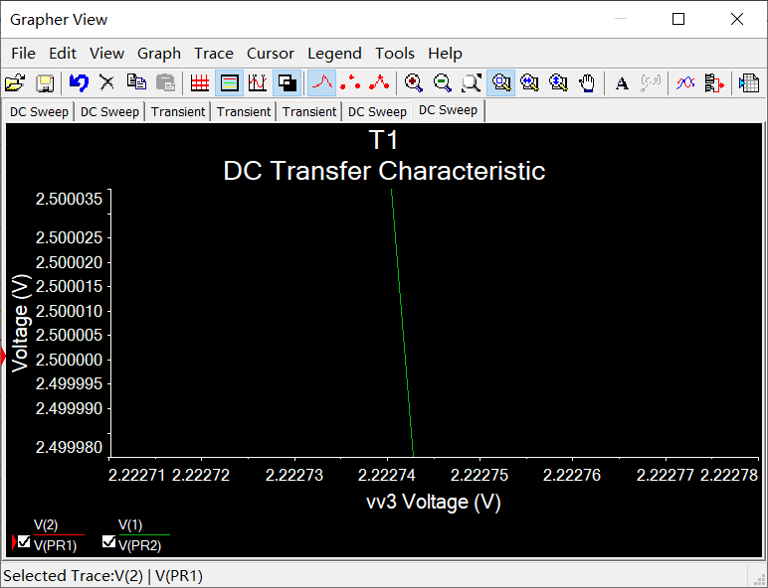

Enlarge the wave of VB, we could find that when VB≈2.5V, the input voltage≈2.222743V.

So let the input voltage=2.222743V, and print the waveform of VB.

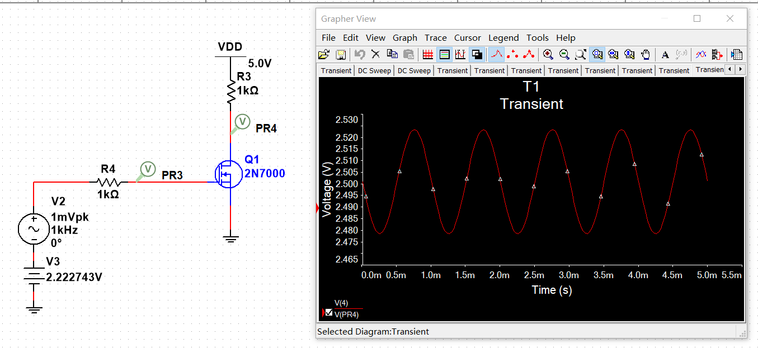

Amplitude of the VB’s wave is 2.523V-2.501V=0.022V

And the Amplitude of the peak voltage is 1mV=0.001V

So the voltage gain is (2.523-2.501)/0.001=22

The voltage gain=22.

***2.Operational amplifier***

Circuit #1

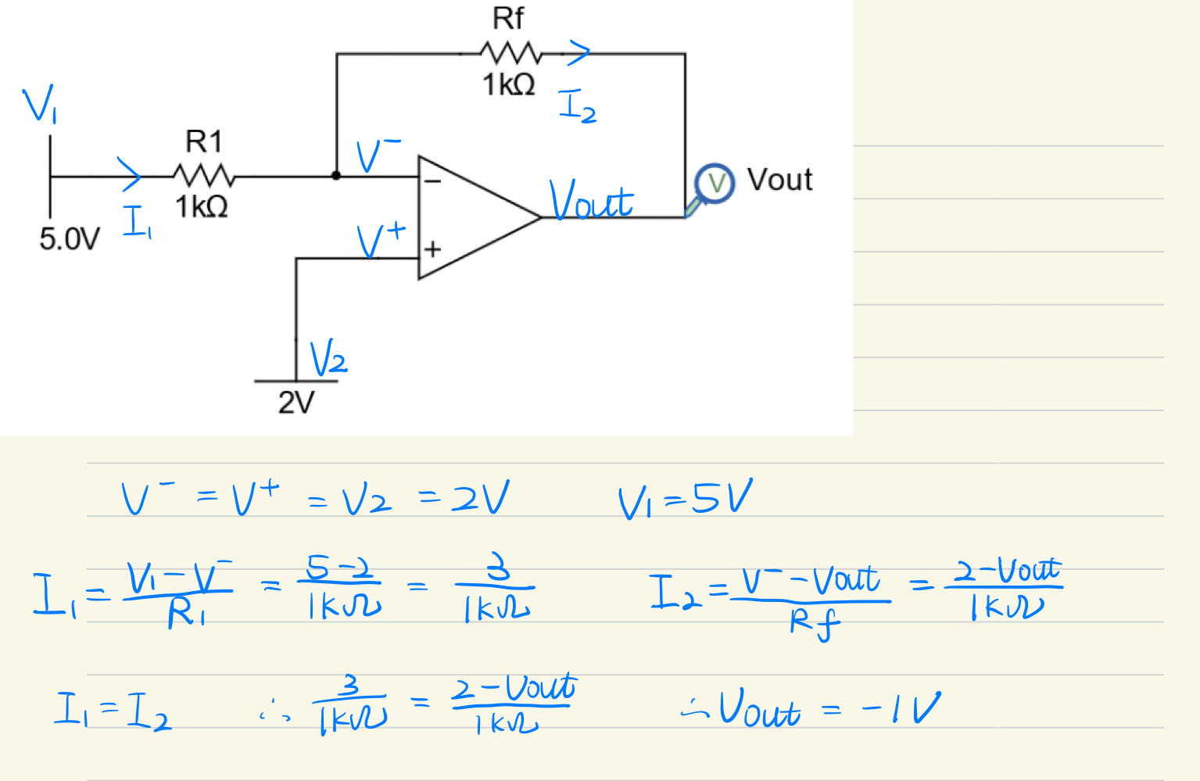

Vout=-1V

Circuit #2

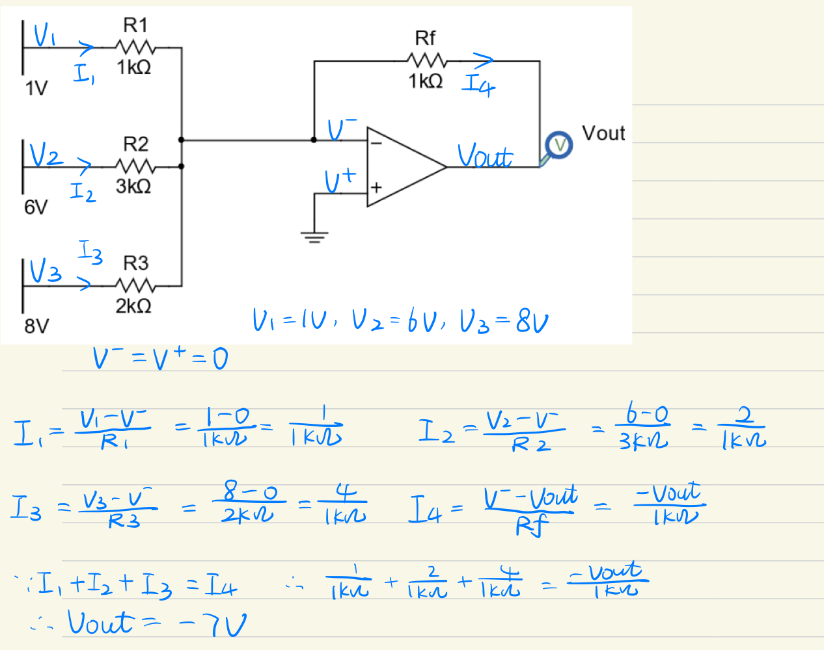

Vout=-7V

***3.Analog-to-digital converter (ADC)***

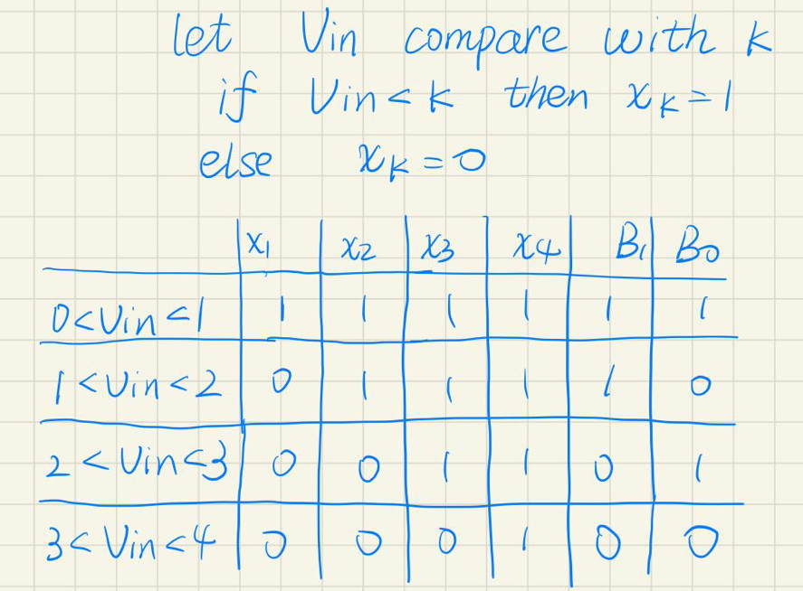

the simplifications of digital circuit:

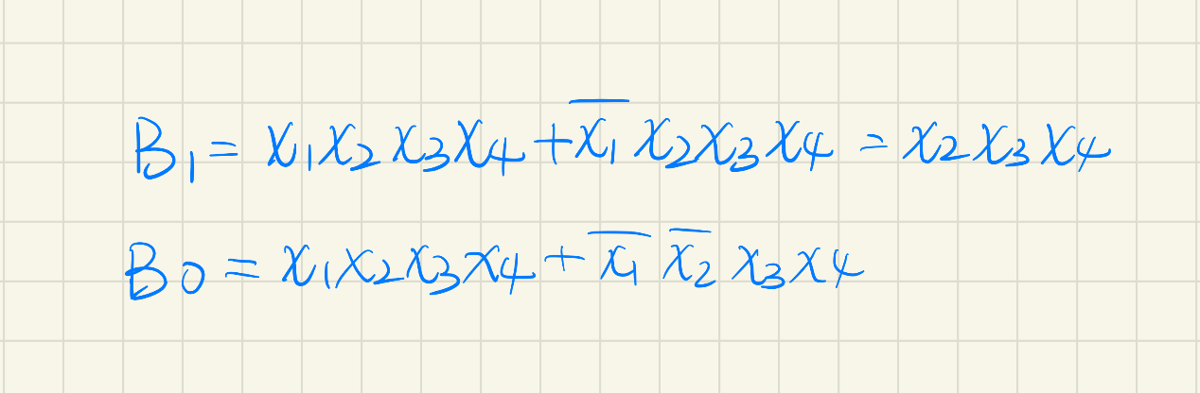

The circuit is as followed.

Change the value of Vin means the change of Vin.

If B1/B0=1, then the corresponding light will light up.

If B1/B0=0, then the corresponding light will extinguish.

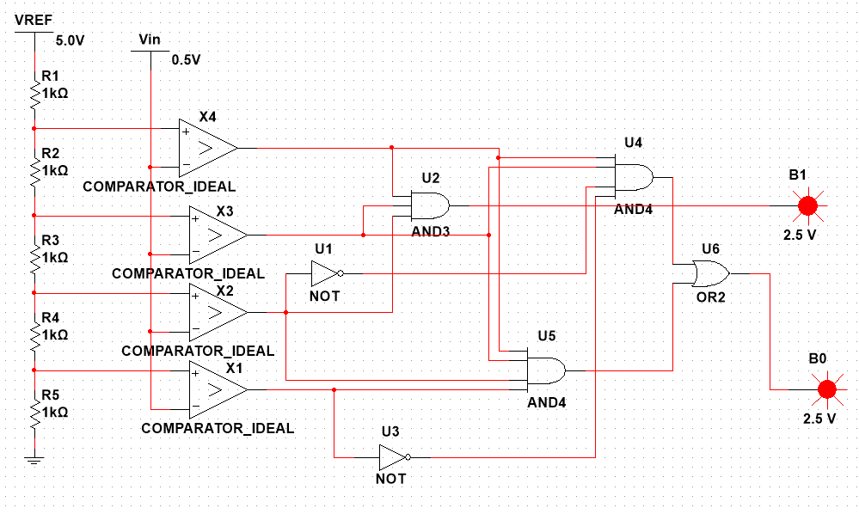

***4.MCU development***

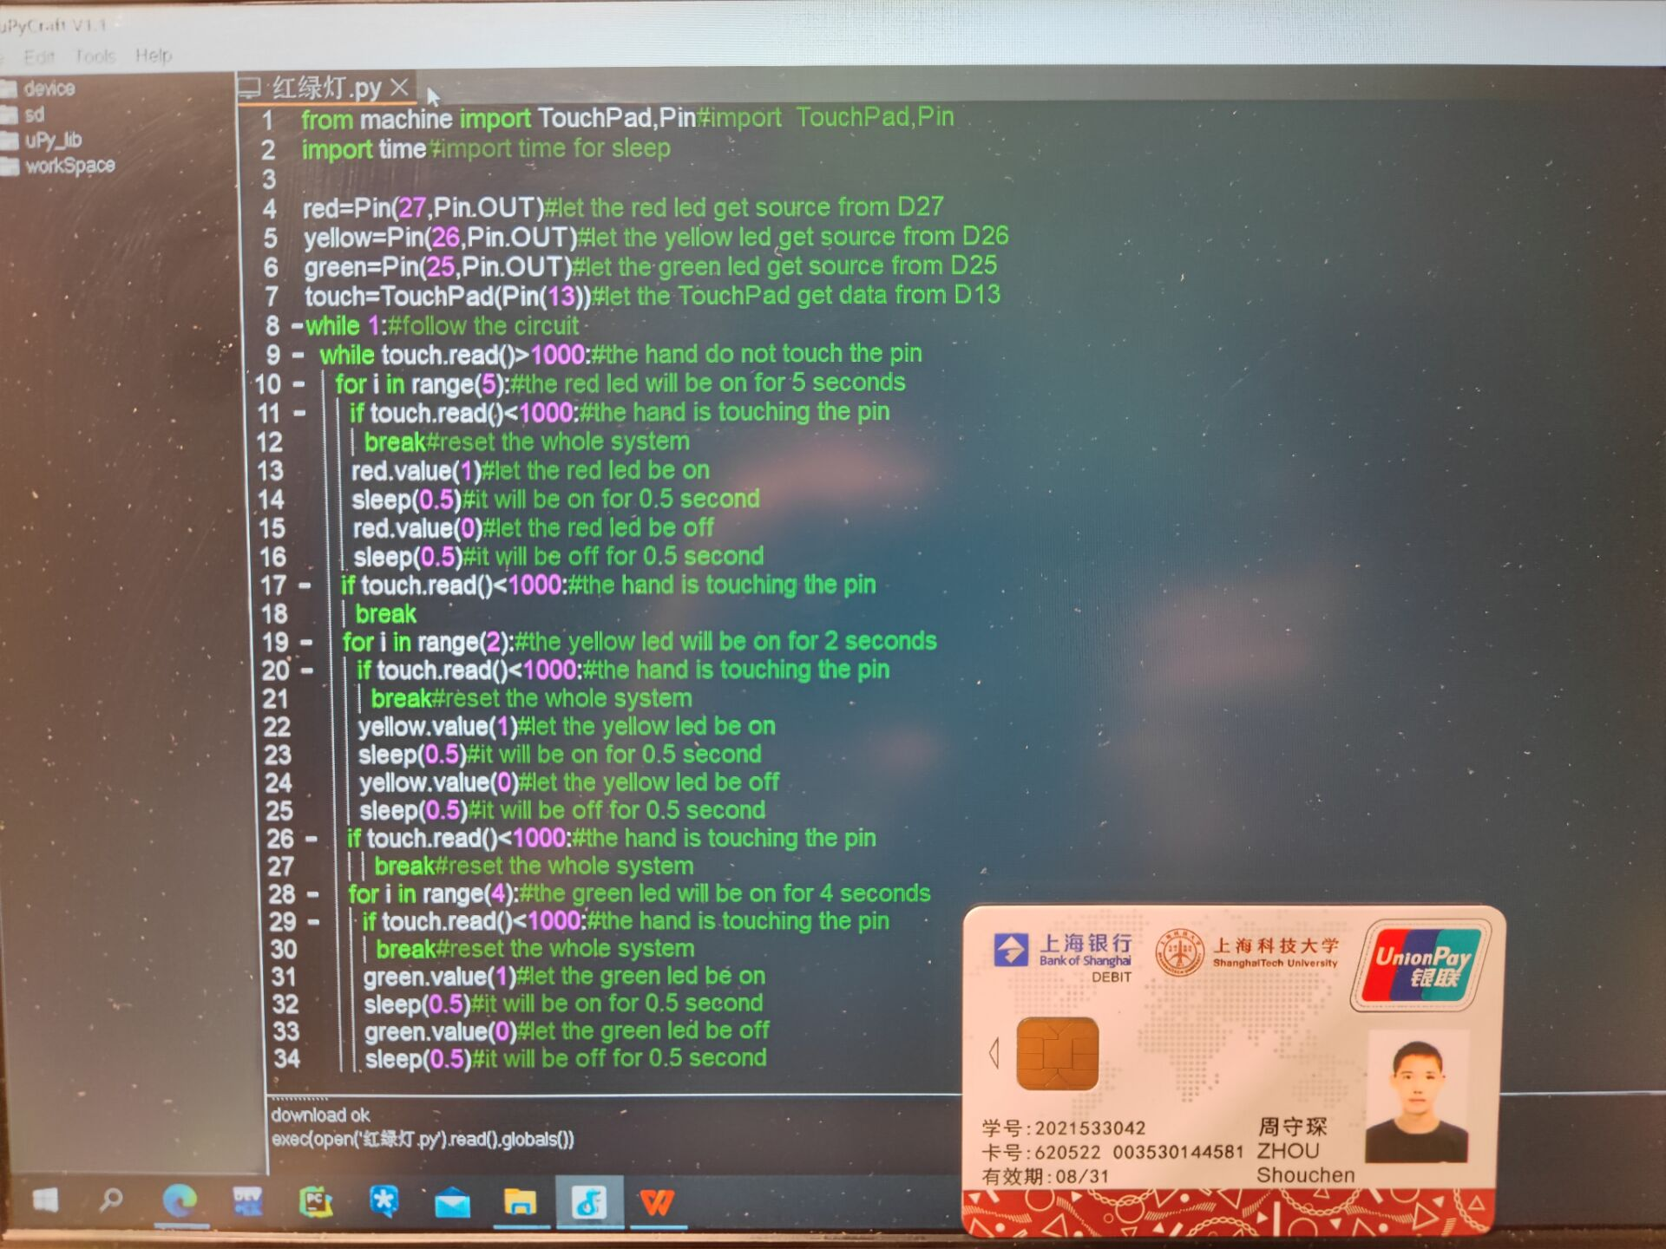

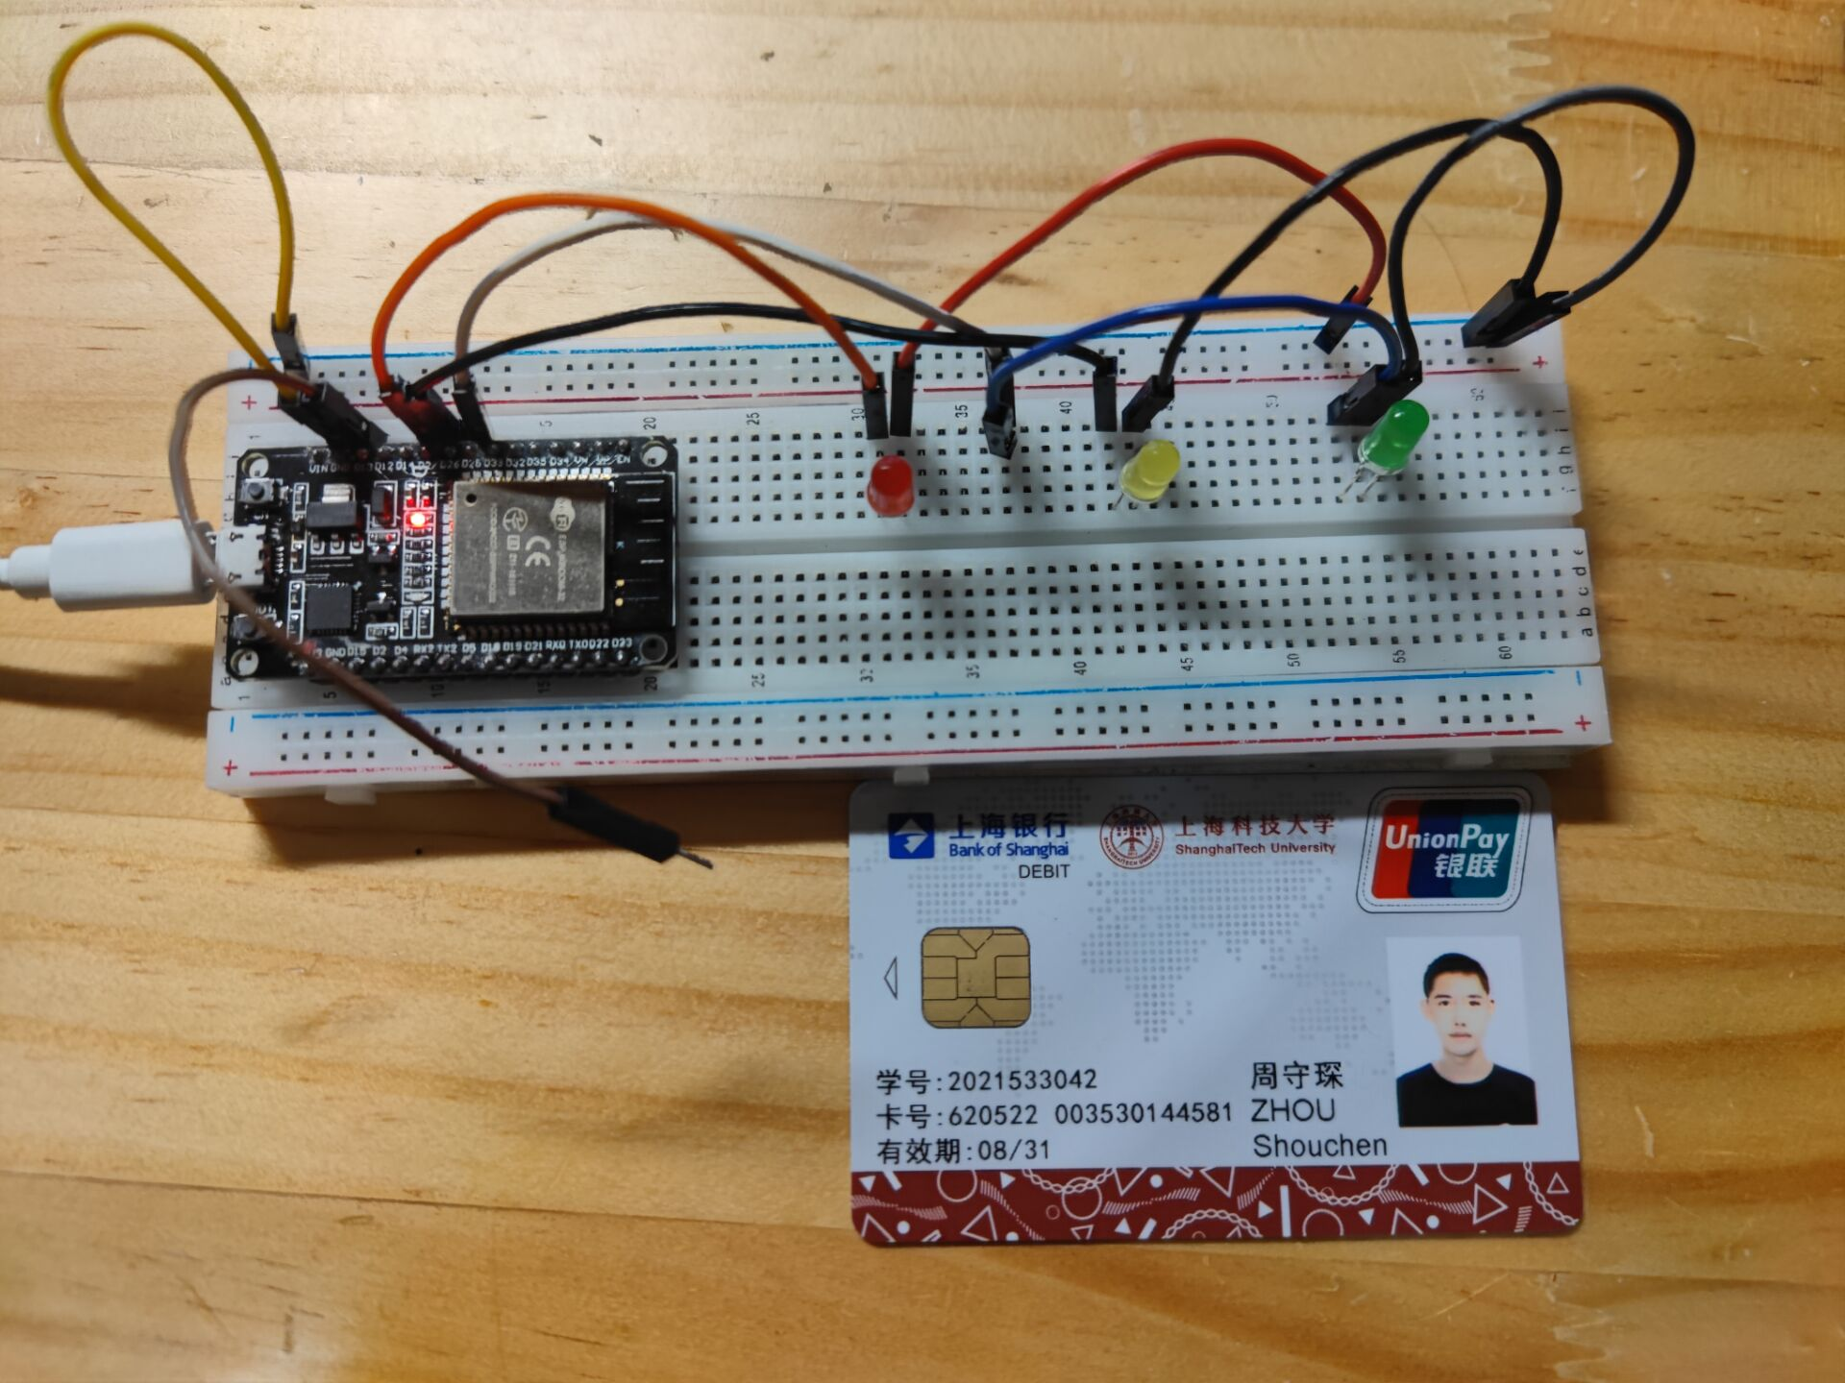

from machine import TouchPad,Pin#import TouchPad,Pinimport time#import time for sleepred=Pin(27,Pin.OUT)#let the red led get source from D27yellow=Pin(26,Pin.OUT)#let the yellow led get source from D26green=Pin(25,Pin.OUT)#let the green led get source from D25touch=TouchPad(Pin(13))#let the TouchPad get data from D13while 1:#follow the circuit while touch.read()>1000:#the hand do not touch the pin for i in range(5):#the red led will be on for 5 seconds if touch.read()<1000:#the hand is touching the pin break#reset the whole system red.value(1)#let the red led be on sleep(0.5)#it will be on for 0.5 second red.value(0)#let the red led be off sleep(0.5)#it will be off for 0.5 second if touch.read()<1000:#the hand is touching the pin break for i in range(2):#the yellow led will be on for 2 seconds if touch.read()<1000:#the hand is touching the pin break#reset the whole system yellow.value(1)#let the yellow led be on sleep(0.5)#it will be on for 0.5 second yellow.value(0)#let the yellow led be off sleep(0.5)#it will be off for 0.5 second if touch.read()<1000:#the hand is touching the pin break#reset the whole system for i in range(4):#the green led will be on for 4 seconds if touch.read()<1000:#the hand is touching the pin break#reset the whole system green.value(1)#let the green led be on sleep(0.5)#it will be on for 0.5 second green.value(0)#let the green led be off sleep(0.5)#it will be off for 0.5 second