*1.CMOS logic gate*

-*Truth table and logic circuit (gate level) design*

|  |  |  |
| --- | --- | --- |
| A | B | A XOR B |
| 0 | 0 | 0 |
| 0 | 1 | 1 |
| 1 | 0 | 1 |
| 1 | 1 | 0 |

AB= +=

*-CMOS-level implementation*

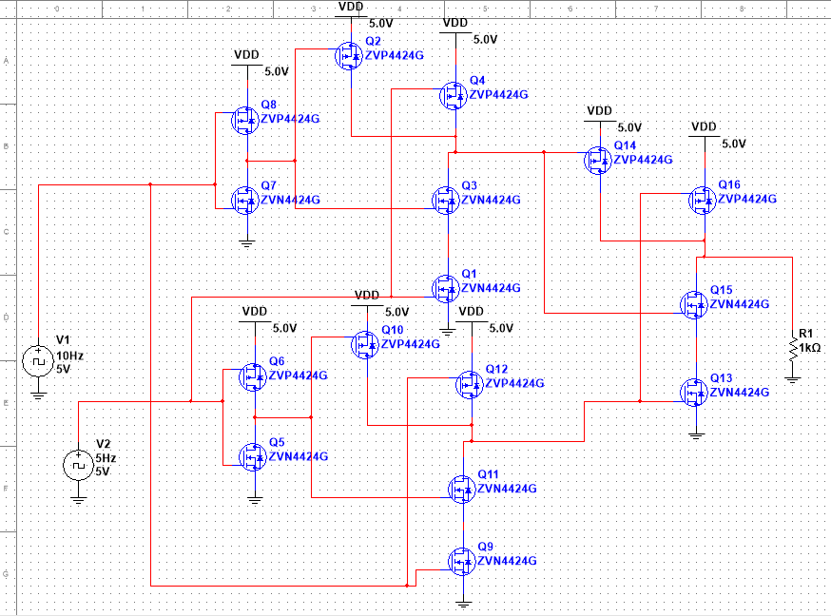

-*Measurement results*

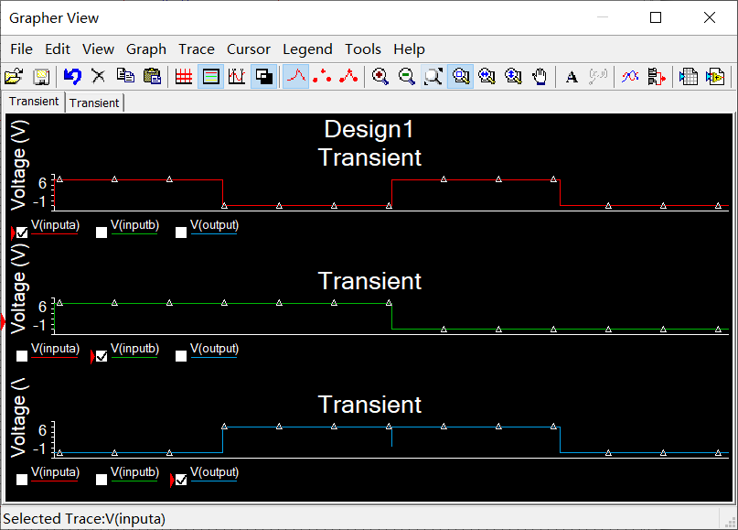

*2.Combinational logic circuit exercises*

-*the Boolean equations*

(a)Y=++

(b)Y=+

(c)Y=++++

(d) Y=++++++

(e) Y=+++++++

- *Simplify the logic using the K-map*

(a)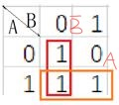 Y=A+

(b)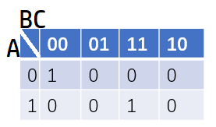 Y=

(c)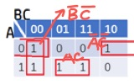 Y=

(d)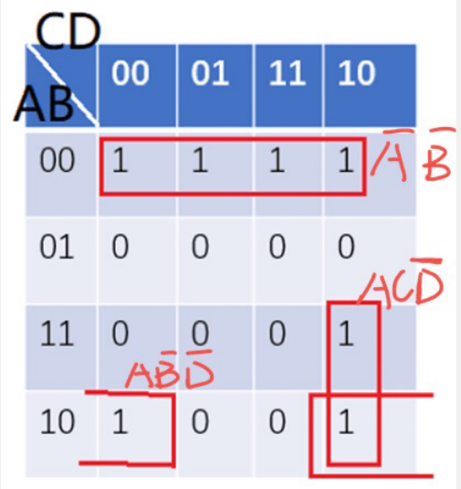 Y=++

(e)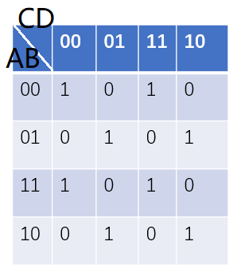 Y=

-*Implement the circuits in Multisim and test their performance*

1. 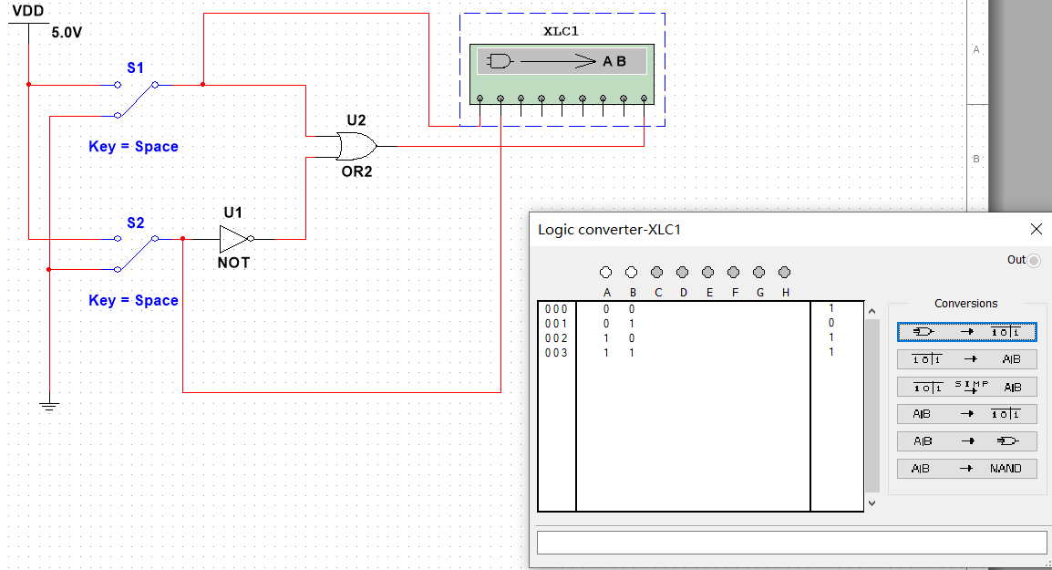
2. 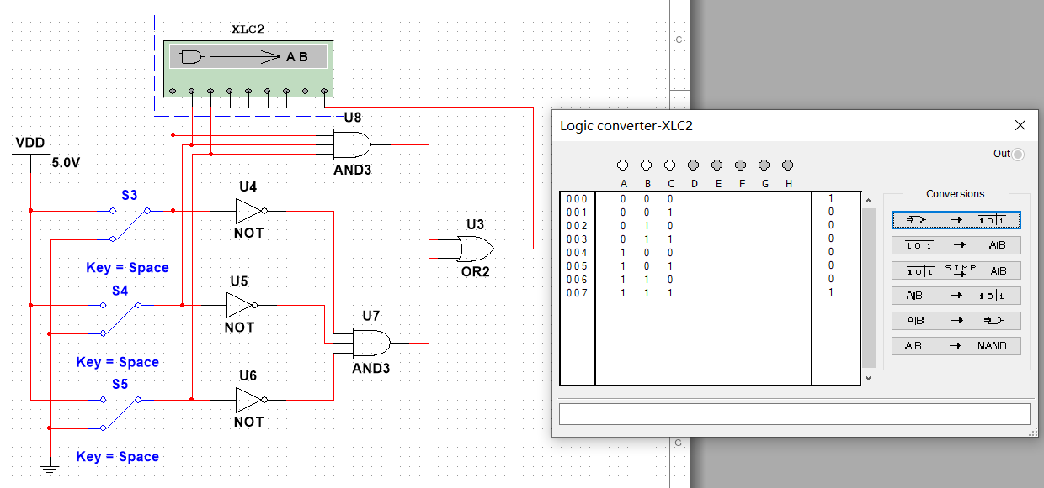
3. 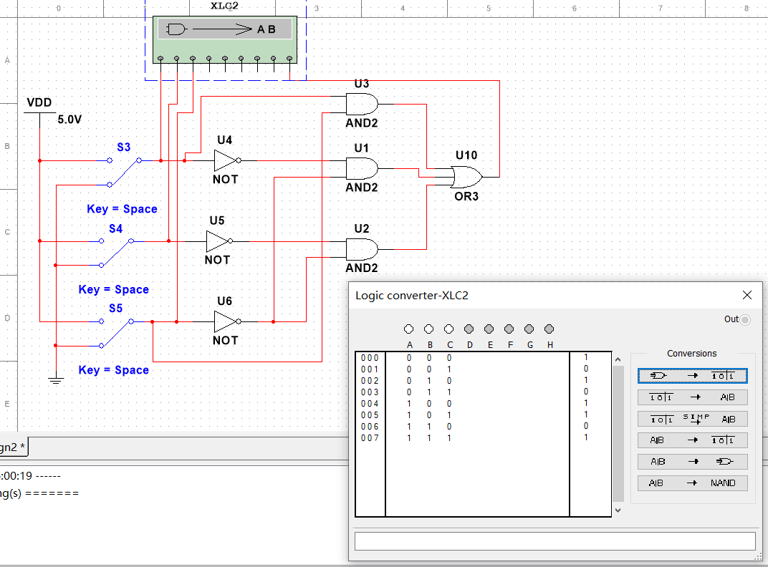
4. 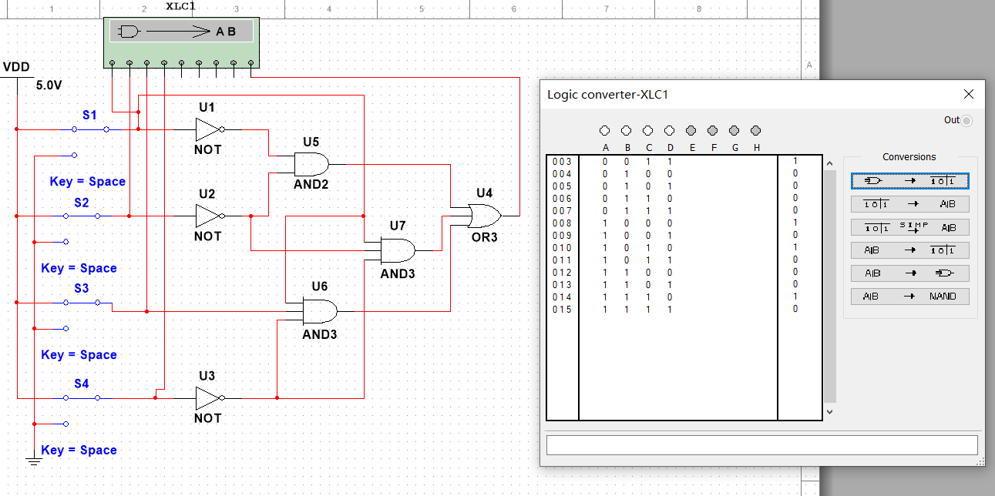
5. 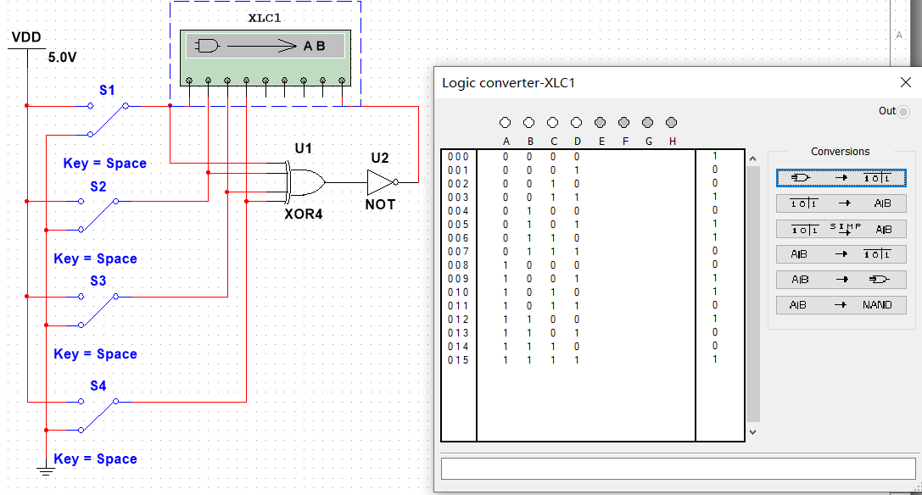

*3.Majority voting and 14-segment display*

-*Show the design procedures and final circuit schematic*

Let vote for Trump be 1, vote for Biden be 0.

If we want to let Trump win, so we must have at least two 1.

Let Y=++

If Y=0 then Trump wins, otherwise Biden wins.

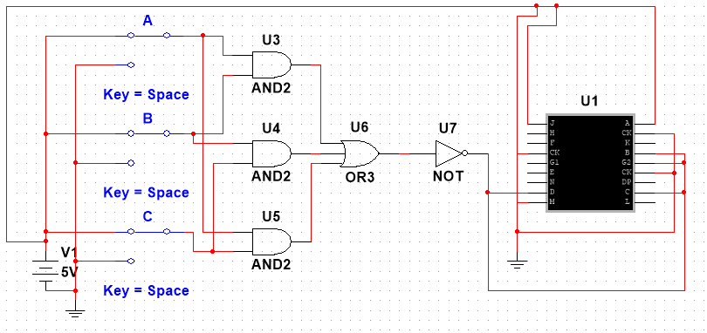

-*Show the result pictures of eight input conditions*

1 is for Trump and 0 is for Biden

The results are as followed

000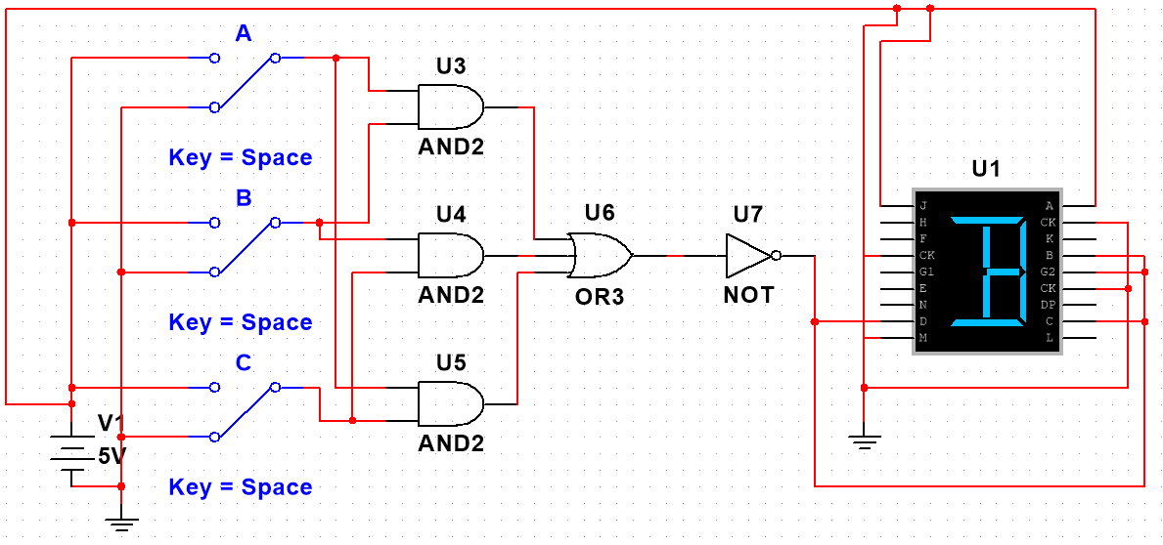

001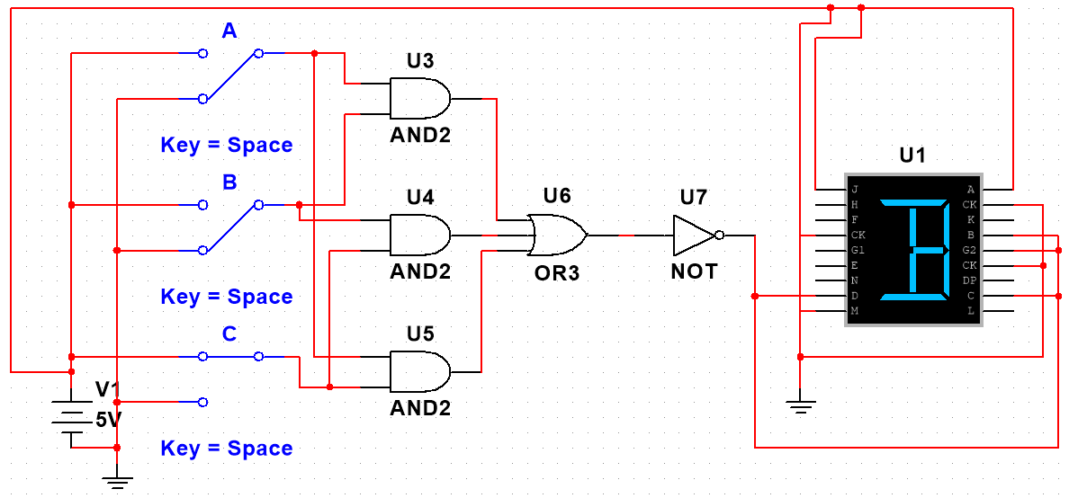

010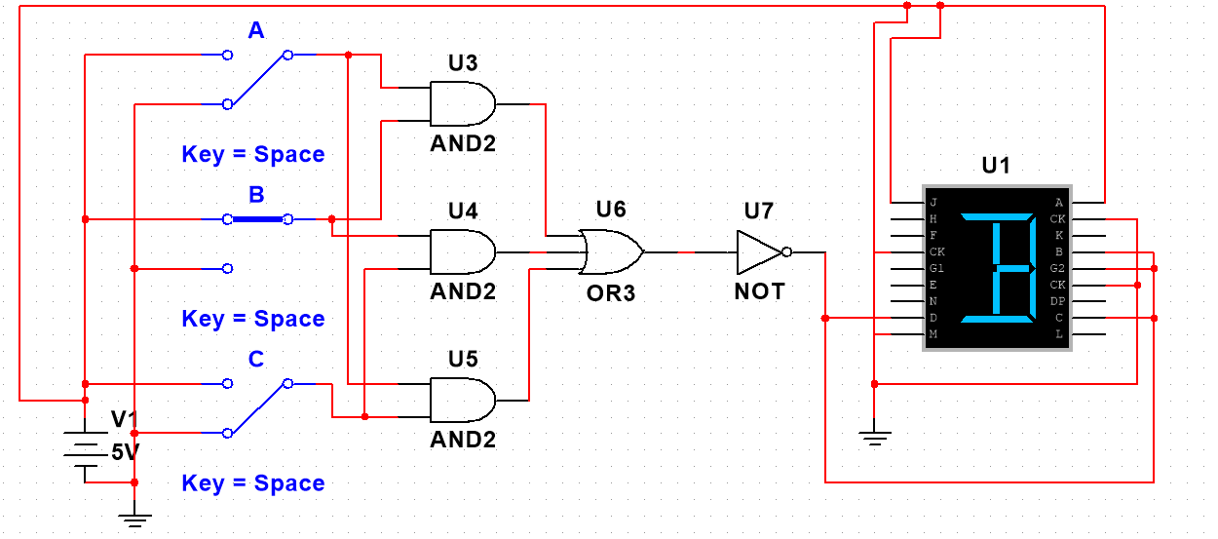

011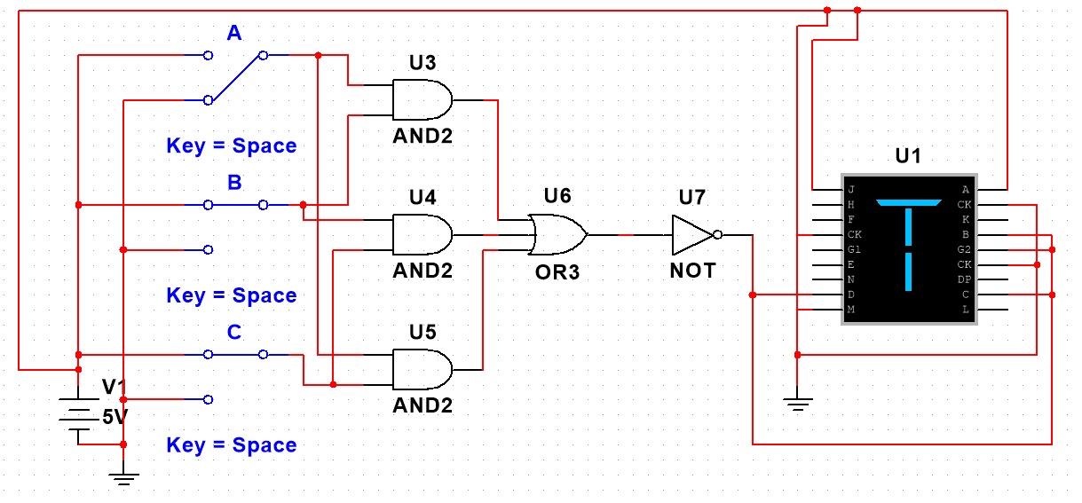

100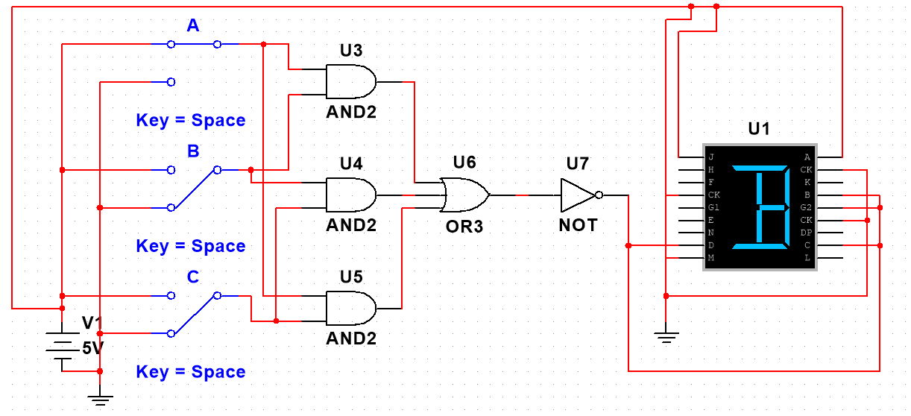101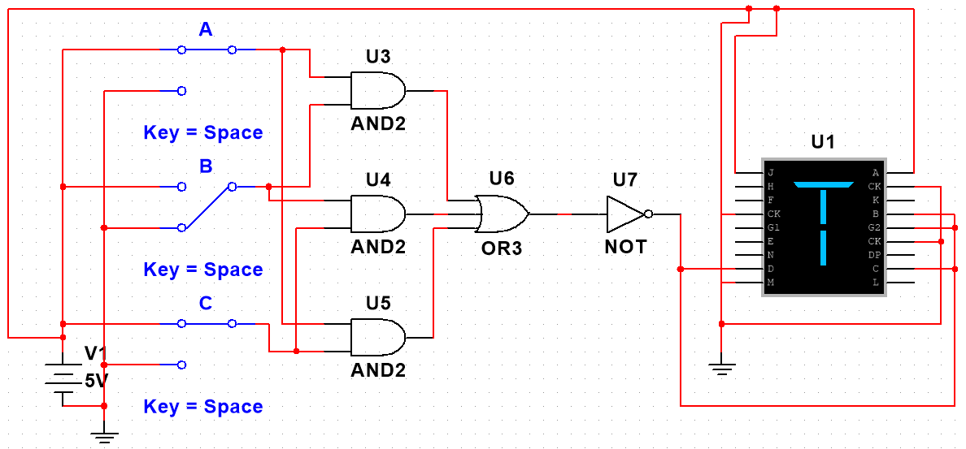

110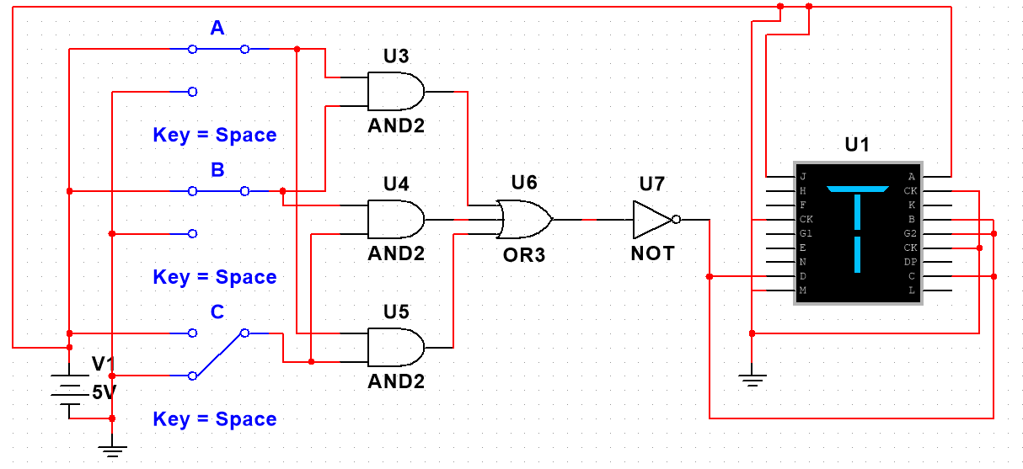

111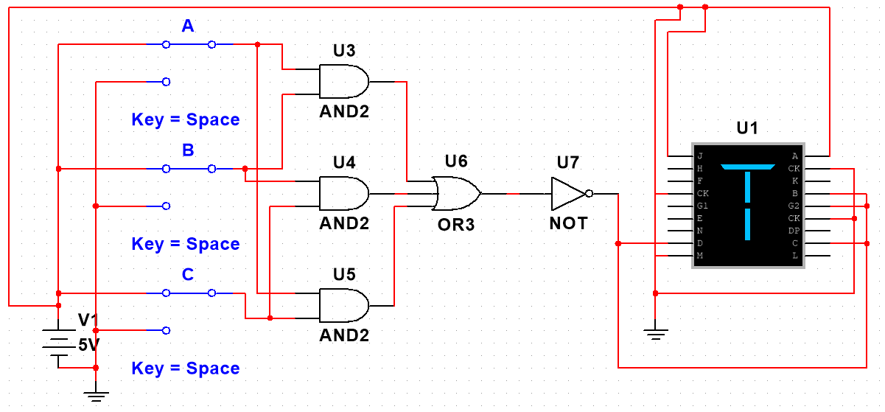

*4.MCU development*





from machine import ADC,Pin#import ADCfrom machine import DAC,Pin#import DACimport timedac=DAC(Pin(26))#source at D26adc=ADC(Pin(35))#get the voltage of the resistor at D35adc.atten(ADC.ATTN_11DB)#设置衰减比adc.width(ADC.WIDTH_12BIT)#设置12位数据精度for i in range(0,255,4):#output voltage from 0 to 255 with step of 4 dac.write(i)#the output voltage is i x=adc.read()#the voltage of resistor is x output=i/255.0*3.3#if i is 255 then is voltge is 3.3V vr=x/4095.0*3.3#if x is 4095 then the voltage is 3.3V v=output-vr#get the voltage of diode i=vr/235.0#get the current of diode the resistor is 470*470/(470+470)=235 Ohm print(v,i)#print the voltage and the current sleep(0.1)#sleep for 0.1 second

*Bonus question*





from machine import ADC,Pin#import ADC

from machine import DAC,Pin#import DAC

import time

dac=DAC(Pin(26))#source at D26

adc=ADC(Pin(35))#get the voltage of the resistor at D35

adc.atten(ADC.ATTN_11DB)#设置衰减比

adc.width(ADC.WIDTH_12BIT)#设置12位数据精度

for i in range(0,255,4):#output voltage from 0 to 255 with step of 4

dac.write(i)#the output voltage is i

x=adc.read()#the voltage of resistor is x

output=i/255.0*3.3#if i is 255 then is voltge is 3.3V

vr=x/4095.0*3.3#if x is 4095 then the voltage is 3.3V

v=output-vr#get the voltage of diode

i=vr/940.0#get the current of diode the resistor is 470*2=940 Ohm

print(v,i)#print the voltage and the current

sleep(0.1)#sleep for 0.1 second