***1.******Demosaicing and color balance***

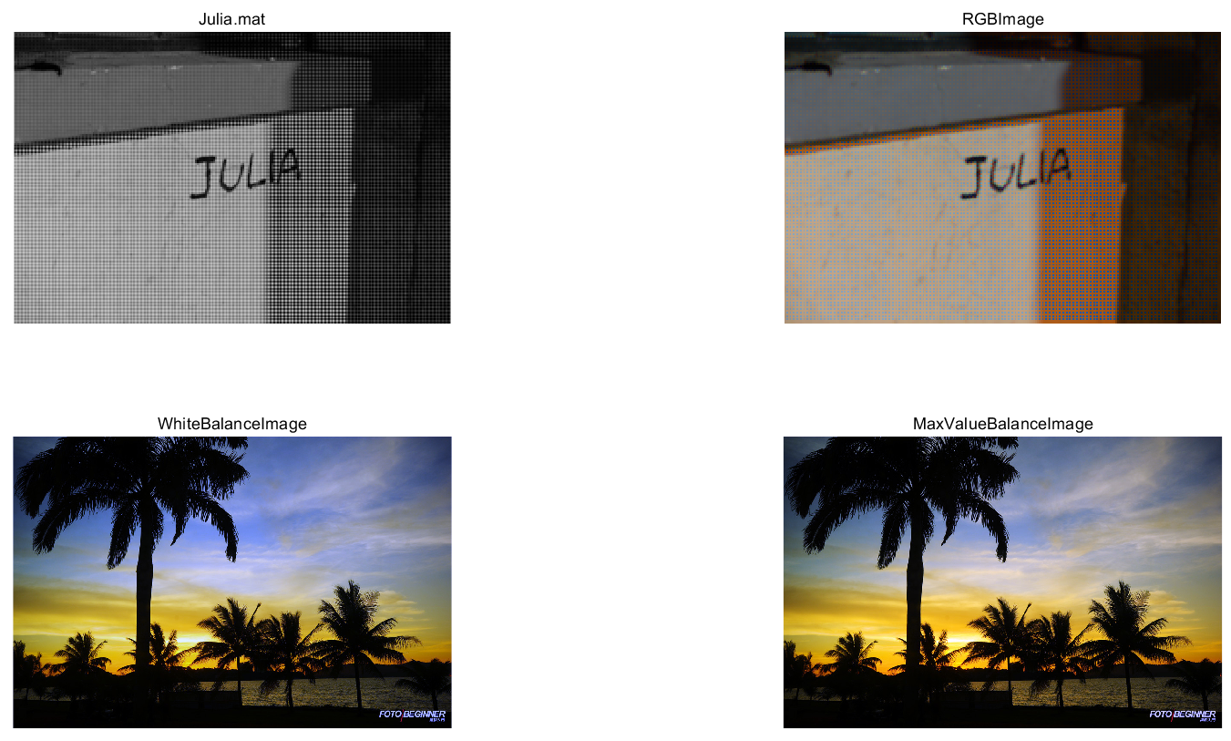

clear all;

clf;

load 'Q1\Julia.mat';

[n,m]=size(Julia);

a=double(Julia);

img_B=uint8(zeros(n,m));

img_G=uint8(zeros(n,m));

img_R=uint8(zeros(n,m));

for i=[2:n-1]

for j=[2:m-1]

x1=a(i-1,j)+a(i+1,j)+a(i,j-1)+a(i,j+1);%相邻4个

x1=uint8(x1/4);

x2=a(i-1,j-1)+a(i-1,j+1)+a(i+1,j-1)+a(i+1,j+1);%角上4个

x2=uint8(x2/4);

x3=a(i,j-1)+a(i,j+1);%左右2个

x3=uint8(x3/2);

x4=a(i-1,j)+a(i+1,j);%上下2个

x4=uint8(x4/2);

if mod(i,2)==1%奇数行

if mod(j,2)==1%蓝色

img_B(i,j)=uint8(a(i,j));

img_G(i,j)=x1;

img_R(i,j)=x2;

else%绿色

img_B(i,j)=x4;

img_G(i,j)=uint8(a(i,j));

img_R(i,j)=x3;

end

else

if mod(j,2)==1%绿色

img_B(i,j)=x4;

img_G(i,j)=uint8(a(i,j));

img_R(i,j)=x3;

else%红色

img_B(i,j)=x2;

img_G(i,j)=x1;

img_R(i,j)=uint8(a(i,j));

end

end

end

end

img_B(1,1)=uint8(a(1,1));

img_G(1,1)=uint8((a(2,1)+a(1,2))/2);

img_R(1,1)=uint8(a(2,2));

img_B(n,1)=uint8(a(n,1));

img_G(n,1)=uint8((a(n-1,1)+a(n,2))/2);

img_R(n,1)=uint8(a(n-1,2));

img_B(1,m)=uint8(a(1,m-1));

img_G(1,m)=uint8(a(1,m));

img_R(1,m)=uint8(a(2,m));

img_B(n,m)=uint8(a(n,m-1));

img_G(n,m)=uint8(a(n,m));

img_R(n,m)=uint8(a(n-1,m));

for i=[2:n-1]

if mod(i,2)==1

img_B(i,1)=uint8(a(i,1));

img_G(i,1)=uint8((a(i-1,1)+a(i,2)+a(i+1,1))/3);

img_R(i,1)=uint8((a(i-1,2)+a(i+1,2))/2);

img_B(i,m)=uint8(a(i,m-1));

img_G(i,m)=uint8(a(i,m));

img_R(i,m)=uint8((a(i-1,m)+a(i+1,m))/2);

else

img_B(i,1)=uint8((a(i-1,1)+a(i+1,1))/2);

img_G(i,1)=uint8(a(i,1));

img_R(i,1)=uint8(a(i,2));

img_B(i,m)=uint8((a(i-1,m-1)+a(i+1,m-1))/2);

img_G(i,m)=uint8((a(i-1,m)+a(i,m-1)+a(i+1,m))/3);

img_R(i,m)=uint8(a(i,m));

end

end

for i=[2:m-1]

if mod(i,2)==1

img_B(1,i)=uint8(a(1,i));

img_G(1,i)=uint8((a(1,i-1)+a(2,i)+a(1,i+1))/3);

img_R(1,i)=uint8((a(2,i-1)+a(2,i+1))/2);

img_B(n,i)=uint8(a(n,i));

img_G(n,i)=uint8((a(n,i-1)+a(n-1,i)+a(n,i+1))/3);

img_R(n,i)=uint8((a(n-1,i-1)+a(n-1,i+1))/2);

else

img_B(1,i)=uint8((a(1,i-1)+a(1,i+1))/2);

img_G(1,i)=uint8(a(1,i));

img_R(1,i)=uint8(a(2,i));

img_B(n,i)=uint8((a(n,i-1)+a(n,i+1))/2);

img_G(n,i)=uint8(a(n,i));

img_R(n,i)=uint8(a(n-1,i));

end

end

result=cat(3,img_R,img_G,img_B);

sky=imread('Q1\sky.jpg');

fr=sky(:,:,1);

fg=sky(:,:,2);

fb=sky(:,:,3);

i=0.299*fr+0.587*fg+0.114*fb;

imean=sum(i(:));

frmean=sum(fr(:));fgmean=sum(fg(:));fbmean=sum(fb(:));

kr=imean/frmean;kg=imean/fgmean;kb=imean/fbmean;

gr=kr*fr;gg=kg*fg;gb=kb*fb;

whitebalance=cat(3,gr,gg,gb);

[m,n]=size(fr);

rmax=max(fr(:));gmax=max(fg(:));bmax=max(fb(:));

srgb=min([rmax,gmax,bmax]);

nr=sum(sum(fr>srgb));ng=sum(sum(fg>srgb));nb=sum(sum(fb>srgb));

nmax=max([nr,ng,nb]);

r=sort(fr(:),'descend');tr=r(nmax);

g=sort(fg(:),'descend');tg=g(nmax);

b=sort(fb(:),'descend');tb=b(nmax);

kr=srgb/tr;kg=srgb/tg;kb=srgb/tb;

gr=kr*fr;gg=kg*fg;gb=kb*fb;

colorbalance=cat(3,gr,gg,gb);

subplot(2,2,1);imshow(uint8(Julia));title('Julia.mat');

subplot(2,2,2);imshow(result);title('RGBImage');

subplot(2,2,3);imshow(whitebalance);title('WhiteBalanceImage')

subplot(2,2,4);imshow(colorbalance);title('MaxValueBalanceImage');

***2.******Noise generation and degeneration***

(1) *Noise generation*

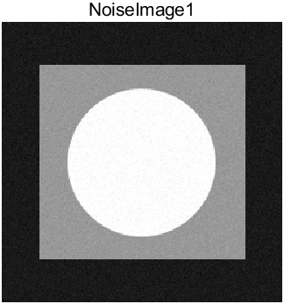

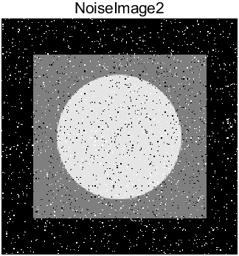

(2) *Noise degeneration*

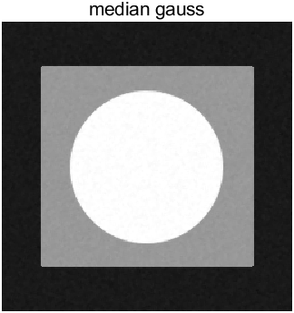

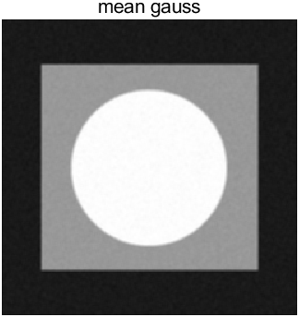

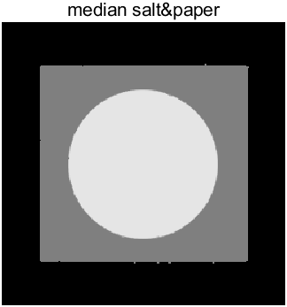

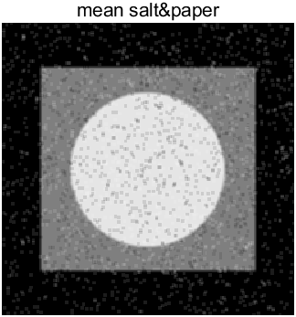

load Q2\init_img.mat

a=init_img;

imshow(a);title("init img");

b=imnoise(a,'gaussian',25/255,25/255/255);

c=imnoise(a,'salt & pepper',0.05);

imshow(b);title("NoiseImage1");

imshow(c);title("NoiseImage2");

median_gauss=medfilt2(b);

median_saltpaper=medfilt2(c);

x=fspecial('average');

mean_gauss=imfilter(b,x);

mean_saltpaper=imfilter(c,x);

imshow(median_gauss);title("median gauss");

imshow(mean_gauss);title("mean gauss");

imshow(median_saltpaper);title("median salt&paper");

imshow(mean_saltpaper);title("mean salt&paper");

***3.******Histogram equalization and histogram matching***

(1)*Histogram*

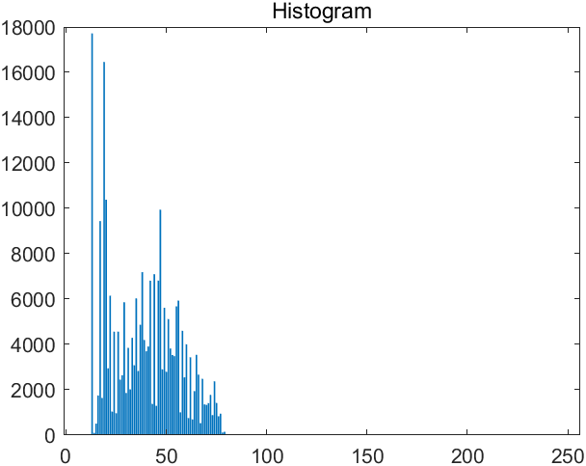

(2)*Histogram equalization*

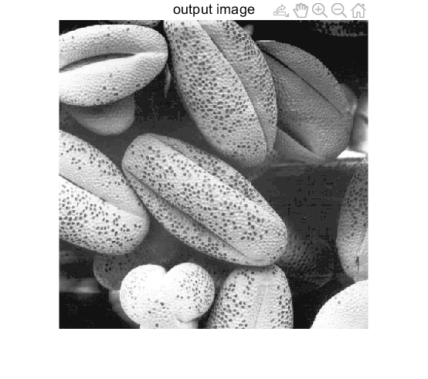

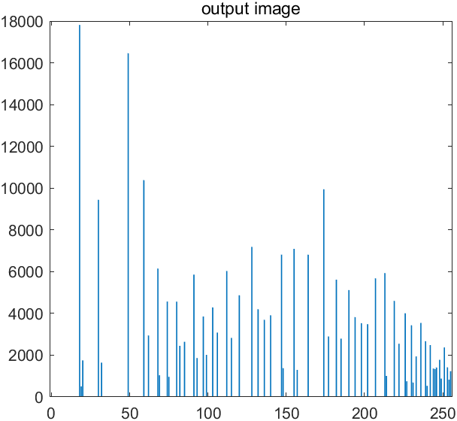

(3)*Histogram matching*

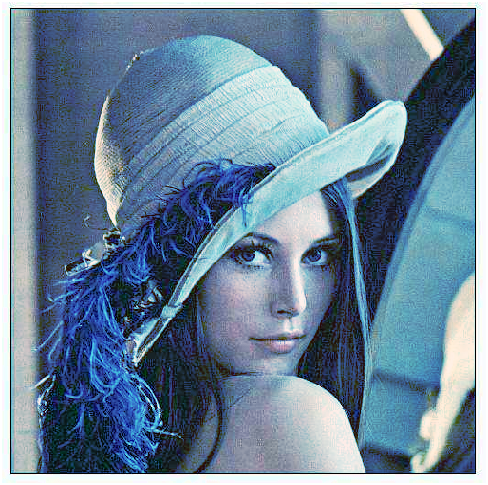

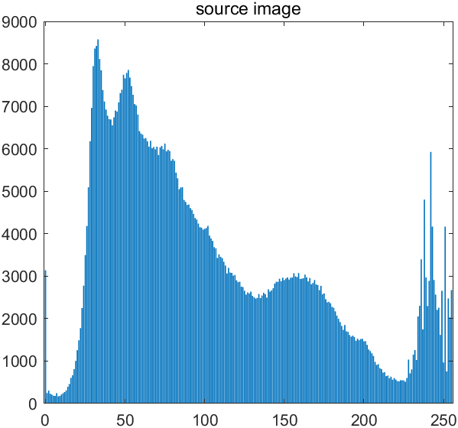

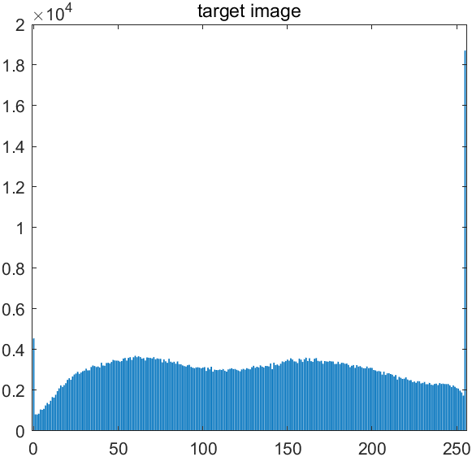

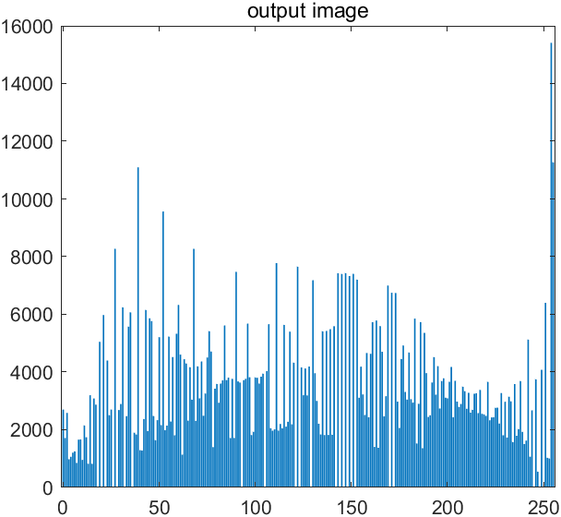

load Q3\original_img.mat;

source=imread("Q3\source.jpg");

target=imread("Q3\target.jpg");

[n,m]=size(original_img);

cnt=zeros(256,1);

bin=zeros(256,1);

for i=[1:256]

bin(i,1)=i-1;

end

for i=[1:n]

for j=[1:m]

cnt(original_img(i,j)+1,1)=cnt(original_img(i,j)+1,1)+1;

end

end

bar(bin,cnt);title("Histogram");

p=cnt/(n*m);

p=cumsum(p);

p=p*255;

p=round(p);

output=uint8(zeros(n,m));

for i=[1:n]

for j=[1:m]

output(i,j)=p(original_img(i,j)+1,1);

end

end

imshow(output);title("output image");

[counts,binLocations]=imhist(output);

bar(binLocations,counts);title("output image");

[source_n,source_m,dim]=size(source);

[target_n,target_m,dim]=size(target);

x=uint8(zeros(source_n,source_m,3));

for k=[1:3]

source_x=source(:,:,k);%获取原图像k通道

source_hist=imhist(source_x);%获取原图像k通道直方图

target_x=target(:,:,k);%获取匹配图像k通道

target_hist=imhist(target_x);%获取匹配图像k通道直方图

%x(:,:,k)=histeq(source_x,target_hist);

source_p=cumsum(source_hist)/(source_n*source_m);

target_p=cumsum(target_hist)/(target_n*target_m);

map=zeros(1,256);%从0到255分别的映射

%help min

for i=[1:256]

[val,pos]=min(abs(source_p(i)-target_p));

%找到target_p中与source(i)最接近的位置

map(i)=pos-1;

end

x(:,:,k)=map(double(source_x)+1);

end

result=cat(3,x(:,:,1),x(:,:,2),x(:,:,3));

imshow(result);

[counts,binLocations]=imhist(source);

bar(binLocations,counts);title("source image");

[counts,binLocations]=imhist(target);

bar(binLocations,counts);title("target image");

[counts,binLocations]=imhist(result);

bar(binLocations,counts);title("output image");