C4 Survey – The Colby College Climate Change Survey

College Students Taking the Nation’s Pulse on Climate Change

Cole Kleinberg

May 14, 2014

EC476 – Professor Dissanayake

**Summary**

We find that our overall results confirm existing literature. While we do find that the proportion of people who believe the climate is changing is higher than the existing national average, we do see that for our survey that the mean age is skewed toward the younger end of the spectrum and mean income is skewed towards the higher end, both of which help explain the difference. Our most interesting result comes from the section analyzing the potential consequences of climate change, where even among people who said they believe in climate change, there is disagreement and uncertainty as to what the future effects will be. Additionally, we see that as the level of familiarity with climate change decreases, the beliefs about the causes of climate change start to move away from human activity, and grow in favor of natural processes.

**Introduction**

Is Earth’s climate changing? This is a simple question that countless people are asking around the world today, yet the answer will likely vary depending on whom you consult. Much of the variability in beliefs regarding climate change can be attributed to the fact that the average person does not have a significant amount of knowledge surrounding the issue.[1] In a recent study from the Center for Climate Change Communication (CCCC) at George Mason University, scientists set out to understand Americans’ beliefs regarding global warming in April, 2013. In their words, “Global warming refers to the idea that the world’s average temperature has been increasing over the past 150 years, may be increasing more in the future, and that the world’s climate may change as a result.”[2] This definition does not relate any human activity as the cause for such rise in temperatures and the percent of Americans who believe that global warming is happening can be seen in figure 1, to the right. Clearly, there is a strong majority of people who believe that global warming is happening, but when respondents are then questioned about the confidence of their beliefs, the numbers tend to tell a different story. As figures 2 and 3 clearly depict, there is a large amount of variability in the confidence of people’s beliefs, both for people who believe global warming is happening as well as for those who do not believe global warming is happening.

But why is it important that people understand the significance of the issue at hand? As NASA states on its Global Climate Change website, “The potential future effects of global climate change include more frequent wildfires, longer periods of drought in some regions and an increase in the number, duration and intensity of tropical storms.”[3]

Evidently, climate change is a very serious issue and for those who do believe in climate change, surely they would recognize the potential harm involved. However, when believers were asked if they perceive global warming as a threat to themselves, their families, and their local communities, an interesting trend arises. Although a significant portion of the American population finds global warming to be a serious threat to the world, the percentage decreases as the scale of consideration becomes more personal.

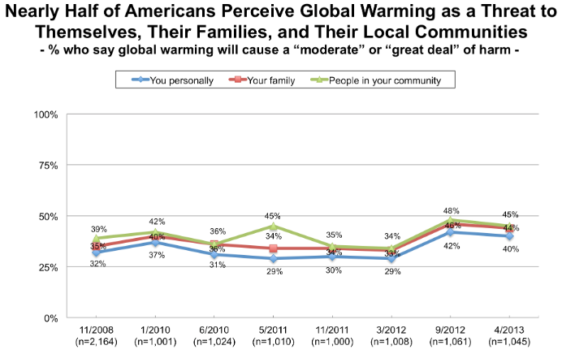

Figure 5

In other words, people find global warming to be less of a threat to them personally compared to people in their community, country, or world.

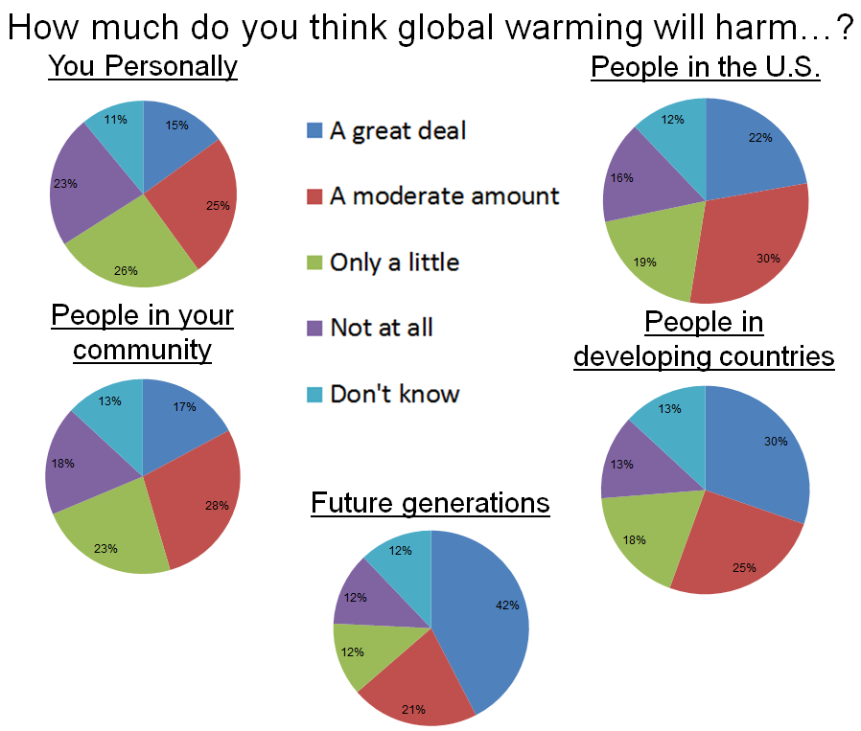 Furthermore, when the scale is expanded out in the charts in figure 6, we can see that the percent of Americans who think global warming will cause a great deal of harm to people in their community is far less than that of people in the U.S. This trend continues as Americans find global warming more serious for people in developing countries and finally, most serious for future generations. Clearly, Americans not only ignore the potential effects of global warming at the individual level, but they are also averse to dealing with the issue now. Even as the majority of Americans find that global warming will harm future generations a “great deal” or “moderate amount”, there seems to be a lack of initiative to mitigate current trends.

Figure 6

**Intentions and Implementation of Our Survey**

The goal of our survey is to corroborate or challenge some of the Yale and George Mason findings as well as explore more deeply some of the opinions surrounding the potential consequences of climate change.

During the spring of 2014, we distributed a survey intended to analyze participants’ beliefs about climate change. The survey was developed by Cole Kleinberg and Professor Sahan Dissanayake and distributed by the approximately 65 students in Professor Dissanayake’s Environmental and Natural Resources Economics course. We had 408 responses with approximately 10% of responses being incomplete, where the respondent answered most questions but left a few blank, and 2% being totally incomplete, where the respondent essentially returned a blank survey. These discrepancies are accounted for in our data analysis.

**Initial Findings & Respondent Characteristics**

Environmental and Natural Resource Economics students of Colby College, the survey was handed out to hundreds of respondents in the spring of 2014. A total of 409 survey responses were collected with the majority of respondents located in the United States (a small number of responses were collected in foreign countries).

The survey was split into five different sections: the first section, titled “Beliefs on Climate Change”, discussed respondents’ basic views and familiarity with climate change; the second section, titled “Beliefs on Causes of, Impacts from and Solutions to Climate Change”, addressed respondents views on the issue in more detail; the third section, titled “Beliefs on Local and Severe Weather”, addressed respondents’ experiences and beliefs regarding droughts, very harsh winters, unusually severe snow/rain storms, flooding, etc.; the fourth section, titled “Risk and Time Preferences”, contained a series of questions to measure the respondents’ risk and time preferences; the fifth section, titled “Demographic Questions”, included a series of questions on respondents’ education, gender, age and household income. The following quote “You should think of climate change as a change in the climate compared to historical trends which may or may not be caused by human action” was included at the beginning of each section

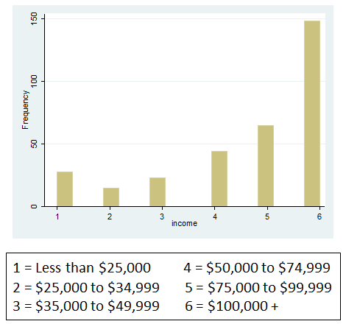It is important to note that survey sample is not a randomized nationally representative sample. At the same time the sample represents a broad demographic composition but is on average younger and wealthier compared to a nationally representative sample; the average age was approximately 33.9 years with the majority of respondents skewed towards the low 20’s, as expected with college students distributing the survey. The gender of respondents was fairly represented with 47.5% male and 52.5% female. Similarly, 53.4% of respondents had a college degree while 46.6% did not. As for household income levels, the majority of respondents came from households with a total income greater than $100,000. Although this is clearly not representative of the general population, this was largely expected as Colby College students, who were distributing the survey, often come from more affluent backgrounds.

Figure 7

Figure 8

Beyond the general characteristics of the respondents, the vast majority (about 97%) identified as being familiar with the issue of climate change before taking the survey. Of those who were familiar, about 2% identified as having “expert” familiarity with climate change, while 38% were “very familiar”, 50% were “somewhat familiar”, and 9% were “not very familiar”. Most importantly though, about 88% of respondents believe that the climate is changing (regardless of cause), with 8% not sure, and 4% said they did not believe the climate was changing (figure X). The number of respondents who believe that the climate is changing is obviously much higher than the national average obtained by the CCCC study. This may be explained by a possible selection bias when the Colby students were distributing the survey; Colby is a liberal arts institution with a strong student involvement in environmental issues and because the Colby community is, on average, more aware of the environmental consequences of climate change, it would not be surprising to find that the people surveyed by members of the community have similar views.

**Beliefs on the Consequences and Causes of Climate Change.**

Looking towards the portion of the survey asking about potential consequences of climate change, we notice some interesting trends. Participants were asked to respond with the degree of likelihood (‘Very likely’, ‘Likely’, ‘Not likely’, “Very unlikely’, or ‘Not sure’) corresponding to their beliefs that climate change will cause harsher winters, higher temperatures, extreme weather, sea-level rising, flooding, droughts, impacts on glaciers/icecaps, higher food prices, political instability, job loss, and slow economic growth. We group together the affirmative responses and the negative responses to examine trends in how people believe, do not believe, or are unsure of the potential effects of climate change.

When examining the responses, we notice that the responses to possible effects fall into three clusters based on the proportion answering ‘Very likely’ or ‘likely’. The first cluster has a proportion of ‘Very likely’ or ‘likely’ in the 80%-90% range. In this group are higher temperatures, extreme weather, sea level rising, flooding, and impacts on glaciers/icecaps. These effects are the commonly understood consequences of global warming, and their higher perceived likelihood may be a result of their popularity in the media over the past generation.

The second cluster has a proportion of “very likely” or “likely” in the 68%-75% range. The effects include harsher winters, droughts, and higher food prices. When compared to the first cluster, we see that the shift in this confidence is largely a result of more people responding ‘Not sure’, rather than in the negative. These three effects can be viewed as primary consequences of those effects in the first cluster, but the discrepancy may be explained by the differences in media attention.

The final group of effects are political instability, loss of jobs, and slow economic growth which has a proportion of ‘Very Likely’ or ‘Likely’ in the 42%-54% range. While we do see an increase in the proportion of people who respond ‘Not likely’ and ‘Very unlikely’ from around 8% to around 15%, the bulk of the shift is from the affirmative to the ‘Not sure’ response. These three effects may be considered long-term secondary effects of a change in the Earth’s climate, but not necessarily direct consequences (is there a citation that we can use for this?). It is therefore unsurprising that we find a lesser degree of certainty in the likelihood of these effects.

Prior to answering the “How likely do you believe climate change will cause the following…?” respondents were asked to give an open response listing what they believed potential consequences of climate change are. The responses in this category, while not influenced by the questions which follow, are mirrored therein. Frequently, responses involving changing temperatures, sea level, and weather patterns, and a lot of people indicate concerns about food prices and water availability. We also see occasional responses about political instability, risk of geopolitical conflict, and higher prices in other markets, particularly energy markets. Additionally, a number of people expressed concern for the consequences of climate change with regards to animal populations, particularly destruction of habitats.

Next we expand upon the CCCC study’s findings that people tend to view climate change as an issue important for the world rather than themselves personally. Figures 10 and 11 illustrate how serious respondents believe climate change is for the world, the U.S., their community, and them personally.

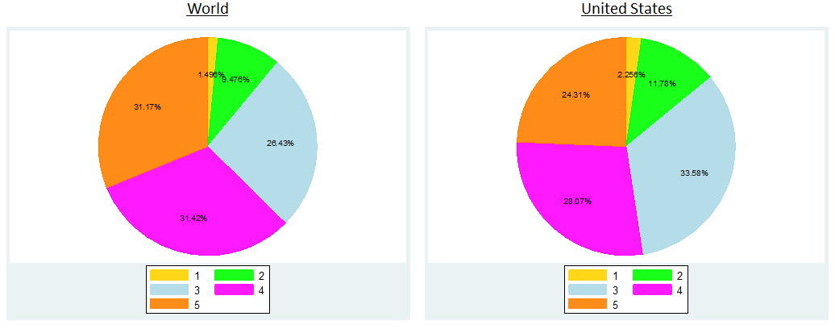

Figure 11

Figure 12

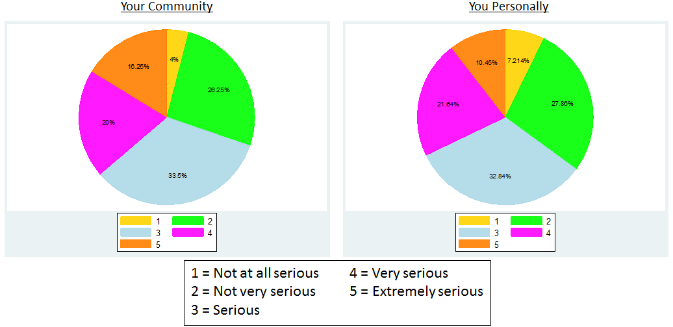

Figure 13

Figure 14

We can clearly see that the seriousness of climate change quickly decreases as we move from a worldwide view to a personal view. This finding has policy implications for attempts to mitigate climate change; if the public feels that climate change is someone else’s problem and will affect them less, they may be less inclined to take action toward mitigating climate change.

There is an interesting trend within this data regarding the respondents’ familiarity with the issue of climate change. Keeping the view consistently *worldwide* (how serious do you believe climate change is for the world?), we can compare the views of respondents who identify as expert, very familiar, somewhat familiar, or not very familiar with climate change in figures 15-18:

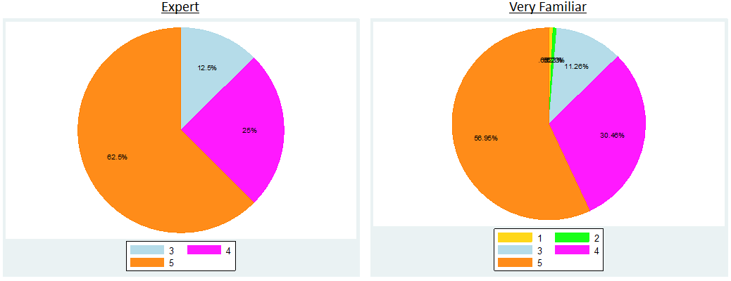

Figure 16

Figure 15

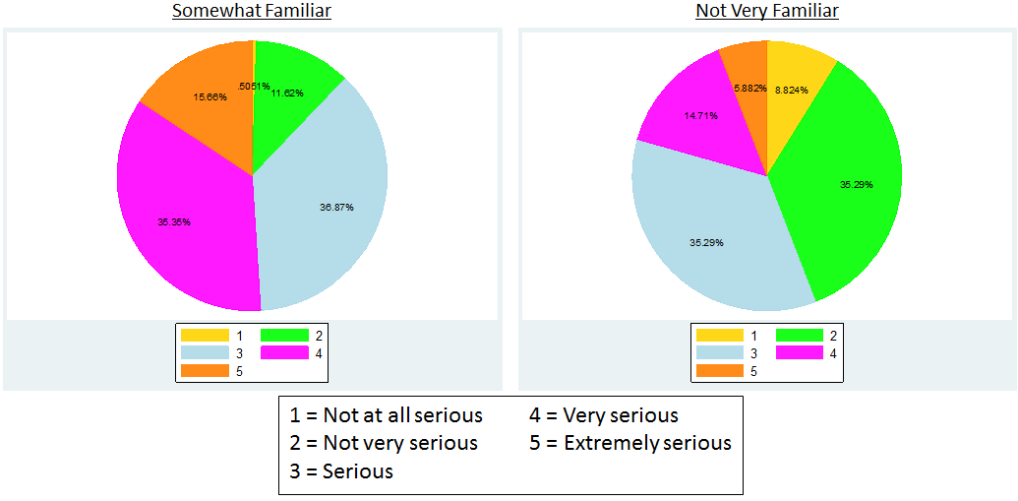

Figure 17

Figure 18

As we can see in figures 17 and 18 above, as familiarity with climate change decreases, respondents find climate change to be less serious of an issue for the world. This result is consistent if we were to focus on respondents’ views for the U.S., their communities, as well as themselves personally.

Next we explore respondents’ beliefs regarding the causes of climate change. For the entire population of respondents, the following chart (figure 19) represents their corresponding views:

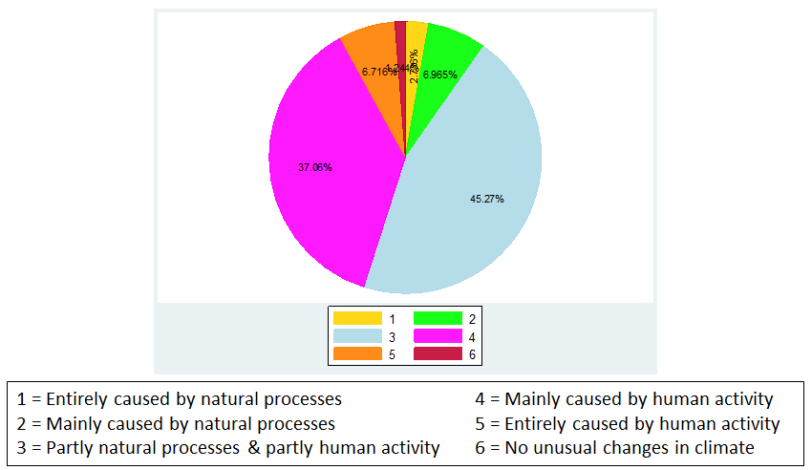

Figure 19

As we can see, roughly 45% of respondents find climate change is caused partly by natural processes and partly by human activity, followed by 37% of respondents who believe that climate change is mainly caused by human activity. To better understand peoples’ views, we should also look at beliefs about the causes of climate change based on different levels of familiarity with climate change, which can be seen in figures 20-23, below:

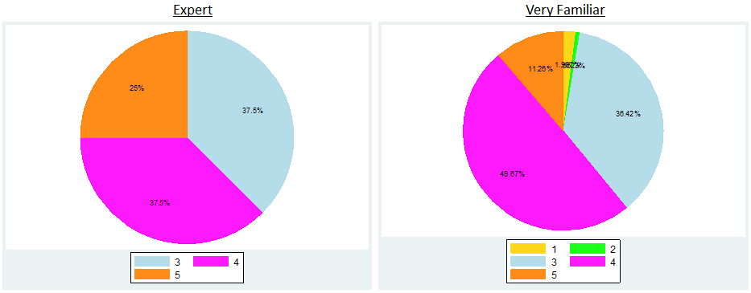

Figure 20

Figure 21

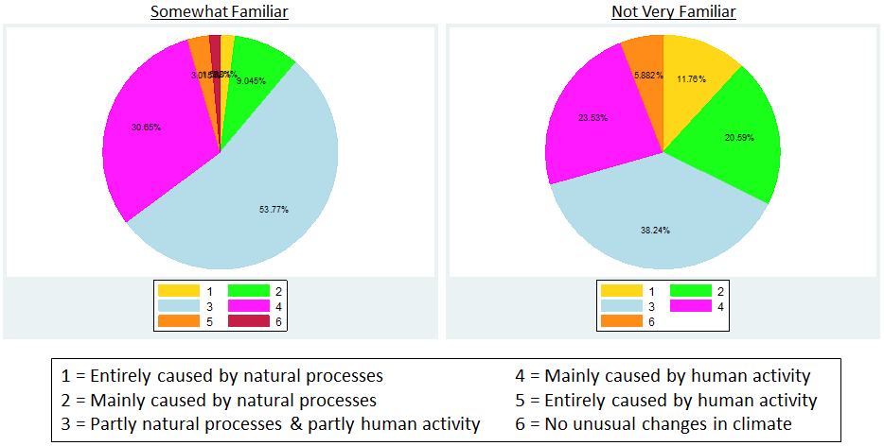

Figure 23

Figure 22

From figures 20-23, there is a clear relationship between familiarity on climate change and views about the causes of climate change. Specifically, those who are most familiar (experts), are almost evenly split between entirely caused by human activity, mainly caused by human activity, as well as partly natural processes & partly human activity. As the level of familiarity with climate change decreases, the beliefs about the causes of climate change start to move away from human activity, and grow in favor of natural processes. In particular, 21% of those respondents who are not very familiar with climate change believe that climate change is mainly caused by natural processes, whereas no respondents who identified as an expert believe that climate change is caused by natural processes.

Next, we look to section three of the survey which obtains information about respondents’ exposure to sever weather. As mentioned previously, NASA states that the potential future effects of global climate change include an increase in the number, duration and intensity of storms and droughts. Thus, it is important that we explore the impact of severe weather on respondents’ views of climate change, which can be seen in figures XX-XX.

n=314

From the charts above (figures XX-XX), severe weather clearly has an impact on respondents’ beliefs regarding climate change. Specifically, a higher percentage of respondents that have been affected by severe weather in the past believe that the climate is changing (compared to respondents who have not been affected by severe weather in the past). The time period in which respondents were affected by severe weather does not significantly change the percent of respondents that believe in climate change.

**Demographic Trends**

Finally we analyze how respondent demographic characteristics influence beliefs. We continue look at the percent of respondents who believe that the climate is changing. The charts below (figures 36 & 37) show the difference in respondent’s views by gender:

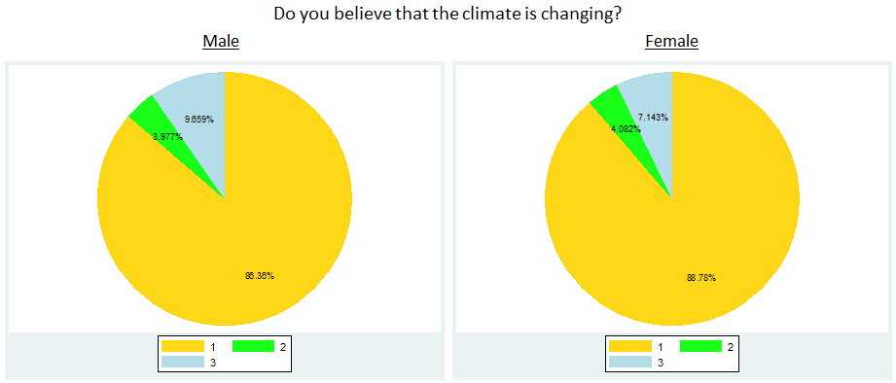

Figure 37

Figure 36



There appears to be no real significant difference in beliefs in climate change between male and female respondents. Figures XX-XX illustrate respondents’ beliefs on climate change based on income level:

The charts above for whether respondents believe the climate is changing (for different income levels) yield some very interesting results. Mainly, 100% of respondents that have a household income of less than $35,000 believe that the climate is changing. For income levels $35,000-$79,999 73% of respondents believe the climate is changing, while 23% are not sure and 4% do not. With income levels greater than $75,000 there are similar results, with increasing percentages of people who believe the climate is changing as income increases.

Next we look at the effect of education on beliefs regarding climate change. For simplification, respondents were identified as college graduates or non-college graduates. Climate change beliefs based on college education are as follows in figures 44 and 45:

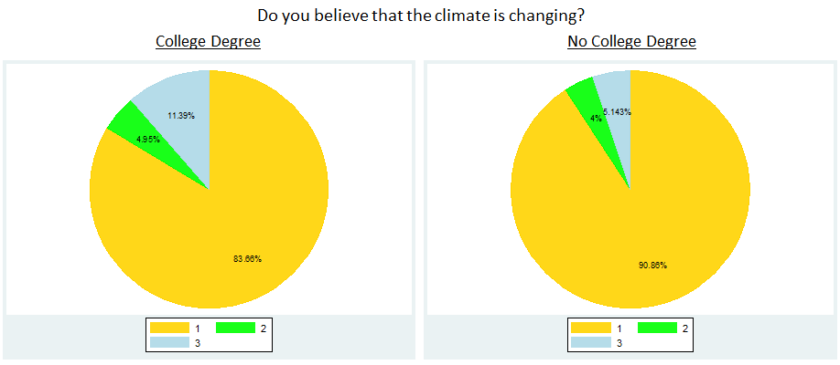

Figure 45

Figure 44

Based on the charts above (figures 44 & 45), 84% of respondents with a college degree believe that the climate is changing. On the other hand, 90% of respondents without a college degree believe that the climate is changing. This may be explained by a large percentage of college students in the response pool. If we find nearly 150 respondents who have only completed high school and are between the ages of 18 and 24, which strongly suggests they are currently in college.

Our final result corroborates the Yale finding that people tend to view climate change as more threatening to people on a global scale than to their community. When we break up the responses by self-identified expertise and plot the proportion of each who stated that climate change is a ‘serious’, ‘very serious’ or ‘extremely serious’ threat to the world, the United States, their community, and them personally (figure X), we see a downward sloping trend on the first three points, and no universal trend between the last two, indicating that people feel that climate change is more serious for the world than for the United States, and more serious for the United States as a whole than their own community.

Ignoring the ‘expert’ group, as it had too few respondents to be statistically significant (n=8), we also notice that in terms of absolute severity, people who are more familiar with climate change believe it is more serious than those who are less familiar.

**Conclusion**

The results obtained from the survey show many significant trends, many of which support previous studies such as the aforementioned study by the Center for Climate Change Communication at George Mason University. In particular, the results show a ar reluctance for people to confront and mitigate climate change even though a significant majority of respondents acknowledge the serious implications climate change will have in the future. Further, respondents clearly find that climate change is a serious issue for the world, but when confronted about the potential effects to them personally, far fewer respondents find this to be a serious issue.

In addition, the demographic trends among respondents reveal similar results to a previous study conducted by Christopher Borick and Barry Rabe regarding a national survey of American public opinions on climate change. They found that 60% of Americans with a college degree believe that the climate is changing, while 27% do not. For Americans without a college degree, they found that 66% believe that the climate is changing, while 24% do not.[4] Although the results from this survey have a higher overall percentage of people who believe that the climate is changing (84% of respondents with a college degree believe that the climate is changing and 90% of respondents without a college degree believe that the climate is changing), this is likely due to the fact that that the survey was distributed by Colby students participating in an environmental economics course, as mentioned previously. Nonetheless, as Borick and Rabe point out, “traditional demographic categories such as gender, race and educational attainment offer little in the way of providing cues about an individual’s standing on [climate change].”[5] As is evident in the results of my survey, there also does not appear to be a significant change in views based on education.

On the other hand, an interesting trend resulted from my analysis of different levels of income and the associated beliefs on climate change. As discussed earlier, for lower levels of income (less than $35,000), 100% of respondents believe that the climate is changing. Only until respondents’ income levels exceed $35,000 do we see any proportion of people who believe that the climate is changing. We also find that those surveyed indicated frequently that severe weather is a potential consequence of climate change and that people who experienced severe weather either in the last one year or between one and five years ago believed that the climate is changing.

Lastly, one of the most interesting findings in this study surrounds the level of familiarity each respondent has with climate change. For both the causes of and degree of seriousness resulting from climate change, there were telling patterns regarding respondents’ level of familiarity. Particularly, respondents who were more familiar with the issue found climate change to be a more serious matter than those who were not. Similarly, those who more familiar with the issue also found the causes of climate change to be more directly related to human activity rather than just natural causes.

**Works Cited**

Leiserowitz, Anthony, et al. "Climate change in the American mind: Americans’ global warming beliefs and attitudes in April, 2013." *Yale University and George Mason University. Yale Project on Climate Change Communication, New Haven* (2013).

Rabe, B. G., and C. P. Borick. "Fall 2011 national survey of American public opinion on climate change, Issues in Governance Studies." *Brookings Institution, Washington, DC* (2012).

Stern, Nicholas, ed. *The economics of climate change: the Stern review*. Cambridge University press, 2007.

"The Current and Future Consequences of Global Change." *Global Climate Change*. National Aeronautics and Space Administration, n.d. Web. 15 Apr. 2014. <http://climate.nasa.gov/effects>.

1. Leiserowitz, Anthony, et al. "Climate change in the American mind: Americans’ global warming beliefs and attitudes in April, 2013." *Yale University and George Mason University. Yale Project on Climate Change Communication, New Haven* (2013).
2. Ibid.
3. "The Current and Future Consequences of Global Change." *Global Climate Change*. National Aeronautics and Space Administration, n.d. Web. 15 Apr. 2014. <http://climate.nasa.gov/effects>.
4. Rabe, B. G., and C. P. Borick. "Fall 2011 national survey of American public opinion on climate change, Issues in Governance Studies." *Brookings Institution, Washington, DC* (2012).
5. Ibid.