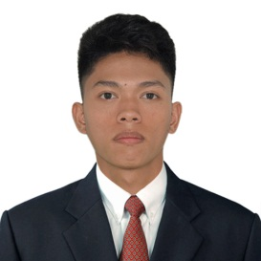

### Experience

1/2019 to 04/2019

**Student Assistant / Data Encoder**

**Management Information System (MIS) Office**, BiPSU

* Maintenance, Manage and operate the computers in MIS and Laboratory.
* Encoding the Data in Microsoft Office Word and Excel.
* Assist the CIICT Instructor to set up the projector in ANDAYA Building.
* Troubleshoot the hardware in the ANDAYA laboratory.

12/2020 to 12/2021

**Freelance Software Developer**

* Developed BiPSU Vehicle Monitoring System
* Developed Trace Biliran based on web-application
* Created DePED Student Attendance Monitoring System using QR Code with SMS Alert
* Implemented the Naval Online Public Library

### Skills

* Adept with Microsoft Office Suite(Word, PowerPoint, Excel, Outlook), Gliffy Diagrams and Adobe Acrobat
* Zoom, Google Meet and etc.
* MySQL Database Design & Management
* Programming Language: Java, Xml, C#, Php, Javascript, Css, Html
* Tools: Android Studio, Android SDK, Xampp, Visual Studio
* Database: MySQL and MariaDB
* Hardware & Software Troubleshooting
* Network Technical Support
* Windows 10 Installation, Configuration & Upgrading
* Photoshop and Video Editing

### Objective

To obtain a full time position in a multinational which offers a professional working environmental and enables me to grow while meeting the corporation’s goals.

### Education

Bachelor of Science in Computer Science - 2020

Biliran Province State Univiersity Naval, Biliran

### References

**FO2, James Q. Matugas**  
Fire Safety Inspector  
Bureau of Fire Protection  
Naval, Biliran

0965-426-1025

**Engr. Ralph Q. Espregante**Civil Engineer  
Biliran Province State University

Naval, Biliran

0916-526-8483

**Stephen Janseen D. Balo**Part-time Instructor  
Biliran Province State University  
Naval, Biliran  
0917-164-7007

JOSHUA P. CASAS  
Barangay P.I Garcia Sitio Santol. Naval, Biliran   
casassedny@gmail.com

0938-444-8321

P. CPASAS

Sitio Santol, Brgy P.I Garcia.

Naval , Biliran

0938-444-8321

casassedny@gmail.com