CHAPTER 5 – 12

CHAPTER 5 – DATA ANALYTICS LIFECYCLE
Phase | Key Activities
- Discovery  Understand the business domain and objectives. Identify past efforts, available resources, and project constraints. | - Learn business goals and context  - Review past analytic projects  - Identify stakeholders and success metrics  - Formulate Initial Hypotheses (IH)
- Data Preparation  Collect, clean, and organize data into a usable form for analysis. | - Create analytic sandbox  - Perform ELT/ETL (Extract, Load, Transform)  - Explore, clean, and integrate data  - Handle missing or inconsistent data
- Model Planning  Decide on the modeling approach and techniques to be used. | - Select suitable algorithms (e.g., regression, clustering, classification)  - Identify key variables and relationships  - Define analytical methods and workflows
- Model Building  Build, test, and refine models using the prepared data. | - Split data into training, testing, validation sets  - Implement and tune models  - Optimize model performance using hardware resources (e.g., parallel processing)
- Communicate Results  Present findings and insights in a way stakeholders can understand and act upon. | - Evaluate success criteria  - Summarize key findings  - Quantify business value  - Create visualizations, reports, and narratives
- Operationalize  Deploy the model and ensure it delivers ongoing business value. | - Deliver final reports and code  - Run pilot deployment  - Monitor model performance in production  - Communicate results effectively to non-technical audiences

Aspect | CRISP-DM (Cross Industry Standard Process for Data Mining) | KDD (Knowledge Discovery in Databases) | SEMMA (Sample, Explore, Modify, Model, Assess)
Primary Goal | Provide a structured, industry-standard process for conducting data mining projects. | Focus on discovering useful patterns and knowledge from large datasets. | Focus on building predictive models through a data mining process.
Main Phases | 1.Business Understanding  2. Data Understanding  3. Data Preparation  4. Modeling  5. Evaluation  6. Deployment | 1. Selection (choose data sources)  2. Preprocessing (cleaning & integration)  3. Transformation (feature selection & reduction)  4. Data Mining (pattern discovery/modeling)  5. Interpretation/Evaluation (analyze discovered patterns) | 1. Sample (extract representative data)  2. Explore (visualize & understand data)  3. Modify (clean & transform data)  4. Model (apply modeling techniques)  5. Assess (evaluate model performance)
Core Focus | Aligns analytical work with business goals and deployment of results. | Emphasizes the entire discovery process from data to knowledge. | Focuses on efficient model building using statistical and machine learning techniques.
Approach Type | Business-driven and iterative | Research and data-driven | Model-driven (mainly for predictive analytics)
Iteration Nature | Highly iterative — allows moving back between phases (e.g., from modeling to preparation). | Iterative — feedback between steps (e.g., evaluation may trigger re-preprocessing). | Iterative — can revisit previous phases to improve model accuracy.
Tools Commonly Used | RapidMiner, Python | SQL databases, Python, Weka, R | SAS Enterprise Miner
End Deliverable | Deployed, actionable data mining solution aligned with business value. | Knowledge or insights extracted from data. | Optimized predictive model for decision-making
Strengths | - Business-oriented  - Industry-standard and well-documented  - Widely adopted | - Theoretical and comprehensive  - Focuses on knowledge extraction, not just prediction | - Practical for machine learning  - Streamlined for predictive modeling workflows
Limitations | - Time-consuming  - Heavy focus on business alignment may delay modeling | - Lacks strong emphasis on deployment  - Less standardized than CRISP-DM | - Tool-dependent (SAS)  - Less emphasis on business context and deployment

🧠 Summary Insights
- CRISP-DM → Best for industry projects where business goals and deployment are critical.
- KDD → Best for academic or exploratory research, focusing on discovering knowledge from raw data.
- SEMMA → Best for model-building and predictive analytics, especially in environments using SAS tools.

CHAPTER 6 – DATA PREPROCESSING
Question 1 – Need for Data Preprocessing & Data Quality Dimensions
Data preprocessing is an essential step in the data mining process because real-world data is often incomplete, inconsistent, and noisy. Without preprocessing, the models built on raw data can produce inaccurate or misleading results.
Six Dimensions of Data Quality:
Accuracy | Refers to how correct the data is.  Example: Customer’s age recorded as 300 is inaccurate.
Completeness | Checks if all required data is available.  Example: Missing customer income values reduce completeness.
Consistency | Ensures data does not contradict itself across databases.  Example: A customer’s gender is “Male” in one table and “Female” in another.
Timeliness | Refers to how up-to-date the data is.  Example: Using last year’s sales for this year’s analysis may lead to poor decisions.
Believability | Measures the credibility of the data source.  Example: Data collected from official surveys is more believable than from unknown websites.
Interpretability | Indicates how easily data can be understood.  Example: Using clear labels like “Revenue (USD)” improves interpretability.

Data Preprocessing | Description
Data Cleaning | Tasks: Fill in missing values, identify outliers and smooth noisy data, and correct inconsistent data from a dataset  Reason:  Equipment malfunction, inconsistent with other recorded data and thus deleted, data not entered due to misunderstanding, not registered history or changes of the data  Techniques:  - Ignore the Tuple – Remove records with missing values  - Fill Manually – Enter missing values manually by experts  - Use Global Constant – Replace missing value with “Unknown” or a fixed number  - Use Attribute Mean – Replace missing values with the average value  - Use Mean by Class – Replace missing values with class-specific mean  - Use Most Probable Value – Estimate using Regression, decision tree, or Bayesian methods  Noisy data refers to random errors or variance in measured variables caused by data entry, transmission, technology limitation, inconsistency in naming convention, or faulty data collection instrument.  - Techniques to handle noisy data:  - Binning (Quantization):  Sort data and divide into bins of equal depth or width.  - Smoothing by bin means  - Smoothing by bin boundaries  ✅ Simple and effective for small datasets.  - Clustering:  Group similar data objects, detect and remove outliers that do not fit any cluster (noises).  ✅Automatically detects anomalies.  - Regression:  Smooth by fitting a regression line or curve to data and replace noisy values with predicted ones.  ✅ Good for continuous data.  - Computer + Human Inspection:  Detect suspicious values and check by human
Data Integration | Combine data from multiple databases, data cubes, or files  Techniques:  - Schema Integration  - Combine metadata (e.g., table names, field names, data types) from different sources.  - Example: cust_id in Database A = customer_number in Database B.  - Entity Identification / Matching  - Identify and merge records that refer to the same real-world entity across sources.  - Example: “J. Lim” and “James Lim” may represent the same person.  - Data Value Conflict Detection & Resolution  - Resolve conflicts when data for the same entity differs between sources.  - Example: One source records “Height = 180 cm”, another “Height = 5.9 ft”.  - Handling Redundant Data  - Detect and remove duplicate or derived data from multiple databases.  - Example: Annual revenue might already include monthly revenue totals.  - Data Standardization and Unit Conversion  - Convert data to common units, scales, and formats (e.g., metric vs imperial).  - Example: Convert “miles” to “kilometers”.
Data Reduction | Reduce data volume and complexity while maintaining the same analytical results, improving processing speed and storage efficiency  - Dimensionality reduction  - Reduce the number of attributes or features.  - Example: Use Principal Component Analysis (PCA) or Feature Selection to keep the most important variables.  - Numerosity reduction  - Replace large datasets with smaller, representative models.  - Techniques include:  - Parametric methods: Use models such as regression or clustering to represent data.  - Non-parametric methods: Use sampling or histograms to approximate data distribution.  - Data compression  - Use encoding methods to store data in compact form without losing meaning.  - Example: Huffman coding, Wavelet transforms.
Data Transformation and Data Discretization | Data transformation improves model performance and analysis by converting data to suitable formats or changing variable distribution  Main Techniques:  - Smoothing  - Remove noise from data  - E.g., using binning, clustering, or regression  - Aggregation  - Summarize data by combining multiple values into one  - E.g., average (daily/weekly/monthly), sum, count).  - Generalization:  - Replace low-level data with higher-level concepts using hierarchies.  - E.g., Youth, Middle-aged, Senior  - Normalization  - Scale numerical values into a specific range (usually 0–1).  - Common methods: Min-Max normalization, Z-Score Normalization, Decimal Scaling  - Logarithmic, Square, or Reciprocal Transformation  - Reduce Skewness and achieve normal distribution  - Rank Transformation:  - Replaces values with their rank order.  - Useful when scale differences distort relationships.  - E.g., Convert income values into ranks 1, 2, 3, etc.  - Box–Cox Transformation:  - Converts skewed data into an almost normal distribution.  - E.g., Used for income or price data with right skewness.  - Histogram  - Visual technique to reshape variable distribution by binning frequency counts.  - Helps understand skewness and determine proper transformation.

CHAPTER 7 - REGRESSION (Supervised Learning)
 | Linear Regression | Logistic Regression
 | Both are supervised learning algorithms, but they differ in their output nature and loss functions.
Purpose | Used to predict continuous numerical values (e.g., sales, temperature, house price). | Used to predict categorical outcomes, typically binary (e.g., yes/no, spam/not spam, disease/no disease).
How It Works | It fits a straight line that minimizes the sum of squared differences between predicted and actual values. The relationship between dependent and independent variables is assumed linear. | It applies a sigmoid (logistic) function to map predicted values into a range between 0 and 1. The output represents the probability of belonging to a specific class.
Output | Direct numerical prediction (e.g., 45.6) | Probability value (0–1), interpreted as the likelihood of belonging to a class
Error Function | Uses Mean Squared Error (MSE) or Root Mean Squared Error (RMSE). | Uses Log Loss (Cross-Entropy Loss) to measure classification performance.
Decision Boundary | Straight line (in simple regression) | Sigmoid (S-shaped) curve that maps input to probability space
Example Use Cases | • House Price Prediction: Estimate house prices based on features like area, location, and number of rooms.  • Sales Forecasting: Predict future sales revenue based on advertising budget and past sales data.  • Demand Prediction: Estimate product demand from seasonal trends, customer income, and promotions.  • Temperature Prediction: Forecast tomorrow’s temperature based on humidity, pressure, and wind speed. | • Spam Email Detection: Classify emails as spam (1) or not spam (0) based on text features and sender info.  • Customer Churn Prediction: Predict whether a customer will leave a service (churn = 1) or stay (0) using account activity and satisfaction score.  • Disease Diagnosis: Predict if a patient has a disease (1) or not (0) based on symptoms and medical test results.  • Credit Default Prediction: Determine whether a borrower will default (1) or repay (0) using credit history and income data.

 | Linear Regression | Logistic Regression
Advantages | - Easy to implement and understand — provides a clear mathematical relationship between dependent and independent variables through a straight line.  - Requires low computational power; can be trained quickly even on large datasets using Ordinary Least Squares (OLS).  - Provides continuous numerical predictions, which are useful for forecasting and regression tasks such as predicting sales or prices.  - Coefficients directly show how each independent variable influences the dependent variable — helpful for understanding cause-effect relationships.  - Forms the basis for more advanced regression techniques such as Ridge, Lasso, and Polynomial Regression. | - Simple and interpretable — outputs probabilities that can be easily understood in terms of likelihood of belonging to a particular class.  - Also computationally efficient; training using Maximum Likelihood Estimation (MLE) converges quickly for small to medium datasets.  - Provides probability-based classification, useful for binary outcomes like churn prediction or disease diagnosis.  - Coefficients represent changes in log-odds, which can help interpret how features increase or decrease the likelihood of an event.  - Serves as the foundation for more complex classification models like Softmax Regression (multiclass), and Neural Network output layers.
Limitations | - Assumes a linear relationship between variables; performs poorly when relationships are nonlinear.  - Strongly affected by outliers — extreme values can distort the regression line and reduce accuracy.  - Cannot handle categorical dependent variables — unsuitable for classification tasks.  - Highly correlated predictors can cause unstable coefficient estimates and reduce interpretability.  - Assumes that the errors are normally distributed and have equal variance; overfitting may occur with too many predictors. | - Assumes a linear relationship between predictors and log-odds, which may not hold true for complex datasets.  - Also sensitive to outliers, as they can disproportionately affect the estimated probabilities and decision boundary.  - Limited to binary classification (unless extended to multinomial logistic regression).  - Suffers from multicollinearity too, which affects the stability and interpretability of log-odds coefficients.  - Assumes independent observations and correct model building with the right variables and relationships; may overfit if too many variables or irrelevant predictors are included.

CHAPTER 8 – NAIVE BAYES (Supervised Learning)
Aspect | Explanation
Definition | A probabilistic classifier based on Bayes’ Theorem.  Assume all features are independent of each other  Assume no relationship between each attribute against target variable
Purpose | Used for classification — predicts the probability that a record belongs to a particular class.
How it works | - Calculate prior probabilities $P(B_{j})$for each class.  - Compute conditional probabilities $P(ai| bj)$
Use Cases | - Spam filtering (email classification) – Spam / Not Spam  - Sentiment analysis – Positive / Negative / Neutral  - Document/text classification – Sport / Politics / Health  - Fraud detection – Fraud / Not Fraud  - Medical diagnosis – Disease Present / Disease Absent  - Credit Risk Assessment – Good Credit / Bad Credit
Data Requirements | - Works best with categorical/discrete variables  - Continuous variables need to be discretized (e.g., Gaussian NB).
Implementation Tips | - Use log probabilities to avoid numerical underflow.  - Apply smoothing (Laplace smoothing) to handle zero probabilities.
Evaluation Methods | - Hold-out testing/cross-validation  - Confusion matrix for accuracy, precision, recall, FPR, FNR  - ROC curve / AUC
Advantages | - Handles missing values quite well (Compared to Logistic Regression)  - Robust to irrelevant variables/outliers. Irrelevant features have little impact because probabilities are multiplied independently.  - Easy to implement. Straightforward and easy to code and explain.  - Resistant to over-fitting. Simplicity of the model helps avoid overfitting, especially with limited data.  - Computationally efficient. Can handle very high-dimensional problems and categorical variables with a lot of levels
Disadvantages | - Assumes independence among features. Real-world data often contains correlated variables, which violates the “naïve” assumption.  - Sensitive to correlated variables. When features depend on each other, probabilities can be “double-counted,” leading to errors.  - Continuous data must be discretized. Naïve Bayes works best with categorical variables. Continuous needs to be converted into intervals. (Not regression friendly)  - Poor at estimating probabilities. Better for classification than probability prediction  - May struggle with small datasets. Probability estimates may be unreliable without smoothing. Need as many columns as possible; the probability is improved based on the input. If the dataset has fewer columns, suggest using linear regression

Why need to do Laplace Smoothing (Add-1)
- No zero probabilities
- Helps the model handle unseen words gracefully
- Ensures all words have at least a small chance of occurring
Question 1
What Is Classification? What Is Prediction? Give an example to illustrate your answer
Classification refers to assigning a class from a predefined set of classes based on the given features. For example, classifying a person as male or female. Prediction is similar to classification, however the output is an estimation of a continuous value and there is no classes from a set to choose from. For example, predicting likelihood of customer churn.

Question 2
The following table contains the training dataset of ABC company:
- Using the Bayesian Classification method to classify the following sets:
W = (youth, medium, yes, fair)
X = (youth, high, yes, excellent)
Y = (senior, low, no, fair)
Z = (junior, medium, yes, poor)
Prior probability
P(buy) = 9/14
P(not buy) = 5/14
Likelihood probability
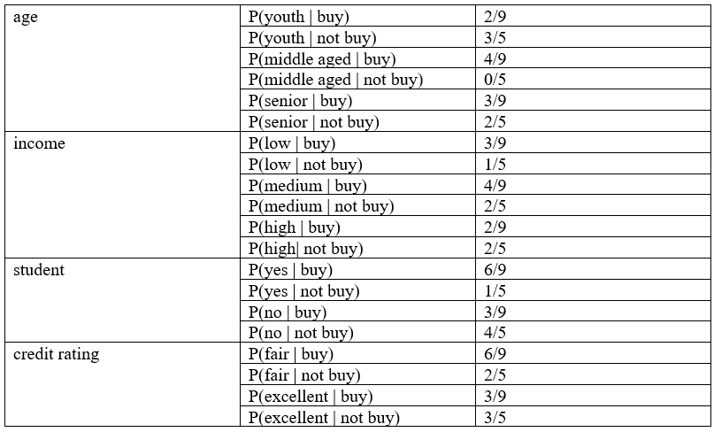
W = (youth, medium, yes, fair)
P(buy | W)
= P(buy) * P(youth | buy) * P(medium | buy) * P(yes | buy) * P(fair | buy)
= $\frac{9}{14}×\frac{2}{9}×\frac{4}{9}×\frac{6}{9}×\frac{6}{9}$
= 0.0282

P(not buy | W)
= P(not buy) * P(youth | not buy) * P(medium | not buy) * P(yes | not buy) * P(fair | not buy)
= $\frac{5}{14} ×\frac{3}{5} × \frac{2}{5} × \frac{1}{5} × \frac{2}{5}=0.0069$
W is predicted to buy a computer.

X = (youth, high, yes, excellent)
P(buy | X)
= P(buy) * P(youth | buy) * P(high | buy) * P(yes | buy) * P(excellent | buy)
= $\frac{9}{14}×\frac{2}{9}×\frac{2}{9}×\frac{6}{9}×\frac{3}{9}$
= 0.0071

P(not buy | X)
= P(not buy) * P(youth | not buy) * P(high | not buy) * P(yes | not buy) * P(excellent | not buy)
= $\frac{5}{14}×\frac{3}{5}×\frac{2}{5}×\frac{1}{5}×\frac{3}{5}$
= 0.0103

X is predicted to not buy a computer.

Y = (senior, low, no, fair)
P(buy | Y)
= P(buy) * P(senior | buy) * P(low | buy) * P(no | buy) * P(fair | buy)
= $\frac{9}{14}×\frac{3}{9}×\frac{3}{9}×\frac{3}{9}×\frac{6}{9}$
= 0.0159

P(not buy | Y)
= P(not buy) * P(senior | not buy) * P(low | not buy) * P(no | not buy) * P(fair | not buy)
= $\frac{5}{14}×\frac{2}{5}×\frac{1}{5}×\frac{4}{5}×\frac{2}{5}$
= 0.0091

Y is predicted to buy a computer.

Z = (junior, medium, yes, poor)
Zero division error

- Use the Laplacian correction to resolve any case that have the probability equal to zero.
Z = (junior, medium, yes, poor)
P(junior | buy) = $\frac{count\left(junior \right|buy)+1}{count\left(buy\right)+(3*1)}$ = $\frac{0+1}{9 +3}$ = $\frac{1}{12}$
P(medium | buy) = $\frac{count\left(medium \right|buy)+1}{count\left(buy\right)+(3*1)}$ = $\frac{4+1}{9 +3}$ = $\frac{5}{12}$
P(yes | buy) = $\frac{count\left(yes \right|buy)+1}{count\left(buy\right)+(2*1)}$ = $\frac{6+1}{9 +2}$ = $\frac{7}{11}$
P(poor | buy) = $\frac{count\left(poor \right|buy)+1}{count\left(buy\right)+\left(2*1\right)}$ = $\frac{0+1}{9 +2}$ = $\frac{1}{11}$
P(buy | Z)
= $\frac{9}{14}×\frac{1}{12}×\frac{5}{12}×\frac{7}{11}×\frac{1}{11}$
= 0.0013

P(junior | not buy) = $\frac{count\left(junior \right|not buy)+1}{count\left(not buy\right)+(3*1)}$ = $\frac{0+1}{5 +3}$ = $\frac{1}{8}$
P(medium | not buy) = $\frac{count\left(medium \right|not buy)+1}{count\left(not buy\right)+(3*1)}$ = $\frac{2+1}{5 +3}$ = $\frac{3}{8}$
P(yes | not buy) = $\frac{count\left(yes \right|not buy)+1}{count\left(not buy\right)+(2*1)}$ = $\frac{1+1}{5 +2}$ = $\frac{2}{7}$
P(poor | not buy) = $\frac{count\left(poor \right|not buy)+1}{count\left(not buy\right)+\left(2*1\right)}$ = $\frac{0+1}{5 +2}$ = $\frac{1}{7}$
P(not buy | Z)
= $\frac{5}{14}×\frac{1}{8}×\frac{3}{8}×\frac{2}{7}×\frac{1}{7}$
= 0.0007

Z is predicted to buy a computer.

CHAPTER 9 – DECISION TREES (Supervised Learning)
 | Decision Tree Classifier
Description | - A supervised machine learning algorithm used for categorical prediction (classification tasks).  - It splits the dataset into smaller subsets based on the most significant features that separate classes.  - The final model resembles a tree-like structure — where each internal node represents a decision rule, each branch represents a possible outcome, and each leaf node represents a final class label (prediction).
How It Works | - The algorithm selects the best feature to split the data using metrics such as Information Gain (based on Entropy) or the Gini Index.  - The dataset is split into branches according to the feature values.  - This process repeats recursively (recursive partitioning) until all data points belong to a single class or a stopping criterion (like maximum depth) is reached.  - The final leaf nodes represent the predicted class labels.
Diagnostics | 🔍 Use Hold-out/Cross-validation for performance validation.  📈 Use ROC/AUC and Confusion Matrix for performance metrics.  🌿 Check tree depth, node sizes, and domain relevance to avoid overfitting.
Example Use Cases | - If predicting whether a customer will buy a product, the tree might first split by Income, then by Age, and finally by Previous Purchases to reach a “Yes/No” decision.  - Classify students as Pass or Fail based on attendance, test scores, and assignments.  - Classify loan applications as Approved or Rejected based on credit score, income, and debt ratio.  - Predict whether a patient has diabetes (Yes/No) based on blood pressure, glucose level, and BMI.
Advantages | - The decision-making process is transparent and interpretable. It can be represented visually as a flowchart, making it easier to explain results to business users or stakeholders.  - Can handle a mix of continuous variables (like age, income) and categorical variables (like gender, education).  - Unlike algorithms such as SVM or KNN, Decision Trees don’t require normalization or standardization of data.  - Decision Trees can split data in a hierarchical way, effectively modeling complex and nonlinear patterns between input features and target labels.  - During training, the algorithm identifies which features contribute most to classification accuracy — useful for feature selection and interpretation.
Limitations | - Decision Trees can become too deep and complex, fitting noise in the training data instead of general patterns. This reduces performance on unseen data.  - Small changes in the dataset can lead to a completely different tree structure, showing inconsistency in predictions.  - Features with many distinct values can dominate splits, leading to biased trees.  - A single Decision Tree may not achieve high accuracy; ensemble methods like Random Forest or Gradient Boosting are usually more reliable.  - To improve generalization, hyperparameters such as max_depth, min_samples_split, or criterion must be carefully adjusted, which adds complexity.

🧠 Summary for Exam
- The Decision Tree Classifier splits data recursively to classify records into categories using decision rules based on feature values.
- It’s interpretable, flexible, and effective for nonlinear problems, but can overfit and lack stability without pruning or ensemble methods.
The table below contains travel agency data information. Draw decision tree using ID3 algorithm.
Example | Type of call | Lang. fluency | Ticket | Age | Decision attribute
E1 | Local | Fluent | Long | Very young | Buy
E2 | Local | Fluent | Long | Old | Buy
E3 | Long dist | Not fluent | Short | Very old | Buy
E4 | Intern | Accent | Long | Very old | Buy
E5 | Local | Fluent | Short | Middle | Buy
E6 | Local | Not fluent | Short | Very young | Not buy
E7 | Intern | Fluent | Short | Middle | Not buy
E8 | Intern | Foreign | Long | Young | Not buy
E9 | Local | Not fluent | Long | Middle | Not buy

List of attributes
- Type of call = {Local, Long dist, Intern}
- Lang. fluency = {Fluent, Not fluent, Accent, Foreign}
- Ticket = {Short, Long, Local}
- Age = {Very young, Young, Middle, Old, Very old}
- Decision (class) = {Buy, Not buy}

First Cycle
P(Buy) = $\frac{5}{9}$
P(Not Buy) = $\frac{4}{9}$
Entropy(S) = $-\frac{5}{9}\log_{2}\frac{5}{9}+(-\frac{4}{9}\log_{2}\frac{4}{9})$
= 0.9911

Type of Call
Local = [3+, 2-]
Entropy(Local) =$-\frac{3}{5}\log_{2}\frac{3}{5}+(-\frac{2}{5}\log_{2}\frac{2}{5})$ = 0.971
Long dist = [1+, 0-]
Entropy(Long dist) = 0
Intern = [1+, 2-]
Entropy(Intern) = $-\frac{1}{3}\log_{2}\frac{1}{3}+(-\frac{2}{3}\log_{2}\frac{2}{3})$ = 0.9183
Avg Entropy = $\frac{5}{9}\left(0.971\right)$ + $\frac{1}{9}\left(0\right)$ + $\frac{3}{9}\left(0.9183\right)$
= 0.8455
Information Gain = 0.9911 – 0.8455 = 0.1456
Lang Fluency
Fluent = [3+, 1-]
Entropy(Local) =$-\frac{3}{4}\log_{2}\frac{3}{4}+(-\frac{1}{4}\log_{2}\frac{1}{4})$ = 0.8113
Not Fluent = [1+, 2-]
Entropy(Intern) = $-\frac{1}{3}\log_{2}\frac{1}{3}+(-\frac{2}{3}\log_{2}\frac{2}{3})$ = 0.9183
Accent = [1+, 0-]
Entropy(Accent) = 0
Foreign = [0+, 1-]
Entropy(Foreign) = 0
Avg Entropy = $\frac{4}{9}\left(0.8113\right)$ + $\frac{3}{9}\left(0.9183\right)$ + $\frac{1}{9}\left(0\right)$ + $\frac{1}{9}\left(0\right)$
= 0.6667
Information Gain = 0.9911 – 0.6667= 0.3244

Ticket
Short = [2+, 2-]
Long = [3+, 2-]
Entropy(Short) = 1
Entropy(Long) = $-\frac{3}{5}\log_{2}\frac{3}{5}+(-\frac{2}{5}\log_{2}\frac{2}{5})$ = 0.971
Avg Entropy = $\frac{5}{9}\left(0.971\right)$ + $\frac{4}{9}\left(1\right)$
= 0.9839
Information Gain = 0.9911 – 0.9839
= 0.0072

Age
Very Young = [1+, 1-]
Entropy(Very Young) = 1
Young = [0+, 1-]
Entropy(Young) = 0
Middle = [1+, 2-]
Entropy(Middle) =$-\frac{1}{3}\log_{2}\frac{1}{3}+(-\frac{2}{3}\log_{2}\frac{2}{3})$ = 0.9183
Old = [1+, 0-]
Entropy(Old) = 0
Very Old = [2+, 0-]
Entropy(Very Old) = 0
Avg Entropy = $\frac{2}{9}\left(1\right)$ + $\frac{1}{9}\left(0\right)$ + $\frac{3}{9}\left(0.9183\right)$ + $\frac{1}{9}\left(0\right)+ \frac{2}{9}\left(0\right)$
= 0.5283
Information Gain = 0.9911 – 0.5283
= 0.4628

Summary
Type of call = 0.1456
Lang. Fluency = 0.3244
Ticket = 0.0072
Age = 0.4628

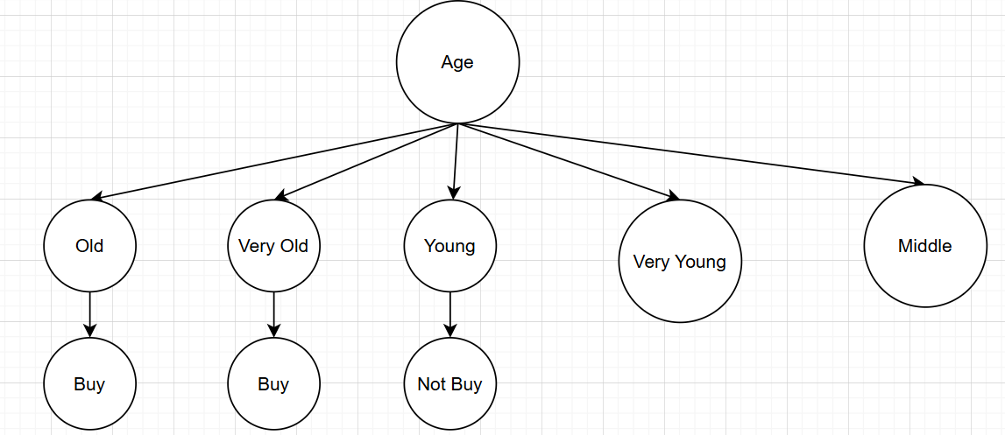

Second Cycle
Remaining - E1, E5, E6, E7, E9
Type of call = {Local, Intern}
Lang. Fluency = {Fluent, Not Fluent}
Ticket = {Short, Long}

Entropy(S) = $-\frac{2}{5}\log_{2}\frac{2}{5}+(-\frac{3}{5}\log_{2}\frac{3}{5})$
= 0.971

Type of Call
Entropy(Local) = 1
Entropy(Intern) = 0
Avg Entropy = $\frac{4}{5}\left(1\right)$+($\frac{1}{5}$)(0)
= 0.8
Information Gain = 1 – 0.8 = 0.2

Lang. Fluency
Entropy(Fluent) = $-\frac{2}{3}\log_{2}\frac{2}{3}+(-\frac{1}{3}\log_{2}\frac{1}{3})$ = 0.9183
Entropy(Not Fluent) = 0
Avg Entropy = $\frac{3}{5}$ (0.9183) + $\frac{2}{5}$ (0) = 0.551
Information Gain = 1 – 0.551 = 0.449

Ticket
Entropy(Short) = $-\frac{1}{3}\log_{2}\frac{1}{3}+(-\frac{2}{3}\log_{2}\frac{2}{3})$ = 0.9183
Entropy(Long) = 1
Avg Entropy = $\frac{3}{5}$ (0.9183) + $\frac{2}{5}$ (1) = 0.951
Information Gain = 1 – 0.951 = 0.049

Summary
Type of call = 0.2
Lang. Fluency = 0.449
Ticket = 0.049
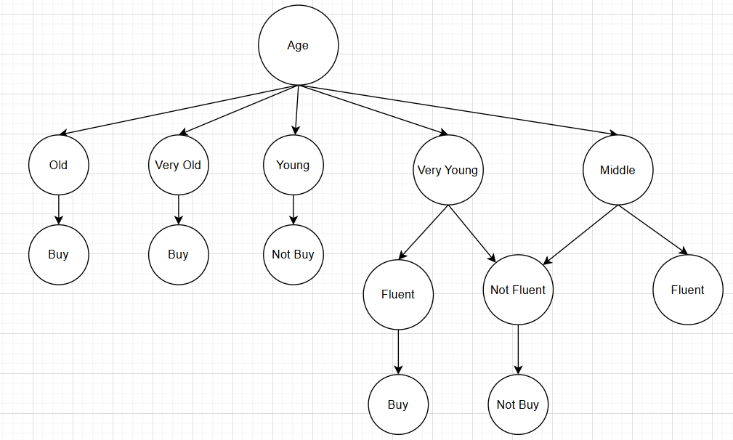

Third Cycle
Remaining – E5, E7
Type of Call
Entropy(Local) = 0
Entropy(Intern) = 0
Information Gain = 1 – 0 = 1

Ticket
Entropy(Short) = $1$
Information Gain = 1 – 1 = 0

Summary
Type of call = 1
Ticket = 0

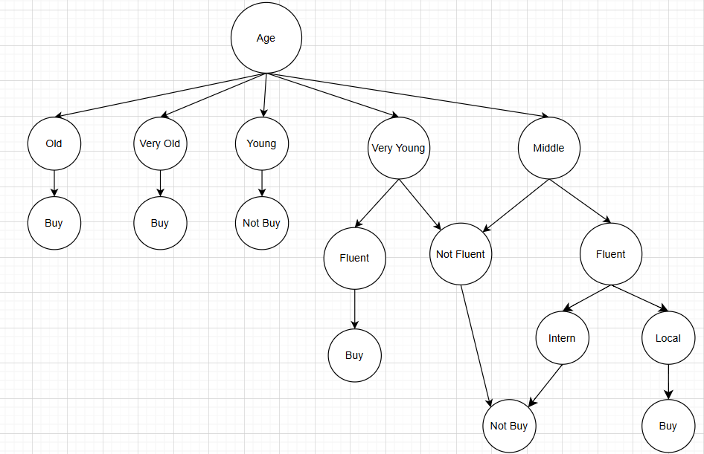

CHAPTER 10 – TEXT MINING
Aspect | Details
Definition | Text mining (or text analysis) is the process of extracting useful information and patterns from unstructured text data such as documents, reviews, or social media posts.  Meaningful insights (TF-IDF) and models (NB) for classification and search/retrieval for relevance
Nature of Text Data | - Unstructured and high-dimensional (each word can be a separate dimension).  - Requires converting text into structured form for analysis.
Key Tasks in Text Analysis | - Parsing – Converts unstructured or semi-structured text into a structured format.  - Search/Retrieval – Finding relevant topics or keywords within a document or a corpus. Results in a structured set of tokens or keywords for further analysis. (E.g., Use a regular expression)  - Text Mining – Understanding content through classification or clustering to derive insights and meaning from the text. (E.g., Topic Tagging, Sentiment Analysis)
Challenges in Text Analysis | - Finding structure in unstructured data. The text is unorganized and needs to be structured before analysis. Example: Turning a review like “I love my bPhone!” into structured data → product: bPhone, sentiment: positive.  - Very high dimensionality (many unique words). Each unique word becomes a feature, leading to a large dataset. Example: 5,000 tweets contain 10,000 unique words → 10,000 features to analyze.  - Managing dynamic and growing text corpora. New text is added constantly, changing word frequency and relevance. Example: New tweets or reviews appear every day, introducing new words like “#bPhonePro”.  - Choosing the right features and preprocessing methods. Proper text cleaning and feature selection are needed for accurate results. Example: “run”, “running”, and “ran” should be treated as the same word → “run”.
Application | Brand Monitoring / Sentiment Analysis: Companies analyze social media (Twitter, Facebook, reviews) to determine what customers think about their products (positive/negative sentiment).  - Marketing & Brand Monitoring – Track public perception of products or campaigns.  - Crisis Detection – Identify early signs of public backlash or negative publicity.  - Competitor Analysis – Compare buzz around competing brands.  - Trend Discovery – Detect emerging topics, hashtags, or consumer interests.  - Political Analysis – Track discussions around policies, candidates, or events.
Buzz Tracking Process | Buzz Tracking is the process of collecting and analyzing online text data (like reviews or social media posts) to detect public opinion, product mentions, and emerging trends using text mining techniques.  - Monitor social networks, review sites for mentions of products.  - Parse and filter data feeds to identify mentions of product names (using Regular Expressions).  - Regular Expression: Detect words or pattern matching (for parsing)  - Collect the reviews.  - Extract relevant raw text, convert it into document representation, and index into the review corpus.  - Bag of Words model: Represents text as a vector of unique terms where each term’s value reflects its frequency (tf) within the document.  - The vector is often high-dimensional (many unique words).  - Dimensionality reduction techniques: Remove stopwords (the, a), remove pronouns, or apply stemming (phone = phones)  - Vector space should include only essential words for meaningful analysis.  - Sort the reviews by product.  - Organize reviews by product categories.  - Classification / Topic Tagging - Assign topics to a document based on terms  - Determine if reviews are good or bad  - Analyze sentiments (positive, negative, neutral).  - Sentiment Analysis  - Marketing reads selected reviews for deeper insights.  - Retrieve and examine selected reviews.  - Search / Information Retrieval  - Measure the quality of the results  - Precision – % of retrieved documents that are relevant.  - Recall – % of all relevant documents in the corpus that were retrieved.  - Inverse Document Frequency (idf): Measures term uniqueness in the corpus (rare terms = higher importance).  - TF-IDF: Combines term frequency and idf to weight uncommon but significant terms more heavily.  - Results are ranked by relevance score using tf-idf.

CHAPTER 11 – K-MEANS CLUSTERING (Unsupervised Learning)
Euclidean Distances Formula
d = $\sqrt{{\left(x_{2}-x_{1}\right)}^{2}}+{\left(y_{2}-y_{1}\right)}^{2}$
Calculation Question:
Suppose that we have the following data:
a (0,2) , b (1,2), c ( 2,2 ), d ( 3,3 ), e ( 5,4), f ( 3,5)
Identify the clusters by applying the k-means algorithm.
Suppose that we required two clusters, k = 2.
Suppose that initial cluster center locations are m1 (1,2) and m2 (3,3).
1) First List
Points | Coordinate | M1 (1,2) M1 - Points | M2(3,3) M2 - Points | Closet to
A | (0,2) | 1 | 10 | M1
B | (1,2) | 0 | 5 | M1
C | (2,2) | 1 | 2 | M1
D | (3,3) | 5 | 0 | M2
E | (5,4) | 20 | 5 | M2
F | (3,5) | 13 | 2 | M2

2) Calculate new centroids
New m1 (Average X coordinates ) | New m2 (Average Y coordinates )
X= (0+1+2)/3 = 1  Y= (2+2+2)/3=2  M1’ = (1,2) | X= (3+5+3)/3 = 11/3  Y= (3+4+5)/3 = 4  M2’ = (11/3, 4)

3) New List (Final Set)
Points | Coordinate | M1’ (1,2) | M2’ (11/3, 4) | Closet to
A | (0,2) | 1 | 17.444 | M1
B | (1,2) | 0 | 3.3333 | M1
C | (2,2) | 1 | 2.6034 | M1
D | (3,3) | 5 | 1.2018 | M2
E | (5,4) | 20 | 1.3333 | M2
F | (3,5) | 13 | 1.2018 | M2

Result: No movement of cluster. Closest to nearest cluster did not change
- Cluster 1: a(0,2), b(1,2), c(2,2)
Centroid m1 = (1,2)

- Cluster 2: d(3,3), e(5,4), f(3,5)
Centroid m2 = (11/3, 4) ≈ (3.6667, 4)

 | K-Means Clustering
What is Clustering? | - Clustering is an unsupervised learning technique used to group similar data points together based on their features, such that data points within the same group (cluster) are more similar to each other than to those in other clusters.  - It is mainly used to discover hidden patterns or structures in data
What is K-Means Clustering? | - K-Means is a partition-based clustering algorithm that divides a dataset into K distinct, non-overlapping clusters based on similarity (measured by a distance metric like Euclidean distance).  - Each cluster is represented by its centroid — the mean of all data points in that cluster.
How K-Means Works | Step 1: Choose the number of clusters K.  Step 2: Randomly initialize K centroids.  Step 3: Assign each data point to the nearest centroid (forming K clusters).  Step 4: Compute new centroids as the average of data points in each cluster.  Step 5: Reassign points to the nearest new centroid and repeat Steps 4–5 until cluster assignments no longer change (convergence).
Optimal Number of K | - The Elbow Method identifies the optimal number of clusters (K) in K-Means by plotting the Within-Cluster Sum of Squares (WSS) against K and selecting the point where the rate of decrease sharply slows down (the “elbow”), indicating a balance between compactness and simplicity.  - WSS measures how tightly the data points in a cluster are grouped around their centroid  - Low WSS = High cluster cohesion, but too low → overfitting.  - The Elbow Point represents where adding more clusters gives diminishing returns.  - Use domain knowledge + visualization to confirm that the selected K makes sense for the problem context.
Example Use Cases | - Customer Segmentation: Grouping customers by purchasing behavior or demographics.  - Image Compression: Reducing colors by grouping similar pixel values.  - Market Segmentation: Identifying groups of consumers with similar spending patterns.  - Document Clustering: Grouping articles or reviews with similar content.  - Anomaly Detection: Identifying data points that do not belong to any cluster (outliers).
Advantages | - Easy to implement and computationally efficient, even on large datasets.  - Performs well on large datasets due to its linear time complexity (O(n)).  - Results (centroids and cluster assignments) are easy to understand and visualize.  - New data points can be quickly assigned to existing clusters by checking the nearest centroid.  - Helps in identifying patterns and reducing dimensionality by summarizing groups with their centroids.
Limitations | - Sensitive to Initial Centroids. Different starting points may lead to different final clusters (local minima problem).  - The number of clusters K must be chosen beforehand, which may be difficult to estimate accurately.  - Cannot directly handle categorical variables. It works only with numerical data.  - Euclidean distance is sensitive to variable scales. Changing units can distort clustering results. Therefore, data standardization or normalization is required before applying K-Means.  - Performs poorly when clusters are non-spherical, elongated, or uneven in size.

CHAPTER 12 – ASSOCIATION RULES
Aspect | Details
Definition | Association rule mining is an unsupervised learning technique used to discover interesting relationships or patterns among variables in large datasets.
Purpose | To find if-then relationships (co-occurrences) between items — e.g., “If a customer buys bread and milk, they are likely to buy diaper.”
Rule Format | X → Y where X (antecedent) and Y (consequent) are itemsets.  Example: {Milk, Diaper} → {Beer}
Type of Data | Transactional data (e.g., market basket analysis, clickstreams, logs).
Steps | - Frequent Itemset Generation  - Generate all itemsets whose support > minsup  - Rule generation  - From each frequent itemset, generate association rules with high confidence.  - These rules show how items are related or bought together.
Common Use Cases | - Market Basket Analysis (products bought together)  - Recommendation systems (e.g., “Users who bought X also bought Y”)  - Web usage mining  - Medical diagnosis (symptom → disease)  - Cross-selling and product placement
Key Terms | - Itemset: A group of items (e.g., {Milk, Bread})  - k-itemset: Itemset with k items (e.g., {Milk, Bread, Butter} is a 3-itemset).  - Support Count (σ): Frequency of occurrence of an itemset  - Support (s): Fraction of transactions that contain an itemset  - Confidence (c): Conditional probability that a transaction having {X U Y} also contains Z
Apriori Algorithm | - A classic algorithm for mining frequent itemsets and association rule  - If an itemset is frequent, all of its subsets must also be frequent.  - If an itemset is infrequent, all supersets can be pruned.
How it works  Apriori | - Let k = 1, Generate frequent 1-itemsets  - Join frequent k-itemsets to form candidate (k+1)-itemsets  - Prune 删除candidates containing infrequent subsets  - Count support and eliminate infrequent candidates  - Generate high-confidence rules
Advantages | - Easy to implement. The Apriori algorithm and association rule mining are straightforward to code and understand — only require counting item combinations and applying thresholds. Example: In a supermarket dataset, it’s easy to find rules like {Bread, Butter} → {Jam} using simple counting and filtering steps.  - Uses Apriori property to reduce search space. The Apriori principle helps skip unnecessary combinations — if an itemset is not frequent, its supersets are automatically ignored. Example: If {Milk, Eggs} is infrequent, there’s no need to test {Milk, Eggs, Diaper} — this saves a lot of computation.  - Easy to parallelize. Each transaction can be processed independently, allowing multiple processors to work on different data parts simultaneously. Example: Large online store data (e.g., Amazon) can be split across servers to calculate frequent itemsets faster in parallel.
Limitations | - Requires many database scans. The algorithm needs to repeatedly scan the dataset to count item frequencies, which is time-consuming for large databases. Example: In a supermarket with 1 million transactions, Apriori must rescan the data for every level (1-itemset, 2-itemset, 3-itemset, etc.), causing slow performance.  - Exponential time complexity. As the number of items increases, the number of possible combinations grows exponentially, increasing computation time. Example: With 100 items, there are over a million possible item combinations — making it very slow to process.  - May find coincident relationships (need Lift/Leverage for validation). Some discovered rules may happen by chance and not represent true relationships — they must be validated using measures like Lift or Leverage. Example: A rule like {Umbrella} → {Milk} may appear frequent just because both are common items, not because they are related purchases.

Calculation Question:
Using Apriori algorithm for the IT store below to classify the results assuming thresholds of s=33% and c=70%. Identify the candidate and frequent itemset for every scan. Finally, present the output of association rule by demonstrating the strong itemset, order by confidence
SET | ITEMS
S1 | Laptop, Mouse, Keyboard
S2 | Laptop, Mouse
S3 | Laptop, Headset, Printer
S4 | Printer, Headset
S5 | Printer, Keyboard
S6 | Laptop, Headset, Printer
Step 1: Support Calculation
Transaction = 6
Items, K=1 | Count | Support
{Laptop} | 4 (S1, S2, S3, S6) | 66.7
{Mouse} | 2 (S1, S2) | 33.3
{Keyboard} | 2 (S1, S5) | 33.3
{Headset} | 3 (S3, S4, S6) | 50
{Printer} | 4 (S3, S4, S5, S6) | 66.7

Items, K=2 | Count | Support
{Laptop, Mouse} | 2(S1, S2) | 33.3
{Laptop, Keyboard} | 1(S1) | 16.7
{Laptop, Headset} | 2(S3, S6) | 33.3
{Laptop, Printer} | 2(S3, S6) | 33.3
{Mouse, Keyboard} | 1(S1) | 16.7
{Mouse, Headset} | 0 | 0
{Mouse, Printer} | 0 | 0
{Keyboard, Headset} | 0 | 0
{Keyboard, Printer} | 1(S5) | 16.7
{Headset, Printer} | 3(S3, S4, S6) | 50

Items, K=3 | Count | Support
{Laptop, Headset, Printer} | 2(S1, S2) | 33.3
{Laptop, Mouse, Printer} | 0
{Laptop, Mouse, Headset} | 0
Step 2: Association Rules
Confidence = support(X∪Y) / support(X)
threshold=70%
L2 | Pairs | Confidence >=70%
{Laptop, Mouse} | Laptop → Mouse: 2/4 = 50% ❌  Mouse → Laptop: 2/2 = 100% ✅ | Mouse → Laptop
{Laptop, Headset} | Laptop → Headset: 2/4 = 50% ❌  Headset → Laptop: 2/3 = 66.7% ❌
{Laptop, Printer} | Laptop → Printer: 2/4 = 50% ❌  Printer → Laptop: 2/4 = 50% ❌
{Headset, Printer} | Headset → Printer: 3/3 = 100% ✅  Printer → Headset: 3/4 = 75% ✅ | Headset → Printer  Printer → Headset

L3: {Laptop, Headset, Printer} | Pairs | Confidence >=70%
{Laptop, Headset} | {Laptop, Headset} → Printer  Printer: 2/2 = 100% ✅ | {Laptop, Headset} → Printer
{Laptop, Printer} | {Laptop, Printer} → Headset  Headset: 2/2 = 100% ✅ | {Laptop, Printer} → Headset
{Headset, Printer} | {Headset, Printer} → Laptop  Laptop: 2/3 = 66.7% ❌

Step 3: Final Output (ordered by confidence)
- Mouse → Laptop (0.33, 100%)
- Headset → Printer (0.5, 100%)
- {Laptop, Headset} → Printer (0.33, 100%)
- {Laptop, Printer} → Headset (0.33, 100%)
- Printer → Headset (0.5, 75%)

EXTRA NOTES:

Diagnostics of Supervised Learning
Techniques | Descriptions
- Hold-out Data (Train-Test Split) | - Split the dataset into training and testing subsets (e.g., 70%-30% or 80%-20%) to evaluate how well the model generalizes to unseen data.
- ROC Curve (Receiver Operating Characteristic) | - A plot of True Positive Rate vs False Positive Rate  - Shows the trade-off between detecting positives and avoiding false alarms.  - A smooth, higher curve indicates better classification performance.
- AUC (Area Under the Curve) | - Numerical measure (0 to 1) of the area under the ROC curve.  - AUC = 1.0 → Perfect classifier; AUC = 0.5 → Random guessing.  - Used to compare models’ discriminative ability.
- Confusion Matrix | - A table showing counts of TP, TN, FP, FN.  - Allows computation of Precision, Recall, Accuracy, and F1-score — provides a full picture of model performance.
- FPR (False Positive Rate) | - FPR = FP / (FP + TN).  - Measures how often the model incorrectly predicts a positive when it’s actually negative.  - Low FPR is desirable; High means too many false alarms
- FNR (False Negative Rate) | - FNR = FN / (FN + TP).  - Measures how often the model misses positive cases.  - Low FNR means the model rarely misses true positives.
- Precision and Recall | - Precision = TP / (TP + FP) → How many predicted positives are correct.  - Recall = TP / (TP + FN) → How many actual positives are detected.  - Used to balance false alarms vs missed detections.  - High precision and recall = strong classifier.
- K-Fold Cross Validation | - Splitting the dataset into k equal parts (folds), training the model on (k − 1) folds, and testing it on the remaining fold  - This process repeats k times, each time using a different fold for testing.  - To ensure the model’s performance is consistent and not dependent on one particular train-test split  - Reduce overfitting and Improve generalization

