FN585 Financial Modelling and Dealing
Assignment 1: Time Series Analysis and Forecasting
Zohaib Shahzada | FN585 | 2024-25

1. Annualised Inflation Rate
The annualised inflation rate is constructed as inflt = 400 * delta ln(PCECTPIt), converting quarterly log differences into an annual percentage. Figure 1 plots the resulting series from 1963:Q1 to 2013:Q4. The mean of inflation is clearly not constant over the sample. During the 1970s inflation rose sharply, peaking above 10% around 1974 and again near 1980, driven by oil price shocks and expansionary policy. After Volcker's disinflation in the early 1980s the series settled into a much lower range, averaging roughly 2-3% through the Great Moderation period. The variance also changes across sub-periods: the 1970s show large swings while the post-1990 era is comparatively calm. This shifting mean and heteroscedasticity are early signs that inflt may not be stationary.
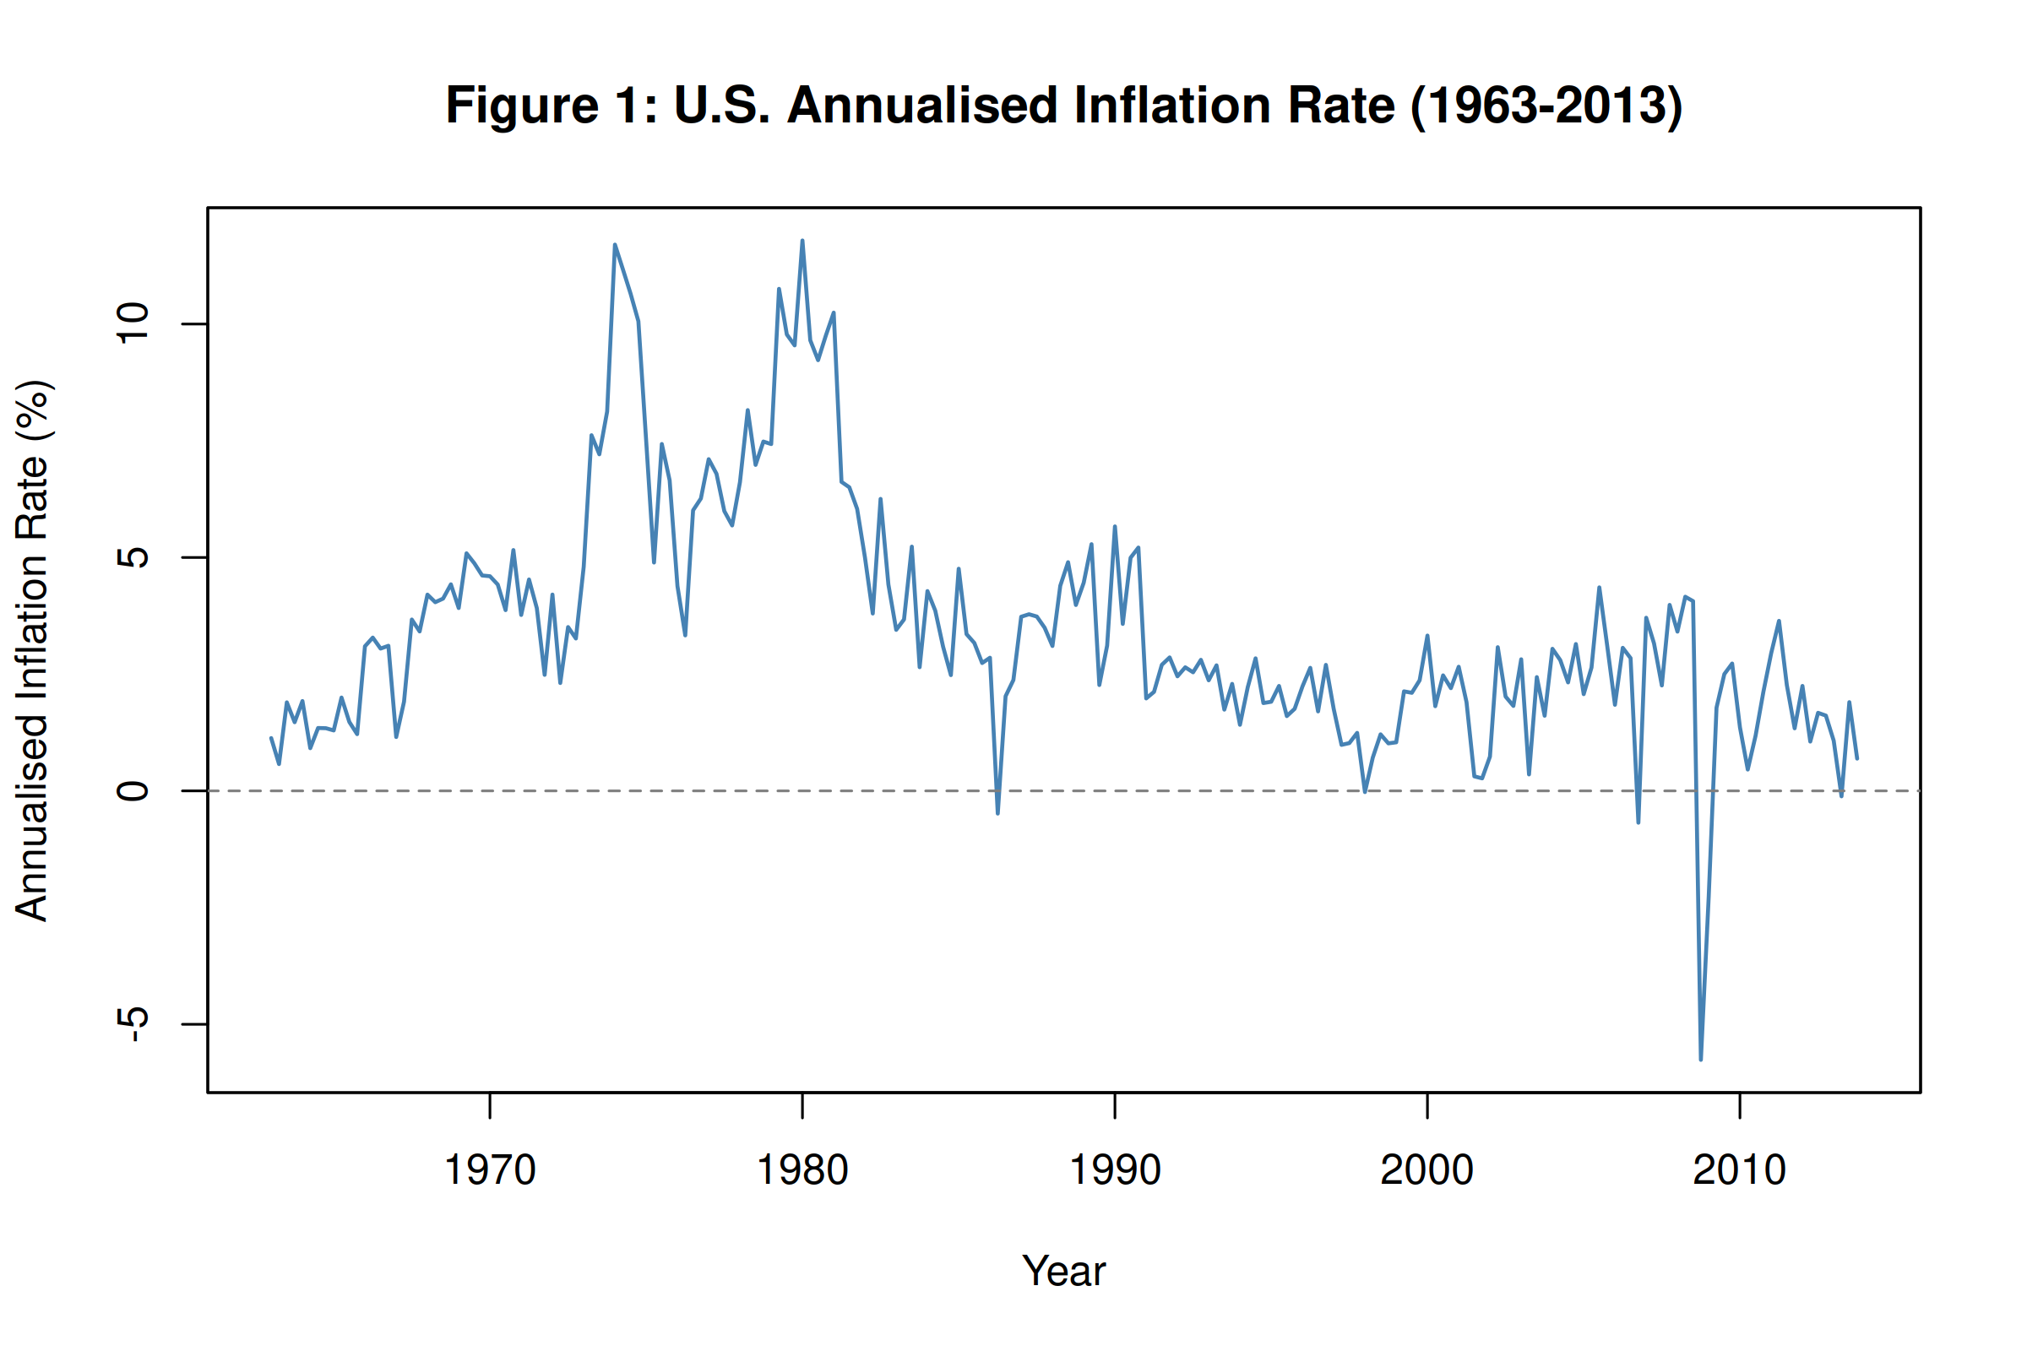
Figure 1: U.S. annualised inflation rate, inflt = 400 x delta ln(PCECTPIt), 1963-2013.
2. Autocovariance and Autocorrelation Functions
The sample autocovariance at lag 0 is 6.5906, which is just the variance of inflt. Figure 2 plots the autocovariance function out to 20 lags, and it declines only gradually. The ACF in Figure 3 tells the same story: the lag-1 autocorrelation is 0.8258 and each subsequent coefficient remains well above zero. All 20 lags sit outside the 95% confidence bands. This slow, near-linear decay is a textbook indicator of strong persistence. When the ACF does not drop off quickly it suggests the series has a unit root or is at least close to one, which fits with what the time-series plot already implied.
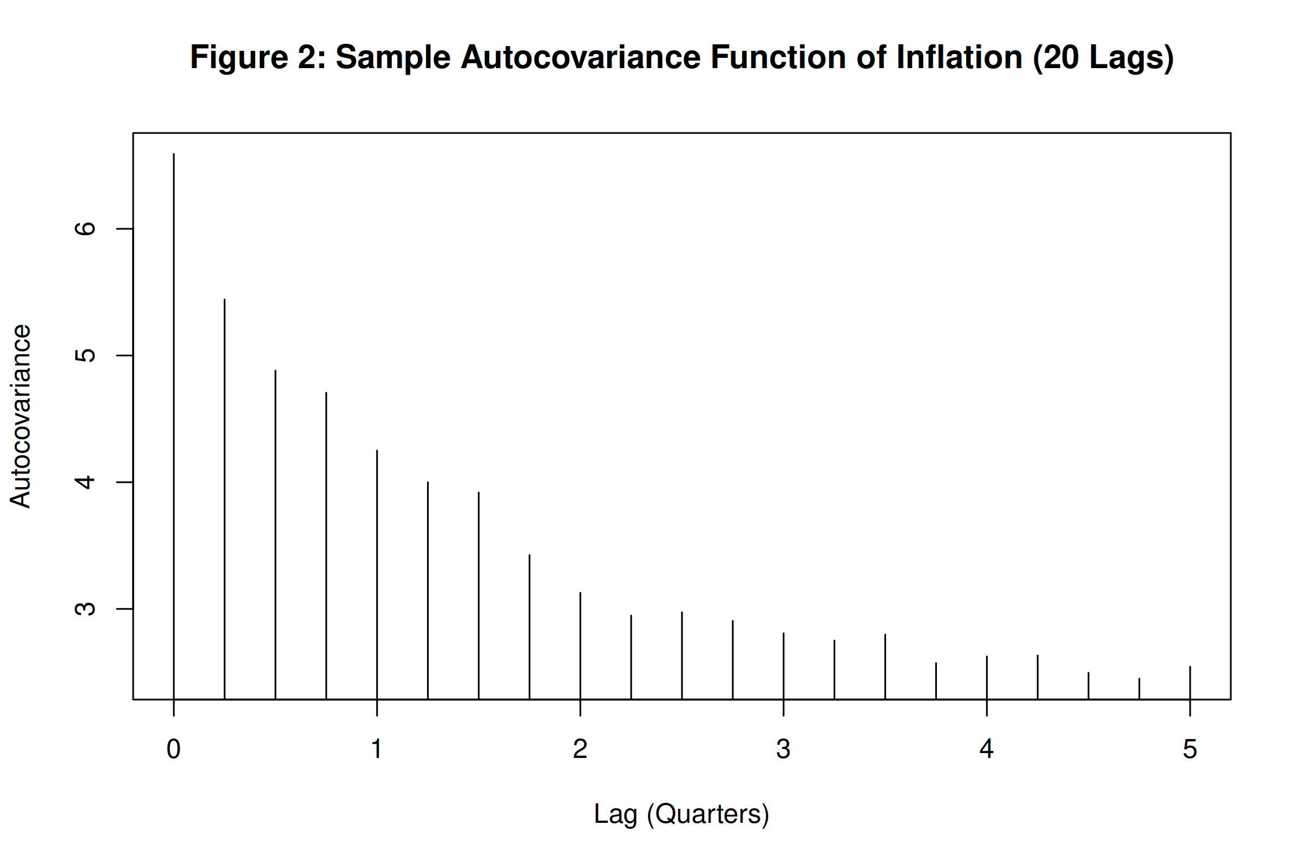
Figure 2: Sample autocovariance function of inflt, lags 0-20.
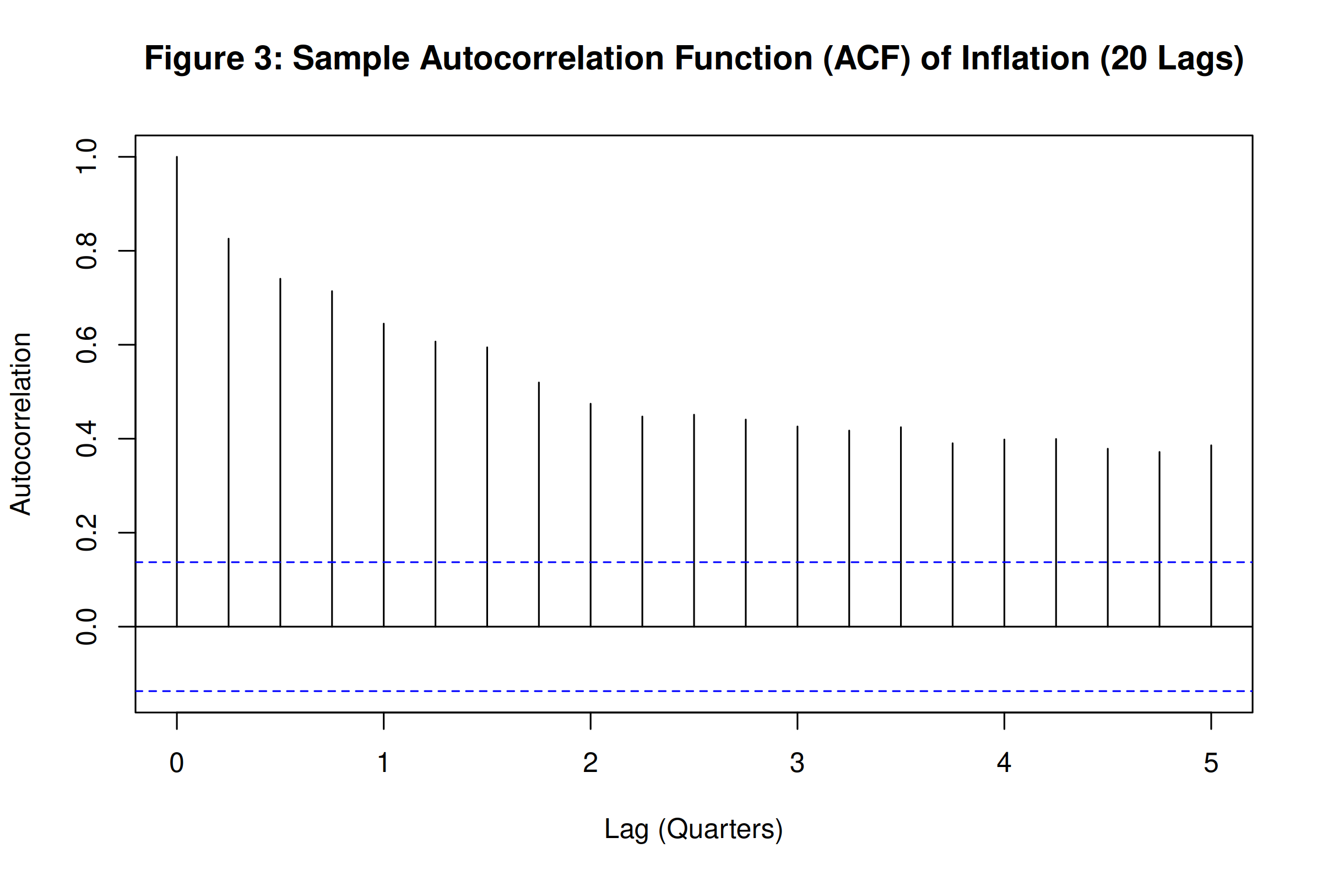
Figure 3: Sample ACF of inflt, lags 1-20. Dashed lines show 95% confidence bands.
3. First Difference of Inflation Rate
Taking the first difference of inflt removes much of the persistence visible in the level series. Figure 4 plots delta inflt, which fluctuates around zero with no obvious trend or wandering mean. The ACF in Figure 5 confirms the change: the lag-1 autocorrelation drops to -0.2583, which is negative and small in absolute terms. Beyond lag 1 the autocorrelations are mostly inside the 95% bands. This rapid decay contrasts sharply with the slow decline in the level ACF. The pattern is consistent with delta inflt being I(0), meaning that inflt itself is I(1) and needs one round of differencing to become stationary.
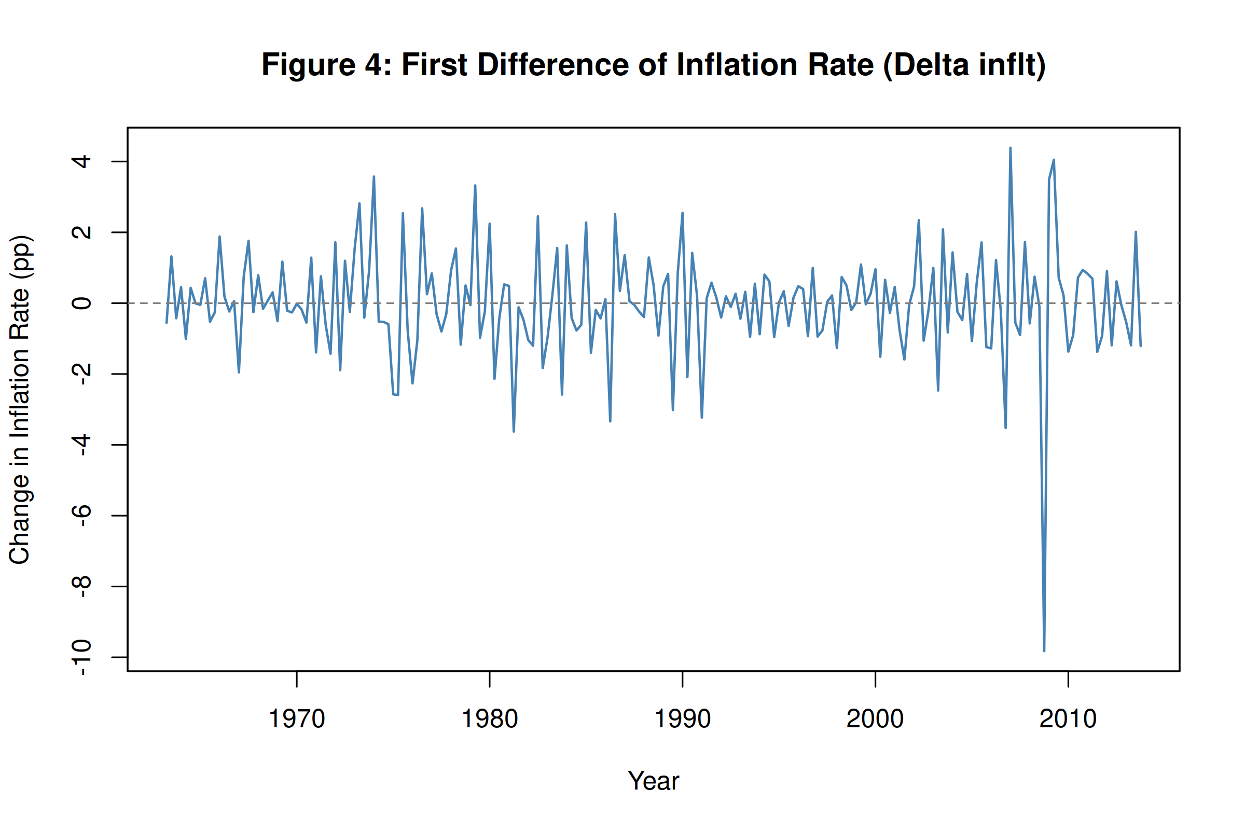
Figure 4: First difference of inflation rate, delta inflt, 1963:Q2-2013:Q4.
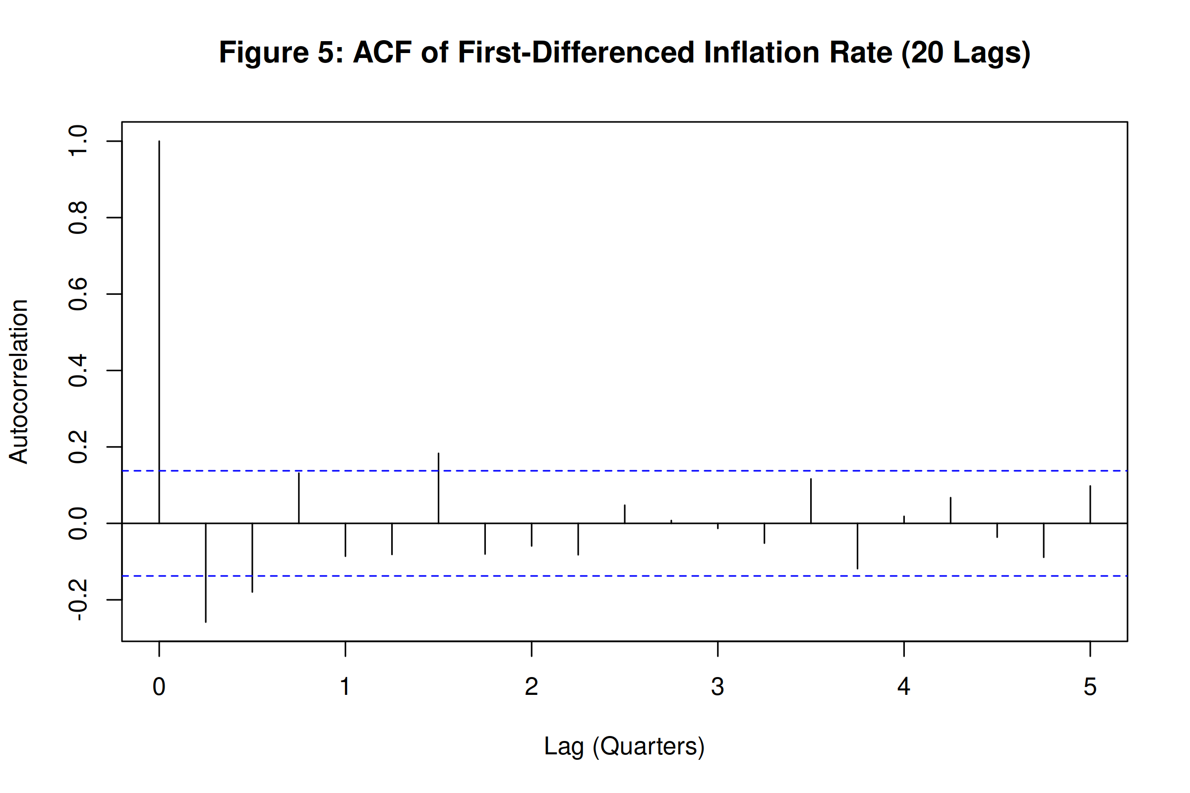
Figure 5: ACF of delta inflt, lags 1-20.
4. Stationarity of inflt
Three pieces of evidence bear on whether inflt is stationary. First, the time-series plot in Figure 1 shows a mean that shifts between distinct regimes and volatility that changes over time. A stationary process would not display these features. Second, the ACF decays very slowly from 0.8258 at lag 1, remaining significant at all 20 lags, which is typical of a unit root process. Third, I run the ADF test using ur.df() in R under three specifications: type="trend" (which includes a constant and time trend), type="drift" (constant only), and type="none" (no deterministic terms). The drift specification is the most appropriate here because inflt has a non-zero mean but no clear linear trend. Under drift the ADF test statistic is -3.4176, compared with critical values of -3.46 (1%), -2.88 (5%), and -2.57 (10%). The test statistic is more negative than the 10% critical value but not more negative than the 5% value, so we cannot reject the null of a unit root at the 5% significance level. Taken together the visual, ACF, and formal test evidence all point to inflt being non-stationary, or I(1).
5. Stationarity of Delta inflt
If inflt is I(1) then delta inflt should be I(0). The time-series plot of delta inflt in Figure 4 oscillates around zero with no visible trend or drifting mean. The ACF drops off immediately, with a lag-1 value of just -0.2583. For the ADF test I use type="none" because once a series has been differenced there is no reason to expect a non-zero intercept or deterministic trend. The test statistic is -14.6636, far more negative than the 1% critical value of -2.58 (5%: -1.95, 10%: -1.62). We reject the null at the 1% level with no ambiguity. Delta inflt is stationary, confirming that inflation is integrated of order one.
6. Autocorrelation of the Unemployment Rate
Figure 6 shows the ACF of the unemployment rate. The lag-1 autocorrelation is 0.9771, extremely close to one, and all 20 lags remain well outside the confidence bands. The decline is even slower than what we saw for inflation in levels. This degree of persistence points toward either a unit root or a highly persistent near-unit-root process in the unemployment rate.
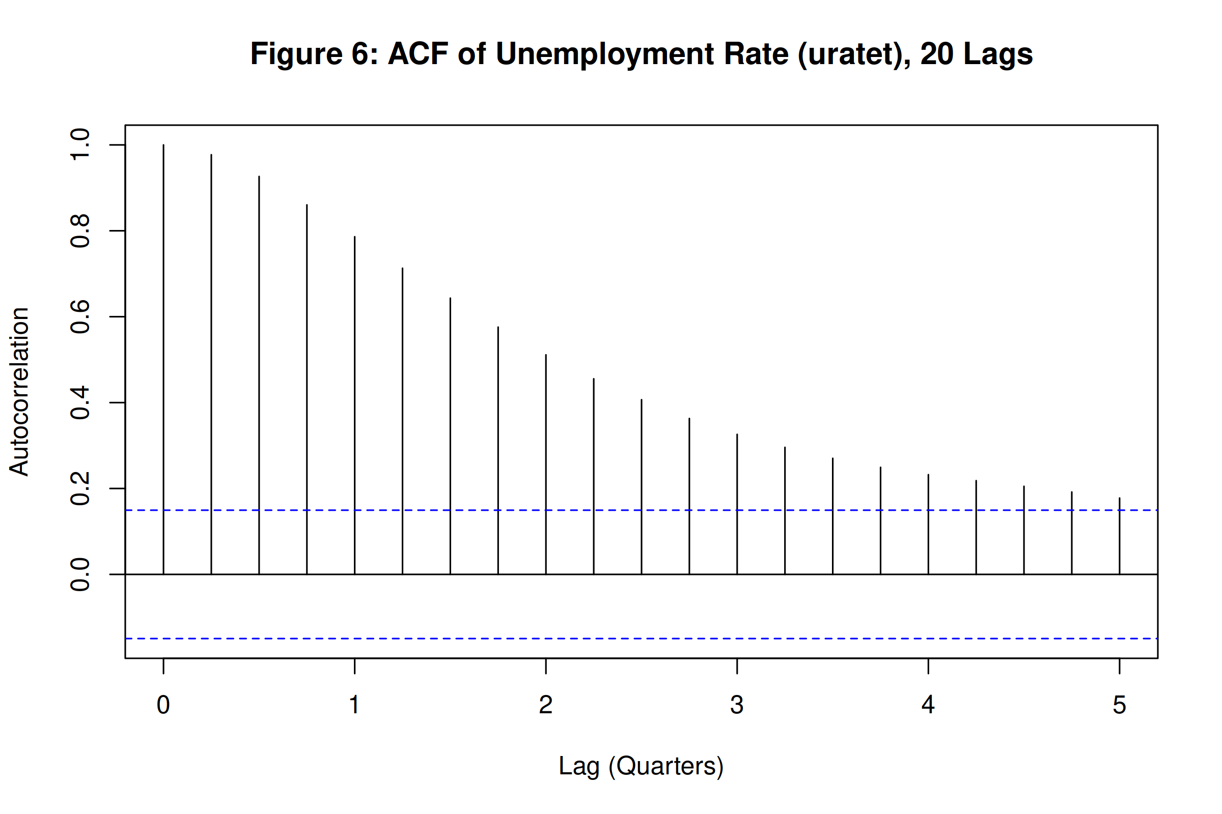
Figure 6: ACF of uratet, 1962:Q3-2004:Q4, lags 1-20.
7. Stationarity of the Unemployment Rate
The unemployment rate plot in Figure 7 shows cyclical fluctuations that recur every few years but no sustained upward or downward trend, so the drift specification is appropriate for the ADF test. The test statistic under drift is -2.8959 against critical values of -3.46 (1%), -2.88 (5%), and -2.57 (10%). The statistic is more negative than the 10% value but fails to beat the 5% critical value, so we cannot reject the unit root null at conventional significance levels. This result should be read carefully. Unemployment is bounded between 0 and 100 in theory and between roughly 3 and 11 in practice, so a true unit root is implausible in the long run. The series is more likely highly persistent with a near-unit root in finite samples. For modelling purposes we treat it as non-stationary or near-integrated over this sample.
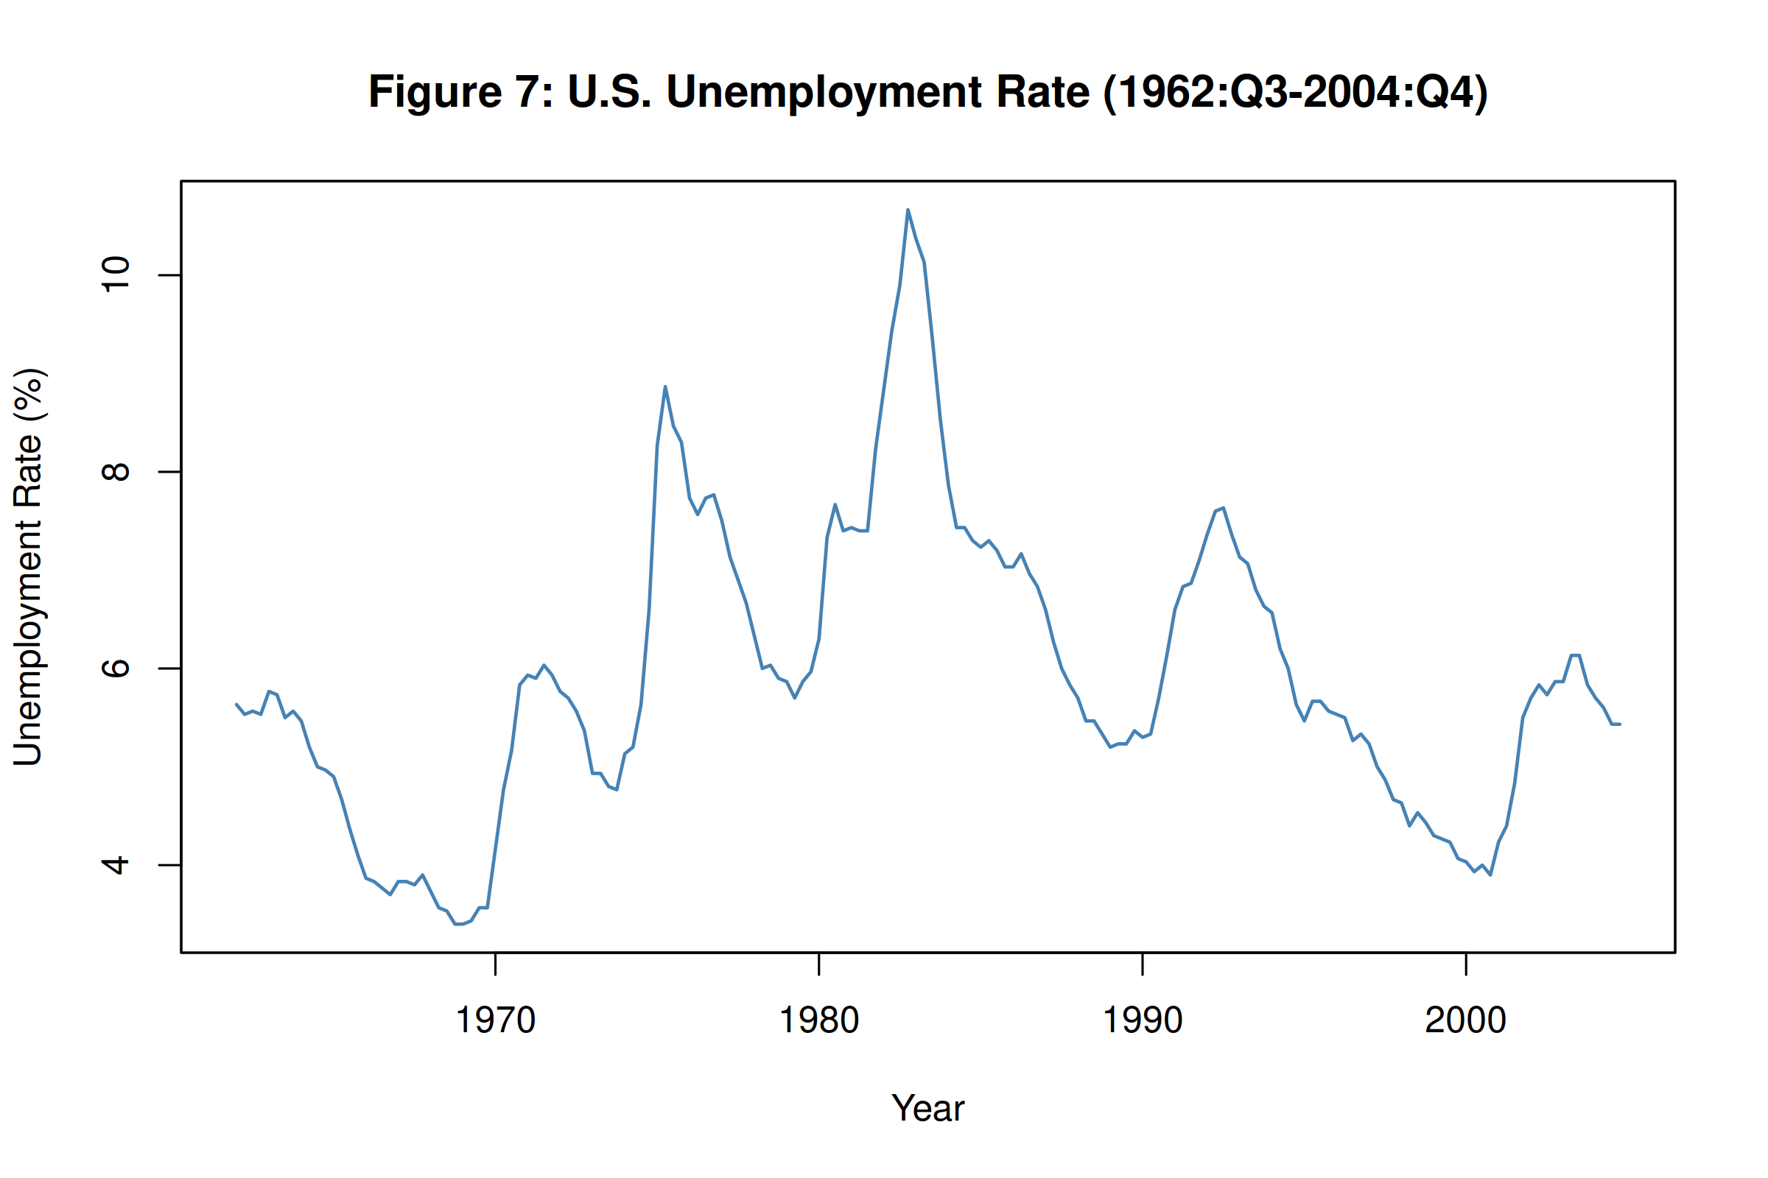
Figure 7: U.S. unemployment rate, uratet, 1962:Q3-2004:Q4.
8. Inflation Changes and Lagged Unemployment
Figure 8 plots delta inflt against lagged unemployment, uratet-1. The OLS line has a negative slope of -0.0809, which aligns with the Phillips curve intuition that higher unemployment is associated with falling inflation. However, the relationship is weak. The HAC-robust p-value on the slope is 0.0360, only just below 5%, and the R-squared is 0.0092. Less than 1% of the variation in inflation changes is explained by lagged unemployment alone. The scatter is wide and noisy. A simple bivariate model is clearly not enough here, which motivates including lagged values of both variables in an ADL specification.
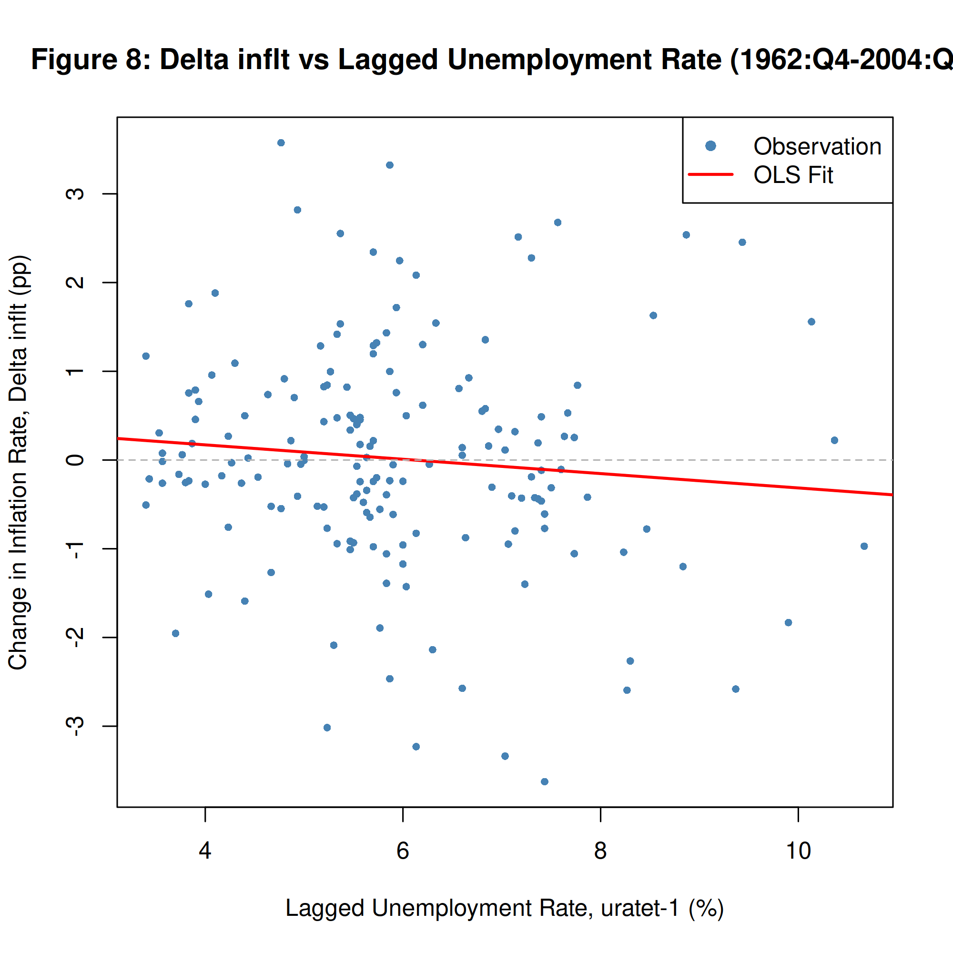
Figure 8: delta inflt against lagged uratet-1, 1962:Q4-2004:Q4. OLS slope = -0.0809 (HAC p = 0.0360), R2 = 0.0092.
9. ADL(2,2) Model: Estimation and Inference
9(a) Does lagged unemployment predict changes in inflation?
To test whether unemployment has predictive power for inflation changes beyond what lagged delta inflt already captures, I test the joint null H0: delta1 = delta2 = 0. The Wald F-statistic is 6.7178 with a p-value of 0.0016. We reject at the 1% level. Lagged unemployment does carry information about future inflation movements that the autoregressive terms alone miss. This supports the Phillips curve channel in the ADL framework.
Table 1: ADL(2,2) estimation results. Dependent variable: delta inflt. Sample: 1963:Q4-2004:Q4 (N = 166). HAC standard errors (Newey-West). R2 = 0.1906, Adj. R2 = 0.1705.
Variable | Coefficient | HAC Std. Error | t-statistic | p-value
Constant | 0.8378 | 0.3440 | 2.4355 | 0.0160*
delta inflt -1 | -0.4147 | 0.0768 | -5.3985 | < 0.001***
delta inflt -2 | -0.2318 | 0.0746 | -3.1083 | 0.0022**
uratet -1 | -1.0508 | 0.3433 | -3.0610 | 0.0026**
uratet -2 | 0.9125 | 0.3415 | 2.6716 | 0.0083**
Note: *** p < 0.001, ** p < 0.01, * p < 0.05. Joint F-test (H0: delta1 = delta2 = 0): F = 6.7178, p = 0.0016. Long-term effect of uratet on delta inflt: -0.0840.
9(b) Why are robust standard errors necessary?
There are two reasons to use HAC standard errors rather than conventional OLS standard errors in this regression. The first is heteroscedasticity. Inflation volatility was substantially higher during the 1970s and early 1980s than in the post-1990 period, so the error variance is not constant across the sample. Ordinary OLS standard errors assume homoscedasticity and will be inconsistent when that assumption fails. The second problem is serial correlation. In a time-series regression with lagged dependent variables, the residuals are likely autocorrelated, which also invalidates conventional standard errors. The Newey-West estimator (Newey and West, 1987) corrects for both heteroscedasticity and autocorrelation simultaneously, producing standard errors that remain consistent under either or both violations.
9(c) Are p = 2 and q = 2 lags appropriate?
Lag selection is based on the Bayesian Information Criterion. Table 2 reports BIC values for all ADL(p,q) combinations with p and q ranging from 1 to 4. The ADL(2,2) specification produces the lowest BIC at 544.50, confirming that two lags of each variable is the preferred choice. BIC is better suited than AIC for this purpose because it imposes a heavier penalty on additional parameters, which guards against over-fitting in finite samples. The selection is data-driven rather than arbitrary, and the fact that BIC picks a relatively parsimonious model is reassuring.
Table 2: BIC values across ADL(p,q) specifications.
 | q = 1 | q = 2 | q = 3 | q = 4
p = 1 | 554.65 | 548.84 | 547.07 | 549.22
p = 2 | 549.38 | 544.50 | 544.96 | 546.97
p = 3 | 551.23 | 546.69 | 550.06 | 552.01
p = 4 | 553.95 | 549.37 | 552.50 | 556.69
Note: Green cell indicates the minimum BIC value across all 16 specifications.
9(d) Why use delta inflt as dependent variable? Why the level of uratet?
These two modelling choices rest on separate arguments. For the dependent variable, inflt is I(1) as established in Questions 4 and 5. Regressing one I(1) variable on another without cointegration produces a spurious regression where t-statistics and R-squared are unreliable (Granger and Newbold, 1974). First differencing transforms inflt into delta inflt, which is I(0), so standard inference applies. The treatment of unemployment is different. On theoretical grounds the expectations-augmented Phillips curve (Friedman, 1968; Phelps, 1968) says that the level of unemployment relative to the natural rate drives changes in inflation. Using the level of uratet rather than its difference preserves this economic relationship. On empirical grounds Stock and Watson (2015) note that unemployment in levels tends to give better forecast performance even when formal tests suggest it may be near-integrated. A differenced unemployment term would measure the acceleration of unemployment rather than its level, which is a different and less interpretable economic concept in the Phillips curve context.
10. Out-of-Sample Forecast: Q1 2005
Table 3: Lagged values used in the Q1 2005 forecast.
Variable | Period | Value
delta inflt -1 | 2004:Q4 | 0.8214
delta inflt -2 | 2004:Q3 | -0.4773
uratet -1 | 2004:Q4 | 5.4333
uratet -2 | 2004:Q3 | 5.4333

To forecast delta inflt for 2005:Q1 I plug the lagged values from Table 3 into the estimated ADL(2,2) equation. The calculation proceeds as shown below. The predicted change in inflation is -0.1436 percentage points. Adding this to the 2004:Q4 inflation level of 3.1452% gives a point forecast of inflt(2005:Q1) = 3.0016%, a small decline from the previous quarter. This is consistent with unemployment sitting above its long-run average, which the model interprets as mild downward pressure on inflation.
delta inflt(2005:Q1) = 0.8378 + (-0.4147) x 0.8214 + (-0.2318) x -0.4773 + (-1.0508) x 5.4333 + (0.9125) x 5.4333 = -0.1436
inflt(2005:Q1) = 3.1452 + -0.1436 = 3.0016%

References
Friedman, M. (1968) 'The role of monetary policy', American Economic Review, 58(1), pp. 1-17.
Granger, C.W.J. and Newbold, P. (1974) 'Spurious regressions in econometrics', Journal of Econometrics, 2(2), pp. 111-120.
Newey, W.K. and West, K.D. (1987) 'A simple, positive semi-definite, heteroskedasticity and autocorrelation consistent covariance matrix', Econometrica, 55(3), pp. 703-708.
Phelps, E.S. (1968) 'Money-wage dynamics and labor-market equilibrium', Journal of Political Economy, 76(4), pp. 678-711.
Phillips, A.W. (1958) 'The relation between unemployment and the rate of change of money wage rates in the United Kingdom, 1861-1957', Economica, 25(100), pp. 283-299.
Stock, J.H. and Watson, M.W. (2015) Introduction to Econometrics. 3rd edn. Harlow: Pearson.

Appendix: R Script
The script below was used to generate all figures, regression estimates, and forecast values in this report. Run from the Assignment1 directory with us_macro_quarterly.xlsx present.
# ============================================================
# FN585 Assignment 1 — Time Series & Forecasting
# Student: Zohaib Shahzada
# Rebuilt from scratch using course methodology (Weeks 1-7)
# ============================================================
library(AER) # coeftest()
library(readxl) # read_xlsx()
library(xts) # xts objects and subsetting
library(zoo) # as.zoo(), as.yearqtr()
library(dynlm) # dynlm() with L() lag notation
library(urca) # ur.df() unit root tests (Weeks 6-7)
library(sandwich) # vcovHAC() — HAC robust standard errors
library(lmtest) # coeftest()
library(car) # linearHypothesis() — joint F-test
library(jsonlite) # toJSON() — export results
# Set working directory
setwd("/home/zo/University/FN585/Assignment1")
# Create output directories
dir.create("figures", showWarnings = FALSE)
dir.create("outputs", showWarnings = FALSE)
# ============================================================
# DATA LOADING
# ============================================================
usmac <- read_xlsx("us_macro_quarterly.xlsx",
sheet = 1,
col_types = c("text", rep("numeric", 9)))
# Rename columns to match actual Excel column order
colnames(usmac) <- c("Date", "GDPC96", "JAPAN_IP", "PCECTPI",
"GS10", "GS1", "TB3MS", "UNRATE",
"EXUSUK", "CPIAUCSL")
# Convert date column to yearqtr format (Week 3 convention)
usmac$Date <- as.yearqtr(usmac$Date, format = "%Y:0%q")
# Create XTS objects for core series
PCECTPI <- xts(usmac$PCECTPI, usmac$Date)
UNRATE <- xts(usmac$UNRATE, usmac$Date)
# ============================================================
# Q1: ANNUALISED INFLATION RATE
# inflt = 400 * delta(ln(PCECTPI_t))
# ============================================================
# Construct inflation rate — annualised quarterly log-difference
inflt <- xts(400 * log(PCECTPI / lag(PCECTPI)))
# Subset to 1963-2013 per assessment brief
inflt_q1 <- inflt["1963::2013"]
# Save figure 1
png("figures/fig1_inflation.png", width = 2400, height = 1600, res = 300)
plot(as.zoo(inflt_q1),
col = "steelblue",
lwd = 1.5,
xlab = "Year",
ylab = "Annualised Inflation Rate (%)",
main = "Figure 1: U.S. Annualised Inflation Rate (1963-2013)")
abline(h = 0, lty = 2, col = "grey50")
dev.off()
# ============================================================
# Q2: AUTOCOVARIANCE AND AUTOCORRELATION FUNCTIONS
# ============================================================
inflt_clean <- na.omit(inflt["1963::2013"])
# Autocovariance
acov <- acf(inflt_clean, type = "covariance", lag.max = 20, plot = FALSE)
png("figures/fig2_autocovariance.png", width = 2400, height = 1600, res = 300)
plot(acov,
main = "Figure 2: Sample Autocovariance Function of Inflation (20 Lags)",
xlab = "Lag (Quarters)",
ylab = "Autocovariance")
dev.off()
# Autocorrelation
acor <- acf(inflt_clean, type = "correlation", lag.max = 20, plot = FALSE)
png("figures/fig3_acf_inflation.png", width = 2400, height = 1600, res = 300)
plot(acor,
main = "Figure 3: Sample Autocorrelation Function (ACF) of Inflation (20 Lags)",
xlab = "Lag (Quarters)",
ylab = "Autocorrelation")
dev.off()
# Store ACF values for results
acf_lag1 <- as.numeric(acor$acf[2]) # lag-1 autocorrelation
acov_lag0 <- as.numeric(acov$acf[1]) # variance (lag-0 autocovariance)
# ============================================================
# Q3: FIRST DIFFERENCE OF INFLATION
# ============================================================
diff_inflt <- diff(inflt["1963::2013"])
diff_inflt_clean <- na.omit(diff_inflt)
# Plot first difference
png("figures/fig4_diff_inflation.png", width = 2400, height = 1600, res = 300)
plot(as.zoo(diff_inflt_clean),
col = "steelblue",
lwd = 1.5,
xlab = "Year",
ylab = "Change in Inflation Rate (pp)",
main = "Figure 4: First Difference of Inflation Rate (Delta inflt)")
abline(h = 0, lty = 2, col = "grey50")
dev.off()
# ACF of first difference
acf_diff <- acf(diff_inflt_clean, lag.max = 20, plot = FALSE)
png("figures/fig5_acf_diff_inflation.png", width = 2400, height = 1600, res = 300)
plot(acf_diff,
main = "Figure 5: ACF of First-Differenced Inflation Rate (20 Lags)",
xlab = "Lag (Quarters)",
ylab = "Autocorrelation")
dev.off()
diff_acf_lag1 <- as.numeric(acf_diff$acf[2])
# ============================================================
# Q4: STATIONARITY OF inflt - THREE-LEVEL ANALYSIS
# ur.df() from urca package, exactly as taught (Weeks 6-7)
# ============================================================
# All three specifications as per Week 7 seminar
q4_none <- ur.df(inflt_clean, type = "none", selectlags = "BIC")
q4_drift <- ur.df(inflt_clean, type = "drift", selectlags = "BIC")
q4_trend <- ur.df(inflt_clean, type = "trend", selectlags = "BIC")
# Print summaries for all three (as taught in Week 7)
cat("\n--- Q4: Unit Root Tests for inflt ---\n")
cat("\nType = none:\n"); summary(q4_none)
cat("\nType = drift:\n"); summary(q4_drift)
cat("\nType = trend:\n"); summary(q4_trend)
# Most appropriate: "drift" - inflation has potential non-zero mean
# (Week 7: "model with drift is the best model")
q4_stat <- as.numeric(q4_drift@teststat[1, 1]) # tau_mu statistic
q4_cval <- q4_drift@cval[1, ] # critical values at 1%, 5%, 10%
cat("\nQ4 ADF (drift) test statistic:", round(q4_stat, 4), "\n")
cat("Q4 Critical values (1%, 5%, 10%):", round(q4_cval, 4), "\n")
# ============================================================
# Q5: STATIONARITY OF Delta inflt - THREE-LEVEL ANALYSIS
# ============================================================
q5_none <- ur.df(diff_inflt_clean, type = "none", selectlags = "BIC")
q5_drift <- ur.df(diff_inflt_clean, type = "drift", selectlags = "BIC")
q5_trend <- ur.df(diff_inflt_clean, type = "trend", selectlags = "BIC")
cat("\n--- Q5: Unit Root Tests for Delta inflt ---\n")
cat("\nType = none:\n"); summary(q5_none)
cat("\nType = drift:\n"); summary(q5_drift)
cat("\nType = trend:\n"); summary(q5_trend)
# Most appropriate: "none" - differenced series needs no drift/trend
# (Week 7: "no constant and no trend is the best model" for differenced series)
q5_stat <- as.numeric(q5_none@teststat[1, 1])
q5_cval <- q5_none@cval[1, ]
cat("\nQ5 ADF (none) test statistic:", round(q5_stat, 4), "\n")
cat("Q5 Critical values (1%, 5%, 10%):", round(q5_cval, 4), "\n")
# ============================================================
# Q6: AUTOCORRELATION OF UNEMPLOYMENT RATE
# ============================================================
uratet <- na.omit(UNRATE["1962::2004"])
acf_urate <- acf(uratet, lag.max = 20, plot = FALSE)
png("figures/fig6_acf_urate.png", width = 2400, height = 1600, res = 300)
plot(acf_urate,
main = "Figure 6: ACF of Unemployment Rate (uratet), 20 Lags",
xlab = "Lag (Quarters)",
ylab = "Autocorrelation")
dev.off()
urate_acf_lag1 <- as.numeric(acf_urate$acf[2])
# ============================================================
# Q7: STATIONARITY OF uratet - THREE-LEVEL ANALYSIS
# ============================================================
png("figures/fig7_urate.png", width = 2400, height = 1600, res = 300)
plot(as.zoo(uratet),
col = "steelblue",
lwd = 1.5,
xlab = "Year",
ylab = "Unemployment Rate (%)",
main = "Figure 7: U.S. Unemployment Rate (1962:Q3-2004:Q4)")
dev.off()
q7_none <- ur.df(uratet, type = "none", selectlags = "BIC")
q7_drift <- ur.df(uratet, type = "drift", selectlags = "BIC")
q7_trend <- ur.df(uratet, type = "trend", selectlags = "BIC")
cat("\n--- Q7: Unit Root Tests for uratet ---\n")
cat("\nType = none:\n"); summary(q7_none)
cat("\nType = drift:\n"); summary(q7_drift)
cat("\nType = trend:\n"); summary(q7_trend)
# Most appropriate: "drift" - unemployment fluctuates around non-zero mean
# (Week 7: "most credible model" for uratet is drift)
q7_stat <- as.numeric(q7_drift@teststat[1, 1])
q7_cval <- q7_drift@cval[1, ]
cat("\nQ7 ADF (drift) test statistic:", round(q7_stat, 4), "\n")
cat("Q7 Critical values (1%, 5%, 10%):", round(q7_cval, 4), "\n")
# ============================================================
# Q8: Delta inflt vs LAGGED uratet SCATTER
# Sample: 1962:Q4 to 2004:Q4
# ============================================================
# Build full inflt from full PCECTPI (extending back before 1963)
inflt_full <- xts(400 * log(PCECTPI / lag(PCECTPI)))
diff_inflt_full <- diff(inflt_full)
# Align via merge: Delta inflt_t paired with urate_{t-1}
urate_lag1_full <- lag(UNRATE)
q8_merged <- merge(diff_inflt_full, urate_lag1_full, join = "inner")
q8_merged <- na.omit(q8_merged["1962::2004"])
y_q8 <- as.numeric(q8_merged[, 1])
x_q8 <- as.numeric(q8_merged[, 2])
# OLS with HAC standard errors
lm_q8 <- lm(y_q8 ~ x_q8)
lm_q8_hac <- coeftest(lm_q8, vcov. = vcovHAC)
q8_slope <- as.numeric(lm_q8_hac[2, 1])
q8_pval <- as.numeric(lm_q8_hac[2, 4])
q8_rsq <- summary(lm_q8)$r.squared
cat("\nQ8 OLS (HAC): slope =", round(q8_slope, 4),
"| p-value =", round(q8_pval, 4),
"| R^2 =", round(q8_rsq, 4), "\n")
png("figures/fig8_scatter.png", width = 2000, height = 2000, res = 300)
plot(x_q8, y_q8,
col = "steelblue",
pch = 16,
cex = 0.7,
xlab = "Lagged Unemployment Rate, uratet-1 (%)",
ylab = "Change in Inflation Rate, Delta inflt (pp)",
main = "Figure 8: Delta inflt vs Lagged Unemployment Rate (1962:Q4-2004:Q4)")
abline(lm_q8, col = "red", lwd = 2)
abline(h = 0, lty = 2, col = "grey70")
legend("topright", legend = c("Observation", "OLS Fit"),
col = c("steelblue", "red"), pch = c(16, NA), lty = c(NA, 1), lwd = 2)
dev.off()
# ============================================================
# Q9: ADL(2,2) MODEL - FULL SPECIFICATION
# Training period: 1963:Q4 to 2004:Q4
# ============================================================
# Prepare training series using merge for alignment
adl_merged <- merge(diff_inflt_full, UNRATE, join = "inner")
adl_merged <- na.omit(adl_merged["1963::2004"])
diff_inflt_train <- adl_merged[, 1]
urate_train <- adl_merged[, 2]
cat("\nADL training observations:", nrow(adl_merged), "\n")
# ---- BIC grid across ADL(p,q) - exactly as Week 7 seminar ----
bic_matrix <- matrix(nrow = 4, ncol = 4,
dimnames = list(paste0("p=", 1:4), paste0("q=", 1:4)))
aic_matrix <- matrix(nrow = 4, ncol = 4,
dimnames = list(paste0("p=", 1:4), paste0("q=", 1:4)))
for (i in 1:4) {
for (j in 1:4) {
m <- dynlm(ts(diff_inflt_train) ~
L(ts(diff_inflt_train), 1:i) +
L(ts(urate_train), 1:j))
bic_matrix[i, j] <- BIC(m)
aic_matrix[i, j] <- AIC(m)
}
}
cat("\nBIC Matrix (ADL p=rows, q=cols):\n")
print(round(bic_matrix, 2))
cat("\nMinimum BIC at:", which(bic_matrix == min(bic_matrix), arr.ind = TRUE), "\n")
# ---- Estimate ADL(2,2) ----
adl22 <- dynlm(ts(diff_inflt_train) ~
L(ts(diff_inflt_train), 1) +
L(ts(diff_inflt_train), 2) +
L(ts(urate_train), 1) +
L(ts(urate_train), 2))
# HAC robust standard errors (as taught Weeks 5-7)
adl22_hac <- coeftest(adl22, vcov. = vcovHAC)
cat("\nADL(2,2) HAC Results:\n")
print(adl22_hac)
# ---- Joint F-test: H0: delta1 = delta2 = 0 ----
f_test <- linearHypothesis(adl22,
c("L(ts(urate_train), 1) = 0",
"L(ts(urate_train), 2) = 0"),
vcov. = vcovHAC(adl22))
cat("\nJoint F-test (H0: delta1 = delta2 = 0):\n")
print(f_test)
f_stat <- as.numeric(f_test$F[2])
f_pval <- as.numeric(f_test$`Pr(>F)`[2])
# ---- Long-term effect ----
coefs <- coef(adl22)
# LTE = (delta1 + delta2) / (1 - beta1 - beta2)
# coefs: [1]=intercept, [2]=beta1, [3]=beta2, [4]=delta1, [5]=delta2
lte <- (coefs[4] + coefs[5]) / (1 - coefs[2] - coefs[3])
cat("\nLong-term effect of urate on Delta inflt:", round(lte, 4), "\n")
# Model fit
adl22_rsq <- summary(adl22)$r.squared
adl22_adj_rsq <- summary(adl22)$adj.r.squared
adl22_nobs <- nobs(adl22)
cat("R^2:", round(adl22_rsq, 4), "| Adj R^2:", round(adl22_adj_rsq, 4),
"| N:", adl22_nobs, "\n")
# ============================================================
# Q10: OUT-OF-SAMPLE FORECAST - Q1 2005
# ============================================================
# Lagged values at end of training period
K <- nrow(diff_inflt_train)
q10_dinfl_t1 <- as.numeric(diff_inflt_train[K]) # Delta inflt at 2004:Q4
q10_dinfl_t2 <- as.numeric(diff_inflt_train[K - 1]) # Delta inflt at 2004:Q3
q10_urate_t1 <- as.numeric(urate_train[K]) # urate at 2004:Q4
q10_urate_t2 <- as.numeric(urate_train[K - 1]) # urate at 2004:Q3
# inflt level at 2004:Q4 (for converting forecast diff to level)
inflt_train_full <- inflt_full["1963::2004"]
q10_infl_2004q4 <- as.numeric(tail(inflt_train_full, 1))
# One-step-ahead forecast (matrix multiply, Week 5-7 convention)
q10_forecast_diff <- as.numeric(coefs %*% c(1, q10_dinfl_t1, q10_dinfl_t2,
q10_urate_t1, q10_urate_t2))
q10_forecast_infl <- q10_infl_2004q4 + q10_forecast_diff
cat("\nQ10 Forecast for Q1 2005:\n")
cat(" Delta inflt(2005:Q1) =", round(q10_forecast_diff, 4), "pp\n")
cat(" inflt(2005:Q1) =", round(q10_forecast_infl, 4), "%\n")
# ============================================================
# EXPORT ALL RESULTS TO JSON
# ============================================================
results <- list(
# Q2
acf_lag1 = acf_lag1,
acov_lag0 = acov_lag0,
# Q3
diff_acf_lag1 = diff_acf_lag1,
# Q4
q4_stat = q4_stat,
q4_cval_1pct = as.numeric(q4_cval[1]),
q4_cval_5pct = as.numeric(q4_cval[2]),
q4_cval_10pct = as.numeric(q4_cval[3]),
# Q5
q5_stat = q5_stat,
q5_cval_1pct = as.numeric(q5_cval[1]),
q5_cval_5pct = as.numeric(q5_cval[2]),
q5_cval_10pct = as.numeric(q5_cval[3]),
# Q6
urate_acf_lag1 = urate_acf_lag1,
# Q7
q7_stat = q7_stat,
q7_cval_1pct = as.numeric(q7_cval[1]),
q7_cval_5pct = as.numeric(q7_cval[2]),
q7_cval_10pct = as.numeric(q7_cval[3]),
# Q8
q8_slope = q8_slope,
q8_pval = q8_pval,
q8_rsq = q8_rsq,
# Q9 coefficients (HAC)
adl22_const = as.numeric(adl22_hac[1, 1]),
adl22_beta1 = as.numeric(adl22_hac[2, 1]),
adl22_beta2 = as.numeric(adl22_hac[3, 1]),
adl22_delta1 = as.numeric(adl22_hac[4, 1]),
adl22_delta2 = as.numeric(adl22_hac[5, 1]),
adl22_se_const = as.numeric(adl22_hac[1, 2]),
adl22_se_beta1 = as.numeric(adl22_hac[2, 2]),
adl22_se_beta2 = as.numeric(adl22_hac[3, 2]),
adl22_se_delta1 = as.numeric(adl22_hac[4, 2]),
adl22_se_delta2 = as.numeric(adl22_hac[5, 2]),
adl22_t_const = as.numeric(adl22_hac[1, 3]),
adl22_t_beta1 = as.numeric(adl22_hac[2, 3]),
adl22_t_beta2 = as.numeric(adl22_hac[3, 3]),
adl22_t_delta1 = as.numeric(adl22_hac[4, 3]),
adl22_t_delta2 = as.numeric(adl22_hac[5, 3]),
adl22_p_const = as.numeric(adl22_hac[1, 4]),
adl22_p_beta1 = as.numeric(adl22_hac[2, 4]),
adl22_p_beta2 = as.numeric(adl22_hac[3, 4]),
adl22_p_delta1 = as.numeric(adl22_hac[4, 4]),
adl22_p_delta2 = as.numeric(adl22_hac[5, 4]),
adl22_rsq = adl22_rsq,
adl22_adj_rsq = adl22_adj_rsq,
adl22_nobs = adl22_nobs,
adl22_f_stat = f_stat,
adl22_f_pval = f_pval,
adl22_lte = as.numeric(lte),
# BIC matrix (all 16 cells)
bic_adl11 = bic_matrix[1, 1], bic_adl12 = bic_matrix[1, 2],
bic_adl13 = bic_matrix[1, 3], bic_adl14 = bic_matrix[1, 4],
bic_adl21 = bic_matrix[2, 1], bic_adl22 = bic_matrix[2, 2],
bic_adl23 = bic_matrix[2, 3], bic_adl24 = bic_matrix[2, 4],
bic_adl31 = bic_matrix[3, 1], bic_adl32 = bic_matrix[3, 2],
bic_adl33 = bic_matrix[3, 3], bic_adl34 = bic_matrix[3, 4],
bic_adl41 = bic_matrix[4, 1], bic_adl42 = bic_matrix[4, 2],
bic_adl43 = bic_matrix[4, 3], bic_adl44 = bic_matrix[4, 4],
aic_adl11 = aic_matrix[1, 1], aic_adl12 = aic_matrix[1, 2],
aic_adl21 = aic_matrix[2, 1], aic_adl22 = aic_matrix[2, 2],
# Q10
q10_dinfl_t1 = q10_dinfl_t1,
q10_dinfl_t2 = q10_dinfl_t2,
q10_urate_t1 = q10_urate_t1,
q10_urate_t2 = q10_urate_t2,
q10_infl_2004q4 = q10_infl_2004q4,
q10_forecast_diff = q10_forecast_diff,
q10_forecast_infl = q10_forecast_infl
)
write(toJSON(results, pretty = TRUE, auto_unbox = TRUE),
"outputs/results.json")
cat("\n==============================================\n")
cat("All results saved to outputs/results.json\n")
cat("All figures saved to figures/\n")
cat("==============================================\n")

