**SESSION 15: ADVANCED HIVE OPERATIONS**

**ASSIGNMENT 2**

Dataset: <https://drive.google.com/open?id=0ByJLBTmJojjzV1czX3Nha0R3bTQ>

Hive>create table olympix(name string, age int, country string, year int, cdate string, sport string,

gold int, silver int, bronze int, total int) row format delimited fields terminated by ‘\t’;

Hive>LOAD DATA LOCAL INPATH ‘/home/acadgild/hive/olympix_data.cvs’ INTO TABLE olympix;

1. **Write a hive program to find the number of medals won by each country in swimming.**

Hive>SELECT country,SUM(total) FROM olympix WHERE sport=”Swimming” GROUP BY country;

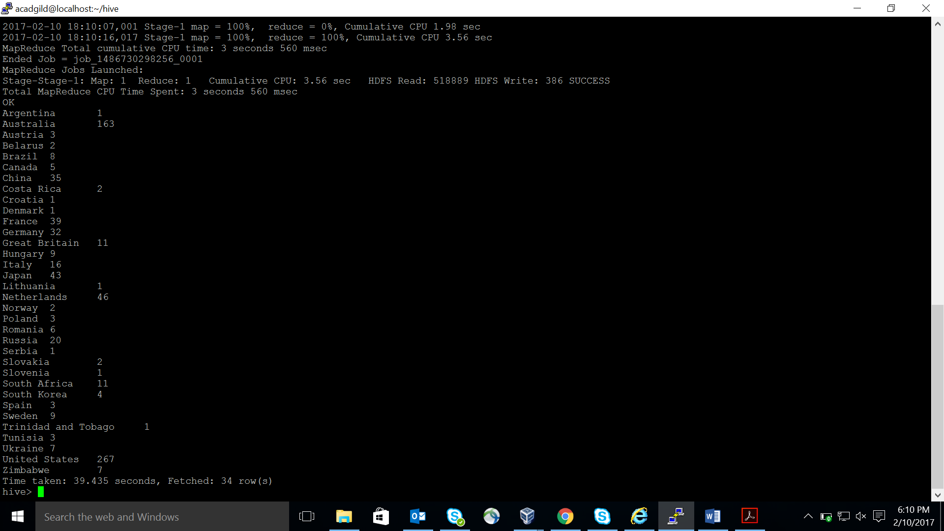

1. **Write a hive program to find the number of medals that India won year wise.**

Hive>Select year,SUM(total) FROM olympix WHERE country=”India” GROUP BY year;

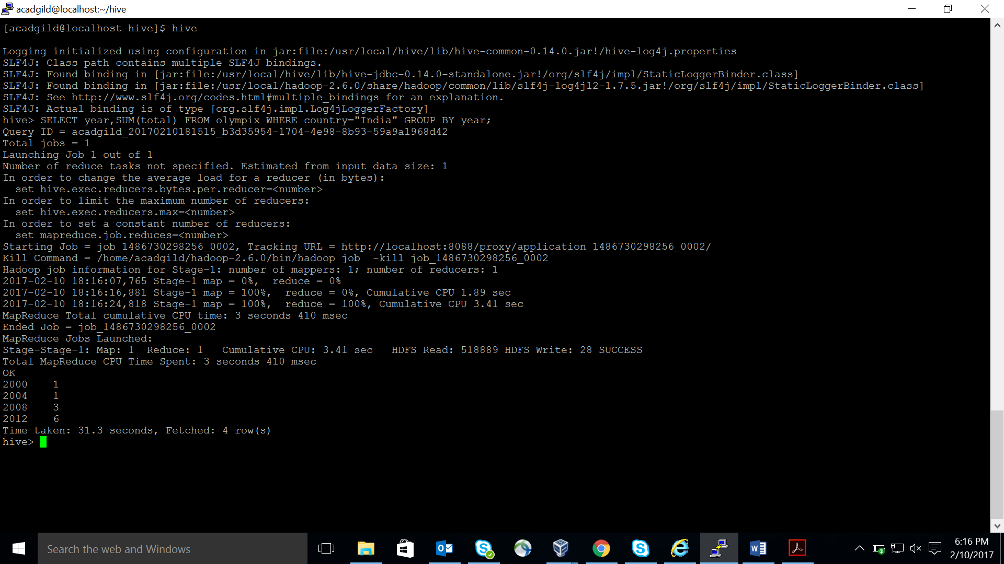

1. **Write a hive program to find the total number of medals each country won.**

Hive>SELECT country,SUM(total) FROM olympix GROUP BY country;

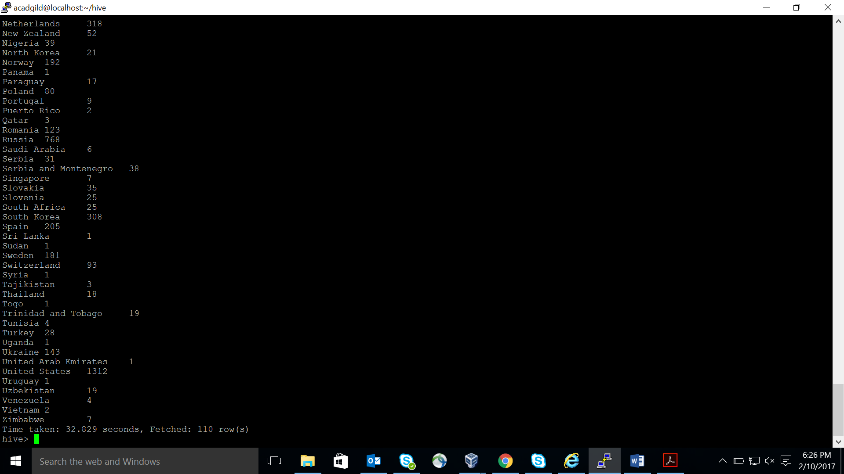

1. **Write a hive program to find the number of gold medals each country won.**

Hive>SELECT country,SUM(gold) FROM olympix GROUP BY country;

