**SESSION 16: UDF DEMO, THRIFT SERVER**

**ASSIGNMENT 1**

**ENABLING ROW LEVEL TRANSACTIONS:**

Hive>set hive.support.concurrency = true;

Hive> set hive.enforce.bucketing = true;

Hive> set hive.exec.dynamic.partition.mode = nonstrict;

Hive>set hive.txn.manager = org.apache.hadoop.hive.ql.lockmgr.DbTxnManager;

Hive>set hive.compactor.initiator.on = true;

Hive>set hive.compactor.worker.threads = 1;

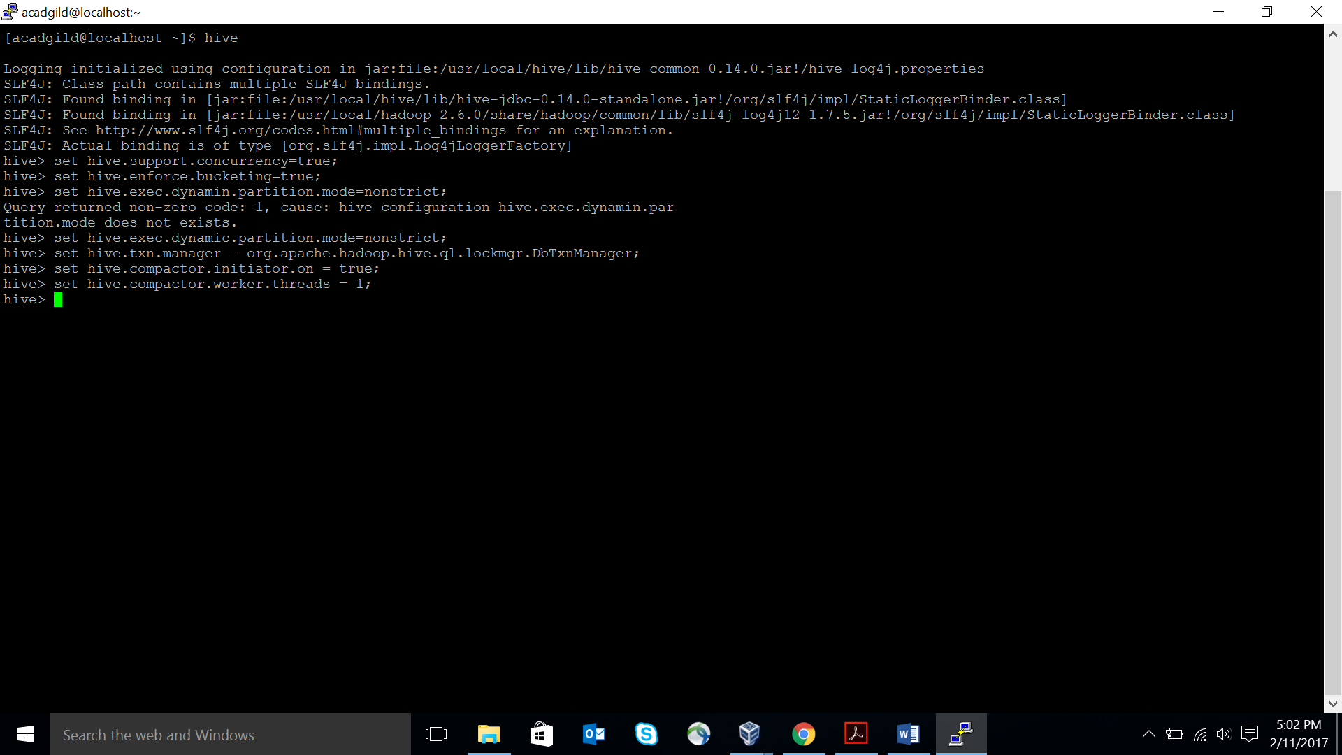

**CREATING A HIVE TRANSACTIONAL TABLE:**

Hive>CREATE TABLE student(id INT, name STRING, subject STRING) CLUSTERED BY (id) INTO 3

BUCKETS STORED AS ORC TBLPROPERTIES(‘transactional’=’true’);

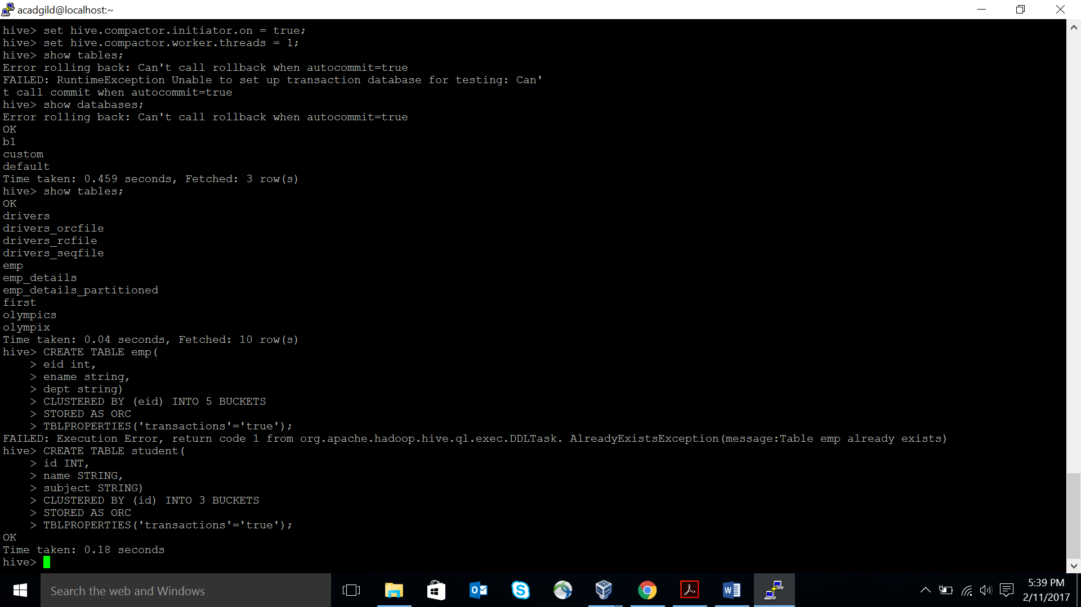

**INSERTING DATA INTO A HIVE TABLE:**

Hive>INSERT INTO TABLE student values (1,”aman”,”ED”), (2,”omid”,”fluids”),

(3,”sanchit”,”marketing”), (4,”gaurav”,”business”), (5,”arjit”,”networks”);

Hive>SELECT * FROM student;

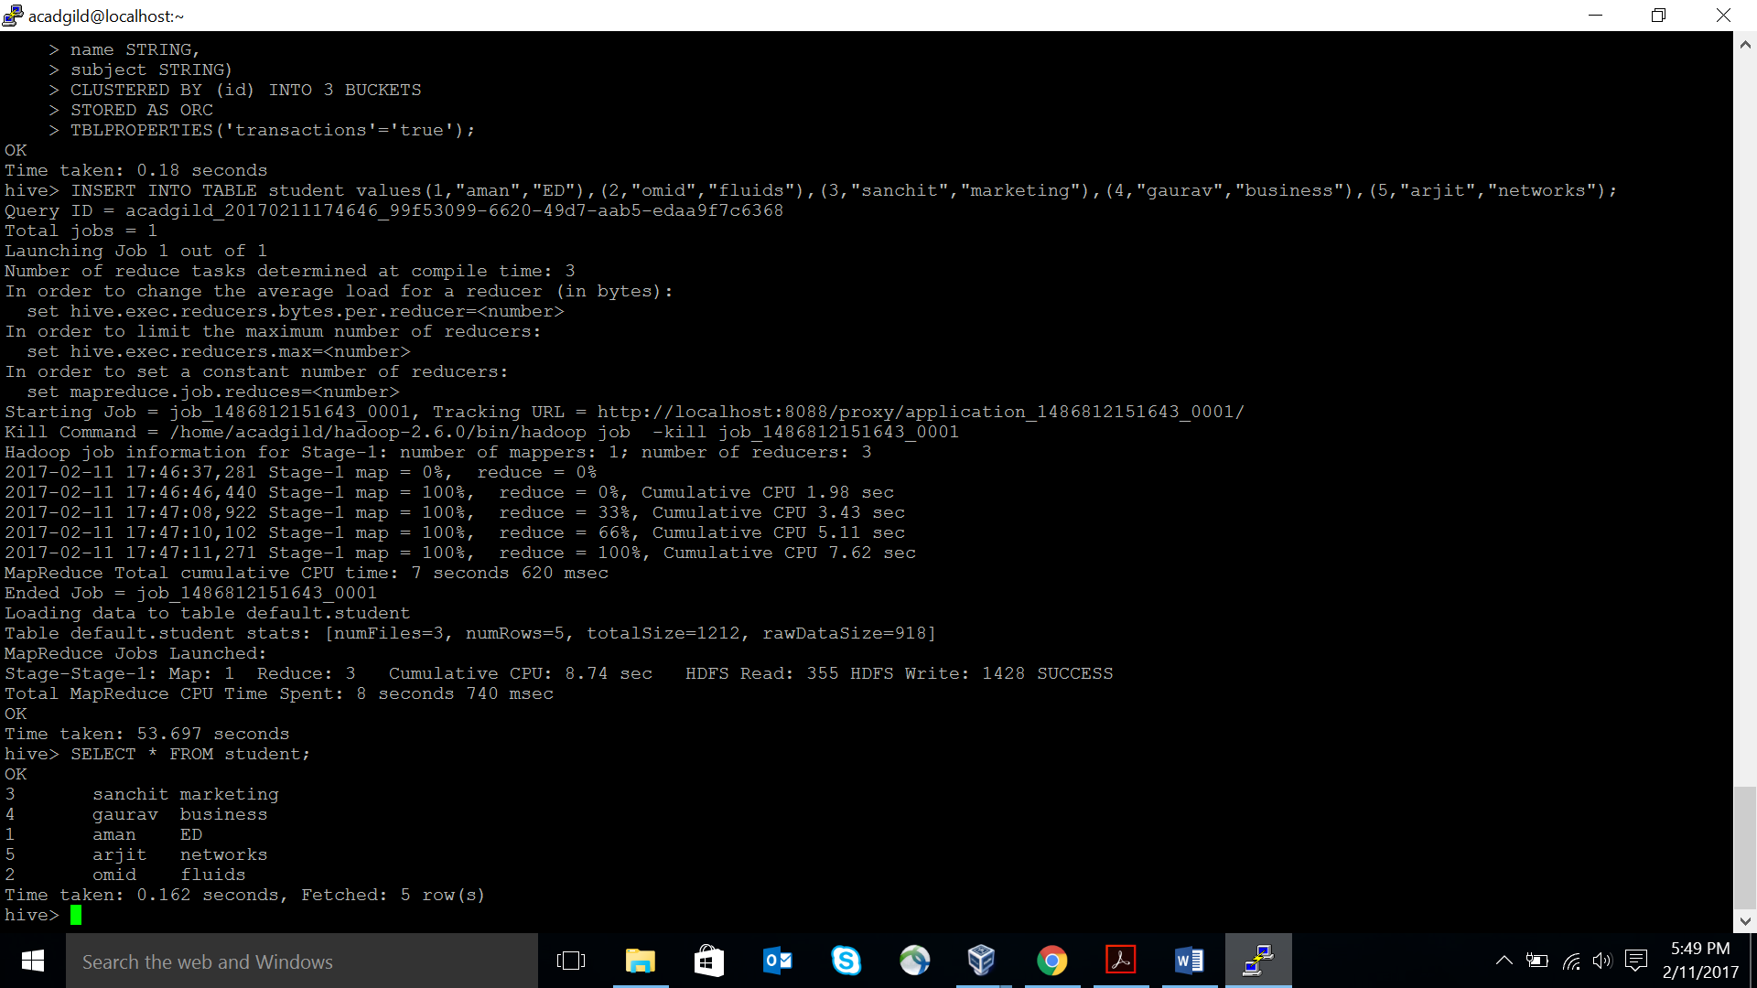

**UPDATING THE DATA IN A HIVE TABLE:**

Hive>UPDATE student SET name=”saurabh” WHERE id=1;

Hive>SELECT * FROM student;

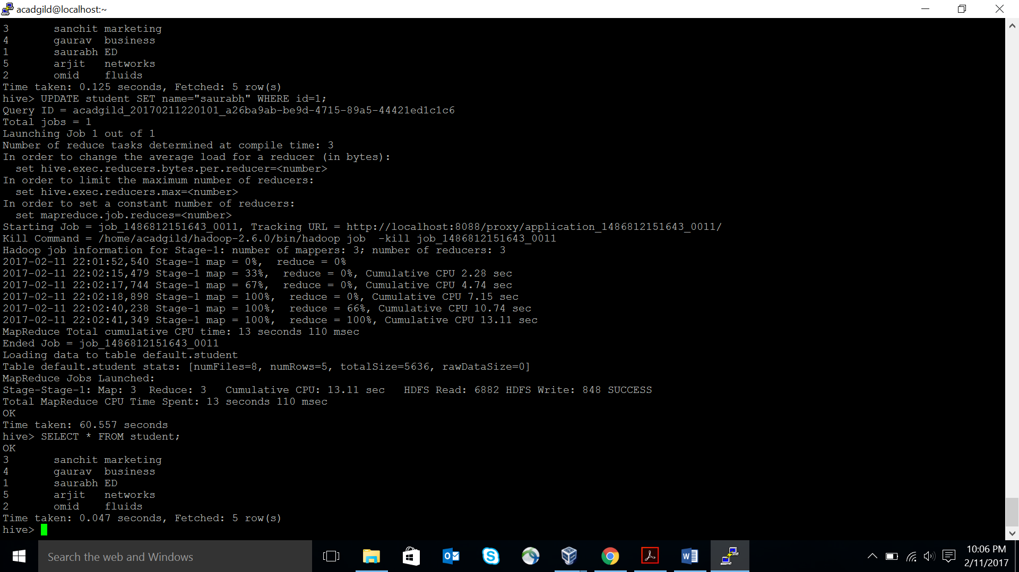

**DELETING A ROW FROM A HIVE TABLE:**

Hive>DELETE FROM student WHERE id=5;

Hive>SELECT * FROM student;

