**SESSION 18: HBASE CRUD OPERATIONS**

**ASSIGNMENT 1**

**Use Hbase shell for performing the following operations.**

1. **Create the table customer with two column families**
   * **Personal details and order details as column families**

hbase(main):001:0> create ‘customer’,’personal’,’order’

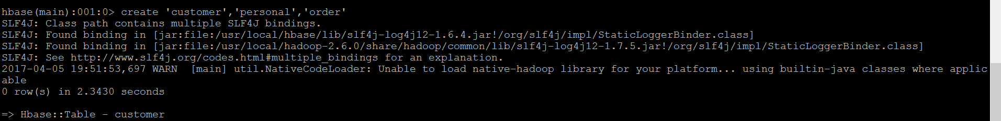

* + **Create a unique number as row key (ssn, adhaar no., etc.)**
  + **Insert at least 10 records to each column**
  + **Insert following values for personal details column family:**

**Name, age, city, state**

* **Insert following values for order details column family:**

**Order number, order quantity and order amount**

* **Use put command to insert the value for each record.**

hbase(main):002:0> put ‘customer’,’1746293’,’personal:name’,’dave’

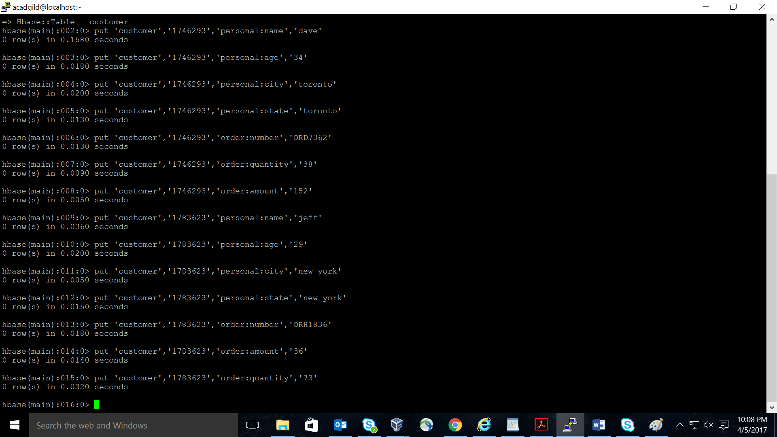

* **Use get command to retrieve all the records of single customer.**

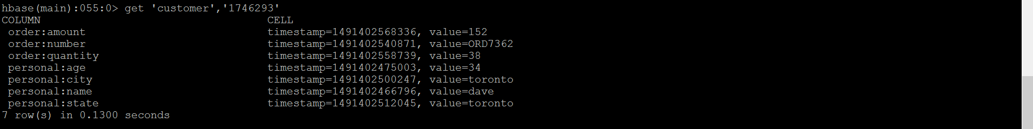hbase(main):055:0> get ‘customer’,’1746293’