**SESSION 19: Hbase Thrift and Rest Server**

**ASSIGNMENT 1**

**INTEGRATING HIVE WITH HBASE:**

Creating the Hbase Table:

hbase(main) :001:0> create ‘student’,’personal’,’academic’

Inserting data into Hbase table:

Hbase(main) :002:0> put ‘student’,’sid01’,’personal:name’,’jenna’

Hbase(main) :003:0> put ‘student’,’sid01’,’personal:location’,’boston’

Hbase(main) :004:0> put ‘student’,’sid01’,’academic:field’,’medicine’

Hbase(main) :005:0> put ‘student’,’sid01’,’academic:cgpa’,’7.7’

Hbase(main) :006:0> put ‘student’,’sid02’,’personal:name’,’damon’

Hbase(main) :007:0> put ‘student’,’sid02’,’personal:location’,’ohio’

Hbase(main) :008:0> put ‘student’,’sid02’,’academic:field’,’engineering’

Hbase(main) :009:0> put ‘student’,’sid02’,’academic:cgpa’,’6.8’

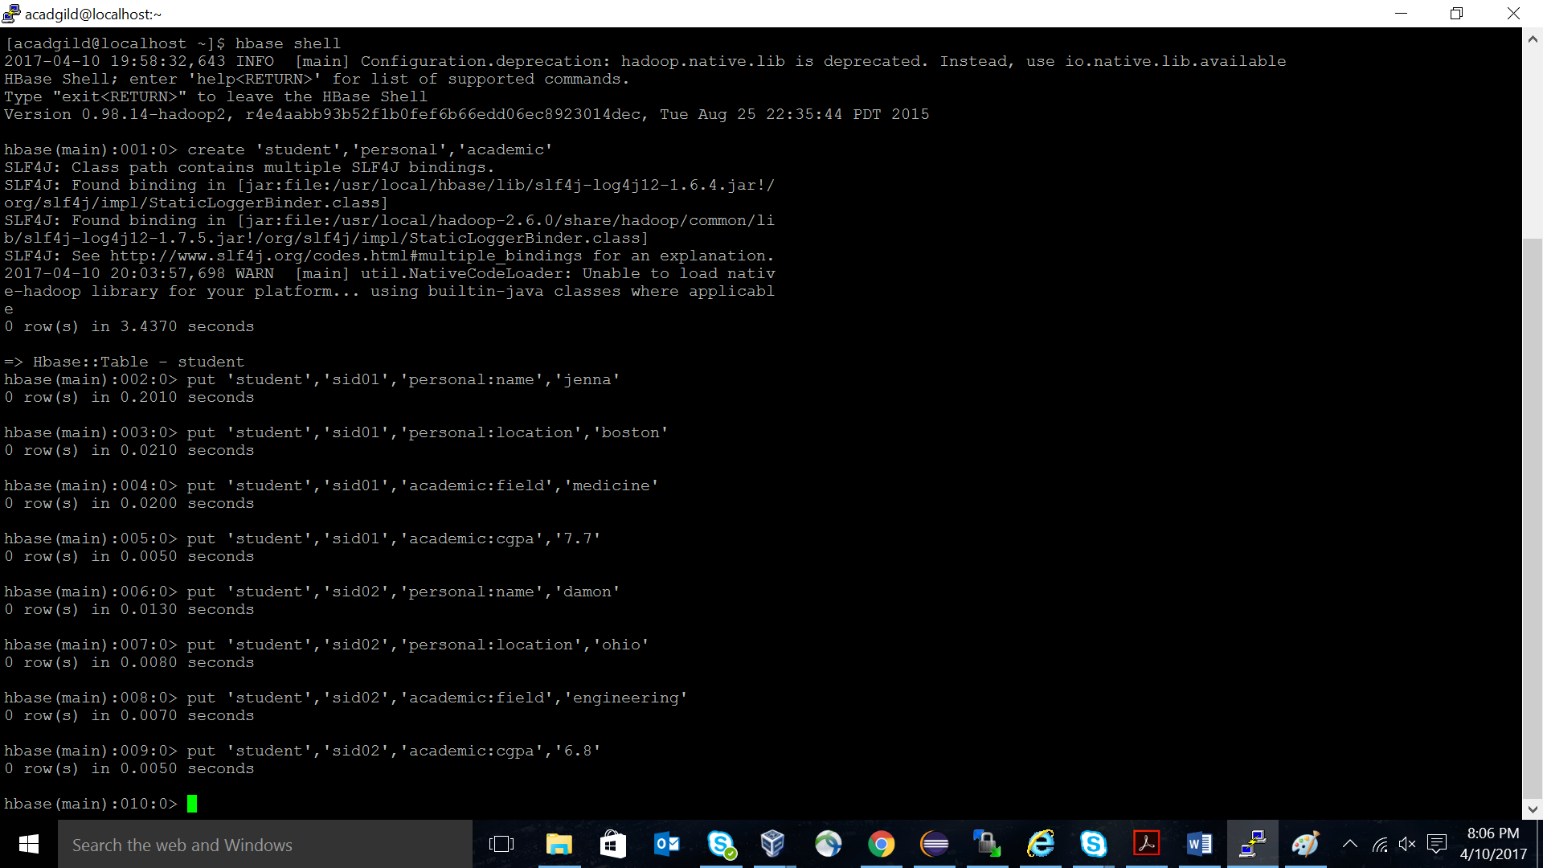

Creating Hive Table pointing to Hbase Table:

hive> create external table per_stud_hbase (

> sid String,

> s_name String,

> loc String)

> STORED BY ‘org.apache.hadoop.hive.hbase.HBaseStorageHandler’

> WITH serdeproperties

(“hbase.columns.mapping”=”:key,personal:name,personal:location”)

> tblproperties(“hbase.table.name”=”student”);

Accessing Hbase data through Hive Table:

select * from per_stud_hbase;

