**SESSION 19: Hbase Thrift and Rest Server**

**ASSIGNMENT 2**

**LOADING DATA INTO HBASE USING PIG SCRIPTS:**

Creating a skeleton in Hbase so that Pig can store data inside it by referring the table name.

Hbase(main):001:0> create ‘studentDB’,’student data’

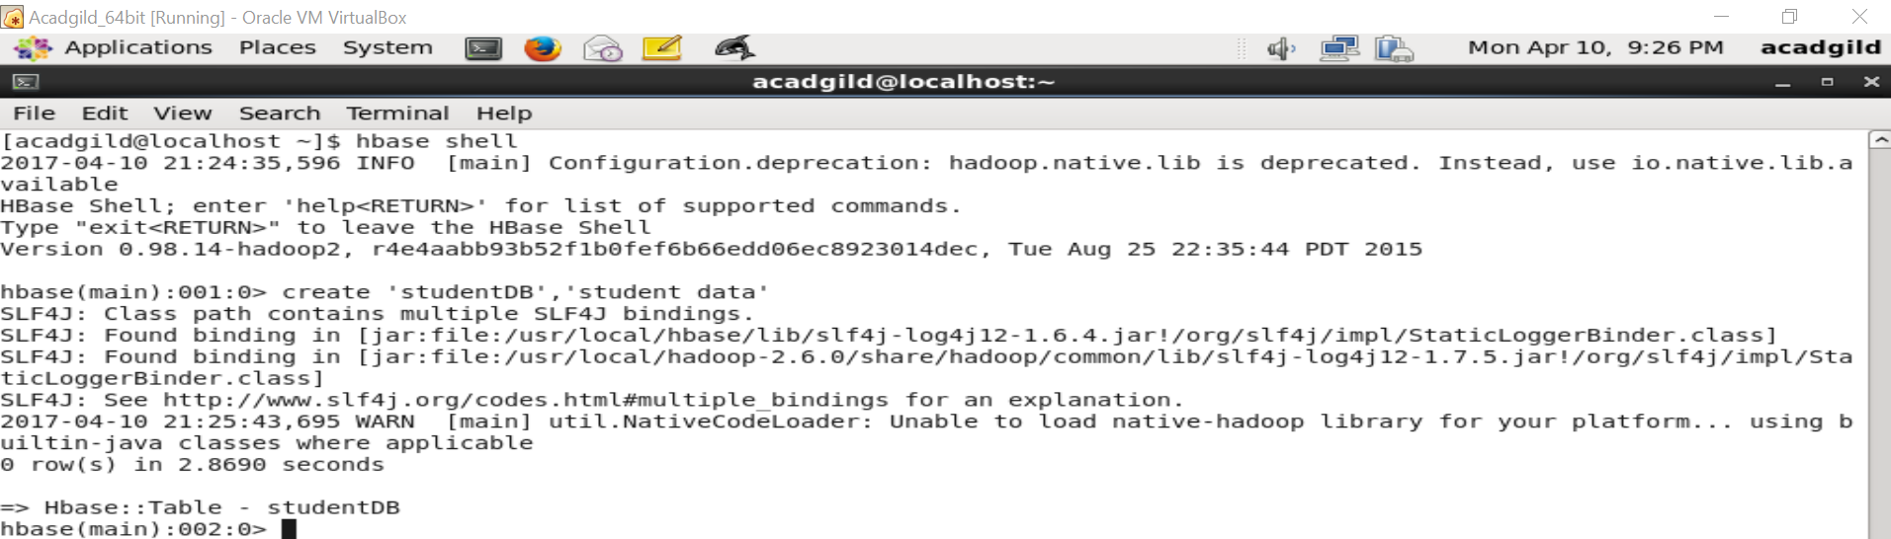

Inside PIG mode, loading data from HDFS to Pig relation.

Grunt> data = LOAD ‘studentDB.txt’ USING PigStorage(‘,’) AS (studentName:chararray,

sector:chararray, dob:chararray, qualification:chararray, score:int, state:chararray,

randomName:chararray);

Transfer the data inside Hbase by using the STORE command.

Grunt> STORE data INTO ‘hbase://studentDB’ USING org.apache.pig.backend.hadoop.hbase.HBaseStorage(‘student_data:studentName, student_data:sector, student_data:dob, student_data:qualification, student_data:score, student_data:state, student_data:randomName’);

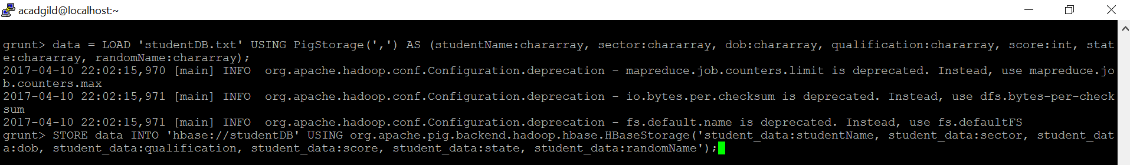

Once the success message comes as shown below, it is confirmed our data is loaded inside HBase.

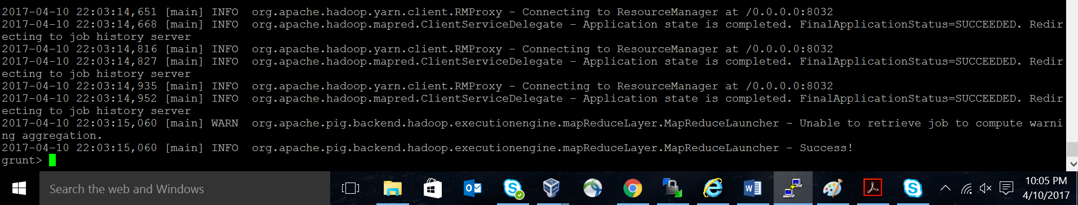

The result can be displayed by viewing the table using scan command in Hbase shell.

