**SESSION 8: PIG – DEMO I**

**ASSIGNMENT 2**

**SAMPLE DATASET**

emp_details.txt emp_expenses.txt

101,Amitabh,Bachchan,20000,1

102,Shahrukh,Khan,10000,2

103,Akshay,Kumar,11000,3

104,Anubhav,Jain,5000,4

105,Pawan,Goel,2500,5

106,Aamir,Khan,25000,1

107,Salman,Khan,17500,2

108,Ranbir,Kapoor,14000,3

109,Katrina,Kaif,1000,4

110,Priyanka,Chopra,2000,5

111,Tushar,Kapoor,500,1

112,Ajay,Devgan,5000,2

113,Jubeen,Garg,1000,1

114,Madhuri,Dixit,2000,2

101 200

102 100

110 400

114 200

119 200

105 100

101 100

104 300

102 400

1. **CONCAT**

emp_d = LOAD ‘emp_details.txt’ using PigStorage(‘,’) AS (emp_id:int, emp_fname:chararray,

emp_lname:chararray, emp_salary:int, emp_rating:int);

full_name = FOREACH emp_d GENERATE CONCAT(emp_fname, CONCAT(‘ ‘, emp_lname)) as fname;

dump full_name;

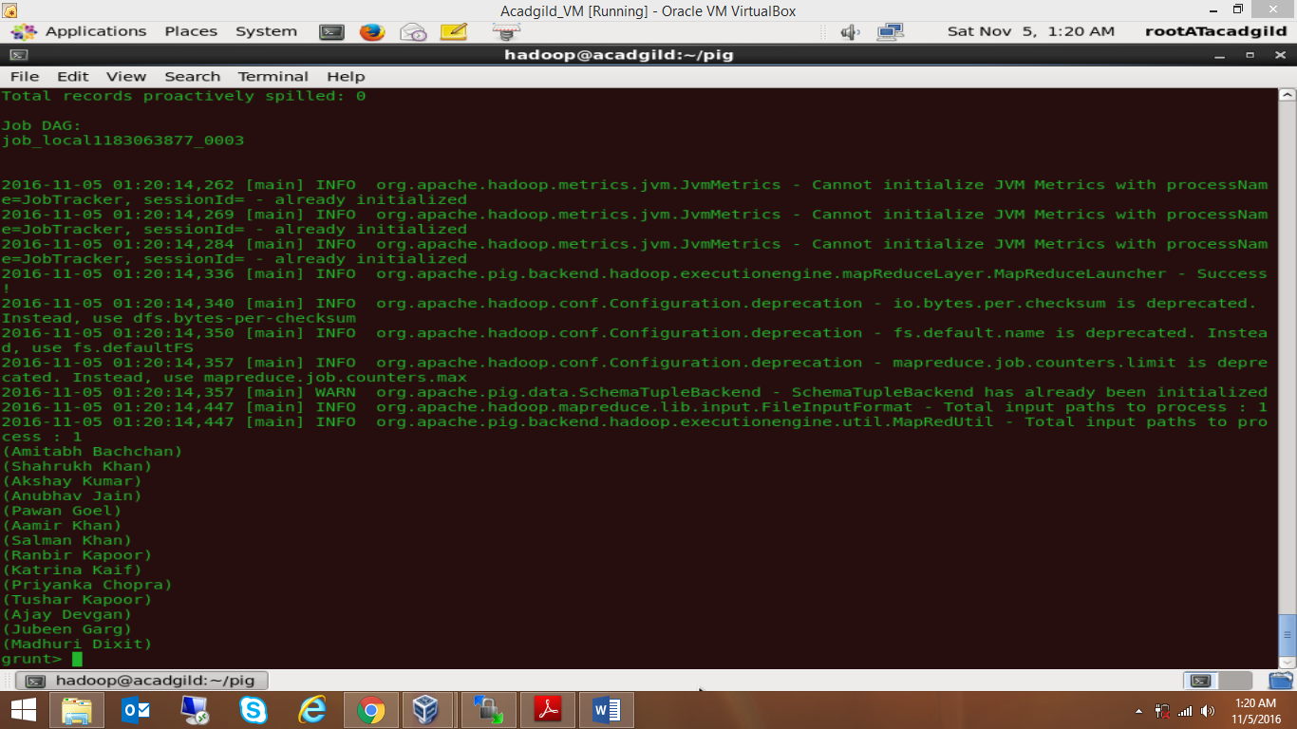

1. **TOKENIZE**

tokens = FOREACH full_name GENERATE TOKENIZE(fname) as name_token;

dump tokens;

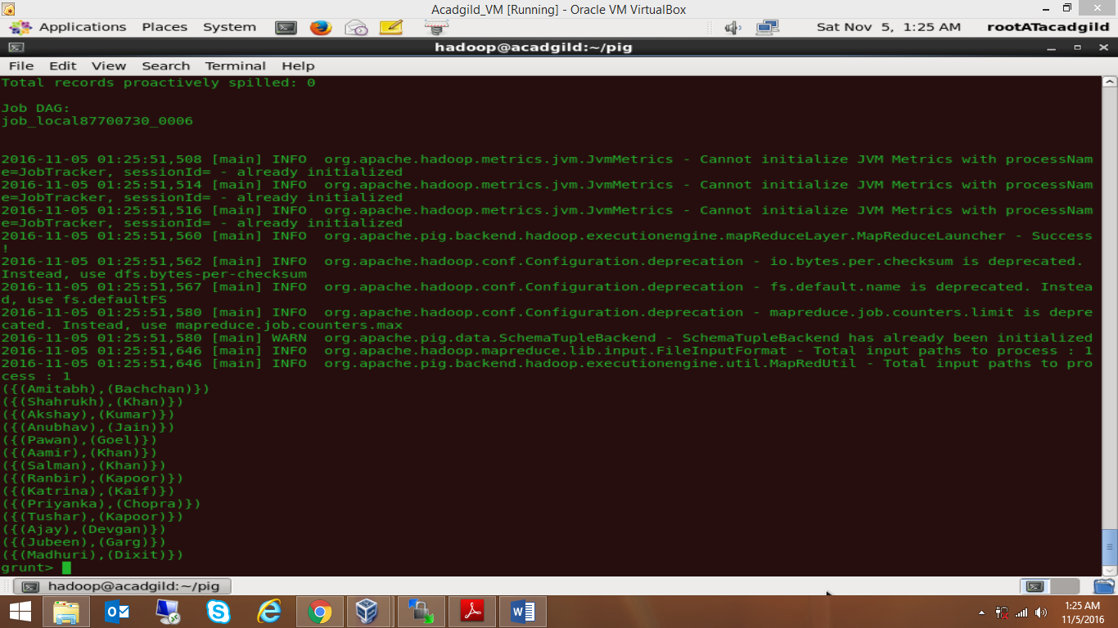

1. **SUM**

grouped_emp = GROUP emp_d all;

total_sal = FOREACH grouped_emp GENERATE SUM(emp_d.emp_salary);

dump total_sal;

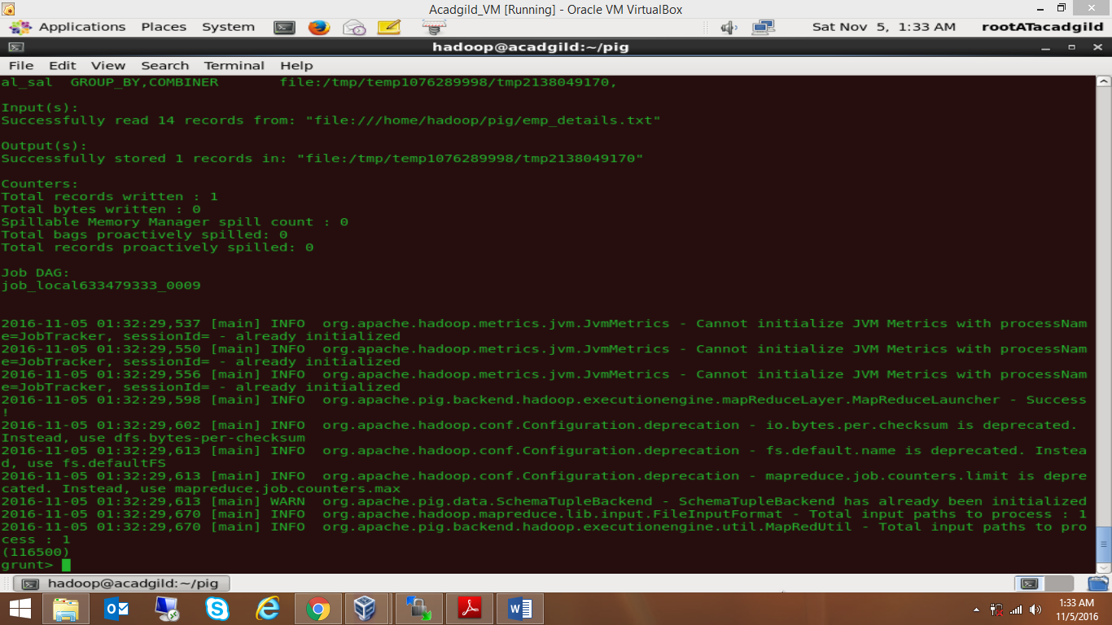

1. **MIN**

min_salary = FOREACH grouped_emp GENERATE MIN(emp_d.emp_salary);

dump min_salary;

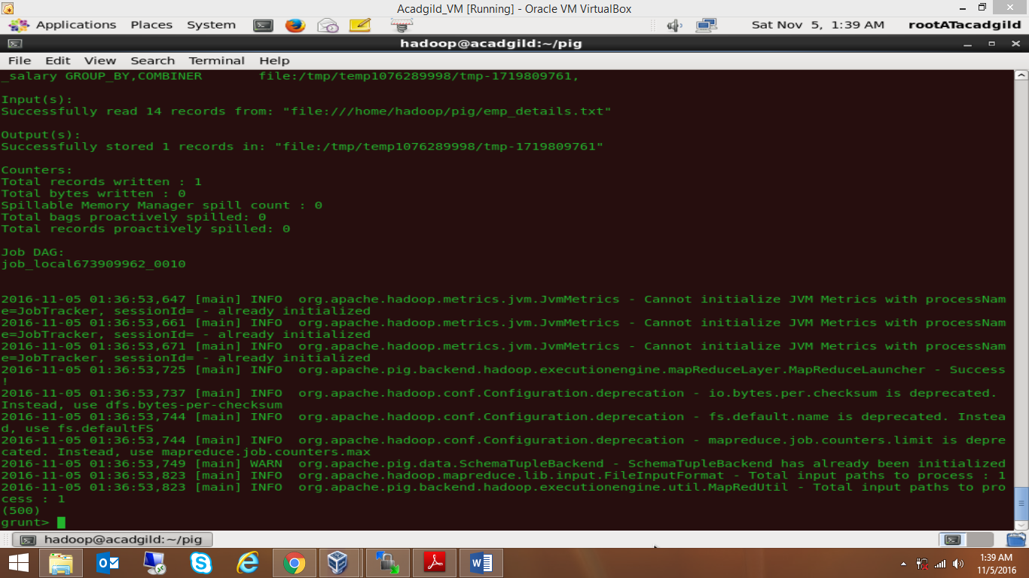

1. **MAX**

max_salary = FOREACH grouped_emp GENERATE MAX(emp_d.emp_salary);

dump max_salary;

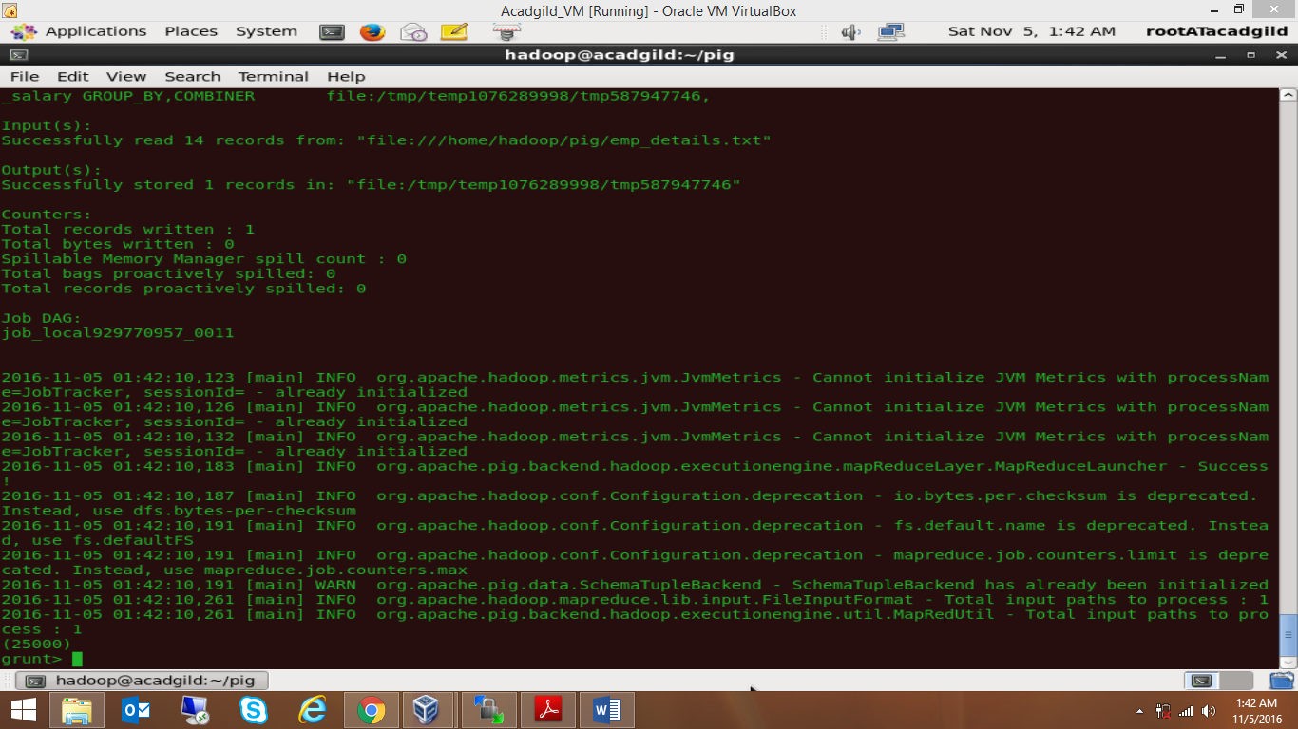

1. **LIMIT**

limit_records = LIMIT emp_d 5;

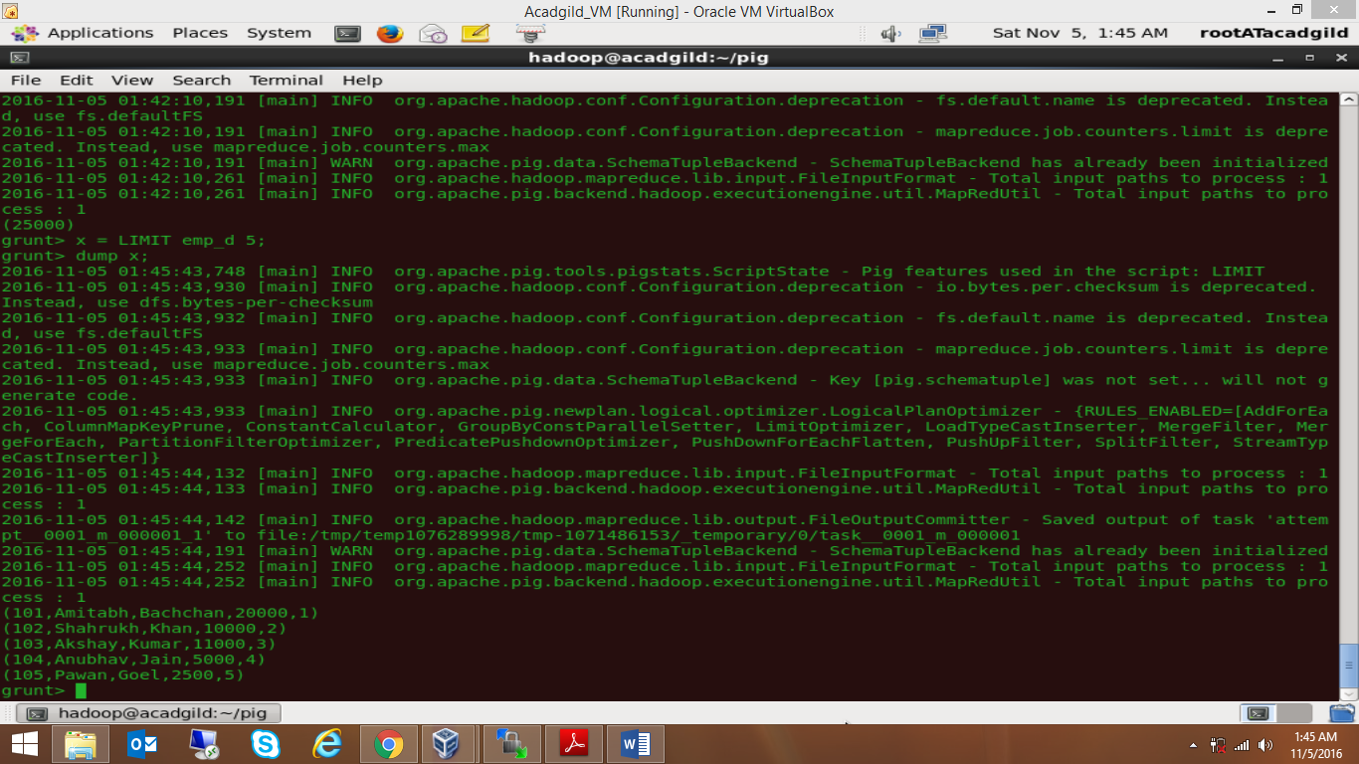

1. **STORE**

STORE limit_records INTO ‘five_emp_records.txt’;

1. **DISTINCT**

sal = FOREACH emp_d GENERATE emp_salary;

distinct_sal = DISTINCT sal;

dump distinct_sal;

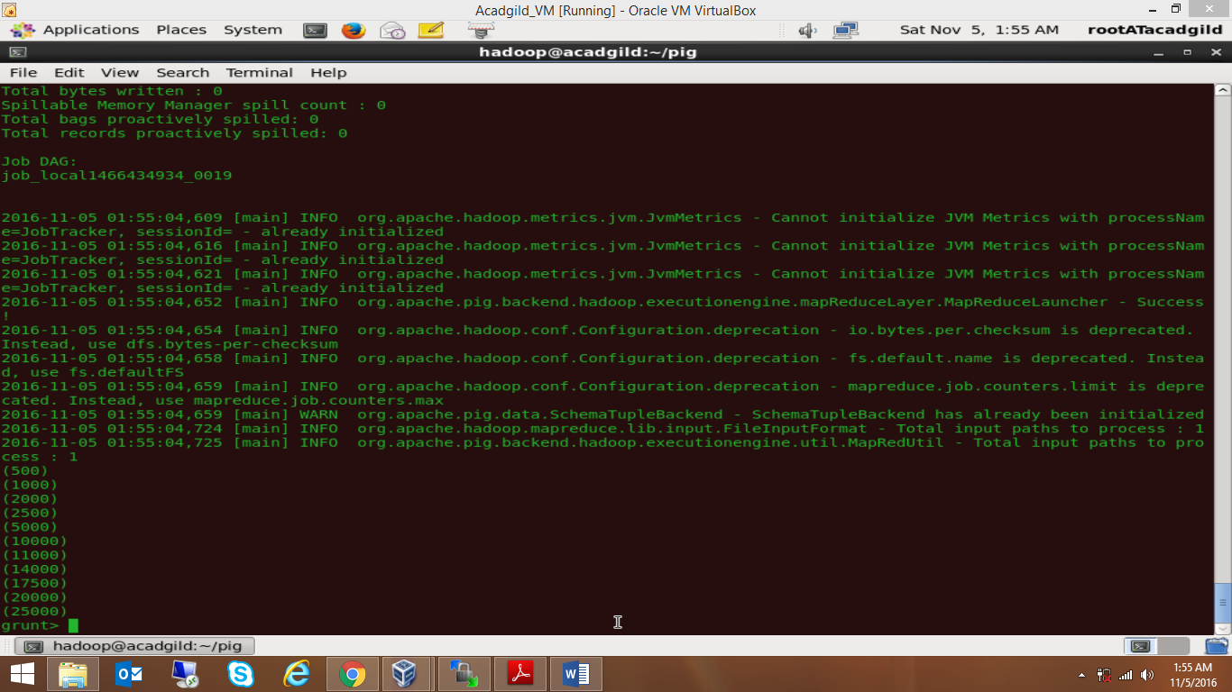

1. **FLATTEN**

flat_tokens = FOREACH tokens GENERATE FLATTEN(name_token);

dump flat_tokens;

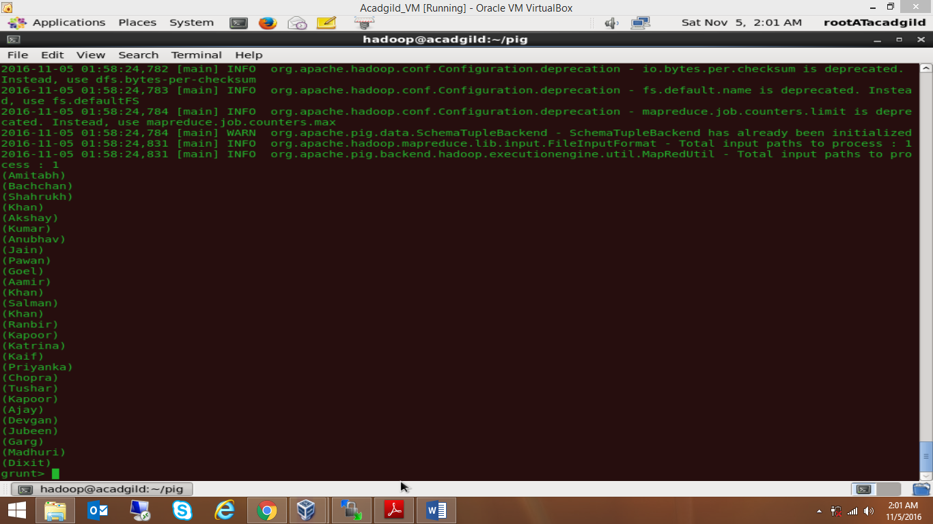

1. **IsEmpty**

emp_e = LOAD ‘emp_expenses.txt’ AS (emp_id:int, emp_expense:int);

co_emp = COGROUP emp_d by emp_id, emp_e by emp_id;

isempty_data = FILTER co_emp BY IsEmpty(emp_e);

dump isempty_data;

