**SESSION 9: PIG – DEMO II**

**ASSIGNMENT 1**

1. **What is the total amount of petrol in volume sold by every distributor?**

dataset = LOAD ‘petrol_input.txt’ USING PigStorage(‘,’) AS (d_id:chararray, d_name:chararray,

buy_rate:chararray, sell_rate:chararray, volin:int, volout:int, year:int);

grouped_dataset = GROUP dataset BY d_name;

total_vol_sold = FOREACH grouped_dataset GENERATE group, SUM(grouped_dataset.volout);

dump total_vol_sold;

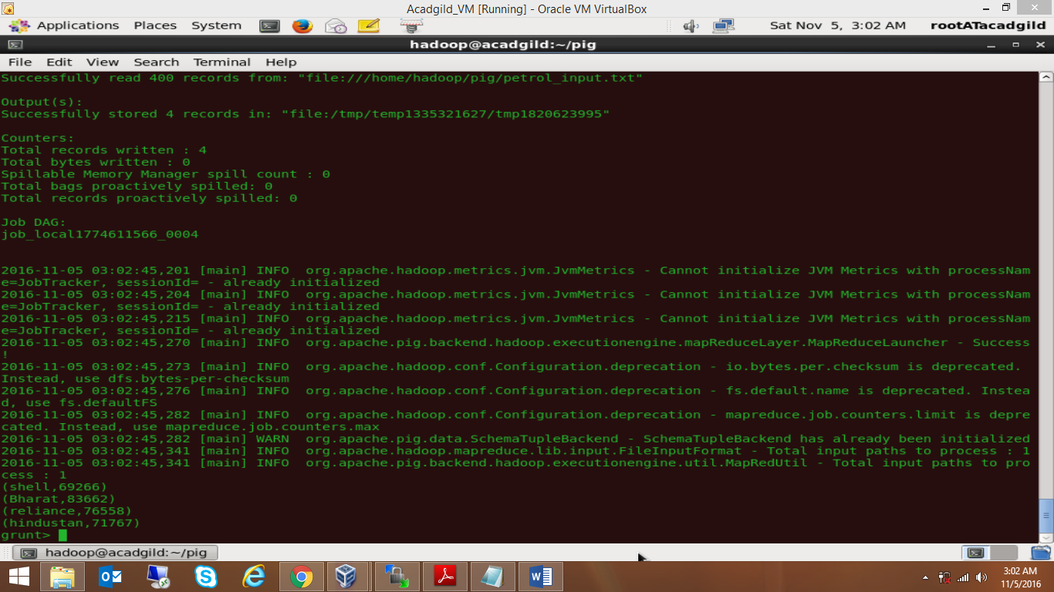

**ANS: (shell,69266)**

**(Bharat,83662)**

**(reliance,76558)**

**(hindustan,71767)**

1. **Which are the top 10 distributer’s IDs for selling petrol? Also, display the amount of petrol sold in volume.**

dataset = LOAD ‘petrol_input.txt’ USING PigStorage(‘,’) AS (d_id:chararray, d_name:chararray,

buy_rate:chararray, sell_rate:chararray, volin:int, volout:int, year:int);

did_volout = FOREACH dataset GENERATE d_id, volout;

sort_did_volout = ORDER did_volout BY volout DESC;

top_ten_did = LIMIT sort_did_volout 10;

dump top_ten_did;

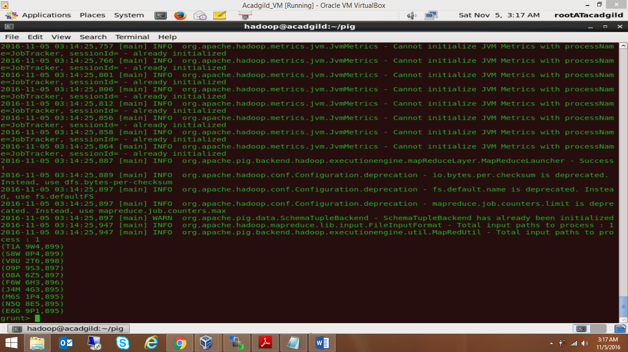

1. **List 10 years where consumption of petrol is more with the distributor ID who sold it.**

dataset = LOAD ‘petrol_input.txt’ USING PigStorage(‘,’) AS (d_id:chararray, d_name:chararray,

buy_rate:chararray, sell_rate:chararray, volin:int, volout:int, year:int);

data = FOREACH dataset GENERATE d_id, volin, year;

sorted_data = ORDER data BY volin DESC;

limit_sorted_data = LIMIT sorted_data 10;

highest_consumer_years = FOREACH limit_sorted_data GENERATE d_id, year;

dump highest_consumer_years;

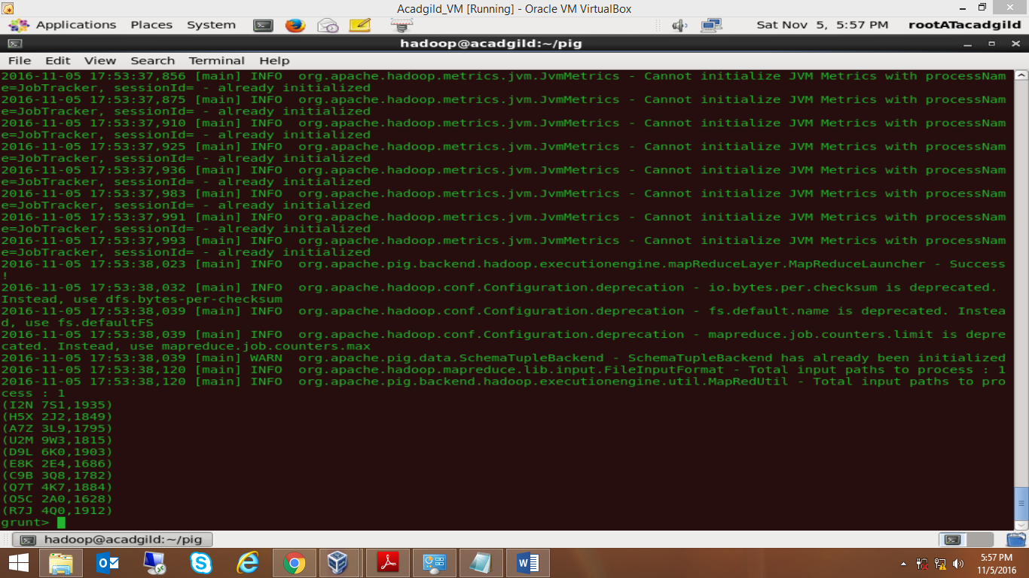

1. **Find the Distributor name who sold petrol in least amount.**

dataset = LOAD ‘petrol_input.txt’ USING PigStorage(‘,’) AS (d_id:chararray, d_name:chararray,

buy_rate:chararray, sell_rate:chararray, volin:int, volout:int, year:int);

grouped_dataset = GROUP dataset by d_name;

dname_volout = FOREACH grouped_dataset GENERATE group, SUM(volout) as tvolout;

sorted_dname_volout = ORDER dname_volout BY tvolout;

least_seller = LIMIT sorted_dname_volout 1;

dump least_seller;

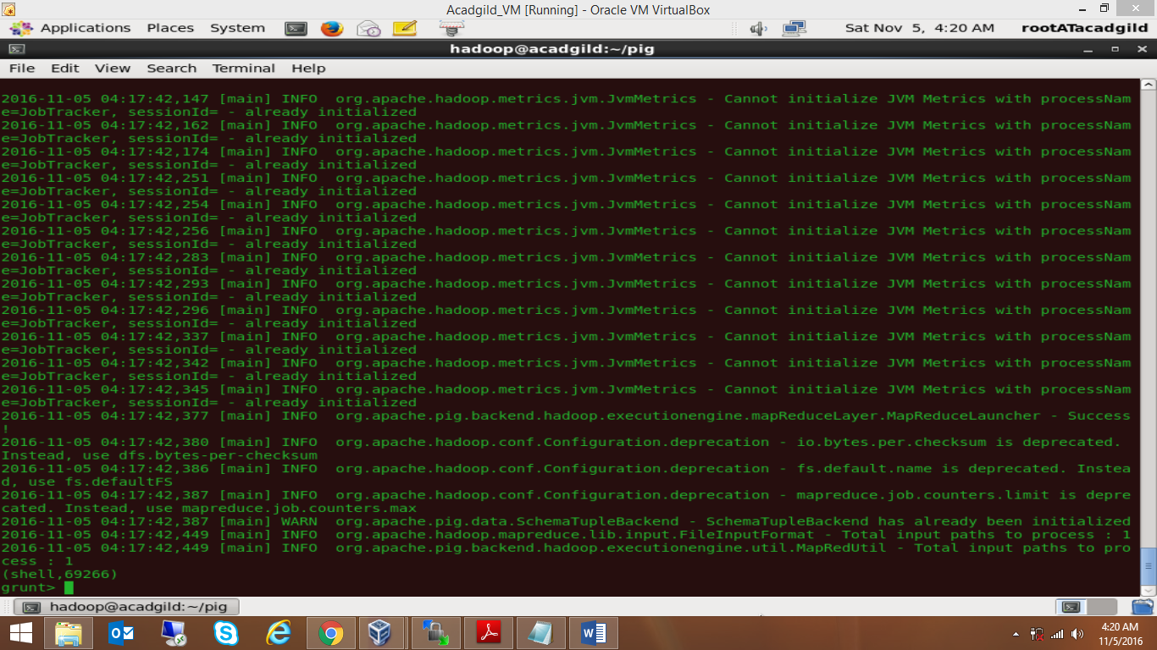

**ANS: (shell, 69266)**