**SESSION 9: PIG – DEMO II**

**ASSIGNMENT 2**

1. **Find the number of students who scored less than 5(50%)?**

studentdb = LOAD ‘studentDS.txt’ USING PigStorage(‘,’) AS (name:chararray, clg:chararray,

dob:chararray, branch:chararray, grade:float, state:chararray, city:chararray);

filter_data = FILTER studentdb BY grade<5;

grp_filter_data = GROUP filter_data all;

result = FOREACH grp_filter_data GENERATE COUNT(filter_data);

dump result;

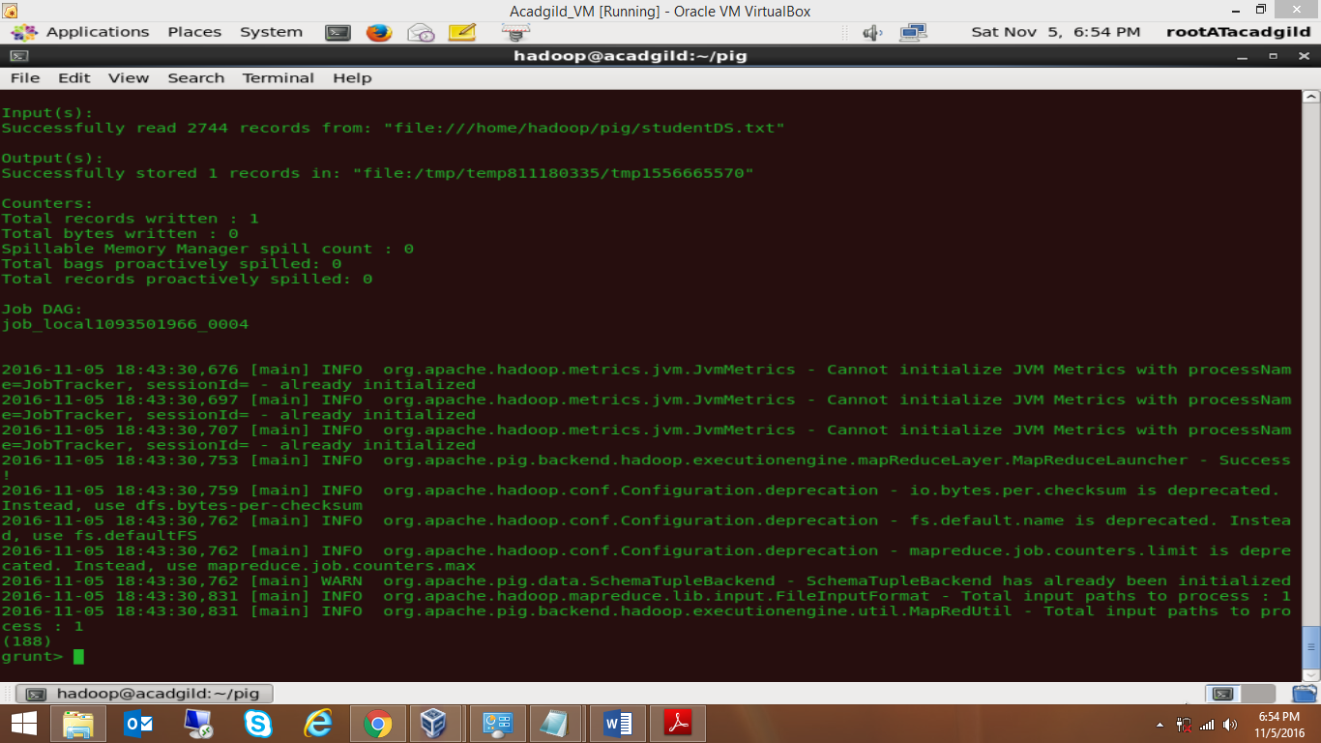

**Ans: (188)**

1. **List the name of students who are from Alaska.**

studentdb = LOAD ‘studentDS.txt’ USING PigStorage(‘,’) AS (name:chararray, clg:chararray,

dob:chararray, branch:chararray, grade:float, state:chararray, city:chararray);

filter_data = FILTER studentdb BY state == ‘alaska’;

result = FOREACH filter_data GENERATE name;

dump result;

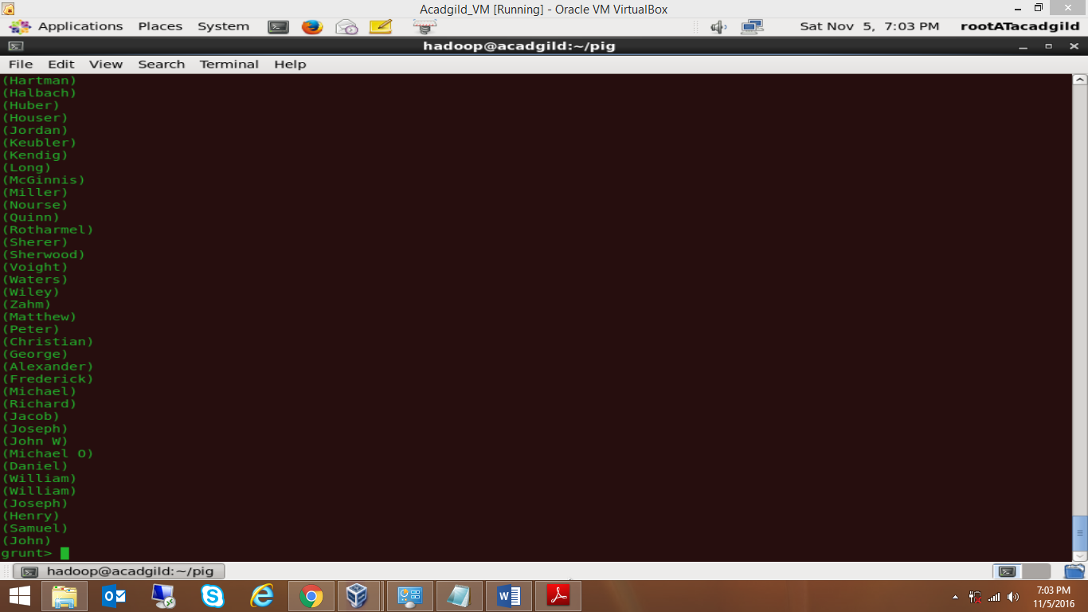

1. **How many government colleges are there in Alabama?**

studentdb = LOAD ‘studentDS.txt’ USING PigStorage(‘,’) AS (name:chararray, clg:chararray,

dob:chararray, branch:chararray, grade:float, state:chararray, city:chararray);

filter_data = FILTER studentdb BY (clg == ‘goverenment’ OR clg == ‘goverement’) AND state ==

‘alabama’;

grp_filter_data = GROUP filter_data all;

result = FOREACH grp_filter_data GENERATE COUNT(filter_data);

dump result;

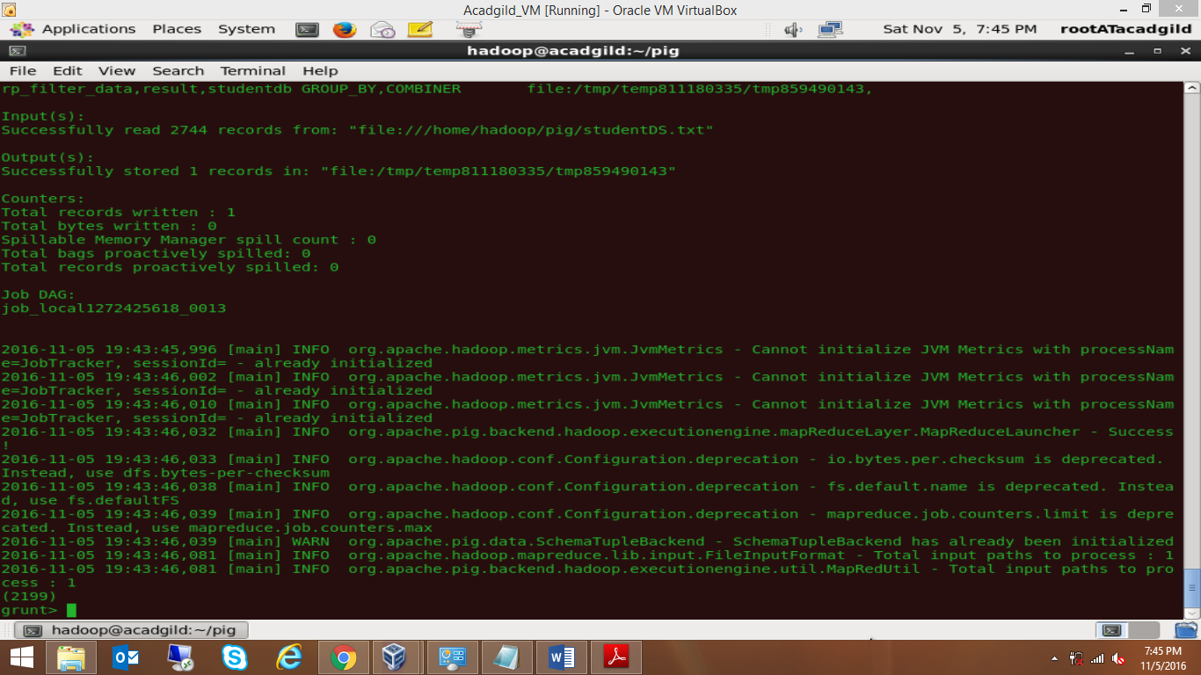

**ANS: (2199)**

1. **List the name of students who are from Oregon and pursuing BE.**

studentdb = LOAD ‘studentDS.txt’ USING PigStorage(‘,’) AS (name:chararray, clg:chararray,

dob:chararray, branch:chararray, grade:float, state:chararray, city:chararray);

filter_data = FILTER studentdb BY branch == ‘BE’ AND state == ‘oregon’;

result = FOREACH filter_data GENERATE name;

dump result;

