Proof of Means of Financial Support
Application for Canada Study Permit
Applicant: MohammadReza Rostamian Delavar

Contents

Cover Letter 2
Available Funds and Cost Estimates 3
My Bank Statement (Tejarat Bank) 4
My Father’s Bank Statement (Bank Melli) 5
Deposit 6
My Payslip 7

Cover Letter
Name: MohammadReza Rostamian Delavar
Phone: (+98) 912 710 2822
Email: mohros@kth.se
To: The Canadian Embassy, Turkey
Date: 7/7/2022
Subject: Applying for Study Permit in Canada
Attention: Visa Officer
Dear Consular Officer,
I have been admitted to the Engr Innovation & Entrepreneurship full-time program at Ryerson University, Canada with the commencement date of September 2022. In this regard, all the required documents and relevant details regarding my financial status to support my education in Canada are elaborated on over the following pages.
Also, noteworthy to mention is that I have deposited 1,000$ upfront as requested by Ryerson University.
I would gladly provide any further information if need be.
Best Regards,
MohammadReza Rostamian Delavar

Available Funds and Cost Estimates
The table below shows the details of estimated costs for the first year of my stay (including the tuition fees according to the website of Ryerson University, the cost of living according to the CIC website as well as other miscellaneous costs.)
Table 1: The details of the estimated costs (tuition fees, cost of living, and other miscellaneous costs) for the first year
Item | Cost | Source
Tuition fees | 32,000.00 | Ryerson University’s website
Living expenses for myself | 10,000.00 | CIC website
Miscellaneous | 5,000.00 | CIC website
Total | 47,000.00

Table 2 illustrates the details of my available funds along with their corresponding sources.
Table 2: The details of my available funds
Account No. | Owner | Bank | Balance (CAD) | Source
3828920552 | Myself | Tejarat Bank | 61,899.10 | My salary and savings
3940110000359 | My father | Melli Bank | 12,982.65 | His USD savings
Total |  |  | 74,881.75

Lastly, the table below shows the details of the deposit I have made as requested by Ryerson University.
Table 3: The details of the deposit I have made as requested by the Ryerson University
Item | Amount | Source
Deposit | 1,000.00 | Ryerson University
Total | 1,000.00

To summarize, the total sum of our available funds (Table 2 and Table 3) is 75,881.75 while the total sum of the estimated cost for the first year (Table 1) is 47,000.00. Therefore, it is evident that I will be able to cover the costs for the first year of my studies without any problems.

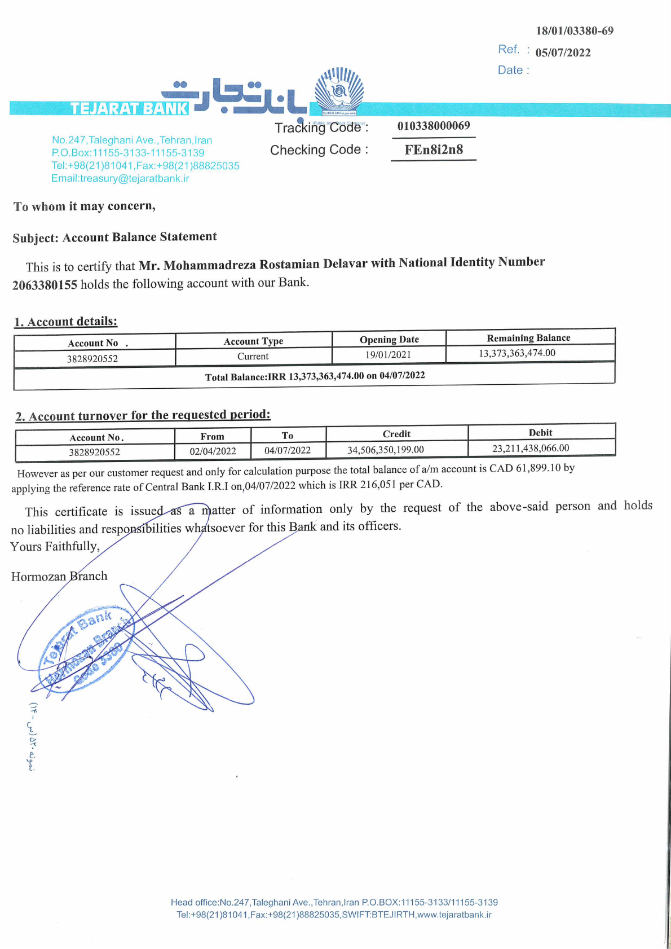
My Bank Statement (Tejarat Bank)

My Father’s Bank Statement (Bank Melli)
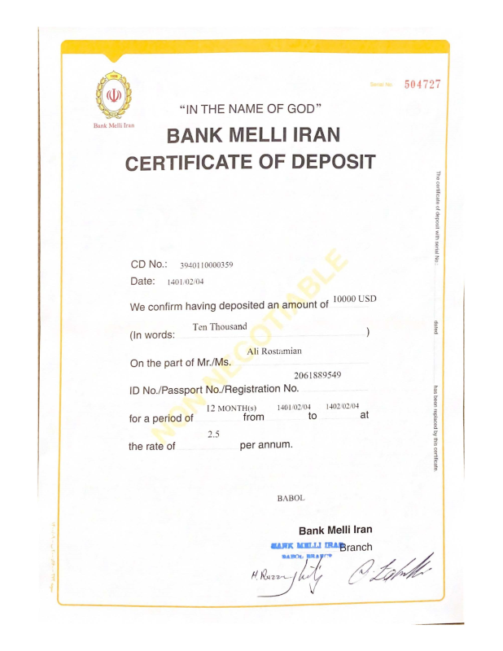

Deposit
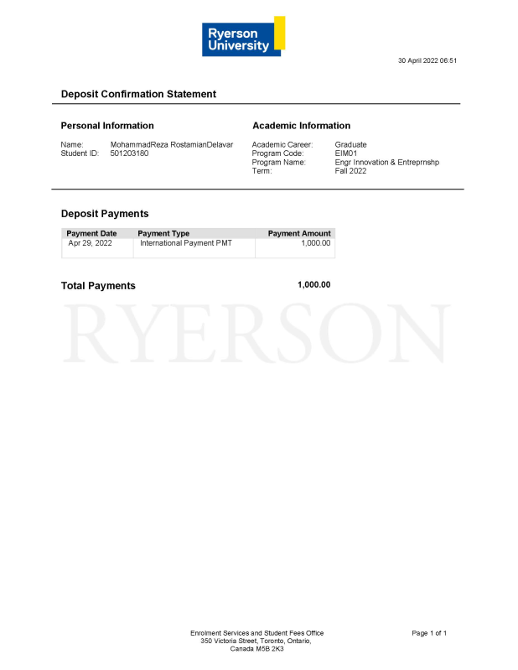

My Payslip


