Java analysis

Aim: be able to drill down into data in the column analysis when using the java engine.

Constraints:
Because we cannot reasonably store all the analyzed data (the volume may be too large),
we will only display samples of data when the user wants to drill down into the data.

We will store the data only in memory (this is why we'll limit the size of viewable data). These data can only be browsed only after an analysis is run. If the studio is restarted, no data will be kept.

Implementation:

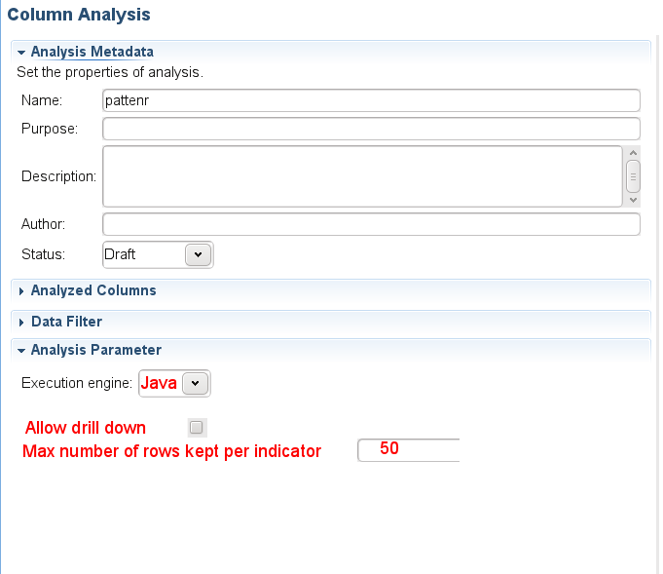

Analysis settings:
The limit on the number of viewable data is a parameter of the analysis that the user can easily change. When the “SQL” engine is chosen, the “allow drill down” and “max number of rows..” are hidden because these parameters are not used.
When the “Java” engine is chosen, these fields are visible and by default, the checkbox is selected and the value of the “max number of rows” is 50.
These parameters are the “storeData” and “maxNumberRows” attributes of the AnalysisParameters class.

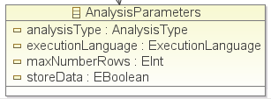

Analyzed data sets:
Most indicators have analyzed data sets. Let's take the example of the null count indicator. For this indicator, with the SQL engine, it's possible to drill down in the data and view the rows which contain a null value. We need to be able to do the same with the java engine.

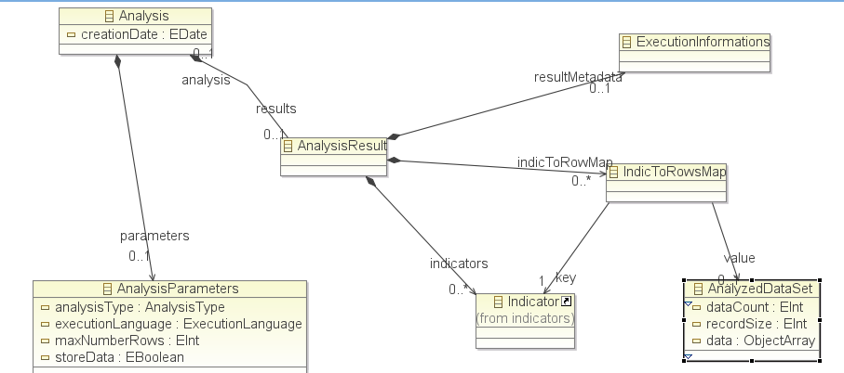

In order to do that, the model has been adapted. See the above image. In this UML diagram, the AnalysisResult contains a map between the indicator and the analyzed data set.

Example:
if we analyze the number of null values of the address fields, the data set of the “null count” indicator will be:
lname, fname, address
Whelply;Derrick;<null>;
Derry;Jeanne;<null>;
Spence;Michael;<null>;
Gutierrez;Maya;<null>;
Damstra;Robert;<null>;

Pseudo-code in IndicatorEvaluator:

Initialize record sets
For each row
record = createrecord(number of columns)
increment rowCount
For each column
object = row.getColumnValue()
record.add(object)
For each indicator
indicator.handle(columnInstance)
if (rowCount < indicator.maxNumberOfRows && indicator.mustStoreRow()) {
// store "view rows" link between indicator and record in analysis results
add record in record set corresponding to this indicator
}
// we must do the same for the other possible links such
// as "view valid rows", "view invalid rows"...
// but it's not implemented in the model yet.
// it will be done later.
if (indicator.isValidRow()) {
}
if (indicator.isInvalidRow()) {
}
} // end of indicator loop
} // end of column loop
store record in record set.

Notes:
- Record.add(object) is approximatively in actual code: AnalysisResult.getIndicToRowMap().get(Indicator).getData()[i] = object
where “i” is the index of the analyzed column.
- Adding the record in the record set will be done with AnalysisResult.getIndicToRowMap().get(Indicator).getData().add(Object[])
- In the “Indicator.handle” method, a boolean must be set to true or false so that the “mustStoreData” method returns true or false. The actual implementation will depend on the indicator.
- Some parameters of the analysis must be passed to the IndicatorEvaluator.
- The code in red color must be skipped if the user does not want to view data (drill down is unchecked or max number of rows is 0).

Then these data must be viewable by the user when he chooses the “view rows” menu on the indicator. This menu will open a table with the data (and the name of the columns as headers).
In the case of the null count indicator, if the count of nulls is greater than maxNumberRows, then a warning will appear in the table to say that not all data are displayed. These information must be stored in the AnalyzedDataSet class in Data Count and getData().size().

Steps:
- Implement this feature for the following indicators:
  - Null count
  - blank count
  - default value count
- The following indicators will be done later (because they will need to remove some analyzed data)
  - Unique count
  - All low frequency tables
- Then we'll handle the other types of data sets
  - the data set listing the valid rows
  - the data set listing the invalid rows
  - these datasets will be required to handle the regex, pattern matching indicators
- We may then provide some functions on the data sets such as export, save as...
- In TDQ, we'll need to be able to generate jobs to retrieve the whole data sets.

