Participant information:  Name________________________________________  Address______________________________________  City___________________State_______Zip_________  Phone________________________________________  Email _________________________________________  Participants must provide their true, full legal name and  phone number when turning in their passport. Please visit: http://quiltersrun.com/documents/SoCalQuiltRun2018Rules.pdf To view all rules on winning.  Start Store  Home Store  Start Store | 2018  SOUTHERN CALIFORNIA  QUILTER'S RUN  20th Anniversary  “California Here We Come”  ADULT PASSPORT  July 12-15 & 19-22  THURS - SAT 9 AM - 7PM  SUNDAY 10AM - 5PM  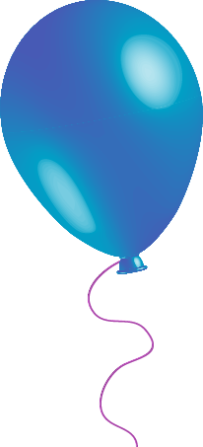  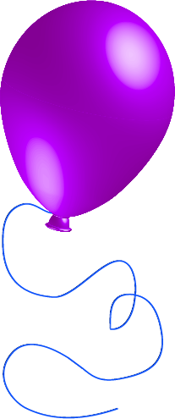  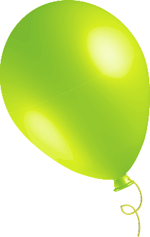  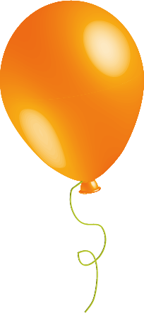  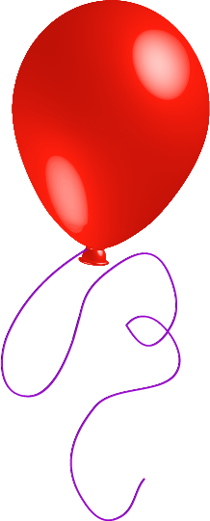  
Participant information:  Name________________________________________  Address______________________________________  City___________________State_______Zip_________  Phone________________________________________  Email _________________________________________  Participants must provide their true, full legal name and  phone number when turning in their passport. Please visit: http://quiltersrun.com/documents/SoCalQuiltRun2018Rules.pdf To view all rules on winning.  Start Store  Home Store  Start Store | 2018  SOUTHERN CALIFORNIA  QUILTER'S RUN  20th Anniversary  “California Here We Come”  ADULT PASSPORT  July 12-15 & 19-22  THURS - SAT 9 AM - 7PM  SUNDAY 10AM - 5PM
  Bolts in the Bathtub  723 West Lancaster Blvd Lancaster, CA 93534 (661) 945-5541 | Cotton & Chocolate Quilt Co.  1724 E. Avenida De Los Arboles #E Thousand Oaks, CA 91362  (805) 241-0061
  Sewn Together  1700 Hamner Ave., Suite 112 Norco, CA 92860 (951) 479-5121 | Orange Quilt Bee  628 E. Katella Ave. Orange, CA 92867 (714) 639-3245
  The Quilter's Faire  34500 Gateway Dr. #110 Palm Desert, CA 92211 (760) 328-8737 | Monica's Quilt & Bead Creations  77780 Country Club Dr. #C-D Palm Desert, CA 92211 (760) 772-2400
  Quilt In a Day  1955 Diamond St. San Marcos, CA 92078 (760) 591-0929 | Inspirations Quilt Shop  27350 Valley Center Rd. #B Valley Center, CA 92082 (760) 751-9400
  Quilt Emporium  4918 Topanga Canyon Blvd. Woodland Hills, CA 91364  (818) 704-8238 | The Sew N Sew  160 North Glendora Ave. #E Glendora, CA 91741  (626) 852-2223
  Quilter's Cocoon  9901 Indiana Ave. #104 Riverside, CA 92503 (951) 351-0346 | Tops & Bobbins  15550 Main St. #B-6 Hesperia, CA 92345 (760) 881-4025
  Quilter's Cottage  131 E. Fig St., Suite 6 Fallbrook, CA 92028 (760) 723-3060 | Fat Quarters Quilt Shop  728 Civic Center Dr. Vista, CA 92084  (760) 758-8308
  Memory Lane Quilt Shop  1626 N. Magnolia Avenue El Cajon, CA 92020 (619) 562-2288 | Cozy Creative Center  756 Jamacha Rd. El Cajon, CA 92019 (619) 670-0652
  Bolts in the Bathtub  723 West Lancaster Blvd Lancaster, CA 93534 (661) 945-5541 | Cotton & Chocolate Quilt Co.  1724 E. Avenida De Los Arboles #E Thousand Oaks, CA 91362  (805) 241-0061
  Sewn Together  1700 Hamner Ave., Suite 112 Norco, CA 92860 (951) 479-5121 | Orange Quilt Bee  628 E. Katella Ave. Orange, CA 92867 (714) 639-3245
  The Quilter's Faire  34500 Gateway Dr. #110 Palm Desert, CA 92211 (760) 328-8737 | Monica's Quilt & Bead Creations  77780 Country Club Dr. #C-D Palm Desert, CA 92211 (760) 772-2400
  Quilt In a Day  1955 Diamond St. San Marcos, CA 92078 (760) 591-0929 | Inspirations Quilt Shop  27350 Valley Center Rd. #B Valley Center, CA 92082 (760) 751-9400
  Quilt Emporium  4918 Topanga Canyon Blvd. Woodland Hills, CA 91364  (818) 704-8238 | The Sew N Sew  160 North Glendora Ave. #E Glendora, CA 91741  (626) 852-2223
  Quilter's Cocoon  9901 Indiana Ave. #104 Riverside, CA 92503 (951) 351-0346 | Tops & Bobbins  15550 Main St. #B-6 Hesperia, CA 92345 (760) 881-4025
  Quilter's Cottage  131 E. Fig St., Suite 6 Fallbrook, CA 92028 (760) 723-3060 | Fat Quarters Quilt Shop  728 Civic Center Dr. Vista, CA 92084  (760) 758-8308
  Memory Lane Quilt Shop  1626 N. Magnolia Avenue El Cajon, CA 92020 (619) 562-2288 | Cozy Creative Center  756 Jamacha Rd. El Cajon, CA 92019 (619) 670-0652

