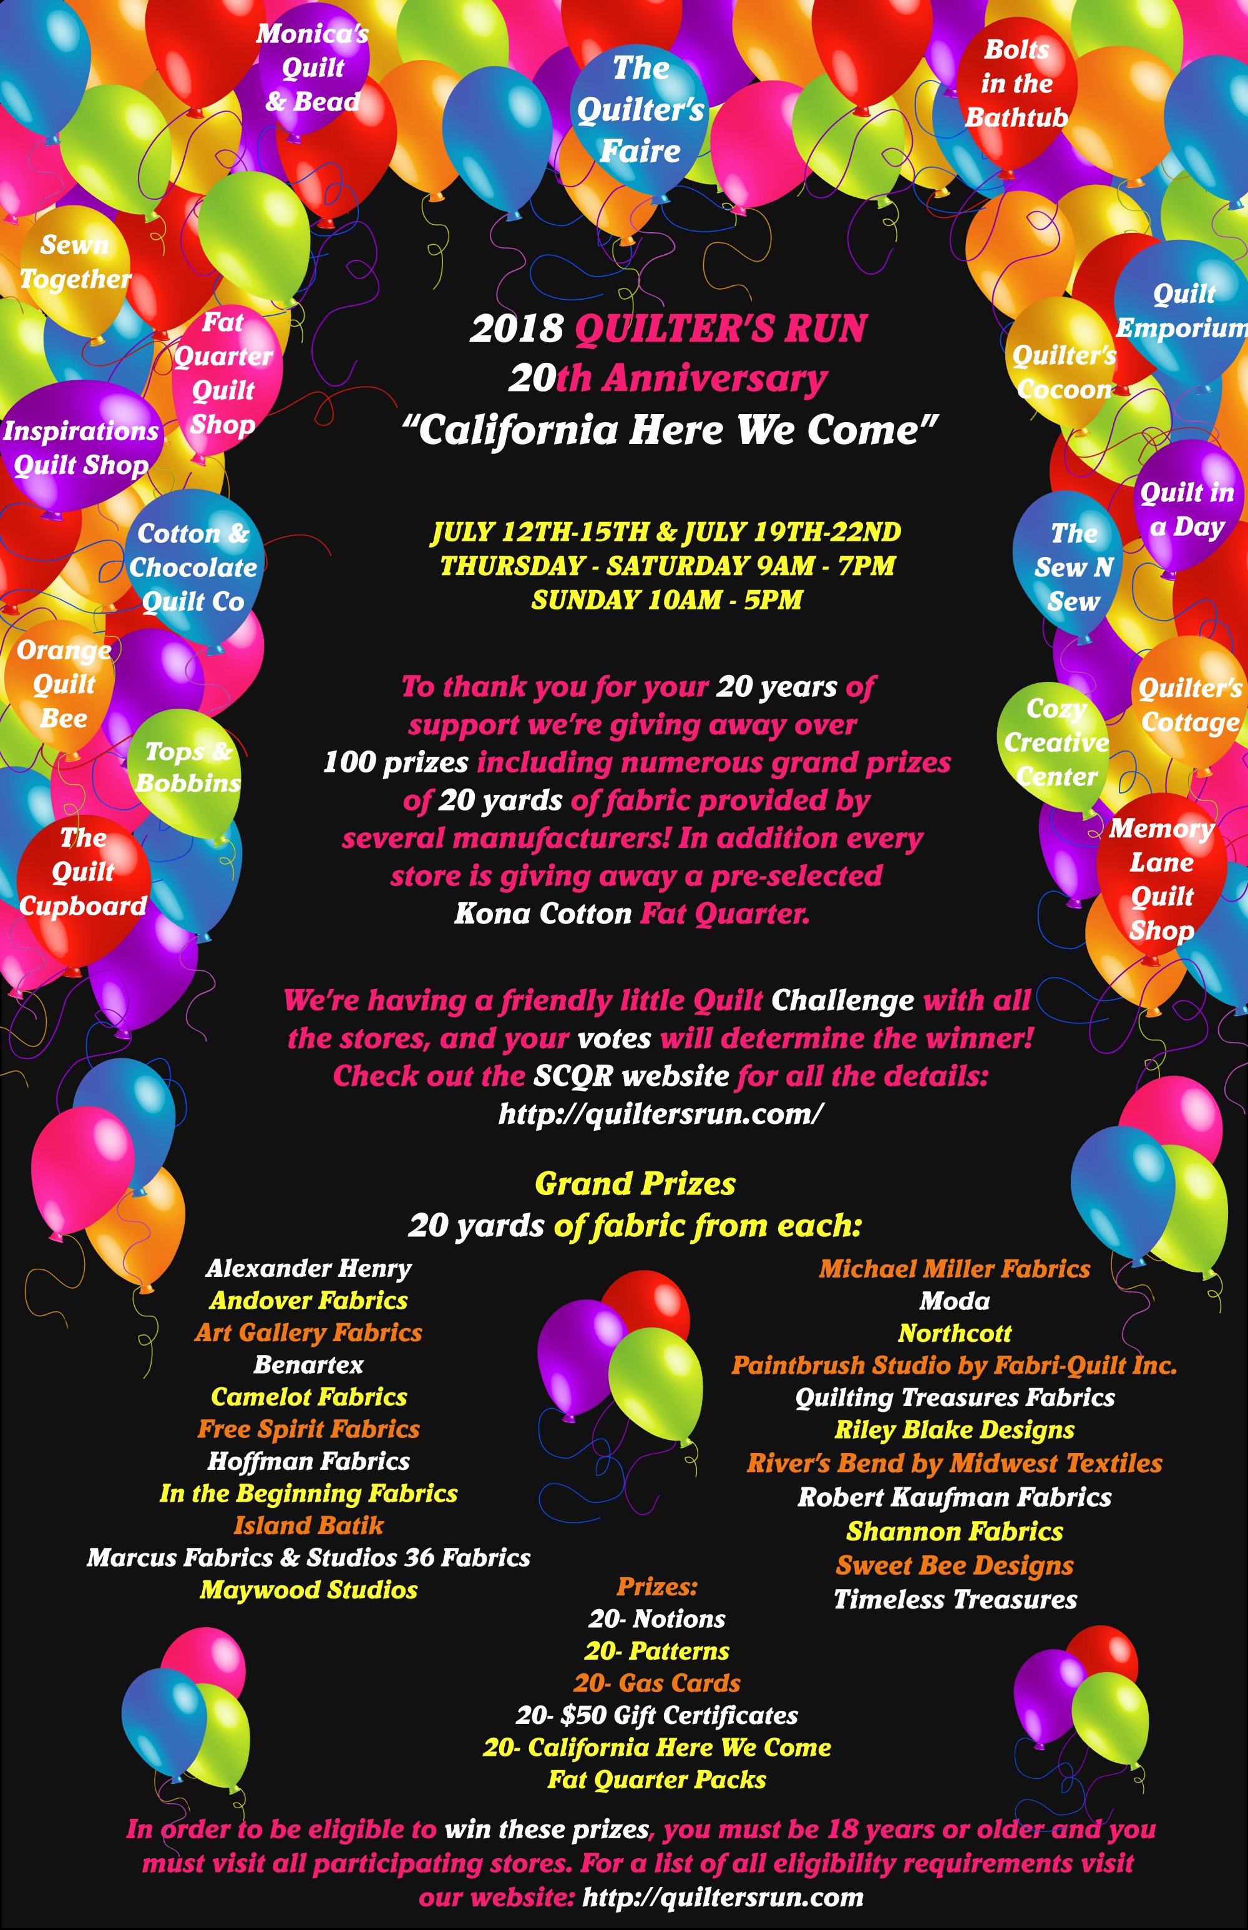

|  |  |
| --- | --- |
| Cozy Creative Center | (619) 670-0652 |
| 756 Jamacha Rd. | [www.cozyquilt.com](http://www.cozyquilt.com/) |
| El Cajon, CA 92019 |  |
|  |  |
| Take Fwy 8 to Second Street in El Cajon. Go South on Second St. (Turn right if coming from San Diego/LaMesa. Turn left if coming from East County/Alpine.) After about 1 mile, cross Washington. We are on the right in the CVS/Outback parking lot. | |

|  |  |
| --- | --- |
| Bolts in the Bathtub | (661) 945-5541 |
| 723 West Lancaster Blvd | [www.boltsinthebathtub.com](http://www.boltsinthebathtub.com/) |
| Lancaster, CA 93534 |  |
|  |  |
| From the 14 Fwy North, exit at 20th St. West/Ave J. Turn right onto 20th, drive approx. 3/4 of a mile to Lancaster Blvd. and turn right again. Drive 1 mile, crossing 10th St. W and turn left on Fern Avenue. Make a right into the alley and drive until you see the BITB sign over our back entrance. Limited parking available on Lancaster Blvd. | |

|  |  |
| --- | --- |
| Cotton & Chocolate Quilt Co. | (805) 241-0061 |
| 1724 E. Avenida De Los Arboles #E | [www.cottonandchocolate.com](http://www.cottonandchocolate.com/) |
| Thousand Oaks, CA 91362 |  |
|  |  |
| From the 101 Fwy, take the CA 23N exit. Drive approx. 3 miles and exit right on Avenida De Los Arboles. At the first light, turn right into Oakbrook Shopping Center. The store is located north of Gelsons. From the 118 Freeway, take the 23 Fwy South and exit at Avenida De Los Arboles. Turn left under the Fwy and then right into the shopping center. | |

|  |  |
| --- | --- |
| Quilt Emporium | (818) 704-8238 |
| 4918 Topanga Canyon Blvd. | [www.quiltemporium.com](http://www.quiltemporium.com/) |
| Woodland Hills, CA 91364 |  |
|  |  |
| From the 101 Fwy west bound, exit Topanga Canyon Blvd. South. From the 101 Fwy east bound, exit Ventura Blvd. - Topanga Cyn, turning right onto Topanga Cyn. Drive 0.8 miles. Turn left onto Dumetz St. (Starbucks is on the corner). Make an immediate left into the parking lot behind the Quilt Emporium. | |

|  |  |
| --- | --- |
| The Sew N Sew | (626) 852-2223 |
| 160 North Glendora Ave. #E | [www.thesewnsew.com](http://www.thesewnsew.com/) |
| Glendora, CA 91741 |  |
|  |  |
| From the 210 Fwy, exit Grand Ave. Go North to Foothill Blvd. and turn right. Continue east to Vista Bonita (one street past Glendora Blvd.) Turn left on Vista Bonita. Continue 1/2 block past the grey house on the left side of the street. This is a public parking lot. We are in the plaza on the north side. | |

|  |  |
| --- | --- |
| Sewn Together | (951) 479-5121 |
| 1700 Hamner Ave., Suite 112 | [www.sewntogethernorco.com](http://www.sewntogethernorco.com/) |
| Norco, CA 92860 |  |
|  |  |
| From the 15 North exit Hidden Valley Parkway, turn left on Hidden Valley Parkway, turn right on Hammer Ave. We are on the left. From 15 South exit 2nd St, turn right on 2nd, turn left on Hammer Ave. We are on the right. | |

|  |  |
| --- | --- |
| The Quilt Cupboard | (714) 993-3091 |
| 1243 East Imperial Highway | [www.thequiltcupboard.net](http://www.thequiltcupboard.net/) |
| Placentia, CA 92870 |  |
|  |  |
| From the 91 Freeway, exit Imperial Hwy, turn North onto Imperial Hwy. From the 57 Fwy, exit Imperial Hwy, turn East on Imperial Hwy. The Quilt Cupboard is located on the Northeast corner of Rose Dr. and Imperial Hwy. Not: DO NOT USE GPS- it will take you to Brea. | |

|  |  |
| --- | --- |
| Orange Quilt Bee | (714) 639-3245 |
| 628 E. Katella Ave. | [www.orangequiltbee.com](http://www.orangequiltbee.com/) |
| Orange, CA 92867 |  |
|  |  |
| From the 55 Fwy, exit Katella Ave. and go west. Orange Quilt Bee is just past Cambridge on the left. Our shop is located in a dark brown single story building. Note: DO NOT USE GPS - the directions are not correct and will take you west 1/2 miles on Katella. | |

|  |  |
| --- | --- |
| Quilter's Cocoon | (951) 351-0346 |
| 9901 Indiana Ave. #104 | [www.quilterscocoon.com](http://www.quilterscocoon.com/) |
| Riverside, CA 92503 |  |
|  |  |
| From the 91 Fwy East, exit Van Buren and turn right onto Indiana Ave. From the 91 Fwy West, exit Van Buren. Turn left onto Van Buren, then turn right onto Indiana Ave. Just after you pass Harrison, we are on the right. | |

|  |  |
| --- | --- |
| Tops & Bobbins | (760) 881-4025 |
| 15550 Main St. #B-6 | [www.topsandbobbins.com](http://www.topsandbobbins.com/) |
| Hesperia, CA 92345 |  |
|  |  |
| From the 15 Fwy North; exit Main St. and turn right. Stay on Main St. for about 5 miles, make a U-turn at 9th St. Turn right into the Plaza on Main shopping center by Cancun Restaurant and Samurai Sushi. From Palm Desert: take CA-62 W to Old Woman Springs Road to Hwy 18. Take Bear Valley Rd. to 7th Street, turn left. Turn right onto Main St., continue across 9th street and turn right in the Plaza on Main shopping center. From Lancaster/Palmdale: Pearblossom Hwy to CA-138 E to Phelan Rd. (Phelan Rd. becomes Main St.) Make a U-turn at 9th St. Turn right into the Plaza on Main shopping center. | |

|  |  |
| --- | --- |
| The Quilter's Faire | (760) 328-8737 |
| 34500 Gateway Dr. #110 | [www.quiltersfaire.com](http://www.quiltersfaire.com/) |
| Palm Desert, CA 92211 |  |
|  |  |
| From the 10 Fwy, take the Monterey exit. Travel South on Monterey and turn left on Dinah Shore Dr. Turn right at Gateway Dr. We are located in an office/industrial park opposite the back of the Wal-Mart/Sam's Club shopping center. Turn left at the second driveway. Follow the signs that say Quilters. | |

|  |  |
| --- | --- |
| Monica's Quilt & Bead Creations | (760) 772-2400 |
| 77780 Country Club Dr. #C-D | [www.monicasquiltandbead.com](http://www.monicasquiltandbead.com/) |
| Palm Desert, CA 92211 |  |
|  |  |
| From the 10 Fwy East, take the Washington exit. Turn right onto Washington. At the first light, turn right onto Country Club Dr. The store is located on the right-hand side of the street, just past the first light. | |

|  |  |
| --- | --- |
| Quilter's Cottage | (760) 723-3060 |
| 131 E. Fig St., Suite 6 | [www.myquilterscottage.com](http://www.myquilterscottage.com/) |
| Fallbrook, CA 92028 |  |
|  |  |
| From the 15 Fwy, exit Mission Road/Fallbrook. Go West at the signal. Turn right as the road becomes Mission Rd. After approx. 4 miles, turn left on Main Ave. Turn left onto Fig St. Quilter's Cottage is located on the right in the third driveway past Wells Fargo. | |

|  |  |
| --- | --- |
| Fat Quarters Quilt Shop | (760) 758-8308 |
| 728 Civic Center Dr. | [www.fatquartersquiltshop.com](http://www.fatquartersquiltshop.com/) |
| Vista, CA 92084 |  |
|  |  |
|  |  |
| From the 15 Fwy, take 78W. From the 5 Fwy, take 78E, then take the Civic Center Dr. exit. Go North on Civic Center Dr. through several lights. We are one block after South Santa Fe, just past the shopping center. (Civic Center used to be Escondido Avenue, still used on older GPS versions) | |

|  |  |
| --- | --- |
| Quilt In a Day | (760) 591-0929 |
| 1955 Diamond St. | [www.quiltinaday.com](http://www.quiltinaday.com/) |
| San Marcos, CA 92078 |  |
|  |  |
| From San Diego on Interstate 5, exit La Costa Ave. and turn right. Turn left onto Rancho Santa Fe Rd. Turn right onto La Costa Meadows Dr. Turn right onto Diamond St. and follow it to the end. We are on the left. From San Diego or Los Angeles on Interstate 15, merge onto Hwy 78 West. Exit on Rancho Santa Fe Rd. Go 5 miles then turn left onto Melrose Dr. Turn right onto Diamond St. and follow it to the end. We are on the left. | |

|  |  |
| --- | --- |
| Inspirations Quilt Shop | (760) 751-9400 |
| 27350 Valley Center Rd. #B | [www.inspired2quilt.com](http://www.inspired2quilt.com/) |
| Valley Center, CA 92082 |  |
|  |  |
| From the coast, take Interstate 5 to 78 East. The Fwy ends and becomes Lincoln Ave. in Escondido. Travel on Lincoln approx. 2 miles, turn right on El Norte Pkwy. Turn left onto Valley Pkwy., which turns into Valley Center Rd. Turn left into the parking lot and park in back. The entrance is across the bridge. From North inland, take Interstate 15 South to Gopher Canyon Rd. Turn left under the Fwy, then right onto Old Hwy 395. Take the first left onto Old Castle Rd. Go approx. 12 miles. The road will become Lilac Rd. Turn right onto Valley Center Rd. The store is on the right. From South inland, go North on Interstate 15 to Via Rancho Pkwy and turn right. Turn right onto Valley Pkwy. | |

|  |  |
| --- | --- |
| Memory Lane Quilt Shop | (619) 562-2288 |
| 1626 N. Magnolia Avenue | [www.memorylanequiltshop.com](http://www.memorylanequiltshop.com/) |
| El Cajon, CA 92020 |  |
|  |  |
| From Interstate 5 South or Interstate 15 South, go southbound to CA-52 East. Exit Magnolia Avenue and turn right to destination. From 8 East, go eastbound to CA-67 North. Exit Bradley, turn left and go over freeway. Turn right on Magnolia Ave. to destination. | |