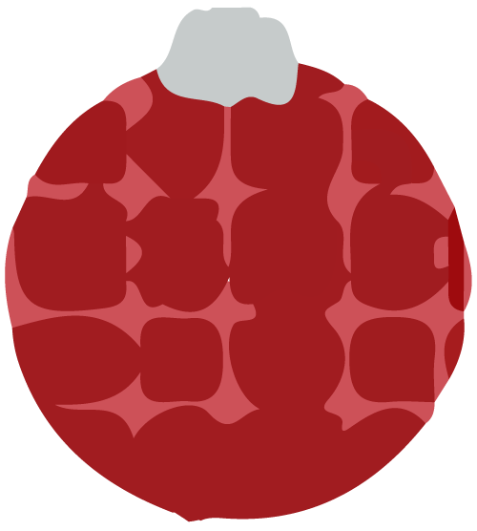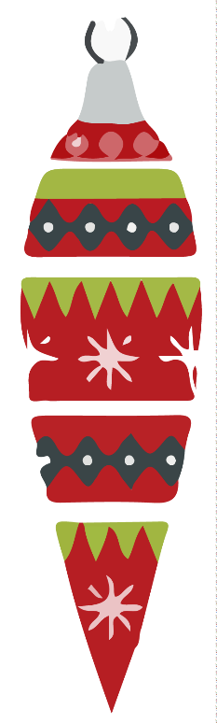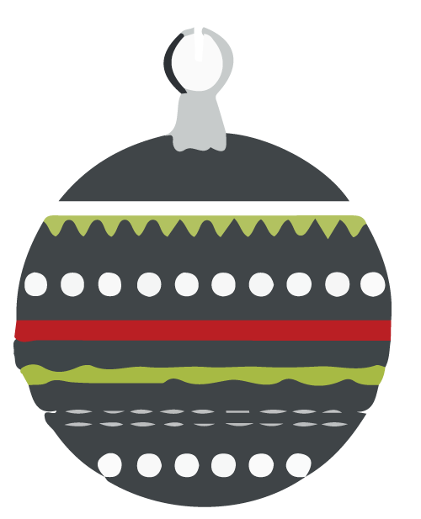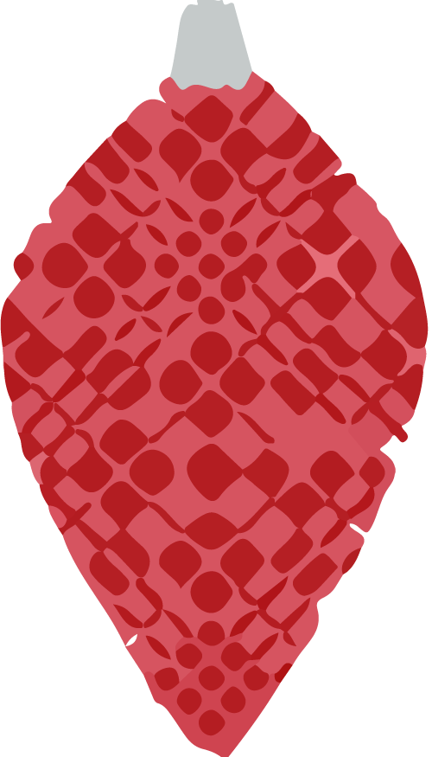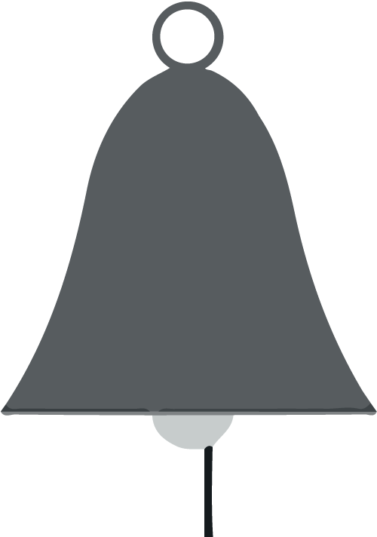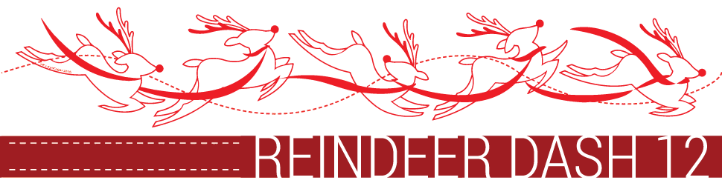

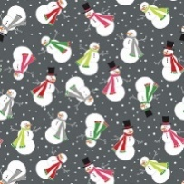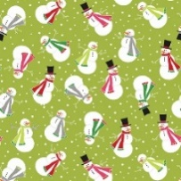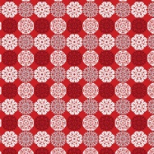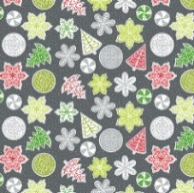

Grand Prize #1: Baby Lock Rachel

Sewing Machine.

2 Grand Prizes

Grand Prize #2: 21 Yards of Fabric.

Choice of 3 Yards of Fabric from

each Quilt Shop.

Free Fat Quarter

(While Supplies Last)

Let It Snow by Benartex

OCT 4th, 5th, & 6th 2018

Thursday thru Saturday 9AM to 6PM

|  |  |
| --- | --- |
| Monica's Quilt & Bead Creations (760) 772-2400  77780 Country Club Dr, Suite C & D  Palm Desert, CA 92211  Directions: From I-10 East, exit at Washington. Turn right. At the first signal, turn right on Country Club Dr. After the first signal, look to the right and there we are. From I-10 West, exit at Washington. Turn left. At the first signal, turn right on Country Club Dr. After the first signal, look to the right and there we are. | The Quilter's Faire (760) 328-8737  34500 Gateway Dr, Suite 110  Palm Desert, CA 92211  Directions: (From East or West) Take the I-10 Freeway to the Monterey exit. Go South on Monterey to the 1st traffic light at Dinah Shore Dr. Turn left. Travel on Dinah Shore Dr. to the second stop light at Gateway Dr. Turn right. We are located in an office/industrial park opposite the back of the Wal-Mart/Sam's Club Shopping Center. Turn left into the 2nd parking lot where there are a few turns. |
| Susan's Quilt Paradise (951) 845-8445  851 E 6th St Suite A4, Beaumont, CA 92223  Directions: FROM 10 FRWY HEADING WEST: take the Pennsylvania Avenue exit, #95, turn right onto Pennsylvania Avenue, then take the first left onto East 6th Street, the Chestnut Center is about 0.26 miles on the left. Susan's Quilt Paradise is in the Chestnut Center, #A4. FROM 10 FRWY HEADING EAST: take the CA-79/Beaumont Avenue exit, #94, turn left onto CA-79/Beaumont Avenue, turn right onto East 6th Street, the Chestnut Center is about 0.38 miles on the right. It is just past Palm Avenue. Susan's Quilt Paradise is in the Chestnut Center, #A4. | Cherry Berry Quilt Shop (909) 795-9090  1096 Calimesa Blvd., Suite B Calimesa, CA 92320  Directions: From I-10 East, exit at County Line Rd. Turn left, then right at Calimesa Blvd. Continue to our shop on the right. From I-10 West, exit at Calimesa Blvd. and then merge onto Calimesa Blvd. Continue to our shop on the left. |
| Cotton Gin Fabric (909) 963-5610  411 E State St, Redlands, CA 92373  Directions: Heading west exit Cypress, turn left on Cypress, Right on Redlands Blvd, left on State ST. We ae on the right #411 E. State Street. Heading East get off Eureka continue on Pearl, right on 6th ST, left on State ST- we are on the left. | Quilter's Cocoon Quilt Shop (951) 351-0346  9901 Indiana Ave., # 104 Riverside, CA 92503  Directions: From 91 West, exit Van Buren and turn left. Turn right at Indiana. Our shop is approximately 3/4 mile down on the right. From 91 East, exit Van Buren and turn right. Our shop is approximately 1/4 mile down on the right. |
| Sewn Together Quilt Shop (951) 479-5121  1700 Hammer Ave., Suite 112 Norco, CA 92860  Directions: From the 15 North exit Hidden Valley Parkway, turn left on Hidden Valley Parkway, turn right on Hammer Ave. We are on the left. From 15 South exit 2nd St, turn right on 2nd, turn left on Hammer Ave. We are on the right. | 20% Off Coupon  Bring non-perishable food  items to each shop for a 20%  Off Coupon good for the month  of December 2018. (Limit one  coupon per person. Excludes sewing  machines, classes and sale items.)  No expired Food please. |