March 7, 8, & 9 2019

Thursday thru Saturday 9AM to 6PM

7 Participating Quilt Shops

Free Fat Quarter

(While Supplies Last)

Berry Sweet by Wilmington Prints

Two Grand Prizes!

Runners who make it to All 7 Quilt Shops will be entered into the Grand Prize Drawings.

**Grand Prize #1:** Baby Lock Rachel Sewing Machine.

**Grand Prize #2:** 21 Yards of Fabric. Choice of 3 Yards of Fabric from each Quilt Shop.

20 % Off Coupon

Bring non-perishable food

items to each shop for a 20%

Off Coupon good for the month of May 2019.

limit 1 per customer.

$50 Gift Certificates

All participants are eligible for drawings in each shop they visit. (One Winner from each

Quilt Shop.)

2019 Spring Fling Quilt Run

https://springflingquiltrun.com

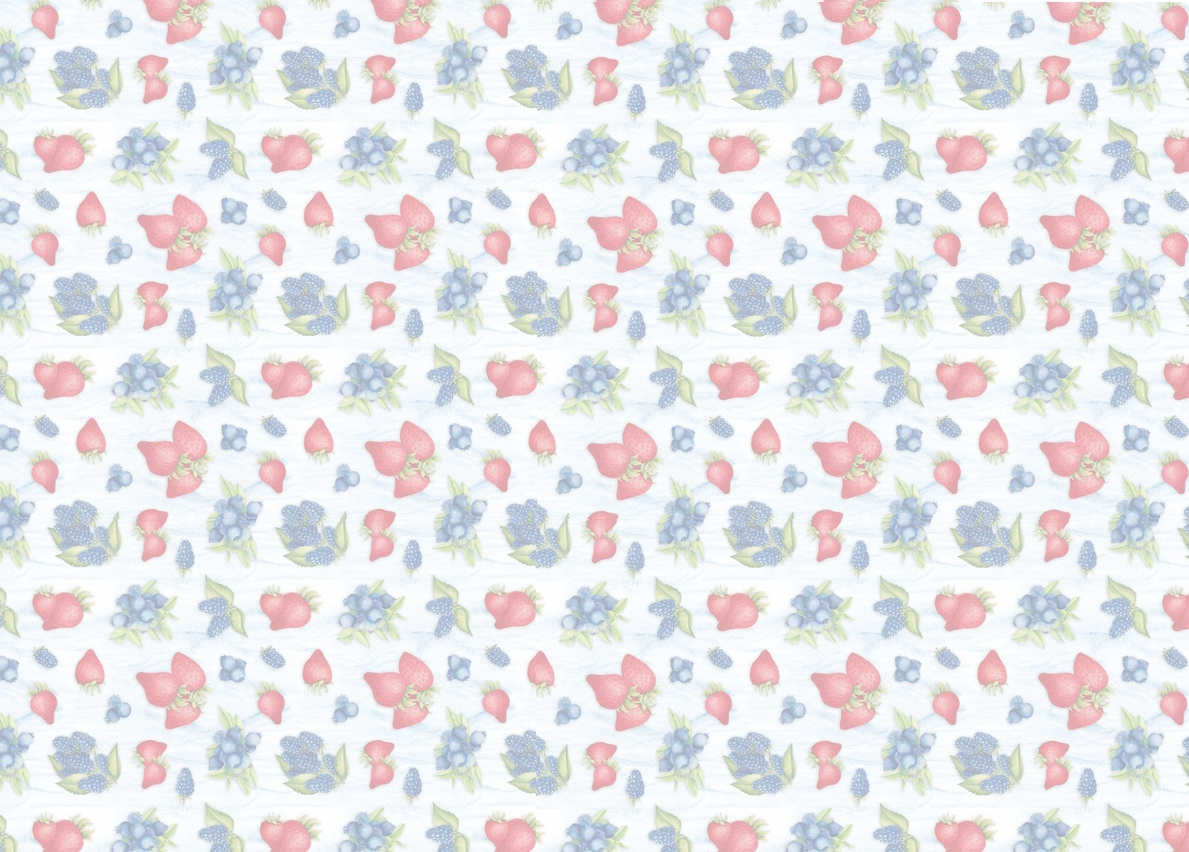

**Monica's Quilt & Bead Creations**

77780 Country Club Dr., Suite C & D Palm Desert, CA 92211 (760) 772-2400

Directions: From I-10 East, exit at Washington. Turn right. At the first signal, turn right on Country Club Dr. After the first signal, look to the right and there we are. From I-10 West, exit at Washington. Turn left. At the first signal, turn right on Country Club Dr. After the first signal, look to the right and there we are.

**Sewn Together Quilt Shop**

1700 Hamner Ave., Suite 112 Norco, CA 92860 (951) 479-5121

Directions: Directions: From the 15 North exit Hidden Valley Parkway, turn left on Hidden Valley Parkway, turn right on Hamner Ave. We are on the left. From 15 South exit 2nd St, turn right on 2nd, turn left on Hamner Ave. We are on the right.

**Cherry Berry Quilt Shop**

1096 Calimesa Blvd., Suite B Calimesa, CA 92320 (909) 795-9090

Directions: From I-10E exit at County Line Rd. Turn left, then turn right onto Calimesa Blvd. Continue on Calimesa Blvd to Atlas Storage Center on the right. From I-10W exit at Calimesa Blvd, then merge onto Calimesa Blvd. Continue on Calimesa Blvd to Atlas Storage Center on the left.

**Cotton Gin Fabric**

411 E State St, Redlands, CA 92373 (909) 963-5610

Directions: Heading west exit Cypress, turn left on Cypress, Right on Redlands Blvd, left on State ST. We are on the right #411 E. State Street. Heading East get off Eureka continue on Pearl, right on 6th ST, left on State ST- we are on the left.

**Quilter's Cocoon Quilt Shop**

9901 Indiana Ave., # 104 Riverside, CA 92503 (951) 351-0346

Directions: From 91 West, exit Van Buren and turn left. Turn right at Indiana. Our shop is approximately 3/4 mile down on the right. From 91 East, exit Van Buren and turn right. Our shop is approximately 1/4 mile down on the right.

**Susan's Quilt Paradise**

851 E 6th St Suite A4, Beaumont, CA 92223 (951) 845-8445

Directions: FROM 10 FRWY HEADING WEST: take the Pennsylvania Avenue exit, #95, turn right onto Pennsylvania Avenue, then take the first left onto East 6th Street, the Chestnut Center is about 0.26 miles on the left. Susan's Quilt Paradise is in the Chestnut Center, #A4. FROM 10 FRWY HEADING EAST: take the CA-79/Beaumont Avenue exit, #94, turn left onto CA-79/Beaumont Avenue, turn right onto East 6th Street, the Chestnut Center is about 0.38 miles on the right. It is just past Palm Avenue. Susan's Quilt Paradise is in the Chestnut Center, #A4.

**The Quilter's Faire**

34500 Gateway Dr., Suite 110 Palm Desert, CA 92211 (760) 328-8737

Directions: (From East or West) Take the I-10 Freeway to the Monterey exit. Go South on Monterey to the 1st traffic light at Dinah Shore Dr. Turn left. Travel on Dinah Shore Dr. to the second stop light at Gateway Dr. Turn right. We are located in an office/industrial park opposite the back of the Wal-Mart/Sam's Club Shopping Center. Turn left into the 2nd parking lot where there are a few turns.