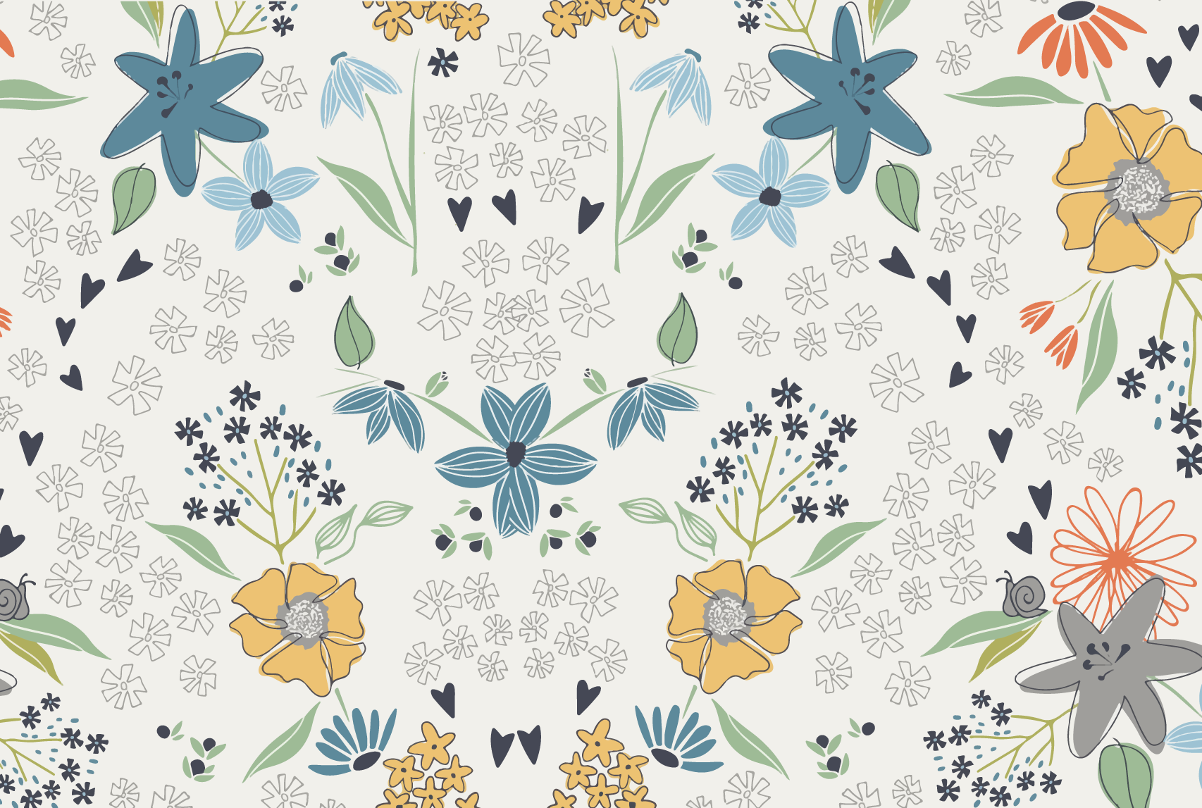

Spring Fling Quilt Run 2018

February 22, 23, & 24 2018

Thursday thru Saturday 9AM to 6PM

8 Participating Quilt Shops

Free Fat Quarter

(While Supplies Last)

Summer Breeze

from Sweet Bee Designs

sss

Two Grand Prizes!

Dashers who make it to All 6 Quilt

Shops will be entered into the

Grand Prize Drawings.

Grand Prize #1: Baby Lock

Rachel Sewing Machine.

Grand Prize #2: 24 Yards of Fabric.

Choice of 3 Yards of Fabric from

each Quilt Shop.

20% Off Coupon

Bring non-perishable food

items to each shop for a 20%

Off Coupon good for the month

of May 2018.

Limit 1 per customer

$50 Gift Certificates

All participants are eligible for

drawings in each shop they visit.

(One Winner from each Quilt Shop.)

Visit the our new website:

http://springflingquiltrun.com/



Quilter's Cocoon Quilt Shop 9901 Indiana Ave., # 104 Riverside, CA 92503 (951) 351-0346

Directions: From 91 West, exit Van Buren and turn left. Turn right at Indiana. Our shop is approximately 3/4 mile down on the right. From 91 East, exit Van Buren and turn right. Our shop is approximately 1/4 mile down on the right.

Painted Lady Quilt Shop 461 Tennessee St., Suite J Redlands, CA 92373 (909) 793-1868

Directions: From the I-10 East, exit at Tennessee St. Turn left, go past Redlands Blvd. to Park. Turn right and then left into the shopping center on the corner. From the I-10 west, exit at Tennessee St. Turn right, go past Redlands Blvd. to Park. Turn right and then left into the shopping center on the corner.

Cotton Gin Fabric 411 E State St, Redlands, CA 92373 (909) 963-5610

Directions: Heading west exit Cypress, turn left on Cypress, Right on Redlands Blvd, left on State ST. We are on the right #411 E. State Street. Heading East get off Eureka continue on Pearl, right on 6th ST, left on State ST- we are on the left.

Susan's Quilt Paradise 851 E 6th St Suite A4, Beaumont, CA 92223 (951) 845-8445

Directions: From I-10 heading west: take the Pennsylvania Avenue exit, #95, turn right onto Pennsylvania Avenue, then take the first left onto East 6th Street, the Chestnut Center is about 0.26 miles on the left. Susan's Quilt Paradise is in the Chestnut Center, #A4. From I-10 heading east: take the CA-79/Beaumont Avenue exit, #94, turn left onto CA-79/Beaumont Avenue, turn right onto East 6th Street, the Chestnut Center is about 0.38 miles on the right. It is just past Palm Avenue. Susan's Quilt Paradise is in the Chestnut Center, #A4.

The Quilter's Faire 34500 Gateway Dr., Suite 110 Palm Desert, CA 92211 (760) 328-8737

Directions: (From East or West) Take the I-10 Freeway to the Monterey exit. Go South on Monterey to the 1st traffic light at Dinah Shore Dr. Turn left. Travel on Dinah Shore Dr. to the second stop light at Gateway Dr. Turn right. We are located in an office/industrial park opposite the back of the Wal-Mart/Sam's Club Shopping Center. Turn left into the 2nd parking lot where there are a few turns.

Cherry Berry Quilt Shop 1096 Calimesa Blvd., Suite B Calimesa, CA 92320 (909) 795-9090

Directions: From I-10 East, exit at County Line Rd. Turn left, then right at Calimesa Blvd. Continue to our shop on the right. From I-10 West, exit at Calimesa Blvd. and then merge onto Calimesa Blvd. Continue to our shop on the left.

Sewn Together Quilt Shop 1700 Hammer Ave., Suite 112 Norco, CA 92860 (951) 479-5121

Directions: From the 15 North exit Hidden Valley Parkway, turn left on Hidden Valley Parkway, turn right on Hammer Ave. We are on the left. From 15 South exit 2nd St, turn right on 2nd, turn left on Hammer Ave. We are on the right.

Monica's Quilt & Bead 77780 Country Club Dr., Suite C & D Palm Desert, CA 92211 (760) 772-2400

Directions: From I-10 East, exit at Washington. Turn right. At the first signal, turn right on Country Club Dr. After the first signal, look to the right and there we are. From I-10 West, exit at Washington. Turn left. At the first signal, turn right on Country Club Dr. After the first signal, look to the right and there we are.Monica's Quilt & Bead Creations