**Dakota Bunn**

*I’m a Microbiologist and Bioinformatician*

Microbiology and bioinformatics are two subfields of biology that use different approaches to study the living world around us. Microbiologist study small organisms such as bacteria, viruses, and fungi while a bioinformatician combines biological knowledge with computer science and statistics to analyze and interpret biological data. These subfields are frequently combined to study the DNA and genetics of microorganisms! However, as a rule biology rarely works alone and these two fields commonly overlap with climate science, field biology, biomedical science and many other interesting sub disciplines.

*Current Project*

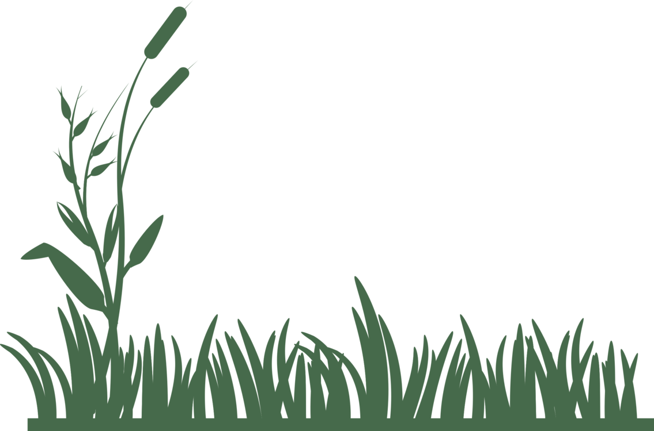I am currently a fourth-year doctoral candidate at the Illinois Institute of Technology with my research focusing on the western bean cutworm and its associated microsporidian pathogens. The western bean cutworm is a pest of corn and dry beans that was once native to the western Great Plains region of the United States and has recently expanded its range to include most of the United States and parts of Canada.

My research looks to understand how host plants affect the adult population of the western bean cutworm and to determine the current infection levels of the microsporidian pathogen. Additionally, I am looking to better understand the genomics of the microsporidian pathogen and what parts contribute to its pathogenicity and host mortality rate. This information can help contribute to better control of agricultural pests, subsequently increasing crop yields and the production of food for us to eat!

*What do you think?*

How can climate change affecting bugs increase the cost of corn?

Why are pathogens that only infect bugs important to study and how can understanding their genes help us outside of the lab?