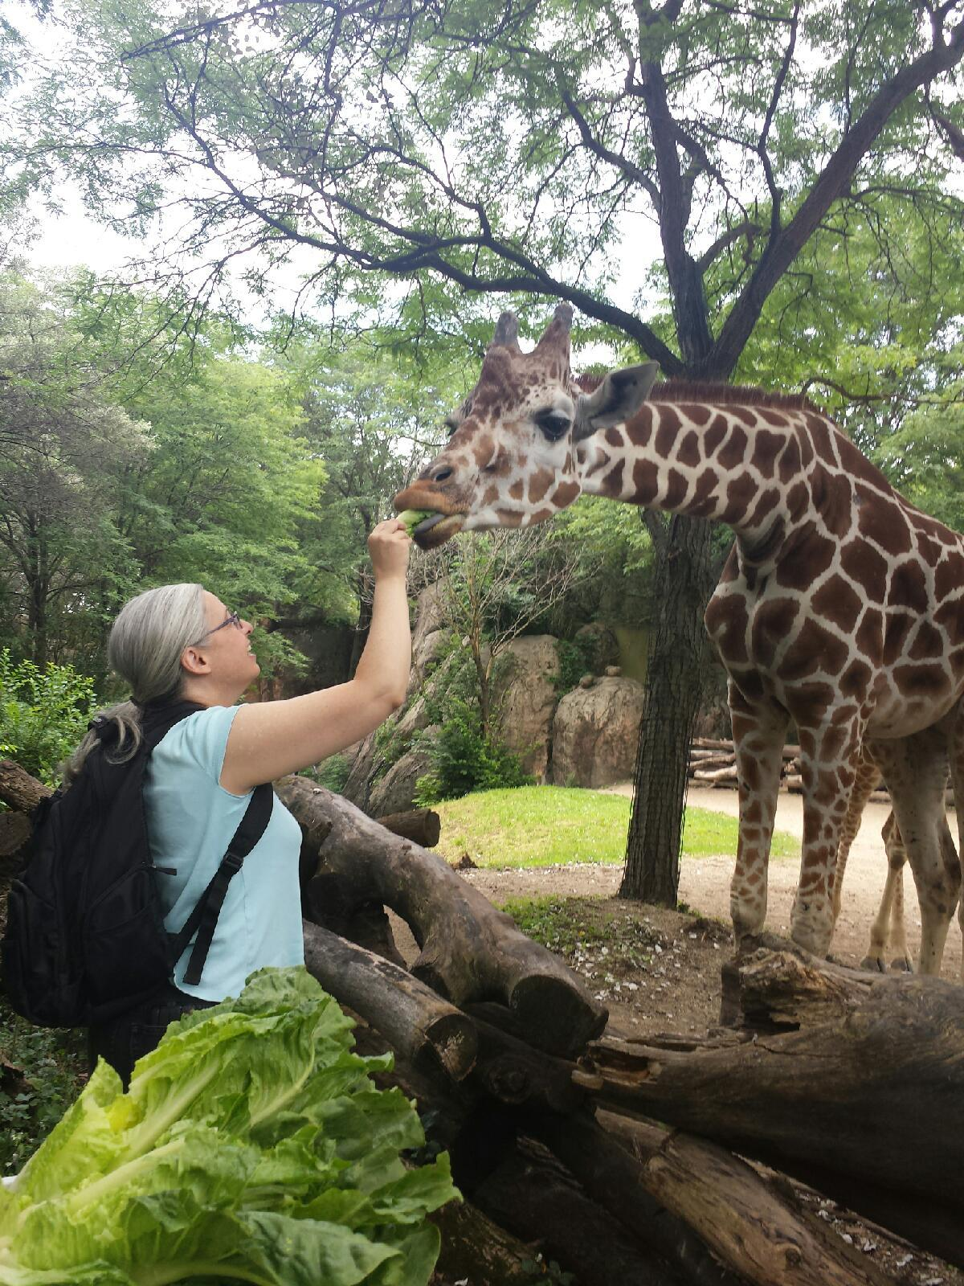Sally Laurent-Muehleisen

***I’m an Astrophysicist***

I am a senior lecturer at Illinois Tech and the only astrophysicist in the Department of Physics. Astrophysicists are scientists who study things in space, including the Moon, Sun, stars, planets, galaxies and the universe as a whole. When astrophysicists collect information about space, they are almost always only looking at the light that comes from, reflects off, or is absorbed by the objects we study. Astrophysicists try to figure out how objects form, how big they are, what they are made of and how they change over time. This includes figuring out where the building blocks which make up the earth – and all the people, animals and plants on it – came from.

*This was taken at Brookfield Zoo during a different incarnation of our NLU-IIT Teacher PD institutes!*

***Current Project***

I work on special types of galaxies that have large Black Holes at their centers (“Active Galaxies”). These Black Holes are as massive as many millions or even billions of Suns. They produce a large amount of exotic kinds of light, some of which appears mostly at radio energies. This radio light comes from jets of material being propelled away from the Black Hole at close to the speed of light. I try to understand how all the different kinds of galaxies with these Black Holes are actually related to each other.

For IN STEP, though, I am turning my attention to astrophysics that is a bit closer to home. I want to look at the habitability of different planets. We will see how factors like proximity to their parent star, how much land they have compared to oceans, whether or not they have a lot of volcanoes and other properties affect how friendly the planet is to life. This is important for learning about how to best care for OUR planet and keeping it a good place for humans, animals and plants to live and thrive.

***What do you think?***

What do you think is the most important thing a planet needs to make it friendly to living organisms? What implications are there to changing a planet’s habitability quickly? How might this affect people who need to access to fresh food and water in terms of the price they will have to pay for those basic necessities?