PEC 2

Reproducible analysis and interactive reports using containers and R/Shiny in bioinformatics pipelines
   | Nombre Estudiante  Luis Morís Fernández  MU Bioinf. i Bioest.  Omics  Nombre Tutor/a de TF  Mireia Ferrer Almirall  Profesor/a responsable de la asignatura  David Merino Arranz  Fecha Entrega  21/11/2022

Title
Reproducible analysis and interactive reports using containers and R/Shiny in bioinformatics pipelines

Project Progress
For this section we first include a copy of the Gantt chart and project milestones included in PEC1:

Milestones
- Workplan (17/07/2022)
- Literature review and state of the art
- Creating a pipeline using targets
- Defining the interactive output
- EC2 (21/11/2022)
- Implementing interactive output
- Containerize the pipeline
- PEC3 (24/12/2022)
- Manuscript and slides (27/12/2022 – 15/01/2023)
- Public defense (23/01/2023 - 03/02/2023)
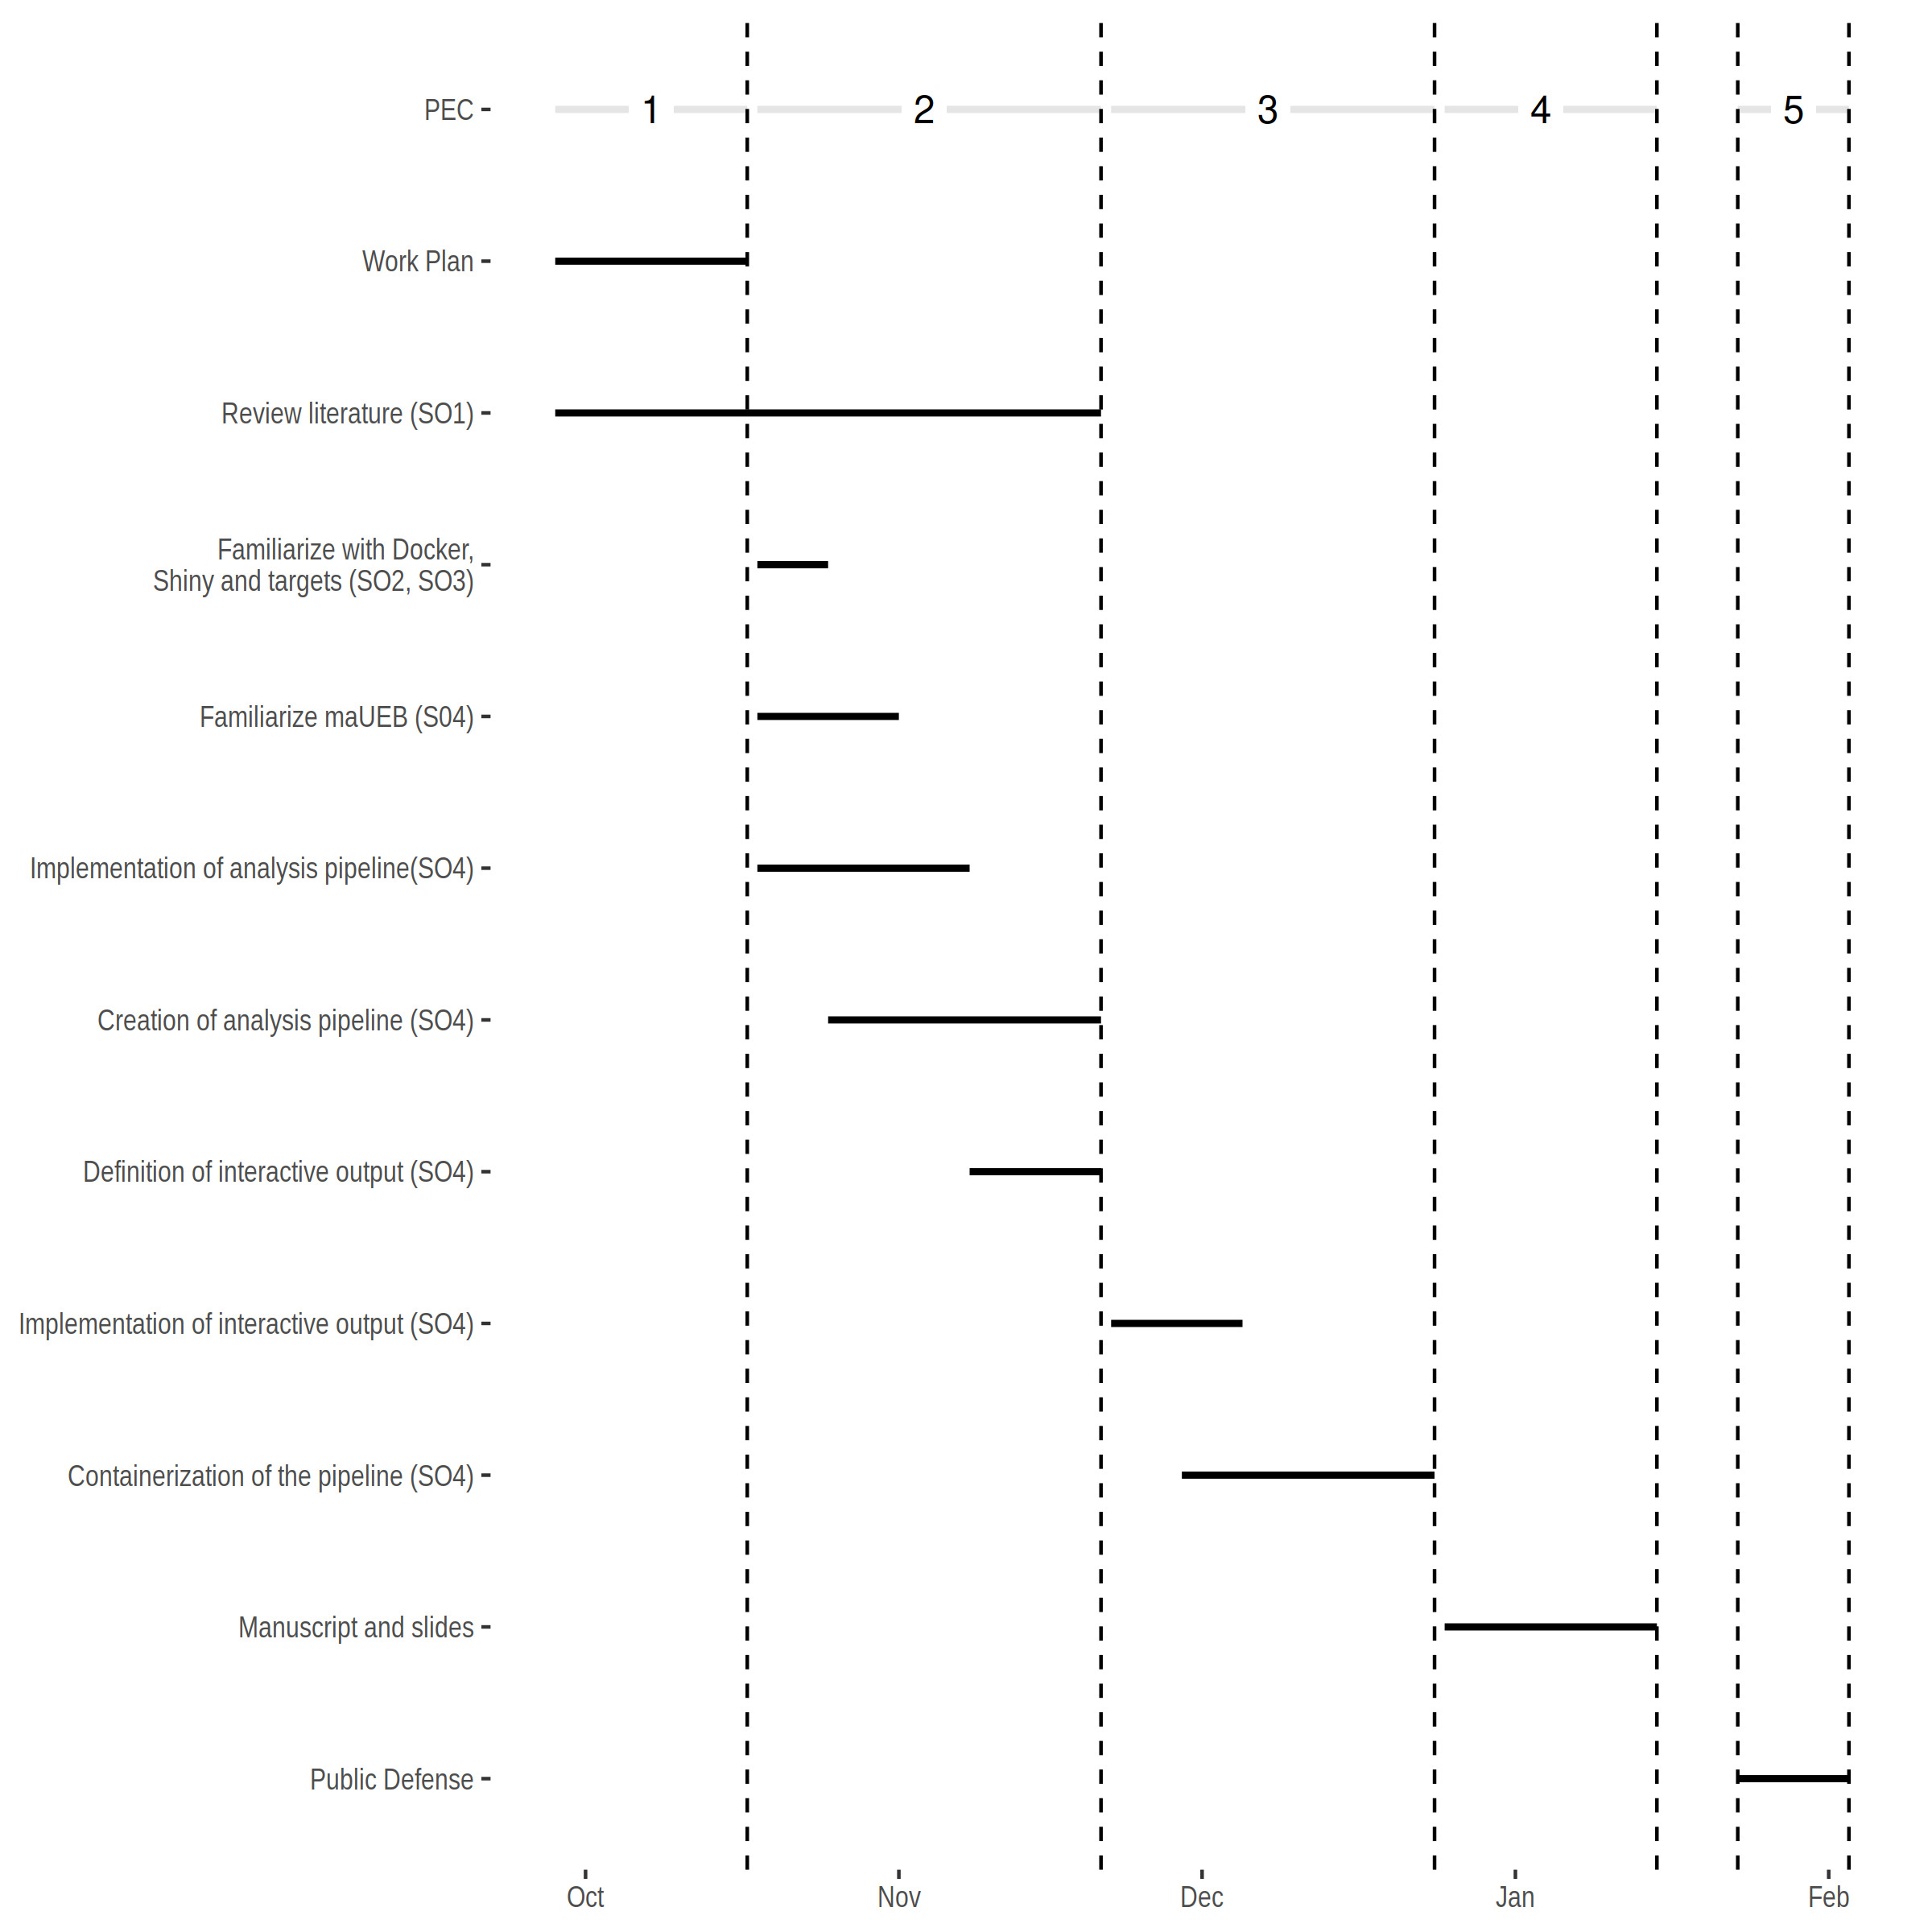

Achieved goals and planned results
This project has achieved the proposed goals according to the workplan established in the first PEC. As detailed in the next sections, we have a working pipeline implemented using the targets package. On top of this, we have a draft of an static output report that serves as an initial step toward the interactive one.
It has also been defined which charts will be implemented as interactive outputs, the first one will be the volcano plot. As the project progresses, further charts will be prioritized until the PEC3 extension allows.
A little delay has been identified in the literature review task, nonetheless this deviation is minimal and will be covered during the PEC3 and PEC4.

Justification of project modifications
In the initial workplan it was proposed that the final report would be an R/Shiny application, nonetheless, after discussing it with the project tutor, it has been decided that another option will be implemented.
R/Shiny allows creating highly interactive applications, nonetheless sharing these applications is not necessarily effortless. The application can be deployed in a server and users can access remotely but this has several implications from an IT and security that maybe not be affordable for everyone. The other option is to share set of scripts and files that can be run locally, but this is not always simple as library versions, OS or file pathing can make the task more complicated than desirable.
Nonetheless, there is another option that is creating local HTML files with some interactivity included in the form of javascript enhanced charts (see https://d3js.org/ (Bostock, n.d.) https://vega.github.io/vega-lite/ (Satyanarayan et al. 2017) or https://c3js.org/ (c3js.org, n.d.) among others). In the PEC3 an Rmarkdown report which will include interactive figures wil be created. This venue has been less explored and it has several advantages, they can be shared as regular documents (sent by e-mail, or stored in a hard drive), they are more reproducible as they are created once and stored (i.e.: they do not depend of a runtime environment). It also has disadvantages being the most salient the reduced degree of interactivity as compared to full R/Shiny applications.

Tasks performed

Tasks planned according to work plan
The tasks to be covered in PEC2 were:
- Review literature for:
  - (SO1) General problems of reproducibility in science and in bioinformatics
  - (SO1) Current approaches to solve this problem
- Software and technical knowledge and familiarization with:
  - (SO2, SO3) Docker, R/Shiny and targets R package
  - (SO4) maUEB package
- (SO2, SO4) Definition and implementation of the analysis pipeline

All of these were achieved satisfactorily.

Unplanned tasks
Although not planned for this PEC2 time allowed to implement a draft of an static report document.

Deviations from scheduled plan and mitigations
As mentioned in the previous sections, a slight delay in literature review has been detected, but given the remaining time no particular mitigation plan is required.
The other modification referred to the nature of the interactive output that will be implement in an static (note that static here refers to the fact that it does not require a server-side, not to the nature of the container charts that will be interactive) HTML file instead of an R-Shiny application

Partial results
All the results for this PEC2 can be found in the github repository https://github.com/zsigmas/UOC_TFM
This contains a _targets.R file with the pipeline itself as well as some helper functions in the R/ folder. The draft report can be found in the report.Rmd file.

References
Bostock, M. (n.d.). Data-driven documents. D3.js. Retrieved November 20, 2022, from https://d3js.org/
Arvind Satyanarayan, Dominik Moritz, Kanit Wongsuphasawat, and Jeffrey Heer. 2017. Vega-Lite: A Grammar of Interactive Graphics. IEEE Transactions on Visualization and Computer Graphics 23, 1 (January 2017), 341–350. https://doi.org/10.1109/TVCG.2016.2599030

c3js.org (n.d.) C3.js: D3-based Reusable Chart Library, C3.js Available at: https://c3js.org/ (Accessed: November 20, 2022).

