PEC 3

Reproducible analysis pipelines using containers and data exploration using R/Shiny
  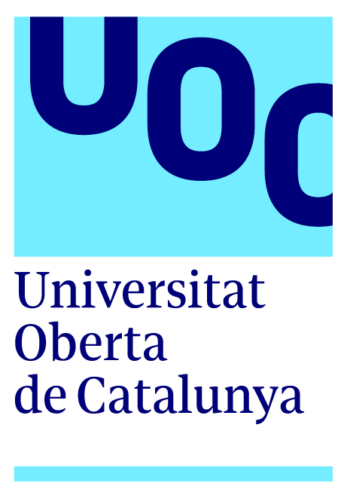 | Nombre Estudiante  Luis Morís Fernández  MU Bioinf. i Bioest.  Omics  Nombre Tutor/a de TF  Mireia Ferrer Almirall  Profesor/a responsable de la asignatura  David Merino Arranz  Fecha Entrega  24/12/2022

Title

Reproducible analysis pipelines using containers and and data exploration using R/Shiny

Project Progress
For this section we first include a copy of the Gantt chart and project milestones included in PEC1:

Milestones
- Workplan (17/07/2022)
- Literature review and state of the art
- Creating a pipeline using targets
- Defining the interactive output
- EC2 (21/11/2022)
- Implementing interactive output
- Containerize the pipeline
- PEC3 (24/12/2022)
- Manuscript and slides (27/12/2022 – 15/01/2023)
- Public defense (23/01/2023 - 03/02/2023)
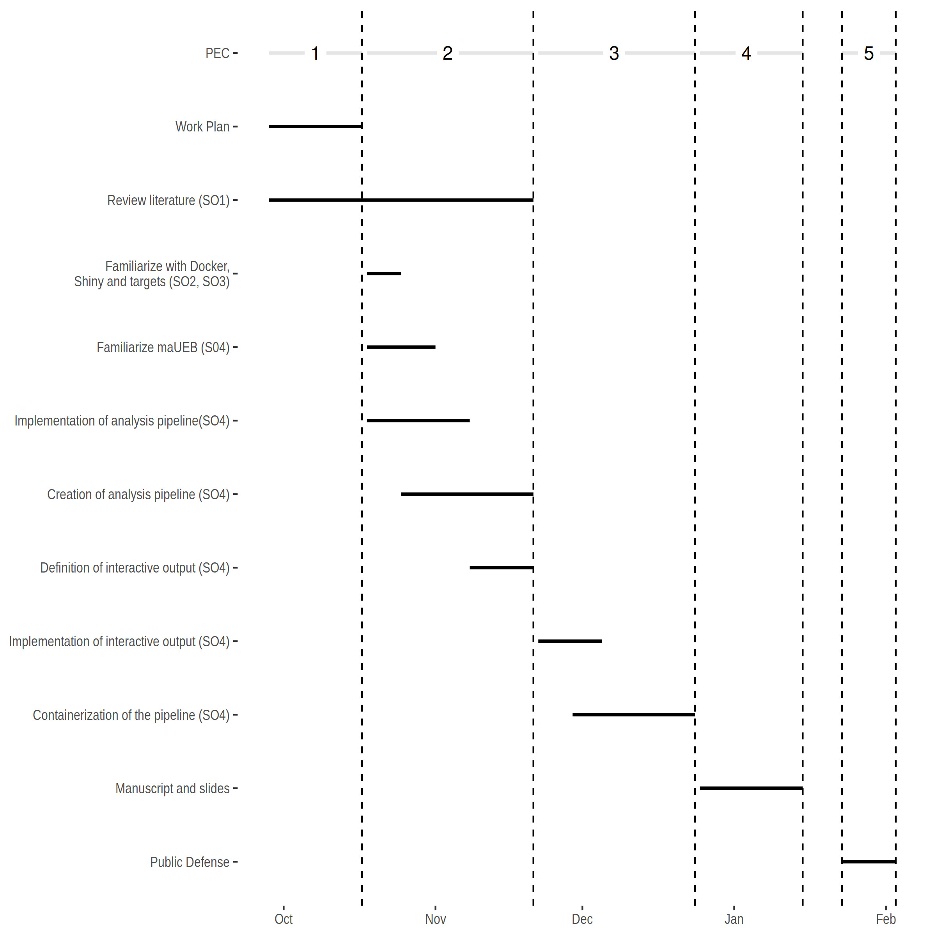

Achieved goals and planned results
This project has achieved the proposed goals according to the workplan established in the first PEC. As detailed in the next sections, we have a working pipeline implemented using the targets, a sample static report produced by the analysis pipeline, a set of scripts to run the pipeline inside a Docker container and an interactive Shiny application to explore some of the results of the pipeline.
Several approaches regarding the result exploration and reporting were explored. In the previous PEC2, the intention to explore Javascript visualizations that could be included directly in HTML documents, in the end a Shiny application has been developed in replacement of this javascript visualizations.

Justification of project modifications
Unfortunately, the Javascript visualizations proposed in the previous PEC carried other technical problems regarding the implementation and the degree of interactivity that could have been achieved during the timeframe of the present work was unsatisfactory. It was decided that the Javascript visualizations would be replaced by a Shiny application that would offer an enhanced Volcano plot with an alternative visualization to the Venn diagram.

Tasks performed

Tasks planned according to work plan
The tasks to be covered in PEC3 were:
- (SO3, SO4) Definition and implementation of the interactive report
  - Replaced by a Shiny app
- (SO2, SO4) Containerization of the pipeline

Considering the above deviations, all of these were achieved satisfactorily.

Unplanned tasks
None.

Deviations from scheduled plan and mitigations
It was detected that the timeframe of the work did not allow the proper exploration of the solutions offered by Javascript visualizations and it was replaced by a Shiny application.

Partial results
All the results for this PEC2 can be found in the github repository https://github.com/zsigmas/UOC_TFM
The package implementing the Shiny app can be found in https://github.com/zsigmas/brightPlots, https://zsigmas.github.io/brightPlots/
and a demo can be found at https://zsigmas.shinyapps.io/brightplots_demo/
and https://zsigmas.shinyapps.io/brightplots_demo_upload/

