Real Centroids V0.5

RealCentroids plugin creates a point shape file with internal points of a polygon shape, similar to PostGIS (GEOS) ST_PointOnSurface. The point will be inside the polygon in all cases. Not only the points are created but the attributes are also copied from the polygon to the internal points . A single point is generated for multipart geometry too.

New features in this version
- Optionally generate centroids for selected features
- Use pointOnSurface function for QGIS 2.4 and above

Installation
Use the plugin manager or unzip the downloaded realcentroids.zip into your plugins directory, e.g. ~/.qgis2/python/plugins/.

Usage
Enable the plugin in the Plugins/Manage and Install Plugins ... dialog. Open the polygon layer you want to create centroids. Start the plugin clicking on the icon in the plugins toolbar or select it from the plugins menu. The following dialog appears
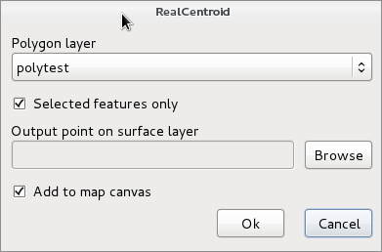
In the Polygon layer list you can select one from the loaded polygon layers. If the active layer is a polygon layer then it will be selected in the list. The Selected features only is enabled if there are selected features in the selected layer. Select a new shapefile clicking on the Browse button, . If you select an existing shapefile, you get a warning weather to overwrite that shape. If you check Add to map canvas the point shape with the internal points is added to the current project. The attributes of the polygons are also copied to the target point shape file. If Polygon layer or Output point on surface layer is empty, a warning will be displayed.
Why do we need such plugin? There is a Polygon centroids option in the Vector/Geometry Tools menu. This will create centroids at the weight point of the vertexes of the polygon. So it can be outside the polygon in a concave or multipart case. Realcentroid will place the point always inside the polygon. See figures below to compare the results of the two methods. From QGIS 2.4 the GEOS pointOnSurface is available from Python/C++ API too, but the Polygon centroids tool doesn't use it. My plugin uses pointOnSurface function for QGIS version 2.4 and newer.
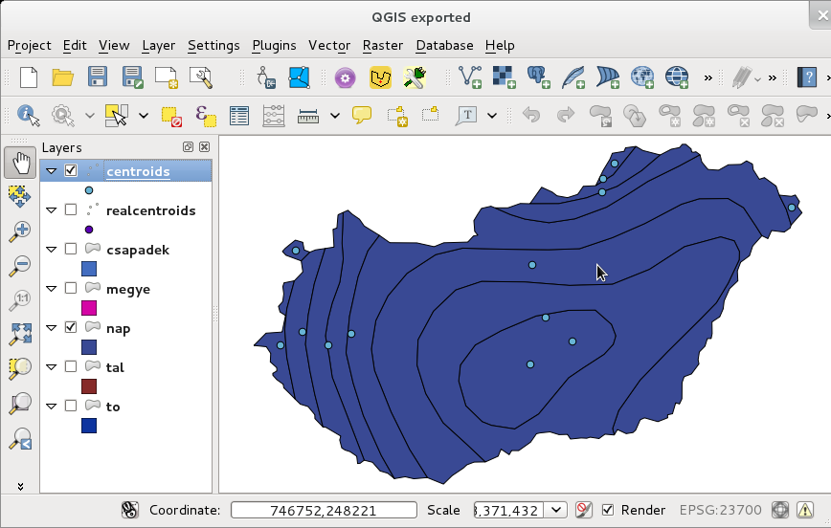
Centroids (weight points) created by Vector/Geometry Tools/Polygon centroids
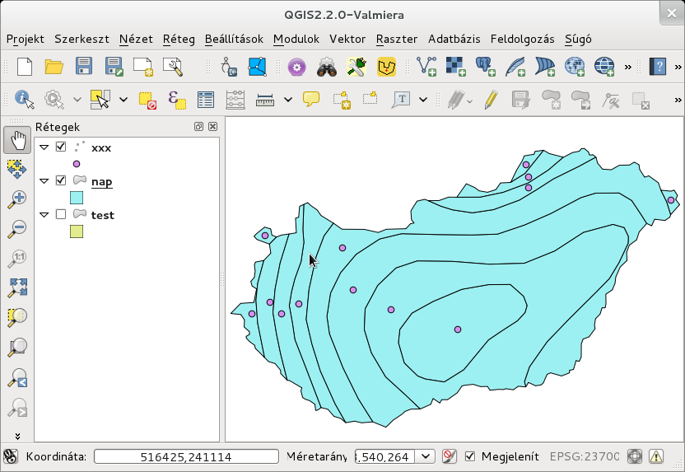
Points on surface generated by RealCentroids plugin

Algorithm used before QGIS 2.4
For each polygons the weight point is generated first. If the weight point is outside, the intersection of the horizontal line through the weight point and the polygon is generated. The midpoint of the longest line segment from the intersection result will be used. See the figure below.
For multipart polygons the algorithm is used for the largest part.
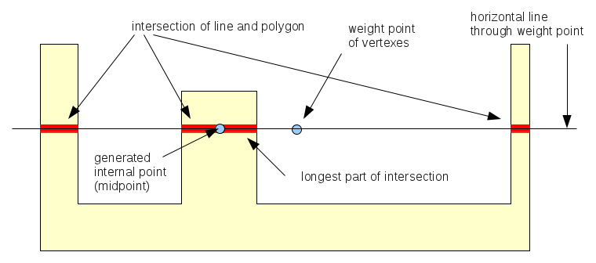
Internal point generation
After QGIS 2.4 the pointOnSurface (GEOS) function is used.
Thanks to Seal Phone, Jukka Rahkonen, ozak and pxp44 (github) giving advices, bug reports to improve the plugin.

