Vysoká škola ekonomická v Praze
Fakulta informatiky a statistiky
Katedra informačních technologií

Studijní program: Aplikovaná informatika
Obor: Informační systémy a technologie

Object Metamorphism

Doctoral Dissertation

Student : Mgr. Zbyněk Šlajchrt
Vedoucí : Ing. Rudolf Pecinovský C.S.c.
Oponent : Jméno a příjmení s tituly

201<

Prohlášení:
Pásnká verze:
Prohlašuji, že jsem bakalářskou/diplomovou práci zpracoval samostatně a že jsem uvedl všechny použité prameny a literaturu, ze které jsem čerpal.
Dámská verze:
Prohlašuji, že jsem bakalářskou/diplomovou práci zpracovala samostatně a že jsem uvedla všechny použité prameny a literaturu, ze které jsem čerpala.

V Praze dne den. měsíc 201x . . . . . . . . . . . . . . . . . . . . . . . . . . . . . . . . . .
Jméno a příjmení

Poděkování
Teoreticky tato pasáž ve vaši práci být nemusí a můžete ji smazat. Pokud byste však chtěli někomu poděkovat, zde je to správné místo. V poděkování můžete uvést vedoucího práce, případně konzultanta, nesmíte zde však uvést oponenta. Mezi ty, kterým děkujete, můžete samozřejmě zařadit i své blízké, i když to nebývá zvykem.
Počítejte s tím, že tento oddíl se automaticky zarovnává ke spodnímu okraji stránky, takže když budete psát, bude se nadpis automaticky posouvat vzhůru.

Abstrakt
Tuto a následující stránku použijete v případě, že vytváříte bakalářskou nebo diplomovou práci. V abstraktu vymezíte řešenou oblast, shrnete cíle práce, způsob jejich dosažení, naznačíte strukturu práce a stručně charakterizujete přínos práce (vlastní příspěvek k řešenému tématu).

Klíčová slova
Zde vyjmenujete termíny, které charakterizují obsah vaší práce. Neměl by to být termín jediný a nemělo by jich být zbytečně moc. Optimální počet je zhruba 5.

Abstract
In the English version of abstract you translate the Czech version of abstract into English.

Keywords
English translation of the keywords from the Czech version

Obsah
1 Úvod 1
2 Case Study 1: Structural Aspects Of Multidimensionality 2
2.1 Modeling Multidimensional Data 3
2.1.1 Scanner Protodata Overview 3
2.1.2 Modeling Multidimensional Data Without Traits 4
2.1.3 Modeling Multidimensional Data With Traits 5
2.1.4 Modeling Multidimensional Data With Static Traits in Scala 6
2.1.5 Solutions to the Exponential Growth 8
2.1.6 Modeling Multidimensional Data With Dynamic Traits in Groovy 9
2.1.7 Modeling Multidimensional Data By Generated Classes w. Run-Time Checks 10
2.1.8 Modeling Multidimensional Data By Generated Classes w. Compile-Time Checks 12
2.1.9 Summary 15
2.2 Mapping Multidimensional Data 16
2.2.1 New Context Domain For Protodata 16
2.2.2 Mapping Target Objects To Source Ones 17
2.2.3 Mapping Currencies To Items by Properties 18
2.2.4 Mapping Currencies To Items by Properties and Static Traits 19
2.2.5 Mapping Currencies To Items by Static Traits Only 22
2.2.6 Mapping Currencies To Items by Dynamic Traits 23
2.2.7 Mapping Currencies To Items by Class Generator 24
2.2.8 Summary 29
3 Case Study 2: Behavioral Aspects Of Multidimensionality 31
3.1 Protean Services 31
3.2 Modelling the Service Without Traits 32
3.2.1 Assembling the Service 36
3.2.2 Summary 38
3.3 Modelling Protean Service With Static Traits 40
3.3.1 Assembling the Service 43
3.3.2 Summary 45
3.4 Modelling Protean Services With Dynamic Traits 45
3.4.1 Modeling the Domain 46
3.4.2 Implementing the Behavior 47
3.4.3 Summary 49
3.5 Modelling Protean Services With Class Builder (static/dynamic) 51
3.5.1 Modelling the Domain 51
3.5.2 Modelling the Behavior 53
3.5.3 Runtime Morphing 54
3.5.4 Summary 55
4 Object Morpher 56
4.1 Terminology And Conceptual Requirements 57
4.1.1 Morph Fragment 57
4.1.2 Morph Type 57
4.1.3 Morph Alternative 57
4.1.4 Lowest Upper Bound (LUB) of Morph Type 57
4.1.5 Morph Model 58
4.1.6 Object Metamorphism 58
4.1.7 Morph 58
4.1.8 Morph Reference 58
4.1.9 Morpher 59
4.1.10 Morph Assembler 59
4.1.11 Morph Mapper 59
4.1.12 Morph Strategy 59
4.2 Code Samples 59
4.2.1 Morph Fragments 60
4.2.2 Morph Type Expression 60
4.2.3 Bulding a morph with the post-initializer 60
4.2.4 Custom Morph Strategy 61
4.2.5 Composing Incomplete Model to Produce Complete One 61
4.2.6 Mutable Morphs 61
4.3 Object Morpher Design 61
5 Morph Assembler 65
6 Morph Mapper 114
7 Development Essentials 115
7.1 Modelling Simple Entity 116
7.2 Adding Some Behavior 117
7.3 Abstracting Contact Printer 118
7.4 Reusing Fragment Instance 119
7.5 Using Morphs In Java 121
7.6 Multiple Dimensions 122
7.6.1 Adding more dimensions 122
7.6.2 The or disjunctor 124
7.6.3 Obtaining morph's alternative 124
7.6.4 The asMorphOf reshaper 125
7.6.5 The select matcher 125
7.7 Morphing Strategies 126
7.8 Mutable Morphs 129
7.8.1 Morphing from within a morph 130
7.9 Delegating and Sharing 132
7.10 Dimension Wrappers 135
7.11 Fragment Wrappers 137
7.12 Using Morph as Fragment 140
7.13 Kernel References 142
7.13.1 Using annotations in model types 147
7.13.2 Conclusion 149
7.14 Kernel References Use Cases 149
7.14.1 Morph Kernel Factory 149
7.14.2 Morph Visitor 152
7.14.3 Morph State Controller 154
7.15 Promoting, Masking and Rating Alternatives 154
7.15.1 Promoting 155
7.15.2 Masking 157
7.15.3 Rating 159
7.15.4 Composing strategies 159
7.15.5 A Use Case 160
8 Appendix 1: Protodata 164
9 Apendix 2: DCI and Object Metamorphism 167
9.1 What is DCI? 167
9.2 Background 167
9.3 Solution 168
9.4 Example 168
9.5 Using Morpheus 170
9.5.1 Modelling Data 170
9.5.2 Modelling Context 171
9.5.3 Modelling Interactions (Roles) 172
9.5.4 Running the Program 173
10 Appendix 3: Protean Applications and Knowledge Matrix 174
11 Výkonná pole a makra používaná v tomto dokumentu 178
Terminologický slovník 179
Seznam literatury 180
Seznam obrázků a tabulek 181
Základní text 181
Seznam obrázků 181
Seznam tabulek 181
Přílohy 181
Seznam obrázků 181
Seznam tabulek 181
Rejstřík 182

- Úvod
Tento text vznikl jako reakce na neutěšený stav grafické úpravy semestrálních i závěrečných prací našich studentů. Mnozí studenti dokáží navrhnout takovou úpravu dokumentu, na kterou je radost pohledět, ale větší část studentů bohužel grafickou podobu svých prací odbývá, a pokud se jí věnuje, tak s evidentním cílem zařídit, aby práce měla větší rozsah, než odpovídá jejímu obsahu.
V textech prací nacházíme chyby všeho druhu počínaje chybami gramatickými (vyjmenovaná slova a shoda podmětu s přísudkem jsou pro mnohé nepřekonatelnou bariérou), přes chyby stylistické (řada studentů netuší, že to, že slovosled českého a slovenského jazyka je volný, ještě neznamená, že je libovolný) až po chyby typografické (obrázek je na jiné stránce než jeho popisek).
Záplava typografických prohřešků naznačuje, že mnozí studenti neznají naprosto základní typografické zásady. Řada studentů netuší, že řídké řádkování uplatňované v textu, by se nemělo objevit v obsahu a už vůbec bychom je neměli najít v případných programech. Ve své snaze vytvořit co nejvíce stránek jim pak řídké řádkování nestačí a dělají obludné (i sedmicentimetrové) okraje a dopouští se dalších typografických prohřešků.
Tento dokument by vám měl ukázat, jak lze vytvořit typograficky střídmou, ale dobře zalomenou publikaci. Měli byste v něm najít ukázky řešení většiny typografických úloh, s nimiž se můžete při tvorbě vašich prací setkat. Doufám, že v ní najdete i inspiraci pro úlohy, jejichž ekvivalenty tu přímo řešené nejsou.
Dokument čerpá jak z autorových zkušeností, tak z řady materiálů, které pro vás připravili ostatní pracovníci katedry a jsou povětšinou vystaveny na katedrovém webu, tak z připomínek spolupracovníků, kteří ještě doplnili řadu informací, na které jsem původně zapomněl.
Protože tento dokument má sloužit pouze jako pomocný, neprošel tak důkladnou korekturou, jako dokumenty, které jsou určeny k otištění a zveřejnění. Není proto vyloučeno, že se v něm objeví nějaké překlepy či jiné chyby. Budu vděčen, když mne na ně upozorníte. Neostýchejte se napsat i v případě, kdy se vám bude zdát, že vám v tomto dokumentu nějaká informace chybí.
Tento dokument píšu ve volných chvílích, kterých mám velmi poskrovnu. Přesto se jej budu snažit průběžně aktualizovat a doplňovat o další informace. Pokud vás proto jeho obsah zaujme, tak se před tím, než přistoupíte k vlastnímu psaní své práce, podívejte na stránku http://knihy.pecinovsky.cz/sablona, jestli se tam neobjeví novější verze. Číslo verze najdete na titulní straně.
Rudolf Pecinovský
rudolf@pecinovsky.cz
- 1st Case Study: Structural Aspects Of Multidimensionality
(TODO: Say something about the structural aspects.)
For the sake of simplicity and clarity let us assume this fictional narrative:
An airport outsources its security check procedure to a company operating high-tech scanners, which are able to recognize three and two-dimensional objects in baggage. After each scan the scanner creates a record describing the recognized objects in a piece of baggage. The record is provided with some metadata and sent to a server at the mother company's premises through a wide-area network connection.
The company's server receives a potent stream of such events from a number of installations at several airports. The events in the stream are stored in a clustered database, where they remain for one year. The stored events are not processed in any way, the only reason for storing the events follows from the contract with the airports, which obliges the company to keep the records for one year due to forensic purposes.
A major limitation of the scanner is that it is able to classify baggage items only by their geometrical properties and material. The recognized item is described as a plain geometrical object and not as a wallet, shaver etc.
The contract itself does not forbid the company to use the scanner data commercially under the condition that such usage reveals no private and sensitive information.
Such data is a typical example of protodata. The owning company comes to a conclusion that the data cannot be easily utilized as such due to its primitive characteristics and possible infringement of the contract by selling it in raw form to another entity, which could combine it with its own data and possibly misuse the insights by revealing sensitive information.
The owner realizes that without discovering a new context the scanner data is virtually of no use.
But before such a context is discovered and applied, an overview of the scanner protodata should be given.
  - Modeling Multidimensional Data
    - Scanner Protodata Overview
The scan event consists of two parts: metadata and data. The metadata contains the time of the scan, the serial number of the scanner and the id of the baggage. The data part consists of a list of items recognized in the baggage. Each item contains space coordinates relative to the baggage and geometrical and material properties. A sample of a scan event is in Figure 1.

{
"id":8488484,
"scanTime": "2013-05-23T00:00:00Z",
"scannerId": 78700,
"items": [
{
"id": 0,
"shape": "cylinder",
"material": "metal",
"x": 234.87,
"y": 133.4,
"z": 12.94,
"diameter": 13.45,
"height": 0.45,
"reflexivity": 0.8
},
{
"id": 1,
"shape": "rectangle",
"material": "paper",
"x": 673.87,
"y": 394.4,
"z": 132.93,
"width": 13.45,
"height": 8.21,
"reflexivity": 0.2
}
]
}
The sample suggests that the structure of the scanned item has two degrees of freedom: shape and material. These two dimensions can be described as traits of the scanned item.
Using term trait seems quite adequate since some programming languages, such as Scala, implement the concept of trait (or mixin), which perfectly suits to modeling multidimensional objects.
The following diagram depicts sample objects with various "traits" from the protodata domain.
Figure 2: Protodata sample model
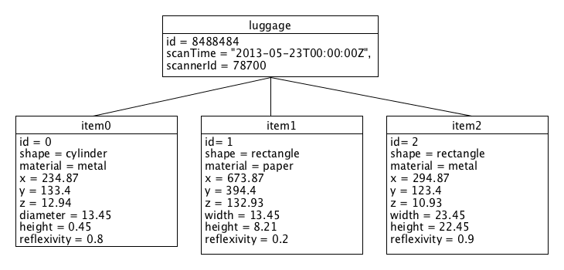

    - Modeling Multidimensional Data Without Traits
Modeling multidimensional objects in languages, which do not include traits or similar concepts, may become rather difficult and the resulting model may not accurately represent reality. For example in Java, which has no equivalent to traits, we have to implement the item's dimensions by composition. It follows that for each dimension there will be one property in the Item class (material, shape).
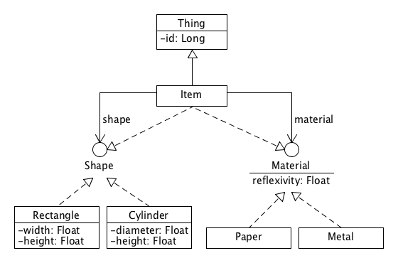
Considering such a no-trait model, a new item can be created as follows:
Item item = new Item(10.1, 20.4, 3.1, new Metal(), new Cylinder(0.3, 10.32));
However, such a composition comes with some serious design flaws. In Java, if one needs to know what an object is, (s)he uses the instanceof operator. For example, if an instance of Item is tested whether it is Thing or Material by this operator, the result will always be true by definition, since according to the model, every item is an instance of Thing, Shape and Metal, unless it is null. On the contrary, testing the item for being Baggage will always be false.
boolean isThing = item instanceof Thing; // always true
boolean isMaterial = item instanceof Material; // always true
boolean isBaggage = item instanceof Baggage; // always false
It is clear that such a type examination is redundant and does not reveal any additional information about the item's characteristics. On the other hand, what we could wish to find out, by means of the "what-it-is" instanceof operator, for example, is whether the item is metal or not, since the item may or may not have such a trait. It would be natural to express the condition as follows:
boolean isMetal = item instanceof Metal; // always false, even if the item is metal
Unfortunately, this statement will be always false, since the type system would have to consult somehow the item's state to determine the "real" type of the item.
The problem is rooted in the model itself. The item's real characteristics are not completely carried by the item itself, but also by the wrapped instances. It looks as if the item suffers from some kind of type schizophrenia, since its characteristics are scattered across three instances: the item itself, and the material and shape delegatees.
Actually, this is just one of several problems arising when models use delegation or composition (e.g. composite, decorator, adapter, state, strategy, proxy, bridge).
The similar problem of object schizophrenia is discussed here.
    - Modeling Multidimensional Data With Traits
Traits can be used to model dimensions of an object. Typically, each dimension (material) is represented by one abstract trait (Material). Such an abstract trait is the base for other concrete traits (Metal, Paper) corresponding to "values" in the dimension (metal, paper).
The concept of traits is dealt with in greater detail here (Groovy, Scala).
In contrast to the no-trait model, here the Thing type and the two dimensions are separated. The composition is deferred until the moment of creation of a new item.
Figure 4: Traits diagram
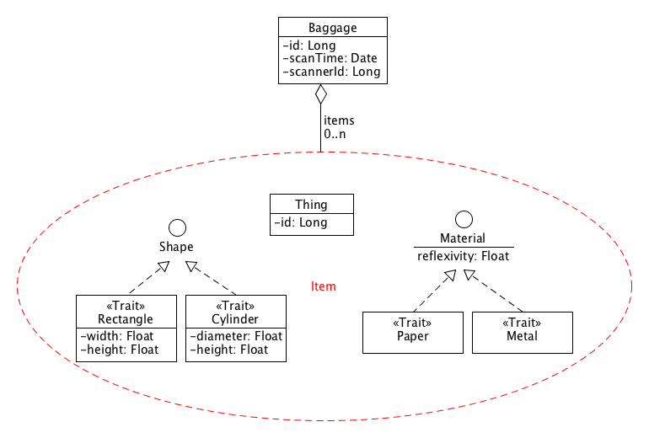
The following Scala code shows how such a creation with the deferred composition may look.
val item = new Thing with Metal with Cylinder {
val x = 10.1
val y = 20.4
val z = 3.1
val height = 0.3
val radius = 10.32
}
Then the item can be tested with isInstanceOf, which is analogous to Java's instanceof.
val isMetal = item.isInstanceOf[Metal] // true
val isCylinder = item.isInstanceOf[Cylinder] // true
Now, it is possible to determine the exact type, i.e. what the object exactly is. The reason is that the type is no longer scattered among more instances but is carried solely by the item.
Furthermore, one can also use composite types to test instances:
val isMetalCylinder = item.isInstanceOf[Metal with Cylinder] // true or false
The absence of the type schizophrenia in models is the key prerequisite for a type-safe mapping between two distinct multidimensional domain models, as shown later.
    - Modeling Multidimensional Data With Static Traits in Scala
Before going further, we should take a closer look how a new multidimensional instance is actually created from external data in Scala. The concept of static traits seems to fit well with this multidimensional problem, since they can model the individual dimensions.
Static traits are applied to target types at compile-time, which contributes to the robustness of the code. The compiler checks, among other things, whether the resulting composite classes are complete (i.e. all abstract members are implemented) and that the used traits are applied to correct types.
When instantiating a multidimensional type, we must specify a list of traits used for the instantiation by selecting one concrete trait (e.g. Paper, Rectangle) for each dimension trait (Material, Shape) in accordance with the input data. This list of traits represents a point in the multidimensional space given by the dimensions and the traits in the list corresponding to the point's coordinates.
There is an important limitation, however, stemming from Scala's strong static type system: traits can be specified only as part of the class declaration. This fact actually rules out any step-by-step imperative way to build the list of traits from the input data (i.e. the builder pattern). Instead, the initialization procedure must handle all possible combinations of concrete dimension traits. I will illustrate the problem in the following example.
Let us assume that the external data for the item is stored in a dictionary-like object event. In order to create a new item then for every (material, shape) combination there must be a dedicated test in the creation code, as shown in the following snippet.
val x = event.get("thing").get("x")
val y = event.get("thing").get("y")
val z = event.get("thing").get("z")
val item = if (event.containsKey("metal") && event.containsKey("cylinder")) {
new Thing(x, y, z) with Metal with Cylinder {
val height = event.get("cylinder").get("height")
val radius = event.get("cylinder").get("radius")
}
} else if (event.containsKey("metal") && event.containsKey("rectangle")) {
new Thing(x, y, z) with Metal with Cylinder {
val width = event.get("rectangle").get("width")
val height = event.get("rectangle").get("height")
}
} else if (event.containsKey("paper") && event.containsKey("cylinder")) {
new Thing(x, y, z) with Metal with Cylinder {
val height = event.get("cylinder").get("height")
val radius = event.get("cylinder").get("radius")
}
} else if (event.containsKey("paper") && event.containsKey("rectangle")) {
new Thing(x, y, z) with Metal with Cylinder {
val width = event.get("rectangle").get("width")
val height = event.get("rectangle").get("height")
}
}
It is obvious that such an instantiation is unsustainable since the number of lines (boilerplate) grows exponentially with the number of dimensions. Unfortunately, there is currently no practical solution in Scala to cope with this problem.
Let us have a closer look at this problem. It is desirable that every item provides information about what it is through the type system only and not from the item's state. In other words this information must be encoded in the class of which the item is an instance. It follows that there must be as many classes in the system as the number of all possible forms which an item can assume.
Next, there are only two ways to define a class. Either it is compiled from its definition in the source code, or it is generated. Application developers normally use the former way only, while the latter is there for frameworks.
If we momentarily forget the possibility to generate classes then the source code must inevitably contain all possible composite class declarations allowed by the domain model. Such explicit declarations may assume basically two forms.
The concrete one (using Scala notation):
class ThingPaperRectangle extends Thing with Paper with Rectangle
or an anonymous one, which is part of the initialization statement:
new Thing with Paper with Rectangle
In any case, for all coordinates in the multidimensional space there is an exactly one distinct composite class declaration.
On one hand we need composite classes since their instances carry complete information about themselves (what they are). On the other hand, using the standard means of statically typed languages leads to the excessive amount of boilerplate and large number of classes.
    - Solutions to the Exponential Growth
The exponential growth of code results from the inability to apply the concrete dimension traits in a step-by-step manner analogous to how instances are created by the builder pattern [LINK]. Before creating an instance, the builder must be configured in several steps according to the context and the input data. This configuration directly or indirectly specifies the parts from which the builder will compose the instance.
Such a step-by-step approach effectively eliminates the exponential growth, because the number of statements is proportional to the number of dimensions (see below).
There are basically two types of such a multidimensional builder. The first one generates a composite class according to the dimension configuration. The resulting object is then instantiated from this generated class. The other type instantiates a preliminary instance from the common base class and this instance is then decorated by the selected concrete dimension traits.
While the first approach generating a composite class would require that the developer use some rather exotic low-level tools for byte-code generation, the second approach can be very easily employed with the help of a suitable dynamic language. Therefore, in this paragraph we will examine this second approach, based on the application of dynamic traits on an existing instance.
    - Modeling Multidimensional Data With Dynamic Traits in Groovy
Groovy is a dynamic language, which also supports some optional static language features, like a compile-time type check. It also contains traits that can be applied to both types and instances. To solve the exponential growth problem we will try to rewrite the previous code by means of Groovy's dynamic traits in a builder-like manner.
The common data of the item is represented by trait Thing, which contains the coordinates (x, y, z) of the item in the luggage. The following code creates the item object implementing the Thing trait. The item object is then initialized from the input data.
def item = new Object() as Thing
Map thingData = event.get("thing")
item.x = thingData.get("x")
item.y = thingData.get("y")
item.z = thingData.get("z")
Now we can use the dynamic traits and extend the item step-by-step by the right traits. We use the withTraits method invoked on the item object to extend it by the selected trait. The selected trait is immediately initialized from the input data.
// Shape dimension
if (event.containsKey("cylinder")) {
item = item.withTraits(Cylinder)
Map cylinderData = event.get("cylinder")
item.height = cylinderData.get("height")
item.radius = cylinderData.get("radius")
} else if (event.containsKey("rectangle")) {
item = item.withTraits(Rectangle)
Map rectangleData = event.get("rectangle")
item.height = rectangleData.get("height")
item.width = rectangleData.get("width")
}
// Material dimension
if (event.containsKey("metal")) {
item = item.withTraits(Metal)
} else if (event.containsKey("paper")) {
item = item.withTraits(Paper)
}
It is clear that using dynamic traits and the step-by-step extensions resolves the problem of the exponential growth. The number of conditions is proportional to the number of dimensions and not to the number of all possible combinations.
The resulting object also carries all type information about itself. The instanceof operator can test it.
def isThing = item instanceof Thing
def isRectangle = item instanceof Rectangle
def isPaper = item instanceof Paper
if (isThing && isRectangle && isPaper)
println(/${item.x}, ${item.y}, ${item.z}, ${item.width}, ${item.height}/)
Although this solution based on using the dynamic traits seems to be perfect, because it allows us to capture the multidimensional characteristics of data by traits, preserves the types and prevents the code from exponential growth, there are still a couple of serious problems resulting from the step-by-step approach as well as from the dynamic nature of the language and its weak type system.
- Incompleteness: The configuration procedure may forget to select a trait for some dimension
- Redundancy: The withTraits method can possibly add two mutually exclusive traits from the same dimension to the builder.
- Missing Dependencies: A trait from one dimension may depend on another trait from another dimension. The configuration procedure must take these inter-trait dependencies into account, because it is beyond the capabilities of dynamic languages. This additional requirement makes the code fragile and open to inconsistencies.
- Ambiguous Dependencies: The configuration procedure must also guarantee that there is no ambiguity in the dependencies.
Since the above-mentioned responsibilities are solved on the application level and not on the platform level, the dynamic traits approach tends to develop unmanagable code.
    - Modeling Multidimensional Data By Generated Classes w. Run-Time Checks
There still remains one possibility how to instantiate an instance of a multidimensional entity: to generate the composite class at run-time. Class generation is usually chosen as a last resort to solve problems in applications. It is rather an extreme low-level technique requiring experienced developers and which should be used mostly in frameworks or platforms.
Let us assume that there is a framework whereby it is possible to create a class builder, which can be configured to build a class composed from selected traits. The resulting class is then used to create the final instance. In contrast to the dynamic trait approach, which creates a preliminary instance on which it then applies the selected traits, the class generating approach first creates the class composed of the selected traits, from which the final instance is created.
The following code shows how such a class builder could be created.
val classBuilder = new ClassBuilder[Thing with Material with Shape]()
The type parameter of the builder's constructor specifies the common type for all possible combinations of traits, which is Thing with Material with Shape. This composite type will also be type of the instance created from the generated class.
The builder's addTrait method serves to register a selected concrete trait. The method also accepts a function for the initialization of the trait when the resulting object is instantiated from the generated class.
The Thing trait is present in every item, so the builder is always configured to use Thing along with the trait initialization function.
classBuilder.addTrait[Thing](thing => {
thing.x = event.get("thing").get("x")
thing.y = event.get("thing").get("y")
thing.z = event.get("thing").get("z")
})
Next, the procedure handles the Material dimension. According to the existence of metal or paper keys in the input data, the builder is configured for the corresponding trait.
if (event.containsKey("metal")) {
classBuilder.addTrait[Metal]
} else if (event.containsKey("paper")) {
classBuilder.addTrait[Paper]
}
The Shape dimension is handled similarly, except the additional trait initialization function passed to addTrait, by means of which the trait's properties will be initialized from the input data upon the instantiation.
if (event.containsKey("rectangle")) {
classBuilder.addTrait[Rectangle](rect => {
rect.width = event.get("rectangle").get("width")
rect.height = event.get("rectangle").get("height")
})
} else if (event.containsKey("cylinder")) {
classBuilder.addTrait[Cylinder](cyl => {
cyl.height = event.get("cylinder").get("height")
cyl.radius = event.get("cylinder").get("radius")
})
}
Now it is possible to build the class and use it to create the new item instance.
val itemClass: Class[Thing with Material with Shape] = classBuilder.buildClass
val item: Thing with Material with Shape = item.newInstance
All problems associated with the dynamic traits mentioned in the previous paragraph may be solved by the framework at run-time, but not at compile-time, because of the imperative character of the configuration. Thus the conclusion is that:
The generated classes approach would be a progress in modeling multidimensional objects in comparison to the dynamic traits. So far it is the best technique.
It improves the run-time part only. It would be desirable, however, to perform all those necessary checks at compile-time.
    - Modeling Multidimensional Data By Generated Classes w. Compile-Time Checks
In this paragraph we will attempt to come up with an improvement of the previous class generator, which would allow moving the run-time consistency checks of the generated class to compile-time.
The previous class builder is very constrained in terms of static consistency checks primarily because there is no static model or schema for the generated classes. The only information available at compile-time is the type of the resulting instance, specified as the type parameter of the builder's constructor:
Thing with Material with Shape
This type is actually the lowest upper type bound of all possible trait combinations (LUB). From the LUB the compiler can infer the abstract dimensions, however, it cannot infer the concrete traits constituting these dimensions. The choice, which concrete traits come into consideration when building a class, is the task for the developer, not the compiler. It follows that the developer must pass this information to the compiler declaratively so as to allow a compile-time verification of multidimensional class models.
It follows that we have to introduce some declarative construct to allow a specification of multidimensional structures. On a statically typed platform such as Scala, it is the most natural to express the multidimensional structure by special type.
The principal idea is to substitute the abstract dimension traits in the type parameter in the builder constructor with a list of possible concrete traits. The traits in the list will be delimited by or to emphasize the mutually exclusive character of the traits in the list.
Thing with (Metal or Paper) with (Rectangle or Cylinder)
The previous type could be treated as a logical formula, which can also be expressed in the disjunctive normal form as follows:
(Thing with Metal with Rectangle) or
(Thing with Metal with Cylinder) or
(Thing with Paper with Rectangle) or
(Thing with Paper with Cylinder)
Such a type actually determines all possible forms of the generated composite class. Since this information is encoded in a type, it is also available to the compiler, which can use to perform the necessary consistency checks.
So, the following statement would create the new builder:
val classBuilder = new ClassBuilder[Thing with (Metal or Paper) with (Rectangle or Cylinder)]({
case rect: Rectangle =>
rect.width = event.get("rectangle").get("width")
rect.height = event.get("rectangle").get("height")
case cyl: Cylinder =>
cyl.height = event.get("cylinder").get("height")
cyl.radius = event.get("cylinder").get("radius")
})
The type argument of the constructor specifies the model,
For each trait in the model the builder maintains a trait factory creating an instance of the trait's stub object. Whenever a factory creates a new stub, the trait initializer passed as the optional class builder’s constructor argument may additionally initialize the stub. The new stub may be initialized by one case block in the partial function [LINK] implementing the trait initializer. It may become useful when a new trait instance must be loaded with some external data like in this case.
In respect of the model, it is assumed that there would be a compiler extension that could handle this special type and could also build a model, from which all possible trait compositions could be derived.
Once the compiler extension knows all trait compositions, it can take one by one and verify whether all traits in a given composition satisfy the rules, such as completeness, unambiguity etc.
The model serves primarily to check the consistency of all trait compositions. There must be another concept, however, through which the developer can determine, which trait composition will be used to compose the generated class.
This concept is called class builder strategy and its primary task is to select the right trait composition from the model. A new instance of such a strategy could be obtained from the class builder instance as follows:
val classBuilderStrategy = new HintClassBuilderStrategy()
The HintClassBuilderStrategy strategy contains hintTrait method through which the developer specifies hints to the strategy, which traits must be in the resulting trait composition.
It is not necessary to provide a hint for the Thing traits, since, according to the model, it must be present always by default.
The trait hints for the material dimension can handled in the following way:
if (event.containsKey("metal")) {
classBuilderStrategy.hintTrait[Metal]
} else if (event.containsKey("paper")) {
classBuilderStrategy.hintTrait[Paper]
}
And the shape dimension can be handled similarly:
if (event.containsKey("rectangle")) {
classBuilderStrategy.hintTrait[Rectangle]
} else if (event.containsKey("cylinder")) {
classBuilderStrategy.hintTrait[Cylinder]
}
Calling newInstance on the class builder and passing the configured strategy create the resulting instance.
val item: Thing with Material with Shape = classBuilder.newInstance(classBuilderStrategy)
The item's type is the LUB of the multidimensional model, however, its concrete type can be determined by isInstanceOf
val isPaperRectangle = item.isInstanceOf[Paper with Rectangle]
or by the match block
item match {
case pr: Paper with Rectangle =>
...
case mc: Metal with Cylinder =>
...
}
This analysis indicates that all run-time checks performed by the previous version of the class builder could be theoretically performed at compile-time in compiler extension. Such a statically typed class builder would give developers a powerful tool for type-safe processing of multidimensional objects.
    - Summary
- The traditional approach to model multidimensional data objects uses composition. The composition produces an object (item) by wrapping other objects (material, shape), which can assume various forms. The number of wrapped objects corresponds to the number of dimensions. For each dimension the top object exposes the corresponding interface by means of delegation.
- Composition hides the real shape (characteristics, type) of the object. We cannot determine from the top object's type that it is a rectangular paper, for instance. Instead, we just find out that the item is something of some shape and material. To determine the real type, one cannot use the instanceof operator only. Instead, he must resort to examining the object's attributes, i.e. the state, holding references to the wrapped objects (getMaterial(), getShape()) and additionally apply instanceof to each wrapped instance. Alternatively, the classes may be equipped with a custom type-management complementing the platform’s type system.
- The identity of the composite object are scattered across the object and its components, which results in object schizophrenia.
- Traits are a natural concept for modeling multidimensional objects, which helps preserve full object's type information and avoid type schizophrenia.
- Modeling multidimensional objects by means of static traits (Scala) leads to the exponential explosion of code making the static traits practically unusable.
- One solution to the exponential growth could be to use a dynamic language such as Groovy with a capability to extend object at run-time. This approach however also suffers from a couple of serious issues as shown earlier in this chapter.
- Another solution could be to create the instance from a generated class composed of the selected traits. However, without a new declarative language construct for specifying multidimensional models such a class builder could perform the important consistency checks at run-time only.
- If the type system is extended in such a way that it allows declaring optional types (union-like), the developer can specify all possible trait compositions, i.e. the model, by means of a type expression analogous to boolean expression. This type expression can be processed by the compiler extension and provide all necessary checks at compile-time.
  - Mapping Multidimensional Data
(TODO: Say something about the topic)
    - New Context Domain For Protodata
Now we turn our attention back to the airport scanner protodata and the effort to find some use for it.
Let us assume that someone comes up with an idea to build an application performing some analytics of the luggage contents and publishing the insights via a web portal to customers, which could be for example the statistics bureau, economic chambers or customs.
As the first analysis the application will publish the aggregate amount of cash detected in luggage per some time period.
Such a task requires that the application be able to recognize coins and banknotes among luggage items. Considering the scanner protodata contains information about the shape and material only, it seems inevitable to use other source to detect reliably coins and banknotes. Such a source can be a database of international currencies containing comprehensive information about current and historical world currencies including physical properties. (Note: There is a limitation in this scenario, since all U.S. banknotes have the same dimensions. The database could not recognize individual dollar banknotes just on the basis of their size).
The domain model of the new context is depicted on the following diagram:
Figure 5: The context domain diagram
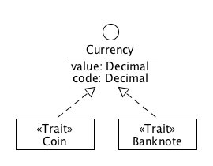
The basic logic of the currency flow analysis is very simple. It scans a segment of the protodata corresponding to the selected time period and it attempts to convert each luggage item into a currency. Such a set of currency objects is then aggregated into a statistical report and published on the portal.
The relation between the currency and luggage items domain is sketched on the following diagram.
Figure 6: Mapping context domain to proto-domain diagram
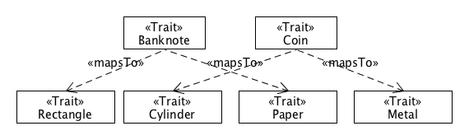
Each concrete type in the target domain is mapped to a subset of the source domain concrete types. Moreover, this mapping is orthogonal since all these subsets do not overlap with one another.
The only missing part is the construction of currency objects from the source objects, i.e. from appropriate items and currency database records. This task is called mapping and is analyzed in the next paragraph.
    - Mapping Target Objects To Source Ones
The purpose of the mapping is to bind objects from the target domain directly to the objects from the source domain in order to avoid any intermediary processes normalizing and transforming the source domains objects into the target domain ones. Such processes often discard some source data, which could potentially be utilized in subsequent transformations.
The goal is to construct a lossless mapping. In other words, the target objects preserve both data and behavior of the source objects.
A target object constructed by binding it directly to its source objects allows tracking its origins, which is as desirable property in the case when the target object becomes a source in another mapping. Such a secondary mapping may exploit the information about the origin of the source (then-target) object to perform a finer-grained binding.
In the following paragraphs we will attempt to design such a lossless mapping procedure.
    - Mapping Currencies To Items by Properties
The following listing is an example of a low-level lossless mapping in Scala. The source and target objects are plain maps, whose values can be other maps or scalar values. The result of the mapping procedure is a map representing a scanned currency, whose single property isExported combines properties from the item and the currency record in the database. The result also wraps the source objects (item, exemplar) so as not to loose the track of its origin.
def makeCurrency(item: Map[String, Object]): Option[Map[String, Object]] = {
val shape = item.get("shape")
val material = item.get("material")
if (shape == null || !"rectangle".shape.get("type") ||
material == null || !"paper".material.get("type")) {
None
} else {
val w = shape.asInstanceOf[Map[String, Object]].get("width");
val h = shape.asInstanceOf[Map[String, Object]].get("height");
val c = material.asInstanceOf[Map[String, Object]].get("color");
currencyDb.findBanknote(w, h, c) match {
case None => None
case Some(banknote) =>
val isExported = banknote.get("issuingCountry") == item.
get("luggage").asInstanceOf[Map[String, Object]].
get("scanner").asInstanceOf[Map[String, Object]].
get("location").asInstanceOf[Map[String, Object]].
get("country")
val banknote = Map("type" -> "scanned-banknote",
"isExported" -> isExported,
"item" -> item,
"currency" -> banknote)
Some(banknote)
}
} else ... // a similar code for a coin
}
The method first checks whether the shape and material dimension properties hold rectangle, respective paper data. If so, the method retrieves the width, height and color from the two components. Then the currency database is queried for a banknote having the corresponding properties. It a banknote exemplar is found, a new map representing the banknote is created.
Although this mapping is lossless, it suffers from several flaws, such as:
- It is too low-level; domain objects are represented as maps, not as domain types. It is prone to type mismatch errors.
- There is no behavior on the domain objects (maps). Target objects should be able to inherit some behavior from the source objects. For example, the Shape trait could define a method calculating the area (or surface) of the shape. It makes good sense for banknotes and coins as the target objects to inherit this method.
- There must be some convention on how the source data are embedded into the target objects. Such a convention makes the mapping subsystem very proprietary.
- It is too verbose, too much boilerplate.
- The absence of types and behavior is evidently the most annoying issue of this property-based approach. Let us try therefore to evaluate an approach using properties and types of the domain objects.
    - Mapping Currencies To Items by Properties and Static Traits
The mapping procedure in this paragraph combines the properties of the domain objects as well as their types. The item contains two properties, shape and material, representing the two independent dimensions of the item. The mapping procedure first reads the wrapped objects held in these two dimension properties and examines their concrete types. In other words, in order to find out what the item really is we have to look into its properties and determine the types of their values (i.e. type schizophrenia).
The item, its dimensions (i.e. material, shape) and the dimensions' "values" (i.e. paper, rectangle etc.) are represented by Scala static traits.
Let us assume first, that the multidimensional character of the item is modeled by means of composition. This approach would have to be used on platforms without dynamic traits (such as Scala or Java) because of the problems with the exponential growth of code described previously.
trait Item {
def shape: Shape
def material: Material
...
}
The source domain is described in the previous section, so here we focus on the description of the currency database types and the target domain types.
The currency database has a simple model consisting of two types of currency records: Banknote and Coin, both having the same ancestor Currency.
trait Currency {
def currencyValue: BigDecimal
def currencyCode: String
def issuingCountry: String
}
trait Banknote extends Currency
trait Coin extends Currency
The Currency trait consists of a couple of basic properties, while the other traits may carry some specific properties. (They are omitted since they are not important for the purpose of this example.)
The target types mimic the structure of the currency database domain. The ScannedCurrency trait represents a currency found in a luggage and its single property isExported combines data from the two source domains: a currency is considered exported if the currency's issuing country is the same as the country where the item was scanned.
trait ScannedCurrency {
this: Currency with Item =>
val isExported: Boolean = issuingCountry == luggage.scanner.location.country
}
trait ScannedBanknote extends ScannedCurrency {
this: Banknote with Item =>
}
trait ScannedCoin extends ScannedCurrency {
this: Coin with Item =>
}
The self-type (=>) of ScannedCurrency constrains the application of this trait only to the compositions containing Currency and Item traits. Since any object containing ScannedCurrency must also contain the two traits it is possible to access the Currency and Item members from the body of ScannedCurrency.
ScannedBanknote constrains its application even more to objects with the Banknote and Item traits. Similarly, ScannedCoin limits is use to the context of Coin and Item.
The self-type constrains in ScannedBanknote and ScannedCoin could be even stricter if we could replace Item with Paper with Rectangle, resp. Metal with Cylinder. However, it is not possible, because of the type schizophrenia of the item.
Now, let us turn our attention to the mapping method makeCurrency using the above-mentioned types.
def makeCurrency(item: Item): Option[ScannedCurrency] = {
if (item.shape.isInstanceOf[Rectangle] && item.material.isInstanceOf[Paper]) {
val rect = item.shape.isInstanceOf[Rectangle]
val paper = item.material.isInstanceOf[Paper]
val w = rect.width;
val h = rect.height;
val c = paper.color;
currencyDb.findBanknote(w, h, c) match {
case None => None
case Some(banknote) =>
val scannedBanknote = new ScannedBanknote with Banknote with Item {
val itemDlg = item
val banknoteDlg = banknote
// Delegating methods ...
}
Some(scannedBanknote)
}
} else ... // a similar code for a coin
}
The method must first check the types of the two dimensions shape and material included in the item as its properties. Then the values are type-casted to the concrete types to retrieve the width, height of the rectangle and the paper color.
Then the database is asked to find the corresponding banknote. If it is found, a new instance of ScannedBanknote is created, which implements both Banknote and Item traits by delegation.
At first sight, the code looks much tidier than the property-based one. However, there are still some issues:
- Nothing prevents ScannedBanknote from being instantiated with wrong (i.e. not banknote-like) item. The reason is that the proper composition of ScannedBanknote with luggage items must be guaranteed by the developer and not by the platform. The developer does it by examining the item's state, while the platform would do it by examining the types. It could be prevented by specifying the self-type of ScannedBanknote as Banknote with Paper with Rectangle, but it is not possible because of the type schizophrenia of the item.
- Another issue relates to the delegation: on each consecutive mapping the item instance looses some behavior because not all interfaces implemented by the source object must be implemented by the target object. The wrapped item instance also sinks one delegation level down becoming gradually unreachable.
These two findings can be formulated more generally:
- A multidimensional source object modeled by composition makes subsequent compositions prone to type inconsistencies.
- The construction of target objects by means of delegations tends to lose behavior and type.
    - Mapping Currencies To Items by Static Traits Only
In this paragraph we will examine a purely static type-based approach to mapping target objects on the source ones by means of static traits.
Since one of the problems described in the previous paragraph was caused by composition, i.e. by the dimensions wrapped in the item object, in this example we will try to model the multidimensionality of items by Scala static traits (no type schizophrenia). It follows that there will be no properties in Item representing the two dimensions. Instead, the dimensions become part of the item's type expressed by means of traits.
Note: Let us temporarily forget the problem with the exponential growth of code linked to using statically specified traits as described in the previous section.
Since now the shape and material dimension are part of the item's type, we can refine the binding self-type in the ScannedBanknote so as to refer Banknote with Rectangle with Paper instead of Banknote with Item.
trait ScannedBanknote extends ScannedCurrency {
this: Banknote with Rectangle with Paper =>
}
This refinement actually solves the problem with the possibility of combining ScannedBanknote with inappropriate item. The type system ensures that ScannedBanknote can be instantiated only with an item implementing Rectangle and Paper.
Thanks to the presence of dimension types in the item's type the mapping method can perform the test for paper rectangles directly on the item. Instead of using isInstanceOf[Rectangle with Paper] we use Scala's match block, which is more suitable for this purpose:
def makeCurrency(item: Item): Option[ScannerCurrency] = {
item match {
case paperRect: Rectangle with Paper =>
currencyDb.findBanknote(paperRect.width, paperRect.height, paperRect.color) match {
case None => None
case Some(exemplar) =>
val scannedBanknote = new ScannedBanknote with Banknote with Rectangle with Paper {
val paperRectDlg = paperRect
val banknoteDlg = banknote
// Delegating methods ...
}
Some(scannedBanknote)
}
case _ => None
}
}
Unfortunately, the new instance cannot avoid the delegation. The conclusion is that with the supposition of ignoring the problem of the exponential growth of code,
- The composition issue is over, ScannedBanknote can be accompanied by paper rectangles only
- The delegation issue still persists, i.e. behavior and type degrade on every successive mapping
    - Mapping Currencies To Items by Dynamic Traits
In this paragraph we will try if the above-mentioned problems disappears if we use dynamic traits.
The semantics of the makeCurrency method is the same as in the previous paragraphs except the return type, which is not optional. The method simply returns null in case it cannot construct a currency object.
public Currency makeCurrency(Item item) {
if ((item instanceof Paper) && (item instanceof Rectangle)) {
Banknote banknote = currencyDb.findBanknote(item.width, item.height, item.color)
if (banknote != null) {
ScannedBanknote scannedBanknote = item.withTraits(ScannedBanknote, Banknote)
// we cannot avoid the copying of the banknote's state to scannedBanknote
scannedBanknote.adoptBanknote(banknote)
return scannedBanknote;
} else {
return null;
}
} else ... // a similar code for a coin
}
As shown in the previous section, on a platform with dynamic traits it is possible to extend objects in such a way that the extending objects can completely preserve the type information carried by the extended objects. It permits us to determine what the object is by means of instanceof.
Thus, the makeCurrency method determines whether the item is a paper rectangle by two invocations of instanceof. Then the method asks the currency database if such a banknote is registered. If so, it uses withTraits to create a new proxy object from the item object. The new proxy object has all the item's traits plus ScannedBanknote and Banknote.
Unfortunately, using withTraits helped us only in part. We avoided copying the item's state to the new instance, but there is the banknote object left, whose state must be copied to the new instance. This is a conceptual problem stemming from the nature of traits, which are primarily supposed to extend the target object's behavior, not its state. Yet if a trait has some state, such a state has no meaning out of the target object's scope. In the light of this concept it makes a perfect sense for Groovy to provide the withTraits special method, which is invoked on the target object accepting a list of trait types, not trait "instances".
The conclusion is:
- The use of dynamic traits solves the problem with losing the item's type and behavior, because withTraits automatically implements all interfaces on the source object.
- The removal of the delegation was helpful in the previous issue, however it brings another problem: the banknote's state must be copied to the scannedBanknote instance. The banknote can theoretically be an instance of a Banknote subclass carrying additional data. This extra state will not be copied to scannedBanknote, thus there is a potential of losing some information when copying state.
- The problem of combining ScannedBanknote with a wrong item emerges again, because the weak type system and the dynamic nature of Groovy does not allow checking the inter-trait relationships.
    - Mapping Currencies To Items by Class Generator
So far no mapping attempt has offered an ideal solution. The Scala showed to be too stiff while Groovy too flexible. This paragraph is dealing with an alternative approach searching for a middle course, which would lead us to a statically checked yet dynamic mapping.
The basic building block in such an approach is the fictional class builder presented in the previous section. This builder is able to build consistent compositions of traits according to the model specified as a special type expression in the builder's constructor. The compiler is supposed to execute the consistency checks of the model so that the builder can rely on the model's consistency at run-time.
In Scala it is possible to define type aliases by means of the so-called type members. To make the code more maintainable and readable, we will use such type aliases instead of the original type expressions throughout the code. The first one is the alias of the item's multidimensional model.
type ItemModel = Thing with (Metal or Paper) with (Rectangle or Cylinder)
This model can be rewritten to the equivalent disjunctive form, which shows better the four possible compositions of the traits.
(Thing with Metal with Rectangle) or
(Thing with Metal with Cylinder) or
(Thing with Paper with Rectangle) or
(Thing with Paper with Cylinder)
The item builder is created by instantiating ClassBuilder and specifying the ItemModel type alias as the constructor's type argument and the trait initializer as the other argument.
val itemBuilder = new ClassBuilder[ItemModel]({
case rect: Rectangle =>
rect.width = event.get("rectangle").get("width")
rect.height = event.get("rectangle").get("height")
case cyl: Cylinder =>
cyl.height = event.get("cylinder").get("height")
cyl.radius = event.get("cylinder").get("radius")
})
val itemBuilderStrategy = new HintClassBuilderStrategy[ItemModel]()
... // configuring the strategy
val itemRef: Ref[ItemModel] = itemBuilder.newInstanceRef(itemBuilderStrategy)
At this stage, for each trait in the model, the builder holds a trait factory, which may be asked to create the trait's stub object.
Then the developer configures the builder strategy, which is used by the builder during the instantiation to consult which trait composition should be selected for the instantiation. The HintClassBuilderStrategy strategy allows specifying traits that should be present in the selected trait composition.
The strategy object may actually contain inconsistent hints, but they will never lead to using an inconsistent composition of traits. Hints only help the builder to select the best matching trait composition to the given hints. Without any hint the class builder selects the first composition from the list of all possible compositions.
After the builder selects the valid trait composition, after consulting the selection with the builder strategy's hints, it invokes the corresponding trait factory for each trait in the selected composition.
The builder can be used repeatedly to instantiate various trait compositions.
val otherItemRef: Ref[ItemModel] = itemBuilder.newInstanceRef(otherItemBuilderStrategy)
Since the builder uses always the same trait factories, it becomes very important, whether a factory is stateless or stateful. If a factory is stateless it always creates a new trait stub instance. On the other hand, if a factory is stateful it may implement some instance management such as pooling. In the simplest case it works as a singleton factory, which creates only one instance.
If all trait factories are singleton factories, then the same trait stub objects may appear in different trait line-ups produced by the same builder.
The state of the singleton factories before the first instantiation.
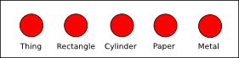
The state of the singleton factories after the first instantiation.
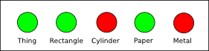
The state of the singleton factories after the second instantiation.
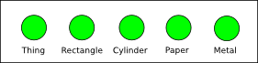
Such a configuration reminds object morphing. The instances returned by the builder with singleton factories only may be seen as different forms of a single multi-instance consisting of the trait stub objects held by the singleton factories in the builder.
After the item builder is configured, it returns the result wrapped in a special Ref object.
This object, in contrast to the plain reference returned by newInstance, keeps a link to the model, from which the instance is created. Using the Ref object reference instead of the plain reference allows performing additional compile-time checks when the reference is passed to a method as its argument.
The instance may be retrieved by invoking the instance method on the reference object.
val item: Thing with Material with Shape = itemRef.instance
Now, let us turn our attention to the target domain model. It may be expressed in terms of a one-dimensional model with two concrete traits ScannedBanknote and ScannedCoin belonging to the ScannedCurrency dimension.
type ScannedCurrencyModel = ScannedBanknote or ScannedCoin
This model generates only two trivial trait compositions and it may be tempting to create an instance of this in a similar way as the item instance, as shown in the previous section.
val curBuilder = new ClassBuilder[ScannedCurrencyModel]()
... // the strategy configuration
val curRef = curBuilder.newInstanceRef(curBuilderStrategy)
Unfortunately, it will not work. The reason is that the traits ScannedBanknote and ScannedCoin are dependent on other traits via their self-type. In other words, the model used in the builder is incomplete.
To make it complete we would have to extend it by the required dependencies:
type ScannedCurrencyModelComplete =
(ScannedBanknote with Banknote with Rectangle with Paper) or
(ScannedCoin with Coin with Cylinder with Metal)
Now we could make an instance of this model, however, we would have to copy data from outer instances of the selected traits. And this is exactly what we do not want. What we want is to reuse those outer trait instances by the scanned currency builder.
Reusing the item's trait stubs in the currency builder should be as easy as passing the item's reference object to the constructor of the currency builder:
def makeCurrency(itemRef: Ref[ItemModel]): Ref[ScannerCurrencyModel] = {
val curBuilder = new ClassBuilder[ScannedCurrencyModel](itemRef)
...
}
Now, the compiler has all necessary information about the the target model (which is incomplete) and the source model retrieved from the object reference type (i.e. ItemModel). The compiler must be able to determine if the source model can deliver all trait stubs required by the traits in the incomplete target model.
In this case the compiler should fail, since the source model cannot deliver Banknote and Coin trait stubs.
One solution could be to extend again the ScannedCurrencyModel by Banknote and Coin, but it would lead to another copying of data from external currency instances returned by the currency database to the instance created by the builder.
type ScannedCurrencyModelCompleteWithCurrency = (ScannedBanknote with Banknote) or (ScannedCoin with Coin)
There is, however, another way to incorporate an existing trait instance to a new composition: the target model may be extended by special traits implementing the factories for the missing traits. Since the two missing traits are Banknote and Coin, the extended target model will look as follows:
type ScannedCurrencyModelWithLoaders = (ScannedBanknote with BanknoteLoader) or (ScannedCoin with CoinLoader)
The BanknoteLoader and CoinLoader are trait factories providing the missing trait stubs and may be implemented as shown in this listing:
trait BanknoteLoader extends TraitFactory[Banknote] {
this: Paper with Rectangle =>
def load(): Option[Banknote] = {
currencyDb.findBanknote(width, height, color)
}
}
trait CoinLoader extends TraitFactory[Coin] {
this: Metal with Cylinder =>
def load(): Option[Coin] = {
currencyDb.findCoin(2 * radius, height)
}
}
The BanknoteLoader implements the TraitFactory interface and specifies its dependencies on Paper and Rectangle by the self-type. This self-type gives the loader access to the paper's and rectangle's properties, which are used to locate the corresponding banknote object in the currency database in the load method. The result of the method is optional, which allows indicating a failure to find the banknote in the database by returning None.
The CoinLoader works analogously.
Note: A trait factory must not depend on the trait it creates.
Now we can pass the target model with the loaders to the currency builder's constructor along with the item's reference object.
def makeCurrency(itemRef: Ref[ItemModel]): Ref[ScannerCurrencyModel] = {
val curBuilder = new ClassBuilder[ScannedCurrencyModelWithLoaders](itemRef)
loaderBuilder.newInstanceRef
}
The compiler should not complain now, since all missing trait stubs may be delivered either by ItemModel or by the currency loaders.
The target model effectively shrinks the number of possible input compositions from four to two, because only Thing with Metal with Cylinder and Thing with Paper with Rectangle matches with the target model.
ScannedBanknote with BanknoteLoader with Banknote -> Thing with Metal with Cylinder
ScannedCoin with CoinLoader with Coin -> Thing with Paper with Rectangle
It is important to emphasize, that there is no builder strategy used in this case, since the resulting composition is determined by the composition wrapped in itemRef. The currency builder in fact inherits the strategy from the itemRef.
The effective joined model may be expressed as follows:
(Thing with Metal with Cylinder with Coin with CoinLoader with ScannedCoin) or
(Thing with Paper with Rectangle with Banknote with BanknoteLoader with ScannedBanknote)
A possible state of singleton factories in the joined model.
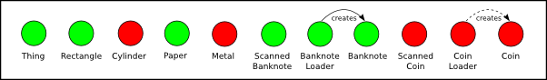
There are two scenarios, however, in which the reference's instance method may fail:
- The item reference carries an unmapped composition (i.e. Thing with Metal with Rectangle or Thing with Paper with Cylinder)
- A currency loader does not find the corresponding currency record in the database.
Both scenarios are considered application exceptions, i.e. are part of the use-case and must be handled by the application.
In order to facilitate handling of such conditions, the reference object provides the maybeInstance method, which returns Some(instance) in case of success or None otherwise.
val itemOpt: Option[Thing with Material with Shape] = itemRef.maybeInstance
The conclusion is that mapping based on the class builder
- may ensure consistency of target compositions at compile-time
- may avoid loosing behavior and data in successive mappings
- may reuse more stubs
    - Summary
- The data objects in the protodata manifest the so-called multidimensional polymorphism. Multidimensional polymorphism means that the set of all forms, which an object can assume, is equivalent to a cartesian product of the so-called dimensions. A dimension represents an abstract trait of the object and consists of types implementing this trait.
- The target domain and the source domains are structurally very distant, practically orthogonal. The protodata (items) and the auxiliary data (currency database) must be somehow adapted for the new context domain.
- Transformation and normalization are lossy processes, thus they remove data, which the application could use in the future. Next, such a processing may cause delays and put additional burden on the infrastructure. In the course of time the transforming processes tend to become unmaintainable.
- The solution is to map the new context domain directly to the source domains and to compose the target domain objects of the objects from the source domains.
- Such a mapping should be domain-agnostic, i.e. its functionality should not be principally driven by the knowledge of the participating domains. In other words, the mapper should be able to map one domain onto another only by means of the underlying language platform, especially the type-system. There more reasons for it:
- Stability: The character or meaning of domain entities is more stable than the structure of individual entities. It follows that if the meaning and character is expressed by types and not by state, then possible structural changes in the domain model should not affect the mapping schema.
- Type safety: The type system verifies the consistency of the mapping rules, i.e. that the types involved in the mapping can be mapped and composed as intended. It can detect missing parts and makes the mapping schema robust against changes in the domain models.
- Early error discovery: If a static language is used then the consistency check and the verifications are carried out at compile-time. It follows that possible errors and inconsistencies in the mapping may be caught early.
- Clean code: Since many of responsibilities can be delegated on the underlying platform, the code contains only the necessary stuff.
- Java's type system does not provide sufficient means to express the real character of objects by type. Therefore, designers must resort to the modeling of the object character by state (e.g. delegation) whereby they incorporate type schizophrenia into the model.
- The concept of traits as implemented in Scala or Groovy fits very well to the needs of such a mapping.
- However, using static traits to express multidimensional objects leads to the explosion of class declarations and the code as such. Using dynamic traits solves this problem.
- Neither static nor dynamic traits solve the problem of copying states between source and target instances during the mapping.
- The solution may be a mapper based on the concept of the class builder
- 2nd Case Study: Behavioral Aspects Of Multidimensionality
  - Protean Services
In contrast to the previous case study, this one focuses on behavioral aspects of the adaptive applications development (i.e. protean applications).
Before delving into the analysis, let me introduce the subject by the following narrative.
A company plans to offer an email service for both its customers and its employees. Although the functionality of the service is mostly the same for both types of users, such as a virus scan, it differs in a couple of details, such as an insertion of the employees's signature into the end of every email and a verification that the customer's account is not expired.
For eligible users the email service may provide some extending functionality, such as sending fax by email for premium customers.
A number of employees are also company's customers. Such employees are allowed to use the service under their employee account when they are in the office, otherwise they use the service under their customer account. To allow a continuous usage for such users, the email service is able to switch transparently between the accounts either automatically or manually.
The description suggests that the service's behavior is very contextual. How it actually works depends on several factors, such as the type of the current account (employee, customer), the user's traits (e.g. premium), the message being sent and also time, since the service can switch between the accounts in the background.
Additionally, the service's interface is also mutable, since at various times it can provide various extending features. This fact puts some special requirements on the service's user interface, which must be able to reflect these mutations. For example, if a user is both an employee and a premium customer, then the user interface should adapt its look when the service switches the account to the premium customer one in the background so that the user could send faxes by email.
In the following paragraphs I am examining how such a service can be designed on two platforms: the first having no concept of traits and the other with traits.
  - Modeling the Service Without Traits
Before modeling the service itself, let us begin with the domain model. It consists of two domain entities only: RegisteredUser and Employee. Since the two entity classes have no common ancestor, it is necessary to add an adapter interface, which will establish the common basis for the service, as shown in the following diagram.
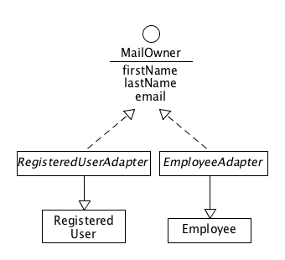
In order to promote the conversion of "IS" properties to types, there is the PremiumUser interface so that the instanceof operator could determine the “isPremium” property.
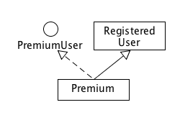
The MailOwner interface contains properties having their counterparts in both entity classes. There are also two implementations of MailOwner, each for one entity class.
Now, when the domain entities can be adapted to a common base, it is possible to model the mail service.
The UserMail interface declares two methods. Method sendEmail is the core method for sending emails. The other method, validateEmail, allows the user to validate a message before sending it.
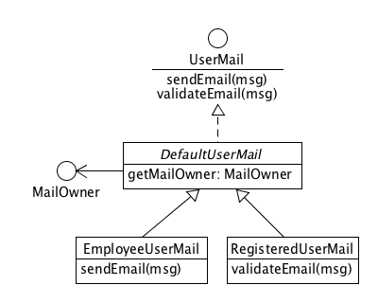
The default implementation DefaultUserMail works in the context of the current user account, from which it retrieves the field from for emails, among others. This user account is held in a reference attribute of DefaultUserMail.
The sendEmail method in DefaultUserMail invokes the validateEmail method before the email is actually sent. It allows for subclasses to override the default validation by adding more specific checks.
As mentioned above, the service's behavior reflects the type of the user account. Therefore there are two specializations of DefaultUserMail for both account types.
EmployeeUserMail overrides method sendEmail so as to add the employee's signature at the end of every email.
On the contrary, RegisteredUserMail overrides validateEmail in order to check if the user's account is not expired.
The service also contains a stack of pluggable email processors forming a processing pipeline. These processors implement UserMail interface and are connected through delegation. One of such processors is VirusDetector.
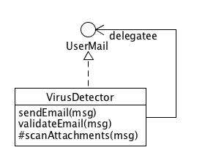
Here, one important weakness related to the absence of traits is evident. The VirusDetector class overrides sendEmail as well as validateEmail, although it would make sense to override validateEmail only. The virus scan in email attachments may be considered part of the validation performed before sending the mail by DefaultUserMail.
Unfortunately, since the virus detector and the wrapped email service are separate objects connected by a reference only, the invocation of validateEmail in DefaultUserMail will always either remain in DefaultUserMail or jump to some of its subclasses overriding validateEmail. Since VirusDetector is not a subclass of DefaultUserMail, its implementation of validateEmail will never be called from within the wrapped instance. Therefore this method must be explicitly invoked from sendEmail in VirusDetector. Not only does it complicate the code but it also introduces some inconsistency related to the semantics of validateEmail. On one hand it may be desirable to implement the virus scan in this method, since the client uses this method to check whether the email is valid. On the other hand, the validations are supposed to be invoked from the "deepest" sendEmail method in a UserMail implementation. It is the implementations's decision whether to invoke the validations or not (even if it makes sense to do it always). In the case that the implementation decides to skip the validations, the VirusDetector wrapper will ignore this decision and will validate the email anyway, possibly throwing an exception if it detects some virus.
This complication is just one of the unfortunate consequences of object schizophrenia.
In the following paragraph I am explaining that if the platform were equipped with the concept of traits, the processors could be linked by means of the stacking of traits [LINK] and the above-mentioned problem could be avoided elegantly.
Besides the general email service, there is also an extension offering sending faxes by email. This service add-on is available to premium customers only.
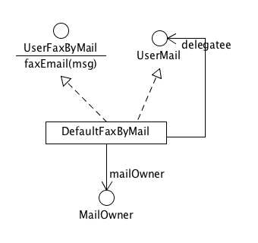
The only method in UserFaxByMail sends faxes and has the same signature as sendEmail. The default implementation also works in the context of the current user account and holds a reference to MailAccount. It also implements UserMail by delegation in order to facilitate the composition of UserFaxByMail and UserMail interfaces.
On top of the model there is the AlternatingUserMail class, whose purpose is to switch transparently between the two accounts if the user has both. AlternatingUserMail contains two references to two instances of the mail services and the class is implemented by means of the state pattern.[LINK]
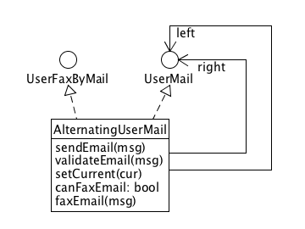
This class also implements the UserFaxByMail interface, which is only a conditional implementation, since unless the current mail service implements UserFaxByMail, the faxEmail method throws an exception.
Whether the faxEmail is possible to invoke may be determined by canFaxEmail. The positive test, however, does not guarantee that the invocation of canFaxEmail will be pass, since the current mail service in the AlternatingUserMail instance might change in the meantime.
Such design is error-prone, because it requires that the topmost wrapper in a fax-by-mail service instance be one composing UserMail and UserFaxByMail interfaces, such as DefaultUserFaxByMail, in order to indicate the presence of both interfaces. The reason is that AlternatingUserMail determines whether a mail service instance is UserFaxByMail by checking its type. It follows that it may happen that another wrapper possibly hiding the UserFaxByMail type wraps the topmost wrapper of such a mail service.
Additionally, it would be practically impossible for the client to determine the actual user account type without using some reflection tricks or introducing a new getUserAccount method in the UserMail interface. Both solutions are bad.
The former would be a plain hack, while the latter purblindly introduces a backward incompatible change to the general contract declared by the UserMail interface. It would force all UserMail implementations to add the new method even if it would make no sense for them, since some implementation may not wrap any user account object at all. Such classes would have to return null as an indication there is no underlying user account object. Moreover, the return type of the getUserAccount method would have to be Object, since there is no common ground shared by all potential user accounts; the diversity of user accounts is actually the main presupposition of this case study.
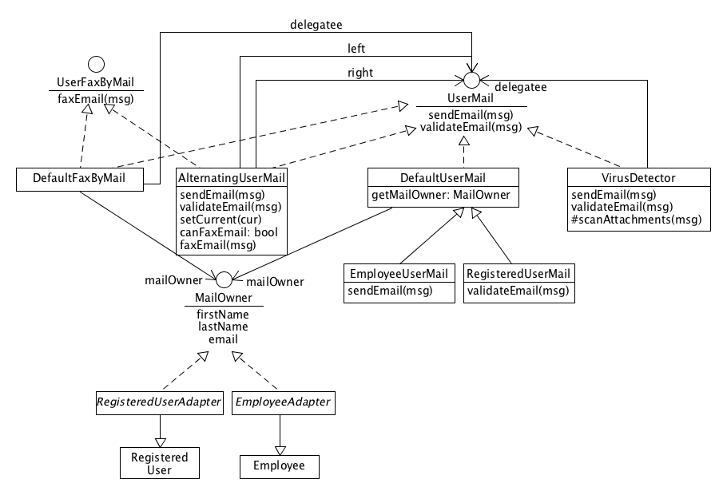
    - Assembling the Service
The following code sketches how the email service may be assembled from individual components.
public static void useMailService(Map<String, Object> employeeData, Map<String, Object> regUserData) {
Employee employee = initEmployee(employeeData);
RegisteredUser registeredUser = initRegisteredUser(regUserData);
// The client must be fixed to AlternatingUserMail through which it can determine whether the service supports fax.
AlternatingUserMail userMail = initMailService(employee, registeredUser);
Message msg = new Message();
msg.setRecipients(Collections.singletonList("pepa@gmail.com"));
msg.setSubject("Hello");
msg.setBody("Hi, Pepa!");
userMail.sendEmail(msg);
}
public static Employee initEmployee(Map<String, Object> employeeData) {
Employee employee = new Employee();
employee.load(employeeData);
return employee;
}
public static RegisteredUser initRegisteredUser(Map<String, Object> regUserData) {
RegisteredUser registeredUser;
if (Boolean.TRUE.equals(regUserData.get("isPremium"))) {
class Premium extends RegisteredUser implements PremiumUser {}
registeredUser = new Premium();
} else {
registeredUser = new RegisteredUser();
}
registeredUser.load(regUserData);
return registeredUser;
}
public static AlternatingUserMail initMailService(Employee employee, RegisteredUser registeredUser) {
// We need to clone the state of both employee and registeredUser
EmployeeAdapter employeeAdapter = new EmployeeAdapter(employee);
final UserMail employeeMail = new VirusDetector(new EmployeeUserMail(employeeAdapter));
final RegisteredUserAdapter registeredUserAdapter = new RegisteredUserAdapter(regUser);
final UserMail regUserMail = new VirusDetector(new RegisteredUserMail(registeredUserAdapter));
final UserMail regUserMailPremium = new DefaultFaxByMail(registeredUserAdapter, regUserMail);
return new AlternatingUserMail() {
@Override
protected UserMail getDelegate() {
Calendar c = Calendar.getInstance();
int h = c.get(Calendar.HOUR_OF_DAY);
if (!(h >= 8 && h < 17)) {
return getEmployeeMail();
} else {
return getRegUserMail();
}
}
UserMail getEmployeeMail() {
return employeeMail;
}
UserMail getRegUserMail() {
if (regUser.isPremium() &&
regUser.getValidTo() != null &&
regUser.getValidTo().compareTo(Calendar.getInstance().getTime()) >= 0)
return regUserMailPremium;
else
return regUserMail;
}
};
}
It is assumed here that the user owns both types of accounts. The variables employee and registeredUser are loaded from external data retrieved from a persistent storage.
The initRegisteredUser method converts the isPremium attribute of the data record into a "trait" by means of a local class Premium. If there were more such "IS" properties, it would lead to the explosion of such local classes.
The two accounts are adapted to the common ground by corresponding adapters and used as the argument to EmployeeUserMail and RegisteredUserAdapter constructors.
VirusDetector wraps both particular service instances userMail1 and userMail2.
If the user is a premium customer, then his email service is wrapped by DefaultFaxByMail to provide the fax-by-mail extension. Unfortunately, the test on a premium customer cannot use the PremiumUser type since it has gotten lost during the preceding adaptation and wrapping.
Then AlternatingUserMail is implemented and instantiated. This instance is able to switch the accounts in the background according to the current time. (If it is between 8am-17pm then employeeMail is used.) When the account of the registered user is to be used, the implementation also checks whether the registered user is a premium one and whether his account is valid. If so, the AlternatingUserMail instance uses the regUserMailPremium mail service.
AlternatingUserMail must be the topmost wrapper so as to preserve the FaxByMail type of the resulting service instance.
The rest of the code creates an email message and switches the accounts.
    - Summary
Developing a protean service on a platform without traits significantly reduces design options and tends to hide type information about the domain objects.
* As far as the two account adapters are concerned, there is no serious design flaw. The combination of inheritance and interface implementation preserves both types in instances (i.e. no object schizophrenia). Thus it is possible to check the type of an instance and then to cast it to either Employee or RegisteredUser to get access to the account specific members.
- A potential problem lurks behind the converting of the isPremium property into the PremiumUser "trait". Such an approach does not scale with the growing number of "IS" properties. This is, however, a limitation of the underlying "no-trait" platform.
- Another weakness is the cloning, because the state of the original account instances must be copied to the new adapted instances.
- The implementations of DefaultUserMail as well as of its two specializations EmployeeUserMail and RegisteredUserMail are pretty straightforward. The DefaultUserMail is designed as a package private abstract class. Thus it cannot be instantiated and only classes in from its package can extend it. The package contains only two such classes: EmployeeUserMail and RegisteredUserMail.
- The only flaw is the getMailOwner public method introduced in DefaultUserMail mediating the access to the underlying user account and which might indicate a loss of user account type information in DefaultUserMail's instances. However, since the type of the account is indirectly carried by the only two subclasses EmployeeUserMail and RegisteredUserMail, this issue is of a minor importance.
- On the contrary, the VirusDetector copes with serious complications caused by the induced object schizophrenia, as described above. Further, until the mail service instances are not wrapped by VirusDetector, they preserve their account type information.
- The implementation of the optional fax service DefaultFaxByMail also hides the account type. Additionally, there is a possibly dangerous assumption that it must be the topmost wrapper. Also, the test on premium user cannot be done by type.
- Probably the most problematic component is AlternatingUserMail. Besides its serious object schizophrenia stemming from the state pattern used to implement the switching, its most serious flaw is the conditional implementation of UserFaxByMail. Further, it must be the final wrapper, which is handed over to the mail service client, which is tightly coupled with AlternatingUserMail, through which the client can determine the presence of the fax extension and access it.
- The preservation of types when adapting or extending other classes helps loosen the coupling between the instances and their client. For example, the user interface would be able to adapt itself to the type of the account and its functionality extensions (such fax-by-mail) just on the basis of the mail service instance's type.
- The presence of various isSomething properties may be alarming since it may indicate mixing of "has" and "is" aspects in the design. Such properties often exist primarily in persistence models as boolean or enumeration columns since there is no concept of traits in databases. In order to avoid the propagation of object schizophrenia through the domain model, such properties should be converted to traits or interfaces.
  - Modelling Protean Service With Static Traits
The previous analysis showed that modeling a protean component without traits leads inevitably to a design suffering from serious flaws, most of them caused by object schizophrenia, which results from using delegation instead of inheritance (or extension).
In this article I will be dealing with modeling the mail service by means of static traits. The term static suggests here that traits are applied at compile-time and it is not possible to add them to any existing object at run-time. The code listings use Scala, since it fully implements static traits.
The domain model designed by means of traits is at first sight very similar to that of the non-trait case:
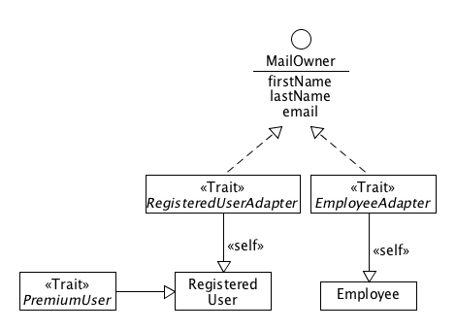
However, there are several substantial differences.
First, the PremiumUser type is a real trait, which, in contrast to the interface PremiumUser, extends the concrete class RegisteredUser. This extension explicitly declares that it is meant to be a trait of the registered user. Also, this trait can be applied on RegisteredUser only.
Second, the adapter types are also traits and not concrete classes.
trait EmployeeAdapter extends MailOwner {
this: Employee =>
override def nick(): String = employeeCode
override def email(): String = employeeCode + "@bigcompany.com"
override def birthDate(): Date = birth
}
Implementing the adapters as traits makes them "composable" with other types in the application, in particular with the UserMail implementations. This is the important step toward the elimination of the delegation.
The adapter traits do not extend the corresponding account classes as their counterparts in the no-trait design do. Instead, each adapter specifies its self-type to refer to the corresponding account class. To put it briefly, the self-type of a trait specifies a type with which the trait is supposed to be composed. Specifically, the EmployeeAdapter may only exist in a composition with Employee. The self-type also makes public and protected members accessible from the trait, actually, it behaves as if the trait privately extended the self-type, i.e. the trait does not expose the self-type.
As far as the mail service is concerned, it also utilizes traits as much as possible with the intent to eliminate delegation. All UserMail implementations DefaultUserMail, EmployeeUserMail and RegisteredUserMail are traits. It makes possible to compose them with the adapters as well as with the account classes. Each mail service trait also specifies the self-type to express its dependency on other types.
The composition of the account classes, adapters and mail service types is depicted on the following diagram.
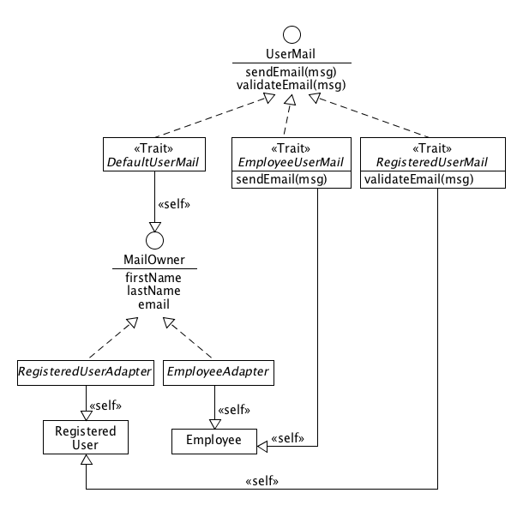
If we compare this diagram with its no-traits counterpart, there is a significant difference: there is no delegation. All references are replaced by extensions. It follows, that there is no loss of type information, since the resulting mail service is an instance of a class completely composed of all constituting types. For example, it is possible to invoke mailService.isInstanceOf[Employee] to determine whether the email service is built for an employee account.
Not even the VirusDetector introduces any delegation in contrast to the no-trait design. As expected, the VirusDetector is implemented also as a trait.
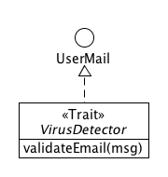
Since VirusDetector is a trait, it is possible to implement the validateEmail method only and omit the overriding of sendEmail to invoke explicitly the validation. This workaround is no longer necessary, since there is no delegation and the trait becomes one monolith including DefaultUserMail. This default email service implementation invokes validateEmail within its sendEmail method. The invocation jumps into the top-most trait overriding the validateEmail method, from where the invocation may be propagated by super.validateEmail(msg).
Similarly to the VirusDetector, the UserFaxByMail is also implemented as a trait, as shown in the following picture.
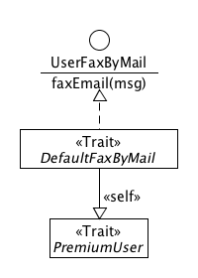
The trait is applied only if the user is a premium customer. This condition is stressed by the self-type of UserFaxByMail.
So far the design has manifested no flaws. Unfortunately, the implementation of the AlternatingUserMail must introduce some delegation. As seen in the following figure, the model is identical to that of the no-trait case.
The reason is that the trait platform has no type-safe tool to implement an instance, whose composition could be modified in real-time. Thus, all issues described in the no-trait case hold here as well.
The whole system is depicted on the following diagram:
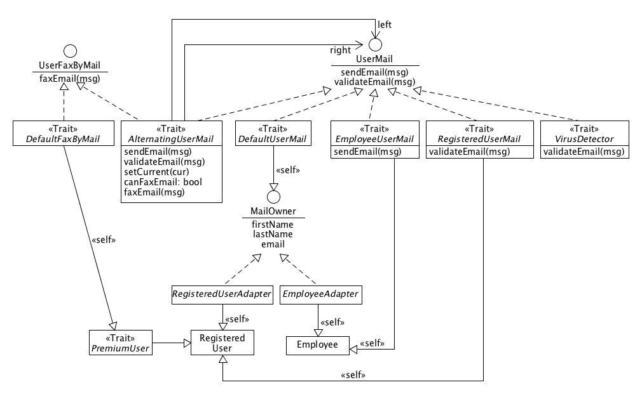
    - Assembling the Service
The following code sketches how the email service may be assembled from individual components.
def initializeMailUser(employee: Employee, registeredUser: RegisteredUser): UserMail = {
val employeeMail = new Employee() with
EmployeeAdapter with
DefaultUserMail with
EmployeeUserMail with
VirusDetector
employeeMail.adoptState(employee)
val regUserMail = new RegisteredUser() with
RegisteredUserAdapter with
DefaultUserMail with
RegisteredUserMail with
VirusDetector
regUserMail.adoptState(registeredUser)
val regUserMailPremium = new RegisteredUser() with PremiumUser with
RegisteredUserAdapter with
DefaultUserMail with
RegisteredUserMail with
VirusDetector with
DefaultFaxByMail
regUserMailPremium.adoptState(registeredUser)
new AlternatingUserMail {
override protected def getDelegate: UserMail = {
Calendar c = Calendar.getInstance()
def h = c.get(Calendar.HOUR_OF_DAY)
if (h >= 8 && h < 17) {
getEmployeeMail
} else {
getRegUserMail
}
}
def getEmployeeMail = {
employeeMail
}
def getRegUserMail = {
if (regUser.premium &&
regUser.validTo != null &&
regUser.validTo.toCalendar().after(Calendar.getInstance()))
regUserMailPremium
else
regUserMail
}
}
The first look on the code suggests that the assembling code is more compact. It is caused mainly by the Scala's syntax and partly by using traits. For example, it is not necessary to define the auxiliary Premium class, since the PremiumUser trait can be specified as part of the anonymous class signature in the new statement.
The AlternatingUserMail is an abstract class, whose useLeft method must be implemented to determine, which one of the two wrapped instances of UserMail will be used for the delegation. Here, the decision is made according to the current time. If it is between 8am-17pm then the employee email service is used (i.e. the "left" one).
    - Summary
There are two statements creating the registered user's mail instance; the only difference is that the latter creates an instance with the additional Premium trait. It is obvious that if there were another dimension, which should be expressed by type, such as gender, it would lead to further bifurcation. It follows that, there would have to be as many pre-initialized instances as the number of all possible compositions of the registered user's mail service. It means, however, that modeling multidimensional objects by means of static traits is practically impossible for a higher number of dimensions because of the combinatorial explosion of instantiating statements.
We still need to clone the state of both preexisting employee and registeredUser instances. The adoption methods are annoying.
EmployeeUserMail and RegisteredUserMail are now more general since they extend UserMail and not DefaultUserMail.
It would make sense to share one VirusDetector instance between the employee and the registered user. VirusDetector contains a virus counter, which could count the per person and not per Employee and RegisteredUser separately. However, static traits do not allow such a construction. A solution could be to apply the VirusDetector as a trait of AlternatingUserMail. Unfortunately, in such a case the virus detector's validateEmail method would not be invoked from DefaultUserMail.sendEmail because of delegation.
The complete type information propagates well until the instantiation of the AlternatingUserMail. Therefore the client must be still tightly coupled with AlternatingUserMail and nothing really changes from his perspective.
  - Modelling Protean Services With Dynamic Traits
In certain dynamic programming languages such as Groovy and Ruby it is possible to add one or more traits to an object at run-time [LINK]. A trait is added to an object by invoking a special method on the object and specifying the trait's type. This provide us with a way to hook various traits on an object step-by-step, in contrast to the static traits, where the traits are specified declaratively at once in the initialization statement. The imperative decoration by traits sounds promising as far as tackling with the problem of combinatorial explosion of class declarations is concerned.
There are a couple of languages providing dynamic traits, although they offer them under different names. Among others I have to mention Ruby (modules), Groovy (mixins, traits) and Python (mixins) [LINKS]. Such languages are usually dynamic with dynamic types. For the purpose of this section I use Groovy as a representative of such languages. The main reason is that Groovy is capable of some static type checking and that its trait syntax is very similar to that of Scala, which I used when dealing with static traits. In addition, Groovy's syntax is generally very close to the syntax of Java, which is used here as a non-trait language.
    - Modeling the Domain
Groovy traits may be stateful, what makes them a possible replacement for classes in some cases. For example, when modeling a domain entity we can use a trait instead of a class. This possibility is especially important when extensions must not hide extended types. When extending by a trait Groovy actually creates a proxy wrapping the object and implementing all interfaces of the object plus the newly added traits, which, as opposed to classes, are also considered interfaces. It follows that if a domain entity were modeled as a class the new proxy object would loose the information about the entity type. Since the entity can be modeled by a trait, it is possible to overcome that obstacle.
trait Employee {
private String firstName;
...
}
In order to instantiate an entity instance, we have to attach it to an "empty" object first, since a trait cannot be instantiated alone in Groovy.
def employee = new Object() as Employee;
employee.load(employeeData)
def regUser = new Object() as RegisteredUser;
regUser.load(regUserData)
The as keyword actually creates a proxy object, which wraps the "empty" object and implements Employee, resp. RegisteredUser.
Note: Although Groovy is primarily a dynamic language it also supports static compilation. Types or other parts of code annotated by @CompileStatic are compiled statically. [LINK]
    - Implementing the Behavior
Now, when the domain objects are created in a way, which allows loss-less extension, we can implement the functionality of the mail service.
The diagrams are practically identical to those for the static traits case. The only main difference is that the types specified in the self-type are added to the list of implemented interfaces. It might sound confusing, however, the self-type in Scala is essentially a syntactic sugar for the same thing.
@CompileStatic
trait DefaultUserMail implements UserMail, MailOwner {
...
As mentioned above, the step-by-step extensions of objects sounds like a solution to the exponential explosion of statements. In order to make it more obvious, we will introduce additional dimensions such as Gender with "values" Male and Female, and AgeGroup with values Child and Adult.
Since the logic in the traits is the same as in the static traits case, we will focus on the AlternatingUserMail class, whose instance is handed over to the email client.
The abstract class AlternatingUserMail does not wrap any mail service explicitly; instead, it invokes the abstract getDelegate method to obtain the actual delegatee. In this case, there are basically two mail service instances, one for each account type. The employee's mail service is used during the office hours, i.e. 8am-17pm, and the registered user's one in the remaining time. The following listing shows the implementation of getDelegate the anonymous class extending AlternatingUserMail.
AlternatingUserMail userMail = new AlternatingUserMail() {
@Override
UserMail getDelegate() {
Calendar c = Calendar.getInstance();
def h = c.get(Calendar.HOUR_OF_DAY);
if (!(h >= 8 && h < 17)) {
return getEmployeeMail();
} else {
return getRegUserMail();
}
}
...
The getEmployeeMail method is trivial; it always returns the same instance, since the composition of the employee's mail service is fixed. Its instance is held in empMail field in the anonymous implementation of AlternatingUserMail.
Note: In Groovy, one uses withTraits to add traits at run-time to an object. This method accepts one or more trait types and is invoked on the target object.
UserMail empMail = employee.withTraits(EmployeeAdapter, DefaultUserMail, VirusDetector)
UserMail getEmployeeMail() {
return this.empMail;
}
The getRegUserMail method is more complex, since the actual composition of the service depends on several circumstances. The rules for the composition can be summarized as follows:
- If the registered user owns a premium license and this license is still valid, then the resulting mail service instance is marked by the Premium trait and extended by DefaultFaxByMail.
- If the user is mail, the instance is further marked by Male or Female traits.
- If the use is older then the instance is marked by Adult.
UserMail getRegUserMail() {
UserMail regUserMail = regUser.withTraits(RegisteredUserAdapter, DefaultUserMail, VirusDetector);
def calendar = Calendar.getInstance()
// Dimension 1
if (regUser.premium && regUser.validTo.toCalendar().after(calendar)) {
regUserMail = regUserMail.withTraits(Premium, DefaultFaxByMail);
}
// Dimension 2
if (regUser.isMale()) {
regUserMail = regUserMail.withTraits(Male);
} else {
regUserMail = regUserMail.withTraits(Female);
}
// Dimension 3
def isAdult = (calendar.get(Calendar.YEAR) - regUser.birthDate.toCalendar().get(Calendar.YEAR)) > 18;
if (isAdult) {
regUserMail = regUserMail.withTraits(Adult);
}
return regUserMail;
}
The above-mentioned rules represent three independent dimensions constituting a configuration space, where every point corresponds to one possible composition of the resulting mail service instance for the registered user.
The very important fact is, however, that the assembling code no longer blows up exponentially with the number of dimension. This fact is a consequence of the step-by-step extensions.
Nevertheless, there are several downsides. First, a new composite instance is created again and again on each invocation of getDelegate, even when the structure of the new instance remains the same. This problem can be mitigated by storing the information about the structure of the last instance into a field. A new instance would be created only if its structure differs from that of the last one.
Second, each extension step leads to the creation of a new proxy object wrapping the object from the previous step. Here, we can end up in having a cascade of four proxies (three dimensions plus the proxied RegisteredUser entity). It follows that to get a value of a property in the RegisteredUser entity amounts to four delegated invocations on the nested proxies.
Third, it makes no sense for the extending traits to be stateful, because the state of an extension attached to the last instance gets lost on every re-instantiation. Here, it concerns the VirusDetector trait, since it holds a counter of detected viruses in email attachments, which would be periodically reset. A solution, or rather a workaround, could be to hold the extension's state out of the extension, which is not a good design practice violating encapsulation of data.
    - Summary
There is no doubt that using dynamic traits helped resolve some problems.
- Combinatorial explosion is over, the number of initialization statements (O(n)) is proportional to the number of dimensions (3) and not to the cardinality of the cartesian product of the dimensions (O(2^n)).
- We no longer have to clone the state of domain entity objects to the new extended instances.
- On the other hand, dynamic traits did not help solve the problem of metamorphism, and the client is still tightly coupled with AlternatingUserMail class, which provides the client with an interface to determine the current functionality of the mail service instance, for example. The metamorphism must still be implemented by delegation.
- Dynamic traits also bring a couple of new problems, some are inherently connected to the concept of dynamic traits, while others to Groovy's implementation.
- A trait does not have to implement all methods from the extended type, because it may be assumed that the missing methods will be delivered by other traits when extending an object. Since the extension mechanism includes no trait completeness check, it may happen that some methods will be missing after extending the object by such a set of traits. The dynamic nature of a dynamic traits language also make it difficult to introduce some reliable completeness check.
- A traits may also depend on other traits. In dynamic languages it is in general also very difficult to check dependencies at the moment of extending an object, since the object may or may not contain the required traits. Composing more complex structures by dynamic traits is therefore prone to missing dependencies.
- Objects can be extended by trait type, not by trait instance. It has important consequences especially for stateful traits, since their state is initialized at the moment of extending an object. It follows that while the extended object remains the same during a series of repeated extensions, the attached traits themselves are always newly instantiated. It would be useful if we could extend two objects by the same trait instance to share the trait's state between the two objects.
- A cascade of step-by-step extensions leads to stacked proxies. As a result of it an invocation of a method belonging to the most bottom trait is mediated by the whole stack of proxies. (requirement: to flatten the proxies)
- Dynamic languages have a weak type system, which does not allow constructing composite types, such as RegisteredUser & Male & Premium & Adult. Such types would serve as a sort of type query language used to determine concrete traits in multiple dimensions:
if (userMail instanceof RegisteredUser & Male & Premium & Adult) {
//...
}
In Scala we could use the match construct to distinguish between various combinations of traits:
userMail match {
case u: RegisteredUser with Male with Premium with Adult =>
//...
}
UserMail with Employee empMail = employee.withTraits(EmployeeAdapter, DefaultUserMail)
The above-mentioned findings indicate that because of the lack of a strong static type system, modeling multidimensional domains by dynamic traits with complex dependencies is prone to errors and the resulting implementation will tend to end up in a unmaintainable chaos. With the growing number of dimensions and concrete traits there will be an increasing probability that some method or some dependency is missing in the final composition of traits used to extend an object.
The step-by-step concept of extending objects seems to be too unconstrained delegating the responsibility for the consistency of trait compositions on the developer. However, considering that the number of trait combinations grows exponentially with the number of dimensions, the system will quickly run out of control of any developer.
It leads us to the conclusion that only a platform equipped with a strong static type system allowing for a safe dynamic composition of traits is suitable for developing complex multidimensional mutable applications must be.
  - Modelling Protean Services With Class Builder (static/dynamic)
In the section dealing with the modeling of multidimensional data [LINK] is shown that the current languages and platforms do not match perfectly with such a task. Scala as a representative of a statically typed platform is not able to represent statically the multitude of combinations arising from the multidimensionality. On the other hand, Groovy as a dynamic language with some support of static features, offers a very high flexibility, which, however, cannot guarantee consistency of trait compositions made at run-time.
It has also been demonstrated that the concept of a class builder, which combines declarative and dynamic features, may be a solution to problem of modeling complex multidimensional domains.
The goal of this section is to examine whether the class builder can solve the main issues associated with the purely dynamic and static approaches.
    - Modeling the Domain
We will begin with modeling the data objects, on which the mail service is built on. The multiform character of the data can be easily express declaratively by the following type expression.
type UserModel = Employee or (RegisteredUser with (PremiumUser or Unit))
The type may be interpreted as follows: a user may be either an employee or a registered user, which may also be a premium user.
When rewritten to the equivalent disjunctive normal form, the type reveals three possible compositions:
Employee or
(RegisteredUser with PremiumUser) or
RegisteredUser
A user instance is created by means of the class builder, whose constructor is specified with UserModel and the trait initializer. The model allows the compiler extension to check the consistency of the model. For example, PremiumUser requires through its self-type that it can appear only in the compositions including RegisteredUser too. The trait initializer allows an additional initialization of trait stubs.
val userBuilder = new ClassBuilder[UserModel]({
case emp: Employee => emp.initFromMap(employeeData)
case ru: RegisteredUser => ru.initFromMap(registeredUserData)
})
The builder goes hand in hand with the builder strategy when creating a new instance. The strategy recommends, which compositions or alternatives fits best with the context or input data. A strategy implements isRecommended interface, which includes one method returning a boolean value reflecting the strategy's opinion on the alternative passed as the argument.
trait ClassBuilderStrategy {
def isRecommended(alt: Alternative): Boolean
}
The mutating nature of the user, which alternates between being Employee and RegisteredUser, requires that we create a special implementation of ClassBuilderStrategy.
val userBuilderStrategy = new ClassBuilderStrategy {
def isRecommended(alt: Alternative): Boolean = if (isOfficeHours) {
alt.containsTrait[Employee]
} else {
userData.get("premium") match {
case true => alt.containsTrait[RegisteredUser] && alt.containsTrait[PremiumUser]
case _ => alt.containsTrait[RegisteredUser] && !alt.containsTrait[PremiumUser]
}
}
}
During the office hours this strategy is recommending the alternative containing Employee, otherwise it is recommending the alternatives containing RegisteredUser either with or without PremiumUser in accordance with the value of the premium property in the registered user input data.
The user reference is created as follows:
val userRef = userBuilder.newInstanceRef(userBuilderStrategy)
Such a reference object may be passed to other methods for subsequent mappings.
    - Modeling the Behavior
Now let us turn our attention to the modeling of the email service. Its interface consists of fixed and optional parts. The fixed one provides methods for sending and validation of emails, while the optional one, which is available for premium users only, allows the user to send faxes by email.
The behavior of the fixed interface has an invariant component, which scans email attachments for viruses, while the variant component varies according to the underlying user object. If the user is an employee, the service automatically appends the employee's signature. If the user is a registered user, the service checks if the user's license is still valid.
The described behavior can decomposed to traits and modeled by the following type:
type MailServiceModel = DefaultUserMail with VirusDetector with
((EmployeeUserMail with EmployeeAdapter) or
(RegisteredUserMail with RegisteredUserAdapter with (DefaultFaxByMail or Unit)))
This type can be rewritten to the following disjunctive normal form, which shows the three alternatives (trait compositions) corresponding to the states of the email service.
(DefaultUserMail with VirusDetector with EmployeeUserMail with EmployeeAdapter) or
(DefaultUserMail with VirusDetector with RegisteredUserMail with RegisteredUserAdapter with DefaultFaxByMail) or
(DefaultUserMail with VirusDetector with RegisteredUserMail with RegisteredUserAdapter)
The class builder may construct a new reference to the mail service by specifying the incomplete MailServiceModel as the type parameter of the constructor and by passing the userRef, which will deliver the missing traits.
val mailServiceBuilder = new ClassBuilder[MailServiceModel](userRef)
val mailServiceRef = mailServiceBuilder.newInstanceRef
Let us have a look now, how the service model alternatives actually map to the alternatives of the user model:
DefaultUserMail with VirusDetector with EmployeeUserMail with EmployeeAdapter-> Employee
DefaultUserMail with VirusDetector with RegisteredUserMail with RegisteredUserAdapter with DefaultFaxByMail -> RegisteredUser with PremiumUser
DefaultUserMail with VirusDetector with RegisteredUserMail with RegisteredUserAdapter-> (RegisteredUser or (RegisteredUser with PremiumUser))
The first mail service alternative maps exactly to one alternative of the user model, because EmployeeAdapter depends on Employee. Similarly, the second alternative maps exactly to one user model alternative, since only one has both RegisteredUser and PremiumUser as required by RegisteredUserAdapter and DefaultFaxByMail.
However, the third alternative depending on RegisteredUser through RegisteredUserAdapter can be satisfied by two user model alternatives. This ambiguity may cause problems when the class builder instantiates a mail service and is selecting the target alternative for a user instance implementing both RegisteredUser and PremiumUser traits, since there are two eligible alternatives in the mail service model.
Taking into account the sorting order of the target alternatives may solve this problem: the first matching target alternative wins. So in this case the second alternative (with DefaultFaxByMail) would win.
    - Runtime Morphing
For the client of the mail service, such as the UI, the mail service mutations, which take place in the background, should be as transparent as possible. The core functionality should always be available regardless of the current composition of the service. Thus, the client must be given a mail service reference, which handles such changes quietly and is usable all the time the service is offered.
Such a reference may be obtained from the reference wrapper object through the mutableInstance method.
val mailService: UserMail = mailServiceRef.mutableInstance
The returned object is in fact a proxy holding a reference to the current mail service composition of traits. The proxy implements the lowest upper bound type (LUB) for all target alternatives by delegating on this reference. (The LUB in this example is UserMail.)
To refresh the proxy's delegate reference could be a responsibility of the proxy itself or of an external agent other than the client.
Besides the LUB, the proxy also implements the "control" interface MutableInstance, which allows the client to control the proxy:
val mailService: UserMail with MutableInstance[MailServiceModel] = mailServiceRef.mutableInstance
The control interface exposes the reference through the delegate method. This method may be used in situations, when the client wishes to customize its appearance, for example.
To determine for which type of user the email service is currently provided, one may call delegate and check the result type by isInstanceOf or by the match block:
mailService.delegate match {
case Employee => // handle an employee
case RegisteredUser with PremiumUser => // handle a premium registered user
case RegisteredUser => // handle a registered non-premium user
}
In a similar manner the client can detect that the service currently implements the FaxByMail extension:
mailService.delegate match {
case fax: FaxByMail => // use fax
case _ =>
}
    - Summary
- All forms, which a particular object can assume during its lifetime, may be expressed declaratively by a special type expression. The same expression is used in the previous case study to describe all forms, with which object can be born with. Such an object keeps the form for all its life. Thus, the concept of the class builder developed in this section generalizes the concept from the previous case study.
- The type expression defines the object morphing model and is analogous to the finite state machine.
- All advantages described in the previous case study [LINK] hold here as well, such as the consistency check at compile-time, preservation of types and behavior during mappings, no combinatorial explosion, no need for copying, wrapping and delegating.
- The only delegation is present in the mutable proxy, which is, however, handled on the platform level, and not on the application level. The instance held by the delegating reference in the proxy never sinks as in the case of the repeated wrapping in the previous approaches.
- It is possible to avoid creating redundant instances of the same trait as in the case of VirusDetector in the previous approaches.
- The client may check the availability of extension interfaces (e.g. FaxByMail) through the delegate method on the mutable instance; AlternatingUserMail is no longer needed.
- All trait stub objects, regardless of many mappings the underwent, remain on the top of the instance, i.e. they are not "sinking" after every mapping.
- Summary of Case Studies
The two case studies analyzed in this chapter showed that modeling multidimensional objects might be surprisingly difficult in Java, Scala and Groovy as three representatives of current popular languages. Java as a non-trait language has proven to be the least suitable language for the multidimensional modeling. Because of the lack of traits, one must resort to compositions and delegations, which leads to obscuring both type and behavior during consecutive mappings between domains. In Scala each form of a given object must be declared as a class. Since the number of forms grows exponentially with the number of dimensions, the number of class declarations quickly becomes unsustainable. Groovy can cope with this problem by means of the dynamic traits applied to objects at runtime, however in contrast to Scala, its weak type system is not able to guarantee the consistency of trait compositions made in a step-by-step way (i.e. imperatively).
In the course of the case study analysis a new concept of the class builder has been developed and treated as an additional platform evaluated in each scenario. The class builder is conceived as an extension of Scala and its purpose is to generate a class for any possible trait composition given by a model, which is defined by means of a special type expression. The compiler extension should be able to check the consistency of the model by decomposing the model type and examining the dependencies of all individual traits specified in the traits' self-type.
When instantiating a new object the class builder selects the right trait composition, called alternative, according to the recommendation of the class builder strategy. Since the strategy does not determine the trait compositions directly and only hints, which prefabricated alternatives match some external conditions, it is guaranteed that the builder always generates a class made up of mutually consistent set of traits corresponding to one alternative given by the statically checked model.
In case the class builder is instantiated with an incomplete model (i.e. it has some missing dependencies), a special reference object must be passed to the class builder's constructor. Through this reference the compiler extension can trace the model type associated with the reference and verify whether that model delivers all missing dependencies.
The combination of an incomplete model with the special reference may be considered the equivalent to the mapping between two domains. Such a mapping has all the appealing properties formulated in the analysis for domain mappings: it uses neither delegation nor composition (no type schizophrenia); the source trait stubs form the resulting target composition in line with the target trait stubs (the source stubs do not sink).
The following paragraphs are focusing on anchoring some basic terminology and on conceptual requirements for the class builder.
  - Terminology And Identified Concepts
The terminology defined here should be seen as conceptual, which is going to be sharpened in the course of this work.
    - Object Metamorphism
Object metamorphism is a capability of an object to assume one or more forms defined by the object's morph model. Naturally, the object assumes only one form at a given moment. Such an object is also called a protean object.
    - Recognizer
A recognizer corresponds to the concept of the class builder identified in the case studies. It is a device, whose purpose is to compose and recompose objects from smaller parts called fragments. The name reflects the fact that the recognizer must recognize which of the possible fragment compositions matches to the outer conditions such as input data. The airport scanner is an example of such a device.
    - Morph
A morph is an instance of a morph alternative. It is in fact a proxy object implementing all fragments in the alternative by delegation.
A mutable morph is a morph, which may be transparently re-morphed to another alternative. It is important in situation when the client of the morph should be shielded from changes in the morph's composition.
All morphs created from the same object implement the lowest upper bound type (LUB) of the model. Thus, any client communicating through the LUB should not be affected.
    - Morph Model
A complete morph model defines all possible alternatives (forms) of objects instantiated from it. The compiler builds the morph model from the morph type. The compiler analyses the morph type, builds the model from it and performs various checks to guarantee that all alternatives are consistent.
An incomplete morph model is a morph model built from an incomplete morph type. Such a model can be also seen as abstract, because no object may be instantiated from it. To do so, the incomplete model must be merged with other morph model, possibly also incomplete, to produce a complete morph model. This merging corresponds to a domain mapping.
    - Morph Model Alternative
A morph alternative or alternative corresponds to one of the fragment compositions generated by a morph type.
A complete morph alternative is an alternative, in which all dependencies of all fragments are satisfied. A fragment's dependency is satisfied in an alternative, if the alternative contains another fragment compatible with the dependency.
The alternative's type is the type composed of all fragment types in the alternative.
    - Morph Fragment
A morph fragment is a building block in multidimensional compositions of objects. It corresponds semantically to the concept of trait as defined in Scala or Groovy and as it has been used throughout the case study.
A morph fragment represents a typological, behavioral and structural element of multiform objects.
    - Morph Strategy
A morph strategy is an object assisting the recognizer during the instantiation of a morph in the selection of the right alternative. The morph strategy is receiving all possible alternatives one by one and is replying by a recommendation statement. It follows that the recognizer can never instantiate an invalid composition of fragments. The only risk is that the strategy is not properly configured or implemented and may thus recommend improper alternatives.
    - Morph Type
A morph type is a type produced by a special type expression. By the type expression the developer declares all possible alternatives, i.e. compositions of fragments (forms).
The type expression is equivalent to a non-recursive context-free grammar generating a language, where no term (i.e. fragment) occurs more than once in any sequence in the language.
A complete morph type generates complete alternatives only.
    - Lowest Upper Bound (LUB) of Morph Type
The lowest upper bound is the most specific type yet compatible with the types of all alternatives from the morph model.
    - Morph Reference
A morph assembler (see below) may return the morph wrapped in a morph reference. This reference keeps a link to the morph model, from which the morph is created.
Thanks to this link, an incomplete morph model may be transformed to a complete one by composing it with the morph model carried by a morph reference. The morphs produced from this joined type implement the fragments from both models.
    - Morph Assembler
The morph assembler is a component responsible for the morph model management and morph instantiation. Its compile-time part parses and validates morph models, while its runtime part corresponds to the class builder from the case study, which is responsible for generating classes for all alternatives in the morph model associated with the assembler. It uses the generated classes to create morphs.
    - Morph Mapper
The morph mapper is a compile-time component composing one morph model with another. It performs a series of checks to guarantee that the two models produce a complete morph model.
  - Code Samples
The following paragraphs distillate the key snippets of the previous code illustrating the use of the class builder (i.e. the recognizer). These snippets are supposed to capture a notion of how to express the key concepts and operations programmatically. The code snippets should not be treated as a sort of specification; rather they should be seen as a conceptual pseudo-code suggesting possible expressions. The corresponding code using the real recognizer, i.e. the main deliverable of this thesis, may look differently.
    - Morph Fragments
A fragment with no dependency:
trait Rectangle {
var width: Float = _
var height: Float = _
def calculateArea: Float = width * height
}
A fragment with dependencies:
trait ScannedBanknote {
this: Banknote with Rectangle with Paper =>
//...
}
    - Morph Type Expression
A complete type expression:
Thing with (Metal or Paper) with (Rectangle or Cylinder)
This expression may be rewritten to the disjunctive normal form:
(Thing with Metal with Rectangle) or
(Thing with Metal with Cylinder) or
(Thing with Paper with Rectangle) or
(Thing with Paper with Cylinder)
An incomplete type expression:
(ScannedBanknote with Banknote) or (ScannedCoin with Coin)
    - Bulding a morph with the post-initializer
val itemBuilder = new ClassBuilder[Thing with (Metal or Paper) with (Rectangle or Cylinder)]({
case rect: Rectangle =>
rect.width = event.get("rectangle").get("width")
rect.height = event.get("rectangle").get("height")
case cyl: Cylinder =>
cyl.height = event.get("cylinder").get("height")
cyl.radius = event.get("cylinder").get("radius")
})
val item = Thing with Material with Shape = classBuilder.newInstance
    - Custom Morph Strategy
val userBuilderStrategy = new ClassBuilderStrategy {
def isRecommended(alt: Alternative): Boolean = if (isOfficeHours) {
alt.containsTrait[Employee]
} else {
userData.get("premium") match {
case true => alt.containsTrait[RegisteredUser] && alt.containsTrait[PremiumUser]
case _ => alt.containsTrait[RegisteredUser] && !alt.containsTrait[PremiumUser]
}
}
}
val userRef = userBuilder.newInstanceRef(userBuilderStrategy)
    - Composing Incomplete Model to Produce Complete One
type ItemModel = Thing with (Metal or Paper) with (Rectangle or Cylinder)
type ScannedCurrencyModelWithLoaders = (ScannedBanknote with BanknoteLoader) or (ScannedCoin with CoinLoader)
def makeCurrency(itemRef: Ref[ItemModel]): Ref[ScannerCurrencyModel] = {
val curBuilder = new ClassBuilder[ScannedCurrencyModelWithLoaders](itemRef)
loaderBuilder.newInstanceRef
}
    - Mutable Morphs
Creating a mutable morph:
val mailService: UserMail with MutableInstance[MailServiceModel] = mailServiceRef.mutableInstance
Evaluating the mutable morph's delegate reference:
mailService.delegate match {
case Employee => // handle an employee
case RegisteredUser with PremiumUser => // handle a premium registered user
case RegisteredUser => // handle a registered non-premium user
}

- Recognizer
As mentioned above, a recognizer is a virtual device composing objects from fragments; i.e. morphs. The recognizer is associated with a morph model, which describes all possible combinations of the fragments. The morphing strategy of the recognizer selects the combination of fragments, which matches best to the outer conditions. This combination is then used to create the morph.
Recognizer is also able to recompose the object as long as its outer or inner conditions change. The object may be recomposed in essentially three ways. First, the recognizer uses the same morph model and morphing strategy; in such a case the final composition of the object reflects the changes in the conditions only. Second, the recognizer uses another strategy; in this case, the new composition may reflect different conditions in the context than the original composition. And third, the object may be recomposed by means of a new recognizer associated with a different morph model joined with the original model. In this case the recomposed object will contain new fragments along with the fragments from the original model.
It follows from the above that the recognizer assumes essentially three roles:
- Object Factory creating a new instance from smaller pieces according to the morph model
- Re-morpher recomposing the morph to match the current outer conditions
- Merger re-assembling the morph according to a different model joined with the original one
These three areas are individually elaborated in the following subsections.
  - Object Factory
An example of the recognizer in this role may be the fictional airport scanner from the case study. The input data consists of the data produced by the array of scanner sensors. The data is further processed by the morphing strategy implementing the procedure for recognizing only such objects that can be matched to the alternatives given by the morph model. Another example might be a server-side software component recognizing the remote user by the properties transferred from the remote host.
The recognizer may be seen as a virtual device “perceiving” real objects and producing their representation as a vector of instances of concrete model elements; i.e. fragments and wrappers stubs (6.2.1). The schema of the recognizer is shown in Figure N.
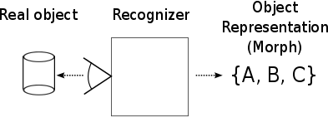
The object representation, as a composition of fragments and wrappers, is equivalent to the notion of the object morph and therefore these two terms are used interchangeably in the following text. It must be reminded that the element stubs may hold a state reflecting the properties of the real object. Thus the three letters in Figure N actually represent stubs, which may hold different states for different recognized real objects.
A recognizer uses the morph model (6.1.11) describing all allowed combinations of model elements or alternatives. This morph model is accompanied by a morphing strategy (6.2.7), which implements the recognition logic of the recognizer by selecting the proper alternative from the morph model. Section 6.2.6 deals in detail with the abstract recognizer with respect to the morph model and morphing strategies.
The resolution of a recognizer is a property, which is directly related to the morph model used by the recognizer. It is defined as the number of unique combinations of concrete model elements, which the recognizer uses to produce representations of real objects. It is actually the number of alternatives described by the model.
    - Fragment Recognizer
A fragment (or wrapper) recognizer is an elementary recognizer capable of recognizing a certain fragment. In case it recognizes the fragment in a real object, it produces a representation consisting of an instance of the fragment initialized by the “measured” values of the real object’s properties. As long as it does not recognize the fragment it produces no representation.
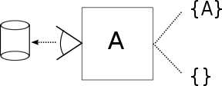
The resolution of the fragment recognizer is 1.
    - Composite Recognizer
A key property of recognizers is their composability, which allows creating more complex recognizers from simpler ones. There are essentially two complementary ways to
compose recognizers: inclusive and exclusive.
The first type is composed of independent recognizers; the recognizers are not mutually exclusive and all may produce some (non-conflicting) representation of the real object. The object representation of such a composite recognizer is a composition of the partial representations produced by the components.
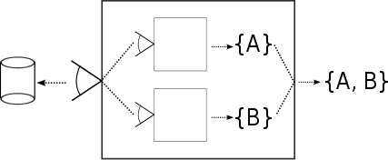
The airport scanner producing the two-dimensional description of the material and shape of items is an example of an inclusive composite recognizer.
The resolution of an inclusive composite recognizer is the product of the resolutions of its components.
On the other hand, the exclusive composite recognizer consists of mutually exclusive recognizers only. Therefore a given real object can be recognized by at most one nested recognizer, whose representation of the object matches with the representation returned by the composite recognizer, as all other empty partial representations do not contribute.

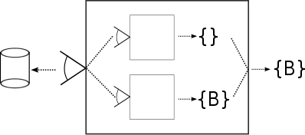

Clearly, a composite recognizer may be used as a component of another composite recognizer.
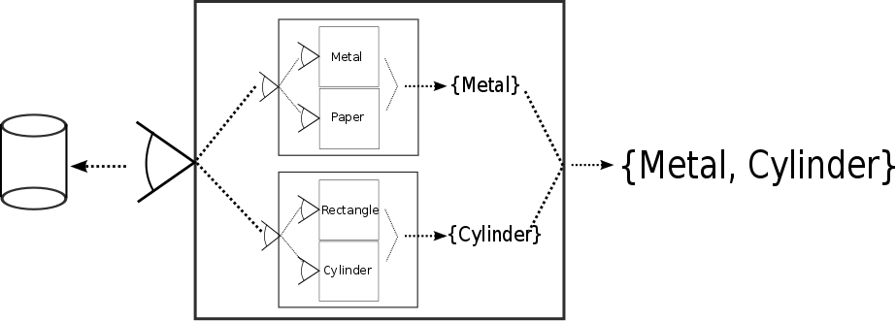
This recursive composition may also be seen as an evolution of a recognizer, in which the old recognizer is replaced by a new composite one, which includes the old one. This evolution may be taking place independently at all levels of a composite recognizer, whereas every evolutionary step leads to an improvement of the recognition capabilities of the top device.
There actually two types of incremental improvements of a recognizer. The first one comprises an introduction of a new fragment mutually exclusive with an existing one. This structural change improves the resolution of
, may be seen as an evolution of the recognizer during which the device improves its recognition capabilities. d
Improving
Adding new fragments improves the resolution of the recognizer .. linearly.
Adding new dimensions represents a qualitative change of the recognizer. exponentially.
  - Re-morpher

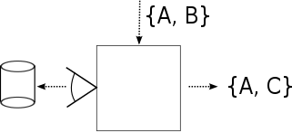

  - Merger
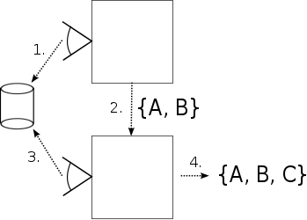
The main benefit of the extending recognizer is that it does not have to be bound to only one source recognizer. Instead, it may be connected to many recognizers with different morph models. Clearly, the source models cannot be arbitrary. They must conform to the morph model of the extending recognizer; in other words, the source alternatives must satisfy all dependencies of the fragments from the extending model. For instance, the morph model producing the alternatives shown in Figure N conforms to the model in Figure N+1.
(Metal, Rectangle), (Metal, Cylinder), (Paper, Rectangle), (Paper, Cylinder)
Figure N
(Banknote), (Coin)
Banknote “depends on” (Paper, Rectangle)
Coin “depends on” (Metal, Cylinder)
Figure N+1
(Banknote, Paper, Rectangle), (Coin, Metal, Cylinder)

Object Recognizer (OM) is a software component implementing object metamorphism. In other words, by means of this component one may create an object assuming one or more forms according to some predefined morphing model. Object Recognizer is also a tool whereby it is possible to map one morph model onto another in order to produce a new joined morph model. Such a mapping can be seen as a generalization of class extension.
Therefore it follows from the above that OM may be broken down into two components: one creating objects according to a morph model and the other mapping one morph model on another. The former component is called Morph Assembler (MA) and the latter is Model Mapper (MM).
Both components have their compile-time and run-time sub-components. The compile-time component of MA parses and validates morph models expressed by means of a special type, while MA’s run-time component instantiates objects according to morph models. The compile-time component of MM checks if the target morph model conforms to the source one and its run-time component composes target and source fragment instances to create a new joined instance.
The high-level design is shown in Figure N.
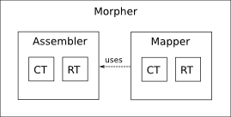
MM uses some functionality of MA, such as morph model management and instantiation, which is indicated by the arrow in the figure.
The following paragraphs summarize the main responsibilities of both components and the sections and 7 deal with the two components in detail.
    - Morph Assembler (MA)

Compile-Time
- Parses and validates morph models at compile-time
- For every valid morph model it generates a special code representing the model. Such a code is loaded and used at run-time by the run-time part of MA.
- Transforms fragment traits so that they may be composed dynamicaly
- Generates auxiliary artifacts such as fragment classes

Run-Time
- Loads morph models
- Creates morphs from morph models according to specified morphing strategies
- Manages fragment factories
- Handles remorphing, i.e. changes a morph’s shape according to the morph model and suplied morphing strategy
- Provides API for implementing custom morphing strategies
- Performs run-time code transformation of fragment classes
    - Morph Mapper (MM)

Compile-Time
- Verifies whether target and source morph models can be mapped; i.e. whether the target model conforms to the source one.
- For every mapping it generates a special code describing how to map the target alternatives to the source ones. Such a code is loaded and used at run-time by the run-time part of MM.

Run-Time
- Loads mapping models
- Joins fragment instances from source and target models and creates morph instances according to mapping models
- Chains target and source morphing strategies
    - Object Recognizer Reference Implementation (RI)
The main goal of this work is not only to develop the theoretical concept of object metamorphism but also to provide a reference implementation as a proof-of-concept prototype. The preceding analysis indicates that the Scala language might be a suitable candidate for an extension that would allow the implementation of Object Recognizer. Having developed the case study’s code examples in three languages I came to the conclusion that it would be much easier to extend the Scala compiler and other Scala subsystems to achieve some dynamicity rather than to extend a dynamic language such as Groove to obtain a robust and static type safety.
Thus the following detailed explanation of the components’ design is accompanied by comments on how a given theoretical concern is implemented in the Scala reference implementation of OM.

- Morph Assembler
As outlined previously, the purpose of Morph Assembler is to instantiate objects from a set of building blocks according to the morph model, which is parsed and validated at compile-time. In the next sections the detailed design of MA along with a number of implementation notes concerning the reference implementation in Scala is presented.
  - Compile-Time Component
Before delving into the description of morph models, we have to define the building blocks from which morph models are composed of. Then we will deal with the actual composition of morph models, their validation and run-time representation.
    - Morph Model Elements
The morph model elements are the types of the parts from which the resulting object, i.e. the morph, can be assembled. There are several kinds of such elements: dimensions, concrete categories, abstract categories (a.k.a. fragments), dimension wrappers and fragment wrappers. These kinds of elements are defined so as not to overlap in terms of their purpose and application; i.e. the system of the elements abides by the separation of concerns design principle.
Another crosscutting property of the model element types is that a model element is either fully implemented (i.e. concrete) or purely abstract (i.e. signatures only, no code). The concrete elements are fragments, dimension wrappers and fragment wrappers, whereas dimensions and abstract categories are purely abstract. The model element kinds are depicted in figure N as a hierarchy of meta-classes.
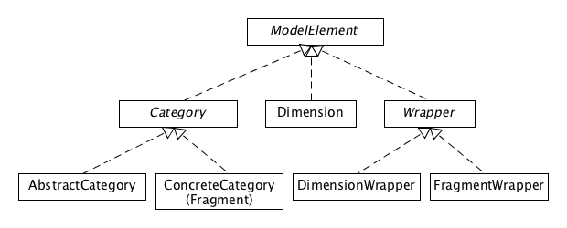

Briefly, a dimension represents a specific view on a set of instances called the dimension’s definition set. The dimension consists of categories, which represent disjoint subsets of the dimension’s definition set. The remaining two kinds are the so-called wrappers. A dimension wrapper is a type that overrides an abstract member declared in the wrapped dimension. On the other hand a fragment wrapper is a type overriding a concrete member defined in the wrapped fragment.
Concrete elements may specify dependencies on other model elements, because they may contain a code that needs the functionality provided by the other elements. It should be remarked that only concrete model elements are allowed to specify dependencies, because the purely abstract elements have no code, which could depend on other elements. The validation of such dependencies is performed during the compilation.
The next paragraphs describe individual elements in more detail.
    - Morph Model Elements – RI Notes
All model elements are represented by Scala traits. To distinguish one model element from another the developer uses a set of special annotations dimension, fragment, category and wrapper.
As described in 6.2.1, all concrete model elements must be able of instantiation. To facilitate the instantiation of model elements, RI generates the so-called stub class for all of them at compile-time. Additionally, RI generates also an auxiliary trait for every dimension on behalf of proxy classes of dimension wrappers, as explained in 6.1.4 and 6.2.4.
    - Dimensions And Categories
A dimension in object metamorphism establishes a specific view on a subset of instances of a given class – the definition set - through a family of disjoint subsets called categories. For example, the items recognized by the airport scanner, which are instances of the Item class, may be viewed as objects of many shapes. The individual shapes recognized by the scanner correspond in this case to the categories of the Shape dimension. Similarly the same items may be viewed from the material perspective establishing so another dimension Material, as shown in Figure N.
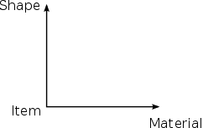
The two dimensions constitute a two-dimensional space – the configuration space -, where each point on a dimension axis corresponds to one category and each point in the product of the dimensions corresponding to one form of an item.
From the programmer’s point of view a dimension coincides with the notion of an interface in object-oriented languages. It is a type that contains no data or code, but defines behaviors through method signatures (LINK). The name dimension is deliberately chosen to emphasize the role of such a type in the multidimensional modeling, where it represents a dimension or one degree of freedom.
The notation for a dimension is the UML symbol for an interface customized by the dimension stereotype.
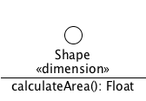
As far as categories are concerned, they are disjoint subsets of the dimension’s definition set. They may or may not fully cover all possible instances of the class. In case that the categories cover the whole definition they represent a partition of the definition set.
Regarding the airport scanner, it will certainly not be able to recognize all possible categories of the shape dimension from the beginning. The scanner will rather begin with a set of the simplest shapes adding others in the course of time, as it becomes more sophisticated. On the other hand, we can consider a dimension presenting the objects as animate or inanimate. The two categories cover the definition set completely.
From the programmer’s point of view, the categories that may appear in morph alternatives must be fully implemented, i.e. must not contain any abstract members, since the morph assembler assumes that all alternatives yielded by a morph model are made up of fully implemented traits possibly depending on other traits. Such a contract makes the assembler’s task easier provided that it can focus on checking the dependencies between the traits in alternatives only and avoid detecting missing (unimplemented) members. Such concrete categories are also called fragments and section 6.1.5 deals with them in detail.
Figure: A fragment and its relationship with the dimension
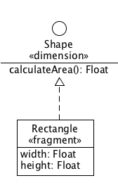
A fragment may be seen as a specialization of its parent dimension, as the fragment defines a subset of the dimension’s definition set. It is also an implementation of the dimension, since a fragment implements all members declared in the dimension. Therefore the UML syntax used for the relationship between a fragment and its parent dimension is the “implements” relationship.
Any category de facto establishes a new definition set, which can be seen through the “eyes” of other specialized dimensions. For example, the set of all metal items may be used as the definition set of the Magnetism dimension partitioning the metal items to three groups: diamagnetic, paramagnetic and ferromagnetic items.
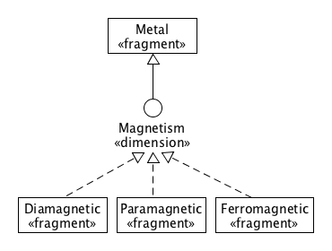
Such a concept allows building hierarchical categorization schemas, as explained later in this section.
In contrast to fragments, abstract categories are not intended to be part of any alternative directly. The purpose of such categories is to categorize existing categories as explained below in section Injected Categorization. As an example of such categories can be given a grouping of the shape fragments according to the number of the spatial dimensions; i.e. 1-D, 2-D and 3-D.
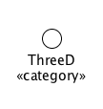
Figure: The UML symbol for an abstract category

Universe
It is natural to assume the existence of a special absolute category representing all objects. Such a category is the root category of all dimensions; i.e. the union of all definition sets of all dimensions. Such an absolute root category is an analogy to the root types found in programming languages (e.g. java.lang.Object, scala.Any etc.).
Since any category belongs to a dimension, we also have to consider the existence of a special root universal dimension having the universal root category as its default category. It leads us, however, to a sort of chicken-egg problem, because, according to its definition, a dimension represents a view on the dimension’s definition set, which clearly coincides with the universal category.
Therefore we have to treat the universal category and dimension as a single type called Universe being a category and dimension at the same time and extending each other as depicted in Figure.
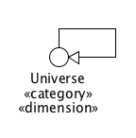
The Universe type
The Universe type is useful when interpreting dimensions and categories that do not explicitly extend any other model element. Its ambivalent nature allows using Universe either as the implicit parent category or dimension for the dimensions or categories extending no explicit parent type.
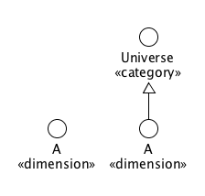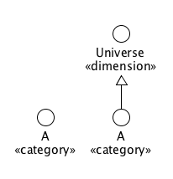
Universe as implicit parent category and dimension
It follows from the above that any two categories with no explicit parent dimension are assumed to belong to the Universe dimension and therefore they are mutually exclusive.

Unit Dimension
The unit object is an object that holds no information. Such an object has neither behavior nor properties (its existence is rather a quantifier than a property [LINK]). Although it makes sense to consider the existence of more such objects, they are inherently indistinguishable and therefore identical. It follows that the size of the set of all such objects is 1. This set is called the unit set (or singleton set) [LINK, singleton type and object, ()]. The name Unit and the shortened notation () denote both the unit set and the unit object.
Furthermore, the unit object may be seen as a fragment of a dimension, whose definition set is the unit set. It is tenable to assume that there is only one such dimension because another dimension could not provide a distinct view on the unit object provided that the unit object holds no information. This fragment and dimension are called the unit fragment and unit dimension.
Taking into account the fact that the unit object carries no information, any composition of the unit element with another model element will be indistinguishable from the other model element itself. Therefore the unit element functions as a neutral element in the composition of model elements; i.e. given a model element A, extending A with the unit element does not actually modify A in any way.
A.Unit = Unit.A = A
The unit object is useful when constructing morph models with optional elements as shown in section 6.1.11.

Nothing Dimension
TODO

Total Dimension
TODO

Basic Definitions
Each category in a dimension represents a subset of the dimension’s definition set. An important requirement for the dimension is its unambiguity, which requires that for every instance from the definition set there be at most one category in the dimension containing the instance, which requires that the categories be mutually disjoint (exclusive). The following definition formulates this requirement more exactly.
Definition 1: Let C be a class, I a set of instances of C, I’=I∪{()}. Further let D={c_{i}}, i ∈ 0..N, N > 0 be a partitioning of I’ such that Unit∈c₀. Then D is a dimension of I, I is the definition set of D, I’ is the extended definition set of D and the sets c_{i} are categories of D. The category c₀ is the default category of D.
Convention: The name of the default category in diagrams is the same as the name of the dimension it belongs to.
The categories other than c₀ are the “proper” categories, which never contain the unit object (); thus c_{i}⊂I for all i>0. On the other hand, c₀ containing the unit object also contains objects from I that do not belong to any “proper” category c_{i} i>0. In view of that the unit object is the representative of all uncategorized objects from I with respect to the given dimension. The construction of the default category as a category of all objects that do not belong to any category is reminiscent of Russel’s paradox [LINK]. But it should be realized that the default category is not a category of I as the others, but a category of the extended definition set I’; provided that an object does not belong to any category of one definition set does not mean that the same object cannot belong to some category of another definition set extending the original one.
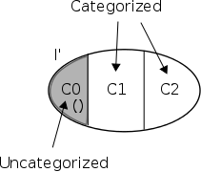
Figure N: D = {C0, C1, C2}
If a dimension consists of only one category, then this single category is the default category. In other words, in a single-category dimension all objects from the dimension’s definition sets are uncategorized.
It is important to emphasize that the fact that an object other than the unit object belongs to the default category does not imply that the object is not of any type associated with the “proper” categories. The correct interpretation is that it is not known whether the object can be categorized by c_{i} i>0. So the default category represents the lack of knowledge or the imperfection of the current categorization. The categorization is rather a dynamic concept, which de facto means that a categorization may improve in the course of time and some objects from the default category may move to other “proper” category in the future.
This discussion brings us to two key aspects of dimensions: completeness and extensibility.
A complete dimension is such a dimension that the union of its categories is identical with the dimension’s definition set. In other words, the dimension can categorize any instance from the definition set as it covers the whole set, as expressed by Definition 2.
Definition 2: Let D={c_{i}}, i ∈ 0..N, N > 0 is a dimension and I is the definition set of D. Then D is complete iff ∪c_{i}=I where i>0.
It follows from the preceding definition that any complete dimension has exactly one uncategorized object, which is the unit object; i.e. the default category is the unit set.
Since an incomplete dimension leaves uncategorized a certain subset of the definition set captured by the default category, it provides a space for a further extension of the dimension’s coverage. Such an extension cannot be arbitrary, however. It is required for any such dimension extension that any instance categorized by the original dimension must remain in the same category after the extension.
In practice it means that such an extension may be done by either adding a new category to the dimension or by generalizing (enlarging) an existing category.
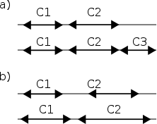
Figure: Adding vs. generalizing
In the context of the airport scanner example, an improvement of the scanner’s firmware might allow recognizing a new shape, which would become a new category in the Shape dimension. On the other hand, another improvement would enable to recognize an existing shape category among the previously uncategorized items. In both cases the set of class instances remains the same; only the categorization was improved, i.e. extended.
While the former extension introduces a new kind of knowledge, the latter only improves the current one by using a better resolution.
The following definition formulates the notion of dimension extension more precisely.
Definition 3: Let D and D’ be two dimensions of the given definition set I; i.e. D={c_{i}}, i∈0..N, N > 0 and D’= {c’_{j}}, j∈0..M-1, M>0. We say that D’ extends D if and only if:
1. ∪c_{i}⊂∪c’_{j} for i>0, j>0
2. For all o∈I for which there exist two categories c_{i}∈D and c’_{j}∈D’ such that o∈c_{i}, o∈c’_{j} it holds that c_{i}⊆c’_{j}.
We can easily proof the following proposition about complete dimensions:
Proposition N: Any complete dimension D of a given definition set I is not extensible unless I is generalized.
Proof: The fact that D is complete means that ∪{c_{i}}=I for i>0. Suppose there exists another dimension of I D’={c’_{j}} c`_{j}⊂I extending D. In such a case ∪c_{i} i>0 must be a strict subset of ∪c`_{j}, but since ∪{c_{i}}=I i>0 then I⊂∪c`_{j} j>0, which is a contradiction, because all c`_{j}⊂I. The only way to satisfy the condition ∪c_{i}⊂∪c`_{j} is to generalize (i.e. enlarge) the set I. Q.E.D.
Let me illustrate the class generalization on the airport scanner example. Let us assume that the scanner has undergone a major improvement resulting in its better resolution. Up until then it could fully categorize every scanned luggage item; i.e. all dimensions used to the categorization have been complete. Now, however, the newly recognized items cannot be categorized yet because of some technical limitations, thus the new items are produced as anonymous ones carrying the basic item properties only. Such an improvement corresponds to a generalization of the Item class, which makes its dimensions incomplete and thus ready for extensions. A next version of the scanner’s firmware will enable the categorization of the new items by one or more dimensions possibly making them complete again.
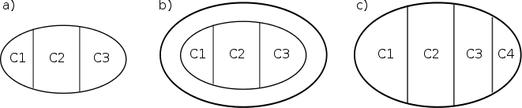
Figure: Generalization of the definition set. a) The set with a complete dimension containing three categories b) The generalized definition set with now incomplete dimension c) The dimension made complete by generalizing C1, C2 and C3 and by adding C4.
A key property of a categorization system is its ability to adopt new concepts. Considering the impossibility to extend complete dimensions, it invites an obvious question: how can the categorization system keep delivering innovative findings when its dimensions are becoming virtually complete?
One way is to identify a new independent dimension and add it to the system. If the new dimension brings a radically novel view on the instances then it may revive the production of new findings, alias categories. Such a dimension should be relevant to all or a significant subset of the instances and not to be too particular, if possible. Otherwise the system will tend to get flooded by single purpose incomplete dimensions. In the course of time, however, to find such a “full-fledged” dimension becomes increasingly difficult.
Nevertheless the fact it is rather easy to find new particular dimensions indicates that there should be some extension mechanism working at a more local level, where those particular dimensions would find their place.
Before explaining how to extend categorizations more locally, we will introduce a couple of auxiliary concepts in order to make diagrams less complicated.

Normalizing Dimension-Dimension Relationship
The concept of the default category makes it possible to formulate a design convention aimed at curbing the complexity of categorization schemas. This convention concerns the situations in which the definition set of a dimension is identical with the default category of another dimension. The convention allows the designer to omit the intermediary default category and to connect the child dimension directly to the parent dimension.
The reverse process to the simplification is called normalization.
The following rule formulates the convention more precisely.
Normalization Rule 1: Let A, B be two dimensions, B extending A. Such a relationship is interpreted in the same way as if B extended A’s default category.
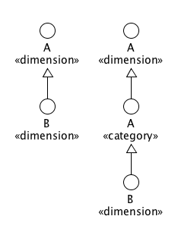
Figure: Normalizing a dimension-dimension relationship

Normalizing Category-Category Relationship
There is another convention, which allows connecting one category directly to another. In order to formulate this convention, it is necessary to introduce the notion of a category’s default nested dimension.
Definition: Let C be a category of a dimension D other than the default one. Then the default nested dimension of C is a dimension, whose definition set is identical to C and whose name is that of C.
It should be remarked that since the parent category cannot be the default category, the definition set of the nested dimension does not contain the unit object. This object is present in the extended definition set of the nested dimension.
Now it is possible to proceed to the formulation of the next convention.
Normalization Rule 2: Let A, B be two categories, B extending A. Such a relationship is interpreted in the same way as if B extended A’s default nested dimension.
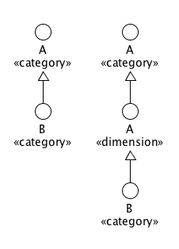
Figure: Normalizing a category-category relationship
The bottom line for the two rules is that the normalized categorization schema must follow a certain structure, in which dimensions are interleaved by categories in the vertical axis. In other words, child elements of a dimension are considered categories, which are mutually exclusive, while children of a category are considered dimensions, which are non-conflicting. However, following this structure leads to unnecessarily complex diagrams and implementations. Using default categories and nested dimensions primarily helps reduce the complexity.

Categories with multiple parent dimensions
The notion of category dictates that a category belongs to a single dimension. Nevertheless, sometimes, for the sake of a more concise expression, a category may be depicted as connected to more dimensions. In order to be compliant with the category notion, this situation is interpreted as if the category belonged to a virtual dimension extending the default categories of the two dimensions, as shown in Figure N.
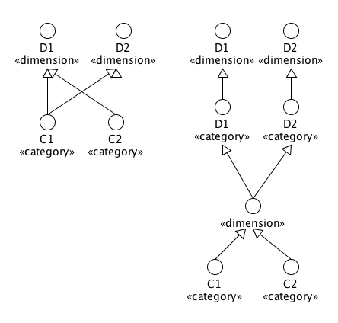
This rule can be formulated by the following definition:
Normalization Rule 3: Let C be a category extending two dimensions D1, D2. Such a relationship is interpreted as if C extended an anonymous dimension extending the default categories of dimensions D1, D2. If there are more categories extending the same dimensions D1, D2 only, in the normalized graph they extends from the same anonymous dimension.

Features
A feature is a dimension containing the default category only. The feature dimension is by definition incomplete since its purpose is to address only a certain subset of instances sharing some properties. It is also static (not extensible) by definition since it will always contain the default category only.
One could raise an objection that a feature might be made complete by modeling it as a binary (two-category) complete dimension FeaturePresent | FeatureNotPresent. However the key difference between the two dimensions is that while the feature dimension addresses only the instances known for possessing a particular feature and it says nothing about the other instances, the binary dimension separates the instances possessing the feature from those not possessing it. Furthermore, any new feature identified among relatively small subset of instances would also affect the other instances by assigning them the “non-feature” (a cylinder would be a non-rectangular, non-regular, non-pyramid, non-stellated etc.).
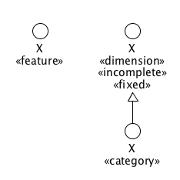
Figure: The compact and normalized notation for a feature.

Nested Categorization
A dimension category defines a certain subset of the dimension’s definition set and as such it can become a new definition set for other dimensions establishing the base for a nested multidimensional categorization. Such a new categorization creates a new configuration space, in which every point corresponds to a nested alternative, i.e. one possible combination of categories (traits) from the nested categorization’s dimension. Such a nested alternative is attached to the parent category occurring in an alternative from the parent categorization.
We can illustrate a nested categorization on the Metal fragment in the airport scanner example. The Metal fragment is a category from the Material dimension and because metals may be categorized in many ways it is a good candidate for a nested categorization.
For the sake of simplicity, we will consider two dimensions Chemistry and Magnetism. The former dimension views metals from the chemical perspective and consists of two fragment categories OneElement and Alloy. The latter dimension takes into account the magnetic properties of metals and consists of three categories Diamagnetic, Paramagnetic and Ferromagnetic.
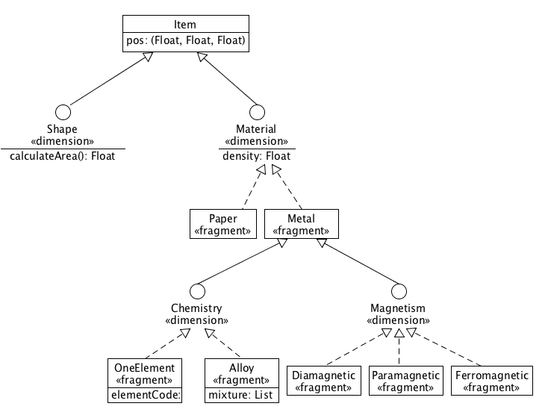
Figure: Nested Categorization for Metal: Chemistry vs. Magnetism
Both new metal dimensions are complete by definition and they generate six possible nested alternatives.
{Alloy with Diamagnetic, Alloy with Paramagnetic, Alloy with Ferromagnetic,
OneElement with Diamagnetic, OneElement with Paramagnetic, OneElement with Ferromagnetic}
These new alternatives are incorporated into the main categorization by combining them with the three “metal” alternatives from the parent categorization.
{Segment with Metal, Rectangle with Metal, Cylinder with Metal}
The following combination of fragments is a sample of the new alternatives emphasizing the nested categories.
Item with Rectangle with Metal with Alloy with Paramagnetic
The upgraded categorization system now produces 21 alternatives in total (3 non-metal ones and 3*6 metal ones), which means that its resolution has improved by factor 3.5 (21/6).
It is important to remark that the leaves of a nested categorization must be concrete (i.e. fragments) so as not to introduce abstract members into concrete parent alternatives, with which they are combined.
To sum up, a nested categorization breaks down an existing category in the same way as the top categorization categorizes the whole set of the class instances. All parent alternatives containing that category are replaced by the Cartesian product of the nested alternatives and those parent alternatives. As a result, the top categorization generates more morph alternatives.

Injected Categorization
Another approach to increase the information value of complete dimensions (and of course of incomplete as well) is based on a categorization of existing categories. This notion becomes more obvious if we consider a dimension consisting of a high number of categories, which is often the case of too general dimensions. As in the case of the set of all instances, also the categories may be looked at from different angles, which is analogous to identifying dimensions in the set of instances. The idea is to identify such dimensions in the set of the categories and insert them between the categories and their dimension. Therefore such dimensions are called injected.
To elucidate this approach we can consider the Shape dimension from the airports scanner example, which clearly has a potential to contain many categories. However, for the sake of simplicity, here it contains only four fragment categories (fragments) Cylinder, Cube, Rectangle and Segment.
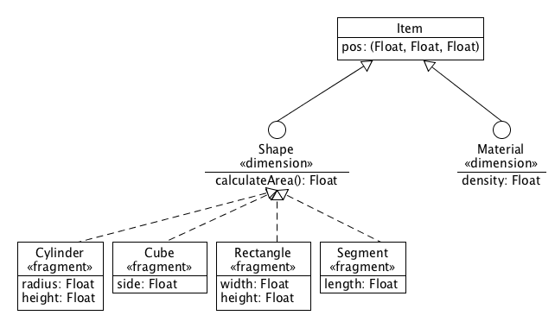
Figure: Unsorted categories of the Shape dimension
Despite the small number of the shape fragments it is quite easy to identify some dimensions. For example, we can categorize a shape according to the number of the shape’s spatial dimensions as shown in the Figure N. The Extent dimension may be considered complete by definition.
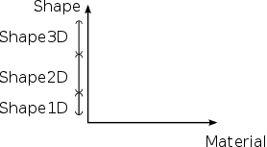
Figure: Partitioning the definition set by means of the injected dimension Extent
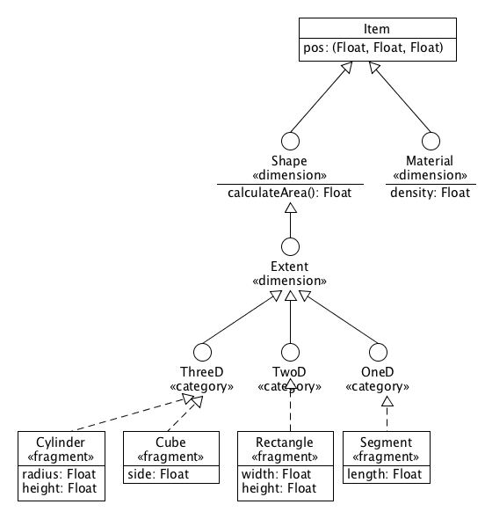
Figure: One injected complete dimension Extent with three categories
Another example may be a dimension selecting polytopic shapes. This dimension is an exemplar of a feature dimension.
Note: A polytope is a geometric object with flat sides. A two-dimensional polytope is called polygon and a three-dimensional polytope is called a polyhedron.
The Figure N depicts the two new dimensions injected in between the shape fragments and their original parent dimension Shape.
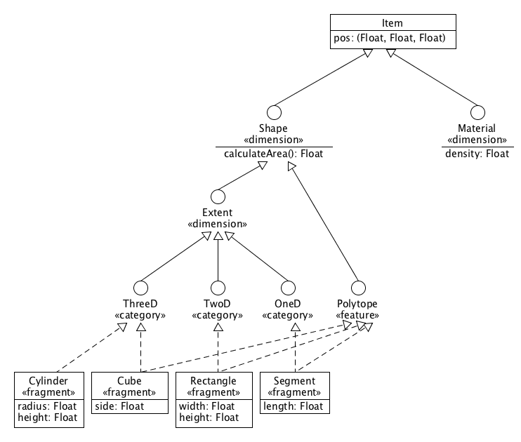
Figure: Two independent injected dimensions Extent and Polytope
An important aspect of the injected categorization is that it introduces abstract categories only, which is in the exact opposition to the nested categorization, which introduces fragments (i.e. concrete categories).
Further, the number of alternatives remains the same. The injected categorization only enriches the existing categories by replacing the direct link to their parent dimension by a network of additional dimensions and abstract categories.
It follows from the previous two sections that a too general fragment may be broken down by a nested categorization, while the fragments in a too general dimension may be categorized by means of an injected categorization.
To sum up, the amount of knowledge about instances can be increased by
- Establishing a new dimension
- Adding a new category to an existing dimension
- Generalizing an existing category (previously not categorized only)
- Categorizing an existing (too general) category
- Categorizing the categories of an existing (too general) dimension

Normal Categorization Form
A categorization schema may be presented as a directed acyclic graph (DAG), in which the vertices correspond to the dimensions and categories and the edges match the extension relationship between them.
A DAG representing a valid categorization must follow several rules.
Validation Rule 1: The graph must have a single root node called the root fragment. The root fragment represent the set of all instances that are subject to the categorization. In the airports scanner example it corresponds to the Item class.

Validation Rule 2: All edges in the normalized graph must only consists of a category as the source and a dimension as the target or vice versa. This requirement expresses the hierarchical character of categorizations consisting of alternating layers of dimensions and categories: a dimension provides a view on its parent category. The dimension also consists of child categories partitioning the parent category. The child categories may be subject to a further partitioning defined by their child dimensions and so on.
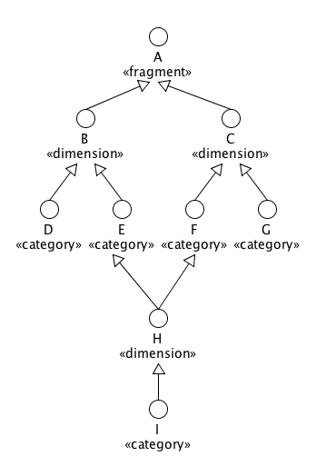
Figure: Interleaving layers of categories and dimensions in normalized categorization schemas
Validation Rule 3: Every category node must be connected to just one dimension target node. This is a natural requirement since a category is tightly associated with its parent dimension. A dimension defines a domain specific semantics giving the meaning to the categories. Thus it would be counterintuitive to consider a category belonging to more than one dimension.

Validation Rule 4: Evety dimension node must be connected to one or more category parent (target) nodes such that the intersection of all parent categories must not be inherently empty. (For the definition see below.)

Validation Rule 5: Every dimension node is public and purely abstract type, i.e. containing member signatures only

Validation Rule 6: Every abstract category node is public and purely abstract type

Validation Rule 7: Every concrete category (i.e. fragment) node is public having no abstract member
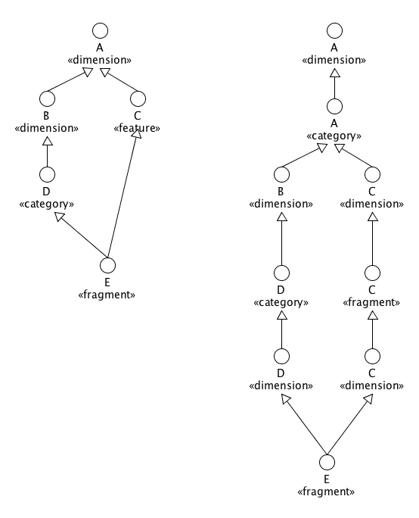
Figure: Categorization form before and after the normalization
Before the exact definition of compatible categories is given, let us introduce a couple of useful concepts. The first one is the common category.
Definition: Let C1 and C2 be any two categories of the same set of instances. Any category P such that C1⊆ P and C2⊆ P is called a common category of C1 and C2.
According to this definition there may exist more common categories for a given pair of categories. However, only the common categories not containing others are interesting with respect to examining relationships between dimensions and categories. Such categories are called lower bound common category.
Definition: Let C1 and C2 be two categories of the same set of instances and P={P_{i}} the set of all common categories. Then any P_{j} for which there is no P_{k} k≠j such that P_{k}⊂P_{j} is called a lower bound common category (LBCC).
An important property of any lower bound common category of two categories is that the two categories always belong to two distinct categories from one or two child dimensions of the LBCC as illustrated in Figure N and proven by Lemma N. This fact allows us to determine whether the two categories are inherently disjoint or not.
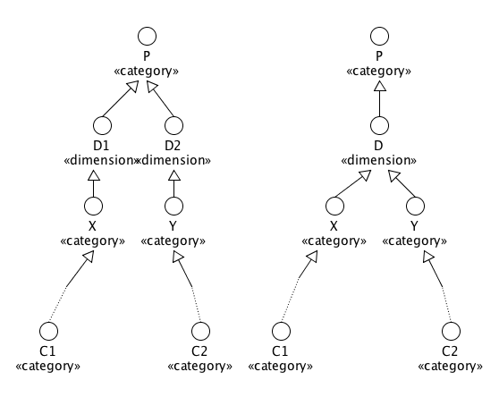
Figure: Inherently disjoint and non inherently disjoint categories C1 and C2
Lemma: Let L be a lower common category of two categories C1, C2. Let X and Y are two categories from L’s child dimensions such that C1⊂X and C2⊂Y. Then X and Y are distinct categories.
Proof: If X and Y were the same category then that category would include C1 and C2 and hence it would be a lower bound common category of C1 and C2 and thus L would not be a lower bound common, which is a contradiction.
This finding helps to determine whether two categories are exclusive. If they have at least one LBCC such that both categories belong to the same child dimension of the LBCC then the two categories are mutually exclusive since they must fall to two distinct categories in the dimension, which are mutually exclusive by definition.
Proposition: Let C1 and C2 be two categories of the same set of instances, {L_{i}} the set of all lower bound common categories of C1 and C2, D1_{i} and D2_{i} dimensions of L_{i} such that C1⊂D1 and C2⊂D2. Then C1 and C2 are inherently disjoint (i.e. mutually exclusive) iff there exists L_{j} such that D1_{j=}D2_{j}.
Proof: For all L_{i} it holds that C1∩C2⊆X_{i}∩Y_{i}⊆L_{i}, where Xi and Yi are different categories from the Li`s child dimensions such that C1⊂X_{i} and C2⊂Y_{i}. It must also hold that C1∩C2⊆∩(X_{i}∩Y_{i})⊆∩L_{i}, as follows from the elementary set operations. Thus if there exists at least one L_{j} such that X_{j} and Y_{j} belongs to the same child dimension of L_{j} then X_{j}∩Y_{j}=Ø and thus C2∩C1=Ø.
Conversely, if C1 and C2 are inherently disjoint (mutually exclusive) then there must exist a dimension D and its two distinct categories X, Y such that C1⊂X and C2⊂Y. Then the parent category P of D must be a lower bound common category of C1 and C2 since C1⊂X⊂P and C2⊂Y⊂P, while C1 and C2 fall into distinct categories X and Y. Q.E.D.
We can use the previous proposition to formulate the condition for inherent emptiness of a set of categories.
Proposition: Let C={C_{i}} i∈0..N-1, N > 1 is a set of categories of the same set of instances. Then ∩C_{i} is inherently empty iff there exists two inherently disjoint categories C_{j}, C_{k} ∈ C.
Proof: It follows from the elements of set theory that ∩C_{i}=∩(C_{j}∩C_{k}), i.e. the intersection of all categories is the same as the intersection of the intersections of all pairs. Then it immediately follows that if there exists an inherently disjoint pair of two categories then the ∩C_{i}=Ø. And conversely, if ∩C_{i} is to be inherently empty then, considering that all C_{i} are not inherently empty, there must exist two inherently disjoint categories. Q.E.D.
The PropositionN provides us with a procedure checking whether two distinct categories C1 and C2 are inherently disjoint:
Algorithm 1:
- Find all LBCC(C1, C2)
- For each LBCC(C1, C2) determine its child dimensions D1 and D2 to which C1 and C2 belongs to
- If D1 and D2 are same than C1 and C2 are inherently disjoint
Further, Proposition(N+1) in combination with AlgorithmN can be used to sketch the algorithm for determining if the intersection of a set of categories {C_{i}} is inherently empty.
Algorithm 2:
- For every pair C_{j} C_{k} invoke AlgorithmN to determine if C_{j} C_{k} are inherently disjoint.
- If there exists such a pair the set ∩C_{i} is inherently empty.
Algorithm N+1 may be used to verify the requirement of rule 4 stipulating that every dimension extend from a set of categories whose intersection is not inherently empty.
We will conclude this section by summarizing the expected compile time checks.

Compiler Responsibilities
This paragraph outlines the checks carried out by the compiler with respect to all dimension and category type. The additional compiler’s checks concerning fragment types are outlined in section 6.1.5.
- Normalizing the categorization schema by applying the Normalization Rules.
- Validating the normalized schema according to the Validation Rules.
    - Dimensions - RI Notes
Since a dimension essentially corresponds to an interface, it is natural to use a pure trait (i.e. signatures only) to represent a dimension in Scala. In order to distinguish the dimension from a normal trait, the dimension trait is annotated with @dimension annotation.
The following code demonstrates an example of a dimension trait.
@dimension
trait Shape {
def calculateArea(): Float
}
As far as categories are concerned, both abstract and concrete ones are also implemented by means of traits annotated with the @fragment annotation. The compiler distinguishes an abstract category trait from a concrete one by checking if the trait is purely abstract.
@fragment
trait OneD extends Shape {
def length(): Float
}

@fragment
trait TwoD extends Shape {
def width(): Float
def height(): Float
}

@fragment
trait ThreeD extends Shape {
def width(): Float
def height(): Float
def depth(): Float
}
Code: Abstract categories example

Dimension Stub Class
For all dimension traits RI generates a stub class making it easier to generate stub classes for dimension wrappers. The generated stub class for the Shape dimension would consist of the following code:
class Shape$dimension extends org.morpheus.SuperBase[Shape] with Shape {
def calculateArea(): Float = $super$.calculateArea()
}
The name of the stub class is made up from the name of the dimension trait and the postfix $dimension. It extends from the abstract class org.morpheus.SuperBase[Shape], which belongs to RI, and from the dimension trait Shape. All methods are implemented by delegating the call to the inherited member $super$, which returns the reference to the next stub handling the call. The next stub may be another dimension wrapper stub or a fragment stub.
The stub classes of all dimension wrappers extending the Shape dimension will extend from this stub class. A dimension wrapper stub will be an instance of SuperBase[Shape] as well as of Shape. The process of dimension stub chaining is described in detail in 6.2.4.
    - Fragments
Fragments are the building blocks, from which object morphs are composed of. As mentioned above, fragments are in fact concrete categories of dimensions, i.e. they do not contain any abstract member. In contrast to other model elements, a fragment may contain dependencies referenced and used by the implementation of the fragment’s logic. The dependencies are expressed by means of the self-type of the fragment.
As a category, a fragment extends exactly one dimension either explicitly or implicitly. The implicit parent dimension is defined as the Universe type described above.
The Figure depicts a space delimited by two dimensions consisting of two fragments each. The black dots correspond to all possible morph alternatives.
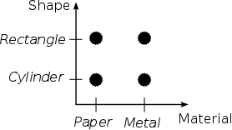
Figure: Two-dimensional configuration space with two fragments in each dimension
Because of its conceptual nearness with the class the UML notation for fragments uses the class element decorated with the fragment stereotype.
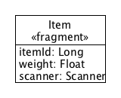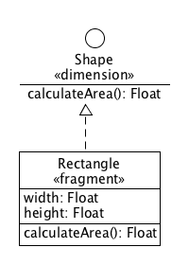
Figure: Fragments with implicit and explicit parent dimension

Nested Categorization of Fragments
The technique described in Nested Categorization may be used to gradually enrich the knowledge about a given fragment without affecting the morph model alternatives containing the category. Let me illustrate such a step-by-step knowledge enrichment on a simple example.
Let us assume a hypothetical application working with objects representing various animals. In the beginning the application makes do with a single class representing dogs, however, in the course of time it extends its functionality by supporting other animals. Each new animal however affects the model, which must be updated by introducing new and more general types encapsulating common properties and behavior of the animals. The following Figure illustrates the evolution of the application model.
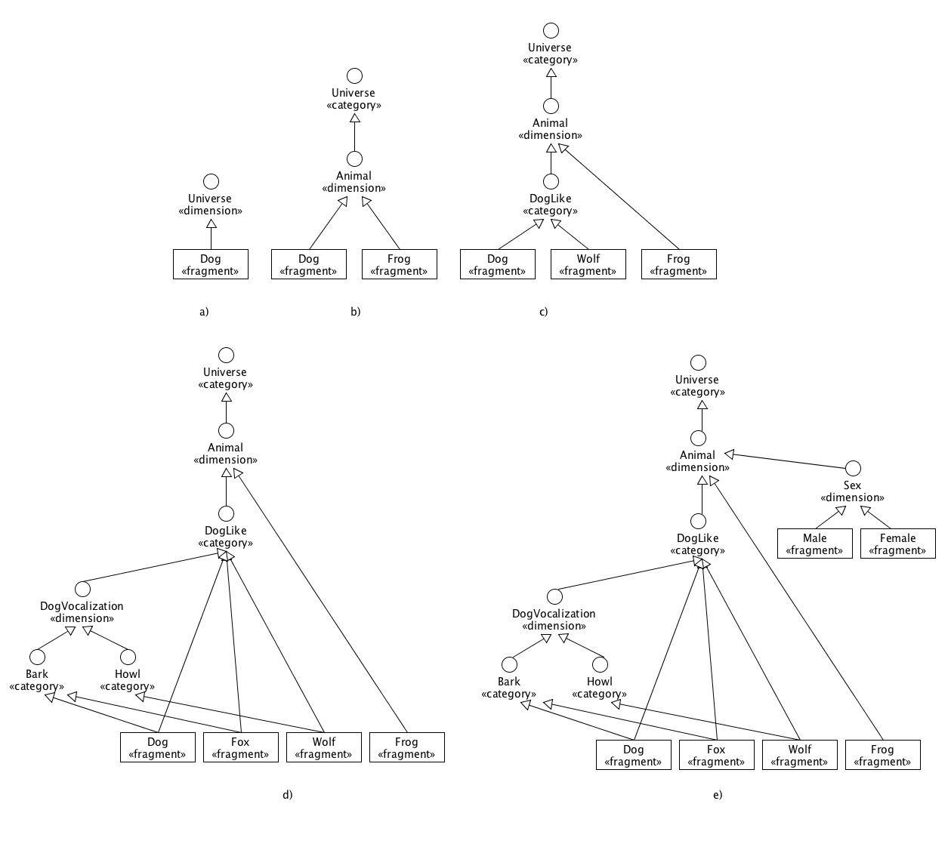 Since the application is supposed to use multidimensional categorization the model must abide by the rules described in 75. The following list outlines the individual steps and comments the applied rules.
- The only class Dog is a fragment that does not explicitly extend any dimension. Therefore it is seen a category of the universal dimension Universe.
- The application newly supports frogs. Both supported animals are moved under the common umbrella dimension Animal, which encapsulates the common properties and behavior of Dog and Frog (not shown). Since the Animal dimension does not explicitly mention its parent category, the Universal category substitutes it. It should be noted that in contrast to the previous case, in which the root element was the Universal dimension, here the root is the Universal category.
- Wolves join the party. Because of the close relationship between dogs and wolves a new general category DogLike is added under the Animal dimension to cover the Dog and Wolf fragments. This is however a non-normal relationship, which gets normalized by applying Normalization Rule 2, i.e. both fragments are connected to the default nested dimension of the DogLike category. It makes Dog and Wolf mutually exclusive fragments.
- Adding foxes raised the need to categorize dog-like animals according to vocalization. The affected animal fragments are now connected to two categories, which is not a normal form. Applying Normalization Rule 2 and Normalization Rule 3 we obtain the following normalized diagram:
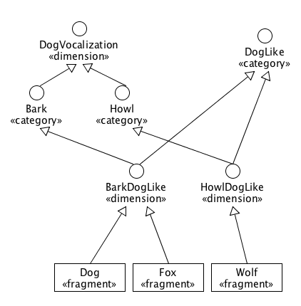
- The final improvement of the application allows distinguishing the animals by sex. The new Sex dimension extends directly from the Animal dimension and contains two fragments. To normalize this dimension-dimension relationship the rule Normalization Rule 1 is used. In contrast to the categories of the DogVocalization dimension, which are already integrated with the dog-like fragments, the two dangling sex dimension fragments are to be appended to an animal fragment per animal instance.

Dependencies
Fragments are elements that are supposed to be fully implemented in contrast to dimensions and categories, which are by definition purely abstract. An implementation often requires an external functionality, which can be provided by other model elements. Such a dependency element may be either a fragment from an independent dimension or a dimension; however, it can never be a wrapper element, since wrappers do not declare any additional specific functionality (see 6.1.7, 6.1.9). In contrast to the dimension dependency, the fragment dependency shrinks the configuration space of possible fragment combinations.
Since the depending fragment is a part of the same instance as any of its dependencies, there are no dedicated references to the dependencies. Instead, the reference to any dependency coincides with the “self” reference. Therefore the UML notation for a reference is marked with the “self” stereotype to distinguish the special meaning of the inter-fragment dependency from the standard one.
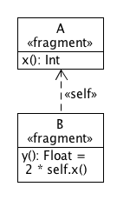
It should be pointed out that there is virtually no difference between the inter-fragment dependency and the “extends” relationship that is supposed to add new members only and not to override any member. Therefore the following diagram is equivalent with the previous one.
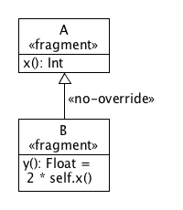
In OM a fragment is allowed to extend other fragment in the sense of the “no-override” relationship only, which is equivalent to a dependency. The purpose of this limitation, which is based on the principle of orthogonality of the OM elements, is to strictly distinguish between fragments as the basic building blocks, which do not override any behavior, and wrappers, which are meant to override only (see 6.1.7 and 6.1.8).
In order to illustrate the shrinking of the configuration space let us recall the currency detection example from the analysis. A banknote is defined as a paper rectangle item with certain proportions. Similarly defined is a coin. The Currency dimension represents an alternative view on the scanned items as coins, banknotes and non-currency items and the constraints for coins and banknotes can be considered fragment dependencies as depicted on the following figure.
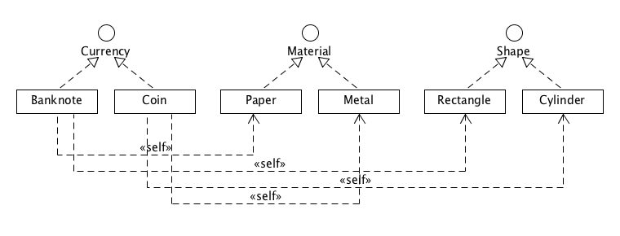
Any currency item instance is a composition of fragments taken from three dimensions: Currency, Material and Shape (see Figure N). A banknote item is composed of fragments Banknote, Paper and Rectangle, while a coin item is composed of Coin, Metal and Cylinder.
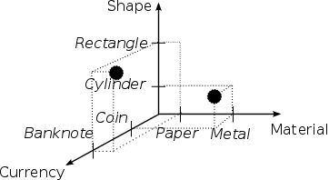
Because of the dependencies of the currency fragments, the configuration space for currency items contains only two valid fragment combinations in the three-dimensional configuration space.
Obviously, the elements in the dependencies must not be contradictory; a fragment may not depend on Paper and Metal at the same time. To fulfill this condition, it must be verified that any two elements in the dependencies are not inherently disjoined, which may be achieved by using the same algorithm that is used to validate the parent categories of a dimension described above.

Alternative Dependencies
It follows from the above that the dependencies may also be seen as a constraint on the fragment’s morph context, i.e. on the composition of the alternatives of which the fragment is a part. The fragment may be very strict in terms of its dependencies and enumerate the fragments, with which it will collaborate. This kind of dependencies curbs drastically the number of possible morph alternatives. Alternatively, the fragment may weaken its dependencies by replacing fragments with dimensions. Or it may specify a list of alternative dependencies. For example, the system for recognizing currency items could produce a general currency object without implementing the finer resolution of banknotes and coins. Then the Currency fragment would have two alternative dependencies: {Paper, Rectangle} or {Metal, Cylinder}.
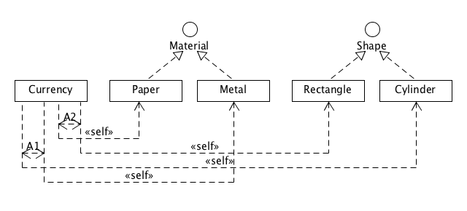
The fragment’s self-type containing such a list of alternative dependencies is treated as a morph reference (see 7.1.4), where the source morph corresponds to the morph instance containing the fragment, i.e. the “self”, and the target morph model corresponds to the list of the dependencies, i.e. the self-type. The validation of the self-type may thus be defined in terms of the validity of the morph reference.

Accessing members in dependencies
Since the fragment and its dependencies are parts of the same morph instance, the fragment can access the members of the dependencies through the “self” reference (which represents the morph instance).
The logic of a fragment with multiple alternative dependencies may invoke directly the members of the LUB of the list of alternatives. In the case of the Currency fragment, the LUB of the dependency alternatives is the composition of Material and Shape types.
self.area() // area() is declared in Shape
In order for the fragment to invoke members from particular dependency alternatives, it must be able to determine which dependency alternative is in use. The simplest way would be testing the type of the “self” reference whether it is compatible with a given dependency alternative as suggested in the following listing.
if (self instanceOf (Paper with Rectangle)) {
// invoke Paper and Rectangle members
} else {
assert(self instanceOf (Metal with Cylinder))
// invoke Metal and Cylinder members
}
An implementation of OM will provide a language construct to determine the current dependency alternative based on the examination of the “self”.

Neutral Fragment
The neutral fragment is a special fragment, which may be combined with any model element, and the result of such a combination is the model element itself. It is analogous to the identity element in algebraic groups.
The symbol of the neutral fragment is Unit, which underlines its neutral character and the connection with the role of 1 in multiplication.
(Unit, X) = (X, Unit) = X
The neutral fragment is useful when constructing morph model expression with optional elements or sub-expressions, as explained later in 6.1.11.

Compiler Responsibilities
The procedures performed by the compiler when validating a fragment are outlined in the following list. It is important to note that these procedures are carried out after the normalization of the categorization graph.
- Validating the extended elements: A normalized fragment may extend only one valid dimension.
- Validating the dependencies: The fragment’s self-type is treated as a morph model whose morph alternatives correspond to alternative dependencies. Before its validation the model is transformed by adding the fragment to each dependency alternative. Then the modified model is checked for consistency as described in 6.1.11.
- Checking the completeness of the implementation: The fragment must implement all members inherited from the parent dimension.
    - Fragments – RI Notes
In RI, a fragment is implemented as a trait annotated with the fragment annotation. It may extend from more dimensions or categories, however after the normalization they must result in a valid dimension.
@fragment
trait Rectangle extends Shape {
var width: Int = _
var height: Int = _
def area = width * height
}

Dependencies
A fragment depending on other elements declares its dependencies in the self-type, which is actually the standard way for traits in Scala to specify the context in which they may occur. However, OM goes further in the interpretation of the self-type since it may be a morph model type, where each alternative corresponds to one dependency alternative. All alternatives implicitly contain the fragment. The following listing shows a fragment with simple dependencies.
@fragment
trait Banknote extends Currency {
this: Paper with Rectangle =>
…
}
Such a trait actually can be instantiated in both Scala and RI.
// Scala
val bankote = new Banknote with Paper with Rectangle
// Morpheus
val banknote = compose[Banknote with Paper with Rectangle].!
The next listing illustrates a fragment with two alternative dependencies. It also shows how to determine which alternative is currently in use by means of the select macro [LINK]. The toString method returns a textual representation of the currency with respect to the context alternative.
@fragment
trait Currency {
this: (Paper with Rectangle) or (Metal with Cylinder) =>
def currencyToString() = {
select[Paper with Rectangle](this) match {
case Some(paperRect) =>
// use the paper rectangle
case None => select[Metal with Cylinder](this) {
case Some(metalCyl) =>
// use the metal cylinder
case _ => // not reachable
}
}
}
}
The fragment can be instantiated by RI, as shown in the next listing, but no longer by the new statement as seen previously, since the fragment’s self-type is a morph model type.
val currency = compose[Currency with ((Paper with Rectangle) or (Metal with Cylinder))].!

Fragment Stub Class
The same instance of a fragment, called a fragment stub, may appear in various morphs, i.e. instances of morph model alternatives. Stubs may encapsulate and preserve mutable state between successive engagements in morphs. Thus a stub may change its state when being a part of one morph and use this changed state later when being in another morph. Even though a stub exists as an object, it cannot be used directly, but only through a morph, which the stub is a part of.
For every fragment trait RI generates a stub class, from which the fragment stubs are instantiated. Every stub class is given the name composed of the name of the fragment and the postfix “$fragment”. For fragments with no dependency RI generates an empty class extending the fragment.
class Rectangle$fragment extends Rectangle {}
Stub classes of fragments with dependencies have the same self-type as the fragment.
class Banknote$fragment extends Banknote {
this: Paper with Rectangle =>
}

Fragment Initialization
RI also solves the problem of initialization of immutable final fields (values) in fragment traits. For example, the Rectangle fragment in the following listing has two such fields. It is not clear how to initialize them from external data, since there is no constructor with parameters (traits have no constructors). These fields cannot even be left abstract, since fragments must not have any abstract member.
@fragment
trait Rectagle extends Shape {
val width: Float = ???
val height: Float = ???
…
}
Even though a fragment trait cannot declare a constructor with parameters, the stub class of the fragment can. Unfortunately the stub class is out of the direct control of the developer, because it is generated.
RI comes up with the following solution. The immutable part of the fragment trait is separated as a new trait called init-trait. The fragment trait adds the ini-trait to its extensions list and marks it with the special marker type dlg[T] as a trait whose members are not to be implemented explicitly in the fragment trait, but automatically by delegation in the fragment’s stub class.
The following listing demonstrates this approach on the Rectangle fragment. The RectangleData init-trait only contains the immutable fields moved from Rectangle, which newly extends RectangleData decorated with dlg[_]. Since the abstract members originate in a trait marked with dlg[_], the fragment does not have to implement them, because they are to be automatically implemented in the stub class.
trait RectangleData {
val width: Float
val height: Float
}
@fragment
trait Rectagle extends Shape with dlg[RectangleData] {
def area(): Float = width * height
}
The dlg marker is defined as the identity generic type thus it has no effect on the extension list; it is just a marker processed by the compiler extension.
type dlg[T] = T
The stub class generated for Rectangle now contains a constructor with one parameter for passing an object carrying the immutable data for the stub. The two immutable members inherited from Rectangle are implemented by delegation on the object passed as the argument.
class Rectagle$fragment($config$: RectangleData) extends Rectangle {
val width = $config$.width
val height = $config$.height
}
For the sake of convenience, every init-trait should be accompanied by a case-class implementing the init-trait.
case class RectangleInitData(width: Float, height: Float) extends ItemData
An instance of this auxiliary class is then passed to a macro preparing the fragment factory. For details see 6.2.2 and 6.2.5.
val rectFragStubFactory = frag[Rectangle, RectangleData](RectangleInitData(100, 50))
TODO: Consider using companion objects to define constraints on dependencies. For example, Banknote’s companion object would check the proportions of paper rectangles.
    - Dimension Wrappers
A dimension wrapper is a special model element, whose purpose is to override any method declared in a given dimension regardless of the fragment that actually implements the dimension. In other words, the dimension may wrap any fragment implementing the dimension and override any of its method provided that it is declared in the dimension.
To illustrate such a wrapper, let us consider the ZoomedShape trait shown in the Figure N-a. This trait is supposed to adjust the size of any shape by a given factor. In OM, such a trait may be modeled as a dimension wrapper overriding the area method declared in the Shape dimension so as to return the original area size multiplied by the factor member of the wrapped.
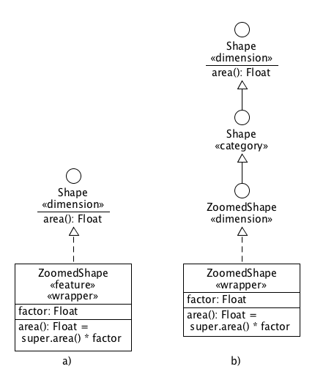
Dimension wrappers are in fact features (see Features), i.e. one-category dimensions, because they represent an optional extension to fragments implementing the same dimension. Thus although the Figure N-a shows the wrapper extending directly the Shape dimension, the normalized diagram looks differently as shown in Figure N-b. To normalize the relationship between both elements, two steps had to be carried out:
- Expanding the feature category as explained in Features
- Normalizing the relationshipt between the new ZoomedShape dimension produced by the step 1 and the Shape dimension, as described in Normalization Rule 1.

Dependencies
Dimension wrappers contain application logic, which may need to collaborate with other elements. Therefore they may specify the dependencies in the same way as fragments do. In addition to that, the dimension wrapped by a dimension wrapper is also considered a dependency.

Compiler Responsibilities
Since a dimension wrapper is a category it is allowed to extend more dimensions, which are normalized by applying Normalization Rule 3. As a result the wrapper extends only one dimension. The compiler is supposed to verify the following steps:
- Validating the extended elements: A normalized dimension wrapper may extend only one valid dimension, which is not the Universe dimension.
- Validating the dependencies: See Step 2) in Compiler Responsibilties in Fragments.
    - Dimension Wrappers – RI Notes
A dimension trait in RI is implemented as a trait marked with two annotations dimension and wrapper. It is supposed to extend at least one dimension trait.
@dimension @wrapper
trait ZoomedShape extends Shape {
val factor: Float
abstract override def area(): Float = factor * super.area()
}
All overridden methods are decorated with abstract override keywords to indicate that the methods override abstract methods.
For each dimension wrapper the compiler extension generates a stub class that extends the stub class of the dimension and the trait of the wrapper.
class ZoomedShape$fragment extends Shape$dimension with ZoomedShape {}
A dimension wrapper may also separate its immutable final members to the init-trait so as to allow the constructor-like initialization.
To illustrate the flow of an invocation of an overridden method, let us assume we create a morph consisting of Rectangle and ZoomedShape and invoke the area method on it, as shown in the following listing.
val zsf = compose[Rectangle with ZoomedShape].!
zsf.area()
Then, considering the trait linearization [LINK], the invocation of area will proceed as follow:
ZoomedShape$fragment.area()
ZoomedShape.area()
Shape$dimension.area()
Rectangle.area()
The invocation on the last line corresponds to the invocation of the next stub in the chain, which is the Rectangle stub. The next stub in the chain is obtained dynamically from the $$super$ dynamic variable in the SuperBase class, which is the direct super class of the dimension stub class Shape$dimension.
The actual chain of wrapper stubs is created at the time of the morph creation.
    - Fragment Wrappers
A fragment wrapper plays a similar role to a dimension wrapper with the exception that it may extend a fragment only. To illustrate a fragment wrapper let us consider the ReversedRectangle trait, which extends the Rectangle fragment and overrides its two methods width() and height() to swap the original width and height of the rectangle, as indicated in Figure N-a.
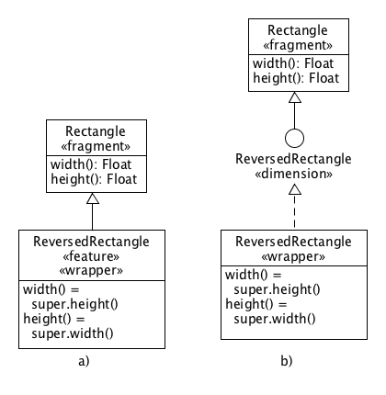
A fragment wrapper is also an optional model element and as such it is modeled as a feature. Figure N-a shows the compact notation, while Figure N-b shows the normalized diagram. Here only one step was performed – the expansion of the feature fragment ReversedRectangle (see Features).

Dependencies
Since fragment wrappers contain application logic, they may specify the dependencies in the same way as fragments and dimension wrappers do. In addition to that, the fragment wrapped by a fragment wrapper is also considered a dependency.

Compiler Responsibilities
- Validating the extended elements: A normalized fragment wrapper may extend only one valid fragment.
- Validating the dependencies: See Step 2) in Compiler Responsibilties in Fragments.
    - Fragment Wrappers – RI Notes
In RI a fragment wrapper is implemented as a trait annotated with fragment and wrapper annotations and extending only one fragment trait. Every overriding method is marked with the override keyword to indicate the method overrides a concrete method.
@fragment @wrapper
trait ReversedRectangle extends Rectangle {
override def width(): Float = super.height()
override def height(): Float = super.width()
}
For each fragment wrapper RI generates a stub class extending the fragment trait only. In this respect the fragment wrapper stub classes are same as the fragment stub classes.
class ReversedRectangle$fragment extends ReversedRectangle {}
A fragment wrapper may also separate its immutable final members to the init-trait so as to allow the constructor-like initialization.
To illustrate the flow of an invocation of an overridden method, let us assume we create a morph consisting of Rectangle and ReversedRectangle and invoke the width method on it, as shown in the following listing.
val revRect = compose[Rectangle with ReversedRectangle].!
revRect.width()
The expected flow of calls is outlined in the following listing.
ReversedRectangle$fragment.width()
ReversedRectangle.width()
Rectangle.height()
The last line is the invocation of the next stub in the chain, which is the Rectangle stub. The reference to the next stub is obtained dynamically by an injected byte code replacing the original byte code sequence performing the “super” invocation. For details see 6.2.3.
    - Morph Model
The morph model describes all possible forms, which a given object may have. At its creation, the object always assumes one form, which, however, may be changed during its lifetime. Each form consists of a list of fragments, which is called a morph model alternative.
To define a morph model of an object means to specify all possible alternatives; i.e. all possible combinations of fragments, from which the object may be composed of. However, in some cases, such a task can be quite laborious due to the number of combinations.
To illustrate the problem, let us consider this example. The task is to create a morph model for a pet, which for the sake of implicitly may be a dog or hamster only. In addition, any instance of a pet may possess zero or more traits such as playful, noisy or hairy. The diagram in Figure N depicts the two animals as fragments of the Pet dimension, whereas the pet traits are modeled as features of dimension Pet. The two fragments Dog and Hamster are mutually exclusive on account of the fact that they belong to the same dimension. By contrast, the three features may be arbitrarily combined in any number with the animal fragments (see Features).
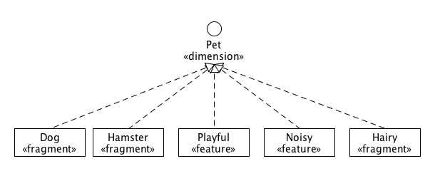
Let us make a further assumption that hamsters are never noisy, which is more or less expectable. Then the complete list of alternatives will consist of 12 combinations.
(Dog) or (Dog, Playful) or (Dog, Noisy) or (Dog, Hairy) or (Dog, Playful, Noisy) or (Dog, Hairy, Noisy) or (Dog, Hairy, Playful) or (Dog, Hairy, Playful, Noisy) or (Hamster) or (Hamster, Playful) or (Hamster, Hairy) or (Hamster, Playful, Hairy)
Clearly, any additional pet trait would double the size of the list, which would quickly make the list practically unmaintainable. In view of this difficulty it must be concluded that to define a morph model by enumerating all combinations is neither practical nor feasible in some cases.
The Listing N actually may be seen as the disjunctive normal form of some more condensed logical formula. In this case, such a formula is shown in Listing N+1.
(Dog, Playful?, Noisy?, Hairy?) or (Hamster, Playful?, Hairy?)
This formula is not only simpler but also it is more natural and expresses better the morph model. Therefore an OM implementation allows specifying morph models in such a compact way.

Morph Model Expression
Whereas the previous paragraph introduced a notion of the morph model expression as a sort of logical formula, this paragraph provides a more formal definition of the morph model expression.
Let E be a set of symbols of selected model elements including the neutral fragment Unit and S={“|”, “,”, “?”, “(“, “)”} the set of special tokens. A morph model expression is any string of tokens from E∪S matching the following grammar defined in terms of Backus-Naur form. The term element stands for any model element name from E.
ModelExpr ::= Disjunction
Disjunction ::= Conjunction “|” Disjunction
Disjunction ::= Conjunction
Conjunction ::= SubExpr “,” Conjunction
Conjunction ::= SubExpr
SubExpr ::= “(“ ModelExpr “)”
SubExpr ::= “?” ModelExpr
SubExpr ::= ModelExpr “?”
SubExpr ::= element
The grammar is a kind of simplified grammar for logical formulas, where symbols “,” and “|” map to the logical operators “AND” and “OR” with the same precedence. There is, however, no equivalent to negation, because morph model expressions must be positive; they are supposed to specify the element combinations, which are possible and not those, which are not possible. The paragraph Negation deals with a workaround to the problem of constructing negative expressions.
Most of the non-terminals are self-explanatory, but there are two, which deserve a detailed explanation. The non-terminals shown in the Listing N+2 represent the so-called optional sub-expressions.
SubExpr ::= “?” ModelExpr
SubExpr ::= ModelExpr “?”
The two non-terms are equivalent to the following ones, which use the neutral fragment Unit.
SubExpr ::= (“Unit” | ModelExpr)
SubExpr ::= (ModelExpr | “Unit”)
The two non-terms define left-optional and right-optional expressions. An optional element Y can be thus specified in two ways:
Y | Unit
Unit | Y
This optional element may be combined with other elements as if it were a normal element.
(X, Y?) = (X, (Y | Unit)) = ((X, Y) | (X, Unit)) = (X, Y) | X
The previous transformation is in fact a conversion of the logical formula in the conjunctive normal form (CNF) to the disjunctive normal form (DNF) [LINK].
Optional elements may be used to significantly compress morph model expressions. To illustrate it, let us assume that (Y1…YN) is an ordered set of N elements, which may be combined with another element X, and which are to be optional in the resulting model. Then such a model can be succinctly expressed as (X, ?Y1, … , ?YN), which matches with the CNF. This formula can be transformed to the DNF shown in the Listing N, where P1...P2N are all ordered subsets of (Y1…YN); i.e. the elements of the power-set of (Y1…YN), where P1 is the empty set corresponding to the neutral element Unit.
(X, ?Y₁, … , ?YN) = (X, (Y1 | Unit), … , (YN | Unit)) =
(X, P1)| … | (X, P2^{N})
It is clear that in this case, the CNF reduces significantly (O(2^{N})->O(N)) the expression with optional elements in comparison to the DNF. [TODO: Find some reference]

Expression Normal Forms
The DNF of a morph model expression is very important, as it reveals the alternatives of the model, as illustrated in the Figure N.
A, B, ?C, (D | (E, F)) =
(A, B, D) | (A, B, E, F) | (A, B, C, D) | (A, B, C, E, F)
The disjunction operator “|” separates the sub-expressions consisting of model elements connected with the conjunction operator “,” only. These sub-expressions correspond to the morph alternatives of the model.
The DNF not only extracts the alternatives, but also it determines their order. This order plays an important role when choosing the alternative, which will be used as the template for a new morph instance. The used morph strategy may not provide enough hints to make the choice deterministic. In such a case the order of the alternatives comes as the means of the last resort to determine the winning alternative as the candidate alternative with the lowest index.
To illustrate the order generated by the DNF, let us consider the expression in Figure N. It shows an expression consisting of one non-optional, one left-optional and one right-optional element in the conjunctive normal form. The CNF is converted to the DNF using De Morgan’s laws and the distributive law [LINKS].
A, ?B, C? = A, (Unit | B), (C | Unit) = ((A, Unit) | (A, B)), (C | Unit) = (((A, Unit) | (A, B)), C) | (((A, Unit) | (A, B)), Unit) =
(A, Unit, C) | (A, B, C) | (A, Unit, Unit) | (A, B, Unit)
For every alternative containing an optional element there exists exactly one other, the so-called dual, alternative, which is the same up to the Unit fragment at the position of the optional element. In the previous DNF there are four such pairs of dual alternatives, which are outlined in Figure N. The elements in boldface indicate the relating elements and the order in the pairs follows the order in the BNF.
(A, Unit, C) = (A, C) ~ (A, B, C)
(A, Unit, Unit) = (A) ~ (A, B, Unit)
(A, B, C) ~ (A, B, Unit) = (A, B)
(A, Unit, C) ~ (A, Unit, Unit) = (A)
In the case of the left-optional element B, both dual alternatives (with Unit) precede those with B. In the case of the right-optional element C the precedence is opposite. In other words, the order of appearance of each alternative in the pair is determined by the fact whether the optional element is left or right optional. The alternatives containing right optional elements always precede their dual alternatives; the alternatives containing left optional elements always are preceded by their dual alternatives.
The concept of dual alternatives can be generalized for any expression containing disjunctions. To perform this generalization, the notion of an option group will be needed. An option group is a biggest group of mutually exclusive model elements in a model morph expression. In order to reveal all option groups in an expression, the expression is converted to the conjunction normal form. In the expression converted into its CNF, the conjunction operator separates the sub-expressions consisting of disjunctions only. Those sub-expressions correspond to all option groups in the expression.
The Figure N demonstrates the conversion of an expression to the CNF revealing (A | B) and (C | D | E) as the options group of the expression.
(A, (C | D)) | (B, C) | (B, (D, E)) | (A, E) =
(A, (C | D)) | (B, (C, D, E)) | (A, E) =
(A, (C | D | E)) | (B, (C, D, E)) =
(A | B), (C | D | E)
The CNF also relates to the dimensionality of the model described by the expression, because the number of the model dimension is equal to the number of the option groups.
Obviously, for every alternative containing an element from an option group of size N, there exist exactly N-1 dual alternatives differing only at the position of the element. Then the dual alternatives for an element from an option group always precede the alternatives with the element if and only if the dual alternatives contain the elements, which precede the element in the option group and vice versa.
To obtain the alternatives the CNF is transformed to the DNF:
(A | B), (C | D | E) = (A | B), ((C | D) | E) =
(A, (C | D)) | (B, (C | D)) | (A, E) | (B, E) =
(A, C) | (A, D) | (B, C) | (B, D) | (A, E) | (B, E)
The following listing outlines all dual alternatives in the model generated by the expression.
(A, C) ~ (B, C)
(A, D) ~ (B, D)
(A, E) ~ (B, E)
(A, C) ~ (A, D) ~ (A, E)
(B, C) ~ (B, D) ~ (A, E)
While for B all dual alternatives (i.e. with A) have higher priority, for D the dual alternatives with C have higher priority, while those with E have lower priority.
In order to elucidate this topic, it is necessary to define the conversion procedure between the CNF and DNF of a morph model expression. Then it will be possible to investigate the relationship between the elements ordering in options groups and the ordering of the resulting morph alternatives.
First of all let us introduce the following symbol convention to express succinctly conjunctions and disjunctions of arbitrary length.
(A₁, … , A_{n}) = ∧_{n}Ai
(B₁ | … | B_{m}) = ∨_{m}B_{j}
Then the conjunctive and disjunctive normal forms can be expressed as follow:
CNF = ∧_{n}(∨_{m}A_{ij})
DNF = ∨_{r}(∧_{s}A_{kl})
Now let us introduce the function C2D converting a CNF into the corresponding DNF.
C2D: CNF -> DNF
Before the complete definition of the C2D function, we will examine its behavior on a simple CNF consisting of two option groups.
C2D((A₁ | A₂), (B₁ | B₂)) = ((A₁ | A₂), B₁) | ((A₁ | A₂), B₂) =
(A₁, B₁) | (A₂, B₁) | (A₁, B₂) | (A₂, B₂)
This simple procedure for two option groups can be generalized as follows:
C2D((∨_{m1}A_{i}), (∨_{m2}B_{j})) = ∨_{m2,m1}(A_{i}, B_{j}) = ∨_{m2.m1}(AB_{k})
Having the C2D function defined for two option groups in a CDF, it is easy to define C2D for any number of option groups. It is possible to split the input CDF of length N into another CDF of the length N-1 and the trailing disjunction.
∧_{n}(∨_{mi}A_{j}) = (∧_{n-1}(∨_{mi}A_{j})), (∨_{mn}A_{k})
The application of the function C2D on the CNF of length N-1 gives the corresponding DNF, i.e. a single disjunction. This single disjunction combined with the trailing disjunction from the original CDF forms another CNF of length 2, which can be processed by the C2D defined for two-group CNFs in the beginning.
C2D(∧_{n}(∨_{mi}A_{j})) = C2D(C2D(∧_{n-1}(∨_{mi}A_{j})), (∨_{mn}A_{k}))
The Figure N shows the DNF obtained from a three-group CNF by means of the C2D function.
C2D((A₁, B₁) | (A₂, B₁) | (A₁, B₂) | (A₂, B₂), (C₁ | C₂)) =
(A₁, B₁, C₁) | (A₂, B₁, C₁) | (A₁, B₂, C₁) | (A₂, B₂, C₁) |
(A₁, B₁, C₂) | (A₂, B₁, C₂) | (A₁, B₂, C₂) | (A₂, B₂, C₂)
Having defined the conversion function from CNF to DNF, it is possible to formulate and prove the following proposition, which connects the precedence in option groups in a CNF with the precedence of alternatives in the DNF.
Proposition N: Let A and A’ be two alternatives generated by C2D and differing just at one position corresponding to an option group G; A=(A1, … Ap, ... An) and A’=(A’1, … A’p, … A’n), A_{p}=G_{pi} and A’_{p}=G_{pj}. Then A precedes A’ if and only if i < j, i.e. if A_{p} precedes A’_{p}.
Proof: Considering the way of constructing DNF by C2D then if A=(… G_{pi}, …) precedes A’=(… G’_{pj}, …) and G’_{pj} precedes G_{pi} in the option group, i.e. i > j, then there must exist a position q to the right of p, i.e. q > p, such that G_{qk} precedes G’_{ql}, k > l.
Therefore let us assume that all elements in A and A’ are the same up to a single position p. Then if A precedes A’ then the element G_{pi} must precede the element G’_{pj} in the corresponding option group, otherwise there would have to exist a position to the right of p, at which there would be two different elements from the same group, which is a contradiction with respect to the assumption.
And in the other way down: if G_{pi} precedes G’_{pj} then the alternative A must precede A’ from the same reasons. Q.E.D.

Ordering of Alternatives
The previous paragraph may be used to define a comparison function, which determines if one alternative precedes other or not. We can attach indices to the model elements increasing from left to right:
Item(0) with (Metal(1) or Paper(2))
with (Cuboid(3) or Cylinder(4))
Then the set of alternatives can be written as this: {(0, 1, 3), (0, 2, 3), (0, 1, 4), (0, 2, 4)}. It allows us to define the ordering of the alternatives in the set quite easily just by comparing indices from right to left between two alternatives. The comparison of two alternatives goes from the common right-most index to the left.
In other words, given two alternatives A1={a1, b1, c1} and A2={a2, b2, c2, d2}, then A1 precedes A2 if and only if relation (c1 < c2) || ((c1 == c2) && (b1 < b2)) || ((c1 == c2) && (b1 == b2) && (a1 < a2)) is true.
Applying this rule to the morph model will produce the following ordering of the alternatives:
{0, 1, 3} < {0, 2, 3} < {0, 1, 4} < {0, 2, 4}
Clearly, this procedure may be generalized to arbitrary number of fragments in alternatives.

Valid Morph Models
Clearly, not all morph model expressions describes a valid morph model. A model expression combines various model elements, which may have various relationships among themselves; one element may require other element as its dependencies, while another element excludes other elements because they are categories of the same dimension.
In order to define a valid morph model expression, we have to define a valid morph model and a valid morph model alternative first.
Definition: A valid morph alternative is such an alternative, which possesses all of the following traits:
1. Valid Elements; i.e. every element used in the alternative must be valid
2. Uniqueness; i.e. every element must occur only once in the alternative
3. Consistency; i.e. there must be no two mutually exclusive elements in the alternative
4. Completeness; i.e. all dependencies of all elements must be satisfied

Definition: A valid morph model is a morph model, which
1. Produces at least one alternative
2. All produced alternatives are valid

Definition: A valid morph model expression is defined as an expression describing a valid morph model, i.e. a morph model whose all alternatives are valid.
The following paragraph deals with a couple of examples of invalid morph model expressions. Since the validity of elements was already debated in the previous sections (6.1.3, 6.1.5, 6.1.7, 6.1.9), here, the examples focus on uniqueness, consistency and completeness.
The following example shows an expression producing an alternative with duplicate element Metal.
Metal, (Cylinder | Metal)
The DNF of the expression is
(Metal, Cylinder) | (Metal, Metal)
The second alternative contains two occurrences of the Metal fragment and thus it violates the uniqueness trait.
The next example illustrates inconsistency.
Metal, (Cylinder | Paper)
The DNF reveals that the second alternative consists of two mutually exclusive fragments Metal and Paper.
(Metal, Cylinder) | (Metal, Paper)
And this example illustrates unsatisfied dependencies. The Banknote fragment specifies two dependencies: Paper and Rectangle. Neither of them is present in the only alternative produced by the following expression.
Banknote, Metal, Cylinder

Instance Morph Models
As long as a morph model is to be used to instantiate a morph instance, none of the model alternatives may contain an abstract element. Therefore, such a morph model may consist of concrete elements only, i.e. of fragments, dimension wrappers and fragment wrappers. Any model consisting of these elements only is called an instance morph model.

Reference Morph Models
A morph model is also be used in the so-called morph references (see 7.1.4). A morph reference variable is supposed to hold a reference to a morph, which conforms to the type of the reference. For example the following morph reference ref1 accepts only such morphs, which may assume any form defined by the reference’s morph model.
val ref1: &[(Metal | Paper), Shape] = morph
On the other hand, the next reference requires that the morph can be re-morphed to at least one form of the reference model.
val ref2: ~&[(Metal | Paper), Shape] = morph
Therefore, a morph that is an instance of (Metal | Paper | Glass), (Rectangle, Cylinder) could be assigned to both references.
An important property of reference morph models is that they may contain abstract members, in contrast to instance morph models. A reference model is not used to instantiate any morph, instead it is used as a pattern for existing morph instances.

Negation
Although it could seem natural for the morph expressions to include negation, it would actually bring more complications than benefits. In the case of instance morph models, negation is of no use taking into account the fact that the alternatives produced by the expression are used as templates for creating morph instances. These templates are used to determine the fragments, from which the morph instance will be composed of. In view of this fact the following fictive expression with a “negation” of Metal would not provide such a template; the assembler would not know which fragment to use instead of Metal.
!Metal, Rectangle
Negation could find some use in reference morph models, which function as a kind of query. For example, the reference expression in the following Figure N (on the left) requires that there must be no Metal fragment in any alternative containing Rectangle.
!Metal, Rectangle <- (Paper | Metal | Glass), Rectangle
The instance model expression on the right satisfies this requirement by eliminating one alternative. The resulting (joined) instance morph model is this:
(Paper | Glass), Rectangle
Although such a reference model is rational, it can be expressed without introducing negation into the expression by means the custom filtering of the source alternatives. The custom filtering is the additional configuration of the mapping engine, which combines the target reference model with the source instance model. The previous example could be rewritten as follows:
(Material, Rectangle)@filter(NoMetalFilter) <- (Paper | Metal | Glass), Rectangle
The filter annotation specifies an object, which will be invoked at run-time on any assignment of the source morph to the target reference. The filter object may also take into account the state of the fragments in the source morph. For more information see 1287.1.4.
The worst complication caused by the introduction of negation would be high complexity of algorithms for the derivation of CNF a DNF from morph model expressions. The positive morph model expressions make this task significantly easier. [LINK]

Parsing Morph Model
In order to start using a morph model in a program, the model must be first parsed from its morph model expression. The previous sentence brings into a causal relationship two activities, which actually belong to two “different worlds”. While the phrase “using a morph model” refers to an activity performed at run-time, “parsing” refers to an activity performed at compile-time. Therefore parsing should be seen rather as a macro processed during compilation and generating some code than a procedure invoked at run-time.
To illustrate this process, let us consider the following statement in Scala declaring a variable itemModel initialized by the result of the invocation of parse.
val itemModel = parse[(Paper | Metal), (Rectangle | Cylinder)]
Even though it looks like a subroutine invocation, parse is actually a macro generating a code according to the morph model expression specified as the macro’s argument. The following Figure N shows how such a generated code might look.
val itemModel = new MorphModel {
type Model = (Paper | Metal), (Rectangle | Cylinder)
type LUB = Material | Shape
val rootNode = ConjNode(List(DisjNode(List(FragmentNode(0),FragmentNode(1))),
DisjNode(List(FragmentNode(2),FragmentNode(3)))))
}
The parsing process consists of two subtasks called validation and reification.
The validation subtask checks the morph model expression for validity according to the rules outlined in Valid Morph Models . In case of any error, the compiler raises an exception, prints a report about the problem and aborts the compilation.
The validation transforms the expression into a tree, which is needed both at compile-time and run-time in order to yield the list of morph model alternatives.
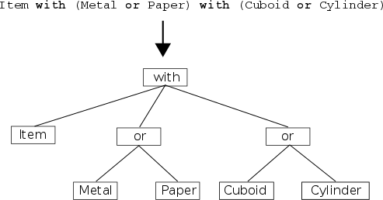

Then all alternatives are iterated by means of the morph model iterator (see Morph Model Iterator) to validate them.
As long as the compiler extension detects no error in the model, it performs the reification, which generates and inserts the morph model code into the place of the macro invocation.
The reification is performed in several steps. First, it translates the expression tree nodes into the abstract syntax tree (AST) of the target language platform. Then it determines the lowest upper bound type (LUB, see below) of the model and finally it generates the code for the model object wrapping the expression tree, LUB and also the original morph model expression. The morph model object also provides the morph model iterator for iterating the model alternatives at run-time. The alternatives returned by the iterator are represented as lists of fragment nodes from the expression tree.
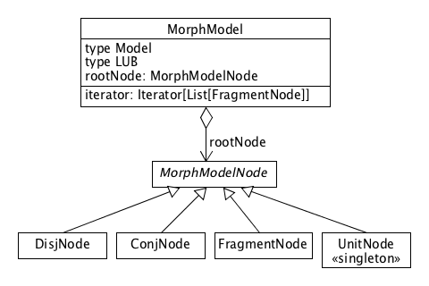
The MorphModelNode type is the base type for all expression tree nodes. The DisjNode represents a disjunction, the ConjNode a conjunction and the FragmentNode a fragment. The UnitNode is represents the neutral fragment, which is naturally a singleton.
Thanks to the reification, the morph model may be used at run-time; typically the assembler uses the model to instantiate new morphs. For example, a code printing all alternatives in the model is shown in Figure N.
val ai = itemModel.iterator
while (ai.hasNext) {
println(ai.next)
}
The first line of the output should be:
List(FragmentNode(0,false),FragmentNode(1,false),FragmentNode(3,false))
…
Printing the expression tree stored in itemModel.rootNode might look like this:
ConjNode(List(FragmentNode(0),DisjNode(List(FragmentNode(1),FragmentNode(2))),DisjNode(List(FragmentNode(3),FragmentNode(4)))))

Lowest Upper Bound Type (LUB)
The lowest upper bound of a morph model is the most specific type compatible with the types of all alternatives. This type is needed when declaring a variable or parameter, to which a morph instance is to be assigned. The type of such a variable or parameter corresponds to the lowest upper bound type of the morph’s model.
For example, the LUB of the following morph model is Material with Shape.
(Paper | Metal), (Rectangle | Cylinder)
Therefore any variable, to which a morph created from this model is to be assigned, will be declared as follows (using Scala syntax):
val item: Material with Shape = createItem(itemData)
As to determine the LUB is not always easy, the LUB is pre-calculated at compile-time and is available through the reified model. In the Figure N, the itemModel variable holds the reified model, whose LUB type member is used as the type of the item variable.
val itemModel = parse[(Paper | Metal), (Rectangle | Cylinder)]
…
val item: itemModel.LUB = createItem(itemData)

Morph Model Iterator (Formula->DNF convertor)

A valid morph model expression produces a morph model type.
Besides a morph model, a dimension may be referred from other places in the code:
- Most often there are one or more fragments fully implementing that dimension
- There may exist dimension wrappers overriding one or more the dimension’s abstract members (see below)
- A dimension may also be specified as a dependency of a fragment or wrapper

OM implementations may choose different symbols than {“|”, “,”, “?”}.

Unit Fragment
    - Morph Model – RI Note

    - Disjunctive Normal Form of Morph Model
    - Inheritance Tree Normalization
- Show how to transform a morph model to the multidimensional config space
- Linearization of traits. How the orthogonality of the model elements affect the linearization, multiple inheritance
- Show how to solve the situation where a trait overrides some methods and add new ones at the same time

  - Run-Time Component
    - Model Element Stubs
All model elements except the dimension must be capable of instantiation, even if the instantiated model element cannot function alone, which is often the case. Such instances are called model element stubs. Their raison d'etre is that every form of a protean object may be composed of repeatedly occurring model elements that should be able to preserve their state over the morph series. Moreover, such repeatedly occurring elements may find themselves in a distinct company of elements. For example, if a fragment occurs in two morph alternatives and depends on a dimension, the fragment’s stub may be collaborating with two distinct fragments implementing the same dimension in each morph.
Figures:
    - Fragment Stubs

ByteCode Instrumentation
    - Fragment Wrapper Stubs

ByteCode Instrumentation
    - Dimension Wrapper Stubs

trait Super[T] {
def $$super$: DynamicVariable[T]
}
abstract class SuperBase[T] extends Super[T] {
override val $$super$: DynamicVariable[T] =
new DynamicVariable[T](null.asInstanceOf[T])
def $super$: T = $$super$.value
}

ByteCode Instrumentation
    - Fragment Factories
    - Recognizer/Recognizer
- TODO: Present a recognizer as a recognizer, which is able to re-recognize the object
- The identity problem

Fragment Clustering in Alternatives (Fragment Affinity)

    - Morphing Strategies
    - Immutable Morphs
    - Mutable Morphs
- Morph Mapper
Introduction
  - Compile-Time Component
    - Target Morph Model
    - Morph Model Conformance Levels
    - Hidden Fragments
    - Kernel References
Filtering alternatives by means of a custom filter object, @filter annotation. See the example in Negation.
  - Run-Time Component
    - Dereferencing

- Recognizer Design Patterns
  - Protean Interface (Chameleon)
An object provides different implementations of the same interface according to the context.
- Development Essentials
  - Modeling Simple Entity
Before starting to play with the basics of Morpheus, we have to install the Morpheus Scala compiler plugin. The instructions can be found here. This plugin generates so called fragment classes for all fragments found in the project.
We can run this tutorial in REPL or as standalone programs that can be found in the tutorial repository.
This tutorial is conceived as a step-by-step development of an imaginary chat application, in which each step reveals a new Morpheus feature.
Before delving into this tutorial, however, I definitely recommend going through the README file, which gives a brief overview of the basic Morpheus concepts.
In this and all following lessons we assume that the following import statements are used.
import org.morpheus._
import Morpheus._
Let's begin with the designing of the Contact entity, which represents the central object of the chat application. Since we plan to use Contact as a fragment in morphs, we have to decorate it by the fragment annotation.
@fragment
trait Contact {
var firstName: String = _
var lastName: String = _
var male: Boolean = _
var nationality: Locale = _
}
Upon the compilation the Morpheus compiler plugin intercepts this trait and generates its fragment class, which can be then instantiated by the runtime part of Morpheus.
Now we can use the singleton macro to instantiate the Contact entity. The morph type consists of Contact type only. It actually describes the simplest morph model with just one fragment and one alternative.
The singleton macro creates the so-called morph kernel, which can be used for assembling various alternatives described by the morph model. There is just one alternative in this case, so we can immediately call use either ! or ~ operators to obtain the reference to the Contact morph.
val contact = singleton[Contact].!
val contact = singleton[Contact].~
The ! operator produces something what is so called immutable morph, while ~ returns a mutable morph. The difference between is not obvious now, since there is only one alternative. When re-morphed, the immutable morph produces a new instance of the newly chosen alternative, while its internal state is not affected in any way. On the other, the mutable morph maintains a mutable reference to an immutable morph. When re-morphing, this reference is set to the new instance of the immutable morph.
Whether we created one morph or another, both can be used as a plain Contact instance.
contact.firstName = "Pepa"
contact.lastName = "Novák"
contact.male = true
contact.nationality = Locale.CANADA
println(s"${contact.firstName} ${contact.lastName} ${contact.nationality} ${contact.male}")
Note: We used the mutable version of the Contact entity just because of its sheer simplicity and since the immutable version would require more Morpheus stuff to be explained. We will switch to the immutable entity later on.
In the following lesson we will add some behavior to entity Contact.
  - Adding Some Behavior
In this second part of the tutorial we will add some simple behavior to the Contact entity. We will not be doing any intervention in that entity; instead we will create a new, purely behavioral fragment, which will add the desired behavior to Contact.
To start, let's do something really simple. For instance, we may want that the Contact be capable of printing its data to the console. The ContactPrinter fragment contains method printContact, which prints the four members from Contact on the console. Instead of extending from Contact, the new fragment expresses its dependency on Contact by the self-type. It may remind us the Cake Pattern used as an alternative to dependency injection.
@fragment
trait ContactPrinter {
this: Contact =>
def printContact(): Unit = {
println(s"$firstName $lastName $nationality $male")
}
}
In Scala, we would merge the two fragments into one object by means of the new and with keywords.
val contact = new Contact with ContactPrinter
In Morpheus it is not much more different. Instead of new we use the singleton macro and ! or ~ morph accessor.
val contact = singleton[Contact with ContactPrinter].!
Now we can initialise the contact members and print the contact.
contact.firstName = "Pepa"
contact.lastName = "Novák"
contact.male = true
contact.nationality = Locale.CANADA
contact.printContact()
In the next lesson we will abstract the printing capability. The goal is to illustrate the problem of reusing a part of one object as a part of another object.
  - Abstracting Behavior
The ContactPrinter fragment is the obvious candidate for the abstraction, since there are many ways to print a contact. Let's make the ContactPrinter a pure trait (i.e. with abstract methods only) and mark it by means of the dimension annotation. This annotation informs Morpheus that this is not a fragment trait but an abstraction. Morpheus generates special classes for all dimensions needed by so called dimension wrappers. We will talk about them later on.
@dimension
trait ContactPrinter {
def printContact(): Unit
}
There will be two fragments implementing the ContactPrinter dimension differing in the style they print a contact.
@fragment
trait ContactRawPrinter extends ContactPrinter {
this: Contact =>
def printContact(): Unit = {
println(s"$firstName $lastName $nationality $male")
}
}
@fragment
trait ContactPrettyPrinter extends ContactPrinter {
this: Contact =>
def printContact(): Unit = {
println(
s"""
First Name: $firstName
Second Name: $lastName
Male: $male
Nationality: $nationality
""")
}
}
The value of prettyPrint determines which printing fragment will be merged with the contact.
val prettyPrint = true
val contact = if (prettyPrint)
singleton[Contact with ContactPrettyPrinter].!
else
singleton[Contact with ContactRawPrinter].!
contact.firstName = "Pepa"
contact.lastName = "Novák"
contact.male = true
contact.nationality = Locale.CANADA
contact.printContact()
  - Reusing Fragment Instance
In this lesson we will learn how we can reuse a fragment instance in another morph kernel.
Let's suppose we will provide some serialization of the contact. This feature can again be expressed by means of a dimension trait:
@dimension
trait ContactSerializer {
def serializeContact: String
}
A simple JSON implementation can look like this:
@fragment
trait JsonContactSerializer extends ContactSerializer {
this: Contact =>
def serializeContact: String = {
s"""
{
'firstName': '$firstName',
'lastName': '$lastName',
'male': $male,
'nationality': '$nationality',
}
"""
}
}
We could now make a new morph by using singleton, however, it would create a new instance of Contact and we would have to initialize its fields again. Instead, we are going to reuse the contact fragment, which has already been initialized in the previous lesson.
First, we have to pull the Contact fragment instance from the original morph's kernel. The kernel of a morph is accessible through method kernel.
val contactKernel = contact.kernel
One way to pull a fragment from a kernel is to invoke fragmentHolder method on it, which looks for the fragment identified by the type argument and returns Option[F], where F is the fragment type being searched for.
val contactFragInst = contact.kernel.fragmentHolder[Contact] match {
case None => sys.error("unexpected")
case Some(holder) => holder.proxy
}
Note: Although this procedure is quite straightforward, it unnecessarily handles the situation when the fragment is not found. It will be fixed in the future. There are other ways to extract a fragment type-safely by means of so called kernel references, which we will be dealing with later on. For the time being one may consult the source code of this lesson for the alternative approaches.
When Morpheus is creating a kernel from a morph type, it is looking for fragment factories for all fragments that occur in the morph type. The lookup mechanism is based on Scala implicit values. For every fragment type, the singleton macro generates an implicit parameter, which is by default satisfied by an implicit macro supplying the singleton factory (creating a new instance of the fragment just once). This behavior can be overridden by declaring an implicit value holding a custom fragment factory. There is a couple of predefined fragment factory macros, but our needs fits best the external macro, which creates a fragment factory producing an already existing fragment instance.
implicit val contactFragInst = external(contactFragment)
This declaration overrides the default fragment factory and the new kernel will be initialized with the factory delivering the existing contact fragment.
val contactSerialKernel = singleton[Contact with JsonContactSerializer]
We can verify that the contact state is reused by calling serialize and printing its result.
val contactJson = contactSerialKernel.!.serializeContact
println(contactJson)
  - Using Morphs In Java
The ability to interoperate with Java (or other JVM languages) is a key requirement for Morpheus. In the following example we will see that this is pretty seamless.
Let's create a Java class having one static method consuming a morph consisting of Contact and ContactPrinter fragments. Although it may sound challenging to express the type of such a morph in Java, it is actually very easy. We can express it by means of a generic type with upper bound T extends Contact & ContactPrinter.
public class ContactClient {
public static <T extends Contact & ContactPrinter> void useContact(T contactPrinter) {
contactPrinter.printContact();
String fn = contactPrinter.firstName();
String ln = contactPrinter.lastName();
}
}
Having the Java class ready, we can pass the morph to the useContact method.
ContactClient.useContact(contact)
  - Multiple Dimensions
In the previous lesson we abstracted the contact printer by introducing the ContactPrinter dimension trait. There were also two implementations of this dimension, but more could have been created, of course. The modelled system - the contact with printing capabilities - became a one-dimensional system having cardinality 2. While it may be vital to keep thinking in terms of dimensions when designing more complex systems, in traditional programming languages, including Scala, adding more dimensions to the system makes it difficult to maintain and control. Moreover, statically typed languages cannot cope with the so-called combinatorial explosion resulting from the fact that all combinations of fragments from all dimensions must be type-checked in compile time, what requires that all combinations must be declared manually one by one in the code, whereas the number of such combinations grows exponentially with the number of dimensions.
In this tutorial we will see how Morpheus embraces multidimensional design and how tackles with the limitation described above.
    - Adding more dimensions
Let's refactor the current chat application. We should separate the printing style from the output device used to print the contact. The following dimension can abstract this output device.
@dimension
trait OutputChannel {
def printText(text: String): Unit
}
There will be two implementing fragments, one printing on the standard output and the other storing the output text to a memory buffer.
@fragment
trait StandardOutputChannel extends OutputChannel {
override def printText(text: String): Unit = print(text)
}
@fragment
trait MemoryOutputChannel extends OutputChannel {
val outputBuffer = new StringBuilder()
override def printText(text: String): Unit = outputBuffer.append(text)
}
Next, we will modify the printer fragments in such a way that they will become dependent on the OutputChannel and use the channel to print the contact textual representation. To express the dependency we will use the self-type of the fragment trait.
@fragment
trait ContactRawPrinter extends ContactPrinter {
this: Contact with OutputChannel =>
def printContact(): Unit = {
printText(s"$firstName $lastName $nationality $male")
}
}
@fragment
trait ContactPrettyPrinter extends ContactPrinter {
this: Contact with OutputChannel =>
def printContact(): Unit = {
printText(
s"""
First Name: $firstName
Second Name: $lastName
Male: $male
Nationality: $nationality
""")
}
}
Nothing extraordinary has been shown so far, of course. What we have developed is a two-dimensional system with cardinalities (2, 2). Now we are going to compose a contact morph. The composition of a morph corresponds to a coordinate in the combinatorial space defined by the two dimensions ContactPrinter and OutputChannel consisting of four elements. Let's assume that the the required combination of fragments is given by coordinates (style, channel) given as the program system properties:
val (style, channel) = (System.getProperty("style", "raw"), System.getProperty("channel", "standard"))
Next, we have to capture all combinations of the coordinates and create the corresponding morph.
val contact = (style, channel) match {
case ("pretty", "memory") => singleton[Contact with ContactPrettyPrinter with MemoryOutputChannel].!
case ("raw", "memory") => singleton[Contact with ContactRawPrinter with MemoryOutputChannel].!
case ("pretty", "standard") => singleton[Contact with ContactPrettyPrinter with StandardOutputChannel].!
case ("raw", "standard") => singleton[Contact with ContactRawPrinter with StandardOutputChannel].!
}
It must be clear now, that adding more dimensions would lead to exponential growth of the case statements. There must be other way to avoid this combinatorial explosion.
    - The or disjunctor
Morpheus provides the or disjunctor to eliminate the above-mentioned explosion. It allow us to express all combinations in one morph type, thus in one statement. The four statements from the previous paragraph can be expressed this way:
val contactKernel = singleton[Contact
with (ContactRawPrinter or ContactPrettyPrinter)
with (StandardOutputChannel or MemoryOutputChannel)]
Adding a new dimension would result in adding another line to the previous statement. Thus the combinatorial explosion is over.
The statement expresses four alternatives. So the question is, which one will be chosen when instantiating the morph? The answer is: the so-called left-most one, which consists of the left-most fragments from each dimension. Here it gives the Contact with ContactRawPrinter with StandardOutputChannel alternative.
val contact = contactKernel.!
contact.firstName = "Pepa"
contact.lastName = "Novák"
contact.male = true
contact.nationality = Locale.CANADA
contact.printContact()
    - Obtaining morph's alternative
Morphs implement one additional trait org.morpheus.MorphMirror. This trait provides some reflection capabilities by which one can look into the actual composition of the morph. One of such methods is myAlternative returning a list of fragment holders representing the constitution of the morph.
println(contact.myAlternative)
It will print this:
List(org.cloudio.morpheus.tutor.chat.frag.step1.Contact, org.cloudio.morpheus.tutor.chat.frag.step4.ContactRawPrinter, org.cloudio.morpheus.tutor.chat.frag.step4.StandardOutputChannel)
    - The asMorphOf reshaper
A morph can be easily reshaped to another alternative from the space of alternatives by means of the asMorphOf macro.
val memoryPrettyPrinter = asMorphOf[ContactPrettyPrinter with MemoryOutputChannel](contact)
memoryPrettyPrinter.printContact()
The type parameter of the asMorphOf macro specifies the fragment composition of the desired alternative form, which the new morph will assume. This is also the return type of the macro. The other argument can be either a morph or a kernel. The macro constructs a new kernel whose morph type corresponds to the macro's type argument. The new kernel thus constructs only one alternative, which is actually the alternative of the morph returned by the asMorphOf macro.
The macro verifies that the type argument matches the morph or kernel passed as the other argument. For example, the following statement will not compile, since the ContactSerializer fragment is not in the type model of morph contact.
// it won't compile
val printerWithSerializer = asMorphOf[ContactRawPrinter with ContactSerializer](contact)
This macro is useful in situations when only a subset of all alternatives makes sense for a certain part of the application. Otherwise, i.e. as long as we need to access all alternatives arbitrarily, using this macro would again lead to the combinatorial explosion. We will learn how to pick an arbitrary alternative elegantly just by specifying its coordinates in the next lesson.
    - The select matcher
How can we determine whether a morph implements certain fragments? The select macro provides this functionality. Its type argument specifies the type query, i.e. the fragments, which we match with the morph. The other argument is the morph. It returns Option[F], where F is the type query.
select[MemoryOutputChannel](memoryPrettyPrinter) match {
case None =>
case Some(memChannel) =>
println(memChannel.outputBuffer)
}
The select macro performs some compile-time analysis during which it checks whether the type query is within the scope of the morph's type model. For example the following statement will not compile, since the type model of the morph does not contain the ContactSerializer fragment.
select[ContactSerializer](contact) // it won't compile
Neither will compile this statement, since the model type of the morph is ContactPrettyPrinter with MemoryOutputChannel, which does not contain ContactRawPrinter.
select[ContactRawPrinter](memoryPrettyPrinter) // it won't compile
On the other hand, the following select statement will compile despite Contact is not explicitly mentioned in the morh type.
select[Contact with ContactPrettyPrinter](memoryPrettyPrinter)
The reason, why the macro allows it, is the fact, that ContactPrettyPrinter depends on Contact and thus any morph having ContactPrettyPrinter in its alternative must also have Contact in it.
  - Using Morphing Strategies
This lesson deals with morphing strategies. A morphing strategy is a key concept in Morpheus determining the composition of morphs. In the following paragraphs we will see how to create and use morphing strategies to control a morph's shape.
Let's begin with the two-dimensional morph that we used in the previous lesson:
val contactKernel = singleton[Contact
with (ContactRawPrinter or ContactPrettyPrinter)
with (StandardOutputChannel or MemoryOutputChannel)]
var contact = contactKernel.!
contact.firstName = "Pepa"
contact.lastName = "Novák"
contact.male = true
contact.nationality = Locale.CANADA
The morph model consists of four alternatives, which are sorted in the following order:
- Contact with ContactRawPrinter with StandardOutputChannel
- Contact with ContactPrettyPrinter with StandardOutputChannel
- Contact with ContactRawPrinter with MemoryOutputChannel
- Contact with ContactPrettyPrinter with MemoryOutputChannel
The ordering is determined by the structure of the morph model tree. This tree consists of three types of nodes: fragments (leaves), disjunctors (or) and conjunctors (with). We can attach indices to the fragment nodes increasing from left to right:
Contact(0) with (ContactRawPrinter(1) or ContactPrettyPrinter(2))
with (StandardOutputChannel(3) or MemoryOutputChannel(4))
Then the set of alternatives can be written as this: {(0, 1, 3), (0, 2, 3), (0, 1, 4), (0, 2, 4)}. It allows us to define the ordering of the alternatives in the set quite easily just by comparing indices from right to left between two alternatives. The comparison of two alternatives goes from the common right-most index to the left.
In other words, given two alternatives A1={a1, b1, c1} and A2={a2, b2, c2, d2}, then A1 precedes A2 if and only if relation (c1 < c2) || ((c1 == c2) && (b1 < b2)) || ((c1 == c2) && (b1 == b2) && (a1 < a2)) is true.
Applying this rule to our morph model, we obtain the following ordering of the alternatives:
{0, 1, 3} < {0, 2, 3} < {0, 1, 4} < {0, 2, 4}
Now, when we know how to index individual alternatives, we can start asking how to pick a particular alternative by its index and to compose a morph according to it.
The answer is a two-step procedure. The first step is to create the so-called promoting strategy, and the second step is to invoke the remorph(strategy) method on the morph and pass the strategy to it. The remorph method is declared in the reflecting trait org.morpheus.MorphMirror, which is implemented by all morphs.
The promoting strategy can be created by means of the promote macro in the following way:
var altNum: Int = 0
val morphStrategy = promote[contactKernel.Model](altNum)
The type argument of the macro specifies the morph model and the other argument is a function returning the index of an alternative. Although the code above looks as if it passes a value to the macro, the altNum expression in the argument actually gets converted to function ()=>Some(altNum). This function is called whenever the strategy is asked to pick an alternative.
We can call the altsCount method on the strategy to obtain the number of alternatives being handled by the strategy:
println(s"There is ${morphStrategy.altsCount} alternatives")
Once we have the strategy we can pass it to the remorph method on the contact morph.
contact = contact.remorph(morphStrategy)
contact.printContact()
Since the altNum variable is initialized by 0, the new contact is composed from the first alternative. Any following remorphing by means of the overloaded no-args remorph method will be driven only by the value of that variable:
altNum = 1
contact = contact.remorph
contact.printContact()
Since indexing alternatives in the whole model can become unwieldy, it is possible to split the one big strategy to more ones and connect them to form a stack of strategies. Typically, we create one strategy for each dimension in our model. The following code snipper shows that:
var printerCoord: Int = 0
var channelCoord: Int = 0
val morphStrategy1 = promote[ContactRawPrinter or ContactPrettyPrinter](RootStrategy[contactKernel.Model](), printerCoord)
val morphStrategy2 = promote[StandardOutputChannel or MemoryOutputChannel](morphStrategy1, channelCoord)
In the previous code we use an overloaded version of the promote macro, whose type arguments specifies the type of a sub-model of the main morph model. There two other arguments: the first accepts a parent strategy and serves for stacking the strategies. The second argument accepts a function for selecting an alternative. It is important to stress that the selector function works in the scope of the morph sub-model specified in the type argument. In our example the two selector functions return indices from range (0, 1).
We use the second strategy as the top of the strategies stack and we pass it as the argument to the remorph method.
contact = contact.remorph(morphStrategy2)
contact.printContact()
The morph's alternative form can now be easily controlled independently by two coordinates (printerCoord, channelCoord).
printerCoord = 1
channelCoord = 1
contact = contact.remorph
contact.printContact()
  - Mutable Morphs
So far we have been working with so-called immutable morphs. The name expresses the fact that a morph does not change its internal state when a remorph method is being called on it and the result is a freshly created instance of another morph. It allows us to write our code in a "clean" functional way. This type of morph is useful in situations when there is no need to store the morph out of the scope of the current call stack (like a request handling) or when a developer wishes to keep various versions of morphs in a storage like an HTTP session.
However, there are situations, in which we would prefer to have a single instance of a morph, which would be able to reshape itself internally. Morpheus offers such a morph, which is called mutable. A mutable morph follows the delegation pattern and wraps another morph - the delegate, which is immutable. The delegate is held by a volatile mutable reference field in the mutable morph instance. This field is the only mutable element in the mutable morph and it is updated upon a call to a remorph method, as long as the call results in a change in the composition of the immutable delegate.
To obtain the mutable version of the morph we will call the ~ accessor on the kernel as shown in the following code.
val contactKernel = singleton[Contact with (ContactRawPrinter or ContactPrettyPrinter) with (StandardOutputChannel or MemoryOutputChannel)]
val contact = contactKernel.~
Then we can work with the morph as usual.
contact.firstName = "Pepa"
contact.lastName = "Novák"
contact.male = true
contact.nationality = Locale.CANADA
All mutable morphs implement the org.morpheus.MutableMorphMirror trait extending org.morpheus.MorphMirror, which we already know from previous lessons. It means that we can call the two remorph methods to reshape the morph.
var altNum: Int = 0
val morphStrategy = promote[contactKernel.Model](altNum)
contact.remorph(morphStrategy)
contact.printContact()
There is, however, a small difference in the semantics of the remorph in contrast to the immutable variant. The mutable versions update the internal reference of the morph and the return value is the new immutable delegate morph, not the mutable one. The return value is usually ignored since it the immutable delegate can be obtained by the delegate method from the mutable mirror trait.
altNum = 3
contact.remorph()
select[MemoryOutputChannel](contact) match {
case None =>
contact.printContact()
case Some(memChannel) =>
contact.printContact()
println(memChannel.outputBuffer)
}
    - Morphing from within a morph
So far we have been remorphing a morph explicitly from the outside of the morph by creating or updating a morphing strategy and invoking a remorph method. So it is the user of a morph, who must know lots of details about the internal structure of the morph or its kernel. Also the user must interact with the Morpheus API, like the morph mirrors, morphing strategies and so on. A much better design would be to shield the user from such details and wrap these reshaping activities in a special fragment that becomes a component of the morph.
We will examine this idea approach in the following example. Let's create two fragments; the former one will be changing the style of printing, while the latter one will be switching the output channel.
@fragment
trait PrinterControl {
this: ContactRawPrinter or ContactPrettyPrinter =>
def rawPrint(): Unit = {
remorph(this, 0)
}
def prettyPrint(): Unit = {
remorph(this, 1)
}
}
@fragment
trait OutputControl {
this: StandardOutputChannel or MemoryOutputChannel =>
def useStandardOutput(): Unit = {
remorph(this, 0)
}
def useMemoryOutput(): Unit = {
remorph(this, 1)
}
}
There is a couple of interesting new things in those new fragments.
Firstly, it is the presence of the or disjunctor in the self-type of the fragments what looks rather strange. So far we have been using the self-type to specify a list of fragments on which the fragment depends. Here, however, the 'or' in the self-type suggest some optionality in the dependencies.
Morpheus goes beyond this classical interpretation of the self-type as the list of dependencies. Instead, it considers the self type of a fragment as a regular morph type. This morph type is interpreted as a requirement for the morph model, of which the fragment will become a part. In other words, before a fragment becomes a part of a morph, it is verified that the morph model defined by the fragment's self type is a valid sub model of the model of the morph under construction. We will be dealing with morph sub models later on in this tutorial, so for the time being we will make do with intuition.
Secondly, the bodies of the methods contain the invocation of the remorph macro. This macro causes remorphing of the mutable morph containing the fragment, which invokes the macro. The first argument is this reference of the invoking fragment and the second argument takes the number of the alternative to which the owning morph will be reshaped. The number of the alternative must correspond to the morph sub model defined by the fragment's self-type as described above. The remorph macro constructs (in compile-time) a special mapping between the fragment's submodel and the main morph model. The mapping is used for translating the set of alternatives from the sub model to the alternatives from the main model.
Now we are ready to incorporate the two new controller fragments into the contact morph model.
val contactKernel = singleton[PrinterControl with OutputControl with Contact with (ContactRawPrinter or ContactPrettyPrinter) with (StandardOutputChannel or MemoryOutputChannel)]
val contact = contactKernel.~
Intuitively, the self-types of the new fragments will be satisfied as both sub models can be found at proper positions in the main morph model.
Repeated invocation of the controller methods on the contact morph causes cumulative reshaping of the morph.
contact.useStandardOutput()
contact.printContact()
contact.rawPrint()
contact.printContact()
contact.prettyPrint()
contact.printContact()
contact.useMemoryOutput()
contact.printContact()
In the end of this lesson we will see how wrapping the morphing code to special fragments makes the integration with Java pretty seamless. We will use the same approach as in a previous lesson and specify the type of the contact morph, now extended by the two new controllers, by a generic parameter.
public class ContactClient {
public static <T extends Contact & ContactPrinter & PrinterControl> void useContact(T contactPrinter, boolean mode) {
if (mode) {
contactPrinter.prettyPrint();
} else {
contactPrinter.rawPrint();
}
contactPrinter.printContact();
}
}
The useContact method can remorph the contact simply by calling the controller methods.
ContactClient.useContact(contact, true)
  - Delegating and Sharing
In this lesson we will be dealing with the delegating and sharing capabilities of Morpheus. We will see how these features can be used to:
- Initialize a fragment before the construction of a morph kernel
- Share the state among fragments
First, let us make some changes in the design. In the chat application the contact entity assumes various states such as being online or offline. This fact leads us to make the contact a dimension. Another change is to make the contact immutable, i.e. changing vars to vals in its body.
@dimension
trait Contact {
val firstName: String
val lastName: String
val male: Boolean
val nationality: Locale
}
There will be two fragments extending the Contact trait, each representing a particular state of a contact. The two fragments will coexist in the same morph kernel, which will choose the right one when composing a morph. Although the two fragments are instantiated independently, it is natural to require that there be only one instance of the Contact ancestor shared by the two fragment instances in the kernel. This can be achieved by marking the shared trait with the dlg markup.
@fragment
trait OfflineContact extends dlg[Contact] {
}
@fragment
trait OnlineContact extends dlg[Contact] {
}
The dlg markup informs Morpheus that the fragment expects an instance of the marked trait as the argument when instantiated. This means that before creating the morph kernel we have to create an instance of Contact and pass it to the fragment's factory. Therefore it will be convenient to have a default implementation of Contact.
case class ContactConfig(firstName: String,
lastName: String,
male: Boolean,
nationality: Locale) extends Contact
Now we can instantiate the morph. We will override the default fragment factories for the new fragments with two implicit values, each containing a factory. The single macro creates a singleton factory having two type-arguments. The first type is the fragment type and the second is the wrapped trait's type (marked by dlg). The only normal argument is that which accepts the instance used as the delegate in the fragment instance under construction.
val contactCfg = ContactConfig("Pepa", "Novák", male = true, Locale.CANADA)
implicit val offlineContactFrag = single[OfflineContact, Contact](contactCfg)
implicit val onlineContactFrag = single[OnlineContact, Contact](contactCfg)
val contactKernel = singleton[(OfflineContact or OnlineContact) with
(ContactRawPrinter or ContactPrettyPrinter) with
(StandardOutputChannel or MemoryOutputChannel)]
val contact = contactKernel.~
In order to show how the current composition of a morph is to be determined from within a fragment instance, we will modify the ContactPrettyPrinter so as to reflect the contact status.
@fragment
trait ContactPrettyPrinter extends ContactPrinter {
this: (OfflineContact or OnlineContact) with OutputChannel =>
def printContact(): Unit = {
select[Contact](this) match {
case None =>
case Some(contact) =>
printText(
s"""
First Name: ${contact.firstName}
Second Name: ${contact.lastName}
Male: ${contact.male}
Nationality: ${contact.nationality}
""")
contact match {
case offline: OfflineContact =>
println("is offline")
case online: OnlineContact =>
println("is online")
}
}
}
}
The self-type of the fragment specifies that the morph model of the kernel must contain (OfflineContact or OnlineContact) with OutputChannel sub-model, i.e. two alternatives, one for each contact status.
The printContact method uses the select macro to obtain the delegate of the current mutable morph so that it can distinguish between the two contact states.
Since there are now three independent dimensions we will create a stack of three partial promoting strategies.
var contactCoord: Int = 0
val contactDimStr = promote[OfflineContact or OnlineContact](contactKernel.defaultStrategy, contactCoord)
var printerCoord: Int = 0
val printerDimStr = promote[ContactRawPrinter or ContactPrettyPrinter](contactDimStr, printerCoord)
var channelCoord: Int = 0
val channelDimStr = promote[StandardOutputChannel or MemoryOutputChannel](printerDimStr, channelCoord)
contact.remorph(channelDimStr)
contact.printContact()
By adjusting various coordinates we will verify the dynamics of the morph.
contactCoord = 1 // online
printerCoord = 1 // pretty print
channelCoord = 0 // standard output
contact.remorph
contact.printContact()
  - Dimension Wrappers
The subject of this and the following lesson is dedicated to using fragments as stackable modifications. These stackable modifications are usually used for the same tasks as aspect-oriented programming is targeting, i.e. logging, profiling, parameter validation, security etc. For such tasks AOP coins term cross-cutting concerns.
In Morpheus these stackable fragments are called wrappers. There are two types of them: dimension and fragment wrappers. The difference lies in the way they override their inherited methods. A dimension wrapper is designed to override a dimension, i.e. abstract methods only (by means of abstract override), while a fragment wrapper is used to override a fragment's methods (by means override). A wrapper can be either a dimension or a fragment wrapper, but not both.
In this part we will be dealing with the dimension wrappers.
A dimension wrapper is a trait, which inherits from exactly one dimension and is annotated with two annotations dimension and wrapper. The methods selected for overriding are decorated with abstract override. The following example introduces two dimension wrappers of the OutputChannel dimension, one calculating the number of characters written to the channel, and the other appending a new-line character to the string being printed.
@dimension
@wrapper
trait ChannelMonitor extends OutputChannel {
private var totalChars_ = 0
def totalChars = totalChars_
abstract override def printText(text: String): Unit = {
super.printText(text)
totalChars_ += text.length
}
}
@dimension
@wrapper
trait NewLineAppender extends OutputChannel {
abstract override def printText(text: String): Unit = {
super.printText(text + "\n")
}
}
When constructing a morph type, wrappers are inserted right next to the fragment they wrap. In the following snippet the two fragments are put to the end of the model type right after (StandardOutputChannel or MemoryOutputChannel). The lowest upper bound of these two channels is OutputChannel, which is exactly the dimension that the two wrappers are designed to wrap.
val contactData = ContactData("Pepa", "Novák", male = true, email = "pepa@depo.cz", Locale.CANADA)
implicit val offlineContactFrag = single[OfflineContact, Contact](contactData)
implicit val onlineContactFrag = single[OnlineContact, Contact](contactData)
val contactKernel = singleton[(OfflineContact or OnlineContact) with
(ContactRawPrinter or ContactPrettyPrinter) with
(StandardOutputChannel or MemoryOutputChannel) with
\?[NewLineAppender] with
\?[ChannelMonitor]]
The \?[F] markup is a shortcut for (Unit or F) making F optional. The Unit type plays the role of the unit fragment in the Morpheus type algebra. Simply put, for every valid fragment F it holds that F with Unit == F. Similarly, the /?[F] markup is a shortcut for (F or Unit), where the F fragment is promoted.
In order to control all dimensions in the model easily, we will create a stack of morphing strategies. We will not dedicate a separate dimension for each wrapper, instead we will put them on one dimension defined by sub-model type \?[ChannelMonitor] with \?[NewLineAppender]. This sub-model can be rewritten as (Unit or ChannelMonitor) with (Unit or NewLineAppender) and consists of four alternatives:
- Unit with Unit == Unit
- ChannelMonitor with Unit == ChannelMonitor
- Unit with NewLineAppender == NewLineAppender
- ChannelMonitor with NewLineAppender
var contactCoord: Int = 1
val contactStr = promote[OfflineContact or OnlineContact](
RootStrategy[contactKernel.Model](), contactCoord)
var printerCoord: Int = 1
val printerStr = promote[ContactRawPrinter or ContactPrettyPrinter](
contactStr, printerCoord)
var channelCoord: Int = 0
val channelStr = promote[StandardOutputChannel or MemoryOutputChannel](
printerStr, channelCoord)
var channelWrappersCoord: Int = 3 // 3 == ChannelMonitor with NewLineAppender
val wrappersStr = promote[\?[ChannelMonitor] with \?[NewLineAppender]](
channelStr, channelWrappersCoord)
var contact = contactKernel.!
contact = contact.remorph(wrappersStr)
println(s"Morph composition: ${contact.myAlternative}")
contact.printContact()
select[ChannelMonitor](contact) match {
case None =>
case Some(chMon) => println(s"Characters written: ${chMon.totalChars}")
}
  - Fragment Wrappers
In the previous lesson we learned how to use dimension wrappers to decorate abstract methods in a dimension trait by optional behavior. In this lesson we will introduce another type of wrappers called fragment wrappers. In contrast to the dimension wrappers, which can be applied on any fragment implementing the wrapper's dimension, a fragment wrapper can wrap only a specific fragment. Such wrappers are usually used in situations when the dimension is too abstract for the wrapper's behavior and therefore it must be associated with a particular implementation.
The goal of this part is to
- Create a simple fragment wrapper
- Use delegation to configure the wrapper
- Incorporate the wrapper to the morph model as an optional component
Let us concentrate on the MemoryOutputChannel fragment. It contains a reference to the buffer for storing the printed text. Since the size of this buffer is not limited in any way, there is a risk that it may overflow. Our task is to provide some protection of this buffer, which will prevent the printer from overflowing the buffer's limit. This limit will be a configurable property of the BufferWatchDog fragment wrapper, which implements the protection mechanism.
We will begin with the wrapper configuration. In a previous step we saw that a fragment can be configured upon its construction by means of delivering an instance of the delegate trait. This delegate trait is marked with the dlg markup in the list of the fragment's parents. The same is true for wrappers. The BufferWatchDogConfig trait will be BufferWatchDog's delegate trait containing the only configurable property - the buffer limit.
trait BufferWatchDogConfig {
val bufferWatchDogLimit: Int
}
case class DefaultBufferWatchDogConfig(bufferWatchDogLimit: Int) extends BufferWatchDogConfig
We also implemented a default implementation of the delegate trait DefaultBufferWatchDogConfig.
Similarly to dimension wrappers, a fragment wrapper is annotated with a pair of annotations @fragment @wrapper. It is allowed to extend exactly one fragment trait, which is MemoryOutputChannel in this case. Additionally, we must also specify the delegate trait BufferWatchDogConfig using the dlg markup.
@fragment @wrapper
trait BufferWatchDog extends MemoryOutputChannel with dlg[BufferWatchDogConfig] {
override def printText(text: String): Unit = {
if (outputBuffer.size + text.length > bufferWatchDogLimit) {
throw new IllegalStateException("Full")
}
super.printText(text)
}
}
Since the wrapper extends MemoryOutputChannel it can access its protected members. The buffer is among them, so the wrapper can control its size in the overridden printText method. This method refuses any attempt to print a text as long as the buffer is full.
Now we can create a wrapper instance by passing an instance of the configuration class DefaultBufferWatchDogConfig.
implicit val bufWDFrag = single[BufferWatchDog, BufferWatchDogConfig](DefaultBufferWatchDogConfig(10))
The other configurations are the same as in the previous step.
val contactData = ContactData("Pepa", "Novák", male = true, email="pepa@depo.cz", Locale.CANADA)
implicit val offlineContactFrag = single[OfflineContact, Contact](contactData)
implicit val onlineContactFrag = single[OnlineContact, Contact](contactData)
Applying of both types of wrappers on a fragment follows the same rules. Thus a fragment wrapper is appended immediately after its fragment or another wrapper decorating the same fragment. Here, we are attaching BufferWatchDog right after MemoryOutputChannel. This configuration ensures that the buffer watch dog will not be active unless the memory channel is. Furthermore, we make the wrapper optional by wrapping to to \?[]. The forward slash indicates that the wrapper is by default on (as long as the memory channel is on, of course).
val contactKernel = singleton[(OfflineContact or OnlineContact) with
(ContactRawPrinter or ContactPrettyPrinter) with
(StandardOutputChannel or (MemoryOutputChannel with \?[BufferWatchDog])) with
\?[NewLineAppender] with
\?[ChannelMonitor]]
Now we can create a stack of morning strategies and instantiate a contact morph.
var contactCoord: Int = 1
val contactStr = promote[OfflineContact or OnlineContact](
RootStrategy[contactKernel.Model](), contactCoord)
var printerCoord: Int = 1
val printerStr = promote[ContactRawPrinter or ContactPrettyPrinter](
contactStr, printerCoord)
var channelCoord: Int = 1
val channelStr = promote[StandardOutputChannel or MemoryOutputChannel](
printerStr, channelCoord)
var bufferCoord: Int = 1
val bufferWatchDogStr = promote[\?[BufferWatchDog]](channelStr, bufferCoord)
var channelWrappersCoord: Int = 3
val wrappersStr = promote[\?[ChannelMonitor] with \?[NewLineAppender]](
bufferWatchDogStr, channelWrappersCoord)
var contact = contactKernel.!
contact = contact.remorph(wrappersStr)
We allocated a special dimension for BufferWatchDog in order to make its control convenient. Also we adjusted the strategies coordinates in such a way that MemoryOutputChannel and BufferWatchDog will be activated.
The buffer limit is adjusted low enough that the following statement will be prevented from printing by the buffer watchdog.
contact.printContact()
  - Using Morph as Fragment
The objective of this lesson is to demonstrate how a morph instance can be used as a fragment in another morph. So far we have been making individual morphs not interacting with one another. However, it is often desirable that one morph, which encapsulates some complex dynamic structure, be used as a fragment in another, possibly also complex, morph. In this way we can reduce the complexity of a highly dynamic system, instead of having a super-complex monolith.
In order to show how this interaction between morphs can be accomplished in Morpheus, we will introduce a new morph representing a service for sending email messages. This service will be composed from other fragments than we use for the contact. In other words, we are going to have two morph domains, one for handling contacts and the other for emails.
The interface for sending emails will be designed as a dimension. This will give us a useful abstraction for providing various implementations. At this stage we will make do with a dummy implementation of the service.
@dimension
trait EmailService {
def sendMail(to: String, subject: String, msg: String)
}
@fragment
trait DummyEmailService extends EmailService {
override def sendMail(to: String, subject: String, msg: String): Unit = {
println(s"to: $to, subject: $subject, msg: $msg")
}
}
The composition of the email morph is very easy as its morph model contains just one fragment.
val emailServiceKernel = singleton[DummyEmailService]
val emailService = emailServiceKernel.!
emailService.sendMail("pepa@gmail.com", "Hello!", "Hello, Pepa!")
Now we will turn our attention to the contacts domain. The new email service opens a new way, in which we can 'print' a contact. We are going to extend the family of OutputChannel implementations by EmailChannel, which will utilize EmailService. This channel will be configurable with one property carrying the default email subject used for sending a contact via email.
trait EmailChannelConfig {
val emailSubject: String
}
case class DefaultEmailChannelConfig(emailSubject: String) extends EmailChannelConfig
@fragment
trait EmailChannel extends OutputChannel with dlg[EmailChannelConfig] {
this: Contact with EmailService =>
override def printText(text: String): Unit = {
sendMail(email, emailSubject, text)
}
}
The EmailChannel fragment depends on Contact and EmailService, what is manifested by its self-type. It means that we have to provide the new contact morph kernel with a fragment implementing EmailService. The external macro serves exactly this purpose. Its type argument specifies the fragment type and the normal argument is used to pass an instance of that fragment type. In this case the fragment type is EmailService and its instance is the emailService morph.
The variable referring the email fragment instance is declared as implicit to override the default fragment factory.
implicit val emailServiceFrg = external[EmailService](emailService)
The rest of the code we should be familiar with.
implicit val contactFrg = single[OfflineContact, Contact](ContactData("Pepa", "Novák", male = true, email = "pepa@gmail.com", Locale.CANADA))
implicit val emailChannelFrg = single[EmailChannel, EmailChannelConfig](DefaultEmailChannelConfig("Contact"))
val contactCmp = singleton[OfflineContact with
ContactPrettyPrinter with
EmailService with
EmailChannel]
val contact = contactCmp.!
contact.printContact()
If you are interested in a more complex version of this example you can consult the source code for this lesson available here.
  - Kernel References
Kernel references are the key instrument in Morpheus used both internally, to implement a number of macros, and also 'externally' in applications.
The main purpose of kernel references is to allow referencing a morph kernel from various places in a code. Using the standard references for this purpose proved to be impractical and in many situations impossible.
The reason is that the kernel factory macros, such as singleton, generate a couple of types, e.g. the lowest upper bound of the model (LUB), which are assigned to abstract type members in the MorphKernel class.
For example, the compilation of the following method useKernel will fail and complain about an unknown printContact member. The problem here is that the type of the contact is stored in the LUB member of MorphKernel, which is not declared in the argument.
def useKernel(kernel: MorphKernel[(OfflineContact or OnlineContact) with
(ContactRawPrinter or ContactPrettyPrinter) with
(StandardOutputChannel or MemoryOutputChannel)]): Unit = {
val contact = kernel.~
contact.printContact // it will not compile, since LUB is not known yet
}
val kernel = singleton[(OfflineContact or OnlineContact) with
(ContactRawPrinter or ContactPrettyPrinter) with
(StandardOutputChannel or MemoryOutputChannel)]
useKernel(kernel)
In order to make it work, we would have to change the signature of the useKernel method.
def useKernel(kernel: MorphKernel[(OfflineContact or OnlineContact) with
(ContactRawPrinter or ContactPrettyPrinter) with
(StandardOutputChannel or MemoryOutputChannel)] {
type LUB = Contact with ContactPrinter with OutputChannel
}): Unit = {
val contact = kernel.~
contact.printContact
}
Not only is it illegible but also extremely error prone.
Morpheus may make using direct kernel references much easier in the future, nevertheless currently the concept of kernel references fully substitutes direct references and even goes beyond this concept in several aspects. We will examine a couple of them in the following examples.
Before presenting these examples we will prepare the morph kernel, which will be referenced.
val contactData = ContactData("Pepa", "Novák", male = true, email="pepa@depo.cz", Locale.CANADA)
implicit val offlineContactFrag = single[OfflineContact, Contact](contactData)
implicit val onlineContactFrag = single[OnlineContact, Contact](contactData)
val kernel = singleton[(OfflineContact or OnlineContact) with
(ContactRawPrinter or ContactPrettyPrinter) with
(StandardOutputChannel or MemoryOutputChannel)]
In general, a kernel reference is a transformation of one morph model to another. The target model must be a valid sub-model of the source model. It is out of the scope of this tutorial to delve into the exact definition of a sub-model of a morph model. See this article to obtain more information on this topic. Here we will make do with a simplified definition.
Let S and T be two morph models and A ∈ S and B ∈ T are two alternatives from the models. A is a compatible alternative with B iff lub[A] <:< lub[B], where lub means the lowest upper bound type.
Let S and T be two morph models. T model is a valid sub-model of S as long as for each alternative in T there exists a compatible alternative in S.
The following statement is the first example of a kernel reference.
val kernelRef: &[Contact] = kernel
The kernel references are instances of the org.morpheus.&[T] type, where T is the target sub-model type. In this case the target type is Contact, while the source model type is (OfflineContact or OnlineContact) with (ContactRawPrinter or ContactPrettyPrinter) with (StandardOutputChannel or MemoryOutputChannel). Symbol & refers to C++, which uses the same symbol for references.
There is an implicit conversion macro, which converts a morph kernel instance into a kernel reference. This conversion macro validates in compile time if the target model is really a sub-model of the source model.
In order to use the sub-model we have to dereference the kernel reference. The result of this dereferencing is a morph kernel of the sub-model. The dereference macro's symbol * is again inspired by C++.
val subKernel = *(kernelRef)
The following statement reveals what morph kernel type is generated by the dereferencing macro.
val subKernel: MorphKernel[Contact] {
type LUB = Contact
type ConformLevel = TotalConformance
} = *(kernelRef1)
The LUB type member contains the lowest upper bound of the morph model and the ConformanceLevel member indicates that the sub-model is fully satisfied by the source model. (There is another, weaker type of kernel references, which do not require that all target alternatives have their counterparts in the source model. Then the ConformanceLevel member would be PartialConformance.)
Having the morph kernel, we can obtain the morph instance as usual.
val contact = subKernel.~
println(contact.email)
And the following statement is here just to disclose what morph type is generated by Morpheus.
val contact: Contact with MutableMorphMirror[Contact] = subKernel.~
What is the composition of this morph? It is actually not very easy to guess since we created the morph from a dereferenced kernel reference. Yet it could be simply impossible in most cases, since we often do not know the source model. We have the reference only.
Let us look at the output yielded by the myAlternative method invoked on the morph.
println(contact.myAlternative.mkString("\n"))
It shows that the morph is composed of the following three fragments.
org.cloudio.morpheus.tutor.chat.frag.step7.OfflineContact
org.cloudio.morpheus.tutor.chat.frag.step7.ContactRawPrinter
org.cloudio.morpheus.tutor.chat.frag.step7.StandardOutputChannel
This composition is determined by the default morphing strategy of the source morph kernel, which is, however, often unknown in the code working with the kernel reference. Of course, we can reshape the morph by means of a morphing strategy; however, such a strategy works only in the scope given by the sub-model, which is trivial in this case having only one alternative {Contact}. Even in more complex sub-models there can still be many hidden alternatives that will remain out of the control of any sub-model strategy.
Although this lack of control may sound like a downside, it actually opens a new way to separate abstract parts from implementation details.
The next example is just a slight variation of the first one. Here, we specify only one concrete fragment.
val kernelRef: &[OfflineContact] = kernel
val subKernel = *(kernelRef)
//val subKernel: MorphKernel[OfflineContact] { type LUB = OfflineContact } = //*(kernelRef)
subKernel.~.tryOnline()
The sub-model definition is obviously met since the source morph model contains at least one alternative compatible with target alternative {OfflineContact}.
The next example presents a more complex kernel reference with a model consisting of two alternatives. It also shows how to use a sub-strategy to partially control the composition of the morph.
val kernelRef: &[(OfflineContact or OnlineContact) with ContactPrinter] = kernel
val subKernel = *(kernelRef)
//val subKernel: MorphKernel[(OfflineContact or OnlineContact) with ContactPrinter] { type LUB = Contact with ContactPrinter } = *(kernelRef)
var contactCoord: Int = 1 // activate OnlineContact
val contactDimStr = promote[(OfflineContact or OnlineContact) with ContactPrinter](subKernel.defaultStrategy, contactCoord)
var contact = subKernel.!.remorph(contactDimStr)
println(contact.myAlternative.mkString("\n"))
By printing the morph's alternative we can be reassured that the OnlineContact has been activated.
org.cloudio.morpheus.tutor.chat.frag.step7.OnlineContact
org.cloudio.morpheus.tutor.chat.frag.step7.ContactRawPrinter
org.cloudio.morpheus.tutor.chat.frag.step7.StandardOutputChannel
The following example is a pretty interesting one, since it presents a kernel reference feature, which goes beyond how references are usually used. The model of a kernel reference can contain the so-called placeholders whereby the reference declares that the sub-model will be extended by the placeholder fragment types. In other words, it extends the requirements for the validity of the sub-model in such a way that the validation process must take into account the presence of the new fragments. Also it must find out where the new fragments will be placed among the original fragments in the resulting morph alternatives. In the example we add one placeholder, which is a dimension wrapper. Wrapper placeholders are put at the end of the stack of other corresponding wrappers, which may already exist in the source model.
@dimension @wrapper
trait RevertingOutputChannel extends OutputChannel {
abstract override def printText(text: String): Unit = {
super.printText(text.reverse)
}
}
val kernelRef: &[(OfflineContact or OnlineContact) with
ContactPrinter with
$[RevertingOutputChannel]] = kernel
val subKernel = *(kernelRef, single[RevertingOutputChannel])
//val subKernel: MorphKernel[(OfflineContact or OnlineContact) with ContactPrinter with RevertingOutputChannel] { type LUB = Contact with ContactPrinter with RevertingOutputChannel } = *(kernelRef, single[RevertingOutputChannel])
println(subKernel.~.myAlternative.mkString("\n"))
println(subKernel.~.printContact)
By printing the morph alternative and the contact we can see the effect of the new wrapper's presence.
org.cloudio.morpheus.tutor.chat.frag.step7.OfflineContact
org.cloudio.morpheus.tutor.chat.frag.step7.ContactRawPrinter
org.cloudio.morpheus.tutor.chat.frag.step7.StandardOutputChannel
org.cloudio.morpheus.tutor.chat.frag.step11.RevertingOutputChannel
The final part of this lesson shows two typical uses of kernel references: as a parameter or a return value.
This code snippet contains a method having a kernel reference as its argument. It also shows an invocation of this method.
def tryMakeOnline(kernelRef: &[OfflineContact]): Unit = {
val kernel = *(kernelRef)
kernel.~.tryOnline()
}
tryMakeOnline(kernel)
And here we have a method returning a kernel reference with a code processing the reference obtained from this method.
def createContactKernel(): &[OfflineContact] = {
kernel
}
val subKernel = *(createContactKernel())
subKernel.~.tryOnline()
    - Using annotations in model types
Kernel transformations can be made more specific by requirements for annotations in the source morph model. These specifications are part of the kernel reference (i.e. the target model) type.
To better elucidate the topic, we will introduce a new annotation.
class funny(val message: String = "") extends scala.annotation.StaticAnnotation
The FunnyOutputChannel fragment becomes the first thing annotated with the funny annotation.
@fragment @funny("haha")
trait FunnyOutputChannel extends OutputChannel {
override def printText(text: String): Unit = {
println(s"$text:-)")
}
}
Next, we will extend the kernel model by the FunnyOutputChannel wrapper.
val funnyKernel = singleton[(OfflineContact or OnlineContact) with
(ContactRawPrinter or ContactPrettyPrinter) with
(StandardOutputChannel or MemoryOutputChannel or FunnyOutputChannel)]
Now we can construct a kernel reference constraining the transformation to a 'funny' output channel without mentioning explicitly FunnyOutputChannel. The requirement for the presence of an output channel fragment annotated with annotation funny("haha") can be done by means of a structural type.
({type ch = OutputChannel @funny("haha")})#ch
Although a bit verbose, the type expression will be comprehensible, if we know how it is structured. The curly brackets enclose an anonymous type structure with a single type member ch. This member contains the OutputChannel type annotated with funny. The # symbol serves to extract a member from the type defined in the parenthesis. In this case we are extracting the value of the ch type member, which is the annotated OutputChannel type.
We work with this expression in the same way as if it were an ordinary fragment type. Thus the statement for the kernel reference assignment will look like this.
val funnyKernelRef: &[(OfflineContact or OnlineContact) with
ContactPrinter with
({type ch = OutputChannel @funny("haha")})#ch] = funnyKernel
In order to get a better insight to the process of the transformation defined by the previous statement, we can use the altMappings member of the funnyKernelRef and invoke sketch on it to obtain a simplified schema of the mappings between the target and source morph models.
println(funnyKernelRef.altMappings.sketch)

Map(
List(0, 2, 3) -> List(List(0, 3, 6), List(0, 2, 6)),
List(1, 2, 3) -> List(List(1, 3, 6), List(1, 2, 6))
)
The result reads like this: there are two alternatives in the target model {0, 2, 3} and {1, 2, 3}. They differ only in the Contact fragment, which is indicated by the first index. The first target alternative is a valid sub-alternative of two source alternatives {0, 3, 6} and {0, 2, 6}. The second target alternative maps to other two source alternatives {1, 3, 6} and {1, 2, 6}. Note that the other source alternatives not containing the sixth source fragment, i.e. FunnyOutputChannel, are not present, thus the transformation carried out the task as expected considering the type condition with the funny annotation.
To demonstrate a negative case, we will try to assign the original kernel without FunnyOutputChannel to the funnyKernelRef.
// this won't compile
val funnyKernelRef: &[Contact with
ContactPrinter with
({type p = OutputChannel @funny("haha")})#p] = kernel
The compiler will refuse to compile this statement since the fragment type condition is not met.
We have just seen how an anonymous structural type can be used to specify a type condition on a fragment in the target morph model type of a kernel reference. Interestingly, the same expression can be used on the source side, i.e. in the morph type of the kernel itself. It is in particular useful in situations when a fragment type is not decorated with a given annotation and we would like to annotate the fragment additionally. The following example demonstrates this case, in which we are annotating ContactRawPrinter and ContactPrettyPrinter additionally with funny. In order to make the code tidier we are introducing two type aliases for the two annotated fragment types.
type FunnyContactRawPrinter = ({ type p = ContactRawPrinter @funny("no fun")})#p
type FunnyContactPrettyPrinter = ({ type p = ContactPrettyPrinter @funny("haha")})#p
val funnyKernel = singleton[(OfflineContact or OnlineContact) with
(FunnyContactRawPrinter or FunnyContactPrettyPrinter) with
(StandardOutputChannel or MemoryOutputChannel)]
Now, we will assign the new kernel to a kernel reference, whose type requires that there must be a ContactPrinter annotated with funny("haha") in the source model.
type FunnyContactPrinter = ({type p = ContactPrinter @funny("haha")})#p
val kernelRef: &[Contact with FunnyContactPrinter] = funnyKernel
println(kernelRef.altMappings.sketch)
Printing the transformation sketch proves that the target model contains one alternative being mapped to four source alternatives, all containing FunnyContactPrettyPrinter only. Ruling out alternatives with FunnyContactRawPrinter follows the condition because this type is annotated with funny("no fun") and not funny("haha").
Map(
List(0, 1) -> List(List(1, 3, 5), List(0, 3, 5), List(1, 3, 4), List(0, 3, 4))
)
    - Conclusion
There is much more stuff concerning kernel references in Morpheus, which is out of the scope of this tutorial. To obtain more information you can visit the main Morpheus wiki or consult the source code to this lesson, tests or source code.
  - Kernel References Use Cases
This lesson presents a couple of kernel references use cases along with some new stuff.
    - Morph Kernel Factory
Kernel references open new ways to separate abstract parts of an application from concrete ones. One of the popular design patterns having such a separation in its heart, is the abstract factory. This example presents an adaptation of this design pattern to Morpheus.
In order to design such a factory properly, we have to find the division line between the abstract and concrete stuff. In our chat application it means to specify an abstract morph model describing well the behaviour of the modelled system, i.e. the chat contact, while being general enough at the same time, so as to give freedom for providing a rich variety of implementations.
Let us define the minimum behavior of the contact as follows. The morph model must allow:
- Switching the contact status between offline and online modes:
- Printing the contact
These behavioral requirements can be satisfied by this morph model type:
(OfflineContact or OnlineContact) with ContactPrinter
Since the contact's members are immutable, the factory must allow passing their values to its abstract factory method.
Now we can specify the factory's interface.
trait ContactKernelFactory {
def makeContactKernel(firstName: String,
lastName: String,
male: Boolean,
email: String,
nationality: Locale): &[(OfflineContact or OnlineContact) with ContactPrinter]
}
The default implementation of this factory will essentially wrap up the code from the previous lessons up to some exceptions.
object DefaultContactKernelFactory extends ContactKernelFactory {
var printerCoord: Int = 0
var channelCoord: Int = 0
def makeContactKernel(firstName: String,
lastName: String,
male: Boolean,
email: String,
nationality: Locale
): &[(OfflineContact or OnlineContact) with ContactPrinter] = {
val contactData = ContactData(firstName, lastName, male,email, nationality)
implicit val offlineContactFrag = single[OfflineContact, Contact](contactData)
implicit val onlineContactFrag = single[OnlineContact, Contact](contactData)
// Use the parse macro to parse the morph model
val contactModel = parse[(OfflineContact or OnlineContact) with
(ContactRawPrinter or ContactPrettyPrinter) with
(StandardOutputChannel or MemoryOutputChannel)](true)
// Prepare the default strategy of the kernel. The strategy deals with two dimensions only:
// ContactPrinter and OutputChannel. The Contact dimensions is left free for the sake of the consumer.
val rootStr = rootStrategy(contactModel)
val printerDimStr = promote[ContactRawPrinter or ContactPrettyPrinter](rootStr, printerCoord)
val channelDimStr = promote[StandardOutputChannel or MemoryOutputChannel](printerDimStr, channelCoord)
// Create the kernel by the overloaded version of the singleton macro allowing specifying
// the default strategy.
val contactKernel = singleton(contactModel, channelDimStr)
contactKernel
}
}
We have to stop here for a moment since there are several new things that deserve some explanation.
Firstly, instead of the one-step instantiation of the kernel by means of the no-argument singleton macro, we are using the two-step kernel instantiation. The reason is that this two step process allows us to specify the default morphing strategy of the kernel. A morphing strategy needs to know the morph model in order to work properly. Therefore we parse the morph model first, then we use it to construct the strategy and finally we can create the kernel passing both the model and the strategy.
Secondly, the parse macro's single argument indicates whether the parsed model will be subject of the dependency check. Sometimes it can be useful to get around this check, but it is not our case now.
Thirdly, although the model has three dimensions, the default strategy handles only two: ContactPrinter and OutputChannel. The Contact dimensions is left free for the sake of the consumer of the kernel. The number of degrees of freedom is thus reduced from 3 to 1. The consumer does not see the fragments from dimensions OutputChannel and ContactPrinter. They are hidden for it.
Fourthly, the two dimensions are governed by the two public integer fields printerCoord and channelCoord. It is assumed that these two fields are primarily manipulated with another part of the application than that of the consumer of the kernel.
Now the factory is finished and we can use it.
val contactKernelRef = DefaultContactKernelFactory.makeContactKernel("Pepa", "Novák", male = true, email="pepa@depo.cz", Locale.CANADA)
val contactKernel = *(contactKernelRef)
val contact = contactKernel.~
Let us print the active alternative of the contact morph.
// Print both the visible and hidden fragments
println(contact.myAlternative)
Since the contact coordinate is 0, i.e. OfflineContact, as well as the two hidden coordinates for the printer and channel are 0 (i.e. ContactRawPrinter and StandardOutputChannel), the output should look like this.
List(org.cloudio.morpheus.tutor.chat.frag.step7.OfflineContact, org.cloudio.morpheus.tutor.chat.frag.step7.ContactRawPrinter, org.cloudio.morpheus.tutor.chat.frag.step7.StandardOutputChannel)
We can change the contact coordinate and see its effect after the remorphing.
// Altering the visible dimension should not affect the hidden dimensions
var contactCoord: Int = 1
val contactDimStr = promote[OfflineContact or OnlineContact](contactKernel.defaultStrategy, contactCoord)
contact.remorph(contactDimStr)
println(contact.myAlternative)
The following code is actually a little hack, since it attempts to change the hidden coordinates by accessing the fields in DefaultContactKernelFactory. Nevertheless, it works.
// Controlling the hidden dimensions
DefaultContactKernelFactory.printerCoord = 1
DefaultContactKernelFactory.channelCoord = 0
contact.remorph(contactDimStr)
println(contact.myAlternative)
    - Morph Visitor
Although the visitor pattern is rarely used in Scala, it may be a good instrument for the illustration of another usage of kernel references.
Let us suppose that we need to handle the two states of the contact by one object (the so-called object switch). The following visitor trait represents such a switch object.
trait ContactStatusVisitor[T] {
def visitOfflineContact(contact: OfflineContact): T
def visitOnlineContact(contact: OnlineContact): T
}
Next, we need another object that will recognise the state of the contact and will invoke the corresponding method on the visitor. Let us call it ContactStatusAcceptor.
class ContactStatusAcceptor(contactStatusRef: &[(OfflineContact or OnlineContact)]) {
private val contactStatus = *(contactStatusRef).~
def acceptVisitor[T](vis: ContactStatusVisitor[T]): T = {
contactStatus.remorph() match {
case c: OfflineContact => vis.visitOfflineContact(c)
case c: OnlineContact => vis.visitOnlineContact(c)
case _ => sys.error("Unexpected status")
}
}
}
The constructor's single parameter is used to pass a kernel reference to the OfflineContact or OnlineContact morph type, which is the minimum one to allow the acceptor to recognise the contact's status.
The contactStatus value contains the default morph of the referenced kernel. This morph is used to query the contact's status in the acceptVisitor method.
The acceptVisitor method has one argument for passing a visitor. It calls remorph on contactStatus in order to sync the morph`s status. Then it matches the result and invokes the corresponding method on the visitor.
The following code creates a new instance of the acceptor and passes the kernel's default morph (~). One may ask why we do not pass contactKernel directly when it perfectly matches ContactStatusAcceptor's constructor parameter. The answer is that we could but the acceptor would not see subsequent re-morphings invoked on the default mutable morph. Instead, passing contactKernel.~ with an implicit conversion acting behind the scenes we 'magically' establish the connection between the default kernel's morph and the acceptor's morph so that the acceptor can sync the state. For more information see this.
val contactAcceptor = new ContactStatusAcceptor(contactKernel.~) // using contactKernel.~ instead contactKernel links the reference with the source morph via its current alternatives
val contactVisitor = new ContactStatusVisitor[Unit] {
override def visitOfflineContact(contact: OfflineContact): Unit = {
println(s"${contact.lastName} is offline")
}
override def visitOnlineContact(contact: OnlineContact): Unit = {
println(s"${contact.lastName} is online")
}
}
Now we can play with the contact morph and verify that the proper visitor's method is invoked when passed to the acceptor.
contactAcceptor.acceptVisitor(contactVisitor)
contactCoord = 1
contactKernel.~.remorph()
contactAcceptor.acceptVisitor(contactVisitor)
    - Morph State Controller
The next example will show how to initiate remorphing through a kernel reference.
The ContactStatusController is able to switch between the two contact states via method setStatus. The class has one argument for passing a kernel reference compatible with the minimum morph model OfflineContact or OnlineContact.
class ContactStatusController(contactStatusRef: &[OfflineContact or OnlineContact]) {
def setStatus(active: Boolean): Unit = {
remorph(contactStatusRef, if (active) 1 else 0)
}
}
The setStatus invokes the remorph macro to reshape the default mutable morph of the referenced kernel. The first argument of this macro is the kernel reference and the second argument is the number of the alternative from the kernel reference's model (i.e. the target model) to be promoted in the kernel's default mutable morph.
val controller: ContactStatusController = new ContactStatusController(contactKernel)
controller.setStatus(false)
contactAcceptor.acceptVisitor(contactVisitor)
controller.setStatus(true)
contactAcceptor.acceptVisitor(contactVisitor)
  - Promoting, Masking and Rating Alternatives
So far we have been dealing with the promoting morphing strategy. Morpheus however offers other strategies, which employ other approaches to choosing the winner alternative. We are going to learn two new strategies in this lesson:
- Masking strategy is used to reduce a morph model's list of alternatives by means of the so-called fragment mask
- Rating strategy assigns a rating to one or more alternatives. Only those alternatives with the highest rating are used to select the winner alternative.
The rating strategy has the highest authority, then the masking one, while the least important is the promoting one.
    - Promoting
Before presenting the masking and rating strategy, we need to get more information on how the promoting strategy works.
Let us consider the following simple morph model
(Offline or Online) with (Raw or Pretty)
This model can be depicted as a tree shown on the following figure.
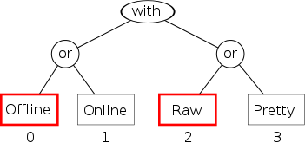
Default promotion tree
The model has two dimensions that correspond to the two disjunctors (or) in the model. Each disjunctor contains two alternative fragments, thus the number of all alternatives defined by this model is 4. A very important aspect is the order of the alternatives in the list since the first alternative in the list is by default taken as the winner. According to the rules described here the list of the alternatives generated by the model will be sorted in this way:
- {0, 2}
- {1, 2}
- {0, 3}
- {1, 3}
Definition: Two fragments are independent if they belong to two different disjunctors (i.e. dimensions).
The goal of the promoting strategy is to 'promote' one or more independent fragments. It means to transform the morph model tree in such a way that the promoted fragments are present in the first alternative in the list generated from the tree, i.e. the default-winning alternative.
We will use notation (contactCoord, printerCoord) to denote the fragments to be promoted. Then (0, 0) is the default promotion leading to choosing the {Offline, Raw} alternative.
In order to promote fragments (1, 0), the promoting strategy must transform the tree as follows.
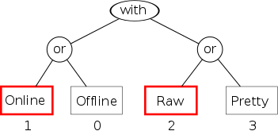
Promotion tree 1
The new tree yields this list of alternatives.
- {1, 2}
- {0, 2}
- {1, 3}
- {0, 3}
We can continue by promoting (1, 1). The corresponding tree will then be this.
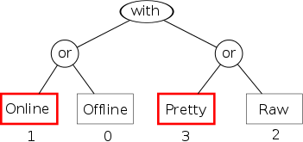
Promotion tree 2
And the corresponding list of alternative is:
- {1, 3}
- {0, 3}
- {1, 2}
- {0, 2}
And finally the remaining combination is (0, 1), which gives this tree:
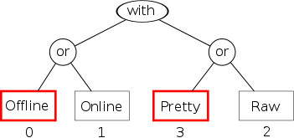
Promotion tree 3
with these alternatives:
- {0, 3}
- {1, 3}
- {0, 2}
- {1, 2}
    - Masking
Masking allows us to suppress alternatives, which do not match the so-called fragment mask. The fragment mask specifies which fragments must be present in the winning alternative. It effectively reduces the set of the alternatives.
In order to make the explanation easier, let us introduce the following notation, which represents an alternative along with a bit vector indicating fragments contained in the alternative.
{fragments}[OfflineBit, OnlineBit, RawBit, PrettyBit]
The four alternatives from our model then look like this:
- {0, 2}[1, 0, 1, 0]
- {1, 2}[0, 1, 1, 0]
- {0, 3}[1, 0, 0, 1]
- {1, 3}[0, 1, 0, 1]
Now, the fragment mask for our model is a vector of four bits. A bit fN set to 1 indicates that the corresponding fragment must be present.
mask = (f0 f1 f2 f3)
We can use this mask to reduce the original list of alternatives A. The sublist S ⊂ A consists of all alternatives whose bit vector a masked with the fragment mask (bitwise AND) gives the fragment mask. It can be formulated more precisely by the following formula.
∀ a ∈ S; a & mask = mask
For a better manipulation with the fragment bits, let us construct the following matrix corresponding to the previous list of alternatives.
|1 0 1 0|
|0 1 1 0|
F = |1 0 0 1|
|0 1 0 1|
When no fragment is explicitly specified, the mask is (0 0 0 0). Masking matrix F gives the zero matrix, where all rows matches the mask. Thus there is no reduction of the original list of alternatives.
|0 0 0 0|
|0 0 0 0|
F & mask = |0 0 0 0|
|0 0 0 0|
If we wish to constrain the list of alternatives only to those containing the Pretty fragment, the mask will be (0 0 0 1). Masking matrix F then will yield the following matrix.
|0 0 0 0|
|0 0 0 0|
F & mask = |0 0 0 1|
|0 0 0 1|
Here, only the last two rows match the mask. The first alternative in the sublist, which preserves the order of the original list, is the winner.
- {0, 3}[1, 0, 0, 1]
- {1, 3}[0, 1, 0, 1]

If we add an additional fragment to the mask, let us say Online, the mask will be (0 1 0 1). Then the masked matrix F will be:
|0 0 0 0|
|0 1 0 0|
F & mask = |0 0 0 1|
|0 1 0 1|
where only the last row matches the mask. This single alternative becomes the winner.
- {1, 3}[0, 1, 0, 1]
Note: Using an invalid mask is equivalent to that of the empty mask, i.e. no alternative is suppressed.
    - Rating
The rating strategy allows us to rate individual alternatives. Then the winner alternative is selected only from those alternatives having the highest rating. For a better understanding let us use the following notation, which depicts the rating of an alternative.
{fragments}:Rating
By default the alternatives have no rating, i.e. their rating is 0. The four alternatives from our model then look like this:
- {0, 2}:0
- {1, 2}:0
- {0, 3}:0
- {1, 3}:0
We can explicitly assign new rating to a selected sub-set of the original alternatives. Let's say we will rate alternatives 1 and 4 by 1. Then the sub-list will look like this
- {0, 2}:1
- {1, 3}:1
since only this two alternatives have the highest rating. The winner is the first alternative in this sub-list.
    - Composing strategies
All strategies can be composed in any order. In the following example we will see the effect of all strategies on the choosing of the winner alternative. We will use the following text decorations to depict the winner alternative, a mask-matching alternative and a suppressed alternative with a low rating.
The default list of alternatives is this:
- {0, 2}:0
- {1, 2}:0
- {0, 3}:0
- {1, 3}:0
Let us first promote the fragment 1.
- {1, 2}:0
- {0, 2}:0
- {1, 3}:0
- {0, 3}:0
Then we will mask fragment 3.
- {1, 2}:0
- {0, 2}:0
- {1, 3}:0
- {0, 3}:0
And next we will rate alternatives {1, 2} and {0, 3} by 1.
- {1, 2}:1
- {0, 2}:0
- {1, 3}:0
- {0, 3}:1
And finally we will unmask fragment 3 and mask fragment 2.
- {1, 2}:1
- {0, 2}:0
- {1, 3}:0
- {0, 3}:1
    - A Use Case
The following use-case shows how the three strategies can be composed in a real code.
Let us first create a morph kernel in two steps. First we have to create the model.
val contactModel = parse[(OfflineContact or OnlineContact) with
(ContactRawPrinter or ContactPrettyPrinter) with
(StandardOutputChannel or MemoryOutputChannel)](true)
Then we construct a stack of three promoting strategies, each controlling one dimension. We do not employ the other two strategies yet. Notice the LastRatingStrategy strategy used as the root (bottom) strategy. It is actually a strategy returning the alternatives (i.e. the list of alternatives, the tree, the fragment mask and the ratings) of the morph, on which method remorph is being called. When calling remorph repeatedly, it always uses the output alternatives from the last invocation as the input alternatives in the next invocation.
var channelCoord: Int = 0
val channelStr = promote[StandardOutputChannel or MemoryOutputChannel](new LastRatingStrategy[contactModel.Model](), channelCoord)
var printerCoord: Int = 0
val printerStr = promote[ContactRawPrinter or ContactPrettyPrinter](channelStr, printerCoord)
var statusCoord: Int = 0
val contactStr = promote[OfflineContact or OnlineContact](printerStr, statusCoord)
Now we can instantiate the kernel.
val contactData = ContactData("Pepa", "Novák", male = true, email="pepa@depo.cz", Locale.CANADA)
implicit val offlineContactFrag = single[OfflineContact, Contact](contactData)
implicit val onlineContactFrag = single[OnlineContact, Contact](contactData)
val contactKernel = singleton(contactModel, contactStr)
In order to see the list of the structure of individual winner alternatives, we will prepare this helper method printing alternatives from the whole combinatorial space (2x2x2).
def printAllAlts(): Unit = {
for (i <- 0 to 1; j <- 0 to 1; k <- 0 to 1) {
channelCoord = i
printerCoord = j
statusCoord = k
contactKernel.~.remorph
println(contactKernel.~.myAlternative)
}
}
Printing the list of alternatives yields this output.
(OfflineContact, ContactRawPrinter, StandardOutputChannel)
(OnlineContact, ContactRawPrinter, StandardOutputChannel)
(OfflineContact, ContactPrettyPrinter, StandardOutputChannel)
(OnlineContact, ContactPrettyPrinter, StandardOutputChannel)
(OfflineContact, ContactRawPrinter, MemoryOutputChannel)
(OnlineContact, ContactRawPrinter, MemoryOutputChannel)
(OfflineContact, ContactPrettyPrinter, MemoryOutputChannel)
(OnlineContact, ContactPrettyPrinter, MemoryOutputChannel)
Now we are going to employ the masking strategy, which will suppress all alternative not containing MemoryOutputChannel.
var fixMemOut = 1
val maskStrategy = mask[\?[MemoryOutputChannel]](contactStr, fixMemOut)
contactKernel.~.remorph(maskStrategy)
printAllAlts()
Remember that \?[MemoryOutputChannel is equivalent to Unit or MemoryOutputChannel. Setting fixMem to 0 will select {Unit} or {} alternative, which maps to all alternatives in the source model and thus all fragments from all source alternatives are masked. If fixMem is set to 1 then the {MemoryOutputChannel} alternative is selected, which is mapped to four source alternatives containing the {MemoryOutputChannel} fragment. Thus only the fragments from these four alternatives are projected into the fragment mask.
Printing all combinations proves that despite promoting alternatives with StandardOutputChannel too, they are overridden by the fragment mask having the MemoryOutputChannel bit set.
(OfflineContact, ContactRawPrinter, MemoryOutputChannel)
(OnlineContact, ContactRawPrinter, MemoryOutputChannel)
(OfflineContact, ContactPrettyPrinter, MemoryOutputChannel)
(OnlineContact, ContactPrettyPrinter, MemoryOutputChannel)
(OfflineContact, ContactRawPrinter, MemoryOutputChannel)
(OnlineContact, ContactRawPrinter, MemoryOutputChannel)
(OfflineContact, ContactPrettyPrinter, MemoryOutputChannel)
(OnlineContact, ContactPrettyPrinter, MemoryOutputChannel)
Next, we will employ the rating strategy, which assigns rating 1 to the alternatives containing ContactPrettyPrinter.
var fixPretty = Set((0, 1))
val ratingStrategy = rate[ContactPrettyPrinter](contactKernel.~.strategy, fixPretty)
contactKernel.~.remorph(ratingStrategy)
printAllAlts()
The rate macro has similar signature as promote and mask, however the last argument contains a function returning a set of pairs, where each pair consists of the number of the alternative in the sub-model specified in the type arguments, and the rating.
The result of the printing of the whole space will be homogenous now.
(OfflineContact, ContactPrettyPrinter, MemoryOutputChannel)
(OnlineContact, ContactPrettyPrinter, MemoryOutputChannel)
(OfflineContact, ContactPrettyPrinter, MemoryOutputChannel)
(OnlineContact, ContactPrettyPrinter, MemoryOutputChannel)
(OfflineContact, ContactPrettyPrinter, MemoryOutputChannel)
(OnlineContact, ContactPrettyPrinter, MemoryOutputChannel)
(OfflineContact, ContactPrettyPrinter, MemoryOutputChannel)
(OnlineContact, ContactPrettyPrinter, MemoryOutputChannel)
And now we are going to unapply the effect of the new strategies. First, let us unapply the fragment mask by
fixMemOut = 0
contactKernel.~.remorph
printAllAlts()
Setting the fixMemOut to 0 selects all fragments in the fragment mask, thus all fragments are equal.
(OfflineContact, ContactPrettyPrinter, StandardOutputChannel)
(OnlineContact, ContactPrettyPrinter, StandardOutputChannel)
(OfflineContact, ContactPrettyPrinter, StandardOutputChannel)
(OnlineContact, ContactPrettyPrinter, StandardOutputChannel)
(OfflineContact, ContactPrettyPrinter, MemoryOutputChannel)
(OnlineContact, ContactPrettyPrinter, MemoryOutputChannel)
(OfflineContact, ContactPrettyPrinter, MemoryOutputChannel)
(OnlineContact, ContactPrettyPrinter, MemoryOutputChannel)
And finally, we will unapply the rating strategy by rating the alternatives with ContactPrettyPrinter by 0.
fixPretty = Set((0, 0))
contactKernel.~.remorph
printAllAlts()
(OfflineContact, ContactRawPrinter, StandardOutputChannel)
(OnlineContact, ContactRawPrinter, StandardOutputChannel)
(OfflineContact, ContactPrettyPrinter, StandardOutputChannel)
(OnlineContact, ContactPrettyPrinter, StandardOutputChannel)
(OfflineContact, ContactRawPrinter, MemoryOutputChannel)
(OnlineContact, ContactRawPrinter, MemoryOutputChannel)
(OfflineContact, ContactPrettyPrinter, MemoryOutputChannel)
(OnlineContact, ContactPrettyPrinter, MemoryOutputChannel)

- Appendix 1: Protodata
Protodata can be described as a collection of diverse data objects having no immediate and meaningful commercial use or value.
It comes into existence usually as a by-product of some business activity, such as journal logs, but it may also be the leftovers from some shut down project or data acquired as part of some acquisition.
Protodata may also be deliberately gathered for a longer period of time without any specific vision of its future use besides the owner's hope that such a large amount of data may become a gold mine in the future.
Applying the knowledge matrix introduced in the previous chapter, the level of the data owner's knowledge at this stage would correspond to categories Known-Knowns or Known-Unknowns, when the known value is insignificant or there is considerable risk embedded in the attempt to sell data possibly containing delicate information. (LINK: Appendix 3)
The lack of a usage means that there is no context within which the data objects in the protodata would yield some commercially or otherwise valuable information. The objects can be treated only as bare wrappers of intrinsic properties (i.e. properties that an object has of itself, independently of other objects, including its context. here)
In order to utilize the protodata, it must be put into a novel context. It can be achieved, for instance, by combining the protodata with other, often apparently unrelated, data or with newly emerged information services.
The owner's effort to find a new context for his protodata can go in two directions: To try to find
- something valuable
- anything valuable
The first way is less difficult, since it evaluates existing contexts against the protodata. For example, a competitor has developed a successful service using data that is somehow similar to ours. So we will examine our protodata to see whether it is able to yield similar, or possibly better, information if combined with other available data sources. This situation corresponds to the Unknown-Knowns epistemological category, since the owner knows the value of the information he would like to retrieve from the protodata, however, it is still unknown, if there is such information.
The second way is significantly more difficult, since its goal is to discover a new and original context, which would become a market differentiator. This approach usually requires a longer research period, while the results are highly uncertain. The knowledge category in this case corresponds to Unknown-Unknowns, since not only does the owner not know if there is anything especially interesting, but even if there were anything interesting he would not know its value.
In any case, if some vital context is found it also comes with a new domain model. Although protodata may be accompanied by some metadata, i.e. having its own domain model - proto-domain, the context domain model may be so structurally and semantically different from the proto-domain that a direct mapping from the proto-domain to the context domain can be difficult.
If such a situation occurs, the usual solution is to transform and normalize the protodata in such a way that the mapping will be easier. However, this approach has several drawbacks.
First, transformations and normalizations are lossy processes by its nature. It follows that during such processes some information, which could be potentially used in future development of the application, will be inevitably lost. In such a case, the processes will have to be redesigned to provide the required additional data and the protodata will have to be re-processed. And this can, of course, consume a lot of resources and time.
Second, if the protodata is just a stream of events, which must be processed in realtime, then any additional pre-processing could be a source of undesired delays.
Third, when another useful context is found, new transforming routes will have to be established, which will put an additional burden on the infrastructure. Moreover, reusing the processes already established for the existing contexts, may not be possible because of the diverse nature of contexts and their domain models.
Fourth, in the course of time when more contexts are implemented the system of processes will tend to become unmaintainable and resistant to refactoring.
It seems that the only way to bypass the above-mentioned issues is to try to map directly the context domain onto the proto-domain, regardless of the diverse character of the two domains, and avoid any intermediary processing.
Furthermore, since the type systems of advanced programming languages are powerful enough to grasp the complex nature of domain objects, domain models should model the objects by type as much as possible and not by state.
If domain objects are modeled by state, then the objects' character, i.e. what the objects are, is retrieved from the properties of the objects. For example in Java, more complex objects with multidimensional character must be modeled by means of delegation, which is de-facto a modeling by state, as shown in the next paragraph.
If domain objects are modeled by type, then the objects' character is retrieved from their type. This approach has many benefits, since a lot of responsibilities can be delegated to the type system. Additionally, if the language is static, many possible errors can be discovered at compile-time.
Languages like Scala or Groovy come with the concept of trait, which is very useful to model diverse nature of complex objects by type.
The main goal of this work (Morpheus) is to prove that it is possible to construct a domain mapper as an extension of the language platform. In other words, the mapper becomes integrated with the language itself in contrast to other mapping tools (list of object-object mappers), which are built on top of the language. It will also be shown that such a mapper inherits the nice properties of static and statically typed languages such as type-safety and early discovery of errors, i.e. the mapping schemas are validated at compile-time.
In the following paragraph I will present an example on which I would like to illustrate the described problems as well as to sketch their solution. The protodata in the example is data collected from a fictional airport scanner, which is able to recognize objects in baggage.
- Apendix 2: DCI and Object Metamorphism
  - What is DCI?
Data, context, interactions (DCI) is a software paradigm whose goal is to bring the end user's mental models and computer program models closer together. To put it in a nutshell, the user must feel that he or she directly manipulates the objects in computer memory that correspond to the images in his or her head.
Data, context and interactions are the three fundamental facets of the end user's interpretation of computer data. Data itself are nothing more than bits in program memory. Only after the data are put into a context, in which they are subjects to interactions between them, the data can yield some information.
Trygve Reenskaug, who is also the inventor of the MVC pattern, invented the paradigm. DCI can be seen as its further development. See this article describing the DCI vision.
  - Background
DCI is anchored in object-oriented programming (OOP), however it must cope with some inherent flaws of OOP. It is generally accepted that OOP is very good at capturing the system's state by means of classes and their properties. OOP is also good at expressing operations with the state captured by a class, unless these operations involve some kind of collaboration with instances of other classes.
However, OOP fails to express collaborations between objects. These collaborations we call use cases. An object may appear in several use cases and it may behave quite differently in each use case. Because of the lack of another concept in OOP we are forced to express such a use-case-specific behavior as an operation in a class. And it has several bad consequences: 1. There is no single file or other artifact dedicated solely to one use case, where we could see all interactions between objects. It makes the orientation in the code and its maintenance pretty difficult. 2. The whole behavior of the use case is scattered across the classes of the collaborating objects. It leads us to add a number of unrelated methods to classes with every new use case (causing higher coupling and lower cohesion of classes). 3. It is practically impossible to separate the stable part of the code, i.e. that which captures the data, from the variable part, i.e. the use cases (behavioral part).
See this article by Victor Savkin, which explains nicely the problem of collaboration in OOP.
  - Solution
DCI represents every use case by means of the so-called context. The context defines roles performing interactions between themselves. Each role in the context is played by one corresponding object (data, entity). The role contains the code that would otherwise reside in the object's class. Thus, roles effectivelly separate the stable part of the code from the unstable.
The context itsels only defines roles and triggers the use-case. The Context and roles should reside in one dedicated file so that one could easily investigate the interactions.
  - Example
The paradigmatical example of DCI is a simulation of a money transfer. It is simple enough to illustrate the fundamentals of DCI.
The use case scenario is this: the end user uses the bank terminal to transfer money from one account to another. He or she selects the source and the destination accounts from the list of accounts. Then he or she specifies the amount of money to be transfered and starts the transaction. Some exceptions can be raised, of course, for instance as long as there is not enough balance in the source account to perform the transfer.
For the sake of simplicity, let us assume that the data model of the bank application is just the list of the end user's accounts. Every account is represented by an object encapsulating some basic properties like the balance along with some basic operations like increaseBalance and decreaseBalance. We can expect that such a data model will be pretty alligned with the end user's mental model.

Bank Accounts
When transferring money the user will intuitively be familiar with the basic steps of the procedure. He or she will know that it is a simple interaction between two accounts, one playing the role of the source account and the other playing the destination account role and that the balance of the source account will be decreased by the amount of the transfered money while the destination's balance will be increased by the same amount.
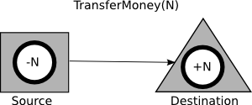
Transfer Money Use-Case
It is important to note that the roles, i.e. the triangle and the rectangle have no identity. They can be regarded as costumes. It is the object playing the role that carries the identity.
In many object oriented programming languages it is usually pretty easy to express both the data and the abstract context (i.e. using roles that are not bound to the objects yet). What is not that easy, however, is the binding of objects to their respective roles in the context. In this use case the goal is to fill the holes in the rectangle and the triangle by the chosen account objects.
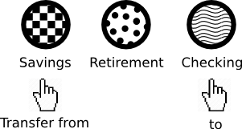
Chosen Bank Accounts
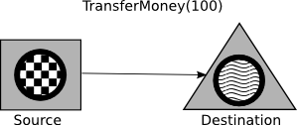
Money Transfer
This is the moment at which the things are becoming complex. Without modern programming concepts like mixins, traits, aspects or meta-programming we would hardly overcome this point. And yet any of these techniques has its own issues and does not perfectly fit to DCI.
See this article on Wikipedia dealing with various issues, or go here to learn what self schizophrenia is.
So let us suppose we have managed to get through this difficult step and the objects are assigned to their roles. Now the context is ready to transfer the money. The user presses the Go button emitting a command that is delegated to the context, which will enact the use case.
  - Using Morpheus
Morpheus is a Scala extension that makes possible for an object to change its shape dynamically. Unsurprisingly, it can be used to implement a DCI application.
You can consult or check out the source code of this example here.
    - Modelling Data
Let us begin with the data model. Actually, there is nothing specific to Morpheus. We are only required to model the entities as traits, not classes.
trait Account {
def Balance: BigDecimal
def decreaseBalance(amount: BigDecimal): Unit
def increaseBalance(amount: BigDecimal): Unit
}
class AccountBase(initialBalance: BigDecimal) extends Account {
private var balance: BigDecimal = initialBalance
def Balance = balance
def decreaseBalance(amount: BigDecimal) = balance -= amount
def increaseBalance(amount: BigDecimal) = balance += amount
}
class SavingsAccount(initialBalance: BigDecimal) extends AccountBase(initialBalance) {
}
class CheckingAccount(initialBalance: BigDecimal) extends AccountBase(initialBalance) {
}
class RetiringAccount(initialBalance: BigDecimal) extends AccountBase(initialBalance) {
}
    - Modelling Context
The next DCI facet is the context defining the interacting roles. In this case the context defines only two roles: Source and Destination. The amount of money to be transferred is also included in the context (as a stage prop).
trait Context {
private[moneyTransfer] val Source: Account with Source
private[moneyTransfer] val Destination: Account with Destination
val Amount: BigDecimal
}
The context is a simple trait declaring the two roles as values of a composite type Account with Source, resp. Account with Destination. The types indicate that the members are accounts playing the corresponding roles in the use case. Source and Destination are roles defined below.
The implementation of the context is also pretty simple. It uses the role macro that hides some Morpheus boilerplate. The macro accepts three types: the role type, the object type and the context type. The only argument is the reference to the object.
class ContextImpl(srcAcc: Account, dstAcc: Account, val Amount: BigDecimal) extends Context {
private[moneyTransfer] val Source = role[Source, Account, Context](srcAcc)
private[moneyTransfer] val Destination = role[Destination, Account, Context](dstAcc)
def trans(): Unit = {
Source.transfer
}
}
The following class is the same as the previous one, however, now wihout the role macro.
class ContextImpl(srcAcc: Account, dstAcc: Account, val Amount: BigDecimal) extends Context {
private[moneyTransfer] val Source = {
implicit val dataFrag = external[Account](srcAcc)
implicit val selfFrag = external[Context](this)
singleton[Account with Source with Context].!
}
private[moneyTransfer] val Destination = {
implicit val dataFrag = external[Account](dstAcc)
implicit val selfFrag = external[Context](this)
singleton[Account with Destination with Context].!
}
def trans(): Unit = {
Source.transfer
}
}
Using the singleton macro allows us to join the account object, the role and the context into one instance.
Note: The singleton macro can do much more things; this is only the most basic functionality.
    - Modelling Interactions (Roles)
The roles are also modelled as traits. Now we have to mark them with the fragment annotation. Both the bound account object and the context are available through the self-type Account with Context.
@fragment
trait Source {
this: Account with Context =>
private def withdraw(amount: BigDecimal) {
decreaseBalance(amount)
}
def transfer {
Console.println("Source balance is: " + Balance)
Console.println("Destination balance is: " + Destination.Balance)
Destination.deposit(Amount)
withdraw(Amount)
Console.println("Source balance is now: " + Balance)
Console.println("Destination balance is now: " + Destination.Balance)
}
}
@fragment
trait Destination {
this: Account with Context =>
def deposit(amount: BigDecimal) {
increaseBalance(amount)
}
}
It is important to note that the context and its roles reside in the same file.
    - Running the Program
And finally we can run the program.
object App {
def main(args: Array[String]): Unit = {
val ctx = new ContextImpl(new AccountBase(10), new AccountBase(50), 5)
ctx.trans()
}
}
- Appendix 3: Protean Applications and Knowledge Matrix
Having a company, which serves millions of users and is still on the rise, is a dream of many. Moreover, if the company develops a software product, which is used world-wide, most likely it is getting a gift in the form of the personal details of its users or their activity. Sooner or later the company's managers will inevitably ask themselves, how they can utilize the large amount of data they have been receiving from their customers for years. There must be something of extraordinary importance in the data. Unfortunately they do not know what it is.
Actually, this gift can easily become both a blessing and curse at the same time. To illustrate this point let me present a fictional company.
The Company launches a search engine, which quickly becomes very popular. In the beginning the search engine algorithm is neutral in terms of the processing of the search queries. In other words it only analyzes the keywords and searches for the best matching pages. Then the Company realizes that the results should reflect the user too. To put it bluntly, they want to scan all of its users to obtain as much of their personal data as possible and to take it into account in the algorithm.
Because the Company has almost no clue who its users are at this moment, it offers users the opportunity to sign up to the search engine under the pretext that they need to improve the search results.
Since the users are reluctant to reveal more personal information, the Company starts to track their activity through a web browser plugin. In addition, the Company unleashes its bots to retrieve additional information, like career history, from specialized social networks.
The Company also launches an email service offering virtually unlimited space for registered users.
Since the company keeps track of who is online and of who knows who thanks to its email service, it comes up with a chat room seamlessly integrated with other services.
At this point the Company's database already contains petabytes of the personal data of its users, their email and chat communication plus individual clickstreams and data gleaned from other social networks.
This is also the moment when the managers ask the above-mentioned question about some utilization of the data.
Looking at their data they see user records containing a couple of plain personal details and some basic relationships between users, like networks of colleagues or contacts, friends etc. Although important, such ordinary information will hardly become the company's market differentiator since there are many specialized social networks around already.
They believe, however, that there must exist plenty of subtle and extremely valuable data and relationships, which are not evident at first glance.
For instance, such non-trivial personal data could be age, religion, politics, sexual preference, education, health, wage group, important life events like marriage, child birth, lottery prizes, accidents, death and so on. They anticipate that such data could be extracted from personal resources like keywords, clickstreams, geographical positions, emails, chat rooms etc.
Further, they identify some examples of non-trivial social relationships and interactions like family, relatives, lawyer<->client, physician<->patient, teacher<->student, creditor<->debtor, aversions, memberships in various institutions and boards, attendance at the same cultural events. They assume that these social interactions could primarily be spotted in and retrieved from the data produced by the services like email or chat. Of course, the clickstream and keywords could be helpful as well.
The company believes that having such types of information about its users and their interactions would make it different on the market. But, there is a big question mark. The managers must again ask themselves: 'Does our data contain such information at all? And if so, how reliable, sensitive and valuable would it really be?'
It would be foolish to begin with musing about business models, designing user interfaces and planing milestones and releases at this stage. It would be nothing else than building castles in the air.
Without good knowledge of the data it is practically impossible to follow the traditional top-down approach of application development, in which use-cases define data. Before going on to more technical aspects let me briefly analyze the knowledge matrix summarizing our ability to identify some information versus our ability to asses its value.
- We know it is there and we know its value (Known knowns): Precisely identified information with precisely identified value. As far as the Company's data is concerned, such information consists of the user's essential personal data such as name, date of birth, basic relationships between users etc. The overall value of such information is low, since it is pretty basic, dull and unexciting.
- We know it is there, however, its value is uncertain or precarious (Known unknowns): The Company identifies a number of instances of such information, for example from the clickstream or search phrases, such as bank accounts and transactions, sexual preference, health status and other private and confidential information. Nevertheless, it must conclude that some pieces of the information have uncertain commercial value while the others may be too risky, delicate or possibly damaging for the company if handled inappropriately. The uncertainty is also rooted in moral and ethical constraints or limitations arising from end-user licenses.
- We do not know whether it is there, but if so, we would know its value (Unknown knowns): The Company's analysts would be glad to get such information from the data, since it would have an indisputable value. Sadly, its presence is far from obvious in contrast to the previous cases. Such insights might come, for instance, from the field of marketing, such as the ability to predict customer behavior, or from the medical field, such as warning users of upcoming possible health issues (bipolar, schizophrenia, epilepsy).
- There may be something which is out of scope of our imagination now and even when brought to light, it may not be clear if it is worth anything (Unknown unknowns) - A "strange fish", which may turn out to be something really unique and revolutionary or something utterly useless.
To put it in a nutshell, as long as the Company can identify some information, it is either unexciting or precarious, as far as the commercial value is concerned.
But there are still the two categories concerning unidentified information. In the former the analysts can enumerate and appreciate such wishful insights, however, the data may or may not yield them. In the latter, the insights, potentially groundbreaking, are shrouded in a veil. The analysts cannot even imagine them.
In contrast to the first two categories of knowledge, the last two may produce something really exciting. The common ground for both is that without some intensive research they will barely produce any value.
As far as the uknown-known case is concerned, the research could be rather short-term engaging the majority of the R&D team. The more or less clearly defined vision parameters should allow the analysts and managers to specify goals and criteria for abandoning an unfruitful branch of research.
On the other hand, the research in the uknown-unknown case should be considered a long-term activity with hazy goals, terra incognita. An ignorance of the potential beneficial findings precludes any attempt to specify both goals and criteria for abandoning the research. Researchers should be highly creative, rather eclectic, combining various methods and tools, stimulating imagination during brainstorming sessions, seeking inspiration and parallels in nature, music, literature, history and so on. In any case, this research requires a small, dedicated team of the most talented members of the Company.
Let me summarize the key characteristics of the four epistemological categories:
- Known-Known: too dull and unexciting
- Known-Unknown: too risky, it's not much about research, rather about business strategy (and the stomach)
- Unknown-Known: promising, short-term research, a feasibility study as the first deliverable
- Unknown-Unknown: terra incognita, it may or may not yield something groundbreaking, requires long-term research by a small team
In any event, the Company must make the important decision as early as possible, whether it is willing to invest into the research or not.
If not, the Company had better concentrate on the development of its flag-ship application and use the data to improve it.
If so, the Company should assess the proportions of the Unknown-Known and Unknown-Unknown research teams. Perhaps, applying Pareto's 80-20 rule might be a good starting point. The proportions of effort invested into the individual knowledge categories might then be adjusted as follows: Known-Known 0%, Known-Unknown 0-10%, Unknown-Known 80%, Unknown-Unknown 10-20%. Furthermore, the Company will have to embrace some bottom-up approach to the development.
In the next part I will be dealing with the development of applications, which emerge as the result of such research. Since developing such applications is often like walking on quicksand, I call this breed of applications protean.

- Výkonná pole a makra používaná v tomto dokumentu

Makra pracující se záložkami a na ně se odkazujícími výkonnými poli jsou v tomto dokumentu konstruována tak, že předpokládají, že název odkazované záložky je ve schránce.

 |  | Tato kapitola je ještě rozpracovaná. Dal jsem přednost zveřejnění dokumentu před jeho uvedením do dokonalého stavu. Omluvte proto prosím případné nedodělky

Tato kapitola je rozpracovaná a bude dokončena v nejbližším možném termínu.

Terminologický slovník

 |  | Tato kapitola je ještě rozpracovaná. Dal jsem přednost zveřejnění dokumentu před jeho uvedením do dokonalého stavu. Omluvte proto prosím případné nedodělky

Termín | Význam [zdroj]
Textový rejstřík
Pevná mezera
Zarovnání na prapor

Seznam literatury
- Anonymous Pro – family of four fixed-width fonts distributed with the Open Font License (OFL). Dostupné z: http://www.ms-studio.com/FontSales/anonymouspro.html.
- Bakalářské práce. Dostupné z: http://kit.vse.cz/bakalarske-studium/bakalarske-prace/
- Bibliografické odkazy pro seznamy a citace. Oficiální výukové stránky Ústavu informačních studií a knihovnictví FF UK. Dostupné z: http://www1.cuni.cz/~brt/bibref/bibref.html
- BRATKOVÁ, Eva. Metody citování literatury a strukturování bibliografických záznamů podle mezinárodních norem ISO 690 a ISO 690-2, Dostupné z: http://citace.com/soubory/csniso690-interpretace.pdf
- Diplomové práce. Dostupné z: http://kit.vse.cz/magisterske-studium/diplomove-prace/
- Pravidla českého pravopisu s dodatkem Ministerstva školství, mládeže a tělovýchovy České republiky. Academia 1998 ISBN 80-200-0992-2.
- ÚSTAV PRO JAZYK ČESKÝ AKADEMIE VĚD ČR: Internetová jazyková příručka. Dostupné z: http://prirucka.ujc.cas.cz/
- TKAČÍKOVÁ, Daniela. Bibliografické citace a etické zacházení s informacemi.
http://dspace.vsb.cz/bitstream/handle/10084/78273/bibliograficke-citace-tkacikova.pdf

Seznam obrázků a tabulek

Základní text

Seznam obrázků
Obrázek 1: Error! Bookmark not defined.
Obrázek 2: Error! Bookmark not defined.

Seznam tabulek
Tabulka 1: Ukázka závěrečného terminologického slovníku Error! Bookmark not defined.

Přílohy

Seznam obrázků
Obrázek 3: Error! Bookmark not defined.
Obrázek 4: Error! Bookmark not defined.

Seznam tabulek
Tabulka 2: Styly použité v tabulkách (Popisek je stylem 0TPopisek, označení je pak navíc stylem písma ZzTucne.) Error! Bookmark not defined.

Rejstřík

— A —
abstrakt
anglicky, iii
česky, ii
— C —
citace, 11
— Č —
čísla
psaní, 25
číslování, 9, 15
číslování stránek, 2
— D —
datum
psaní, 25
— E —
EMF, 13
— G —
grafy
číslování, 9, 15
Grafy, 15
— I —
interpunkce, 23
— J —
jazyk práce, 10
jazykový nešvar
-izmy, 21
optimálnější, 21
pokud, 20
provádět, 20
slang, 22
JPG, 12
— K —
klávesnice
numerická, 22
konec řádku
pevný, 27
kontrola pravopisu, 19
kontrola překlepů, 19
— L —
list
titulní, 2
literatura
požadavky, 3, 6
— M —
mezera
pevná, 27
— N —
nadpisy
dlouhé
psaní, 26
náležitosti, 2
nešvar jazykový
-izmy, 21
optimálnější, 21
pokud, 20
provádět, 20
slang, 22
— O —
obrázky, 11
číslování, 9, 15
formát souborů, 12
EMF, 13
JPG, 12
PNG, 12
SVG, 13
vektorový, 13
obtékání, 14
popisky, 13
rozměr, 12
umístění, 14
velmi velké, 13
obsah
požadavky, 2
obsah práce
požadavky, 3, 4
— P —
pevná mezera, 27
písmo
neproporcionální, 17
velkost
obrázky, 12
PNG, 12
poděkování, iii
pole
výkonná, 15
pomlčky, 24
požadavky
literatura, 3, 6
možná rozšíření, 5
obsah práce, 3, 4
přílohy, 3, 7
rejstřík, 3, 7
rešerše, 3
slovník, 5
terminologický slovník, 3
úvod, 3, 4
závěr, 3, 4
pravidla
typografická, 22
pravopis
kontrola, 19
programy, 16
písmo
požadavky, 17
výpis, 17
prohlášení, ii
překlepy
kontrola, 19
přílohy
požadavky, 3, 7
psaní
čísel, 25
data, 25
zásady, 19
značky, 26
— R —
rejstřík
požadavky, 3, 7
rešerše
požadavky, 3
režimy práce, 20
rozměr
obrázků, 12
rozšíření
požadavky, 5
rozvržení, 3
— S —
slovník
požadavky, 5
slovník terminologický
požadavky, 3
specifika
analýza programů, 8
tvorba programů, 8
zpracování dat, 7
spojovník, 25
stránky
číslování, 2
styl
0Cislovany, 38
0Odrazkovy, 38
0Pismenovy, 38
0PrgPopisek, 41
0Program, 41
0TBezny, 40
0TPopisek, 40
0TZahlavi, 40
0Vycet, 38
1Bezny, 38
1Odrazkovy, 38
1Pismenovy, 38
2Bezny, 38
2Odrazkovy, 38
BPMaly, 40
BPMOznaceni, 40
BPMPopisek, 40
BPVelky, 39
BPVOznaceni, 39
BPVPopisek, 39
N1 – Nadpis 1, 37
N1_Cislovany, 37
N1_Prilohovy, 37
N2 – Nadpis 2, 37
N2_Cislovany, 37
N2_Prilohovy, 37
N3 – Nadpis 3, 37
N3_Cislovany, 37
N4 – N3_Prilohovy, 37
N4 – Nadpis 4, 37
obsahu, 42
ZzAnglickyUS, 41
ZzBKurziva, 41
ZzKurziva, 41
ZzKurzivaUS, 41
ZzKurzivaX, 42
ZzProgram, 42
ZzTucne, 41
ZzTucneUS, 41
ZzTucneX, 41
ZzXJazyk, 41
styly
atuomaticky používané, 42
hitparáda, 34
koncepce, 34
názvosloví, 35
používání, 27
zabudované, 28
SVG, 13
— T —
tabulka
terminologický slovník, 6, 15, 16
tabulky, 15
číslování, 9, 15
formát buněk, 16
umístění, 16
záhlaví, 16
titulní list, 2
typografie, 22
— U —
úvod
požadavky, 3, 4
uvozovky, 23
francouzské, 23
— V —
výkonná pole, 15
výpustka, 23
— Z —
závěr
požadavky, 3, 4
závorky, 24
značky
psaní, 26
znaky
interpunkční, 23
pevné mezery, 27
pevný konec řádku, 27
pomlčky, 24
přímé vkládání, 22
spojovník, 25
uvozovky, 23
francouzské, 23
výpustka, 23
závorky, 24
znaménka. viz znaky
interpunkční, 23

KONEC
Tato stránka odděluje vlastní text vaší práce od částí, kam si pracovně odkládáte texty a objekty, které jste do textu ještě nebo už nezařadili, ale o které z nějakého důvodu nechcete přijít. Současně sem zasahuje záložka označující část dokumentu, která bude zařazována do obsahu.
Tuto závěrečnou část smažte až těsně před tím, než budete práci odevzdávat. Teoreticky ji dokonce nemusíte mazat vůbec, protože stačí, když vytisknete a odevzdáte předchozí část dokumentu.

