Example

test

Zachary M. Smith

2020-03-01

library(ggplot2)  
  
data(iris)

ggplot(iris, aes(Petal.Length, Petal.Width, color = Species)) +  
 geom_point()

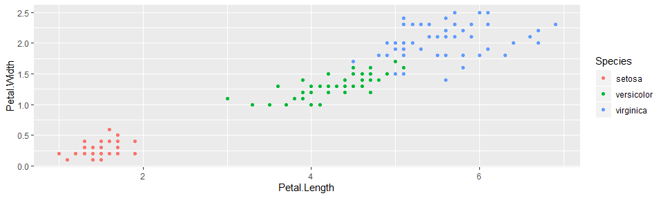

Iris petal length by width.