Project 2 – Assignment 4 – Architecture and Design of a System

Lab group 3 – Guangzu Lee, Bradley Schinker, Zach Snyder

Table of Contents

Class Diagram 2

ER Diagram 3

Activity Diagram (Reading Instructions) 4

Sequence Diagram 5

Use Case Diagram 6,7

Activity Diagram (Upload) 8

Class Diagram

Created by Guangzu, Bradley, Zach

Caption:

For a log in/log out functionality, a student class must have basic information to identify which student it is. Students are allowed to create usernames and/or passwords. All of this information is stored in a database or server. Also saved in that server is the courses class information. The student can log in through the server and view this information. Courses are allowed to create and/or add students to that course. The student can also logout through the server and no longer views any information.

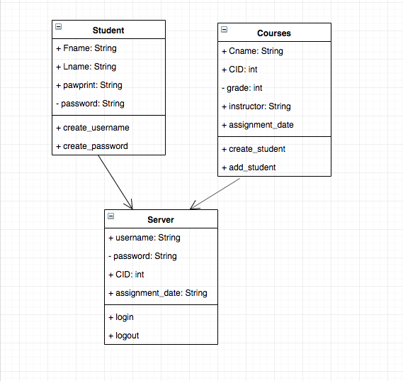

ER Diagram

Created by Guangzu, Bradley, Zach

Caption:

This diagram shows the overall relations between entities in this system. Student has necessary attributes to identify each unique student. Students are in courses and have access to the system admin where they can login to their accounts. TAs and instructors also have identifying attributes and have access to the system admin. Instructors also lead a course. Courses have attributes that identify them from other courses. Each course has different assignments that can hold plenty of different information like due dates and descriptions.

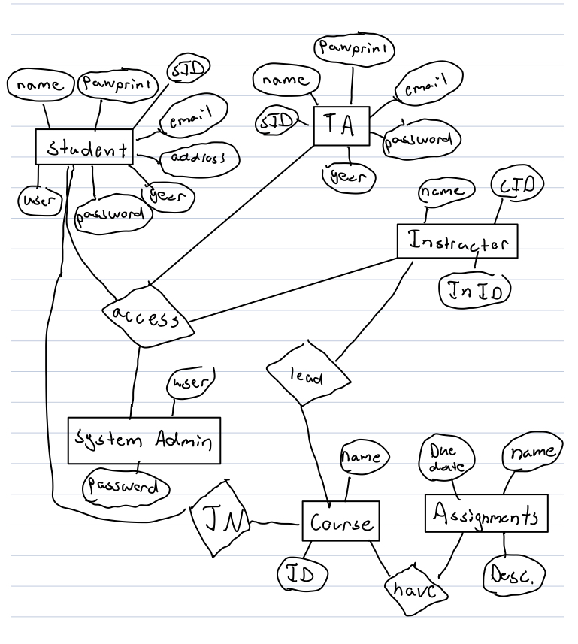

Activity Diagram (Reading Instructions)

Created by Zach

Caption:

This diagram shows how a student could view the instructions on an assignment. The student would select the course and the system would make sure the student is enrolled in that course. The student could then select an assignment and the system would check if that assignment is open or assigned. The system would then get the assignment data and display it to the student. If any steps fail, the system ends, and the student would have to begin again at the start.

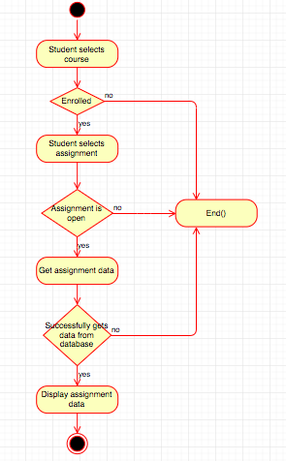

Sequence Diagram

Created by Zach

Caption:

This diagram shows the system grabbing instructions of an assignment. The user or student would open the assignment. The system would open the assignment interface, would look into a database for the assignment data, then would read the data from the database, and finally, return that data to the user so the user can read the instructions.

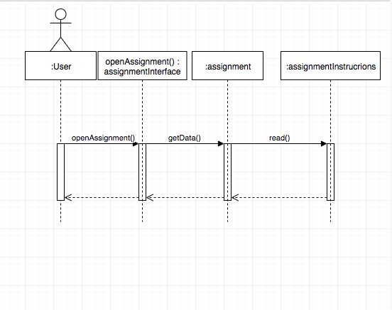

Use Case Diagram

Created by Bradley

Reviewed by Zach

Caption:

**Title:** Upload Files to Class Assignment

**Description:** This function of our assignment submission system allows students to upload files containing their completed homework into the repository for the class. This file submission will be associated with a specific assignment issued.

**Triggers:** To enter the upload process, the user will enter the specific assignment they are submitting to, and will then be presented with an "select files" button, which will take you to a file explorer/finder so you can select files for upload.

**Actors:** Students enrolled in a class that is issuing assignments.

**Precondions:** Student must be enrolled in a class that is a part of the system, and must navigate to the correct assignment to submit to.

**Main Success Scenario (Goals):** The main goal is for the student to select one or more properly formatted files for submission into the class assignment, so they can be viewed and graded by classroom administrators.

**Failed End Condition:** If the file is not of the correct file type that is specified, the upload process will fail. The user will then be alerted that the upload failed and will be prompted to select a new file.

**Extensions:** IF the user desires, they can attach a message or comment along with their uploaded file to be viewed by the classroom administrator.

**Steps for Execution:**

1. Enter desired class
2. Select assignment to submit to
3. Click "select file(s)"
4. Choose files that are in the specified file formats, dictated by class administrator
5. Add an optional message to your submission
6. Click submit
7. Add submission to the class repository under the person's name, so class administrator can view all the class's submissions in one place

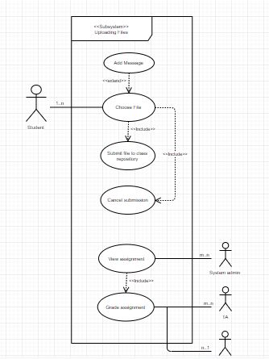

Activity Diagram (Upload)

Created by Bradley

Caption:

