1. Save the full database with „Save full database” button

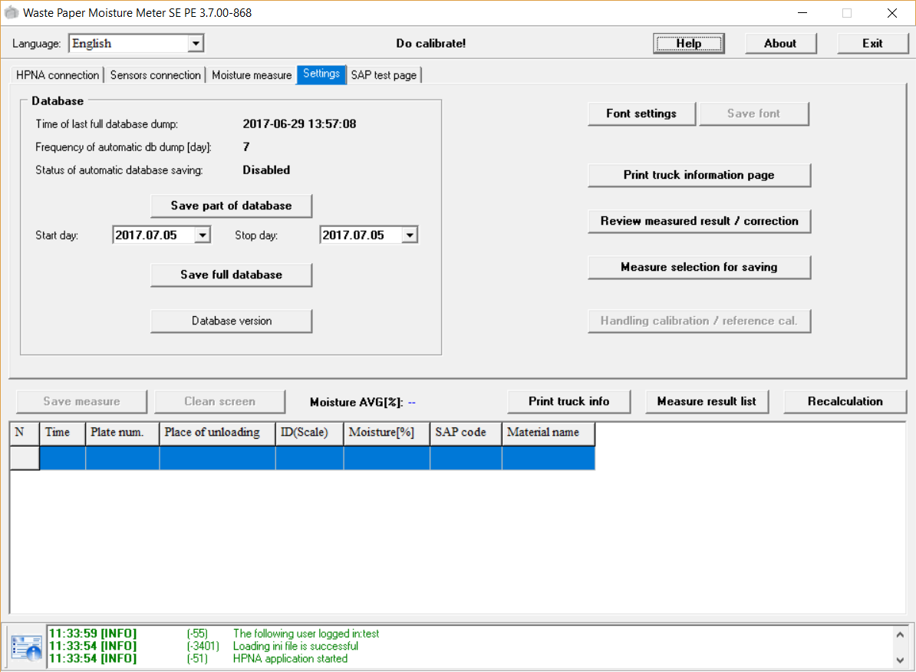

1. You will find the saved database in dbSave directory. It will contains 2017.07.05 timestamp.

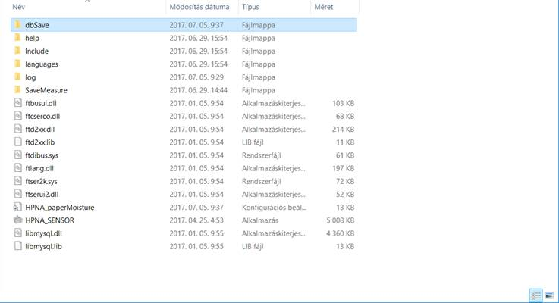

1. ZIP it please. (In Windows right click to file-> add to archive->select rar or zip)
2. Send it to us.