SpectraViewer
User Manual
Version 1.1.6

Author | Zsolt Hidasi
Year | 2026
License | MIT License
GitHub repository | https://github.com/zsolt-hidasi/SpectraViewer
Version DOI | 10.5281/zenodo.20715099

This manual describes the source-code version of SpectraViewer 1.1.6.

Contents
1. Introduction
2. Supported spectrum formats
3. Operating concept
4. System requirements and installation
5. User interface overview
6. Loading files and folders
7. Single file mode
8. Navigation and plot controls
9. Drag and drop
10. Exporting plots
11. Saved settings and automatic state restoration
12. Metadata encoding and code page selection
13. Notes, limitations, and file-count safeguards
14. Citation, DOI, and license
Appendix A. Keyboard shortcuts
Appendix B. Version 1.1.6 change summary

1. Introduction
SpectraViewer is a lightweight desktop application for opening, browsing, and visually inspecting spectrum files. It is designed as a fast spectrum browser rather than a full spectrum-processing or spectrum-manipulation environment.
The program can collect supported spectrum files from a folder, from a folder tree, from a manually selected set of files, or from drag-and-drop input, then display them as a navigable list. This makes it useful for quick inspection, checking, and visual comparison of larger spectrum collections.
SpectraViewer does not replace OPUS or other dedicated spectroscopy software. It does not perform spectral processing, manipulation, identification, or database searching. Its purpose is quick viewing and convenient browsing.

1.1 Purpose of this manual
This manual explains the basic operating logic of SpectraViewer 1.1.6, the user interface elements, the supported file-loading workflows, and the practical limitations that users should be aware of.

2. Supported spectrum formats
SpectraViewer currently supports the following file types:
- OPUS-like native spectrum files with numeric extensions, such as .0, .1, .2, and other numeric extensions.
- JCAMP-DX spectrum files: .dx and .jdx.
- DPT data point table files: .dpt.
During file opening, folder scanning, or drag-and-drop operations, the program considers only supported spectrum files. Unsupported files are ignored, and a warning may be displayed when appropriate.
Not all supported file formats contain the same type or amount of metadata. Some files may provide only the spectrum data, while others may also contain sample name, sample form, or other metadata. If metadata fields are missing, the corresponding header lines remain empty.

3. Operating concept
The operating logic of SpectraViewer differs from the traditional “open one file, display one file” approach. The program is primarily designed for browsing through spectrum collections without repeatedly opening individual files.
In normal mode, opening a single supported spectrum file usually creates a browsable list from the surrounding folder context. The opened file becomes the current item in that list, and the user can move to other spectra using the Previous and Next controls or the corresponding keyboard shortcuts.
If Include subfolders is disabled, SpectraViewer builds the list from the supported spectrum files found directly in the folder that contains the opened file. If Include subfolders is enabled, the program scans the folder tree recursively and builds a single navigable list from all supported spectra found under that folder.
This design is especially useful when the goal is not the detailed analysis of a single file, but the fast visual inspection, checking, or comparison of a larger spectrum set. In this sense, SpectraViewer behaves more like a spectrum browser than a conventional spectrum viewer.

3.1 Main browsing modes
- Folder context mode: opening a file or folder builds a list from the selected folder level.
- Recursive folder context mode: opening a file or folder builds a list from the selected folder and its subfolders.
- Custom list mode: selecting or dropping multiple files creates an ad-hoc playlist from the selected supported files.
- Single file mode: only one selected spectrum is loaded, without collecting the surrounding folder context.

4. System requirements and installation

4.1 Source-code version
The GitHub release provides the source-code version of SpectraViewer. It is a Python/Tkinter application and is primarily developed and tested on Windows. The core program should remain portable as long as the required Python packages and Tcl/Tk support are available.

4.2 Main dependencies
- Python 3.
- NumPy.
- Matplotlib.
- Tkinter / Tcl-Tk.
- tkinterdnd2: optional but recommended for drag-and-drop support.
- brukeropus: optional; required for reading OPUS-like native files.
Tkinter is normally included with standard Python installations on Windows. On some Linux distributions it may need to be installed separately through the system package manager.

4.3 Typical installation workflow
From the project folder, a typical Python virtual environment workflow is:
python -m venv .venv
.venv\Scripts\activate
pip install -r requirements.txt
On Linux or macOS, activate the virtual environment with the appropriate shell command instead.

4.4 Running the program
From the project folder, run:
python SpectraViewer.py

5. User interface overview
The SpectraViewer interface is intentionally simple. The upper part of the window contains the main file and folder controls, the central area displays the current spectrum, and the lower part contains the navigation buttons, display options, the Matplotlib toolbar, and the status bar.

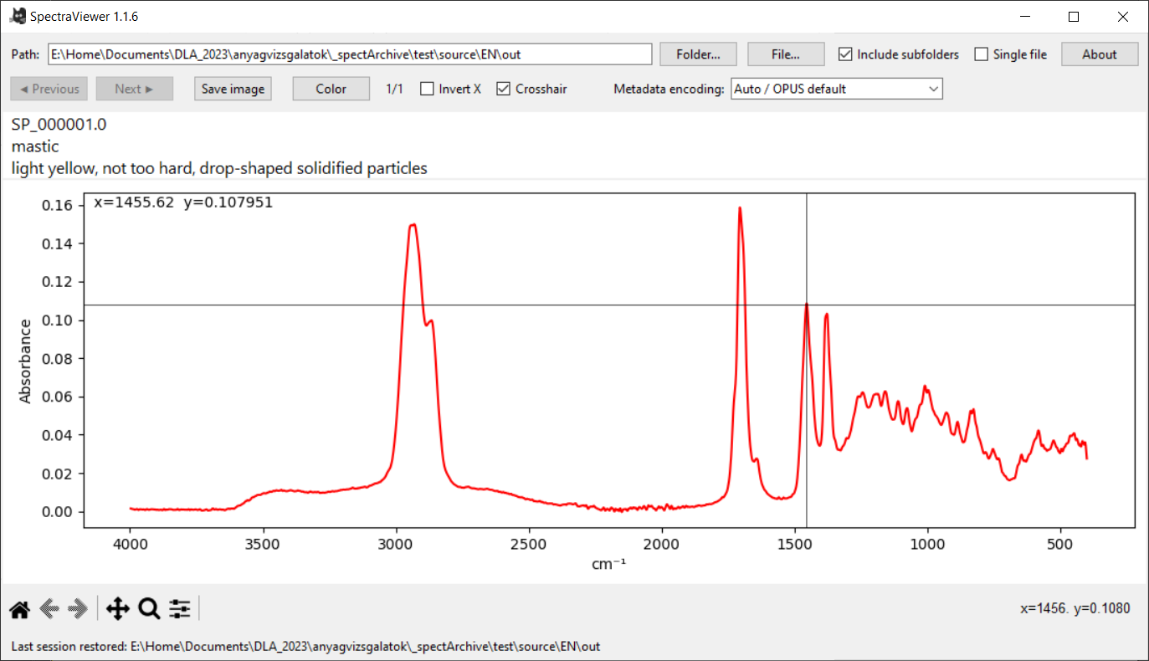
Figure 1. SpectraViewer main window with a loaded spectrum.

5.1 Main controls
Control | Function
Path field | Shows the current path or folder context. It can also be used to type or paste a file or folder path and open it with Enter.
Folder… | Opens a folder and builds a navigable list from supported spectrum files found there. If Include subfolders is enabled, subfolders are scanned as well.
File… | Opens one or more supported spectrum files. In normal mode, opening one file builds a folder-context list; selecting multiple files creates a custom list.
Include subfolders | Controls whether folder scanning is limited to the current folder or includes the full folder tree below it.
Single file | Loads only one selected spectrum without collecting surrounding files. While enabled, Include subfolders is disabled temporarily.
About | Displays version information, supported formats, and keyboard shortcuts.
Previous / Next | Moves through the active file list. These buttons are disabled automatically when the active list contains fewer than two spectra.
Save image | Exports the currently displayed plot as an image file.
Color | Changes the display color of the spectrum curve.
Invert X | Controls the display direction of the x-axis. For FTIR-style wavenumber display, the axis is usually shown from high to low wavenumber.
Crosshair | Displays coordinate-reading helper lines in the plot area. The crosshair can also be toggled with the right mouse button inside the plot area.
Metadata encoding | Manual code-page override for displaying OPUS metadata. The setting affects display only and does not modify spectrum files.

5.2 Spectrum display area
The central plot area shows the currently selected spectrum. The header above the plot displays the file name and, when available, the most relevant metadata fields such as sample name and sample form. For OPUS files, SpectraViewer attempts to display the most recently edited metadata. If a file does not contain these metadata fields, the corresponding lines remain empty.
When the crosshair is enabled, the cursor position is followed by horizontal and vertical helper lines. The current coordinates are displayed in the plot area and can be useful for approximate peak position reading or quick visual checking.

5.3 Matplotlib toolbar and status bar
The Matplotlib toolbar below the plot provides standard viewing tools such as home view, pan, zoom, and subplot adjustment. SpectraViewer removes the default Matplotlib save button from the toolbar and provides its own Save image function instead.
The status bar shows short feedback messages, such as the active file path, save status, warnings, error information, or startup messages from automatic state restoration.

6. Loading files and folders

6.1 Opening a folder
Use Folder… to select a directory. SpectraViewer scans the selected directory for supported spectrum files and builds a navigable list. If Include subfolders is active, the scan is recursive.

6.2 Opening one file
In normal mode, opening a single supported file does not necessarily create a one-file view. Instead, SpectraViewer uses the file as an entry point into its folder context and builds a list from the surrounding supported files. The selected file becomes the current position in that list.

6.3 Opening multiple files
When multiple files are selected in the file dialog, SpectraViewer creates a custom list from the selected supported files. Unsupported items are skipped, and a warning may be displayed if unsupported files were selected.

6.4 Typing or pasting a path
The Path field can be used to type or paste a file or folder path. Press Enter to open it. If the path is a folder, the folder is scanned. If the path is a supported spectrum file, SpectraViewer applies the current loading logic: folder context in normal mode, or one-file loading in Single file mode.

7. Single file mode
Single file mode was introduced in version 1.1.5 to provide a clear, intentional alternative to the normal folder-context browsing logic. It is useful when the user wants to inspect exactly one spectrum without collecting neighboring files.
When Single file mode is enabled, the Include subfolders option is temporarily disabled. SpectraViewer preserves the previous Include subfolders state internally. If a spectrum is already loaded, the active list is reduced to the current file and the counter changes to 1/1.
While Single file mode is active:
- Opening one supported file loads only that file.
- Dropping one supported file loads only that file.
- Dropping or selecting multiple files is rejected with a warning.
- Opening a folder is not allowed, because folder loading contradicts the single-file logic.
- Previous and Next navigation controls are disabled because there is no multi-file list to browse.
When Single file mode is turned off, SpectraViewer restores the previous Include subfolders setting and attempts to rebuild the folder context from the current spectrum. If the restored list contains at least two spectra, navigation becomes available again.

8. Navigation and plot controls

8.1 Spectrum navigation
The Previous and Next buttons move through the active list. Navigation wraps around at the beginning and end of the list. The Home and End keys jump to the first and last item, while PageUp and PageDown jump by larger steps.
Version 1.1.5 disables Previous and Next automatically when the active list contains zero or one spectrum. This avoids misleading navigation controls when there is nothing to browse.

8.2 X-axis direction
The Invert X checkbox controls whether the x-axis is displayed in reversed order. This is useful for FTIR-style wavenumber display, where spectra are commonly shown from higher to lower wavenumber.

8.3 Crosshair
The Crosshair option displays horizontal and vertical helper lines that follow the cursor in the plot area. It can be toggled by the checkbox or by right-clicking inside the spectrum display area. If the crosshair is visible when saving the plot, it will be included in the exported image.

8.4 Spectrum color
The Color button opens a color chooser and changes the line color of the displayed spectrum. This can be useful for preparing quick illustrations or for adapting exported images to a specific document style.

9. Drag and drop
If tkinterdnd2 is available, SpectraViewer accepts drag-and-drop input from the file manager. Users can drop one or more files, folders, or mixed selections onto the application window.
A single dropped file follows the same logic as a typed path or file-dialog selection. In normal mode, it loads the folder context. In Single file mode, it loads only the dropped file.
Multiple dropped items are treated as an ad-hoc playlist in normal mode. Supported files are collected, folders are expanded according to the current Include subfolders setting, duplicates are removed, and unsupported files are skipped. In Single file mode, dropping multiple items is rejected with a warning.
This behavior is useful when files are selected manually from different folders or from a Windows Explorer search result and then dropped into SpectraViewer as a temporary browsing set.

10. Exporting plots
Use Save image to export the currently displayed spectrum plot. Supported output formats include PNG, JPEG, PDF, and SVG, depending on the selected file extension and Matplotlib support.
The saved image reflects the current visible plot state. If the crosshair is enabled and visible, it is included in the exported image. If the crosshair is disabled, it is not included.

11. Saved settings and automatic state restoration
Version 1.1.6 introduces settings memory. When the program exits, it automatically saves the most important user settings to SpectraViewer.ini, located in the same folder as the program. If the INI file does not yet exist, the program creates it.
The INI file currently stores the following state information:
- spectrum curve color;
- crosshair state;
- Invert X state;
- Single file mode state;
- Include subfolders state;
- window size and position;
- last used file or folder path;
- metadata encoding setting.
At startup, the program loads the state stored in the INI file. If the last used path still exists, SpectraViewer automatically attempts to restore the corresponding file or folder according to the saved settings. If the path no longer exists, the program does not display a separate warning dialog; instead, it reports the problem in the status bar.
To restore the default state, delete SpectraViewer.ini. At the next startup, the program will use its default settings and will create a new INI file when it exits.
Automatic restoration is intentionally conservative: if the saved folder would contain too many files, or if the saved path cannot be interpreted as a supported spectrum input, the program does not interrupt startup. It shows status-bar feedback and lets the user choose a new file or folder manually.

12. Metadata encoding and code page selection
Version 1.1.6 adds the Metadata encoding drop-down list. The purpose of this feature is to let the user try to improve the display of metadata that appears incorrectly because of a different or problematic text encoding.
This setting affects metadata display only. SpectraViewer does not physically rewrite or recode spectrum files, and the x/y spectrum data are not changed. The feature works as a display override.
The current drop-down options are:
- Auto / OPUS default
- Windows-1252 / Western European
- Windows-1250 / Central European
- UTF-8
- Latin-1 / ISO-8859-1
- Latin-2 / ISO-8859-2
The Metadata encoding selector can be used to improve the display of text metadata in OPUS and JCAMP-DX files when accented characters or other non-ASCII characters appear incorrectly. The setting affects metadata display only; spectrum files are not modified.
Auto / OPUS default preserves the previous SpectraViewer behavior. Manual options such as Windows-1250, Windows-1252, UTF-8, Latin-1, and Latin-2 let the user test alternative decoding settings when metadata appears garbled.
For Hungarian metadata, Windows-1250 / Central European is usually the first setting to try, especially for files originating from Windows-based workflows. Latin-2 / ISO-8859-2 is also a Central European code page and may give the same result for some Hungarian characters, but Windows-1250 is usually the more natural choice.

13. Notes, limitations, and file-count safeguards

13.1 Not a processing tool
SpectraViewer is intended for viewing and browsing. It does not apply baseline correction, normalization, smoothing, spectral identification, database searching, or other analytical processing steps.
SpectraViewer displays a single spectrum at a time. It does not provide stacked or overlaid multi-spectrum views, as commonly used in dedicated spectral evaluation or processing software.

13.2 OPUS file complexity
Some OPUS files can contain multiple data blocks, such as single-channel data, reference data, mapping points, images, or other auxiliary information. In such cases, SpectraViewer may not always display the spectrum that the user expects as the primary spectrum. If a complex OPUS file does not display correctly, extracting the desired spectrum within OPUS and opening the simpler extracted file may help.

13.3 Metadata differences
Different supported formats store metadata differently. Some files contain sample names, sample forms, or labels; others contain only x/y data. SpectraViewer displays available metadata when it can read it, but the absence of metadata is not treated as an error.

13.4 File-count safeguards
To avoid excessive memory use and very slow operation, SpectraViewer checks the number of files before replacing the active list. Large lists may trigger a warning. If a scan exceeds the configured maximum, the operation is cancelled and the previous valid list is preserved.
Version 1.1.4 improved this behavior so that rejected scans no longer overwrite the previously loaded safe state. Version 1.1.5 kept this behavior and extended the navigation state logic to zero- and one-file lists. Version 1.1.6 also handles startup restoration conservatively, so that large or problematic saved paths do not cause unexpected startup problems.

14. Citation, DOI, and license
SpectraViewer 1.1.5 is archived on Zenodo and can be cited as research software.
Version DOI: 10.5281/zenodo.20715099
The GitHub repository also contains a CITATION.cff file so that GitHub can display citation information for the project.
SpectraViewer is released under the MIT License. The license text is included in the repository as LICENSE.
SpectraViewer was developed by Zsolt Hidasi with assistance from OpenAI ChatGPT during design, refactoring, documentation, and release preparation.

Appendix A. Keyboard shortcuts
Shortcut | Action
Ctrl+O | Open file
Ctrl+Shift+O | Open folder
Left / Right | Previous / Next spectrum
Home / End | First / Last spectrum
PageUp / PageDown | Jump backward / forward through the active list
Ctrl+S | Save current plot as image
Ctrl+Shift+C | Change spectrum color
F1 | Open the About window

Appendix B. Version 1.1.6 change summary
- Added Metadata encoding drop-down list for manual display override of incorrectly displayed OPUS metadata.
- Code-page options: Auto / OPUS default, Windows-1252, Windows-1250, UTF-8, Latin-1 / ISO-8859-1, and Latin-2 / ISO-8859-2.
- Code-page selection affects metadata display only; spectrum files are not physically modified.
- Added SpectraViewer.ini-based settings memory in the program folder.
- Automatic save on exit: color, crosshair, Invert X, Single file mode, Include subfolders, window size and position, last path, and metadata encoding.
- Automatic state restoration at startup based on the INI file.
- Automatic attempt to reopen the last used file or folder according to the saved settings.
- Silent status-bar feedback if the saved path is missing, deleted, or temporarily unavailable.
- Restoring defaults by deleting SpectraViewer.ini is documented.
- The version 1.1.5 Single file mode, navigation-state handling, and localized UI structure are preserved.

