Harmonic (Gartley) Pattern Recognizer

**Mathematical background**:

1. Fibonacci

Fibonacci sequence: 0, 1, 1, 2, 3, 5, 8, 13, 21, 34, 55, 89, 144

Fibonacci ratios **forward**: 0, 1, 0.5, 0.66, 0.6, 0.625, 0.615... **converges to 0.618.**

„Forward” means dividing each number by the number in front of it to get the ratios.

Fibonacci ratios **backward**: inf., 1, 2, 1.5, 1.66, 1.6, 1.625, 1.615... **converges to 1.618.**

„Backwards” means dividing each number by the number behind it.

There are other ratios, for example dividing each number by the number located 2 steps away (1/2 or 3/8) converges to a different number. There’s a whole family of Fibonacci ratios.

1/0.618 = 1.618 and 1/1.618 = 0.618 🡪 „**Golden Ratio**”

2. Retracements

A retracement is basically a price movement that goes against the price movement before it, „retracing” that earlier movement.

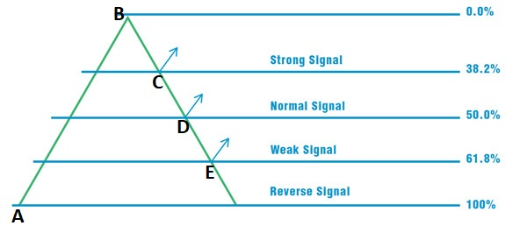

C = 38.2 Retracement of AB

D = 50.0 Retracement of AB

E = 61.8 Retracement of AB

For example, if we were to take the price difference between A & B, and calculate the fibonacci ratios, we would get the length of the BE retracement, which is AB * 0.618 (61.8 % of AB).

So putting these retracements together we get patterns.

**Gartley pattern**:

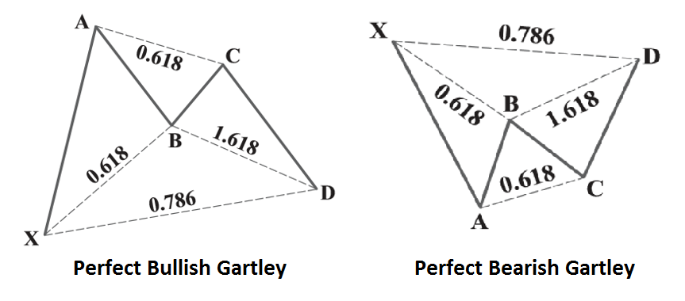

AB is a retracement of XA, BC is a retracement of AB, and CD is a retracement of BC.

Dashlines indicate just about how much of a retracement that retracement should be.

Example: XA * 0.618 = AB, AB * 0.618 = BC, BC * 1.618 = CD or XA * 0.786 = CD.

These numbers are for demonstration only, they may vary, although not by a great margin. XA is the longest, AB should be close to CD in length and the full (ABCD) retrace should be between 0.618 and 0.786 for this pattern to work.

**Implementation**:

After importing our current .csv dataset to work on, we need to identify our price points (X,A etc.). In order to do that, we must find local (relative) extremas/peaks. This procedure is implemented in harmonic_patterns.py’s find_peak function.