***Bug 01***

**Summary**: Typo in the tab of browser ’Factoriall’

**Steps to reproduce:**

1. Open the <http://qainterview.pythonanywhere.com/> in a browser.
2. Check the name of the browser’s tab.

**Actual result:** There is a typo in the name of browser’s tab: ’Factoriall’. Extra ’l’ letter at the end.

**Expected result:** Name of browser’s tab is ‘Factorial’.

**Screenshot:**



***Bug 02***

**Summary**: No error message in case of typing negative integer.

**Steps to reproduce:**

1. Open the <http://qainterview.pythonanywhere.com/> in a browser.
2. Type a negative integer in the input field.
3. Click on ‘Calculate!’.

**Actual result:** Nothing happens, there is no warning or error message. In the browser’ console ‘INTERNAL SERVER ERROR 500’ appears.

**Expected result:** Error or warning message.

**Screenshot:**

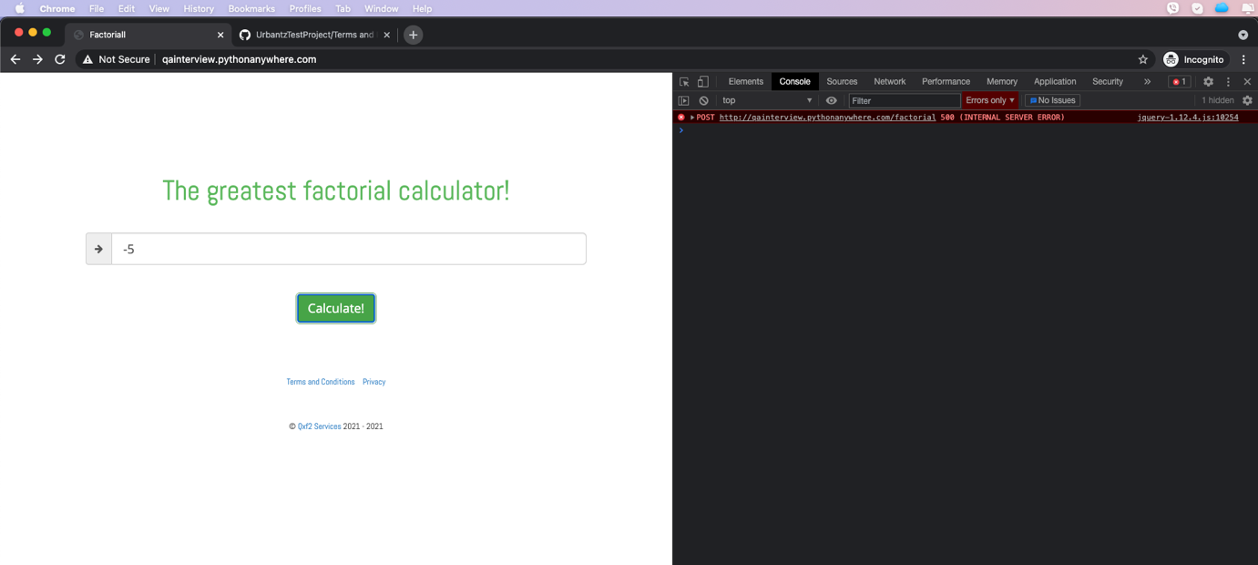

***Bug 3***

**Summary**: ‘Terms and Conditions’ link points to the ‘Privacy’ page.

**Steps to reproduce:**

1. Open the <http://qainterview.pythonanywhere.com/> in a browser.
2. Click on the ‘Terms and Conditions’ link.

**Actual result:** The ‘Terms and Conditions’ link points to the ‘Privacy’ page: <http://qainterview.pythonanywhere.com/privacy>

**Expected result:** The link points to the ‘Terms and Conditions’ page: <http://qainterview.pythonanywhere.com/terms>

***Bug 4***

**Summary**: ‘Privacy’ link points to the ‘Terms and Conditions’ page.

**Steps to reproduce:**

1. Open the <http://qainterview.pythonanywhere.com/> in a browser.
2. Click on the ‘Privacy’ link.

**Actual result:** The ‘Privacy’ link points to the ‘Terms and Conditions’ page: <http://qainterview.pythonanywhere.com/terms>

**Expected result:** The link points to the ‘Privacy page: <http://qainterview.pythonanywhere.com/privacy>

***Bug 05***

**Summary**: Handling floating numbers.

**Steps to reproduce:**

*Case1*

1. Open the <http://qainterview.pythonanywhere.com/> in a browser.
2. Type a floating number e.g. 5.3
3. Click on ‘Calculate!’.

Case2

1. Open the <http://qainterview.pythonanywhere.com/> in a browser.
2. Type a floating number e.g. 5.0
3. Click on ‘Calculate!’.

**Actual result:**

In Case1 the input field gets a red boarder and there is no console error.

In Case2 the input field remains the same without red boarder but there is an ‘INTERNAL SERVER ERROR 500’ error in the browser’s console.

**Expected result:** Handling the floating numbers consistently: same error messages, etc.

**Screenshot:**

Case1

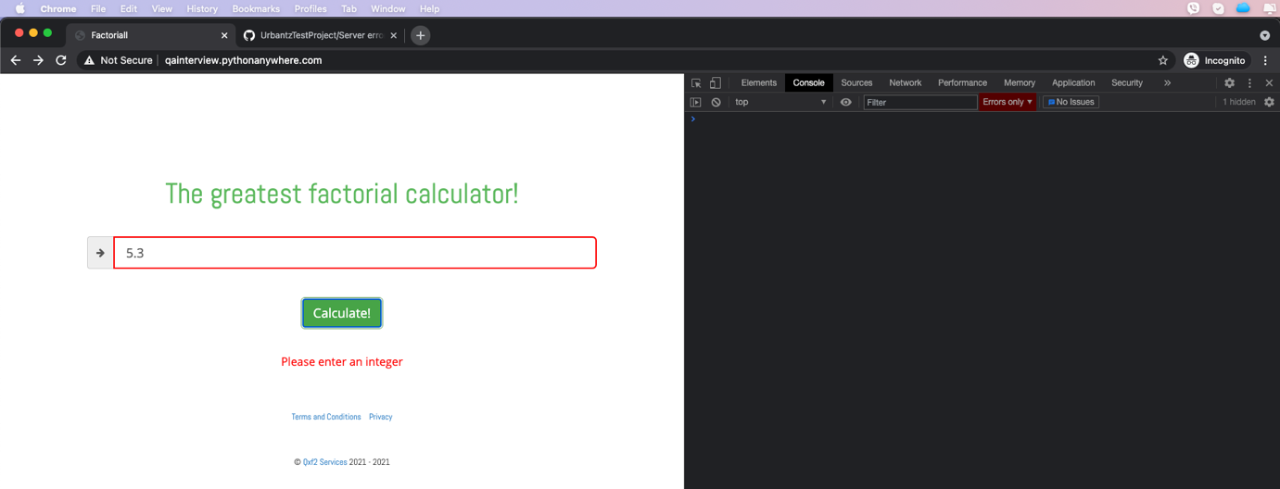

Case2

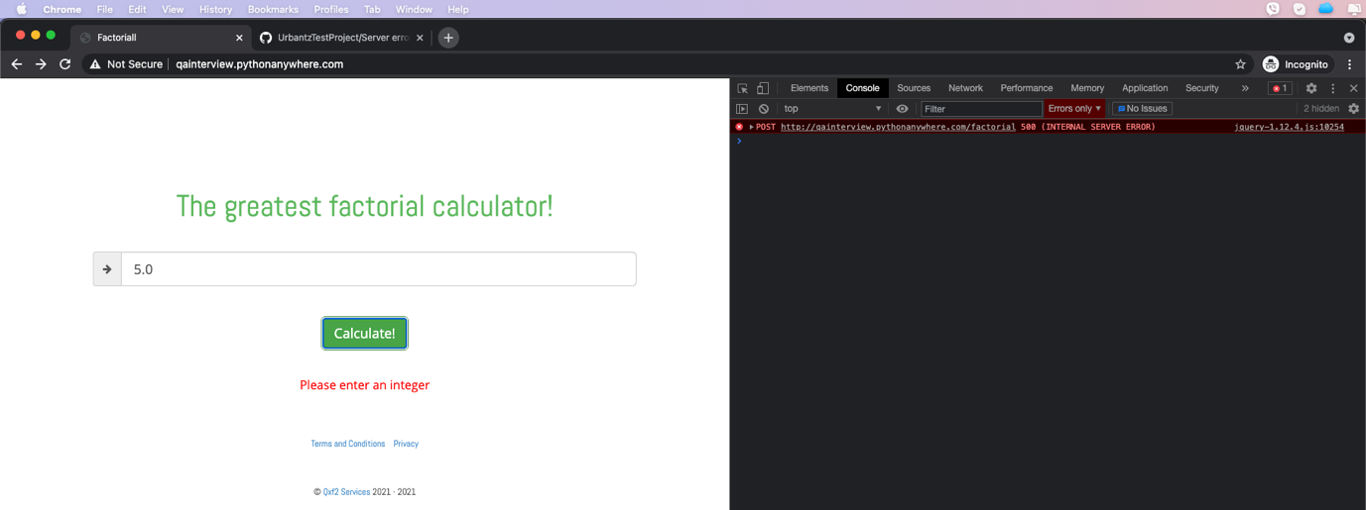

***Bug 06***

**Summary**: Internal Server Error 500 if the integer is greater than 989.

**Steps to reproduce:**

1. Open the <http://qainterview.pythonanywhere.com/> in a browser.
2. Type 990 in the input field.
3. Click on ‘Calculate!’.

**Actual result:** Nothing happens, there is no warning or error message, the user gets back the ‘Infinity’ result. In the browser’ console ‘INTERNAL SERVER ERROR 500’ appears.

**Expected result:** Error or warning message that the number is too high and the server cannot handle it etc.

**Screenshot:**

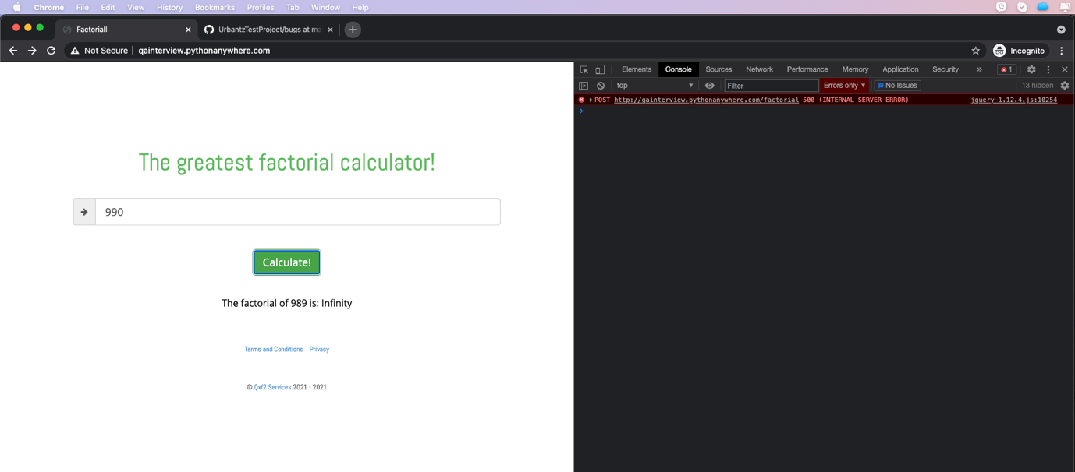

***Bug 07***

**Summary**: Hit ENTER is not working.

**Steps to reproduce:**

*Case1*

1. Open the <http://qainterview.pythonanywhere.com/> in a browser.
2. Type an integer in the input field
3. Hit ENTER on your keyboard.

**Actual result:**

Nothing happens.

**Expected result:** When the user hit ENTER the calculation should be done, the same behavior if you click on ‘Calculate!’ button.

***Bug 08***

**Summary**: Console error occurs after loading the page in Firefox browser.

**Steps to reproduce:**

1. Open the <http://qainterview.pythonanywhere.com/> in a browser.
2. Check the browser’s console error.

**Actual result:**

HTTP 404 error occurs in Firefox after loading the page.

**Expected result:** No console error after loading the page in any browser.

**Screenshot:**

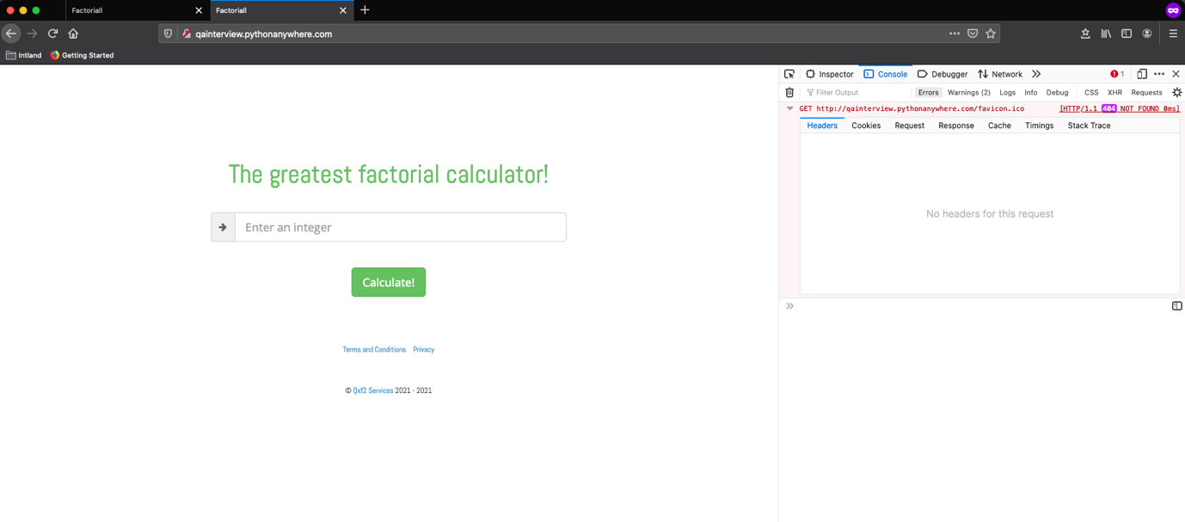

***Bug 09***

**Summary**: The result is ‘Infinity’ although in the REST response the correct result is displayed.

**Steps to reproduce:**

1. Open the <http://qainterview.pythonanywhere.com/> in a browser.
2. Type a high integer in the input field e.g. 850.
3. Check the result in the browser’s network tab.

**Actual result:**

If you check the ‘factorial’ POST request’s response in the network tab you can find that the result is a valid number. However, in the UI the ‘Infinity’ result is displayed.

**Expected result:** The correct result should be displayed in the UI as well.

**Screenshot:**

