Evento Documentation

  - Introduction:
Evento is a full-stack web application designed for event-venue booking, providing a smooth experience for both venue owners and customers. Built with .NET 9 Minimal APIs, Angular 18, and a clean architecture approach.

- Tech used:

  - Backend (API)

- .NET 9 Minimal APIs
- Clean Architecture (Domain, Application, Infrastructure, API layers)
- FluentValidation for endpoint and request validation + CQRS
- Entity Framework Core + PostgreSQL
- SignalR for real-time chat
- Stripe for secure payment handling
- Quartz.NET for background jobs
- Brevo (SendinBlue) for transactional emails
- JWT Authentication & Authorization

  - Frontend (Client App)

- Angular 18
- PrimeNG as the main UI component library
- TailwindCSS for utility-first styling
- SignalR Client for real-time chat and notifications

- Architecture and project structure

Evento follows Clean Architecture, ensuring separation of concerns and long-term maintainability.

- Domain Layer
- Core entities (Venue, Booking, User, Payment, ChatMessage)
- Business rules and abstractions

- Application Layer
- Use cases / Features (CreateBooking, GetVenues, etc.)
- Service interfaces
- FluentValidation rules

- Infrastructure Layer
- EF Core repositories
- Stripe, Brevo, Quartz integrations

- API Layer
- Minimal API endpoints
- Authentication & Authorization
- Endpoint mapping
- Filters and middleware

- Core features
Venue Management
- Browse venues
- Detailed venue pages with pricing, capacity, availability calendar
Booking System
- Book a venue for a specific date/time
- Stripe payment processing
- Email confirmation (Brevo)
- Automated booking cancellation (Quartz jobs)
User Accounts
- Registration & login using JWT
- Booking history

Real-Time Chat (SignalR)
- Live chat between customers and venue administrators
- Online status & message delivery indicators
Admin Tools
- Venue approval & management
- Booking management

- Usage guide

  - Register

The Register screen allows new users to create an account by providing a unique username, a unique email address, and a secure password. Users must enter a password that is at least 12 characters long and includes at least one uppercase letter and one special symbol. They must then confirm the password, and both entries must match exactly. Validation ensures usernames and emails are not already in use and that password requirements are met before the account can be created.
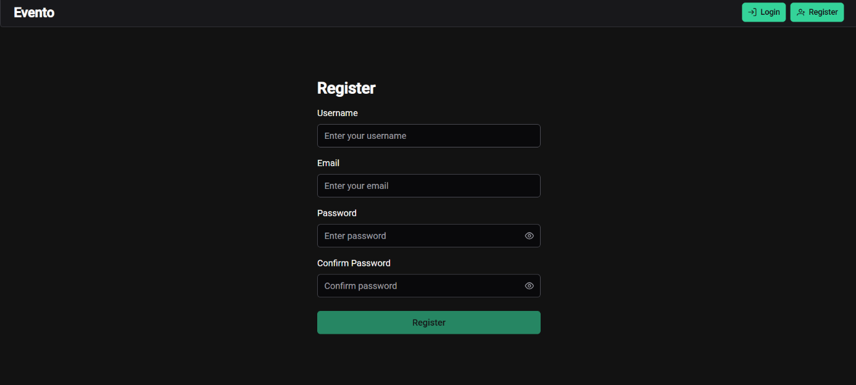
Clear error messages are shown when validation fails, such as when the email or username already exists, the password is too weak, or the confirmation password does not match. Only after all fields pass validation can the user successfully complete registration.

    - Login
The Login screen allows existing users to access their accounts by entering their registered email and password. The system verifies that the provided email exists and that the password matches the one stored for that user. If the email is not found, the user receives an “invalid email” message, and if the password is incorrect, the system returns an “email or password incorrect” error. Both fields are required before the login attempt can be processed.
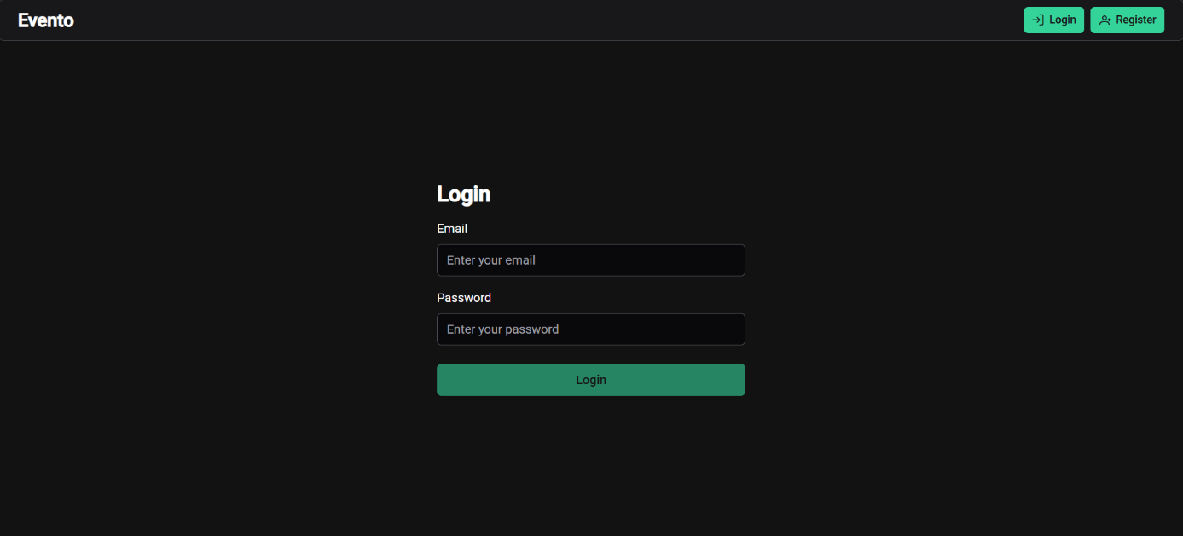
When the credentials are valid, the system signs the user in and issues a JWT authentication token that grants access to protected areas of the application.

    - Venues Page
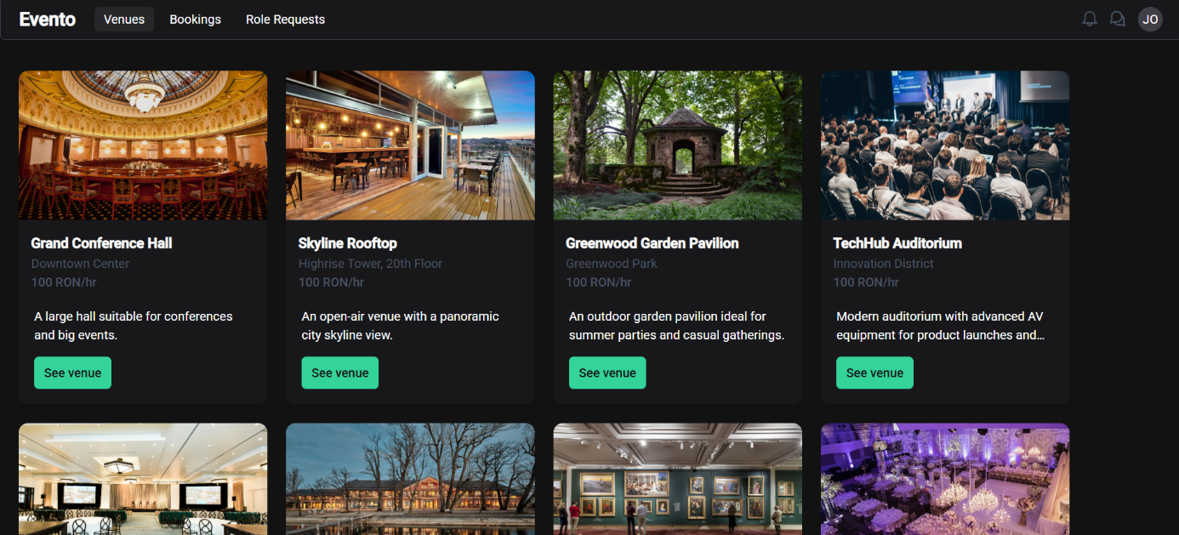

Upon successful login, if the authenticated user has only the User role, they are automatically redirected into the main application. The first page they see is the Venues page, which displays a list of available venues. Each venue entry shows essential details, including the venue’s name, description, and location, giving the user a clear overview of what the venue offers. Every listing also includes a “See Venue” button that, when clicked, redirects the user to the Booking page for that specific venue, allowing them to view more details and proceed with scheduling their reservation.

    - Venue page (with booking option)
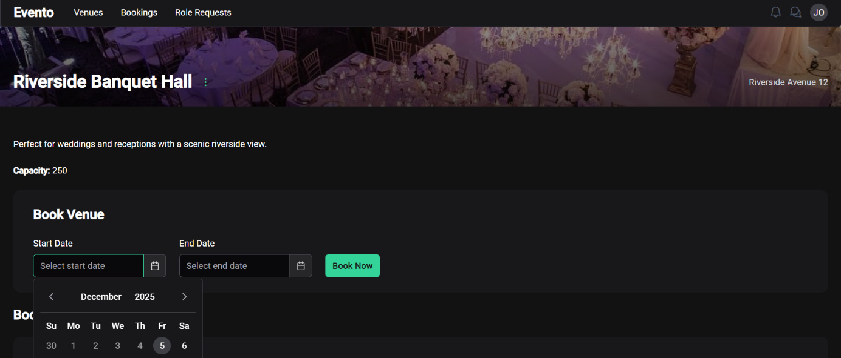

The Venue page provides users with detailed information about a selected venue, including its full description, location, available features, and any other relevant details. From this page, users can initiate the booking process by selecting a start date, start time, end date, and end time, with bookings made on an hourly basis. After entering the required information, the user submits the booking request, which is then created in a Pending state. The venue administrator will later review the request and either approve or reject it.
The booking system includes essential validations to ensure proper scheduling: it checks for overlapping bookings to prevent conflicts, verifies that the start date and time occur before the end date and time, and ensures all fields are completed correctly.
Additionally, this page gives users the option to request venue admin access for the current venue. By submitting this request, the user expresses interest in becoming an administrator for that specific venue, and their request can later be reviewed and approved or rejected by the appropriate venue administrators.
    - Role requests page
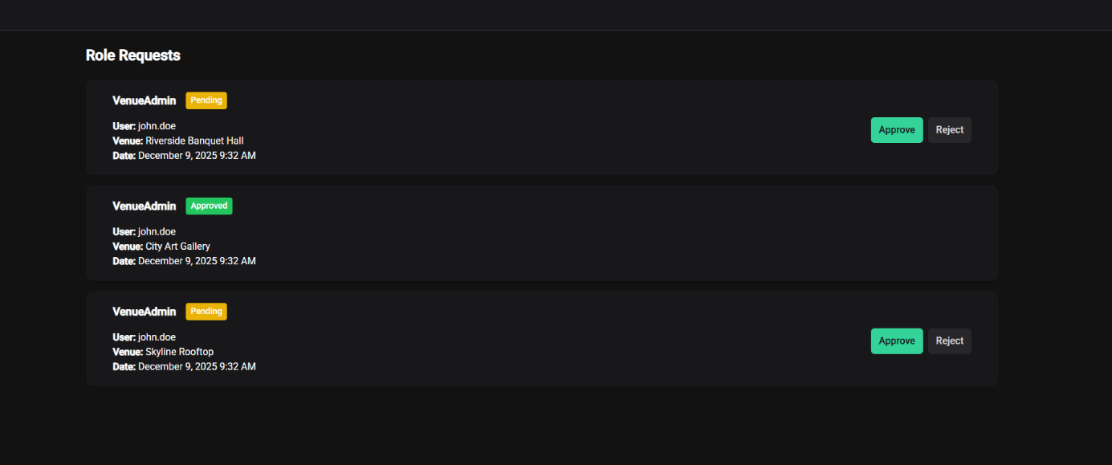

The Role Requests page displays all submitted requests from users who want to become venue administrators. Each request is shown in a clear, read-only format, including details such as the requested role (e.g., VenueAdmin), the current status (Pending, Approved, or Rejected), the requesting user (e.g., john.doe), the venue name (e.g., Riverside Banquet Hall), and the date and time the request was submitted (e.g., December 9, 2025, 9:32 AM). Regular users can only view their own requests on this page, allowing them to check the progress of their application without being able to make any changes.
For users who are already venue administrators, the Role Requests page includes additional actions, like approve or reject incoming requests.

    - Bookings page
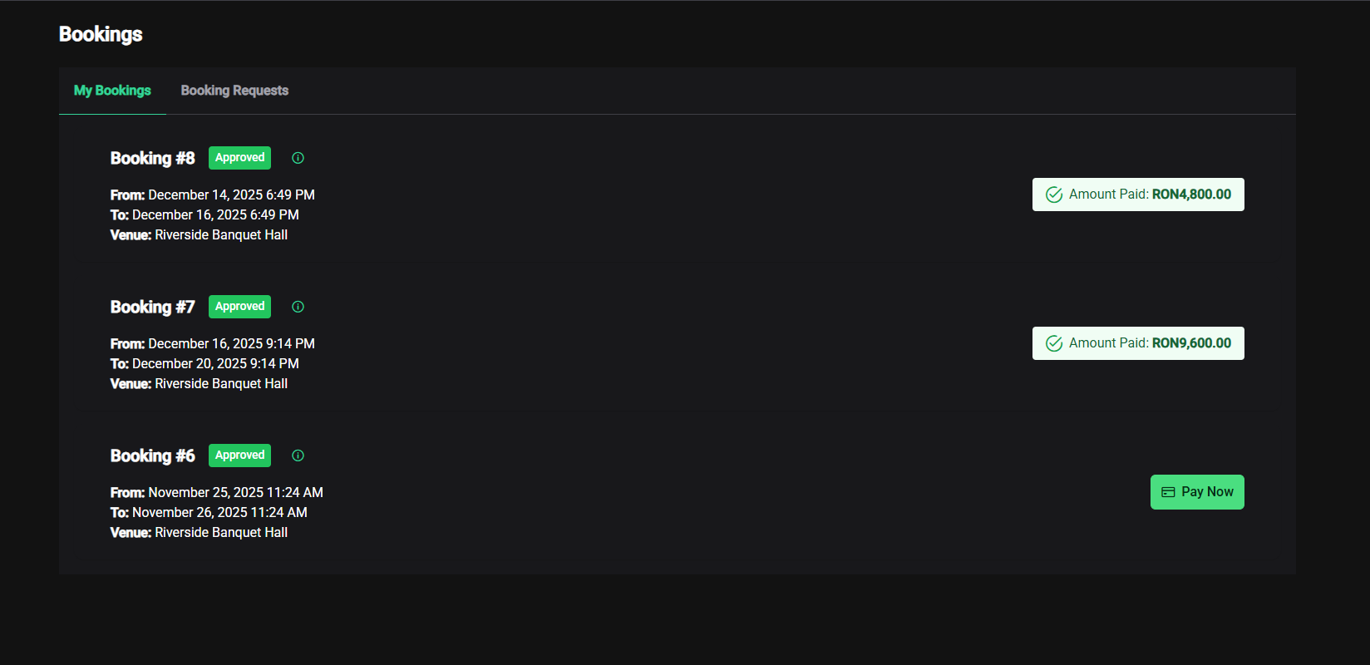

The Bookings page allows users to view all the bookings they have made within the application, along with their current status. Each booking is displayed with clear details such as the booking number (e.g., Booking #8), status (Pending, Approved, or Rejected), the start date and time, end date and time (e.g., From December 14, 2025, 6:49 PM — To December 16, 2025, 6:49 PM), the venue name (e.g., Riverside Banquet Hall), and the amount paid (e.g., RON 4,800.00). When a booking has been approved, a “Pay Now” button becomes available, allowing the user to complete payment directly from this page.
Users also have limited management options for their bookings. While a booking is still in the Pending state, the user can edit the start date and end date or cancel the booking entirely. Once the booking has been approved and paid, these editing options are no longer available. For administrative roles, both App Admins and Venue Admins can review incoming booking requests on the Booking Requests tab, where they have the authority to approve or reject bookings, ensuring that venue schedules remain organized and conflict-free.

    - Payment screen
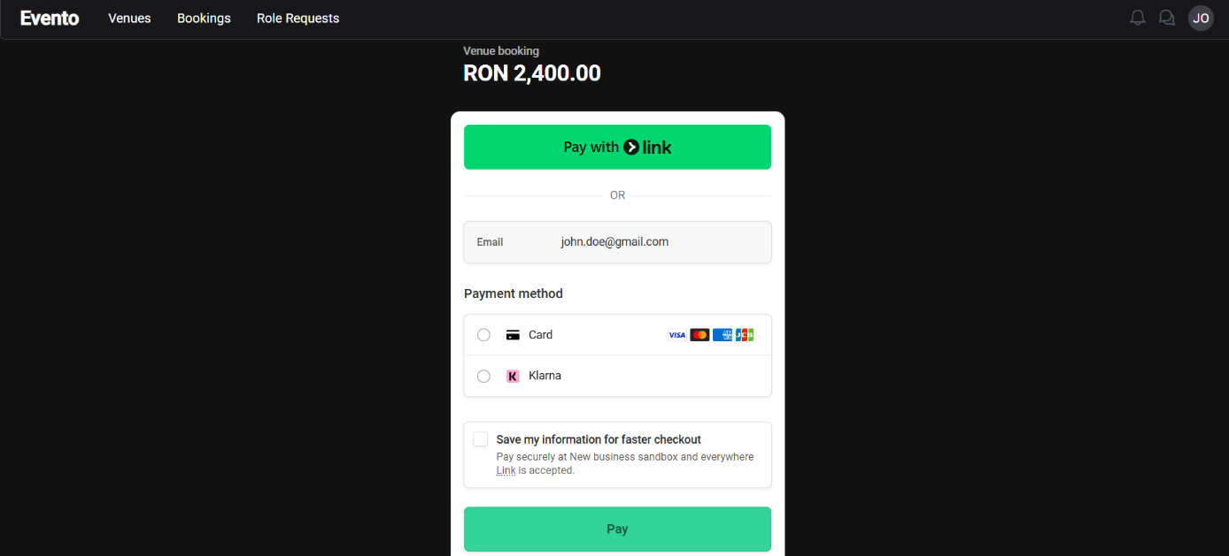

The Payment screen is accessed when the user clicks the “Pay Now” button on an approved booking. This action redirects the user to a Stripe Checkout page, which is currently operating in test mode. Stripe Checkout provides a secure, streamlined payment experience where the user can review the booking details and complete the transaction using supported test payment methods.
Since the system is running in test mode, users must use Stripe test card numbers to simulate real payments. The most commonly used test card is 4242 4242 4242 4242 with any future expiration date, any three-digit CVC, and any billing details. Additional Stripe test cards can be used to mimic specific scenarios, such as:
- 4000 0000 0000 9995 – Payment requires authentication
- 4000 0000 0000 0002 – Declined card
- 4000 0027 6000 3184 – Insufficient funds
After a successful test payment, the booking is marked as paid, and the user is redirected back to the app with a confirmation message, completing the payment process smoothly and securely.

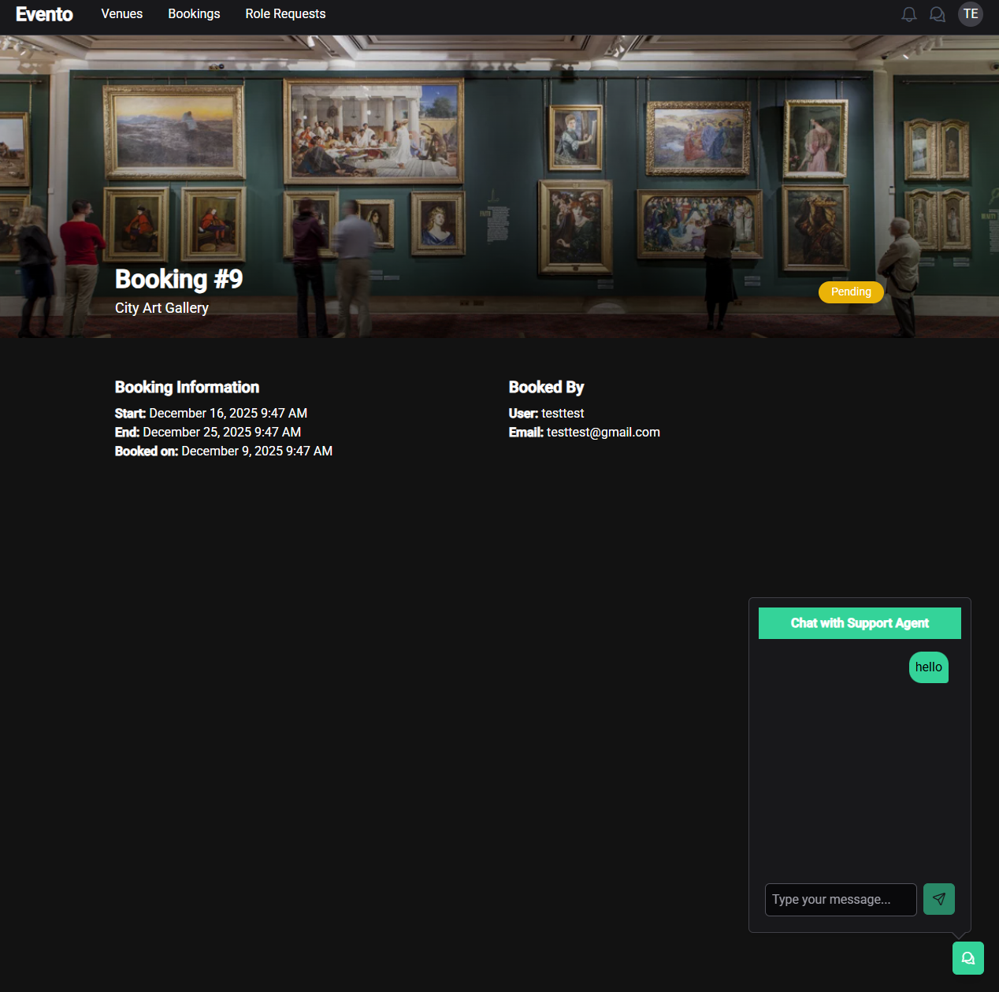
    - Chatting feature

Once a reservation has been made, the user can open the Booking Details page for that specific reservation. Here, in addition to seeing all booking information, the user has access to a chat popup that enables direct communication with the venue administration. The user can send messages at any time to ask questions, clarify details, or discuss anything related to their booking.
When a venue admin responds for the first time, the chat becomes assigned exclusively to that admin, ensuring a consistent and personalized conversation. This prevents multiple admins from overlapping in the same chat and provides the user with a clear, uninterrupted communication channel. The chat feature enhances the user experience by offering quick support and strengthening coordination between the user and the venue.

    - Chat page
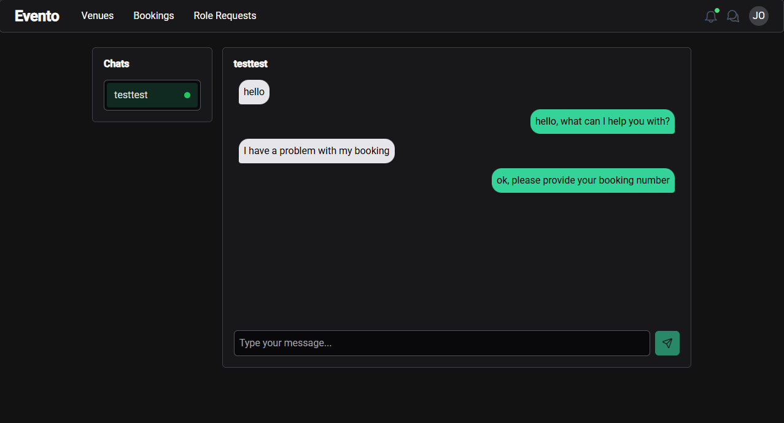

Once a chat is initiated, the full chat history between the user and the venue admin is displayed on the Chat Page, allowing both parties to see all previous messages in chronological order. Each message shows who sent it and the timestamp of when it was sent, providing clear context for the conversation. The chat interface is designed to auto-scroll to the latest message, ensuring users always see the most recent updates without manually scrolling.
Additionally, the chat system provides presence indicators, showing whether the other user (venue admin or regular user) is currently online while typing or reading messages

    - Notification center
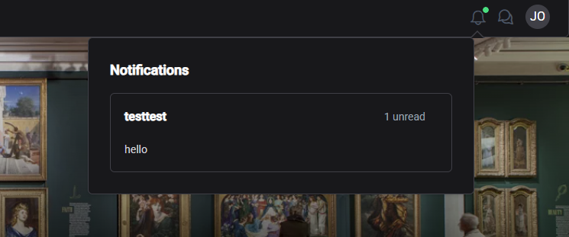

The Notification Center is a popup interface that consolidates all incoming messages and alerts within the app. Notifications are grouped by sender, showing the sender’s name, the time the message was received, and the count of unread messages for each conversation. This provides a quick overview of all pending interactions without needing to navigate through individual chats.
When a user clicks on a notification, they are immediately redirected to the relevant chat, allowing them to respond directly and continue the conversation seamlessly.

- AI project usage

6.0.1. Run fastapi with ai model:

uvicorn script:app --reload --host 127.0.0.1 --port 8000

6.0.2. Login to hugging face:

huggingface-cli login
Enter token: "hf_xxxxxxxxxxxxx" # paste your token here

6.0.3. Or add to code token with read access:

token = "hf_xxxxxxxxxxxxx" # paste your token here

tokenizer = AutoTokenizer.from_pretrained(model_name, use_auth_token=token)
model = AutoModelForCausalLM.from_pretrained(
model_name,
use_auth_token=token,
dtype="auto",
device_map="auto"
)

