Kókány Corporations
Team Description Materials

Logistical info
- Team Name:
- Organisation: Robot TÉP
- Country: Hungary
- Contact person: András Bakti
- Email: baktia@nyirszikszi.hu

The team
We are a Hungarian team, three high school students and our mentor Mr. András Bakti.
This is our first time competing, and we are very excited to put our robot, nicknamed Kókánybot, to the test.

- Máté Mester
  - Máté focuses on the mechanical aspect of our robot, he works on the assembly of the robot. He also deals with the logistical issues for the team.
- Dat Duy Tran
  - Dat also focuses on the mechanical aspect of the robot, he designs parts using CAD software and helps with the assembly of parts. He designed our custom robotic arm which uses stepper motors.
- Zsolt Vadász
  - Zsolt focuses on the software of the robot, both the controls, and the image recognition aspect of it.
- Mr. András Bakti
  - Mr. András Bakti is the team’s mentor, he helps with the acquisition of needed parts, and gives advice with the robot’s assembly and programming.

System description
- Our robot’s body consists of three 5mm plexiglasses. It uses a Raspberry Pi 4B+ as its onboard computer, along with four DC motors, a battery pack housing three 18650 power supplies, an MCP23017 integrated circuit to provide extra GPIO lines for stepper motors, a webcamera, and a 3D printed robot arm. For motor control, we use an L298N integrated circuit. We use an MQ-135-M smoke sensor for CO2 sensing.
- We interact with our robot using a custom control software, named KókányControl (kokanyctl). The program has a graphical interface for displaying the video and the sensor data it receives from Kókánybot. It takes keyboard input, and sends commands to the Raspberry Pi.
- The robot can be controlled via WiFi (2.4Ghz)

Setup and packup of the robot and operator station
- To set up the robot, we charge the 18650 batteries, put them into the battery pack, and flip a switch on our robot.
- For the operating station, we use a laptop. We connect to our portable WiFi router, and access the onboard computer’s web interface.

Mission strategy
We use standard, easily acquirable parts, which makes our robot truly rapidly manufacturable.

Experiments and Testing
We have conducted image recognition tests, and tested the movement of our robot in our school.

Strengths and real-life applications
We focused on making our robot compact, easily manufacturable and well-rounded, with portable software so the same program can be used with different single board computers.

What the team has learned so far
- This was our first time using CAD software, we gained experience with Fusion360 and TinkerCAD
- Instead of Python, we opted for C/C++ for the core functionality which enabled us to learn a lot about interacting with hardware at a lower level:
  - Using standard Linux APIs
  - Using I2C to communicate with integrated circuits
  - Reading datasheets
- We also learned a lot about various multimedia topics such as containers, codecs, pixel formats, hardware acceleration and compression
- We also experimented with various image recognition models

So far, prepairing for this competition has been a great learning experience for the entire team.

What we plan on doing between now and the competition
We still have many improvements to make both on the software, and the hardware.
- We plan to experiment with multiprocessing and multithreading, to be able to fully utilise all the processor cores on the Raspberry Pi 4B+
- We plan on fine-tuning our custom robotic arm and finishing its grabber part
- We plan on buying and installing a webcamera
- We plan on finishing our robot’s image recognition system

Costs
Component | Cost (in Euros)
Raspberry Pi 4B+ | 71
MCP23017 | 2.3
MQ-135-M | 2.1
4x 12V DC motors | 20.10
3x 3.7V mAh 18650 cells | 14.07
8x 28BYJ-48 | 42.8
3 slot 18650 battery pack | 5.02
12V DC step-down module | 1.56
Webcamera | 26.78
3D prints, plexiglass | ~60
L298N-MOD | 3.48
DIP28 IC socket | 0.75
2x LT-623 | 4.23
Overall cost of components | ~254.19

- The above costs have been converted from HUF
- The prices of all the components are listed, however we received some of them from sponsors or found them in our clubroom
- We did not have to pay for the 3D printing nor the plexiglasses because we had enough materials at hand, so those prices are a vague estimate

Software packages used
libgpiod | DC motor control, sensor control, stepper control | https://git.kernel.org/pub/scm/libs/libgpiod/libgpiod.git/about/
libi2c | Communicating with the MCP23017 | https://www.kernel.org/doc/html/v6.1/i2c/index.html
OpenCV | Image recognition | https://opencv.org/
FFmpeg | Video streaming, Image recognition backend (used by OpenCV) | https://ffmpeg.org/
SDL2 | Used by KókányControl to process keyboard input and display video | http://libsdl.org/
SDL2_ttf | Used by KókányControl to draw text for displaying sensor data | https://github.com/libsdl-org/SDL_ttf
SDL2_net | Used by KókányControl to handle networking | https://github.com/libsdl-org/SDL_net

Technical drawings and pictures

Custom socket and shaft for the DC motors
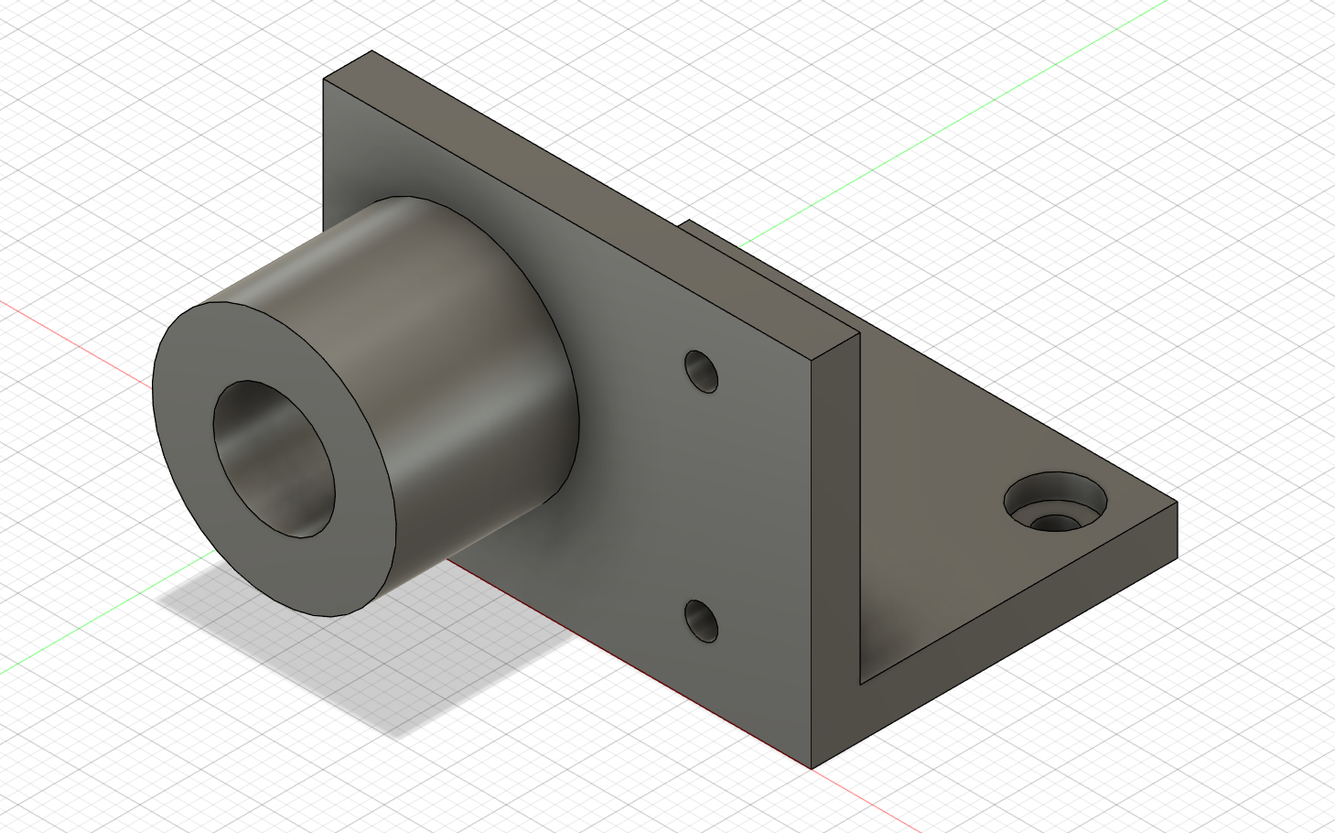
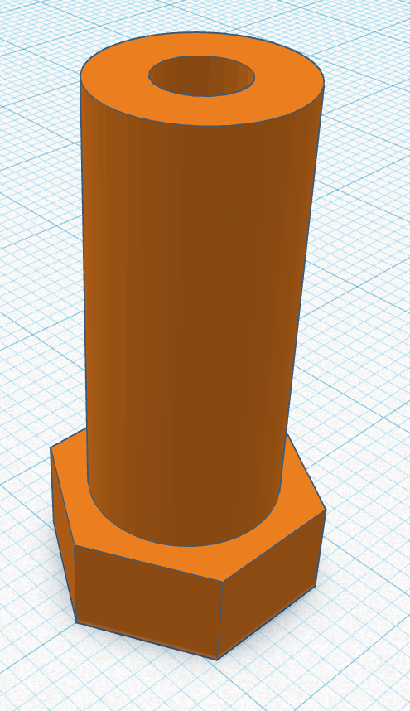
The three plexiglass sheets
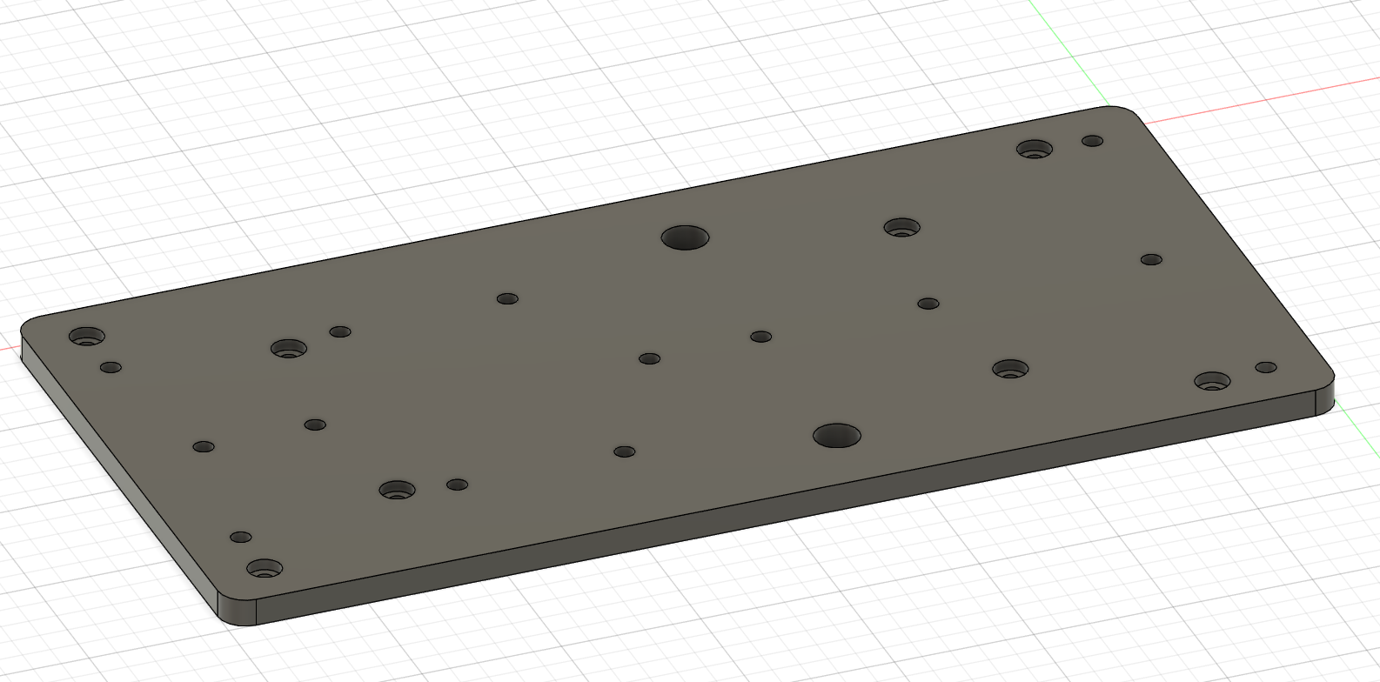
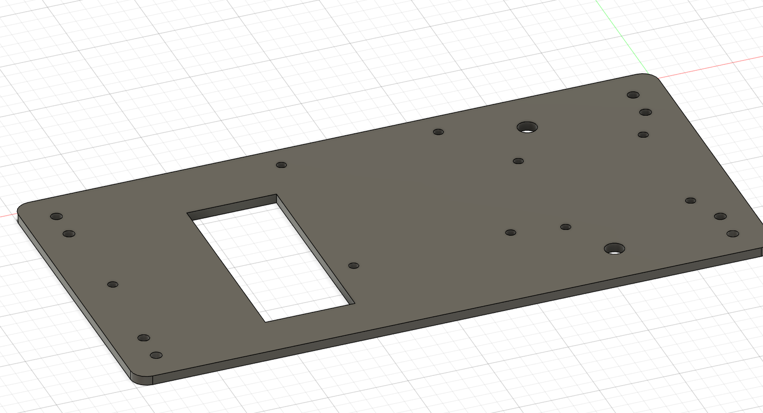
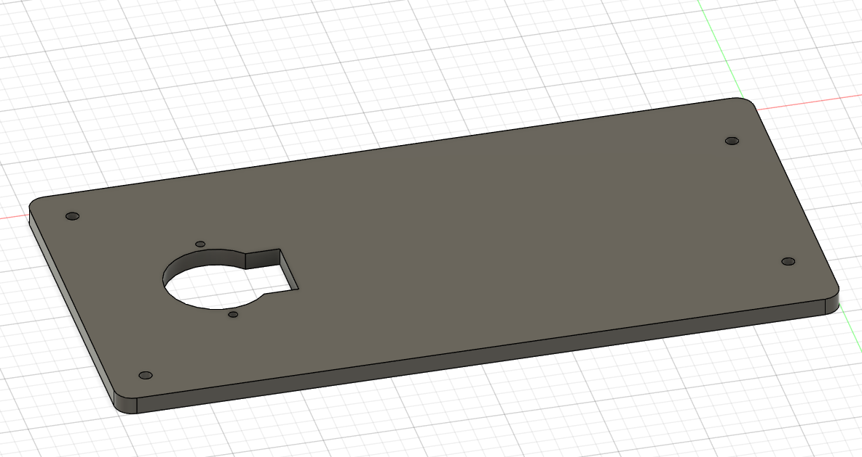
Finished parts of our robotic arm
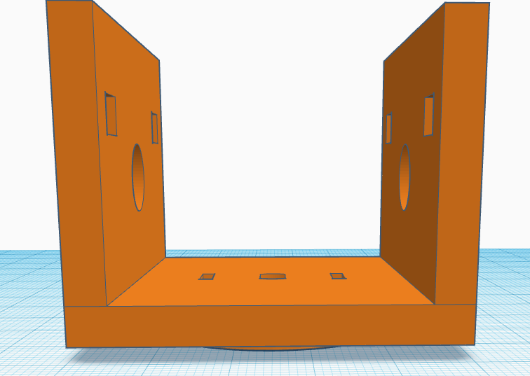
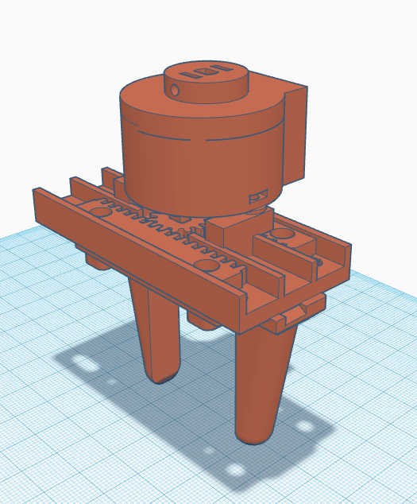
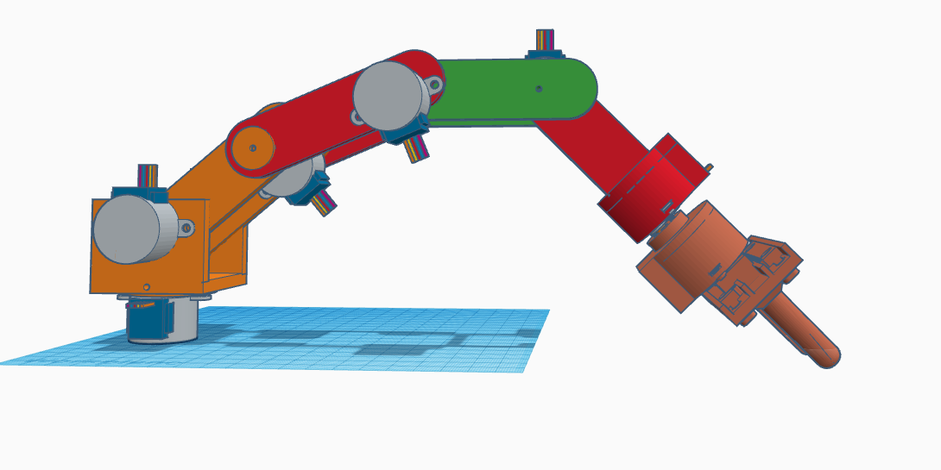
Picture of the current Kókánybot (under construction)
