PAYMASTER.CO
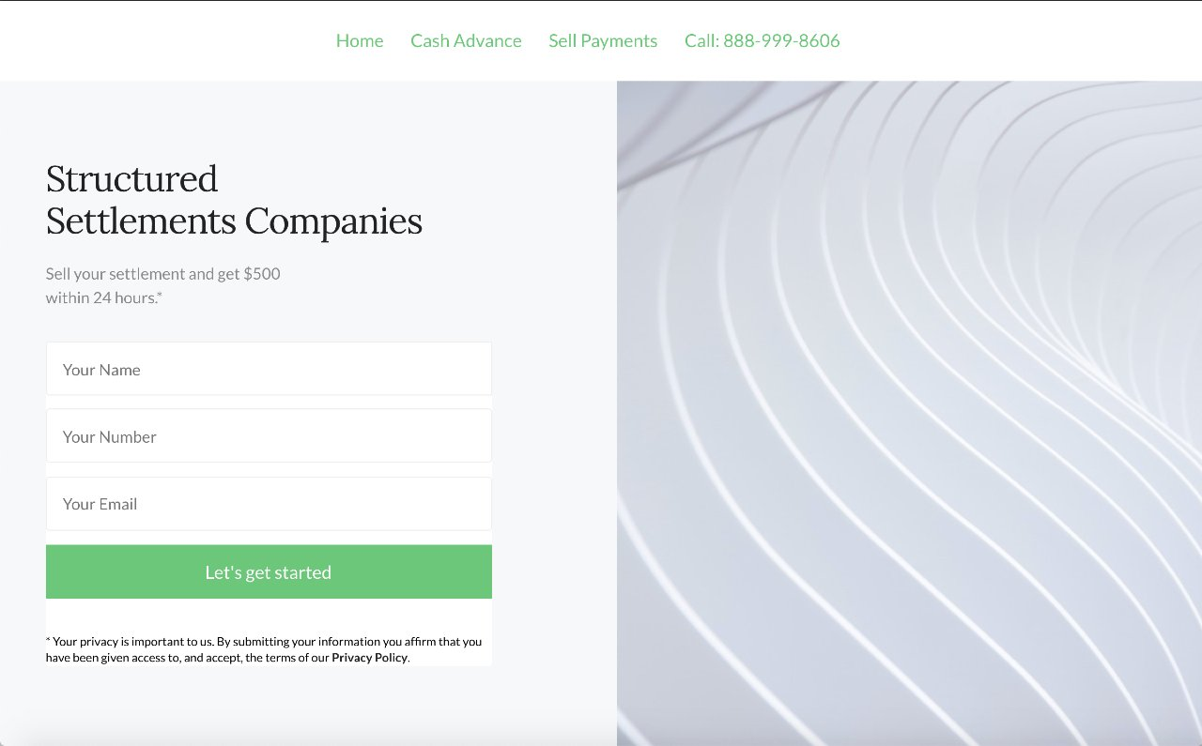
Call 1-888-999-8606
Website: https://paymaster.co
6230 Wilshire Blvd,
Suite 1795
Los Angeles, CA 90048

DRB CAPITAL LLC

1625 S Congress Ave,
Suite 200
Delray Beach, Florida
FAIRFIELD FUNDING
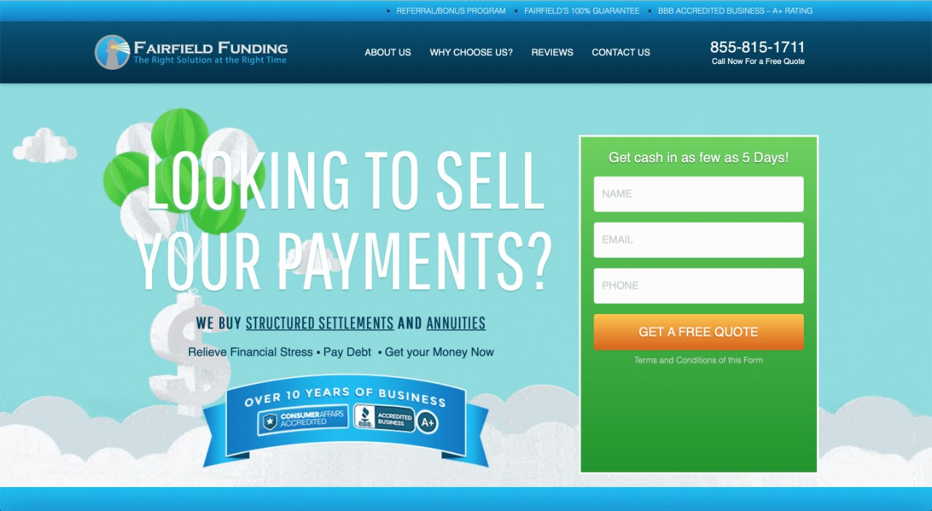

J.G. WENTWORTH
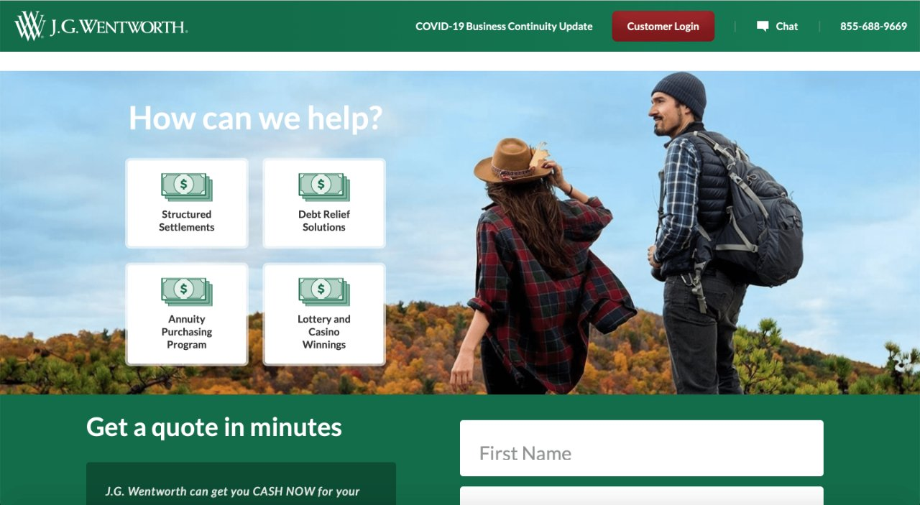
201 King of Prussia Road,
Suite 501
Radnor, PA 19087

LIIBERTY SETTLEMENT FUNDING

1855 Griffin Road
Suite B354
Dania Beach, FL 33004
CBC SETTLEMENT FUNDING
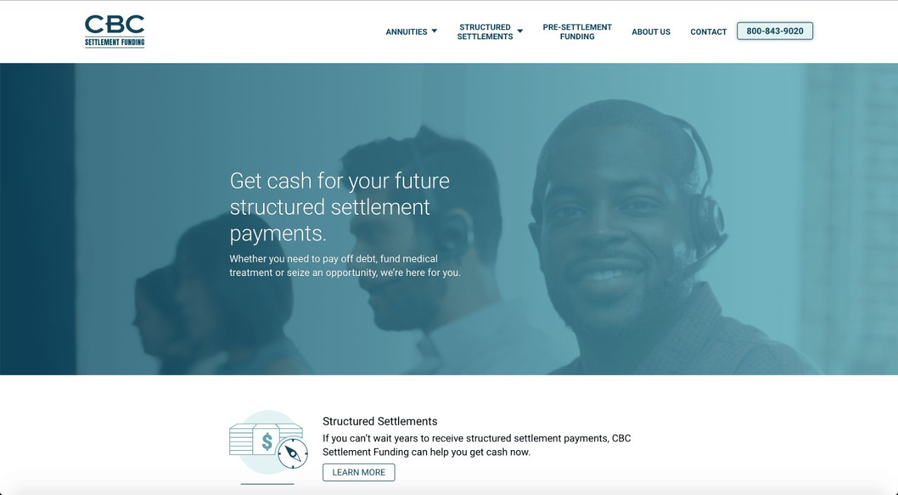
181 Washington Street,
Suite 375
Conshohocken, PA 19428
AMERICAN EQUITY FUNDING
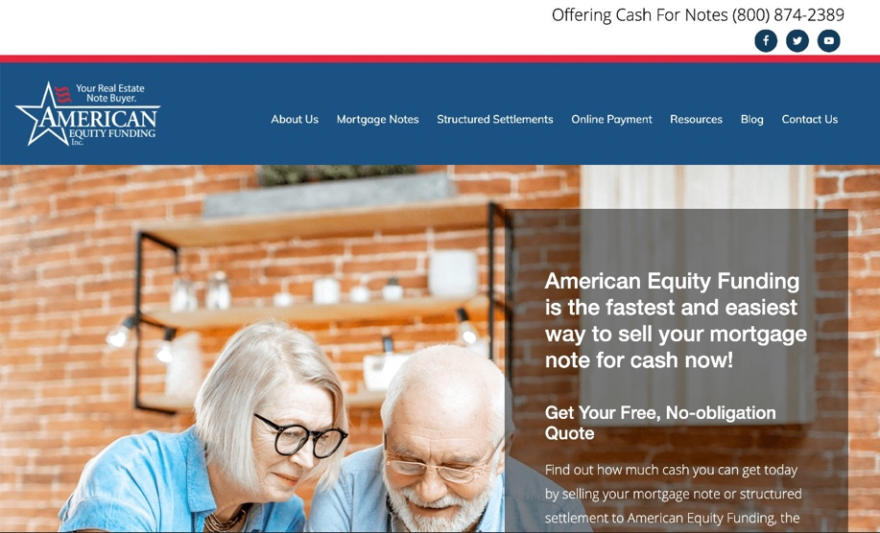
7005 Alma Highway
Van Buren, Arkansas 72956
ANNUITY TRANSFERS, LTD.
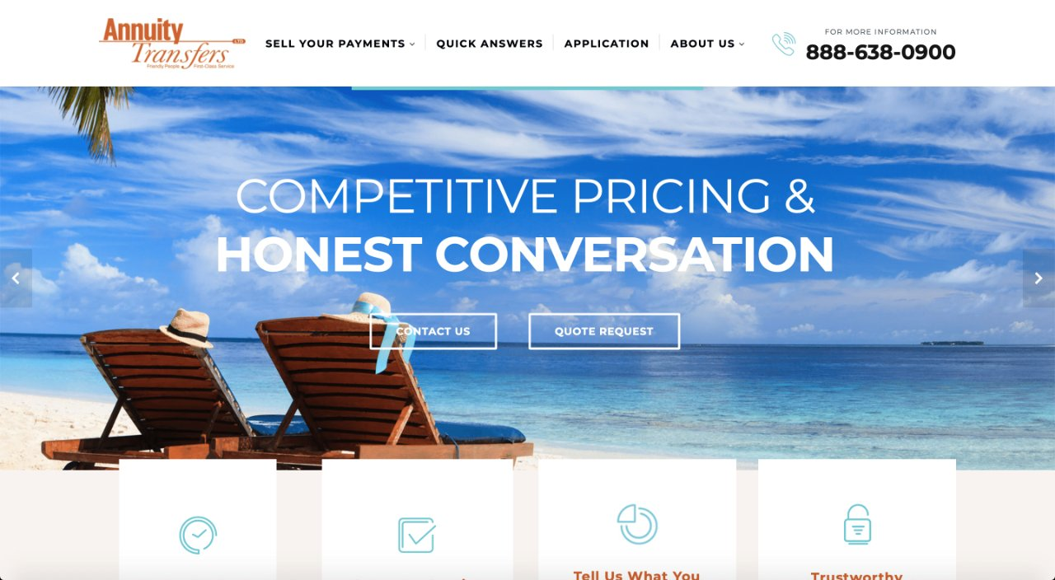
1800 Preston Park Blvd.
Suite 115
Plano, TX 75093
CLIENT FIRST SETTLEMENT FUNDING LLC

301 Yamato Rd #3200
Boca Raton, Florida 33431
CROWFLY
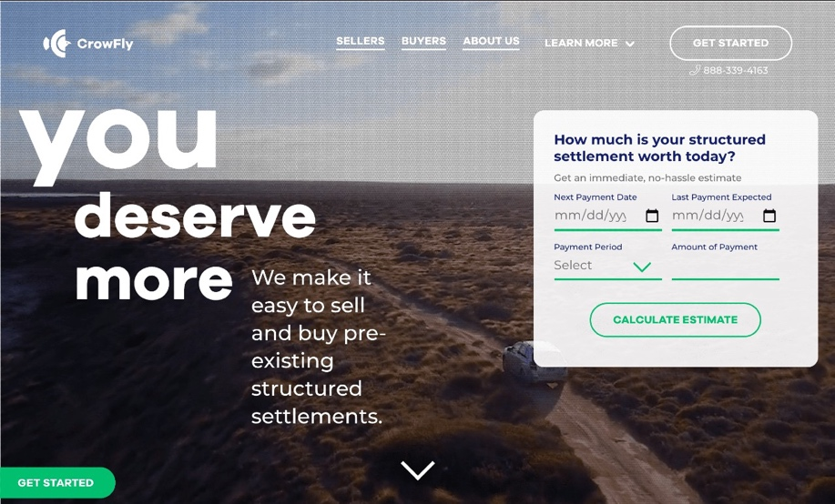
FIRST STRUCTURED SETTLEMENT
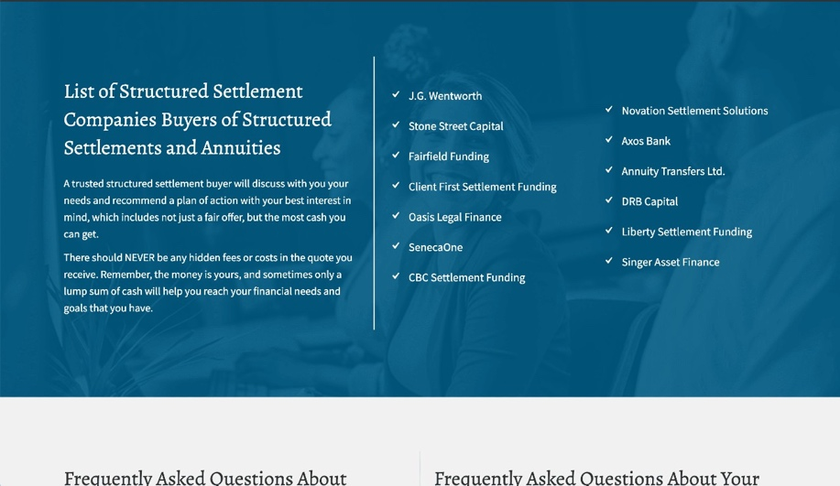
FORTUNE SETTLEMENT SOLUTIONS
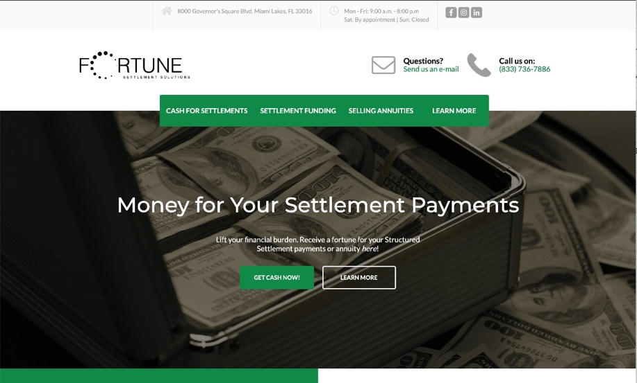
GLOFIN FUNDING
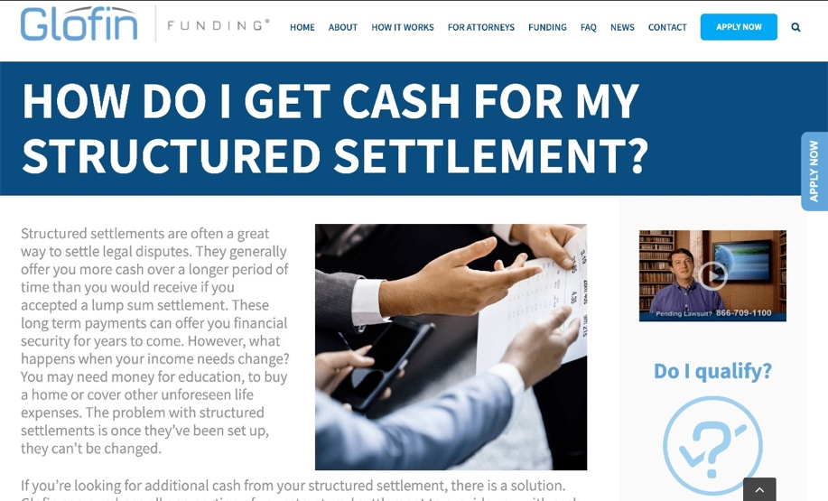
6905 Northcross, Dr
Suite 300
Huntersville, NC 28078
MAINSTREET FUNDING
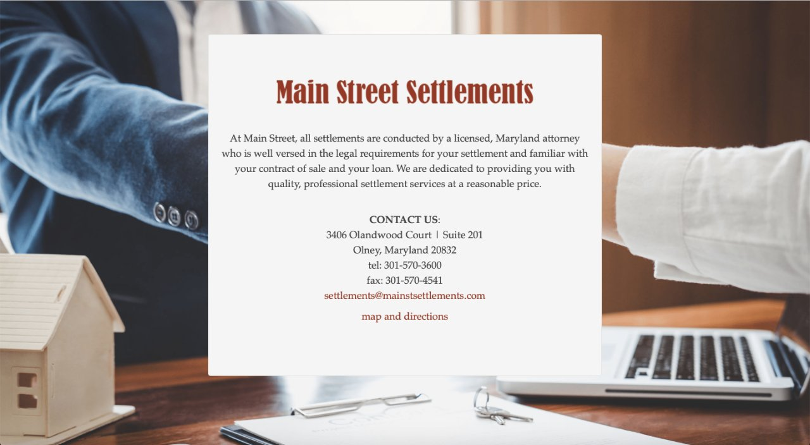
197 West Crogan Street
Lawrenceville, GA 30046
NOVATION SETTLEMENT SOLUTIONS
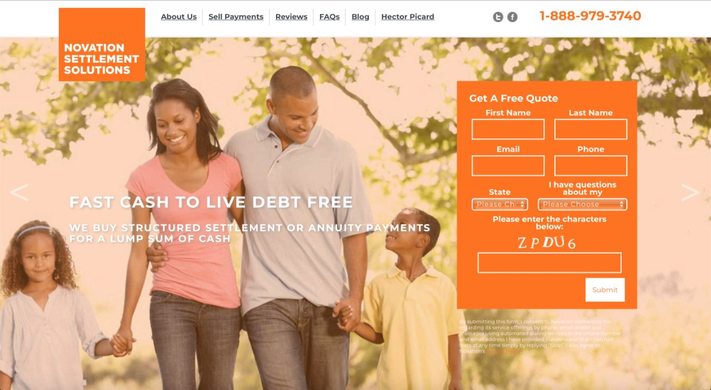
1641 Worthington Road,
Suite 410
West Palm Beach, FL 33409
RSL FUNDING

1980 Post Oak Blvd, Ste 1975
Houston, TX 77056
SENECAONE
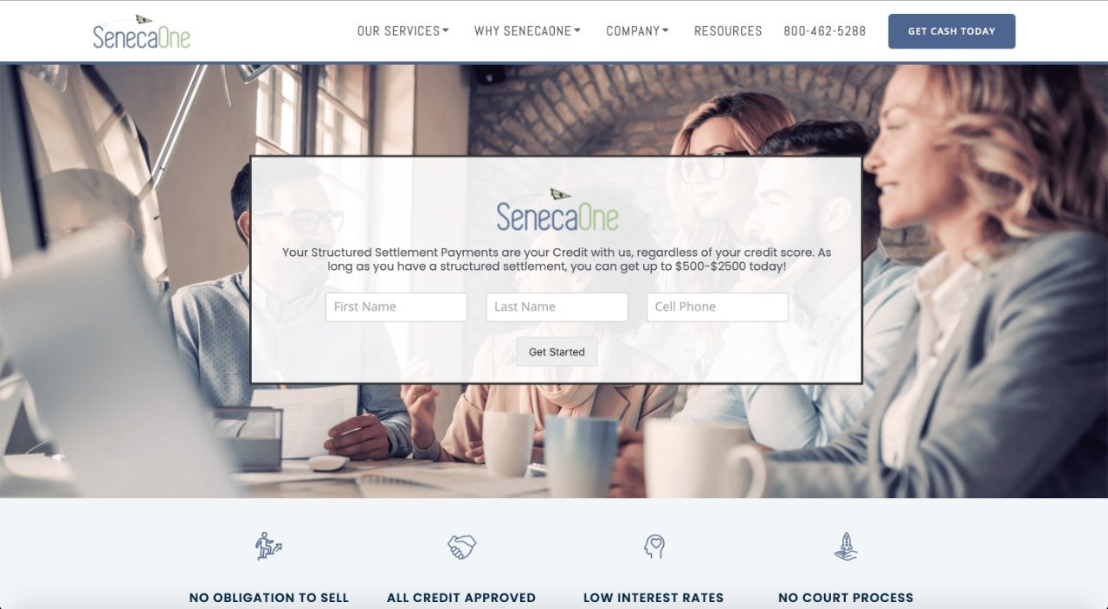
Corporate Headquarters
7920 Norfolk Ave.
Suite #300
Bethesda, MD 20814
Florida Office
105 South Narcissus Avenue,
Suite 710
West Palm Beach, FL 33401
SETTLEMENT CAPITAL CORP.
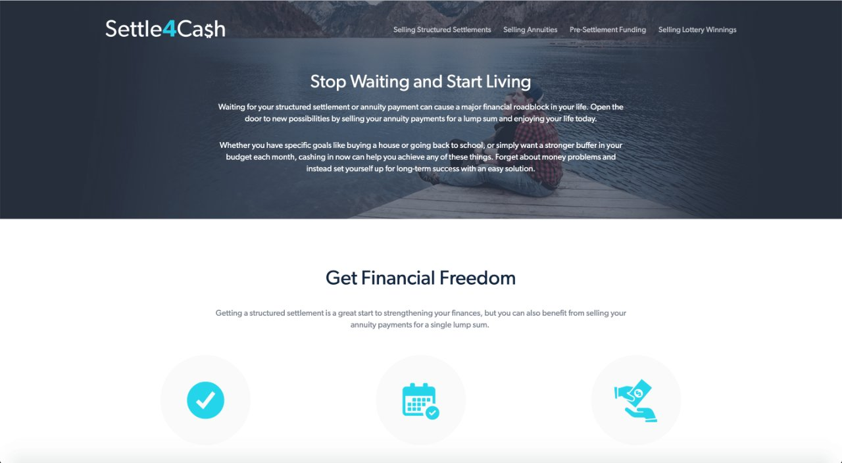
14755 Preston Rd.,
Ste. 610
Dallas, TX 75254
STONE STREET CAPITAL, LLC
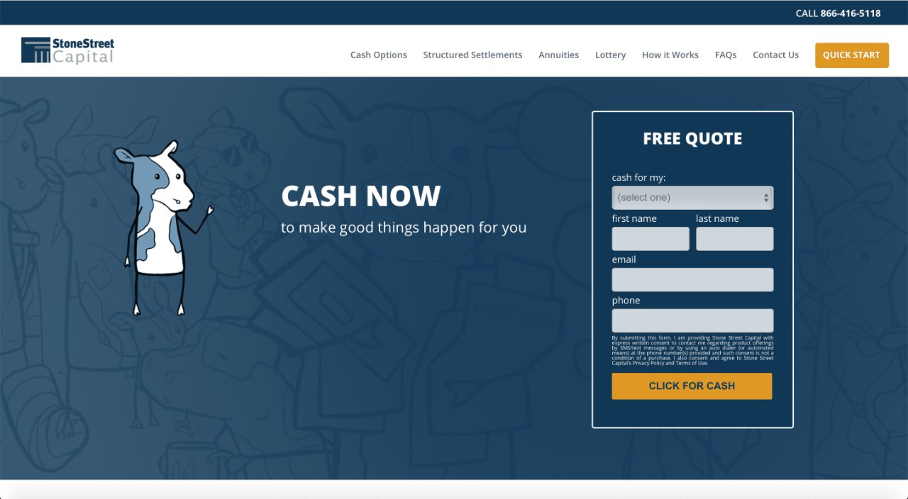
7316 Wisconsin Avenue
Fifth Floor
Bethesda, MD 20814
STRATEGIC CAPITAL
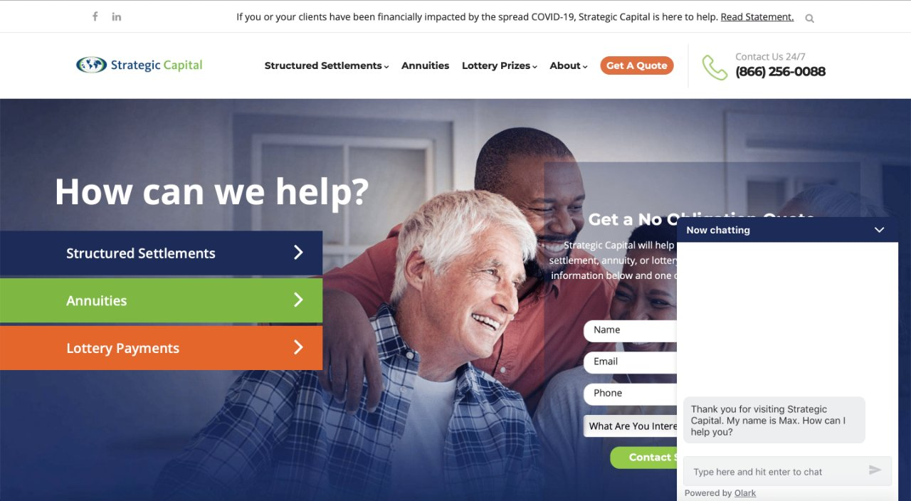
575 Madison Ave
Ste 1006
New York, NY 10022-2511

