# Homework 2

**Instructions**

This homework contains **5** concepts and **8** programming questions. In MS word or a similar text editor, write down the problem number and your answer for each problem. Combine all answers for concept questions in a single PDF file. Export/print the Jupyter notebook as a PDF file including the code you implemented and the outputs of the program. **Make sure all plots and outputs are visible in the PDF.**

Combine all answers into a single PDF named andrewID_hw2.pdf and submit it to Gradescope

before the due date. Refer to the syllabus for late homework policy. Please assign each question a page by using the “Assign Questions and Pages” feature in Gradescope.

Here is a breakdown of the points for questions:

|  |  |
| --- | --- |
| Name | Points |
| Concept 1 | 4 |
| Concept 2 | 2 |
| Concept 3 | 2 |
| Concept 4 | 2 |
| Concept 5 | 2 |
| M2_L1_p1 | 6 |
| M2_L1_p2 | 6 |
| M2_L1_p3 | 6 |
| M2_L2_p1 | 6 |
| M2_L2_p2 | 6 |
| M2_L2_p3 | 6 |
| M2_HW1 | 36 |
| M2_HW2 | 36 |
| **Total** | 120 |
| Bonus | 6 |

**Problem 1**

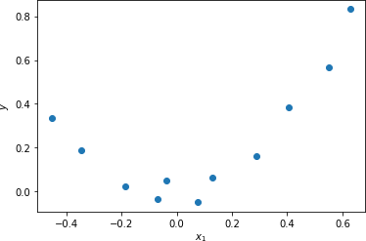

# Consider fitting a second order LLS regression model to the following data:

What is the size (height and width) of the design matrix *X*? What is the size (height and width) of the parameter vector *w*? What is the size of the product *X’X*?

# Now consider a dataset with 1000 points, for the same second order model:

What is the size (height and width) of the design matrix *X*? What is the size (height and width) of the parameter vector *w*? What is the size of the product *X’X*?

# Which of the following statements is true:

* 1. The model complexity is determined by the number of data points used for training
  2. The model complexity is determined by the number of model parameters

**Problem 2**

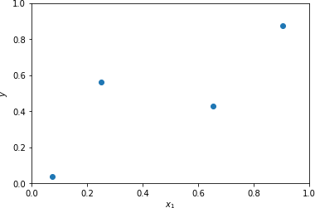

Consider the four points shown in the following figure:

If we use polynomial regression, what is the smallest order polynomial to perfectly interpolate these points? (multiple choice)

1. 1st order - w1x1+ w2
2. 2nd order - w1x12 + w2x1 + w3
3. 3rd order - w1x13 + w x 2 + w3x1 + w4

1

2

1. 4th order - w1x14 + w x 3 + w3x12 + w4x1 + w

1

2

**Problem 3**

Imagine you are hiking to the top of a mountain, but you get lost off trail, and it gets dark. All you have is a dim flashlight, but it is enough for you to see your feet and which way the

mountain slopes. Since you took AIML for engineers you know you can use gradient descent to find the extrema of the mountain. Which of the following formulations will lead you to the top of the mountain?

1. 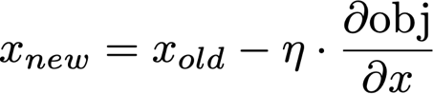
2. 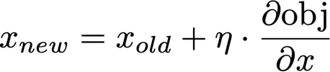

**Problem 4**

You are implementing batch gradient descent but notice that your solution is taking a long time to minimize the objective function due to oscillations. Which of the following approaches are likely to help resolve this issue? (Multiple choice, select all that are true)

1. Increase the batch size
2. Switch to stochastic gradient descent
3. Reduce the learning rate

**Problem 5**

The function for elastic net regularization in sklearn has a L1_ratio parameter which describes the weight of the L1 and L2 penalty terms relative to each other. The 𝛼 parameter describes the strength of the regularization terms. The formulation of the objective function follows:



If the L1_ratio term is 0, what is the formulation equivalent to?

1. Standard LLS
2. LLS with L1 regularization
3. LLS with L2 regularization
4. LLS with L1 and L2 regularization