**Homework 6**

**Instructions**

This homework contains **4** concepts and **7** programming questions. In MS word or a similar text editor, write down the problem number and your answer for each problem. Combine all answers for concept questions in a single PDF file. Export/print the Jupyter notebook as a PDF file including the code you implemented and the outputs of the program. Make sure all plots and outputs are visible in the PDF.

Combine all answers into a single PDF named andrewID_hw6.pdf and submit it to Gradescope before the due date. Refer to the syllabus for late homework policy. Please assign each question a page by using the “Assign Questions and Pages” feature in Gradescope.

|  |  |
| --- | --- |
| **Question** | **Points** |
| Concept 1 | 3 |
| Concept 2 | 3 |
| Concept 3 | 3 |
| Concept 4 | 3 |
| M6_L1_P1 | 6 |
| M6_L1_P2 | 6 |
| M6_L1_P3 | 9 |
| M6_L2_P1 | 6 |
| M6_L2_P2 | 9 |
| M6_HW1 | 36 |
| M6_HW2 | 36 |
| **Total** | **120** |
| Bonus | 6 |

Problem 1

Multiple choice (select one)

Given the original data in A, the data in B and C appears to be:

1. B) Normalized and C) Standardized
2. B) Standardized and C) Normalized
3. B) and C) both unchanged from the original data

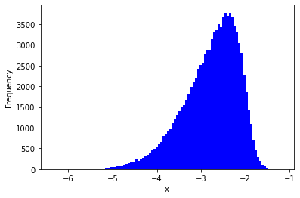

A

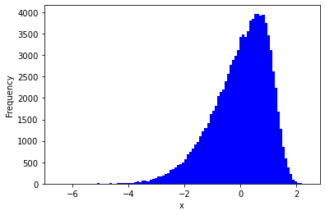

B

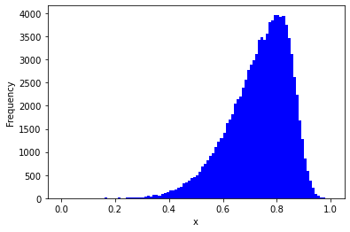

C

Problem 2

Multiple Choice (select one)

Which scaling technique would be best to use on the following data:

X = [0.002, 0.01, 100000, 4000, 500, 0.00008, 7]

1. Normalization
2. Standardization
3. Log Transformation

Problem 3

Compute the Pearson’s correlation coefficient for the following two features by hand:

x1 = [8,4,0,-4], x2 = [-16,-12,-10,2]

Problem 4

Multiple choice (select one)

Consider the dataset with features x1, x2, x3, and label y. We have generated the following correlation matrix, and would like to select a feature to remove. We have set the the following threshold |r| > 0.9 to drop features. Which of the features should be dropped?

1. x1
2. x2
3. x3

