**Homework 9**

**Instructions**

This homework contains **3** concepts and **3** programming questions. In MS word or a similar text editor, write down the problem number and your answer for each problem. Combine all answers for concept questions in a single PDF file. Export/print the Jupyter notebook as a PDF file including the code you implemented and the outputs of the program. Make sure all plots and outputs are visible in the PDF.

Combine all answers into a single PDF named andrewID_hw9.pdf and submit it to Gradescope before the due date. Refer to the syllabus for late homework policy. Please assign each question a page by using the “Assign Questions and Pages” feature in Gradescope.

Here is a breakdown of the points for programming questions:

|  |  |
| --- | --- |
| **Question** | **Points** |
| Concept 1 | 6 |
| Concept 2 | 3 |
| Concept 3 | 3 |
| M9-L1-P1 | 18 |
| M9-L1-P2 | 18 |
| M9-HW1 | 72 |
| **Total** | **120** |
| Bonus | 6 |

Problem 1

Provided the following ground truth vector, y = [-4, 8, 7, -15, 12] and   
the prediction vector, y^ = [2, 9, -1, -16, 18], compute the MAE, MSE, and MAPE without the use of in-built functions

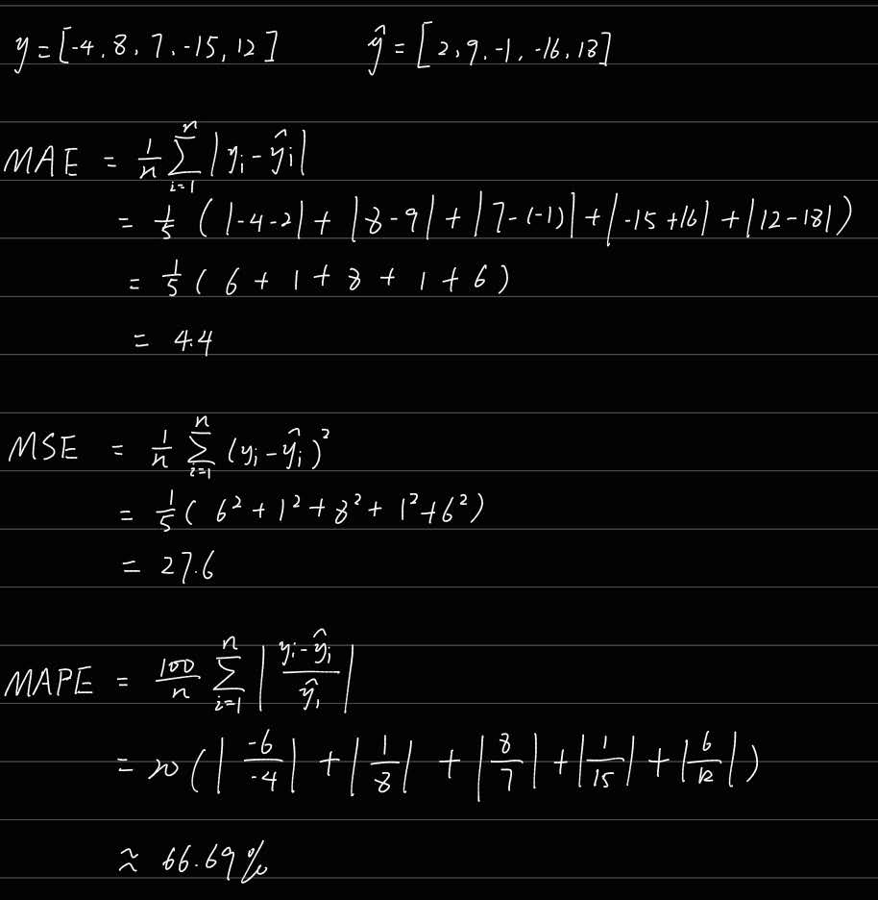

Problem 2

Consider the following model and data, where we use the convention that 1 is the positive outcome.

Which of the following confusion matrices corresponds to the data and fitted model?

Matrix 3

Problem 3

Provided the following confusion matrix, compute the TP, TN, FP, FN, recall, precision, and f1 score, where we use the convention that 1 is the positive outcome.

(Multiple choice, choose one)

1. 8, 10, 2, 0, 1.0, 0.833, 0.909
2. 8, 10, 0, 2, 1.0, 0.833, 0.909
3. 8, 10, 2, 0, 0.8, 1.0, 0.889
4. 8, 10, 0, 2, 0.8, 1.0, 0.889

4 is correct