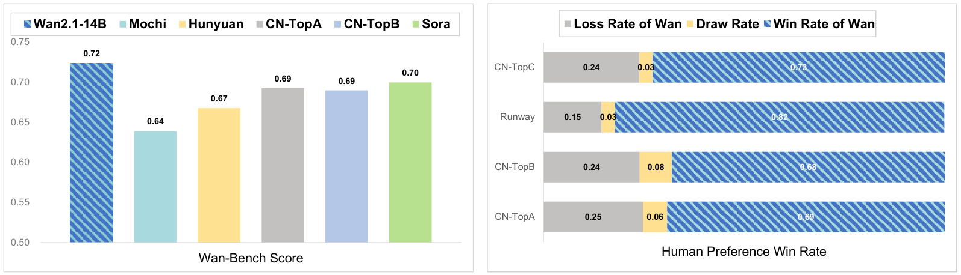
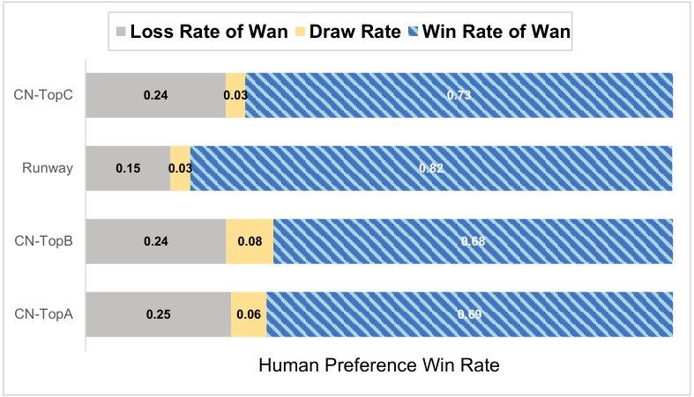
WA N: OPEN AND ADVANCED LARGE-SCALE VIDEO GENERATIVE MODELS
Wan Team, Alibaba Group
ABSTRACT
arXiv:2503.20314v2 [cs.CV] 19 Apr 2025 | This report presents Wan, a comprehensive and open suite of video foundation models designed to push the boundaries of video generation. Built upon the main-stream diffusion transformer paradigm, Wan achieves significant advancements in generative capabilities through a series of innovations, including our novel spatio-temporal variational autoencoder (VAE), scalable pre-training strategies, large-scale data curation, and automated evaluation metrics. These contributions collectively enhance the model’s performance and versatility. Specifically, Wan is characterized by four key features: Leading Performance: The 14B model of Wan, trained on a vast dataset comprising billions of images and videos, demonstrates the scaling laws of video generation with respect to both data and model size. It consistently outperforms the existing open-source models as well as state-of-the-art commercial solutions across multiple internal and external benchmarks, demonstrating a clear and significant performance superiority. Comprehensive-ness: Wan offers two capable models, i.e., 1.3B and 14B parameters, for efficiency and effectiveness respectively. It also covers multiple downstream applications, including image-to-video, instruction-guided video editing, and personal video generation, encompassing up to eight tasks. Meanwhile, Wan is the first model that can generate visual text in both Chinese and English, significantly enhancing its practical value. Consumer-Grade Efficiency: The 1.3B model demonstrates exceptional resource efficiency, requiring only 8.19 GB VRAM, making it com-patible with a wide range of consumer-grade GPUs. It also exhibits superior performance compared to larger open-source models, showcasing remarkable ef-ficiency for text-to-video. Openness: We open-source the entire series of Wan, including source code and all models, with the goal of fostering the growth of the video generation community. This openness seeks to significantly expand the creative possibilities of video production in the industry and provide academia with high-quality video foundation models. In addition, we conduct extensive experi-mental analyses covering various aspects of the proposed Wan, presenting detailed results and insights. We believe these findings and conclusions will significantly advance video generation technology. All the code and models are available at .
Figure 1: Comparison of Wan with state-of-the-art open-source and closed-source models. Following both benchmark and human evaluations, Wan consistently demonstrated superior results. Note that HunyuanVideo Kong . (2024) is tested using the open-source model.
1

Contents
1 | Introduction |  |  |  |  |  |  |  |  |  | 3
2 | Related Work |  |  |  |  |  |  |  |  |  | 3
3 | Data Processing Pipeline |  |  |  |  |  |  |  |  |  | 5
4 | 3.1 | Pre-training Data . . . . . . . . . . . . . . . . . . . . . . . . . . . . . . . . . . . . . . . . |  |  |  |  |  |  |  |  | 6
 | 3.2 | Post-training Data |  |  | . . . . . . . . . . . . . . . . . . . . . . . . . . . . . . . . . . . . . . . |  |  |  |  |  | 7
 | 3.3 | Dense Video Caption . . . . . . . . . . . . . . . . . . . . . . . . . . . . . . . . . . . . . . |  |  |  |  |  |  |  |  | 8
 | 3.3.1 |  | Open Source Dataset |  |  |  |  | . . . . . . . . . . . . . . . . . . . . . . . . . . . . . . . . . |  |  | 8
 | 3.3.2 |  | In-house Dataset |  |  |  | . . . . . . . . . . . . . . . . . . . . . . . . . . . . . . . . . . . |  |  |  | 8
 | 3.3.3 |  | Model Design . . . . . . . . . . . . . . . . . . . . . . . . . . . . . . . . . . . . . |  |  |  |  |  |  |  | 9
 | 3.3.4 |  | Evaluation . . . . . . . . . . . . . . . . . . . . . . . . . . . . . . . . . . . . . . . |  |  |  |  |  |  |  | 10
 | Model Design and Acceleration |  |  |  |  |  |  |  |  |  | 10
5 | 4.1 | Spatio-temporal Variational Autoencoder |  |  |  |  |  |  |  | . . . . . . . . . . . . . . . . . . . . . . . . . . . | 10
 | 4.1.1 |  | Model Design . . . . . . . . . . . . . . . . . . . . . . . . . . . . . . . . . . . . . |  |  |  |  |  |  |  | 10
 | 4.1.2 |  | Training . . . . . . . . . . . . . . . . . . . . . . . . . . . . . . . . . . . . . . . . |  |  |  |  |  |  |  | 11
 | 4.1.3 |  | Efficient Inference . . . . . . . . . . . . . . . . . . . . . . . . . . . . . . . . . . . |  |  |  |  |  |  |  | 11
 | 4.1.4 |  | Evaluation . . . . . . . . . . . . . . . . . . . . . . . . . . . . . . . . . . . . . . . |  |  |  |  |  |  |  | 12
 | 4.2 | Model Training . . . . . . . . . . . . . . . . . . . . . . . . . . . . . . . . . . . . . . . . . |  |  |  |  |  |  |  |  | 13
 | 4.2.1 |  | Video Diffusion Transformer . . . . . . . . . . . . . . . . . . . . . . . . . . . . . |  |  |  |  |  |  |  | 14
 | 4.2.2 |  | Pre-training . . . . . . . . . . . . . . . . . . . . . . . . . . . . . . . . . . . . . . |  |  |  |  |  |  |  | 14
 | 4.2.3 |  | Post-training . . . . . . . . . . . . . . . . . . . . . . . . . . . . . . . . . . . . . . |  |  |  |  |  |  |  | 15
 | 4.3 | Model Scaling and Training Efficiency . . . . . . . . . . . . . . . . . . . . . . . . . . . . . |  |  |  |  |  |  |  |  | 15
 | 4.3.1 |  | Workload Analysis |  |  |  | . . . . . . . . . . . . . . . . . . . . . . . . . . . . . . . . . . |  |  |  | 15
 | 4.3.2 |  | Parallelism Strategy . . . . . . . . . . . . . . . . . . . . . . . . . . . . . . . . . . |  |  |  |  |  |  |  | 16
 | 4.3.3 |  | Memory Optimization . . . . . . . . . . . . . . . . . . . . . . . . . . . . . . . . . |  |  |  |  |  |  |  | 17
 | 4.3.4 |  | Cluster Reliability . . . . . . . . . . . . . . . . . . . . . . . . . . . . . . . . . . . |  |  |  |  |  |  |  | 17
 | 4.4 | Inference . . . . . . . . . . . . . . . . . . . . . . . . . . . . . . . . . . . . . . . . . . . . |  |  |  |  |  |  |  |  | 17
 | 4.4.1 |  | Parallel Strategy . . . . . . . . . . . . . . . . . . . . . . . . . . . . . . . . . . . . |  |  |  |  |  |  |  | 17
 | 4.4.2 |  | Diffusion Cache . . . . . . . . . . . . . . . . . . . . . . . . . . . . . . . . . . . . |  |  |  |  |  |  |  | 18
 | 4.4.3 |  | Quantization . . . . . . . . . . . . . . . . . . . . . . . . . . . . . . . . . . . . . . |  |  |  |  |  |  |  | 18
 | 4.5 | Prompt Alignment . . . . . . . . . . . . . . . . . . . . . . . . . . . . . . . . . . . . . . . |  |  |  |  |  |  |  |  | 19
 | 4.6 | Benchmarks |  | . . . . . . . . . . . . . . . . . . . . . . . . . . . . . . . . . . . . . . . . . . |  |  |  |  |  |  | 20
 | 4.7 | Evaluation |  | . . . . . . . . . . . . . . . . . . . . . . . . . . . . . . . . . . . . . . . . . . . |  |  |  |  |  |  | 22
 | 4.7.1 |  | Metrics and Results . . . . . . . . . . . . . . . . . . . . . . . . . . . . . . . . . . |  |  |  |  |  |  |  | 22
 | 4.7.2 |  | Ablation Study |  |  | . . . . . . . . . . . . . . . . . . . . . . . . . . . . . . . . . . . . |  |  |  |  | 24
 | Extended Applications |  |  |  |  |  |  |  |  |  | 26
6 | 5.1 | Image-to-Video Generation . . . . . . . . . . . . . . . . . . . . . . . . . . . . . . . . . . . |  |  |  |  |  |  |  |  | 26
 | 5.1.1 |  | Model Design . . . . . . . . . . . . . . . . . . . . . . . . . . . . . . . . . . . . . |  |  |  |  |  |  |  | 26
 | 5.1.2 |  | Dataset |  | . . . . . . . . . . . . . . . . . . . . . . . . . . . . . . . . . . . . . . . . |  |  |  |  |  | 27
 | 5.1.3 |  | Evaluation . . . . . . . . . . . . . . . . . . . . . . . . . . . . . . . . . . . . . . . |  |  |  |  |  |  |  | 27
 | 5.2 | Unified Video Editing |  |  |  | . . . . . . . . . . . . . . . . . . . . . . . . . . . . . . . . . . . . . |  |  |  |  | 30
 | 5.2.1 |  | Model Design . . . . . . . . . . . . . . . . . . . . . . . . . . . . . . . . . . . . . |  |  |  |  |  |  |  | 31
 | 5.2.2 |  | Datasets and Implementation . . . . . . . . . . . . . . . . . . . . . . . . . . . . . |  |  |  |  |  |  |  | 34
 | 5.2.3 |  | Evaluation . . . . . . . . . . . . . . . . . . . . . . . . . . . . . . . . . . . . . . . |  |  |  |  |  |  |  | 35
 | 5.3 | Text-to-Image Generation |  |  |  |  | . . . . . . . . . . . . . . . . . . . . . . . . . . . . . . . . . . . |  |  |  | 35
 | 5.4 | Video Personalization |  |  |  | . . . . . . . . . . . . . . . . . . . . . . . . . . . . . . . . . . . . . |  |  |  |  | 35
 | 5.4.1 |  | Model Design . . . . . . . . . . . . . . . . . . . . . . . . . . . . . . . . . . . . . |  |  |  |  |  |  |  | 35
 | 5.4.2 |  | Dataset |  | . . . . . . . . . . . . . . . . . . . . . . . . . . . . . . . . . . . . . . . . |  |  |  |  |  | 37
 | 5.4.3 |  | Evaluation . . . . . . . . . . . . . . . . . . . . . . . . . . . . . . . . . . . . . . . |  |  |  |  |  |  |  | 37
 | 5.5 | Camera Motion Controllability . . . . . . . . . . . . . . . . . . . . . . . . . . . . . . . . . |  |  |  |  |  |  |  |  | 38
 | 5.6 | Real-time Video Generation |  |  |  |  | . . . . . . . . . . . . . . . . . . . . . . . . . . . . . . . . . . |  |  |  | 38
 | 5.6.1 |  | Method |  | . . . . . . . . . . . . . . . . . . . . . . . . . . . . . . . . . . . . . . . . |  |  |  |  |  | 38
 | 5.6.2 |  | Streaming Video Generation |  |  |  |  |  | . . . . . . . . . . . . . . . . . . . . . . . . . . . . . |  | 40
 | 5.6.3 |  | Consistency Model Distillation . . . . . . . . . . . . . . . . . . . . . . . . . . . . |  |  |  |  |  |  |  | 44
 | 5.7 | Audio Generation . . . . . . . . . . . . . . . . . . . . . . . . . . . . . . . . . . . . . . . . |  |  |  |  |  |  |  |  | 44
 | 5.7.1 |  | Model Design . . . . . . . . . . . . . . . . . . . . . . . . . . . . . . . . . . . . . |  |  |  |  |  |  |  | 45
 | 5.7.2 |  | Evaluation . . . . . . . . . . . . . . . . . . . . . . . . . . . . . . . . . . . . . . . |  |  |  |  |  |  |  | 47
 | Limitation and Conclusion |  |  |  |  |  |  |  |  |  | 47
7 | Contributors |  |  |  |  |  |  |  |  |  | 49
2

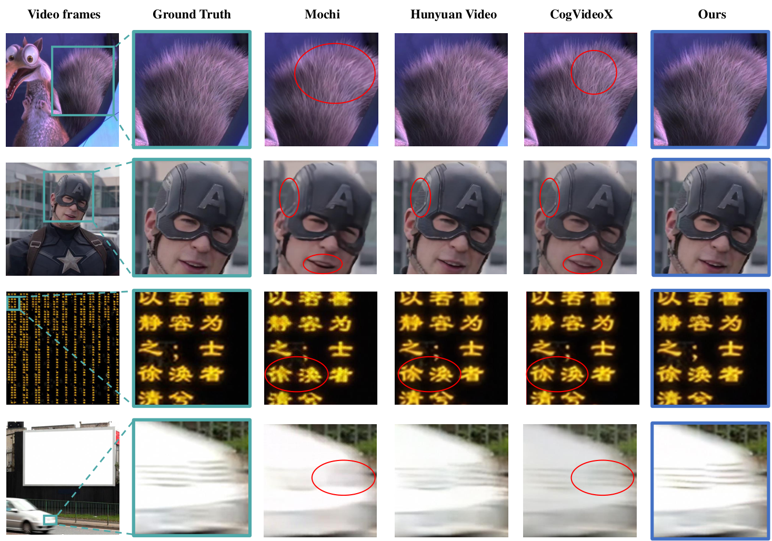
Figure 8: Visualization results of video reconstruction across different scenarios, including texture (first row), face (second row), text (third row), and high-motion (fourth row). The above videos have rich details but are not used in training.
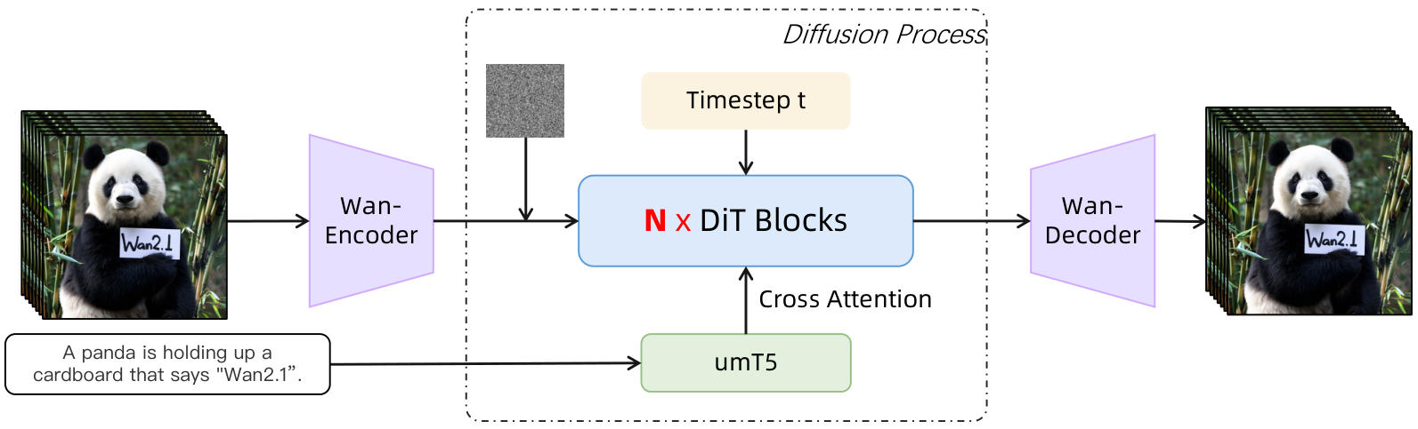
Figure 9: Architecture of the Wan.
features while reducing blurring and distortion around the lips. In the text scene illustrated in the third row, our method successfully restores textual content with clarity, mitigating issues of character distortion and loss. In the high-motion scene presented in the fourth row, Wan-VAE maintains the motion sharpness of video frames. These results indicate that our method offers significant advantages in handling a variety of complex scenarios.
4.2 MODEL TRAINING
In this section, we will provide a detailed introduction to the architecture design of the foundational video model, specifically for the text-to-video task, along with the details of the pre-training and post-training phases.
Fig. 9, we present the architecture of Wan, which is designed based on the current mainstream DiT (Peebles & Xie, 2023) architecture, which typically consists of three primary components: Wan-VAE, diffusion transformer, and text encoder. For a given video V R(1+T )HW 3, the
13

encoder of Wan-VAE encodes it from pixel space into the latent space , which is then fed into the subsequent diffusion transformer structure.
4.2.1 VIDEO DIFFUSION TRANSFORMER

Diffusion transformer. The diffusion transformer mainly consists of three components: a patchifying module, trans-former blocks, and an unpatchifying module. Within each block, we focus on effectively modeling spatio-temporal contextual relationships and embedding text conditions alongside time steps. the patchifying module, we use a 3D convolution with a kernel size of (1, 2, 2) and apply a flattening operation to convert x into a sequence of fea-tures with the shape of (B, L, D), where B denotes the batch size, represents the sequence length, and D indicates the latent dimension. Specifically, as illustrated in Fig. 10, we employ the cross-attention mechanism to embed the input text conditions, which can ensure the model’s ability to follow instructions even under long-context modeling. Additionally, we -ploy an MLP with a Linear layer and a SiLU (Elfwing ., 2018) layer to process the input time embeddings and predict six modulation parameters individually. This MLP is shared across all transformer blocks, with each block learning a distinct set of biases. Through extensive

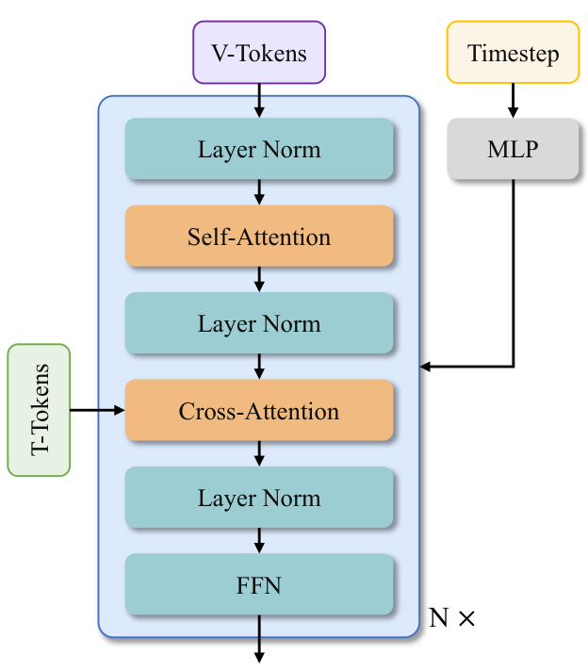
Figure 10: Transformer block of Wan.

experiments, we have demonstrated that this design can reduce the parameter count by approximately 25% and reveal a significant performance improvement with this approach at the same parameter scale.
Text encoder. Wan’s architecture uses the umT5 (Chung ., 2023) to encode input text. Through extensive experiments, we find that umT5 has several advantages in our framework: 1) possesses strong multilingual encoding capabilities, allowing it to understand both Chinese and English effec-tively, as well as input visual text; 2) Under the same conditions, we find that umT5 outperforms other unidirectional attention mechanism LLMs in composition; 3) exhibits superior convergence, with umT5 achieving faster convergence at the same parameter scale. Based on these findings, we ultimately chose umT5 as our text embedder.
4.2.2 PRE-TRAINING
leverage the flow matching framework (Lipman ., 2022; Esser ., 2024) to model a unified denoising diffusion process across both image and video domains. first conduct pre-training on low-resolution images, followed by multi-stage joint optimization of images and videos. The image-video joint training evolves using progressively upscaled data resolutions and extended temporal durations throughout the stages.
Training objective. Flow matching provides a theoretically grounded framework for learning continuous-time generative processes in diffusion models. circumvents iterative velocity prediction, enabling stable training via ordinary differential equations (ODEs) while maintaining equivalence to maximum likelihood objectives. During training, given an image or video latent , a random noise , and a timestep sampled from a logit-normal distribution, an intermediate latent is obtained as the training input. Following Rectified Flows (RFs) (Esser ., 2024), is defined as a linear interpolation between and , i.e.,
(1)
The groud truth velocity is
(2)
The model is trained to predict the velocity, thus, the loss function can be formulated as the mean squared error (MSE) between the model output and ,
14

(3)
where is the umT5 text embedding sequence of 512 tokens long, is the model weights, and denotes the output velocity predicted by the model.
Image pre-training. Our experimental analysis reveals two critical challenges in direct joint training with high-resolution images and long-duration video sequences: (1) Extended sequence lengths (typically 81 frames for 1280 720 video) substantially reduce training throughput. Under fixed GPU-hour budgets, this results in insufficient data throughput, thereby impeding model convergence rates. (2) Excessive GPU memory consumption forces suboptimal batch sizes, inducing training instability caused by spikes in gradient variance. mitigate these issues, we initialize the 14B model training through low-resolution (256 ) text-to-image pre-training, enforcing cross-modal semantic-textual alignment and geometric structure fidelity before progressively introducing high-res video modalities.
Image-video joint training. Following large-scale 256 px text-to-image pre-training, we implement staged joint-training with image and video data through a resolution-progressive curriculum. The training protocol comprises three distinct stages differentiated by spatial resolution areas: (1) In the first stage, we conduct joint training with 256 px resolution images and 5-second video clips (192 px resolution, 16 fps). (2) In the second stage, we initiate spatial resolution scaling by upgrading both image and video resolutions to 480px while maintaining a fixed 5-second video duration. (3) In the final phase, we escalate spatial resolution to 720px for both images and 5-second video clips.
Pre-training configurations. employ efficient training at bf16-mixed precision combined with the AdamW (Loshchilov & Hutter, 2017; Kingma & , 2014) optimizer with a weight decay coefficient of 1e−3. The initial learning rate is set to 1e−4, and dynamically reduced triggered by plateaus of the FID and CLIP Score metrics.
4.2.3 POST-TRAINING
the post-training stage, we maintain the same model architecture and optimizer configuration from the pre-training stage, initializing the network with the pre-trained checkpoint. conduct joint training at resolutions of 480px and 720px using the post-training video dataset detailed in Sec. 3.2.
4.3 MODEL SCALING AND TRAINING EFFICIENCY
4.3.1 WORKLOAD ANALYSIS
Wan, the computational costs associated with the text encoder and VAE encoder are lower than those of the DiT model, which accounts for more than 85% of the overall computation during training. For the DiT model, the main computational cost is given by the expression , where L denotes the number of DiT layers, b is the micro batch size, s indicates the sequence length, and h denotes the hidden dimension size. Here, corresponds to the cost of the linear layers and to that of the attention layer, for the non-causal attention used in Wan, is 4 for the forward pass and 8 for the backward pass. Unlike general LLM models, the sequence length s processed by Wan often reaches hundreds of thousands or more. Since the computational cost of attention increases quadratically with the number of tokens, while the cost associated with the linear layers increases only linearly, the attention mechanism gradually becomes the training bottleneck. scenarios where the sequence length reaches 1 million, the computation time for attention can account for up to 95% of the end-to-end training time.
During the training process, only the DiT model is optimized while the text encoder and the VAE encoder remain frozen. Therefore, GPU memory usage is concentrated on training the DiT. The GPU memory usage for the DiT can be expressed as Lbsh, where depends on the implementation of the DiT layers, L denotes the number of DiT layers. Because video tokens, input prompts, and timesteps are taken as model input, the value of is generally larger than in ordinary LLM models. For example, while standard LLMs might have a of 34 (Korthikanti .), the DiT model’s can exceed 60. Consequently, when the sequence length reaches 1 million tokens and the micro-batch size is 1, the total GPU memory usage for activations in a 14B DiT model can exceed 8 TB.
15

