WA N: OPEN AND ADVANCED LARGE-SCALE VIDEO
GENERATIVE MODELS

ABSTRACT
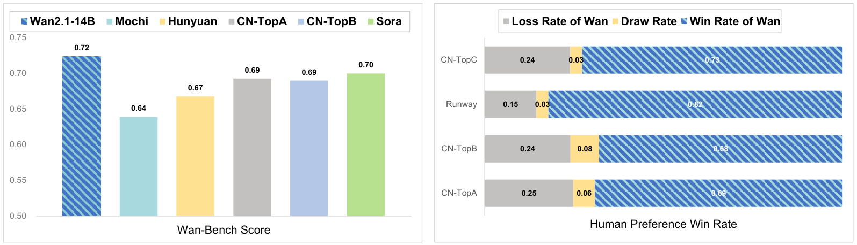
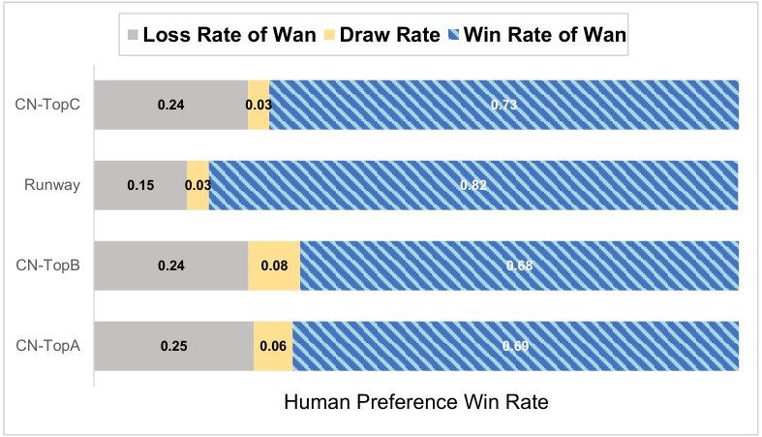

Contents

3
Data Processing Pipeline
5

4
Model Design and Acceleration

Model Design and Acceleration
1

4.1
Spatio-temporal Variational Autoencoder
. . . . . . . . . . . . . . . . . . . . . . . . . . .
10

4.1
Spatio-temporal Variational Autoencoder
. . . . . . . . . . . . . . . . . . . . . . . . . . .
1

.2
Model Training . . . . . . . . . . . . . . . . . . . . . . . . . . . . . . . . . . . . . . . . .
1

.3
Model Scaling and Training Efficiency . . . . . . . . . . . . . . . . . . . . . . . . . . . . .
1

Inference . . . . . . . . . . . . . . . . . . . . . . . . . . . . . . . . . . . . . . . . . . . .
17

5
Extended Applications

Extended Applications
2

Limitation and Conclusion
4

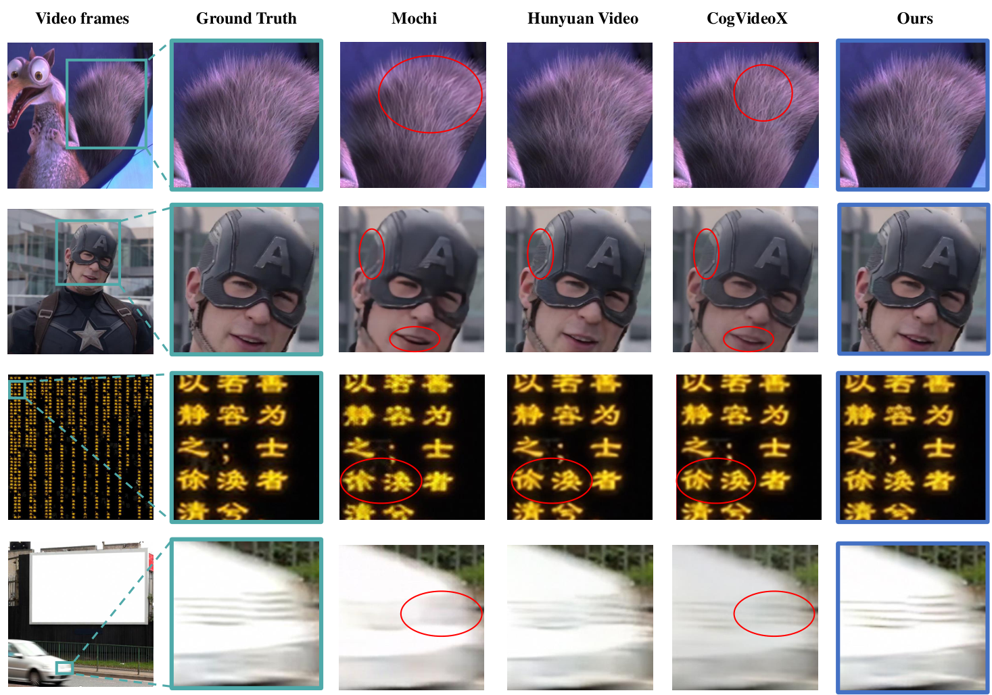
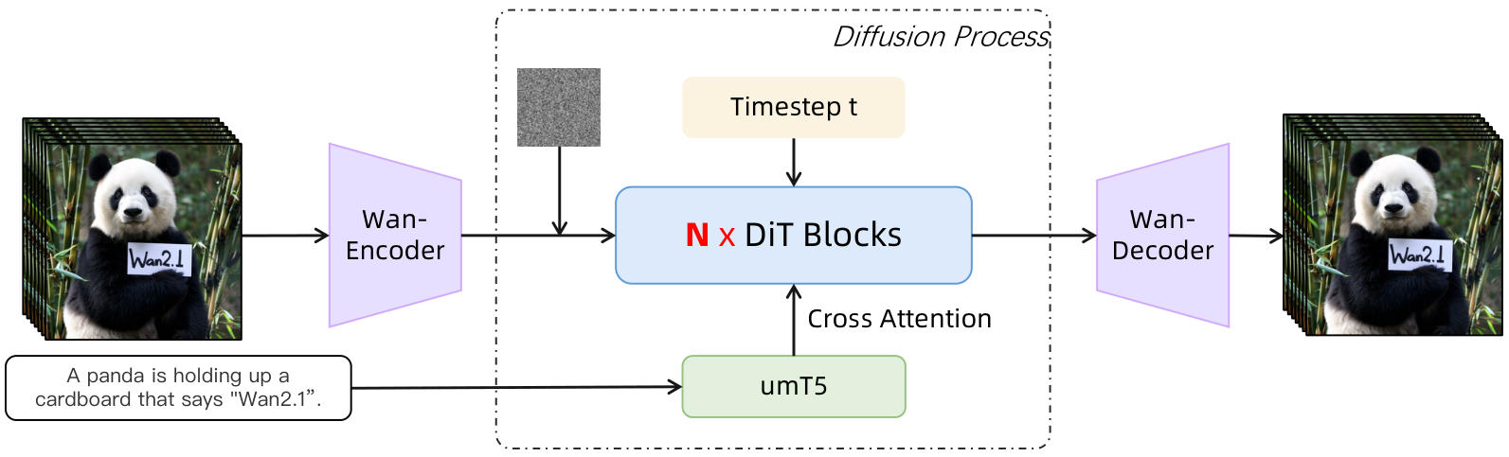

4.2
MODEL TRAINING

4.2.1
VIDEO DIFFUSION TRANSFORMER
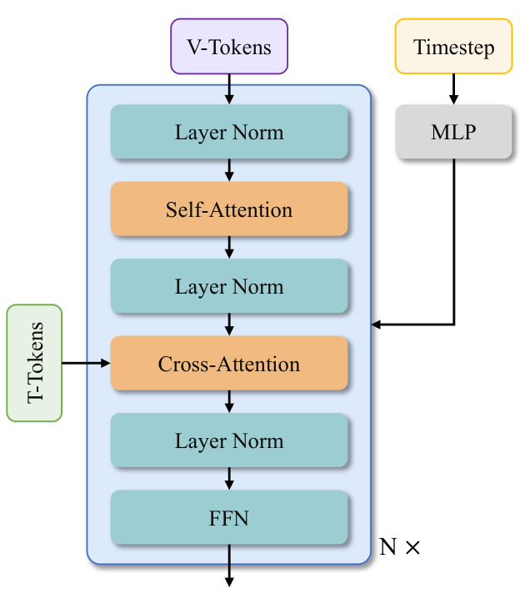

4.2.2
PRE-TRAINING

4.2.3
POST-TRAINING

4.3.1
WORKLOAD ANALYSIS

