Relevance-Guided Binarization for Parsimonious Feature Selection with Sand Cat Swarm Optimization
Bui Quang Huy^{1,*} and Duong Minh Son¹
¹Dong A University, Da Nang, Vietnam
*Corresponding author(s). E-mail(s): huybq@donga.edu.vn; Contributing authors: sondm@donga.edu.vn
Abstract Wrapper feature selection with swarm intelligence typically searches continuously and crosses into the binary domain via a fixed transfer function, a feature-agnostic quantization that discards continuous operators' fine adjustments, an effect we term washout. RG-SCSO replaces this transfer with a per-feature, relevance-modulated binarization: a mutual-information field biases each feature's bit-flip probability so informative features resist removal and noise resists inclusion. Its central and most consistent finding is parsimony: on 18 datasets, including two gene-expression sets, RG-SCSO selects the second-smallest feature subsets of any method tested, trailing only COA, which pays a several-point accuracy cost for it, using on average approximately 56% of the feature count selected by base SCSO, an advantage that remains evident across the reported stress tests, including comparison against optimizers carrying published adaptive transfers, against which RG-SCSO does not lead on accuracy yet still selects 26-43% fewer features. Under a budget-matched, leak-free protocol, where the relevance prior, search, and cross-validated fitness are computed only on the training partition and never on held-out labels, this compactness comes with the best mean held-out accuracy of any method tested, with a consistent edge over the closest competitor. A controlled ablation isolates the contribution of the relevance modulation itself, and cross-classifier, cross-prior experiments test the robustness of the mechanism. The binarization interface is the most reliable injection point for the relevance signal, though not the sparsest: LASSO is sparser on the two gene-expression sets, but accuracy is preserved, not improved, there, and parsimony without that extreme structure is the transferable gain.
Keywords Feature selection, Sand Cat Swarm Optimization, binary optimization, relevance-guided binarization, wrapper feature selection, parsimony, metaheuristic.

1. Introduction
Feature selection removes irrelevant and redundant features to improve classifier accuracy, reduce overfitting, and lower computational cost, a payoff that is greatest for high-dimensional, small-sample problems such as gene-expression classification, where the number of features exceeds the number of samples by orders of magnitude [1, 2]. Wrapper selection, which scores a subset by the performance of a downstream classifier, is frequently cast as a combinatorial problem solved by swarm-intelligence metaheuristics, including grey wolf [3], particle swarm [4], whale [5], and several recent optimizers [6, 7, 8]. Most such methods were conceived for continuous optimization and are adapted to the binary space through a transfer function, most commonly an S-shaped or V-shaped map, that converts a real-valued position into a selection probability [9]. We argue that this retrofit contains a structural weakness: the transfer function is fixed and feature-agnostic, applied identically to every dimension, so the incremental adjustments a continuous-space operator makes are collapsed by the squash-and-threshold step before they can influence the retained subset. We refer to this loss as washout, and show in Methods below that it is not a thought experiment: four well-motivated continuous-space enhancements of SCSO [10] failed to beat the base algorithm under an identical feature-selection protocol (0 wins, 1 loss, 17 ties by Wilcoxon signed-rank; Supplementary Table S5, preliminary washout study).
Existing studies have explored relevance-guided initialization, objective weighting, and adaptive binary transfer mechanisms; however, the explicit injection of a per-feature relevance prior into the binarization operator of SCSO-based feature selection remains insufficiently investigated (Section 2 positions this gap against each cited SCSO-family work in detail).
We close this gap with RG-SCSO: a per-feature, relevance-modulated binarization in which a mutual-information relevance field biases each feature's bit-flip probability, turning a knowledge-agnostic quantization step into a knowledge-carrying operator. SCSO's continuous search, including its sensitivity range, is retained unchanged; the novelty resides entirely in the binarization (Fig. 1). We make four contributions: we identify washout as a mechanistic failure mode and derive a diagnostic bound, together with a cumulative extension linking it to discrete transition dynamics; we propose RG-SCSO, whose ablation-confirmed centerpiece is relevance-modulated sensitivity (RMS), supplemented by a smaller, budget-neutral memetic refinement step (UMR) whose own sensitivity sweep shows it contributes far less than RMS, an online-learning variant of the relevance field is examined and pruned entirely by ablation; we evaluate under a preregistered, budget-matched, leak-free protocol denying the relevance prior any access to test labels; and we report a full statistical treatment, a component ablation, and a size-fair enrichment analysis correlating the observed parsimony with relevance guidance.

Research questions
This study is organized around four research questions, each answered directly by a specific part of Results or Discussion below.
- RQ1. Does relevance-modulated binarization improve held-out feature-selection performance under a fixed computational budget? Addressed in Section 3.1 (Table 2, Fig. 3).
- RQ2. Can RG-SCSO reduce the number of selected features while preserving competitive generalization accuracy? Addressed in Section 3.2.
- RQ3. Is direct relevance injection at the binarization interface more effective than relevance-guided initialization or objective weighting? Addressed in Section 3.4 (Table 4).
- RQ4. How robust is the proposed mechanism across classifiers, relevance priors, and dataset dimensionalities? Addressed in Section 3.6 (Table 7) and Discussion.
The remainder of the paper reviews existing approaches along three axes: (i) binary transfer functions in swarm-based feature selection, (ii) relevance-guided search mechanisms, and (iii) SCSO variants (Section 2).

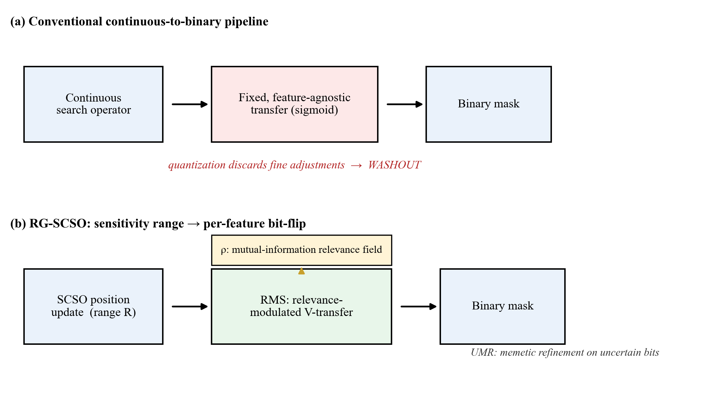
Fig. 1. Conceptual overview. (a) The conventional pipeline, where continuous-operator adjustments are collapsed by a fixed, feature-agnostic transfer (washout). (b) RG-SCSO, where a per-feature, relevance-modulated binarization replaces the feature-agnostic transfer, biasing each feature's bit-flip probability by a mutual-information relevance field, followed by memetic refinement on uncertain bits.

2. Related work

Binary transfer functions in swarm-based feature selection
Swarm-intelligence wrapper selectors, including grey wolf [3], particle swarm [4], whale [5], and several recent optimizers [6, 7, 8], are conceived for continuous optimization and cross into the binary search space through a transfer function, most commonly an S-shaped or V-shaped map [9]. This transfer is fixed and feature-agnostic in every one of these methods: it is applied identically to every dimension regardless of that feature's relevance, the structural weakness this paper terms washout (Introduction, Methods).

Relevance-guided mechanisms in feature selection
Filter criteria such as mutual information and mRMR [1, 2] encode problem knowledge cheaply but are decoupled from the wrapper search; memetic hybridization [11] adds local refinement without addressing the binarization interface; and knowledge-guided metaheuristics that inject filter information into initialization or the objective, such as filter-guided PSO for cancer-genome selection [12], bias where the search starts or what it optimizes but still leave the binarization operator itself knowledge-agnostic. RG-SCSO differs by injecting the relevance signal at the binarization interface itself rather than upstream of it; the signal-position experiment in Results (Table 4) tests this design choice directly against both alternatives.

Sand Cat Swarm Optimization and its variants
SCSO [10] is a comparatively recent continuous metaheuristic. The existing binary SCSO feature selectors [13, 14, 15] apply standard transfer functions without a relevance-aware binarization step, and the broader recent SCSO literature that adds chaotic initialization, differential mutation, or hybridized search strategies [16, 17, 18, 19] improves continuous-space search dynamics while leaving the binarization interface itself untouched, and none of these works, to our knowledge, makes the binarization operator itself per-feature and relevance-aware. Table 1 below positions each of these works against this claim directly.

Literature-positioning summary
Table 1 makes this gap concrete across every SCSO-family work cited above: the three directly-comparable binary feature selectors apply a standard, feature-agnostic transfer with no relevance-aware step, and the four continuous-search variants improve exploration/exploitation dynamics without touching the binarization interface at all. None of the eight prior works positioned here makes the binarization operator itself per-feature and relevance-aware. This is precisely the interface RG-SCSO modifies.

Method | Year | What it modifies | Comparable to this protocol?
Seyyedabbasi & Kiani [10] | 2022 | Base continuous SCSO (no FS) | Baseline (Table 1)
bSCSO [13] | 2023 | Binary wrapper FS, standard transfer | Same-family baseline (Discussion)
Binary SCSO (biomedical) [14] | 2023 | Binary wrapper FS, standard transfer | Same-family baseline (Discussion)
Adaptive SCSO [15] | 2024 | Binary wrapper FS, standard transfer | Same-family baseline (Discussion)
IMSCSO [16] | 2024 | Continuous search (multi-strategy) | No — global optimization only, no FS
SCSO+Lens-OBL+SSA [18] | 2024 | Continuous search (lens-OBL init) | No — global optimization only, no FS
Improved SCSO [19] | 2024 | Continuous search dynamics | No — global optimization only, no FS
MESCSO [17] | 2025 | Continuous search (multi-strategy) | No — global optimization only, no FS
Table 1 Positioning of RG-SCSO against recent SCSO-family literature cited in this paper. The four 2024-2025 continuous-search variants (IMSCSO, SCSO+Lens-OBL+SSA, Improved SCSO, MESCSO) improve exploration/exploitation dynamics in continuous space but are global optimization studies, not feature selectors, so they are not directly comparable under this paper's binary FS protocol; they are cited to establish that none of them touches the binarization interface itself. The three binary SCSO feature selectors (bSCSO and two further variants) are directly comparable and are included as same-family baselines (Discussion).

3. Results

Held-out generalization
RQ1 asks whether relevance-modulated binarization improves held-out performance under a fixed computational budget; this subsection answers it directly. For each dataset, algorithm, and independent run we draw an outer stratified 80/20 split. The relevance prior, the search, and the cross-validated fitness are computed exclusively on the 80% training partition; the selected subset is evaluated once on the untouched 20% hold-out, on which a fresh k-NN classifier (standardized on the training partition) reports accuracy, so the relevance prior never has transductive access to the test labels. Table 2 reports held-out accuracy over all seven algorithms and 18 datasets, at a fixed evaluation budget of max_nfe = 15000 for every algorithm compared. RG-SCSO attains the best average Friedman rank (1.33, ahead of the second-placed AOA at 2.03; chi-square=66.16, p < 0.001). A Holm-corrected Wilcoxon signed-rank test across all pairwise comparisons gives RG-SCSO 64 significant wins, 1 loss, and 43 ties; the only close competitor is AOA, against which the advantage is genuine but moderate (median |d|=0.30), RG-SCSO still leading on mean accuracy.

Dataset | RG-SCSO | AOA | COA | SCSO | RIME | PSO | GWO
BreastEW | 0.9630 (5.2) | 0.9679 (8.7) | 0.9487 (4.7) | 0.9509 (4.4) | 0.9521 (3.9) | 0.9428 (4.8) | 0.9511 (4.1)
ColonCancer | 0.7615 (555.1) | 0.7410 (1958.2) | 0.7205 (484.3) | 0.7410 (1002.3) | 0.7308 (999.3) | 0.7333 (1006.6) | 0.7513 (1007.0)
Diabetes | 0.7229 (4.6) | 0.7279 (7.4) | 0.7000 (4.7) | 0.7030 (4.1) | 0.6883 (3.4) | 0.6695 (3.9) | 0.6708 (3.9)
GermanCredit | 0.7260 (8.4) | 0.7353 (19.9) | 0.6832 (10.8) | 0.7038 (10.0) | 0.7048 (9.8) | 0.6980 (10.5) | 0.6948 (9.7)
HeartDisease | 0.8089 (5.9) | 0.8261 (12.8) | 0.7833 (6.8) | 0.7661 (6.6) | 0.7633 (6.3) | 0.7367 (6.6) | 0.7567 (6.3)
IonosphereEW | 0.8864 (8.0) | 0.8418 (33.9) | 0.8507 (11.0) | 0.8549 (16.5) | 0.8531 (15.8) | 0.8418 (16.6) | 0.8385 (16.5)
KrVsKpEW | 0.9518 (12.2) | 0.9289 (35.0) | 0.8354 (17.3) | 0.8351 (17.5) | 0.7808 (16.4) | 0.7908 (17.1) | 0.7120 (17.2)
Leukemia | 0.9733 (957.4) | 0.9622 (3549.2) | 0.9467 (623.0) | 0.9533 (1770.7) | 0.9644 (1778.9) | 0.9600 (1780.8) | 0.9578 (1788.6)
Lymphography | 0.7978 (7.0) | 0.8167 (17.9) | 0.7722 (9.8) | 0.7711 (9.1) | 0.7556 (8.7) | 0.7611 (8.6) | 0.7356 (8.0)
M-of-n | 0.9960 (6.3) | 0.8712 (12.8) | 0.7892 (7.1) | 0.7733 (7.2) | 0.7480 (6.6) | 0.7263 (6.1) | 0.6985 (6.2)
Parkinsons | 0.9051 (6.6) | 0.9026 (21.7) | 0.8889 (8.8) | 0.8812 (11.2) | 0.8812 (10.8) | 0.8718 (11.0) | 0.8761 (10.8)
Sonar | 0.8079 (16.7) | 0.8024 (59.9) | 0.7937 (28.2) | 0.7976 (29.6) | 0.7897 (29.7) | 0.7944 (30.6) | 0.8024 (29.8)
SpectEW | 0.8204 (7.8) | 0.8099 (21.4) | 0.8012 (9.4) | 0.8012 (11.0) | 0.7951 (10.0) | 0.8074 (11.0) | 0.7932 (10.8)
TicTacToe | 0.8212 (7.7) | 0.7856 (8.4) | 0.6924 (5.9) | 0.6462 (4.5) | 0.6538 (4.8) | 0.6552 (4.6) | 0.6241 (4.1)
Vote | 0.9560 (3.0) | 0.9220 (15.9) | 0.8965 (5.2) | 0.8837 (6.5) | 0.9028 (7.9) | 0.8915 (7.2) | 0.9021 (8.3)
WDBC | 0.9667 (12.5) | 0.9649 (29.7) | 0.9582 (13.7) | 0.9561 (14.9) | 0.9558 (15.0) | 0.9532 (14.5) | 0.9544 (15.0)
WaveformEW | 0.8153 (15.8) | 0.7571 (38.3) | 0.7505 (21.8) | 0.7352 (20.6) | 0.7170 (20.2) | 0.7238 (20.8) | 0.6863 (19.0)
Zoo | 0.9079 (7.8) | 0.9190 (15.7) | 0.8651 (9.0) | 0.8540 (8.3) | 0.8460 (8.0) | 0.8476 (8.3) | 0.8270 (7.8)
Table 2 Held-out generalization: mean accuracy, with mean number of selected features in parentheses, on the outer 20% hold-out over 30 runs (relevance prior, search, and CV fitness fit on the 80% training split only; dataset feature counts are given in Supplementary Table S1). Standard deviations are omitted here for compactness; per-run raw results, from which they can be recomputed exactly, are in the public repository (Data availability). Bold = best accuracy per dataset.

Feature-subset parsimony
RQ2 asks whether RG-SCSO can reduce feature count while preserving competitive accuracy; this subsection answers it directly. Parsimony, more than any accuracy margin, is RG-SCSO's defining property. Table 2 shows it attains the best mean accuracy of any method tested (0.866) while selecting the second-fewest features on the held-out setting, on average 91.6 against 164.2 for base SCSO and 325.9 for AOA. Only COA selects fewer (71.2 on average), and it does so at 0.051 lower mean accuracy, so RG-SCSO is the most compact method that does not trade away accuracy to get there. On ColonCancer it retains 563 of 2000 features versus 1991 for AOA, at higher accuracy. This advantage remains evident across the reported stress tests: against optimizers carrying published adaptive transfers RG-SCSO does not lead on accuracy yet still selects 26–43% fewer features, and against same-family binary SCSO selectors [13, 14, 15] it is 42% smaller at comparable accuracy. The dimensionality reductions are too small relative to these datasets' modest sample counts (50–455 training instances) for a wall-clock inference saving to be resolvable above call overhead. We therefore report a projected, reconstructed inference-cost analysis rather than a measured deployment speedup: replaying the same feature-count reductions at a synthetic deployment-scale workload (5,000 training instances, brute-force k-NN) projects a 10–75% reduction in batch-inference cost relative to AOA (mean 44%); this is a controlled complexity demonstration, not a measurement on the benchmark's own test sets.

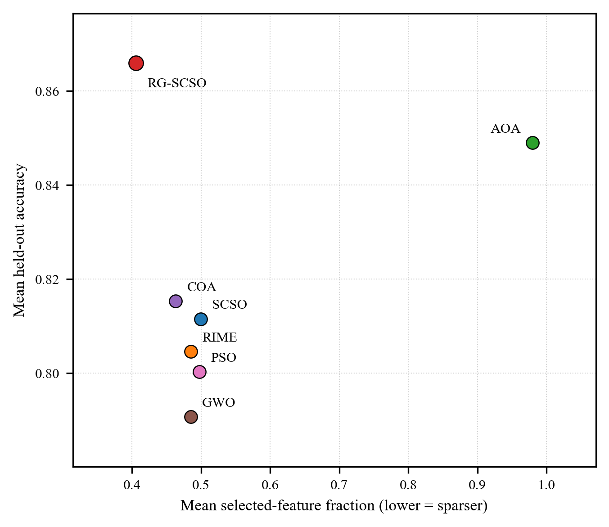
Fig. 2. Mean held-out accuracy vs. mean selected-feature fraction, averaged across all 18 datasets, one point per algorithm. RG-SCSO achieves the highest mean held-out accuracy and the second-smallest mean selected-feature count among the seven algorithms tested. AOA attains the second-highest accuracy but selects on average 98% of available features, essentially no feature selection; COA is the sparsest method but at a distinctly lower accuracy than RG-SCSO.

Ranking and statistical significance
Table 3 gives the in-sample average rank (1.00 for RG-SCSO) and the Holm-significant win/tie/loss against each baseline. These are paired per-dataset comparisons, not independent trials: across the 108 dataset-baseline pairs RG-SCSO wins 107 and loses 0, with predominantly large effect sizes (median |d|=2.15; 96% exceed 0.8). These in-sample effect sizes are an optimistic upper bound: they contract to the small-to-moderate held-out range above once the relevance prior is denied access to test labels, whereas the ranking itself is preserved.

Table 3 Average Rank, Holm-Significant Win/Tie/Loss, and Median Effect Size vs. RG-SCSO.
Algorithm (year) | Avg. rank | W/T/L vs RG-SCSO (Holm) | Median |d|
RG-SCSO (ours) | 1.00 | - | -
AOA (2021) | 2.89 | 17/1/0 | 3.42
SCSO (2022) | 3.94 | 18/0/0 | 1.49
COA (2023) | 4.11 | 18/0/0 | 1.87
RIME (2023) | 4.44 | 18/0/0 | 2.08
PSO (1995) | 4.94 | 18/0/0 | 2.32
GWO (2014) | 6.67 | 18/0/0 | 2.33

Fig. 3 below visualizes the held-out ranking (Table 2, Held-out generalization above) as a critical-difference diagram, the paper's primary ranking evidence, distinct from the in-sample rank in Table 3 just above.

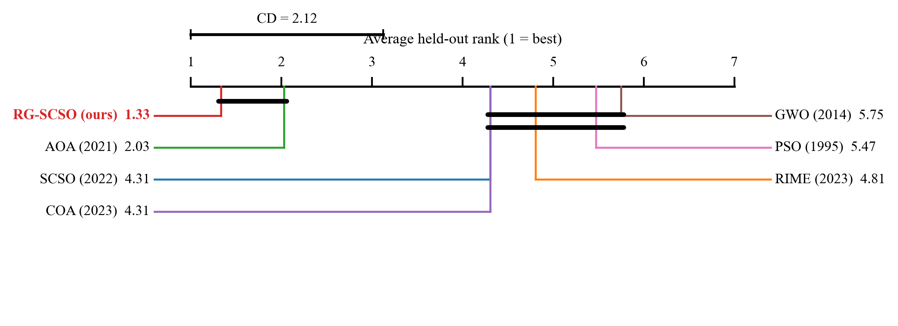
Fig. 3. Critical-difference (Nemenyi) diagram at alpha=0.05 over the held-out ranking (Table 2); algorithms not joined by a bar differ significantly in mean held-out rank.

Ablation and mechanism
We started from a three-component design and tested each part by removal (Table 4), judging significance with a paired Wilcoxon signed-rank test (Holm-corrected across datasets). RMS is the strongest: removing it costs 4.23 accuracy points on ColonCancer (d=3.21, Holm p<0.001). UMR is also load-bearing (1.16 points on Sonar), whereas ORL is not (degrades accuracy on only 0/5 datasets) and is therefore dropped; the final RG-SCSO comprises RMS and UMR only.

Configuration | ColonCancer | Leukemia | Sonar | WDBC | Zoo
Full (RMS+ORL+UMR) | 0.8831 | 0.9860 | 0.8996 | 0.9793 | 0.9801
− RMS | 0.8409† | 0.9856 | 0.8970 | 0.9795 | 0.9804
− ORL (final method) | 0.8809 | 0.9860 | 0.8940 | 0.9794 | 0.9808
− UMR | 0.8815 | 0.9860 | 0.8880† | 0.9789 | 0.9804
MI-guided init (no RMS) | 0.8523† | 0.9878 | 0.8840† | 0.9784 | 0.9807
MI-weighted objective (no RMS) | 0.8431† | 0.9860 | 0.8838† | 0.9743† | 0.9761†
− all three | 0.8441 | 0.9860 | 0.8857 | 0.9781 | 0.9808
Table 4 Component ablation, extended with two alternative relevance-injection points. ‘Final’ is the 2-component RMS+UMR configuration (the ‘− ORL’ row). † = significantly worse than Final (paired Wilcoxon signed-rank, Holm-corrected p < 0.05, 30 runs). Injecting the relevance signal at initialization or as an objective penalty, instead of at the binarization interface, is significantly worse on most datasets; the exception is Leukemia, where MI-guided initialization is statistically indistinguishable from Final while selecting roughly 4× fewer features (245 vs. 940).

RQ3 asks whether direct relevance injection at the binarization interface is more effective than relevance-guided initialization or objective weighting. A dedicated signal-position experiment answers it: injecting the same mutual-information field elsewhere, at initialization or as an objective penalty, rather than at the binarization interface; Table 4 adds both alternatives to the component ablation. MI-weighted objective injection is significantly worse than the deployed RMS+UMR configuration on four of five datasets and tied on the fifth (Leukemia), supporting the original claim that the binarization interface is a more effective injection point than the objective function. MI-guided initialization is a harder comparison: significantly worse on ColonCancer and Sonar, but statistically indistinguishable on Leukemia, WDBC, and Zoo, and on Leukemia specifically it matches RG-SCSO's accuracy while selecting roughly four times fewer features (245 vs. 940). The binarization interface is thus the most reliable injection point across datasets, not a uniformly superior one; on the most extreme p >> n dataset tested, a simpler injection at initialization meets or beats it on both accuracy and parsimony.

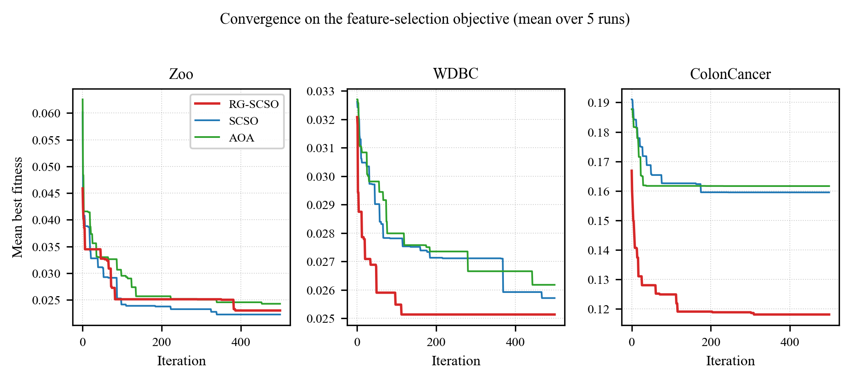
Fig. 4. Mean best fitness versus iteration, RG-SCSO vs. SCSO vs. AOA, on Zoo (16 features), WDBC (30 features), and ColonCancer (2000 features), mean over 5 runs, on the actual feature-selection objective (illustrative, not a new statistical claim). On Zoo the three algorithms converge along essentially the same trajectory. On WDBC and ColonCancer, RG-SCSO both converges faster and plateaus at a lower (better) fitness than SCSO or AOA, which themselves plateau early at a distinctly worse value rather than continuing to close the gap with more iterations; the difference grows with dimensionality.

We also test whether relevance guidance makes RG-SCSO preferentially retain high mutual-information features. Because a subset of size |S| overlaps the top-|S| mutual-information features at a chance rate of |S|/N, we report a size-fair enrichment (Fig. 5), the fraction of selected features in the top-|S| set divided by this chance level. RG-SCSO's subset is enriched above chance on both gene-expression sets, whereas the relevance-agnostic SCSO sits at chance, evidence consistent with the relevance field driving the smaller and more accurate subsets, though enrichment alone is correlational. A direct intervention test, detailed in Supplementary Information, permutes the field's feature identities while preserving its value distribution: the permuted field yields no significant accuracy difference from the real field on three of five datasets, a significant but negligible-effect difference on Leukemia, and a clear difference only on ColonCancer, while inverting the field's sign is significantly worse than both on every dataset. The relevance field's direction and scale therefore matter consistently; the exact per-feature ranking within it matters demonstrably on only one of five datasets, a materially weaker causal claim than the enrichment analysis alone would suggest.

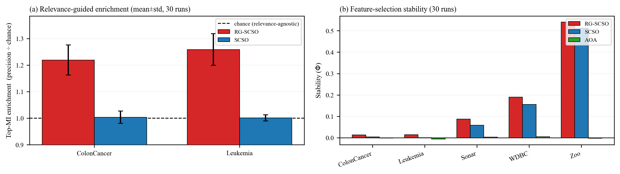
Fig. 5. Mechanism evidence. (a) Size-fair top-MI enrichment on the two gene-expression sets (selection precision divided by the chance level |S|/N; mean over 30 runs, error bars = std): RG-SCSO enriches its subset in relevant features above chance, whereas the relevance-agnostic SCSO sits at chance. (b) Feature-selection stability (Nogueira Phi, 30 runs) across all five representative datasets: RG-SCSO is more consistent run to run than same-family SCSO, clearest on the three lower-dimensional sets, but both are close to the level expected by chance on the two gene-expression sets, where AOA's near-zero Phi reflects that it selects nearly every available feature rather than genuine instability.

Threshold sensitivity
The 0.5 preferred-bit threshold that separates preferred from disfavored bits (Methods) is a convenience, not a theoretically grounded neutral point. This sweep (tau in {0.4, 0.5, 0.6}, 30 independent runs per cell, same protocol and datasets as the main ablation) tests whether that choice is at least empirically reasonable. No single tau dominates uniformly: tau=0.5, the value deployed throughout this paper, attains the highest accuracy on two of five datasets; mean selected-feature count falls monotonically as tau increases on every dataset, at a modest, dataset-dependent, non-uniform accuracy cost.

Dataset | tau | Mean Acc. | Mean #Feat. | Phi
ColonCancer | 0.4 | 0.8704 | 702.5 | 0.009
 | 0.5 | 0.8809 | 563.1 | 0.014
 | 0.6 | 0.8802 | 544.5 | 0.012
Leukemia | 0.4 | 0.9860 | 1205.4 | 0.011
 | 0.5 | 0.9860 | 939.7 | 0.015
 | 0.6 | 0.9864 | 927.6 | 0.012
Sonar | 0.4 | 0.8920 | 20.4 | 0.082
 | 0.5 | 0.8940 | 19.1 | 0.088
 | 0.6 | 0.8916 | 17.1 | 0.093
WDBC | 0.4 | 0.9795 | 13.2 | 0.193
 | 0.5 | 0.9794 | 11.8 | 0.190
 | 0.6 | 0.9791 | 11.1 | 0.163
Zoo | 0.4 | 0.9811 | 7.5 | 0.510
 | 0.5 | 0.9808 | 7.3 | 0.541
 | 0.6 | 0.9794 | 6.3 | 0.661
Table 5 Threshold sensitivity (tau in {0.4, 0.5, 0.6} replacing the fixed 0.5 preferred-bit threshold; 30 independent runs per cell, same protocol and datasets as the main ablation). Highest accuracy per dataset in bold. No single tau dominates uniformly: tau=0.5, the value deployed throughout this paper, attains the highest accuracy on two of five datasets; mean selected-feature count falls monotonically as tau increases on every dataset, at a modest, dataset-dependent, non-uniform accuracy cost. Phi is the Nogueira stability index.

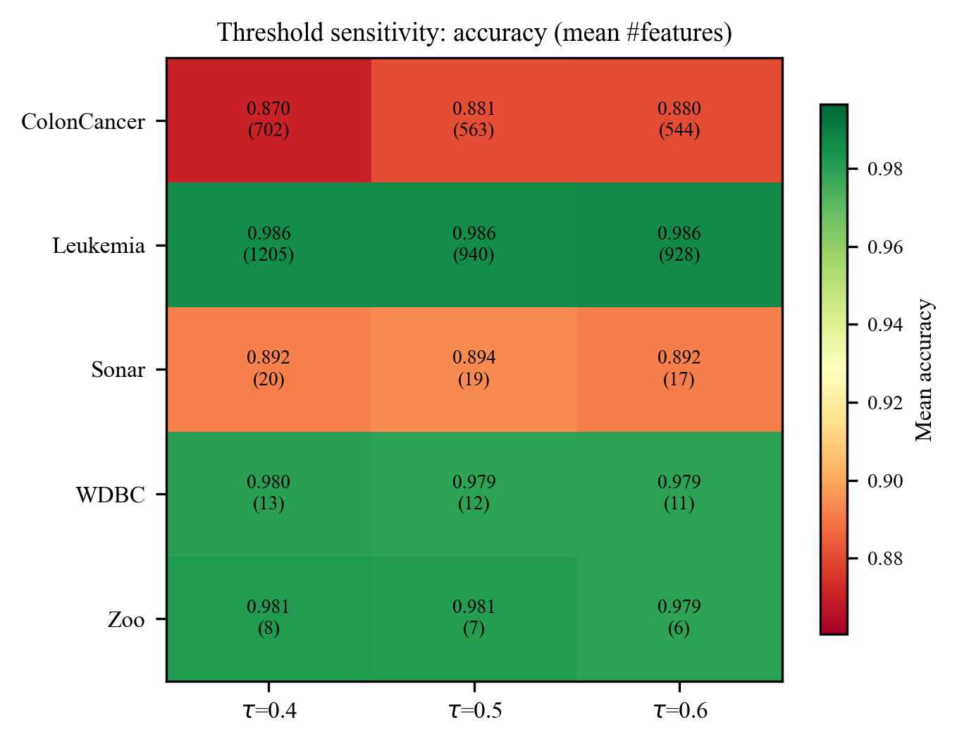
Fig. 6. Mean held-out accuracy (color) and mean number of selected features (in parentheses) across the three preferred-bit thresholds tested (tau in {0.4, 0.5, 0.6}), one row per dataset. Accuracy is essentially flat across thresholds on every dataset (largest swing 0.011, ColonCancer tau=0.4 vs. tau=0.5), while the selected-feature count falls monotonically as tau increases on all five datasets, confirming tau=0.5 is not a fragile choice.

Comparison with classical selectors
RQ4 asks how robust the mechanism is across classifiers, relevance priors, and dataset dimensionalities; this subsection and Table 7 answer it directly. Table 6 compares RG-SCSO against five classical filter, embedded, and wrapper selectors, mutual-information thresholding, mRMR, ReliefF, LASSO, and sequential forward selection, under the identical fitness and evaluation protocol. RG-SCSO significantly outperforms every classical baseline on the three lower-dimensional benchmark datasets (Zoo, Sonar, WDBC). On the two gene-expression (p >> n) datasets, this advantage does not hold: LASSO attains higher accuracy with far fewer features on both Leukemia (99.82% at 23 features vs. RG-SCSO's 98.60% at 940) and ColonCancer (95.70% at 64 features vs. 88.09% at 563), and mRMR is competitive with RG-SCSO on both. RG-SCSO's practical advantage is clearest on datasets without extreme p >> n structure; on ultra-high-dimensional gene-expression data, a computationally far cheaper embedded method such as LASSO is a strong, arguably preferable, alternative. A remaining question is whether this parsimony mechanism is an artifact of the KNN wrapper used throughout; Table 7 answers it directly, extending the same relevance-guided search to SVM and Random Forest wrappers. The advantage over a no-prior baseline is not a KNN artifact, though it is a more consistent parsimony gain than an accuracy one under Random Forest specifically, and the ReliefF-prior degradation already established above reproduces under every wrapper tested.

Method | ColonCancer | Leukemia | Sonar | WDBC | Zoo
RG-SCSO | 0.8809 (563) | 0.9860 (940) | 0.8940 (19) | 0.9794 (12) | 0.9808 (7)
MI-threshold | 0.8359 (3) | 0.9625 (30) | 0.6860 (1) | 0.9428 (10) | 0.7531 (2)
mRMR | 0.9072 (6) | 0.9888 (6) | 0.8516 (18) | 0.9724 (17) | 0.9614 (11)
ReliefF | 0.9074 (11) | 0.9783 (10) | 0.8201 (8) | 0.9682 (13) | 0.9650 (11)
LASSO | 0.9570 (64) | 0.9982 (23) | 0.8082 (59) | 0.9620 (20) | 0.8875 (11)
SFS | 0.9019 (25) | 0.9806 (25) | 0.8222 (25) | 0.9669 (25) | 0.9414 (15)
Table 6 Comparison with classical filter, embedded, and wrapper feature selectors (5-dataset pilot, not the full 18-dataset benchmark; 30 runs each, identical fitness function and evaluation protocol as the main study; cells show accuracy with mean selected-feature count in parentheses, best per column in bold). RG-SCSO significantly outperforms every classical baseline on the three lower-dimensional datasets (Zoo, Sonar, WDBC). On the two gene-expression (p >> n) datasets, LASSO attains higher accuracy with far fewer features, and mRMR is competitive with RG-SCSO.

Wrapper | Method | Mean Acc. | Mean #Feat.
KNN (30 runs) | RG-SCSO (MI) | 0.9442 | 308.2
KNN (30 runs) | RG-SCSO (ReliefF) | 0.9380 | 565.8
KNN (30 runs) | bSCSO (no prior) | 0.9350 | 545.1
SVM (30 runs) | RG-SCSO (MI) | 0.9489 | 299.1
SVM (30 runs) | RG-SCSO (ReliefF) | 0.9476 | 555.2
SVM (30 runs) | bSCSO (no prior) | 0.9468 | 537.5
RF (10 runs) | RG-SCSO (MI) | 0.9521 | 313.1
RF (10 runs) | RG-SCSO (ReliefF) | 0.9514 | 571.6
RF (10 runs) | bSCSO (no prior) | 0.9505 | 546.2
Table 7 Robustness across classifier wrappers and relevance priors, averaged over the same five representative datasets as Table 6 (KNN/SVM use the main study's 30 independent runs per cell; Random Forest uses a reduced 10, given its far higher per-evaluation cost, disclosed rather than matched artificially). Per-dataset detail for all three wrappers is given in Supplementary Information. Fewest features per wrapper in bold.

4. Discussion
These results trace washout, a concrete failure mode of transfer-function-based binary feature selection, to its source and cure it by moving the relevance signal directly inside the binarization operator rather than upstream of it in the objective or the initialization. The formal result motivating this design, presented in Methods, is a diagnostic bound explaining why continuous-space enhancements fail at the binarization boundary, not a convergence guarantee for RG-SCSO itself, and the underlying recipe, a filter prior coupled to a wrapper search with memetic refinement, is a known combination in the feature-selection literature; what is new is the injection point together with a stringent evaluation protocol, budget-matching, a leak-free hold-out, cross-classifier and cross-prior robustness, and an explicit exploration-safety diagnostic. We report parsimony, not raw accuracy, as the transferable outcome of this choice.
Several boundaries delimit what these results establish. RG-SCSO inherits SCSO's continuous search dynamics unchanged, and the RMS rule carries a risk of its own: bias the flip probability too strongly and confidently classified bits can freeze in place, draining population diversity. We measured this directly rather than assuming it away: at an aggressive stress-test bias the risk is real and grows with dimensionality, but the conservative gamma=0.5 this paper deploys keeps the frozen-bit fraction below 1.1% throughout the run on every dataset tested. We also tested whether UMR's benefit specifically requires targeting relevance-uncertain features, or only the extra evaluation budget it spends, by replacing its targeted K-feature selection with K uniformly random features at matched NFE (Supplementary Information). This untargeted control significantly outperforms targeted UMR on both accuracy and feature count on the two gene-expression datasets, where UMR's contribution is largest (ColonCancer: 90.6% vs. 88.1% accuracy, 214 vs. 563 features; Leukemia: 423 vs. 940 features at statistically indistinguishable accuracy), and ties it on the other three. UMR's value over no memetic step at all remains real (Table 4); on the datasets where that value is largest, however, it does not depend on targeting relevance-uncertain features specifically, a more modest claim than "uncertainty-targeted" on its own implies. The relevance field is built from a single filter statistic; swapping in a ReliefF prior exposes a genuine limitation rather than confirming the mechanism, the parsimony advantage disappears (Supplementary Information), so RG-SCSO's compactness depends on a prior that drives uninformative features below the neutral point, not on the mere presence of a relevance signal. This dependence, together with the O(dn log n) one-time cost of the mutual-information prior amortized against the wrapper's N+K per-iteration evaluations, is why the scalability claim is scoped to the wrapper cost dominating overall runtime as feature dimensionality grows (full per-dataset wall-clock cost is in Supplementary Information) rather than to any runtime advantage over same-budget baselines, which we do not claim.
The main objective is also a KNN wrapper; under SVM, tested directly on 16 of the 18 datasets, and under Random Forest on the same five-dataset subset as Table 7 in the Results, the parsimony advantage is not a KNN artifact, though it is a more consistent gain in subset size than in accuracy under Random Forest specifically, and the ReliefF-prior degradation already established above reproduces under every wrapper tested. The selected subset is smaller and more consistent in size than competing algorithms', but not necessarily more consistent in identity: a feature-selection stability index shows RG-SCSO more stable run to run than same-family SCSO on every dataset, clearest on the three lower-dimensional sets, yet on both gene-expression datasets RG-SCSO's own stability is itself close to the level expected by chance, so a much smaller subset there is not a materially more repeatable one (Fig. 5b; Supplementary Information gives the full per-dataset breakdown for both checks).
This wrapper search is itself compute-intensive; absolute wall-clock cost per run, for every algorithm tested, is reported in full in Supplementary Information rather than only argued qualitatively. A genuine outer-fold nested cross-validation pilot on three datasets, also in Supplementary Information, is directionally consistent with the single-split held-out estimate above, though underpowered at five runs per cell to confirm significance independently.
External validity has its own limits: the benchmark spans 8 to 3571 features across biomedical, gene-expression, and categorical domains drawn from a single curated family of UCI and standard microarray sets, and behaviour on ultra-high-dimensional omics data of 10⁴ to 10⁵ features is extrapolated, not measured. The relevance field itself is not perfectly stable on the smallest, highest-dimensional datasets: a bootstrap resampling analysis, reported in Supplementary Information, shows markedly lower rank stability of the mutual-information field on the two gene-expression sets than on the three lower-dimensional benchmarks, a risk the classical-baseline comparison above makes concrete rather than theoretical.
Finally, the accuracy claim is scoped, not universal: against binary particle-swarm and grey-wolf optimizers carrying published adaptive transfers, and against same-family binary SCSO selectors, RG-SCSO does not lead on accuracy, and on the two gene-expression datasets specifically a classical LASSO baseline outperforms RG-SCSO outright, so we do not claim a practical advantage for RG-SCSO on ultra-high-dimensional, small-sample data; we scope its transferable benefit to parsimony on datasets without that extreme structure. These boundaries are gathered together, with the future work they motivate, in Conclusion below.

5. Conclusion
The results support RG-SCSO as a relevance-guided binary feature-selection method whose primary advantage is improved subset parsimony with competitive predictive performance under the tested conditions: across 18 benchmark datasets it selects the second-smallest feature subsets of any method evaluated, trailing only COA, while attaining the best mean held-out accuracy among all seven algorithms compared, under a fixed, budget-matched, leak-free evaluation protocol (RQ1, RQ2).
This advantage is not universal, and the boundaries established in Discussion above are real constraints on the claim, not caveats to be read past. RG-SCSO does not lead on accuracy against optimizers carrying published adaptive continuous-space transfers or against same-family binary SCSO selectors; on the two extreme p >> n gene-expression datasets tested, a classical LASSO baseline outperforms it outright on both accuracy and feature count; its dependence on the underlying relevance prior is genuine, since replacing mutual information with a ReliefF prior removes the parsimony advantage entirely; the 0.5 preferred-bit threshold, while empirically reasonable across the range tested, is not a uniformly optimal choice; and the benchmark itself, though spanning 8–3571 features across biomedical, gene-expression, and categorical domains, is drawn from a single curated family of datasets, so behavior on ultra-high-dimensional omics data of 10⁴–10⁵ features is extrapolated rather than measured.
Future work includes: (i) adaptive, data-driven selection of the preferred-bit threshold, for example via cross-validation or an entropy-based criterion, rather than a fixed value; (ii) an explicit multi-objective formulation that traces an accuracy-parsimony Pareto front rather than a single weighted objective; (iii) extending the relevance-modulated binarization mechanism to other swarm optimizers, such as WOA, HHO, or SMA, to test whether the injection-point argument generalizes beyond SCSO; (iv) evaluation at larger scale, on datasets exceeding 10⁴ features, where a relevance-guided, binary-native operator should be especially valuable; and (v) alternative relevance priors beyond mutual information and ReliefF, such as SHAP-based, mRMR, or learned priors, to test whether the mechanism's benefit is specific to the prior used here or transfers to others.

6. Methods
Table 8 collects the notation used throughout this section for reference.

Symbol | Meaning
d | Total number of features (search-space dimension)
b ∈ {0,1}ᵈ | Candidate binary feature-subset mask
f(b) | Fitness function, Eq. (1)
Acc(b) | Stratified 5-fold KNN accuracy on subset b
|b| | Number of selected features (subset size)
R(t) | SCSO sensitivity range at iteration t
S_{M} | Maximum sensitivity range parameter (= 2)
T_{max} | Maximum number of iterations
T(·) | Continuous-to-binary transfer function, T: R → [0,1]
x_{j} | Continuous position of feature j
δ_{j} | Perturbation applied to x_{j}
Δ_{j} | Induced change in bit-flip probability
‖T′‖∞ | Largest slope (Lipschitz bound) of the transfer function
ε | Slope bound in a flat/saturated region of T
γ | RMS modulation strength (bias intensity)
ρ_{j} | Relevance score of feature j, ρ_{j} ∈ [0,1]
b*_{j} | Preferred bit value for feature j, 1[ρ_{j} > 0.5]
s_{j} | Modulation strength, s_{j} = 2|ρ_{j} − 0.5| ∈ [0,1]
σ_{j} | Direction indicator (+1 toward b*_{j}, −1 otherwise)
p_{j} | RMS-modulated flip probability for feature j, Eq. (2)
V(x_{j}) | V-shaped base transfer, |tanh(x_{j})|
τ | Preferred-bit threshold (deployed at 0.5; swept over {0.4, 0.5, 0.6})
ρ_{static} | Static mutual-information relevance prior
I(X_{j};y) | Mutual information between feature j and the label
H(y) | Label entropy
K | Number of UMR memetic probes per iteration
N | Population size (pop_size)
max_nfe | Total fitness-evaluation budget, pop_size × max_iter
n | Number of samples (in the O(dn log n) MI-prior cost)
Table 8 Notation used in Methods, compiled for reference. T_max (maximum iteration count, used in the SCSO sensitivity-range formula) and T(·) (the continuous-to-binary transfer function used throughout the washout subsection) are kept as distinct symbols to avoid the overloading that a single bare T would otherwise cause.

Problem formulation
We encode a candidate subset as a binary mask b in {0,1}^{d} over the d features, where b_{j} = 1 marks feature j as selected. The wrapper objective minimizes a scalarized trade-off between predictive error and subset cardinality:
$$f\left(b\right) = 0.99\left(1 - Acc\left(b\right)\right) + 0.01\frac{|b|}{d}$$
where Acc(b) is the stratified 5-fold KNN accuracy (k = 5) computed on the selected features alone. Every baseline in this study optimizes this same objective with the same 0.01 cardinality weight; RG-SCSO is granted no structural advantage on subset size from the fitness function itself, so any parsimony gap reported below reflects the search mechanism, not a differently weighted objective. SCSO maintains a population of real-valued positions updated by its exploration and exploitation rules, both governed by the sensitivity range
$$R\left(t\right) = S_{M} - S_{M}·\frac{t}{T_{max}}, S_{M} = 2$$
which RG-SCSO retains while replacing the binarization and adding a relevance field.

Theoretical motivation: transfer-function washout
Consider any binary-native optimizer that keeps a real-valued position and binarizes coordinate j through a transfer T: R → [0,1] that returns a selection-or-flip probability. A continuous-space enhancement can influence the retained subset only by perturbing a coordinate, x_{j} -> x_{j} + δ_{j}; its entire effect on the discrete decision is the induced change in probability Δ_{j} = T(x_{j}+δ_{j}) − T(x_{j}). The next result shows this leverage is governed by the local slope of T alone, and therefore collapses wherever T saturates, the mechanism we call washout.
Lemma 1 (Leverage bound). Let T: R → [0,1] be Lipschitz and piecewise continuously differentiable. If a coordinate-space enhancement perturbs x_{j} by δ_{j}, the induced change in the selection or flip probability satisfies
$$\left|Δ_{j}\right| ≤ {\left\|T'\right\|}_{∞} · \left|δ_{j}\right|$$
where ‖T′‖∞ is the largest slope T attains between x_{j} and x_{j}+δ_{j}. For the two standard transfers ‖σ′‖∞ = 1/4 and ‖|tanh|′‖∞ = 1, and each slope decays away from the origin,
$$σ'\left(x\right) ≤ e^{-|x|}$$
$$\left||tanh|'\left(x\right)\right| ≤ 4e^{-2|x|}$$
in a flat region, where ‖T′‖∞ ≤ ε, the leverage collapses to |Δ_{j}| ≤ ε·|δ_{j}| (proof in the Supplementary Information PDF distributed with this submission).
Remark (why RG-SCSO is exempt). RG-SCSO breaks the premise of the lemma: instead of routing information through the coordinate, it modulates the flip probability directly at the transfer output,
$Δ_{j} = ± γ·s_{j}·V\left(x_{j}\right)$ independent of T′.
Proposition 2 (Transition probability and cumulative leverage). Under the V-shaped binarization rule used throughout this paper, bit j flips at iteration t with probability exactly T(x_{j}(t)), so the one-step bit-transition probability coincides with the flip probability, P(b_{j}(t+1)≠b_{j}(t) | x_{j}(t)) = T(x_{j}(t)). Lemma 1's bound on Δ_{j} is therefore, without further assumption, already a bound on the one-step change in transition probability,
$$\left|ΔP\left(b_{j}(t+1)≠b_{j}(t)\right)\right| ≤ {\left\|T'\right\|}_{∞} · \left|δ_{j}\right|$$
Moreover, if a coordinate's trajectory and a δ-perturbed twin trajectory differ by δ_{j}(t) at each of N successive iterations, and T′≤ε throughout (the flat, saturated regime), linearity of expectation applied to the one-step bound gives a cumulative bound on the expected number of bit flips accumulated over the N steps,
$\left|Σ\left(t=1..N\right) ΔP\left(b_{j}(t+1)≠b_{j}(t)\right)\right| ≤ ε·Σ\left(t=1..N\right)\left|δ_{j}\right|$ (proof in the Supplementary Information PDF).
Scope of this result. This is a local, one-step-composable sensitivity bound, not a convergence guarantee, and it does not establish that continuous-space enhancements are ineffective outside the flat, saturated regime. We use washout, throughout this paper, as a diagnostic framing motivated by these bounds and corroborated empirically (Results; Supplementary Information), not as a formal guarantee that continuous-space enhancements must fail under binary search; the full discussion is in the Supplementary Information PDF.

The RG-SCSO mechanism
Given the updated position x_{j}, the base flip probability uses a V-shaped transfer V(x_{j}) = |tanh(x_{j})|. With relevance ρ_{j} in [0,1], preferred bit b*_{j} = 1 if ρ_{j} > 0.5 else 0, and strength s_{j} = 2|ρ_{j} − 0.5| in [0,1], the flip probability is biased toward b*_{j},
$$p_{j} = clip\left(|tanh\left(x_{j}\right)|·\left(1+γ·σ_{j}·s_{j}\right), 0, 1\right)$$
where σ_{j} = +1 if the flip moves bit j toward b*_{j} and σ_{j} = −1 otherwise. Setting γ = 0 recovers a plain V-shaped operator (the NoRMS ablation). The 0.5 threshold that separates preferred from disfavored bits is a convenience, not a theoretically grounded neutral point: with ρ_{j} = I(X_{j};y)/H(y), the value at which a feature stops being informative depends on the number of classes, the label entropy, the sample size, and the specific MI estimator used, none of which are normalized away by the H(y) division alone. The Discussion shows this dependence is not merely theoretical: the method's compactness is tied to how the chosen relevance statistic happens to place features around 0.5, not to the threshold itself. A threshold sweep (τ in {0.4, 0.5, 0.6}, Results Section 3.5) supports this choice as reasonable rather than arbitrary: τ=0.5 attains the highest accuracy on two of five datasets tested, and every value trades a modest, dataset-dependent accuracy shift for a monotonic reduction in feature count as τ increases, with no single value dominating uniformly.
The field ρ that drives this mechanism is, in the final method, the static prior ρstatic = clip(MI(fj;ytrain)/H(ytrain), 0, 1), a normalized mutual-information filter score [2, 20] computed once per outer split. For each outer split, ρstatic is computed exclusively from the corresponding training partition and is never recomputed using the held-out partition. An online extension adding an EMA credit-assignment term from accepted fitness improvements was examined and dropped, as the ablation shows no accuracy gain on any dataset. A second, smaller component, uncertainty-targeted memetic refinement (UMR), spends a fixed local-search budget where this prior is least decisive: each iteration, the K features whose relevance is closest to 0.5 are greedily flipped on the incumbent best mask [11] and the flip is kept only if fitness improves.

Algorithm and computational cost
Every fitness evaluation, whether from population moves, memetic probes, or initialization, is counted against a single budget max_nfe = pop_size × max_iter = 15000, identical to the baselines, so UMR grants no extra evaluations.
The per-iteration cost is dominated by the N + K wrapper evaluations, each a KNN fit under fixed folds; the mutual-information prior adds a one-time O(dn log n) preprocessing cost (the nearest-neighbor MI estimator [20]), amortized against the wrapper evaluations. RG-SCSO is thus asymptotically no more expensive than base SCSO apart from the K extra probes. In wrapper feature selection generally, classifier-based fitness evaluation, not the search mechanism itself, dominates overall computational cost as feature dimensionality grows; per-dataset wall-clock measurements across the full 8–3571-feature range tested (Supplementary Information) are consistent with this expectation, and we make no runtime-speedup claim for RG-SCSO over same-budget baselines.

Datasets, baselines, and protocol
The benchmark spans 18 preprocessed datasets of 8 to 3571 features across biomedical, gene-expression, and categorical domains, full characteristics in Supplementary Table S1.
We benchmark against six baselines: SCSO (base) [10], AOA [6], CoatiOA [7], GWO [21], PSO [4], and RIME [8]. The protocol is preregistered and locked prior to the full run. All algorithms share: population 30, 500 iterations, 30 independent runs, seed = 42+run_id (paired across algorithms), KNN (k=5) with stratified 5-fold cross-validation, search space [-1,1]d, and the fitness above. Every baseline runs with its library-default published hyperparameters, with only population size and evaluation budget matched across methods; RG-SCSO's γ and K are likewise fixed before the full run.

Statistics and reproducibility
Significance uses the paired Wilcoxon signed-rank test with Holm correction [22], the Holm family formed per dataset, at α = 0.05. A tie denotes failure to reject H0 (no significant accuracy difference) at this threshold; it is not evidence of equivalence. Effect sizes use Cohen's d and rank-biserial r; overall comparison uses the Friedman test with a critical-difference diagram [23]. The experimental design was preregistered and version-controlled before the full run and left unmodified after results were observed; all randomness is seeded deterministically and shared across algorithms.

CRediT authorship contribution statement
Bui Quang Huy: Conceptualization, Methodology, Software, Validation, Formal analysis, Writing – original draft. Duong Minh Son: Supervision, Writing – review & editing.

Declaration of competing interest
The authors declare no competing interests.

Data availability
The datasets are publicly available benchmarks (UCI and standard microarray sets). The source code, the locked preregistration, the per-run seeds, and the raw results are available in an anonymized repository (https://anonymous.4open.science/r/RG-SCSO) and will be released in a public, citable repository upon acceptance.

Funding
No funding was received for this work.

References
[1] I. Guyon and A. Elisseeff, An Introduction to Variable and Feature Selection. Journal of Machine Learning Research 3, 1157–1182 (2003).
[2] H. Peng, F. Long, and C. Ding, Feature Selection Based on Mutual Information: Criteria of Max-Dependency, Max-Relevance, and Min-Redundancy. IEEE Transactions on Pattern Analysis and Machine Intelligence 27, 1226–1238 (2005).
[3] E. Emary, H. M. Zawbaa, and A. E. Hassanien, Binary Grey Wolf Optimization Approaches for Feature Selection. Neurocomputing 172, 371–381 (2016).
[4] J. Kennedy and R. Eberhart, Particle Swarm Optimization. Proceedings of the IEEE International Conference on Neural Networks 4, 1942–1948 (1995).
[5] M. Mafarja and S. Mirjalili, Whale Optimization Approaches for Wrapper Feature Selection. Applied Soft Computing 62, 441–453 (2018).
[6] L. Abualigah, A. Diabat, S. Mirjalili, M. Abd Elaziz, and A. H. Gandomi, The Arithmetic Optimization Algorithm. Computer Methods in Applied Mechanics and Engineering 376, 113609 (2021).
[7] M. Dehghani, Z. Montazeri, E. Trojovská, and P. Trojovský, Coati Optimization Algorithm: A New Bio-Inspired Metaheuristic Algorithm for Solving Optimization Problems. Knowledge-Based Systems 259, 110011 (2023).
[8] H. Su, D. Zhao, A. A. Heidari, L. Liu, X. Zhang, M. Mafarja, and H. Chen, RIME: A Physics-Based Optimization. Neurocomputing 532, 183–214 (2023).
[9] S. Mirjalili and A. Lewis, S-Shaped versus V-Shaped Transfer Functions for Binary Particle Swarm Optimization. Swarm and Evolutionary Computation 9, 1–14 (2013).
[10] A. Seyyedabbasi and F. Kiani, Sand Cat Swarm Optimization: A Nature-Inspired Algorithm to Solve Global Optimization Problems. Engineering with Computers 39, 2627–2651 (2023).
[11] F. Neri and C. Cotta, Memetic Algorithms and Memetic Computing Optimization: A Literature Review. Swarm and Evolutionary Computation 2, 1–14 (2012).
[12] S. A. Ludwig, Guided Particle Swarm Optimization for Feature Selection: Application to Cancer Genome Data. Algorithms 18, 220 (2025).
[13] A. Seyyedabbasi, Binary Sand Cat Swarm Optimization Algorithm for Wrapper Feature Selection on Biological Data. Biomimetics 8, 310 (2023).
[14] E. Pashaei, An Efficient Binary Sand Cat Swarm Optimization for Feature Selection in High-Dimensional Biomedical Data. Bioengineering 10, 1123 (2023).
[15] R. Liu, R. Fang, T. Zeng, H. Fei, Q. Qi, P. Zuo, L. Xu, and W. Liu, A Novel Adaptive Sand Cat Swarm Optimization Algorithm for Feature Selection and Global Optimization. Biomimetics 9, 701 (2024).
[16] K. Zhang, Y. He, Y. Wang, and C. Sun, Improved Multi-Strategy Sand Cat Swarm Optimization for Solving Global Optimization. Biomimetics 9, 280 (2024).
[17] M. Lin, Z. Dai, Z. Qiu, H. Chen, and H. Lin, Multi-Strategy Enhanced Sand Cat Swarm Optimization Algorithm and Its Engineering Applications. Scientific Reports 15, 34391 (2025).
[18] Y. Cai, C. Guo, and X. Chen, An Improved Sand Cat Swarm Optimization with Lens Opposition-Based Learning and Sparrow Search Algorithm. Scientific Reports 14, 20690 (2024).
[19] H. Jia, J. Zhang, H. Rao, and L. Abualigah, Improved Sand Cat Swarm Optimization Algorithm for Solving Global Optimum Problems. Artificial Intelligence Review 58, 5 (2024).
[20] A. Kraskov, H. Stögbauer, and P. Grassberger, Estimating Mutual Information. Physical Review E 69, 066138 (2004).
[21] S. Mirjalili, S. M. Mirjalili, and A. Lewis, Grey Wolf Optimizer. Advances in Engineering Software 69, 46–61 (2014).
[22] S. Holm, A Simple Sequentially Rejective Multiple Test Procedure. Scandinavian Journal of Statistics 6, 65–70 (1979).
[23] J. Demšar, Statistical Comparisons of Classifiers over Multiple Data Sets. Journal of Machine Learning Research 7, 1–30 (2006).

