Relevance-Guided Binarization for Parsimonious Feature Selection with Sand Cat Swarm Optimization
Bui Quang Huy^{1,*} and Duong Minh Son¹
¹Dong A University, Da Nang, Vietnam
*Corresponding author(s). E-mail(s): huybq@donga.edu.vn; Contributing authors: sondm@donga.edu.vn
Abstract Wrapper feature selection with swarm intelligence typically searches in continuous space and crosses into the binary domain through a fixed transfer function, a feature-agnostic quantization that discards the continuous operators' fine adjustments, a failure mode we identify and name washout. We diagnose washout as the reason continuous-space enhancements stop helping at the binarization boundary, and address it at that boundary: RG-SCSO replaces the fixed transfer with a per-feature, relevance-modulated binarization in which a mutual-information field biases each feature's bit-flip probability, so informative features resist removal and noise resists inclusion, while SCSO's continuous search is left otherwise unchanged. The design targets low- to medium-dimensional wrapper feature selection, where the practical goal is a smaller subset at matched accuracy. Evaluated on 18 datasets under a nominal fixed-budget, leak-free protocol that computes the relevance prior, the search, and the cross-validated fitness only on the training partition, RG-SCSO attains the best mean held-out accuracy of the seven metaheuristics compared while selecting the second-smallest feature subsets among them, trailing only the less-accurate COA. A controlled ablation localizes the gain to the binarization decision, not initialization or the objective, and it persists across classifier wrappers, while its parsimony benefit depends on the relevance prior. RG-SCSO also shows higher size-corrected subset stability than the base search on the five evaluated stability datasets. On the two gene-expression (p >> n) sets a classical LASSO baseline is preferable, bounding the method's envelope to data without that extreme structure.
Keywords Feature selection, Sand Cat Swarm Optimization, binary optimization, relevance-guided binarization, parsimony.

1. Introduction
Feature selection removes irrelevant and redundant features to improve classifier accuracy, reduce overfitting, and lower computational cost, a payoff that is greatest for high-dimensional, small-sample problems such as gene-expression classification, where the number of features exceeds the number of samples by orders of magnitude [1], [2]. Wrapper selection, which scores a subset by the performance of a downstream classifier, is frequently cast as a combinatorial problem solved by swarm-intelligence metaheuristics, including grey wolf [3], particle swarm [4], whale [5], and several recent optimizers [6], [7], [8]. Most such methods were conceived for continuous optimization and are adapted to the binary space through a transfer function, most commonly an S-shaped or V-shaped map, that converts a real-valued position into a selection probability [9]. We argue that this retrofit contains a structural weakness: the transfer function is fixed and feature-agnostic, applied identically to every dimension, so the incremental adjustments a continuous-space operator makes are collapsed by the squash-and-threshold step before they can influence the retained subset. We refer to this loss as washout, and show in Methods below that it is not a thought experiment: four well-motivated continuous-space enhancements of SCSO [10] failed to beat the base algorithm under an identical feature-selection protocol (0 wins, 1 loss, 17 ties by Wilcoxon signed-rank; Supplementary Table S5, preliminary washout study).
Existing studies have explored relevance-guided initialization, objective weighting, and adaptive binary transfer mechanisms; however, the explicit injection of a per-feature relevance prior into the binarization operator of SCSO-based feature selection remains insufficiently investigated. Section 2 positions this gap against each cited SCSO-family work in detail.
We close this gap with RG-SCSO: a per-feature, relevance-modulated binarization in which a mutual-information relevance field biases each feature's bit-flip probability, turning a knowledge-agnostic quantization step into a knowledge-carrying operator. SCSO's continuous search, including its sensitivity range, is retained unchanged; the novelty resides entirely in the binarization (Fig. 1). The method is designed for the regime where wrapper feature selection is most often applied in practice, low- to medium-dimensional problems in which the goal is a smaller, more deployable feature subset at matched accuracy, and we evaluate it, and bound it, against that intended use rather than claiming universal dominance; on extreme p >> n gene-expression data a classical embedded selector remains preferable, a boundary we report as a scope of the design, not a hidden caveat. This paper makes four contributions. First, we identify washout as a mechanistic failure mode and derive a diagnostic bound, together with a cumulative extension linking it to discrete transition dynamics. Second, we propose RG-SCSO, whose ablation-confirmed centerpiece is relevance-modulated sensitivity (RMS), supplemented by a smaller, budget-neutral memetic refinement step (UMR) that a sensitivity sweep shows contributes far less than RMS; an online-learning variant of the relevance field is examined and pruned entirely by ablation. Third, we evaluate under a pre-specified, nominal fixed-budget, leak-free protocol that denies the relevance prior any access to test labels. Fourth, we report a full statistical treatment, a component ablation, and a size-fair enrichment analysis correlating the observed parsimony with relevance guidance.

1.1 Research questions
This study is organized around four research questions, each answered directly by a specific part of Results or Discussion below.
- RQ1. Does relevance-modulated binarization improve held-out feature-selection performance under a fixed computational budget? Addressed in Section 3.1 (Table 2, Fig. 3).
- RQ2. Can RG-SCSO reduce the number of selected features while preserving competitive generalization accuracy? Addressed in Section 3.2.
- RQ3. Is direct relevance injection at the binarization interface more effective than relevance-guided initialization or objective weighting? Addressed in Section 3.4 (Table 4).
- RQ4. How robust is the proposed mechanism across classifiers, relevance priors, and dataset dimensionalities? Addressed in Section 3.6 (Table 7) and Discussion.
The remainder of the paper reviews existing approaches along three axes: (i) binary transfer functions in swarm-based feature selection, (ii) relevance-guided search mechanisms, and (iii) SCSO variants (Section 2).

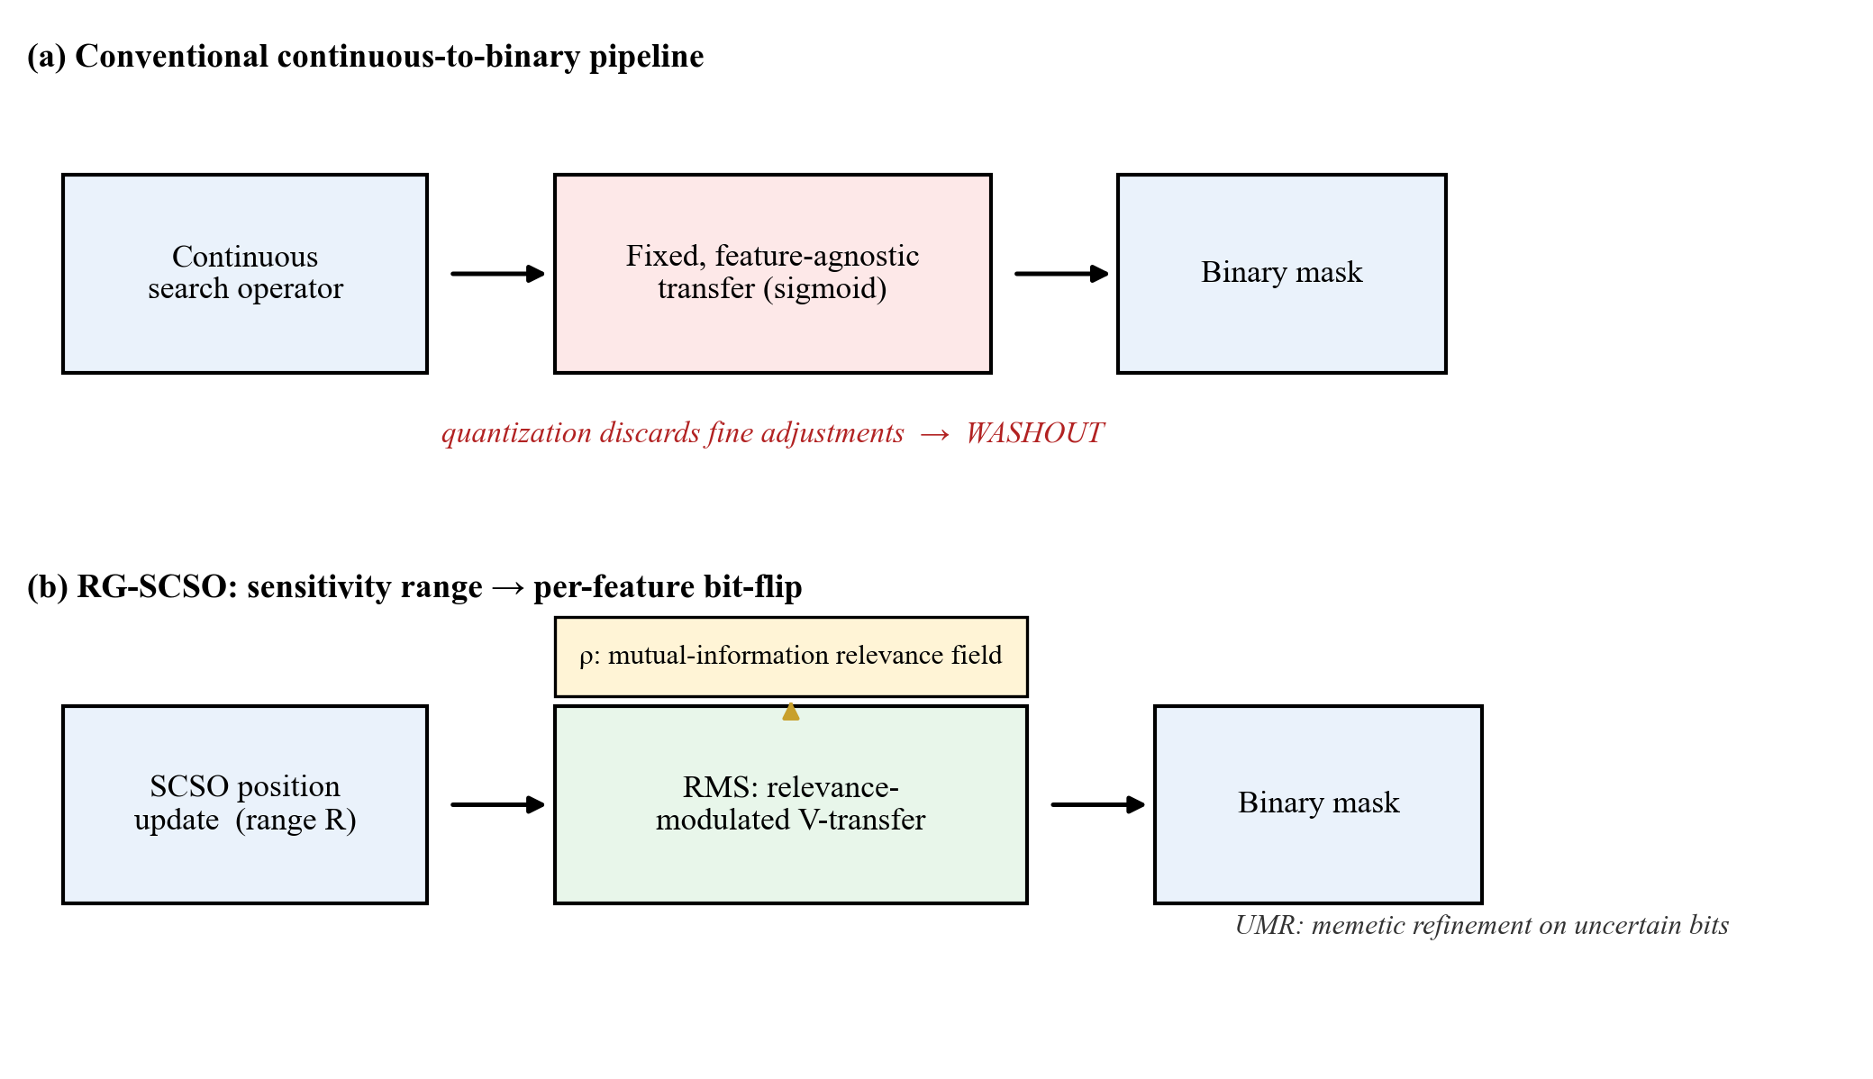
Fig. 1. Conceptual overview. (a) The conventional pipeline, where continuous-operator adjustments are collapsed by a fixed, feature-agnostic transfer (washout). (b) RG-SCSO, where a per-feature, relevance-modulated binarization replaces the feature-agnostic transfer, biasing each feature's bit-flip probability by a mutual-information relevance field, followed by memetic refinement on uncertain bits.

2. Related work

2.1 Binary transfer functions in swarm-based feature selection
Swarm-intelligence wrapper selectors, including grey wolf [3], particle swarm [4], whale [5], and several recent optimizers [6], [7], [8], are conceived for continuous optimization and cross into the binary search space through a transfer function, most commonly an S-shaped or V-shaped map [9]. A substantial recent line of work makes this interface adaptive rather than static: time-varying transfer functions that reshape the squashing curve as the search progresses [24], [26], and fitness- or history-driven schemes that tune it from the swarm's own progress [25], [27]. Crucially, all of these remain feature-agnostic: the same (possibly time-varying) transfer is applied identically to every dimension regardless of that feature's relevance, the structural weakness this paper terms washout (Introduction, Methods). RG-SCSO is orthogonal to this line: it modulates the binarization per feature by a relevance prior, and could in principle be combined with an adaptive transfer rather than replacing one.

2.2 Relevance-guided mechanisms in feature selection
Filter criteria such as mutual information and mRMR [1], [2] encode problem knowledge cheaply but are decoupled from the wrapper search; memetic hybridization [11] adds local refinement without addressing the binarization interface. A large family of knowledge-guided metaheuristics injects filter information upstream of the binary decision, into initialization or the objective. In other swarm families this takes the form of correlation- or mutual-information-guided population initialization [28], [29], filter-guided PSO for cancer-genome selection [12], and memetic hybridization of binary Harris-hawks and whale operators [30]; a parallel, deep-learning-oriented direction drives selection from post-hoc attribution or attention, for example SHAP-guided deep feature selection [31]. All of these bias where the search starts, what it optimizes, or which features a separately trained model highlights, yet leave the binarization operator itself knowledge-agnostic. RG-SCSO differs by injecting the relevance signal at the binarization interface itself rather than upstream of it; the signal-position experiment in Results (Table 4) tests this design choice directly against both the initialization and objective alternatives.
Positioning against relevance-injecting binary GWO/WOA/HHO variants. The closest competitors are binary grey-wolf, whale, and Harris-hawks selectors that already carry a relevance signal: MOBGWO-GMS initializes its population from feature correlation and guides mutation with it [28], the enhanced Harris-hawks optimizer seeds the search with filter-ranked features [29], and hybrid binary whale/Harris-hawks memetics combine two operators for stronger local search [30]. Each injects relevance at initialization, mutation, or hybridization; none makes the per-feature binarization operator itself relevance-aware, which is the specific interface RG-SCSO modifies and the reason its parsimony gain (Results) is not reproduced by these variants' upstream injections.

2.3 Sand Cat Swarm Optimization and its variants
SCSO [10] is a comparatively recent continuous metaheuristic. The existing binary SCSO feature selectors [13], [14], [15] apply standard transfer functions without a relevance-aware binarization step, and the broader recent SCSO literature that adds chaotic initialization, differential mutation, or hybridized search strategies [16], [17], [18], [19] improves continuous-space search dynamics while leaving the binarization interface itself untouched; across the SCSO-family literature we screened, we found none that makes the binarization operator itself per-feature and relevance-aware. A per-reference audit of the binarization mechanism is released with the code; notably, the closest binary SCSO selector that uses relevance injects it at initialization (a differential-expression pre-filter), not at the binarization operator, which is precisely the distinction our signal-position experiment isolates. Table 1 positions each of these works against this claim directly.

2.4 Literature-positioning summary
Table 1 makes this gap concrete across every SCSO-family work cited above; the caption details how each is scored.

Method | Year | What it modifies | Comparable to this protocol?
Seyyedabbasi & Kiani [10] | 2023 | Base continuous SCSO (no FS) | Baseline (Table 1)
bSCSO [13] | 2023 | Binary wrapper FS, standard transfer | Motivates re-implemented configs below, not individually reproduced
Binary SCSO (biomedical) [14] | 2023 | Binary wrapper FS, standard transfer | Motivates re-implemented configs below, not individually reproduced
Adaptive SCSO [15] | 2024 | Binary wrapper FS, standard transfer | Motivates re-implemented configs below, not individually reproduced
IMSCSO [16] | 2024 | Continuous search (multi-strategy) | No, global optimization only, no FS
SCSO+Lens-OBL+SSA [18] | 2024 | Continuous search (lens-OBL init) | No, global optimization only, no FS
Improved SCSO [19] | 2024 | Continuous search dynamics | No, global optimization only, no FS
MESCSO [17] | 2025 | Continuous search (multi-strategy) | No, global optimization only, no FS
Table 1 Positioning of RG-SCSO against recent SCSO-family literature cited in this paper. The four 2024–2025 continuous-search variants (IMSCSO, SCSO+Lens-OBL+SSA, Improved SCSO, MESCSO) improve exploration/exploitation dynamics in continuous space but are global optimization studies, not feature selectors, so they are not directly comparable under this paper's binary FS protocol; they are cited to establish that none of them touches the binarization interface itself. The three binary SCSO feature selectors listed here motivate two representative configurations we directly re-implement and evaluate in Results and Discussion, a standard S-shaped transfer and a V-shaped transfer combined with opposition-based learning, the two most commonly reused binarization recipes in this literature, rather than a claimed one-to-one reproduction of any single one of these three papers' exact reported parameters.

3. Results

3.1 Held-out generalization
RQ1 asks whether relevance-modulated binarization improves held-out performance under a fixed computational budget; this subsection answers it directly. For each dataset, algorithm, and independent run we draw an outer stratified 80/20 split. The relevance prior, the search, and the cross-validated fitness are computed exclusively on the 80% training partition; the selected subset is evaluated once on the untouched 20% hold-out, on which a fresh k-NN classifier (standardized on the training partition) reports accuracy, so the relevance prior never has transductive access to the test labels. Table 2 reports held-out accuracy over all seven algorithms and 18 datasets, at a nominal 15,000-NFE evaluation budget (max_nfe = 15,000) for every algorithm compared, with a documented 0.2% batch-boundary exception for CoatiOA. RG-SCSO attains the best average Friedman rank (1.33, ahead of the second-placed AOA at 2.03; $χ^{2}=67.25$, p < 0.001). A Holm-corrected Wilcoxon signed-rank test across all pairwise comparisons gives RG-SCSO 64 significant wins, 1 loss, and 43 ties; the only close competitor is AOA, over which RG-SCSO holds the higher mean accuracy and a consistently positive paired difference (median |d|=0.30); the more conservative Nemenyi post-hoc, however, does not separate the two (Fig. 3), so we read this as a modest edge rather than a statistically conclusive superiority over AOA. Over the 18 datasets that paired difference against AOA is +0.017 (95% bootstrap CI [+0.003, +0.034], excluding zero) -- small but consistent -- while against every other baseline the paired difference is larger (all 95% CIs excluding zero).
As a further, distribution-free uncertainty estimate beyond the point ranks above, a dataset-level cluster bootstrap (2000 resamples over the 18 datasets) gives a 95% CI of [0.825, 0.907] on RG-SCSO's mean held-out accuracy (0.866) and [0.812, 0.886] for AOA (0.849); the intervals overlap, consistent with the moderate effect size reported above rather than an overwhelming one.

Dataset | RG-SCSO | AOA | COA | SCSO | RIME | PSO | GWO
BreastEW | 0.963±0.014 (5) | 0.968±0.013 (9) | 0.949±0.025 (5) | 0.951±0.020 (4) | 0.952±0.021 (4) | 0.943±0.041 (5) | 0.951±0.016 (4)
ColonCancer | 0.762±0.096 (555) | 0.741±0.098 (1958) | 0.710±0.157 (535) | 0.741±0.087 (1002) | 0.731±0.090 (999) | 0.733±0.114 (1007) | 0.751±0.087 (1007)
Diabetes | 0.723±0.031 (5) | 0.728±0.033 (7) | 0.700±0.054 (5) | 0.703±0.061 (4) | 0.688±0.055 (3) | 0.669±0.042 (4) | 0.671±0.055 (4)
GermanCredit | 0.726±0.029 (8) | 0.735±0.027 (20) | 0.702±0.031 (11) | 0.704±0.044 (10) | 0.705±0.028 (10) | 0.698±0.037 (10) | 0.695±0.038 (10)
HeartDisease | 0.809±0.047 (6) | 0.826±0.051 (13) | 0.782±0.063 (7) | 0.766±0.064 (7) | 0.763±0.060 (6) | 0.737±0.075 (7) | 0.757±0.070 (6)
IonosphereEW | 0.886±0.035 (8) | 0.842±0.041 (34) | 0.854±0.039 (12) | 0.855±0.042 (16) | 0.853±0.037 (16) | 0.842±0.042 (17) | 0.838±0.041 (16)
KrVsKpEW | 0.952±0.010 (12) | 0.929±0.016 (35) | 0.838±0.091 (17) | 0.835±0.104 (18) | 0.781±0.104 (16) | 0.791±0.115 (17) | 0.712±0.074 (17)
Leukemia | 0.973±0.038 (957) | 0.962±0.045 (3549) | 0.951±0.058 (619) | 0.953±0.058 (1771) | 0.964±0.049 (1779) | 0.960±0.048 (1781) | 0.958±0.054 (1789)
Lymphography | 0.798±0.059 (7) | 0.817±0.056 (18) | 0.761±0.076 (10) | 0.771±0.068 (9) | 0.756±0.058 (9) | 0.761±0.075 (9) | 0.736±0.091 (8)
M-of-n | 0.996±0.015 (6) | 0.871±0.029 (13) | 0.788±0.081 (7) | 0.773±0.120 (7) | 0.748±0.108 (7) | 0.726±0.104 (6) | 0.699±0.156 (6)
Parkinsons | 0.905±0.040 (7) | 0.903±0.046 (22) | 0.887±0.046 (10) | 0.881±0.051 (11) | 0.881±0.067 (11) | 0.872±0.053 (11) | 0.876±0.052 (11)
Sonar | 0.808±0.057 (17) | 0.802±0.059 (60) | 0.801±0.063 (29) | 0.798±0.065 (30) | 0.790±0.052 (30) | 0.794±0.055 (31) | 0.802±0.072 (30)
SpectEW | 0.820±0.040 (8) | 0.810±0.045 (21) | 0.803±0.043 (10) | 0.801±0.038 (11) | 0.795±0.029 (10) | 0.807±0.037 (11) | 0.793±0.055 (11)
TicTacToe | 0.821±0.029 (8) | 0.786±0.215 (8) | 0.692±0.201 (6) | 0.646±0.191 (4) | 0.654±0.185 (5) | 0.655±0.185 (5) | 0.624±0.176 (4)
Vote | 0.956±0.027 (3) | 0.922±0.038 (16) | 0.901±0.065 (6) | 0.884±0.084 (6) | 0.903±0.050 (8) | 0.891±0.046 (7) | 0.902±0.040 (8)
WDBC | 0.967±0.016 (12) | 0.965±0.015 (30) | 0.958±0.021 (14) | 0.956±0.017 (15) | 0.956±0.018 (15) | 0.953±0.021 (14) | 0.954±0.018 (15)
WaveformEW | 0.815±0.012 (16) | 0.757±0.063 (38) | 0.746±0.061 (21) | 0.735±0.086 (21) | 0.717±0.067 (20) | 0.724±0.056 (21) | 0.686±0.058 (19)
Zoo | 0.908±0.054 (8) | 0.919±0.058 (16) | 0.846±0.073 (9) | 0.854±0.079 (8) | 0.846±0.078 (8) | 0.848±0.080 (8) | 0.827±0.073 (8)
Table 2 Held-out generalization: mean ± SD accuracy over 30 runs, with mean number of selected features in parentheses, on the outer 20% hold-out (relevance prior, search, and CV fitness fit on the 80% training split only; dataset feature counts are given in Supplementary Table S1). Per-run raw results, from which every figure here can be recomputed exactly, are in the repository (Data availability). Bold = best accuracy per dataset.

3.2 Feature-subset parsimony
RQ2 asks whether RG-SCSO can reduce feature count while preserving competitive accuracy; this subsection answers it directly. Parsimony, more than any accuracy margin, is RG-SCSO's defining property. Table 2 shows it attains the best mean accuracy of any method tested (0.866) while selecting the second-fewest features on the held-out setting, on average 91.6 against 164.2 for base SCSO and 325.9 for AOA. Only COA selects fewer (74.0 on average), and it does so at 0.051 lower mean accuracy, so RG-SCSO is the most compact method that does not trade away accuracy to get there. On ColonCancer it retains 563 of 2000 features versus 1991 for AOA, at higher accuracy. This advantage remains evident across the reported stress tests: against optimizers we implement using published adaptive transfers, RG-SCSO does not lead on accuracy yet still selects 26–43% fewer features, and against two directly re-implemented same-family binary SCSO selectors (Methods) it is 42% smaller in mean feature count aggregated across all 18 datasets, at comparable accuracy. A per-dataset average of the same percentage instead would give a smaller figure, since it would weight every dataset equally regardless of its feature-count scale. The dimensionality reductions are too small relative to these datasets' modest sample counts (50–455 training instances) for a wall-clock inference saving to be resolvable above call overhead; a projected, reconstructed inference-cost analysis at a synthetic deployment-scale workload, a controlled complexity demonstration rather than a measurement on the benchmark's own test sets, is reported in Supplementary Information instead of here.

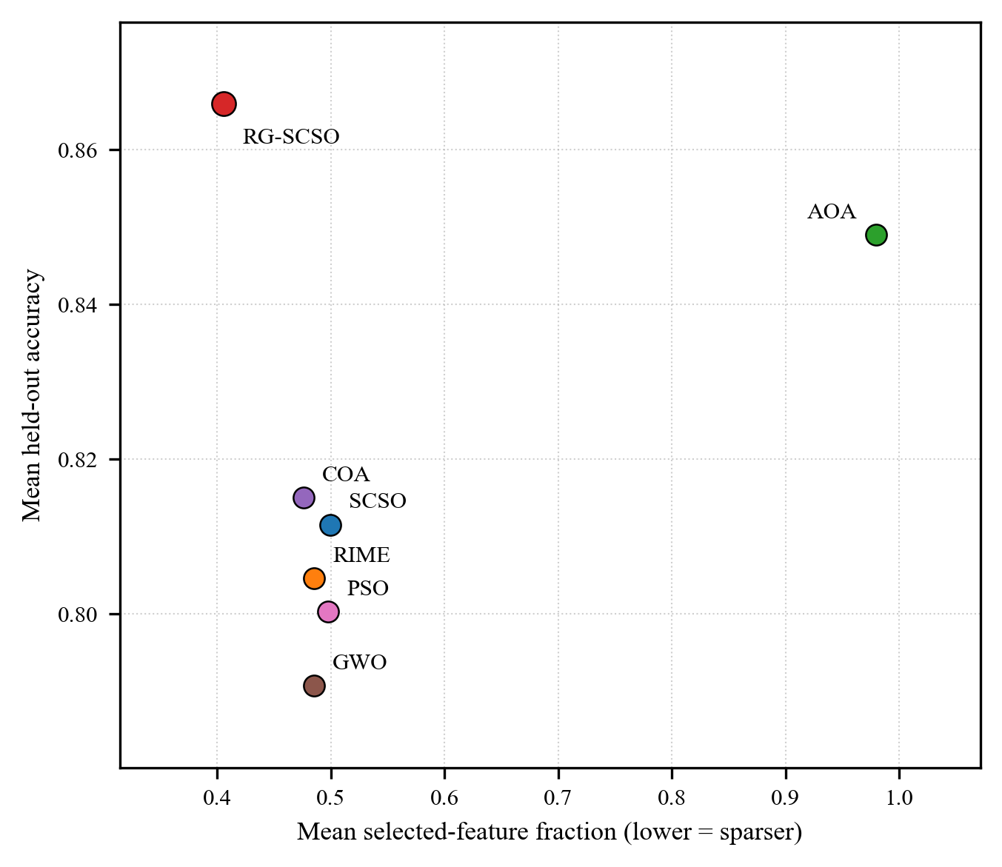
Fig. 2. Mean held-out accuracy vs. mean selected-feature fraction, averaged across all 18 datasets, one point per algorithm. RG-SCSO achieves the highest mean held-out accuracy and the second-smallest mean selected-feature count among the seven algorithms tested. AOA attains the second-highest accuracy but selects on average 98% of available features, essentially no feature selection; COA is the sparsest method but at a distinctly lower accuracy than RG-SCSO.

3.3 Ranking and statistical significance
Table 3 gives the in-sample average rank (1.00 for RG-SCSO) and the Holm-significant win/tie/loss against each baseline. These are paired per-dataset comparisons, not independent trials: across the 108 dataset-baseline comparisons RG-SCSO records 107 significant wins, 1 non-significant tie, and 0 significant losses after Holm correction, with predominantly large effect sizes (median |d|=2.15; 96% exceed 0.8). These in-sample effect sizes are an optimistic upper bound: they contract to the small-to-moderate held-out range above once the relevance prior is denied access to test labels, whereas the ranking itself is preserved.

Table 3 Average Rank, Holm-Significant Win/Tie/Loss, and Median Effect Size vs. RG-SCSO.
Algorithm (year) | Avg. rank | W/T/L vs RG-SCSO (Holm) | Median |d|
RG-SCSO (ours) | 1.00 | - | -
AOA (2021) | 2.89 | 17/1/0 | 3.42
SCSO (2022) | 3.94 | 18/0/0 | 1.49
COA (2023) | 4.11 | 18/0/0 | 1.87
RIME (2023) | 4.44 | 18/0/0 | 2.08
PSO (1995) | 4.94 | 18/0/0 | 2.32
GWO (2014) | 6.67 | 18/0/0 | 2.33

Fig. 3 visualizes the held-out ranking (Table 2, Held-out generalization) as a critical-difference diagram, the paper's primary ranking evidence, distinct from the in-sample rank in Table 3.

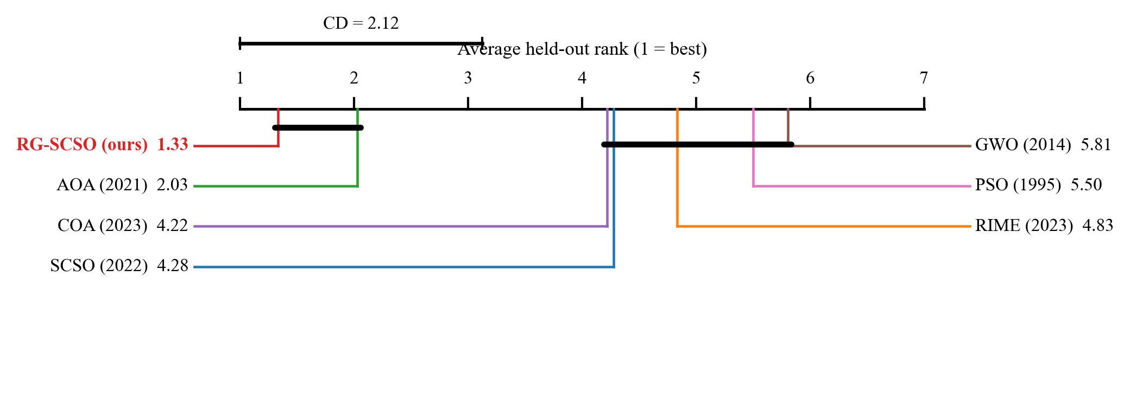
Fig. 3. Critical-difference (Nemenyi) diagram at $α=0.05$ over the held-out ranking (Table 2); algorithms not joined by a bar differ significantly in mean held-out rank.

3.4 Ablation and mechanism
We started from a three-component design and tested each part by removal (Table 4), judging significance with a paired Wilcoxon signed-rank test (Holm-corrected across datasets). RMS is the strongest: removing it costs 4.23 accuracy points on ColonCancer (d=3.21, Holm p<0.001). UMR is also load-bearing (1.16 points on Sonar), whereas ORL is not (degrades accuracy on only 0/5 datasets) and is therefore dropped; the final RG-SCSO comprises RMS and UMR only.

Configuration | ColonCancer | Leukemia | Sonar | WDBC | Zoo
Full (RMS+ORL+UMR) | 0.8831 | 0.9860 | 0.8996 | 0.9793 | 0.9801
− RMS | 0.8409† | 0.9856 | 0.8970 | 0.9795 | 0.9804
− ORL (final method) | 0.8809 | 0.9860 | 0.8940 | 0.9794 | 0.9808
− UMR | 0.8815 | 0.9860 | 0.8880† | 0.9789 | 0.9804
− all three | 0.8441 | 0.9860 | 0.8857 | 0.9781 | 0.9808
Table 4 Component ablation: mean accuracy over 30 runs on five datasets. † = significantly worse than Full (paired Wilcoxon signed-rank, Holm-corrected p < 0.05). ‘− ORL’ is the final RG-SCSO (RMS+UMR); ORL removal never degrades accuracy, so ORL is not retained. The signal-position experiment (alternative relevance-injection points) is reported separately in the Supplementary Information.

On ColonCancer specifically, the −UMR row (0.8815) is marginally higher than the deployed Final configuration (RMS+UMR, the −ORL row, 0.8809), a 0.0006-point gap that is not statistically significant (no † marker, Holm p=1.000). The final configuration is selected globally under the predefined ablation protocol rather than by picking the best-performing row per dataset: ORL is dropped because it is not load-bearing across the ablation as a whole (degrades accuracy on 0/5 datasets), not because RMS+UMR is uniformly optimal on every individual dataset.
RQ3 asks whether direct relevance injection at the binarization interface is more effective than relevance-guided initialization or objective weighting. A dedicated signal-position experiment answers it: injecting the same mutual-information field elsewhere, at initialization or as an objective penalty, rather than at the binarization interface; both alternatives are reported in full in the Supplementary Information. MI-weighted objective injection is significantly worse than the deployed RMS+UMR configuration on four of five datasets and tied on the fifth (Leukemia), supporting the original claim that the binarization interface is a more effective injection point than the objective function. MI-guided initialization is a harder comparison: significantly worse on ColonCancer and Sonar, but statistically indistinguishable on Leukemia, WDBC, and Zoo, and on Leukemia specifically it matches RG-SCSO's accuracy while selecting roughly four times fewer features (245 vs. 940). The binarization interface is thus the most reliable injection point across datasets, not a uniformly superior one; on the most extreme p >> n dataset tested, a simpler injection at initialization meets or beats it on both accuracy and parsimony. Figure 4 traces this ladder: the mean accuracy is essentially flat for relevance at initialization (V1) or in the objective (V2) and rises only once the relevance field enters the binarization decision itself (V3), while parsimony is already gained upstream.

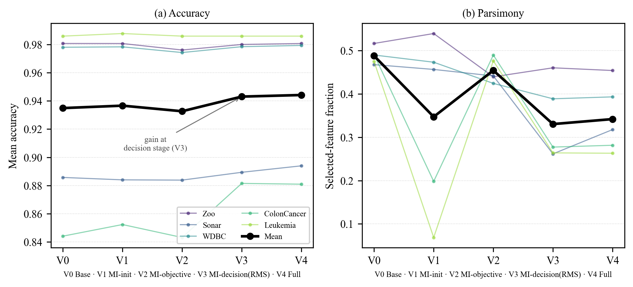
Fig. 4. Controlled injection-point ablation of the relevance signal, from V0 (base SCSO, relevance absent) through V1 (relevance at initialization), V2 (relevance in the objective), V3 (relevance at the binarization decision, RMS) to V4 (full RG-SCSO, RMS+UMR), on five datasets spanning p >> n gene-expression to low-dimensional data, 30 runs per cell. (a) Mean accuracy: thin lines are per-dataset means, the bold line the across-dataset mean. Accuracy is flat for V1 and V2 and rises only at V3, locating the accuracy effect at the binarization interface rather than upstream; the V4 UMR step adds little further accuracy, its benefit being in stability (Fig. 9). (b) Selected-feature fraction: parsimony is already gained at V1/V3, so the two effects arise at different injection points. The pattern is not uniform: on the most extreme p >> n set, initialization (V1) is competitive on both axes.

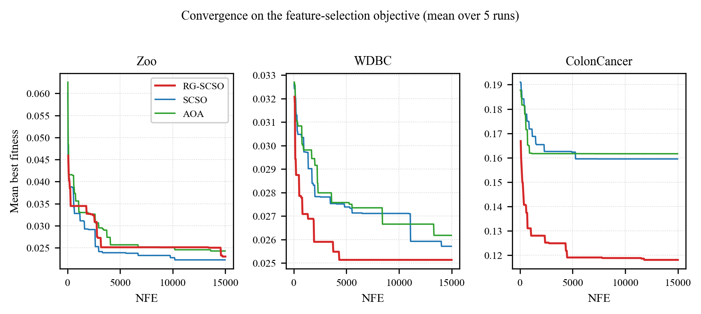
Fig. 5. Mean best fitness versus NFE, the number of fitness evaluations, RG-SCSO vs. SCSO vs. AOA, on Zoo (16 features), WDBC (30 features), and ColonCancer (2000 features), mean over 5 runs on the feature-selection objective. NFE is the shared, fixed-budget resource; raw iteration count would not be comparable, since RG-SCSO's memetic step spends more NFE per iteration than SCSO or AOA. The curves are illustrative rather than a new statistical claim. On Zoo the three algorithms plateau within a narrow final band, mean fitness 0.022–0.024 at NFE=15000, with no meaningful separation. On WDBC and ColonCancer, RG-SCSO plateaus earlier, by roughly NFE=5000, at a lower (better) fitness than SCSO or AOA, which continue to decrease slowly and still finish higher. The gap between RG-SCSO and the baselines grows sharply with dimensionality: final mean fitness differs by about 0.0006–0.001 on WDBC's 30 features versus about 0.04 on ColonCancer's 2000 features.

We also test whether relevance guidance makes RG-SCSO preferentially retain high mutual-information features. Because a subset of size |S| overlaps the top-|S| mutual-information features at a chance rate of |S|/N, we report a size-fair enrichment (Fig. 6), the fraction of selected features in the top-|S| set divided by this chance level. RG-SCSO's subset is enriched above chance on both gene-expression sets, whereas the relevance-agnostic SCSO sits at chance, evidence consistent with the relevance field contributing to the observed subset enrichment and performance pattern, though enrichment alone is correlational. A direct intervention test, detailed in Supplementary Information, permutes the field's feature identities while preserving its value distribution: the permuted field yields no significant accuracy difference from the real field on three of five datasets, a significant but negligible-effect difference on Leukemia, and a clear difference only on ColonCancer, while inverting the field's sign is significantly worse than both on every dataset. The results therefore indicate that the direction and scale of the relevance modulation matter under the evaluated conditions, whereas evidence for the exact per-feature ranking effect is strongest on ColonCancer (demonstrable on only one of five datasets) -- a materially weaker causal claim than the enrichment analysis alone would suggest.

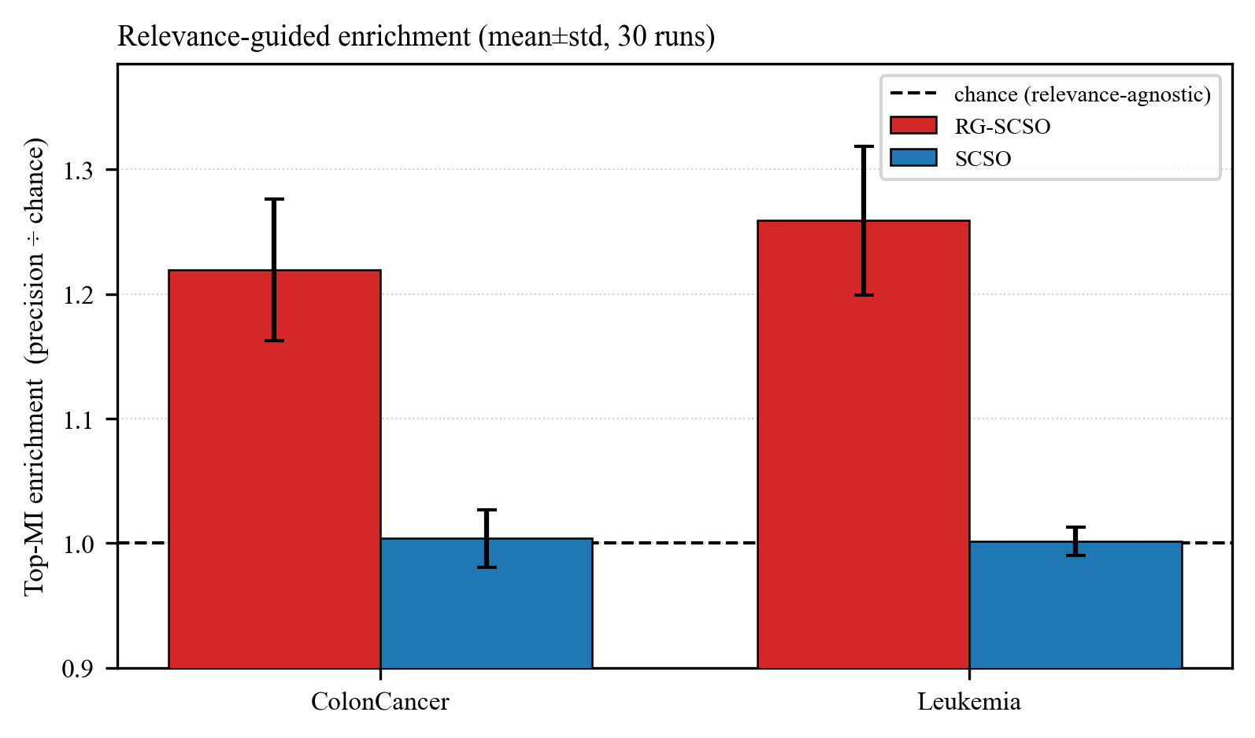
Fig. 6. Mechanism evidence: size-fair top-MI enrichment on the two gene-expression sets (selection precision divided by the chance level |S|/N; mean over 30 runs, error bars = std). RG-SCSO enriches its subset 1.22-1.26x above chance (ColonCancer, Leukemia respectively), whereas the relevance-agnostic SCSO sits at essentially chance (lift 1.00 on both), providing evidence consistent with relevance guidance contributing to the observed subset enrichment and performance pattern. Feature-selection stability is reported separately, with its size correction, in Fig. 9.

Figure 7 shows directly how relevance guidance translates into selection behaviour: RG-SCSO's per-feature selection frequency tracks the mutual-information relevance prior more closely than base SCSO, which does not use it, markedly so on the higher-dimensional sets and essentially tied on low-dimensional Zoo. This alignment is correlational, so the causal weight rests on the shuffled-prior control above, not on the alignment alone.

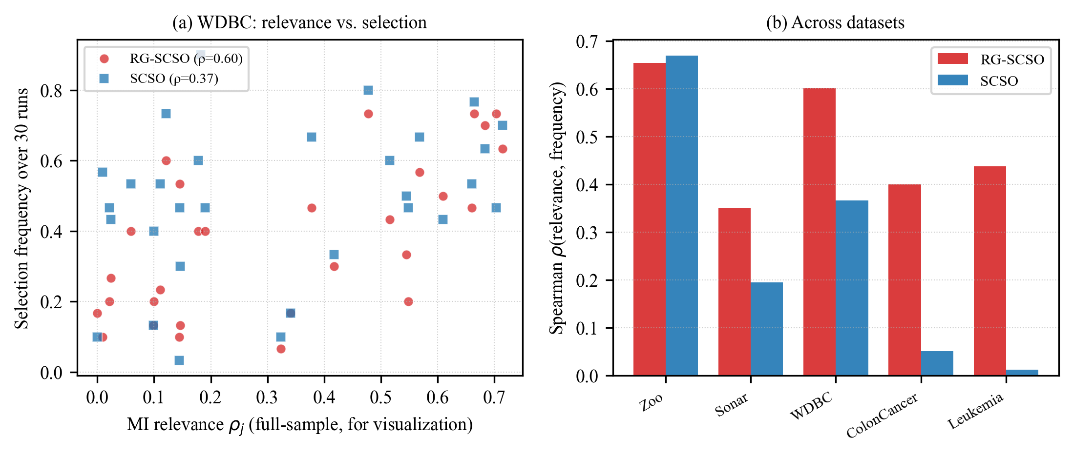
Fig. 7. How relevance guidance translates into selection behaviour. (a) For WDBC, per-feature mutual-information relevance (computed on the full sample for visualization only; the optimizer uses a train-only prior) versus the fraction of 30 runs in which each feature is selected. RG-SCSO's selection frequency tracks relevance more closely than base SCSO (Spearman rho = 0.60 vs. 0.37). (b) The same rank correlation across all five datasets: RG-SCSO is at least as relevance-aligned as SCSO on every set and markedly more so on the higher-dimensional ones (ColonCancer, Leukemia, WDBC), and essentially tied on low-dimensional Zoo. The association is correlational; the causal evidence is the shuffled-prior control (Supplementary Information). The full-sample relevance values plotted here are used solely as an ex-post descriptive visualization; they never enter the optimization, model selection, hyperparameter choice, or any reported statistical test, all of which use the train-only prior.

3.5 Threshold sensitivity
The 0.5 preferred-bit threshold that separates preferred from disfavored bits (Methods) is a convenience, not a theoretically grounded neutral point. This sweep ($τ$ in {0.4, 0.5, 0.6}, 30 independent runs per cell, same protocol and datasets as the main ablation) tests whether that choice is at least empirically reasonable. No single $τ$ dominates uniformly: $τ=0.5$, the value deployed throughout this paper, attains the highest accuracy on two of five datasets; mean selected-feature count falls monotonically as $τ$ increases on every dataset, at a modest, dataset-dependent, non-uniform accuracy cost.

Dataset | $τ$ | Mean Acc. | Mean #Feat. | Phi
ColonCancer | 0.4 | 0.8704 | 702.5 | 0.009
 | 0.5 | 0.8809 | 563.1 | 0.014
 | 0.6 | 0.8802 | 544.5 | 0.012
Leukemia | 0.4 | 0.9860 | 1205.4 | 0.011
 | 0.5 | 0.9860 | 939.7 | 0.015
 | 0.6 | 0.9864 | 927.6 | 0.012
Sonar | 0.4 | 0.8920 | 20.4 | 0.082
 | 0.5 | 0.8940 | 19.1 | 0.088
 | 0.6 | 0.8916 | 17.1 | 0.093
WDBC | 0.4 | 0.9795 | 13.2 | 0.193
 | 0.5 | 0.9794 | 11.8 | 0.190
 | 0.6 | 0.9791 | 11.1 | 0.163
Zoo | 0.4 | 0.9811 | 7.5 | 0.510
 | 0.5 | 0.9808 | 7.3 | 0.541
 | 0.6 | 0.9794 | 6.3 | 0.661
Table 5 Threshold sensitivity ($τ$ in {0.4, 0.5, 0.6} replacing the fixed 0.5 preferred-bit threshold; 30 independent runs per cell, same protocol and datasets as the main ablation). Highest accuracy per dataset in bold. No single $τ$ dominates uniformly: $τ=0.5$, the value deployed throughout this paper, attains the highest accuracy on two of five datasets; mean selected-feature count falls monotonically as $τ$ increases on every dataset, at a modest, dataset-dependent, non-uniform accuracy cost. Phi is the Nogueira stability index.

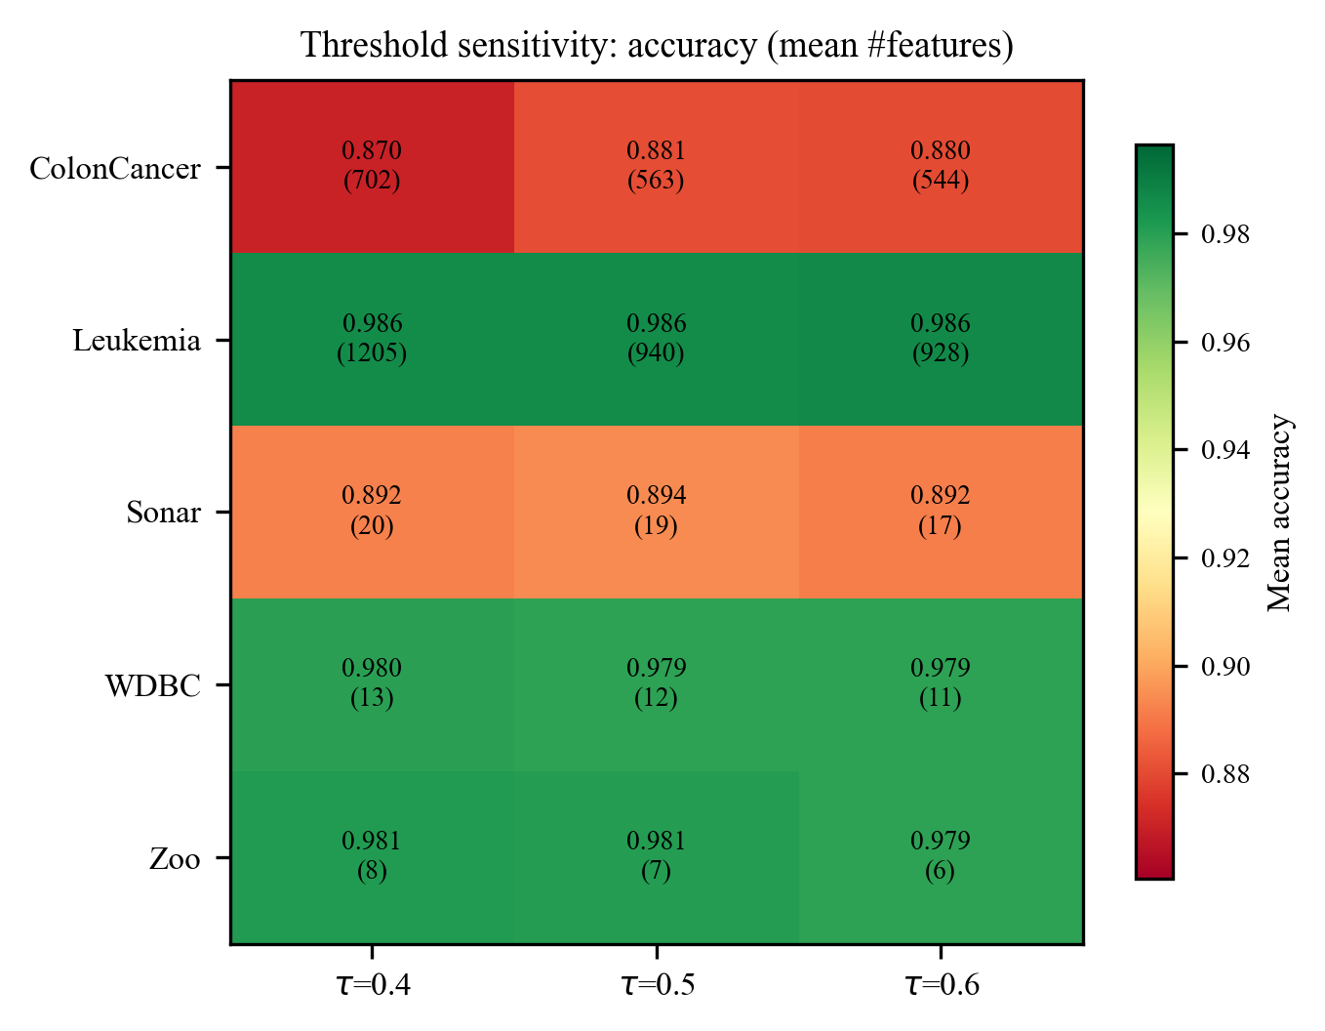
Fig. 8. Mean held-out accuracy (color) and mean number of selected features (in parentheses) across the three preferred-bit thresholds tested ($τ$ in {0.4, 0.5, 0.6}), one row per dataset. Accuracy is essentially flat across thresholds on every dataset (largest swing 0.011, ColonCancer $τ=0.4$ vs$. τ=0.5)$, while the selected-feature count falls monotonically as $τ$ increases on all five datasets, suggesting that $τ=0.5$ is not highly sensitive over the tested range.

3.6 Comparison with classical selectors
RQ4 asks how robust the mechanism is across classifiers, relevance priors, and dataset dimensionalities; this subsection and Table 7 answer it directly. Table 6 compares RG-SCSO across the full 18-dataset benchmark against five classical filter, embedded, and wrapper selectors, mutual-information thresholding, mRMR, ReliefF, LASSO, and sequential forward selection, and a Concrete-Autoencoder deep feature selector, all under one common in-sample stratified 5-fold cross-validation evaluator on the full dataset. These are therefore in-sample cross-validated accuracies, the same optimistic protocol as the in-sample ranking (Table 3), an upper bound rather than the independent outer-hold-out estimates of Table 2; the two sets of numbers answer different questions and are not directly comparable, so this comparison holds the evaluator fixed across methods rather than re-stating the generalization claim. Under this common in-sample protocol, RG-SCSO attains the best accuracy of all methods on 12 of 18 datasets. Across the benchmark it is significantly more accurate (Holm-corrected Wilcoxon signed-rank over the 18 datasets) than mutual-information thresholding, sequential forward selection, mRMR, and LASSO (all Holm p < 0.05); the one classical selector it does not significantly beat is ReliefF, which it still leads on 13 of 18 datasets (p = 0.20). The Concrete-Autoencoder baseline, matched to RG-SCSO's per-dataset subset size, is the weakest selector on the small-sample datasets tested, consistent with deep reconstruction objectives needing far more than the 50-455 training instances these benchmarks provide. The exceptions to RG-SCSO's lead are informative and concentrated: on the two gene-expression (p >> n) datasets a classical LASSO baseline attains higher accuracy with far fewer features on both Leukemia (99.8% at 23 features vs. RG-SCSO's 98.6% at 940) and ColonCancer (95.7% at 64 vs. 88.1% at 563), with mRMR competitive on both; and on four combinatorial or categorical datasets (TicTacToe, M-of-n, KrVsKpEW, WaveformEW) a classical method edges it by at most 1.7 accuracy points. RG-SCSO's advantage is thus broad but not universal: clearest on datasets without extreme p >> n structure, where on ultra-high-dimensional gene-expression data a computationally far cheaper embedded method such as LASSO is a strong, arguably preferable, alternative. A remaining question is whether this parsimony mechanism is an artifact of the KNN wrapper used throughout; Table 7 answers it directly, extending the same relevance-guided search to SVM and Random Forest wrappers. The advantage over a no-prior baseline is not a KNN artifact, though it is a more consistent parsimony gain than an accuracy one under Random Forest specifically, and the ReliefF-prior degradation already established above reproduces under every wrapper tested. The robustness is therefore conditional: behaviour across classifier wrappers is relatively consistent, whereas the parsimony benefit is sensitive to the relevance prior.

Dataset | RG-SCSO | LASSO | mRMR | ReliefF | SFS | MI-thr | CAE
Diabetes | 0.760 (5) | 0.735 (8) | 0.739 (7) | 0.745 (5) | 0.741 (7) | 0.695 (1) | 0.697 (5)
BreastEW | 0.974 (4) | 0.968 (9) | 0.971 (7) | 0.972 (6) | 0.970 (8) | 0.965 (6) | 0.946 (4)
TicTacToe | 0.820 (7) | 0.847 (9) | 0.847 (9) | 0.847 (9) | 0.788 (8) | 0.653 (1) | 0.738 (6)
HeartDisease | 0.849 (5) | 0.821 (12) | 0.825 (11) | 0.829 (10) | 0.808 (12) | 0.740 (1) | 0.753 (5)
M-of-n | 0.994 (6) | 1.000 (6) | 0.965 (8) | 1.000 (6) | 0.868 (12) | 0.664 (1) | 0.712 (6)
Vote | 0.974 (3) | 0.970 (1) | 0.970 (1) | 0.970 (1) | 0.924 (15) | 0.968 (1) | 0.841 (3)
Zoo | 0.981 (7) | 0.888 (11) | 0.961 (11) | 0.965 (11) | 0.941 (15) | 0.753 (2) | 0.871 (6)
Lymphography | 0.865 (8) | 0.823 (17) | 0.836 (13) | 0.862 (12) | 0.815 (17) | 0.695 (1) | 0.769 (7)
GermanCredit | 0.761 (8) | 0.741 (20) | 0.744 (15) | 0.747 (13) | 0.744 (19) | 0.673 (1) | 0.691 (7)
Parkinsons | 0.962 (8) | 0.912 (12) | 0.924 (9) | 0.940 (13) | 0.904 (21) | 0.867 (1) | 0.884 (7)
SpectEW | 0.859 (9) | 0.810 (14) | 0.819 (10) | 0.836 (9) | 0.800 (21) | 0.699 (1) | 0.780 (8)
WDBC | 0.979 (12) | 0.962 (20) | 0.972 (17) | 0.968 (13) | 0.967 (25) | 0.943 (10) | 0.952 (10)
IonosphereEW | 0.914 (8) | 0.844 (31) | 0.905 (3) | 0.899 (4) | 0.860 (25) | 0.822 (1) | 0.862 (7)
KrVsKpEW | 0.943 (15) | 0.936 (32) | 0.923 (26) | 0.954 (15) | 0.949 (25) | 0.522 (1) | 0.614 (12)
WaveformEW | 0.820 (16) | 0.812 (26) | 0.786 (23) | 0.837 (15) | 0.812 (25) | 0.503 (1) | 0.786 (11)
Sonar | 0.894 (19) | 0.808 (59) | 0.852 (18) | 0.820 (8) | 0.822 (25) | 0.686 (1) | 0.787 (16)
ColonCancer | 0.881 (563) | 0.957 (64) | 0.907 (6) | 0.907 (11) | 0.902 (25) | 0.836 (3) | 0.794 (324)
Leukemia | 0.986 (940) | 0.998 (23) | 0.989 (6) | 0.978 (10) | 0.981 (25) | 0.963 (30) | 0.892 (419)
Table 6 Full 18-dataset comparison of RG-SCSO against five classical filter/embedded/wrapper selectors and a Concrete-Autoencoder deep feature selector (CAE); accuracy with mean selected-feature count in parentheses, 30 runs, under one common in-sample evaluator (stratified 5-fold cross-validation on the full dataset, KNN) throughout; these are in-sample cross-validated accuracies, not the independent held-out accuracies of Table 2, and the two are not directly comparable; bold = best accuracy per dataset. Under this common in-sample protocol RG-SCSO has the best accuracy of all methods on 12 of 18 datasets and is significantly more accurate (Holm-corrected Wilcoxon over the 18 datasets) than MI-thresholding, SFS, mRMR, and LASSO; the one classical method it does not significantly beat is ReliefF (RG better on 13/18, p=0.2). The CAE, matched to RG-SCSO's per-dataset subset size, is the weakest selector on these small-sample datasets. LASSO and mRMR lead on the two gene-expression (p >> n) sets.

Wrapper | Method | Mean Acc. ± SD | Mean #Feat.
KNN (30 runs) | RG-SCSO (MI) | 0.944±0.048 | 308.2
KNN (30 runs) | RG-SCSO (ReliefF) | 0.938±0.057 | 565.8
KNN (30 runs) | bSCSO (no prior) | 0.935±0.060 | 545.1
SVM (30 runs) | RG-SCSO (MI) | 0.949±0.044 | 299.1
SVM (30 runs) | RG-SCSO (ReliefF) | 0.948±0.047 | 555.2
SVM (30 runs) | bSCSO (no prior) | 0.947±0.047 | 537.5
RF (10 runs) | RG-SCSO (MI) | 0.952±0.046 | 313.1
RF (10 runs) | RG-SCSO (ReliefF) | 0.951±0.047 | 571.6
RF (10 runs) | bSCSO (no prior) | 0.951±0.047 | 546.2
Table 7 Robustness across classifier wrappers and relevance priors, averaged over the same five representative datasets (Zoo, Sonar, WDBC, ColonCancer, Leukemia; KNN/SVM use the main study's 30 independent runs per cell; Random Forest uses a reduced 10, given its far higher per-evaluation cost, disclosed rather than matched artificially). Per-dataset detail for all three wrappers is given in Supplementary Information. Fewest features per wrapper in bold.

4. Discussion
These results provide evidence that washout, a concrete failure mode of transfer-function-based binary feature selection, can arise at the binarization boundary, and motivate addressing it by moving the relevance signal directly inside the binarization operator rather than upstream of it in the objective or the initialization. The formal result motivating this design (Methods) is a diagnostic bound: it explains why continuous-space enhancements fail at the binarization boundary, but it is not a convergence guarantee for RG-SCSO itself. The underlying recipe, a filter prior coupled to a wrapper search with memetic refinement, is a known combination in the feature-selection literature. What is new is the injection point, together with a stringent evaluation protocol: budget-matching, a leak-free hold-out, cross-classifier robustness and cross-prior sensitivity, and an explicit exploration-safety diagnostic. We report parsimony, not raw accuracy, as the transferable outcome of this choice.
One pattern in Table 2 is worth flagging as descriptive rather than a validated finding: RG-SCSO's held-out accuracy margin over base SCSO is far larger on the three datasets with deterministic Boolean or categorical structure, M-of-n (+22.3 points), TicTacToe (+17.5), and KrVsKpEW (+11.7), than on the continuous-valued biomedical datasets, where the gap is typically 1–5 points. A plausible explanation is that a mutual-information field can lock onto a deterministic logical rule more sharply than a noisy continuous measurement, but this rests on only 3 of 18 datasets sharing that structure, with no held-out test targeting the explanation directly; we report the pattern rather than claim it, and leave a controlled test of it to future work.
Several boundaries delimit what these results establish. RG-SCSO inherits SCSO's continuous search dynamics unchanged, and the RMS rule carries a risk of its own: bias the flip probability too strongly and confidently classified bits can freeze in place, draining population diversity. We measured this directly rather than assuming it away: at an aggressive stress-test bias the risk is real and grows with dimensionality, but the conservative $γ=0.5$ this paper deploys keeps the frozen-bit fraction below 1.1% throughout the run on every dataset tested. We also tested whether UMR's benefit specifically requires targeting relevance-uncertain features, or only the extra evaluation budget it spends, by replacing its targeted K-feature selection with K uniformly random features at matched NFE (Supplementary Information). This untargeted control significantly outperforms targeted UMR on both accuracy and feature count on the two gene-expression datasets, where UMR's contribution is largest (ColonCancer: 90.6% vs. 88.1% accuracy, 214 vs. 563 features; Leukemia: 423 vs. 940 features at statistically indistinguishable accuracy), and ties it on the other three. UMR's value over no memetic step at all remains real (Table 4); on the datasets where that value is largest, however, it does not depend on targeting relevance-uncertain features specifically, a more modest claim than "uncertainty-targeted" on its own implies. The relevance field is built from a single filter statistic. Swapping in a ReliefF prior exposes a genuine limitation rather than confirming the mechanism: the parsimony advantage disappears entirely (Supplementary Information). RG-SCSO's compactness therefore depends on a prior that drives uninformative features below the neutral point, not on the mere presence of a relevance signal. This dependence, together with the O(dn log n) one-time cost of the mutual-information prior amortized against the wrapper's N+K per-iteration evaluations, is why the scalability claim is scoped to the wrapper cost dominating overall runtime as feature dimensionality grows (full per-dataset wall-clock cost is in Supplementary Information) rather than to any runtime advantage over same-budget baselines, which we do not claim.
A further boundary concerns the classifier itself: the fitness objective throughout is a KNN wrapper. The selected subsets were re-evaluated directly under SVM on 16 of the 18 datasets (the full per-dataset breakdown is in Supplementary Information; the remaining two datasets are excluded from the SVM check because an RBF-kernel SVM refit at every one of the wrapper's roughly 15,000 fitness evaluations per run is intractable within budget on the two largest-n datasets), and under Random Forest on the same five-dataset subset as Table 7. The parsimony advantage holds beyond KNN. Under Random Forest specifically it is a more consistent gain in subset size than in accuracy, and the ReliefF-prior degradation established above reproduces under every wrapper tested. The Random Forest check is reported at 10 independent runs per cell rather than 30, a predefined, compute-bound scope decision, as an RF-wrapper run refits a 100-tree ensemble at every fitness evaluation and costs roughly 22x the wall-clock of the KNN wrapper (Supplementary Information); it is therefore read as a directional robustness check rather than a fully powered test. The selected subset is smaller and more consistent in size than competing algorithms', but not necessarily more consistent in identity. Measured by the size- and chance-corrected Nogueira Phi (Fig. 9a), RG-SCSO exhibited more size-corrected feature-selection stability than the baseline SCSO across the evaluated datasets, clearest on the three lower-dimensional sets, yet on both gene-expression datasets RG-SCSO's own Phi is itself close to the level expected by chance, so a much smaller subset there is not a materially more repeatable one. The size correction matters here: an uncorrected pairwise Jaccard would rank AOA as the most 'stable' method only because it selects almost every feature every run (Fig. 9b), overlap that is an artifact of subset size rather than genuine repeatability; the raw-Jaccard values are reported as a metric-diagnostic in Supplementary Information to make this behaviour explicit rather than to headline a favourable number. The full per-dataset breakdown for both checks is in Supplementary Information.

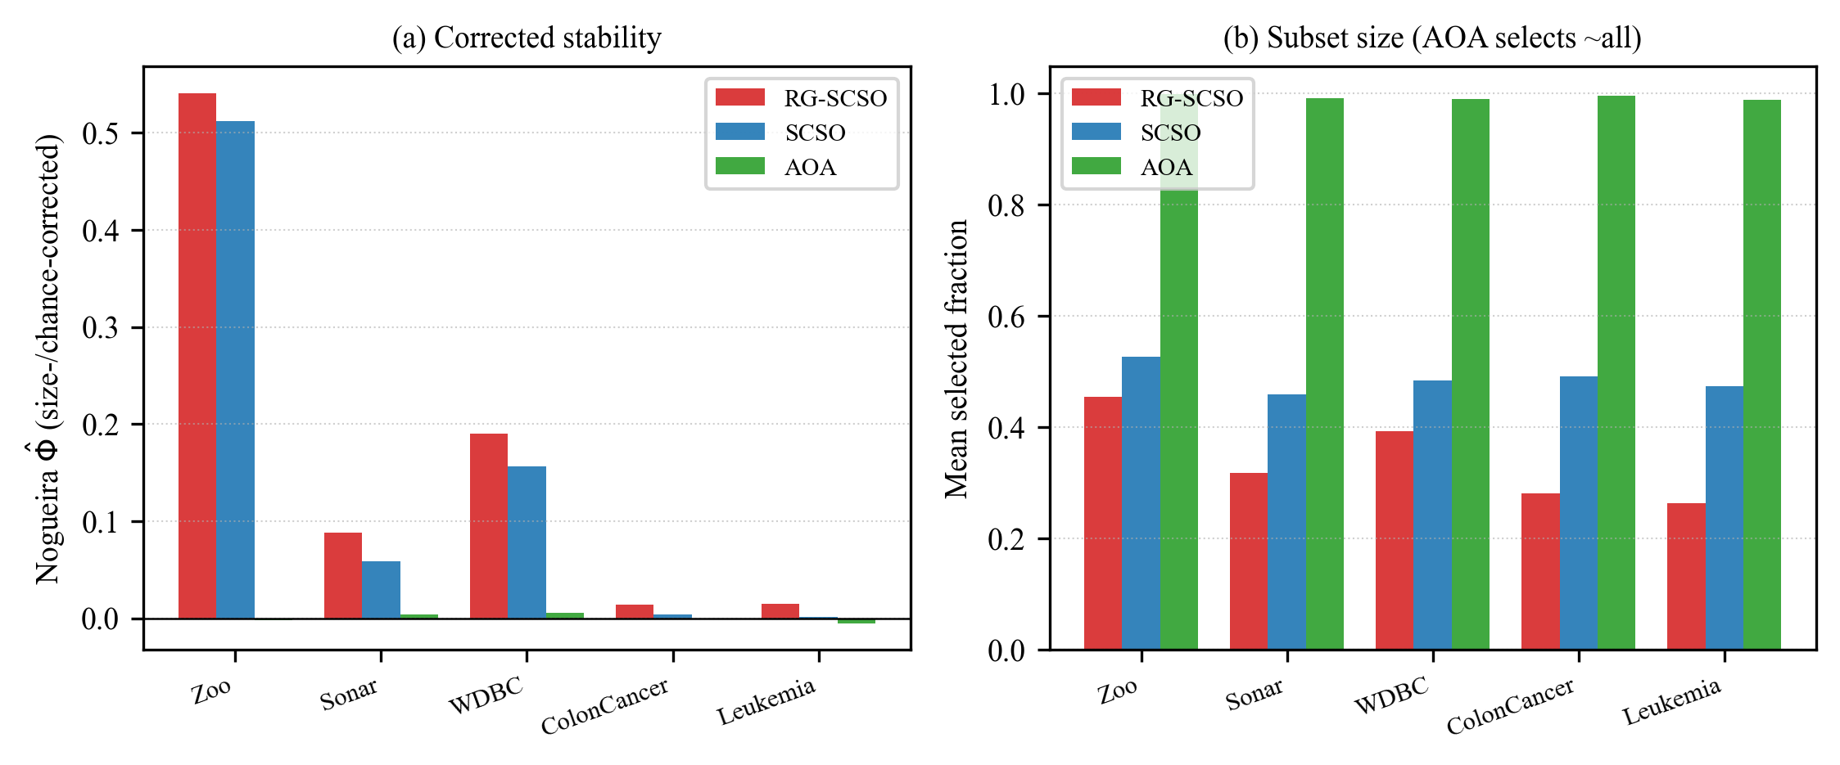
Fig. 9. Feature-subset stability across the five representative datasets, 30 runs each. (a) Size- and chance-corrected Nogueira Phi: RG-SCSO exhibited more size-corrected run-to-run stability than the baseline SCSO on every evaluated dataset, while AOA sits at Phi about 0 (no better than chance). (b) Mean selected fraction, explaining why an uncorrected metric misleads: AOA selects about 98-99% of all features, so its subsets trivially overlap, whereas RG-SCSO selects the fewest. Raw pairwise Jaccard (confounded by this size imbalance) is provided only as a Supplementary diagnostic.

This wrapper search is itself compute-intensive; absolute wall-clock cost per run, for every algorithm tested, is reported in full in Supplementary Information rather than only argued qualitatively. A genuine outer-fold nested cross-validation pilot on three datasets, also in Supplementary Information, is directionally consistent with the single-split held-out estimate above, though underpowered at five runs per cell to confirm significance independently.
External validity has its own limits. Generalization here is assessed in the sense appropriate to a supervised feature-selection benchmark — held-out instances, cross-classifier, cross-prior, and cross-dimensionality evaluation; unseen-class generalization is not an applicable estimand for this task and is therefore not tested. The benchmark spans 8 to 3571 features across biomedical, gene-expression, and categorical domains drawn from a single curated family of UCI and standard microarray sets. Its top end (3571 features, Leukemia) is still an order of magnitude below the 10⁴-10⁵-feature omics and high-dimensional text regimes where a binary-native, relevance-guided operator should matter most, so behaviour at that scale is extrapolated, not measured; a genuine >10⁴-feature evaluation is deferred to future work because a full seven-optimizer, 30-run wrapper study at that dimensionality is compute-bound by the KNN fitness evaluations rather than by the relevance mechanism itself, and lies outside this study's fixed budget. The relevance field itself is not perfectly stable on the smallest, highest-dimensional datasets: a bootstrap resampling analysis, reported in Supplementary Information, shows markedly lower rank stability of the mutual-information field on the two gene-expression sets than on the three lower-dimensional benchmarks, a risk the classical-baseline comparison above makes concrete rather than theoretical.
Finally, the accuracy claim is scoped, not universal: against binary particle-swarm and grey-wolf optimizers we implement using published adaptive transfers, and against same-family binary SCSO selectors, RG-SCSO does not lead on accuracy, and on the two gene-expression datasets specifically a classical LASSO baseline outperforms RG-SCSO outright, so we do not claim a practical advantage for RG-SCSO on ultra-high-dimensional, small-sample data; we scope its transferable benefit to parsimony on datasets without that extreme structure. A further boundary is that the baselines are evaluated at their published/default control parameters under a shared protocol rather than individually re-tuned per dataset; this is a faithful-reproduction comparison, and a per-dataset tuning study of every competitor is left to future work. A final, deliberate scope boundary concerns the host optimizer: the robustness evaluated here is across classifiers, relevance priors, and dataset dimensionalities (RQ4), all within SCSO. Whether the same per-feature, relevance-modulated binarization operator transfers its benefit to other swarm optimizers was not evaluated in the present study and therefore remains an open direction for future work (Future work, item iii); accordingly we make no cross-optimizer generalization claim. These boundaries are gathered together, with the future work they motivate, in Conclusion below.

5. Conclusion
The results support RG-SCSO as a relevance-guided binary feature-selection method whose primary advantage is improved subset parsimony with competitive predictive performance under the tested conditions: across 18 benchmark datasets it selects the second-smallest feature subsets among the seven algorithms evaluated, trailing only COA, while attaining the best mean held-out accuracy in that comparison, under a nominal fixed-budget, leak-free evaluation protocol (RQ1, RQ2).
This advantage is not universal, and the boundaries established in Discussion above are real constraints, not caveats to be read past. RG-SCSO does not lead on accuracy against adaptive-transfer or same-family SCSO baselines, and LASSO outperforms it outright on the two extreme p >> n gene-expression datasets. Its parsimony depends on the relevance prior's quality: a ReliefF prior removes the advantage entirely. The preferred-bit threshold, while empirically reasonable, is not uniformly optimal. And the 8–3571-feature benchmark, drawn from a single curated dataset family, leaves behavior at 10⁴–10⁵ features extrapolated rather than measured.
In practical terms, RG-SCSO is designed to drop into the binarization step of an SCSO-based wrapper, adding only a small, fixed set of hyperparameters (the modulation strength $γ$, the preferred-bit threshold $τ$, and the memetic budget K) that show limited sensitivity over the tested ranges, although $τ$ is not uniformly optimal; its main practical payoff is a smaller feature subset that is cheaper to store and can lower downstream feature-processing cost wherever feature acquisition and preprocessing scale with dimensionality, at accuracy that matches or exceeds the swarm-based selectors it was compared against.
Future work includes: (i) adaptive, data-driven selection of the preferred-bit threshold, for example via cross-validation or an entropy-based criterion, rather than a fixed value; (ii) an explicit multi-objective formulation that traces an accuracy-parsimony Pareto front rather than a single weighted objective; (iii) extending the relevance-modulated binarization mechanism to other swarm optimizers, such as WOA, HHO, or SMA, to test whether the injection-point argument generalizes beyond SCSO; (iv) evaluation at larger scale, on datasets exceeding 10⁴ features, where a relevance-guided, binary-native operator should be especially valuable; and (v) alternative relevance priors beyond mutual information and ReliefF, such as SHAP-based, mRMR, or learned priors, to test whether the mechanism's benefit is specific to the prior used here or transfers to others.

6. Methods
Table 8 collects the notation used throughout this section for reference.

Symbol | Meaning
$d$ | Total number of features (search-space dimension)
$b ∈ {\{0,1\}}^{d}$ | Candidate binary feature-subset mask
$f\left(b\right)$ | Fitness function, Eq. (1)
$Acc\left(b\right)$ | Stratified 5-fold KNN accuracy on subset b
$\left|b\right|$ | Number of selected features (subset size)
$λ$ | Cardinality weight in f(b) (deployed at 0.01; swept over {0, 0.001, 0.005, 0.01, 0.02, 0.05})
$R\left(t\right)$ | SCSO sensitivity range at iteration t
$S_{M}$ | Maximum sensitivity range parameter (= 2)
$T_{max}$ | Maximum number of iterations
$T\left(·\right)$ | Base/unmodulated continuous-to-binary transfer function, T: R $→ [0,1]$ (Lemma 1, Proposition 2; NOT RG-SCSO's own flip probability, which is p_{j} below)
$x_{j}$ | Continuous position of feature j
$δ_{j}$ | Perturbation applied to x_{j}
$Δ_{j}$ | Induced change in bit-flip probability
${\left\|T′\right\|}_{∞}$ | Largest slope (Lipschitz bound) of the transfer function
$ε$ | Slope bound in a flat/saturated region of T
$γ$ | RMS modulation strength (bias intensity)
$ρ_{j}$ | Relevance score of feature j, $ρ_{j} ∈ [0,1]$
${b*}_{j}$ | Preferred bit value for feature j, $1[ρ_{j} > 0.5]$
$s_{j}$ | Modulation strength, $s_{j} = 2|ρ_{j} − 0.5| ∈ [0,1]$
$σ_{j}$ | Direction indicator (+1 toward b*_{j}, −1 otherwise)
$p_{j}$ | RMS-modulated flip probability for feature j, Eq. (2)
$V\left(x_{j}\right)$ | V-shaped base transfer, |tanh(x_{j})|
$τ$ | Preferred-bit threshold (deployed at 0.5; swept over {0.4, 0.5, 0.6})
$ρ_{static}$ | Static mutual-information relevance prior
$I\left(X_{j};y\right)$ | Mutual information between feature j and the label
$H\left(y\right)$ | Label entropy
$K$ | Number of UMR memetic probes per iteration
$N$ | Population size (pop_size)
$max_nfe$ | Total fitness-evaluation budget, pop_size $×$ max_iter
$n$ | Number of samples (in the O(dn log n) MI-prior cost)
Table 8 Notation used in Methods, compiled for reference. T_max (maximum iteration count, used in the SCSO sensitivity-range formula) and $T(·)$ (the continuous-to-binary transfer function used throughout the washout subsection) are kept as distinct symbols to avoid the overloading that a single bare T would otherwise cause.

Algorithm 1 RG-SCSO
Input: training partition $\left(X, y\right)$ of the current outer split; population size $N$; iterations $T_{max}$; budget max_nfe; memetic size $K$; bias strength $γ$; threshold $τ$
Output: best feature mask $b^{*}$
1: $ρ_{j}$ ← normalized mutual information $I\left(X_{j}; y\right)$ for all $j$, computed on $\left(X, y\right)$ only ▷ static relevance field
2: for all $j$: preferred bit ${pref}_{j}$ ← 1 if $ρ_{j} > τ$ else 0; strength $s_{j}$ ← $2\left|ρ_{j} − τ\right|$
3: initialize positions $x_{i}$ ~ $U{\left(−1,1\right)}^{d}$, $i = 1..N$; form the initial masks by sign only (bit=1 if $x>0$, else 0); evaluate; set $b^{*}$ ▷ the relevance-modulated flip rule (lines 8–11) is not applied at initialization
4: while nfe < max_nfe do
5: $R$ ← $S_{M} · \left(1 − t/T_{max}\right)$ ▷ sensitivity range contracts
6: for each agent $i = 1..N$ do
7: update $x_{i}$ by the SCSO position rule using range $R$
8: for each feature $j$ do
9: $p_{base}$ ← $\left|tanh\left(x_{ij}\right)\right|$ ▷ base transfer $T\left(x_{ij}\right)$
10: $p_{j}$ ← $p_{base}\left(1 + γ·s_{j}\right)$ if the flip moves bit $j$ toward ${pref}_{j}$, else $p_{base}\left(1 − γ·s_{j}\right)$
11: flip bit $j$ with probability $clip\left(p_{j}, 0, 1\right)$
12: evaluate mask; update $b^{*}$ if improved
13: $U$ ← $K$ features whose $ρ_{j}$ is closest to $τ$ ▷ UMR on uncertain bits
14: for each $j ∈ U$ do
15: flip bit $j$ of $b^{*}$; keep the flip only if fitness improves
16: return $b^{*}$

6.1 Problem formulation
We encode a candidate subset as a binary mask b in {0,1}^{d} over the d features, where b_{j} = 1 marks feature j as selected. The wrapper objective minimizes a scalarized trade-off between predictive error and subset cardinality:
$$f\left(b\right) = (1 − λ)\left(1 − Acc\left(b\right)\right) + λ\frac{|b|}{d}, λ = 0.01$$
where Acc(b) is the stratified 5-fold KNN accuracy (k = 5) computed on the selected features alone and $λ$ is the cardinality weight (Table 10, later in this section, reports a sensitivity sweep over $λ)$. Every baseline in this study optimizes this same objective with the same $λ = 0.01$. RG-SCSO is granted no structural advantage on subset size from the fitness function itself, so any parsimony gap reported below reflects the search mechanism, not a differently weighted objective. SCSO maintains a population of real-valued positions updated by its exploration and exploitation rules, both governed by the sensitivity range
$$R\left(t\right) = S_{M} − S_{M}·\frac{t}{T_{max}}, S_{M} = 2$$
which RG-SCSO retains while replacing the binarization and adding a relevance field.

6.2 Theoretical motivation: transfer-function washout
Consider any binary-native optimizer that keeps a real-valued position and binarizes coordinate j through a transfer T: R $→ [0,1]$ that returns a selection-or-flip probability. A continuous-space enhancement can influence the retained subset only by perturbing a coordinate, x_{j} -> $x_{j} + δ_{j}$; its entire effect on the discrete decision is the induced change in probability $Δ_{j}$ = $T(x_{j}+δ_{j})$ − T(x_{j}). The next result shows this leverage is governed by the local slope of T alone, and therefore collapses wherever T saturates, the mechanism we call washout.
Lemma 1 (Leverage bound). Let T: R $→ [0,1]$ be Lipschitz and piecewise continuously differentiable. If a coordinate-space enhancement perturbs x_{j} by $δ_{j}$, the induced change in the selection or flip probability satisfies
$$\left|Δ_{j}\right| ≤ {\left\|T′\right\|}_{∞} · \left|δ_{j}\right|$$
where $‖T^{′}‖∞$ is the largest slope T attains between x_{j} and $x_{j}+δ_{j}$. For the two standard transfers $‖σ^{′}‖∞ = 1/4$ and ‖|tanh$|^{′}‖∞ = 1$, and each slope decays away from the origin,
$$σ′\left(x\right) ≤ e^{−|x|}$$
$$\left||tanh|′\left(x\right)\right| ≤ 4e^{−2|x|}$$
in a flat region, where $‖T^{′}‖∞ ≤ ε$, the leverage collapses to $|Δ_{j}| ≤ ε·|δ_{j}|$ (proof in the Supplementary Information PDF distributed with this submission).

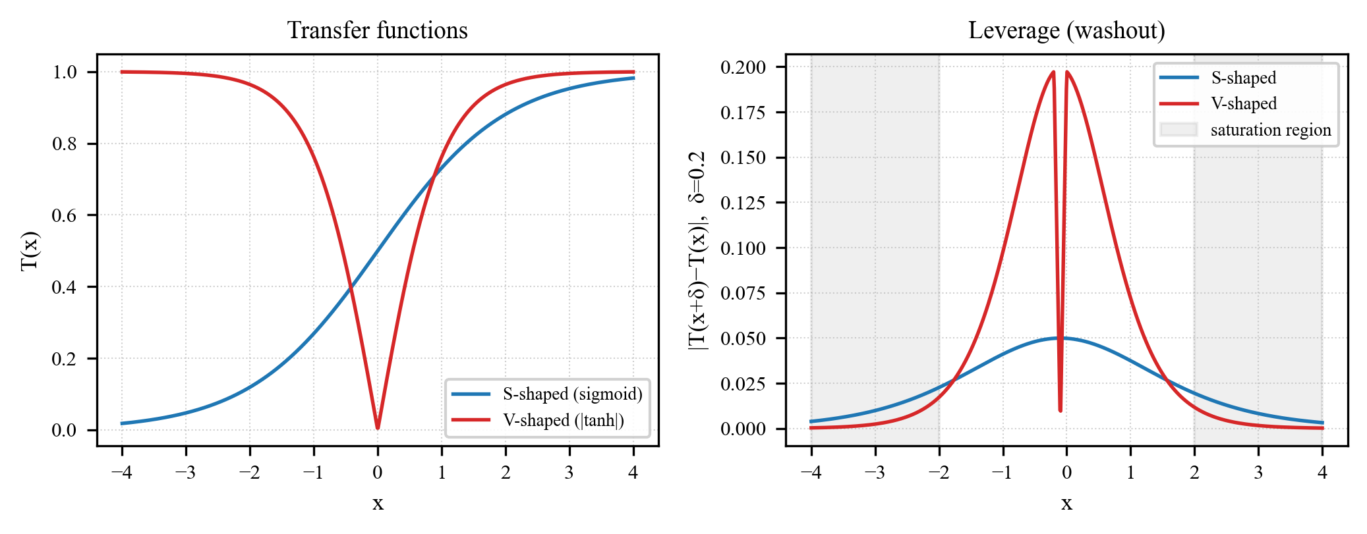
Fig. 10. Illustration of Lemma 1. Left: the two standard transfers, S-shaped (sigmoid) and V-shaped (|tanh|). Right: the induced leverage $|T(x+δ)−T(x)|$ for a fixed perturbation $δ=0.2$, plotted against the coordinate x. Both transfers saturate away from the origin (shaded region), where leverage falls toward zero regardless of which optimizer produced the perturbation; V-shaped attains a higher peak leverage near the origin but saturates over a narrower range than S-shaped. RG-SCSO's flip-probability modulation bypasses this transfer entirely (Remark below), so its leverage does not collapse in the shaded region.

Remark (why RG-SCSO is exempt). RG-SCSO breaks the premise of the lemma: instead of routing information through the coordinate, it modulates the flip probability directly at the transfer output,
$$Δ_{j} = ± γ·s_{j}·V\left(x_{j}\right)$$ independent of T′.
This exemption has one boundary case worth flagging: it holds where the clip in Eq. (2) is inactive. If $V(x_{j})(1+γσ_{j}s_{j})$ already falls outside [0,1], the clip absorbs the modulation and pⱼ saturates regardless of $γ$, so RG-SCSO is not immune to washout at that extreme. It is immune only to the slope-driven collapse that constrains the base transfer everywhere short of it.
The base transfer T still appears inside RG-SCSO's own rule as one multiplicative factor (Eq. (2) below), but Proposition 2, which follows next, characterizes only the base operator's transition probability T(x_{j}(t)) itself, not RG-SCSO's realized flip probability p_{j}, which this Remark has just shown is exempt from Lemma 1's bound by construction.
Proposition 2 (Transition probability under the base V-shaped transfer). This proposition characterizes only the base, unmodulated V-shaped transfer introduced above (the NoRMS reference operator used in the ablation); RG-SCSO's own operator is exempt from it by construction, per the Remark above. Under this unmodulated V-shaped binarization rule, bit j flips at iteration t with probability T(x_{j}(t)), so the base operator's one-step bit-transition probability coincides with T,
$$P_{base}\left(b_{j}(t+1)≠b_{j}(t) | x_{j}(t)\right) = T\left(x_{j}(t)\right)$$
Lemma 1's bound on $Δ_{j}$ is therefore, without further assumption, already a bound on the one-step change in the base operator's transition probability,
$$\left|ΔP\left(b_{j}(t+1)≠b_{j}(t)\right)\right| ≤ {\left\|T′\right\|}_{∞} · \left|δ_{j}\right|$$
Moreover, if a coordinate's trajectory and a $δ$-perturbed twin trajectory differ by $δ_{j}(t)$ at each of N successive iterations, and $T^{′}≤ε$ throughout (the flat, saturated regime), linearity of expectation applied to the one-step bound gives a cumulative bound on the expected number of bit flips accumulated over the N steps,
$$\left|Σ\left(t=1..N\right) ΔP\left(b_{j}(t+1)≠b_{j}(t)\right)\right| ≤ ε·Σ\left(t=1..N\right)\left|δ_{j}\right|$$ (proof in the Supplementary Information PDF).
Scope of this result. This is a local, one-step-composable sensitivity bound, not a convergence guarantee, and it does not establish that continuous-space enhancements are ineffective outside the flat, saturated regime. We use washout, throughout this paper, as a diagnostic framing motivated by these bounds and corroborated empirically (Results; Supplementary Information), not as a formal guarantee that continuous-space enhancements must fail under binary search; the full discussion is in the Supplementary Information PDF.

6.3 The RG-SCSO mechanism
Given the updated position x_{j}, the base flip probability uses a V-shaped transfer V(x_{j}) = |tanh(x_{j})|. With relevance $ρ_{j}$ in [0,1], preferred bit b*_{j} = 1 if $ρ_{j} > 0.5$ else 0, and strength $s_{j} = 2|ρ_{j} − 0.5|$ in [0,1], the flip probability is biased toward b*_{j},
$$p_{j} = clip\left(|tanh\left(x_{j}\right)|·\left(1+γ·σ_{j}·s_{j}\right), 0, 1\right)$$
where $σ_{j} = +1$ if the flip moves bit j toward b*_{j} and $σ_{j} = −1$ otherwise. Setting $γ = 0$ recovers a plain V-shaped operator (the NoRMS ablation). The 0.5 threshold that separates preferred from disfavored bits is a convenience, not a theoretically grounded neutral point: with $ρ_{j}$ = I(X_{j};y)/H(y), the value at which a feature stops being informative depends on the number of classes, the label entropy, the sample size, and the specific MI estimator used, none of which are normalized away by the H(y) division alone. The Discussion shows this dependence is not merely theoretical: the method's compactness is tied to how the chosen relevance statistic happens to place features around 0.5, not to the threshold itself. A threshold sweep ($τ$ in {0.4, 0.5, 0.6}, Results Section 3.5) supports this choice as reasonable rather than arbitrary: $τ=0.5$ attains the highest accuracy on two of five datasets tested, and every value trades a modest, dataset-dependent accuracy shift for a monotonic reduction in feature count as $τ$ increases, with no single value dominating uniformly.
$ρ$$ρ$$ρ$The field that drives this mechanism is, in the final method, the static prior static = clip(MI(fj;ytrain)/H(ytrain), 0, 1), a normalized mutual-information filter score [2], [20] computed once per outer split. For each outer split, static is computed exclusively from the corresponding training partition and is never recomputed using the held-out partition. An online extension adding an EMA credit-assignment term from accepted fitness improvements was examined and dropped, as the ablation shows no accuracy gain on any dataset. A second, smaller component, uncertainty-guided memetic refinement (UMR), spends a fixed local-search budget on the K features whose relevance sits closest to 0.5, the boundary where the prior is least decisive: each iteration, these features are greedily flipped on the incumbent best mask [11] and the flip is kept only if fitness improves. Discussion reports a control showing this targeting rule is not always what drives UMR's benefit.

6.4 Algorithm and computational cost
Every fitness evaluation, whether from population moves, memetic probes, or initialization, is counted against a single budget,
$$N × T_{max} = 15,000,$$
so UMR's extra probes are drawn from this same fixed total rather than added on top of it; the exact accounting against every baseline, verified on the implementation rather than assumed, is given below.
The per-iteration cost is dominated by the N + K wrapper evaluations, each a KNN fit under fixed folds; the mutual-information prior adds a one-time O(dn log n) preprocessing cost (the nearest-neighbor MI estimator [20]), amortized against the wrapper evaluations. RG-SCSO is thus asymptotically no more expensive than base SCSO apart from the K extra probes. In wrapper feature selection generally, classifier-based fitness evaluation, not the search mechanism itself, dominates overall computational cost as feature dimensionality grows; per-dataset wall-clock measurements across the full 8–3571-feature range tested (Supplementary Information) are consistent with this expectation, and we make no runtime-speedup claim for RG-SCSO over same-budget baselines.

Algorithm | Position-update cost/iter | Wrapper evaluations/iter | Extra structural cost
RG-SCSO | $O(N·d)$ | N + K (30 + 8 = 38) | O(dn log n) one-time MI-prior
SCSO | $O(N·d)$ | N (30) | –
AOA | $O(N·d)$ | N (30) | –
CoatiOA | $O(N·d)$ | N (30) | –
GWO | $O(N·d)$ | N (30) | –
PSO | $O(N·d)$ | N (30) | –
RIME | $O(N·d)$ | N (30) | –
Table 9 Per-iteration computational cost of the seven compared algorithms. N = population size (30), d = search-space dimension (number of features), K = number of UMR memetic probes per iteration (8). Position-update cost is the standard $O(N·d)$ class shared by every population-based metaheuristic compared here; none introduces an asymptotically different update rule. The wrapper evaluation itself, a stratified 5-fold KNN fit under the shared fitness function, is identical across all seven and, as noted above, dominates real-world cost as feature dimensionality grows; this table isolates the search mechanism's own footprint rather than re-ranking that shared, dominant term.
Nominal fitness-evaluation budget is
$$N × T_{max} = 30 × 500 = 15,000.$$
This cap is enforced identically for every algorithm, verified directly against the implementation. RG-SCSO and the base SCSO maintain an evaluation counter checked before every individual evaluation (each population move and each UMR probe), stopping the moment the counter reaches 15,000; each population-based baseline (AOA/GWO/PSO/RIME/CoatiOA via the mealpy library) is run under a hard function-evaluation termination at the same 15,000. The only residual difference is CoatiOA, which evaluates in sub-population batches and so halts at the first batch boundary not below the cap (15,030, a 0.2% excess that favours the baseline, not RG-SCSO). Budgets are thus matched to within 0.2% across all seven methods, removing any budget advantage for the proposed method; UMR's extra per-iteration cost is absorbed within, not added on top of, this cap.

6.5 Cardinality-weight sensitivity
The $λ = 0.01$ cardinality weight in Eq. (1) was fixed before the full run, together with every other hyperparameter (Statistics and reproducibility, below). To check that this choice is not load-bearing, we reran the full protocol on five representative datasets (Zoo, Sonar, WDBC, ColonCancer, Leukemia; 30 independent runs each) at five additional $λ$ values spanning zero cardinality penalty to $5×$ the deployed weight. Table 10 reports the sweep.

Dataset | $λ$ | Mean Acc. | Mean #Feat.
ColonCancer | 0.000 | 0.8837 | 568.4
 | 0.001 | 0.8809 | 563.1
 | 0.005 | 0.8809 | 563.1
 | 0.010 | 0.8809 | 563.1
 | 0.020 | 0.8809 | 563.8
 | 0.050 | 0.8824 | 557.8
Leukemia | 0.000 | 0.9860 | 1441.4
 | 0.001 | 0.9860 | 939.7
 | 0.005 | 0.9860 | 939.7
 | 0.010 | 0.9860 | 939.7
 | 0.020 | 0.9860 | 939.7
 | 0.050 | 0.9860 | 939.7
Sonar | 0.000 | 0.8951 | 19.0
 | 0.001 | 0.8947 | 19.5
 | 0.005 | 0.8930 | 18.7
 | 0.010 | 0.8940 | 19.1
 | 0.020 | 0.8943 | 18.4
 | 0.050 | 0.8934 | 17.2
WDBC | 0.000 | 0.9787 | 13.7
 | 0.001 | 0.9793 | 12.4
 | 0.005 | 0.9793 | 12.4
 | 0.010 | 0.9794 | 11.8
 | 0.020 | 0.9785 | 10.5
 | 0.050 | 0.9763 | 8.2
Zoo | 0.000 | 0.9808 | 8.3
 | 0.001 | 0.9805 | 7.3
 | 0.005 | 0.9805 | 6.8
 | 0.010 | 0.9808 | 7.3
 | 0.020 | 0.9804 | 7.2
 | 0.050 | 0.9775 | 6.0
Table 10 Cardinality-weight sensitivity ($λ$ in {0, 0.001, 0.005, 0.01, 0.02, 0.05} in Eq. (1); 30 independent runs per cell, same protocol and five of the 18 datasets used elsewhere in this section). Highest accuracy per dataset in bold. Accuracy is essentially flat across the sweep: $λ=0.01$, the value deployed throughout this paper, attains the highest accuracy on one of five datasets and is within 0.3 percentage points of the best value on the remaining four, well inside the run-to-run standard deviation. Mean selected-feature count trends downward as $λ$ increases on every dataset (cleanest on WDBC, noisier on the higher-dimensional ColonCancer and Sonar sets), so $λ$ mainly trades a modest, dataset-dependent subset reduction against a negligible accuracy change; 0.01 sits inside this flat region rather than at either extreme.

6.6 Datasets, baselines, and protocol
The benchmark spans 18 preprocessed datasets of 8 to 3571 features across biomedical, gene-expression, and categorical domains, full characteristics in Supplementary Table S1.
Leakage control (data flow). Every step that could learn from the labels or the held-out partition is confined to the training fold: raw data $→$ label-independent cleaning/encoding $→$ outer 80/20 split $→ [$on the 80% train only] fit standardizer $·$ compute MI relevance prior $ρ · 5$-fold CV fitness $·$ feature-subset search $→$ freeze selected mask $→ [$on the 20% hold-out] transform with the train-fitted standardizer only $→$ single KNN evaluation. No standardizer, relevance prior, CV fold, or hyperparameter is ever fit on, or given access to, the held-out partition; the hold-out is touched exactly once, for final evaluation.
$γ = 0.5$$τ = 0.5$$τ$$λ$$γ$We benchmark against six baselines: SCSO (base) [10], AOA [6], CoatiOA [7], GWO [21], PSO [4], and RIME [8]. The protocol is pre-specified and locked prior to the full run. All algorithms share: population 30, 500 iterations, 30 independent runs, seed = 42+run_id (paired across algorithms), KNN (k=5) with stratified 5-fold cross-validation, search space [-1,1]d, and the fitness above. This is a faithful published-default comparison, not an equally-tuned one: every baseline runs at its own published/library-default control parameters under this identical shared protocol, and no method is re-tuned per dataset. RG-SCSO's , , and K = 8 are likewise fixed before the full run; and the cardinality weight are additionally characterized by the sensitivity sweeps in Supplementary Information, while and K were frozen from the pre-specification pilot and not tuned on the test data. A per-method fidelity table (source, version, control parameters, search space, tuning, budget, seed) is provided in the released repository (Baseline_Fidelity_Report); the limitation of comparing against untuned baselines is acknowledged in Discussion.

6.7 Statistics and reproducibility
We state the inference units explicitly. The experimental unit is one independent run (an outer 80/20 split under a distinct seed). The primary cross-algorithm comparison is at the dataset level: for each dataset and algorithm the 30 runs are aggregated to a mean held-out accuracy, giving 18 paired per-dataset summaries that are the units for the Friedman test, the critical-difference diagram, and the paired bootstrap confidence intervals of the accuracy difference (RG-SCSO − baseline). The per-dataset Wilcoxon signed-rank test instead treats the 30 paired runs within a single dataset as its unit; those within-dataset results are repeated-run comparisons, not cross-dataset generalization, and are reported as such. Cohen's d and rank-biserial r are computed on the same paired samples as the test they accompany.
$α = 0.05$Significance uses the paired Wilcoxon signed-rank test with Holm correction [22], the Holm family formed per dataset, at . A tie denotes failure to reject H0 (no significant accuracy difference) at this threshold; it is not evidence of equivalence. Effect sizes use Cohen's d and rank-biserial r; overall comparison uses the Friedman test with a critical-difference diagram [23]. The experimental design was pre-specified and version-controlled before the full run and left unmodified after results were observed; all randomness is seeded deterministically and shared across algorithms.
Two further baselines used in Discussion isolate specific alternative explanations for RG-SCSO's parsimony and are run under the identical protocol above (same 18 datasets, 30 runs, matched budget), not drawn from prior publications: adaptive continuous-space transfer functions, specifically bPSO and bGWO equipped with the time-varying transfer of Islam et al. [24] and the V4 transfer of Teng et al. [25]; and two directly re-implemented same-family binary SCSO selectors, with a standard S-shaped and a V-shaped-plus-opposition-based-learning transfer respectively.
The relevance prior, the binarization threshold $τ$, the cardinality weight $λ$, and every other hyperparameter are fixed or estimated using only the training partition of each outer split; none is tuned, selected, or recomputed using held-out labels at any stage of the search, evaluation, or hyperparameter sweep.

Author Contributions
Bui Quang Huy: Conceptualization, Methodology, Software, Validation, Formal analysis, Investigation, Data curation, Writing – original draft, Writing – review & editing, Visualization, Supervision. Duong Minh Son: Formal analysis, Writing – review & editing.

Statements and Declarations

Funding
No funding was received for this work.

Conflict of interest
The authors declare no competing interests.

Ethical approval
Not applicable. This study uses only publicly available benchmark datasets (UCI and standard microarray sets) and involves no human participants, human data, or animals.

Declaration of generative AI and AI-assisted technologies in the writing process
During the preparation of this work the authors used a generative AI-assisted tool in order to improve the readability and language of the manuscript. After using this tool, the authors reviewed and edited the content as needed and take full responsibility for the content of the publication; all experimental design, implementation, results, and scientific claims are the authors' own.

Data Availability Statement
The datasets analysed in this study are publicly available benchmarks (UCI and standard microarray sets); Supplementary Table S1 lists each source. The source code, the locked pre-specification, the per-run seeds, a complete hyperparameter table, a pinned dependency list (requirements.txt), an MIT LICENSE, and the raw per-run results are available for review in an anonymized repository (https://anonymous.4open.science/r/RG-SCSO) at the manuscript's release commit, and will be deposited in a public, citable repository with a permanent Zenodo DOI upon acceptance. With the pinned dependencies (requirements.txt, Python 3.10) and the per-run seeds, the tables and figures can be regenerated from the released raw results, and the experiments re-run deterministically.

References
[1] I. Guyon and A. Elisseeff, An Introduction to Variable and Feature Selection. Journal of Machine Learning Research 3, 1157–1182 (2003).
[2] H. Peng, F. Long, and C. Ding, Feature Selection Based on Mutual Information: Criteria of Max-Dependency, Max-Relevance, and Min-Redundancy. IEEE Transactions on Pattern Analysis and Machine Intelligence 27, 1226–1238 (2005).
[3] E. Emary, H. M. Zawbaa, and A. E. Hassanien, Binary Grey Wolf Optimization Approaches for Feature Selection. Neurocomputing 172, 371–381 (2016).
[4] J. Kennedy and R. Eberhart, Particle Swarm Optimization. Proceedings of the IEEE International Conference on Neural Networks 4, 1942–1948 (1995).
[5] M. Mafarja and S. Mirjalili, Whale Optimization Approaches for Wrapper Feature Selection. Applied Soft Computing 62, 441–453 (2018).
[6] L. Abualigah, A. Diabat, S. Mirjalili, M. Abd Elaziz, and A. H. Gandomi, The Arithmetic Optimization Algorithm. Computer Methods in Applied Mechanics and Engineering 376, 113609 (2021).
[7] M. Dehghani, Z. Montazeri, E. Trojovská, and P. Trojovský, Coati Optimization Algorithm: A New Bio-Inspired Metaheuristic Algorithm for Solving Optimization Problems. Knowledge-Based Systems 259, 110011 (2023).
[8] H. Su, D. Zhao, A. A. Heidari, L. Liu, X. Zhang, M. Mafarja, and H. Chen, RIME: A Physics-Based Optimization. Neurocomputing 532, 183–214 (2023).
[9] S. Mirjalili and A. Lewis, S-Shaped versus V-Shaped Transfer Functions for Binary Particle Swarm Optimization. Swarm and Evolutionary Computation 9, 1–14 (2013).
[10] A. Seyyedabbasi and F. Kiani, Sand Cat Swarm Optimization: A Nature-Inspired Algorithm to Solve Global Optimization Problems. Engineering with Computers 39, 2627–2651 (2023).
[11] F. Neri and C. Cotta, Memetic Algorithms and Memetic Computing Optimization: A Literature Review. Swarm and Evolutionary Computation 2, 1–14 (2012).
[12] S. A. Ludwig, Guided Particle Swarm Optimization for Feature Selection: Application to Cancer Genome Data. Algorithms 18, 220 (2025).
[13] A. Seyyedabbasi, Binary Sand Cat Swarm Optimization Algorithm for Wrapper Feature Selection on Biological Data. Biomimetics 8, 310 (2023).
[14] E. Pashaei, An Efficient Binary Sand Cat Swarm Optimization for Feature Selection in High-Dimensional Biomedical Data. Bioengineering 10, 1123 (2023).
[15] R. Liu, R. Fang, T. Zeng, H. Fei, Q. Qi, P. Zuo, L. Xu, and W. Liu, A Novel Adaptive Sand Cat Swarm Optimization Algorithm for Feature Selection and Global Optimization. Biomimetics 9, 701 (2024).
[16] K. Zhang, Y. He, Y. Wang, and C. Sun, Improved Multi-Strategy Sand Cat Swarm Optimization for Solving Global Optimization. Biomimetics 9, 280 (2024).
[17] M. Lin, Z. Dai, Z. Qiu, H. Chen, and H. Lin, Multi-Strategy Enhanced Sand Cat Swarm Optimization Algorithm and Its Engineering Applications. Scientific Reports 15, 34391 (2025).
[18] Y. Cai, C. Guo, and X. Chen, An Improved Sand Cat Swarm Optimization with Lens Opposition-Based Learning and Sparrow Search Algorithm. Scientific Reports 14, 20690 (2024).
[19] H. Jia, J. Zhang, H. Rao, and L. Abualigah, Improved Sand Cat Swarm Optimization Algorithm for Solving Global Optimum Problems. Artificial Intelligence Review 58, 5 (2024).
[20] A. Kraskov, H. Stögbauer, and P. Grassberger, Estimating Mutual Information. Physical Review E 69, 066138 (2004).
[21] S. Mirjalili, S. M. Mirjalili, and A. Lewis, Grey Wolf Optimizer. Advances in Engineering Software 69, 46–61 (2014).
[22] S. Holm, A Simple Sequentially Rejective Multiple Test Procedure. Scandinavian Journal of Statistics 6, 65–70 (1979).
[23] J. Demšar, Statistical Comparisons of Classifiers over Multiple Data Sets. Journal of Machine Learning Research 7, 1–30 (2006).
[24] M. J. Islam, X. Li, and Y. Mei, A Time-Varying Transfer Function for Balancing the Exploration and Exploitation Ability of a Binary PSO. Applied Soft Computing 59, 182–196 (2017).
[25] X. Teng, H. Dong, and X. Zhou, Adaptive Feature Selection Using V-Shaped Binary Particle Swarm Optimization. PLOS ONE 12, e0173907 (2017).
[26] M. Li, Q. Luo, and Y. Zhou, BGOA-TVG: Binary Grasshopper Optimization Algorithm with Time-Varying Gaussian Transfer Functions for Feature Selection. Biomimetics 9, 187 (2024).
[27] S. Gupta and S. Gupta, Fitness and Historical Success Information-Assisted Binary Particle Swarm Optimization for Feature Selection. Knowledge-Based Systems 306, 112699 (2024).
[28] X. Li, Q. Fu, Q. Li, W. Ding, F. Lin, and Z. Zheng, Multi-Objective Binary Grey Wolf Optimization for Feature Selection Based on Guided Mutation Strategy. Applied Soft Computing 145, 110558 (2023).
[29] A. Alzaqebah, O. Al-Kadi, and I. Aljarah, An Enhanced Harris Hawk Optimizer Based on Extreme Learning Machine for Feature Selection. Progress in Artificial Intelligence 12, 77–97 (2023).
[30] R. Alwajih, S. J. Abdulkadir, H. Al Hussian, N. Aziz, Q. Al-Tashi, S. Mirjalili, and A. Alqushaibi, Hybrid Binary Whale with Harris Hawks for Feature Selection. Neural Computing and Applications 34, 19377–19395 (2022).
[31] X. Chen, M. Liu, Z. Wang, and Y. Wang, Explainable Deep Learning-Based Feature Selection and Intrusion Detection Method on the Internet of Things. Sensors 24, 5223 (2024).

