https://marathon-club-site.web.app/

Sprint Backlog

- User Stories:

As a prospective team member, I want to create an account on the website, so that I can access member-only content and sign up for events.

As a prospective team member, I want to log in securely using my email and password, so that I can access my account safely.

As a current team member, I want to register for an event or practice directly after logging in, so that my participation is automatically tracked.

As a current team member, I want to upload or share photos/documents within my account securely, so that resources are centralized and easy to access.

As an executive board member, I want to view a list of registered users for each event in the admin dashboard, so that I can manage attendance efficiently.

As an executive board member, I want to monitor failed login attempts and account activity, so that the website remains secure and protected against unauthorized access.

As an executive board member, I want to approve or reject content uploads (photos/resources) from members, so that the website remains professional and organized.

Tasks for Authentication: (essentially copy Trello board) and burndown chart

Task | Duration | Priority | Complexity | Lead Person
Create account using Firebase authentication (sign up) | 5 hrs | High | Medium | Zach, Nathan
Develop log in securely and password confirmation | 4 hrs | High | Medium | Prasi, Andrew
Implement secure sign out functionality | 2 hrs | Medium | Low | Prasi, Sam
Maintenance of ReadMe document | 2 hrs | Medium | Low | Drew
Monitor Registered Accounts through Firebase | 2 hrs | High | Medium | Zach, Nathan
Plan daily scrum meetings and maintain scrum evidence | 3 hrs | High | Low | Drew

Overarching Team Goal for Sprint: The goal for Sprint 2 is to implement secure user authentication and enhance core functionality for the UW–Madison Marathon Club website. This includes creating a Firebase-based sign up, sign in, and sign out system, improving event registration features, and adding member content capabilities. By the end of this sprint, both prospective and current team members should be able to create accounts, log in securely, and access key features that improve engagement and site usability.

Public Trello Board Link: https://trello.com/b/oI4lpA4A/sprint-2

GitHub URL: https://github.com/zstrobel-eng/marathon-club-site.git

Burndown Charts:
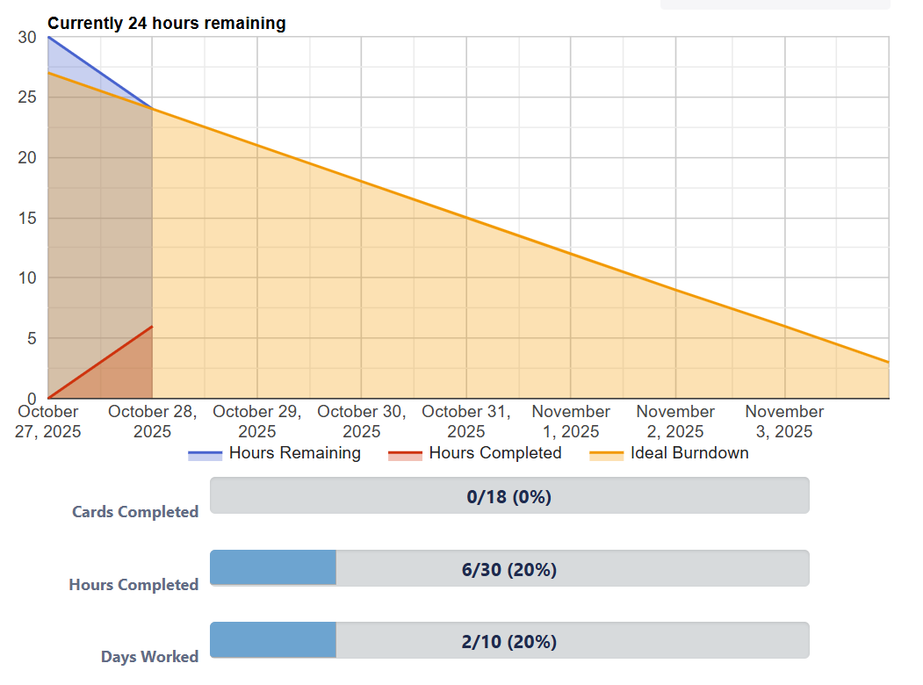
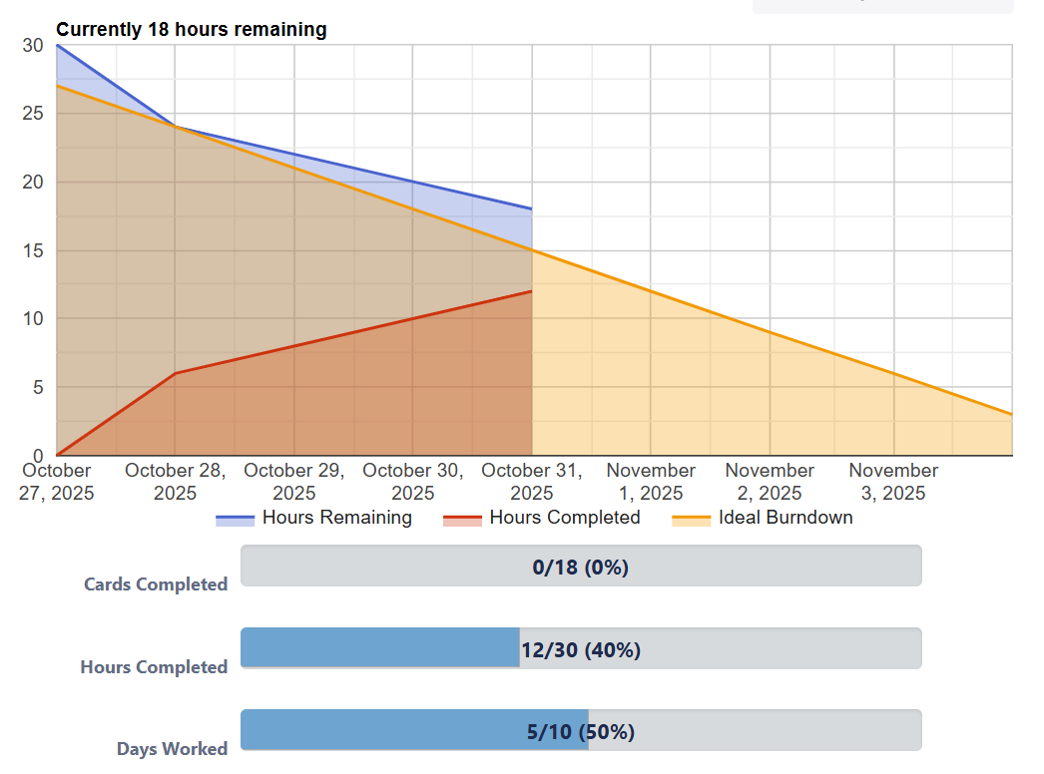
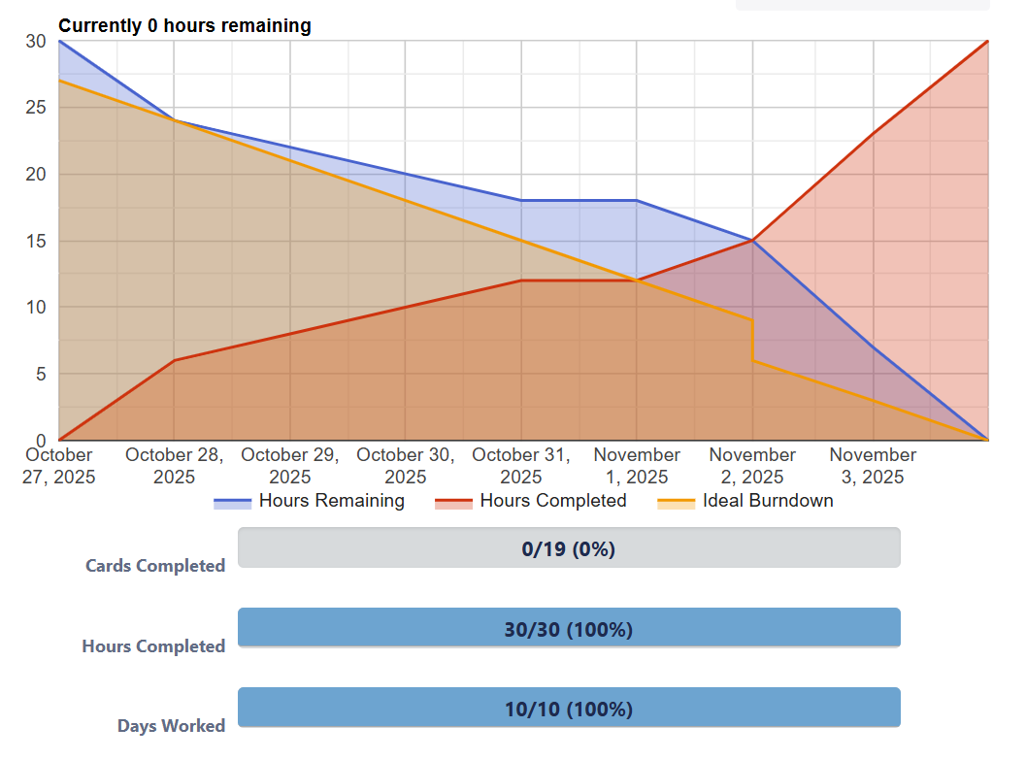

Daily Scrum Evidence:

Scrum Evidence 1: 10/28/25

Zach’s Responses:
- Yesterday (10/27): Coordinated with the client to receive feedback on site design and confirm features to be implemented in Sprint 2
- Today (10/28): Added tasks to the Trello board and created the project on Firebase
- Problems: Coordinating with the team to delegate tasks for the sprint

Sam’s Responses:
- Yesterday (10/27): Reviewed tasks and requirements for Sprint 2
- Today (10/28): Create Trello board and burndown charts for the rest of the sprint
- Problems: Need to discuss with team members all that needs to get done throughout the sprint

Drew’s Responses:
- Yesterday (10/27): Created the outline for the ReadMe document and formed an overall gameplan for sprint planning for the group
- Today (10/28): Finalized a daily scrum schedule amongst the group members
- Problems: Finding set times for the entire group to meet proved to be difficult once again with everyone’s busy schedules.

Nathan’s Responses:
- Yesterday (10/27): Checked Trello Board for daily tasks
- Today (10/28): Asked other group members if they needed assistance
- Problems: No direct problems

Andrew’s Responses:
- Yesterday (10/27): Planned out assignment of tasks for sprint
- Today (10/28): Assisted with organizing readme
- Problems: No issues

Prasi’s Responses:
- Yesterday (10/27): Looked over Trello board to understand tasks and assignments
- Today (10/28): Help out where I can because my task can only be completed later on in the sprint
- Problems: Can’t address task directly due to dependency on other previous tasks
Scrum Evidence 2: 11/02/25

Zach’s Responses:
- Yesterday (11/01): Built strava routes and embedded them on the routes page
- Today (11/02): Added photos, made design changes to index.html, and deployed the webpage
- Problems: There were some unexpected errors that occurred while I was attempting to deploy the webpage. I was able to troubleshoot, and eventually I was able to deploy the webpage

Sam’s Responses:
- Yesterday (11/01): Updated Trello board and burndown chart
- Today (11/02): Looking into code to connect to Firebase
- Problems: Need to discuss with the team what has all been completed and what still needs some work.

Drew’s Responses:
- Yesterday (11/01): Added in the events and actions needed to complete the Sprint, also ensured our Trello board was up to date
- Today (11/02): Refined the ReadMe document and communicated with other team members asking if they needed assistance in any other sections of the sprint
- Problems: No problems during this scrum meeting evidence for my tasks

Nathan’s Responses:
- Yesterday (11/01): Looked over at tasks for completion while going over code
- Today (11/02): Continued looking over code and double checking firebase
- Problems:Had some personal issue with connecting branches but was resolved

Andrew’s Responses:
- Yesterday (11/01): Transferred github link into readme
- Today (11/02): Completed small items and organization to help project efficiency
- Problems: Collaborating with multiple people on a single task

Prasi’s Responses:
- Yesterday (11/01): Reviewed status of project by pulling repo
- Today (11/02): Completed thorough check of the site to ensure no major bugs in the design
- Problems: Still need to implement some error messages that are not yet present and make the site functional but not easy to use

Sprint Review:

What did you learn in this sprint?
During this sprint, we reinforced our understanding of Firebase authentication by implementing sign up, sign in, and sign out functionality on the website. We learned more about integrating authentication with the front-end so that users can interact with the site seamlessly. We also gained insight into coordinating tasks across the team, especially when multiple people were updating the same features and managing GitHub access. Overall, this sprint helped us strengthen both our technical workflow and team collaboration.

What went well and why?
The implementation of user authentication went well because our team used GitHub effectively, creating separate branches for each feature which allowed multiple people to work on different parts of the website without overwriting each other’s work. Clear communication and frequent pull requests made it easy to review changes and merge them smoothly into the main branch. Testing the sign up, sign in, and sign out processes early on helped us catch issues with session management and data syncing before they became bigger problems. Overall, using GitHub and branches strategically, combined with strong collaboration, allowed us to implement the authentication features efficiently and confidently.
What challenges did you face?
One of the main challenges we faced was integrating the authentication system smoothly with the existing website, making sure that sign up, sign in, and sign out features worked correctly across different pages. We also had to troubleshoot session management and ensure that user data synced properly with Firebase, which required careful testing and debugging. Additionally, coordinating who would work on the front-end versus back-end features sometimes caused minor delays. Despite these challenges, frequent team check-ins and collaborative problem-solving helped us stay on track and successfully implement the authentication features.
How will you improve in the next sprint?
In the next sprint, we plan to improve by breaking down tasks into smaller, more manageable pieces to make progress more predictable and easier to track. We also want to dedicate more time to testing new features thoroughly before integrating them into the main site, which will help reduce bugs and rework. Additionally, we will improve communication by holding brief check-ins whenever a team member encounters an obstacle, so issues can be addressed quickly. Overall, these steps should help us work more efficiently and deliver features with greater confidence.
(If applicable) any client feedback.

GitHub Public Repo URL: https://github.com/zstrobel-eng/marathon-club-site.git

